SnapIMS Operator Guide
Complete verified operator procedures
Active release v0.15.0 · inventory schema 16 / 16 · August 5, 2026
This guide describes the verified SnapIMS browser interface and operator workflow. Shopify draft creation is the default; live publication requires an explicit typed confirmation.

1. Release identity
Identity | Expected
Application | 0.15.0
Inventory schema | 16 / 16
Data directory | ~/SnapIMS-data
Batch Home | ~/SnapIMS-data/batches

2. Install or upgrade
unzip SnapIMS-v0.15.0-full-source.zip
cd SnapIMS-v0.15.0
chmod +x install_v0150.sh
SNAPIMS_DATA_DIR="$HOME/SnapIMS-data" ./install_v0150.sh
snapims status
snapims up
Back up the data directory before upgrade. The installer and runtime reject unsupported schema/application combinations.

3. Import protocol
Folder boundaries define the batch. NEXT ITEM is the only routine QR command. Batch name and location are entered or overridden in the browser.
Situation | Result
No NEXT card | Valid one-item batch
Leading/trailing NEXT | Ignored with warning
Consecutive NEXT | Collapsed with warning
Consumer QR | Product photo
Legacy START/END/location QR | Ignored legacy command

4. Review and Batch Editor
- Review immutable Item IDs, photos, title, price, description, tags, quantity, condition, location, Rare, and Physical Review.
- Fill Down supports Tags, Location, Review, Rare, Title, Price, Discount, and Description.
- Tags Fill Down replaces the destination set; Append Tags adds without replacing.
- Stale edits are rejected rather than overwriting newer changes.
Batch Editor controls for selection, filtering, and exact bulk changes.

5. Shopify setup
- Required capabilities are derived from actual operations: locations, products, inventory, media, and publications.
- SnapIMS stores Client Secret and access-token cache encrypted and refreshes the token automatically.
- Select the active inventory location and the live publication by name.
- The saved legacy static token is deprecated and should be removed after client credentials pass.
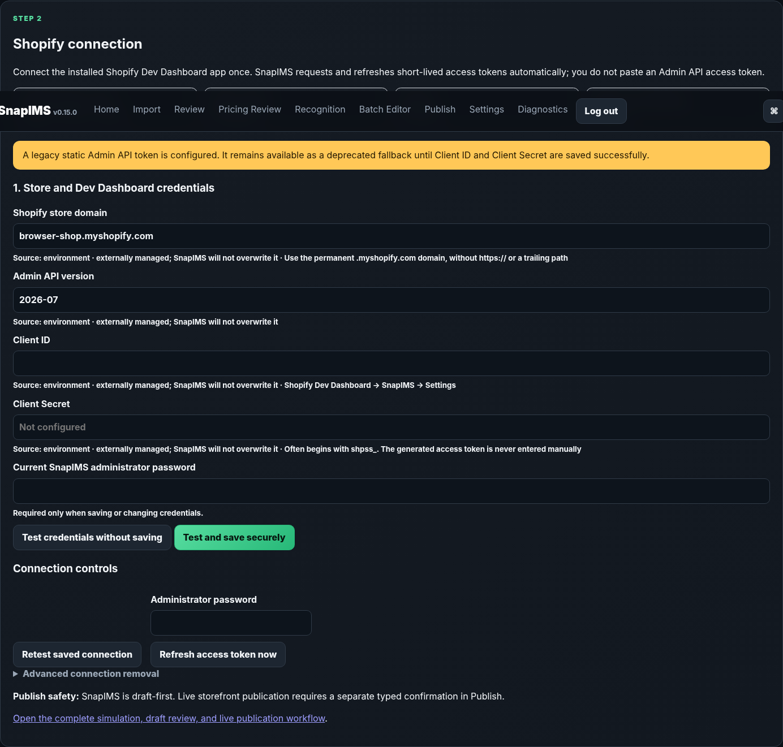
Shopify settings with read-only verification and recovery controls.

Shopify publish workflow
- Open Publish and select the working batch.
- Resolve all validation blockers. Live actions remain unavailable while blockers exist.
- Run Shopify Simulation. Simulation performs no Shopify write.
- Choose Create Shopify Drafts. SnapIMS uploads only publish-ready items and records Product, Variant, and Inventory Item GIDs.
- After success, SnapIMS opens Shopify draft products in a separate browser tab. The Publish page also provides Open in Shopify, Copy Product Link, and Copy Product GID controls.
- Review drafts when desired, then type SUBMIT and choose Publish Drafts Live.
- For deliberate direct publication, type SUBMIT LIVE. This bypass is not the default path.
Action | Required confirmation | Effect
Create Shopify Drafts | None after successful simulation | Creates unpublished Shopify products
Publish Drafts Live | SUBMIT | Activates products and publishes them to the selected publication
Publish Directly | SUBMIT LIVE | Creates drafts and then publishes them live
Archive | ARCHIVE | Makes selected Shopify products inactive
Restore Draft | RESTORE | Returns selected products to draft state
Delete | DELETE | Permanently deletes selected Shopify products
Keep Shopify | KEEP SHOPIFY | Imports the remote product snapshot into supported SnapIMS fields
Merge | MERGE | Applies the supported conflict merge operation
- Use checkboxes for selected-item operations; use the explicit entire-batch scope only when intended.
- Select All, Invert Selection, search, filtering, sorting, retry, reconciliation, archive, restore, and delete are available from the management section.
- Durable jobs show pending, running, retrying, complete, skipped, and failed rows with progress, elapsed time, ETA, and failure details.
- Restarting SnapIMS recovers unfinished jobs. Completed rows are not repeated.
- SKU reconciliation and stored Shopify GIDs prevent accidental duplicate creation.
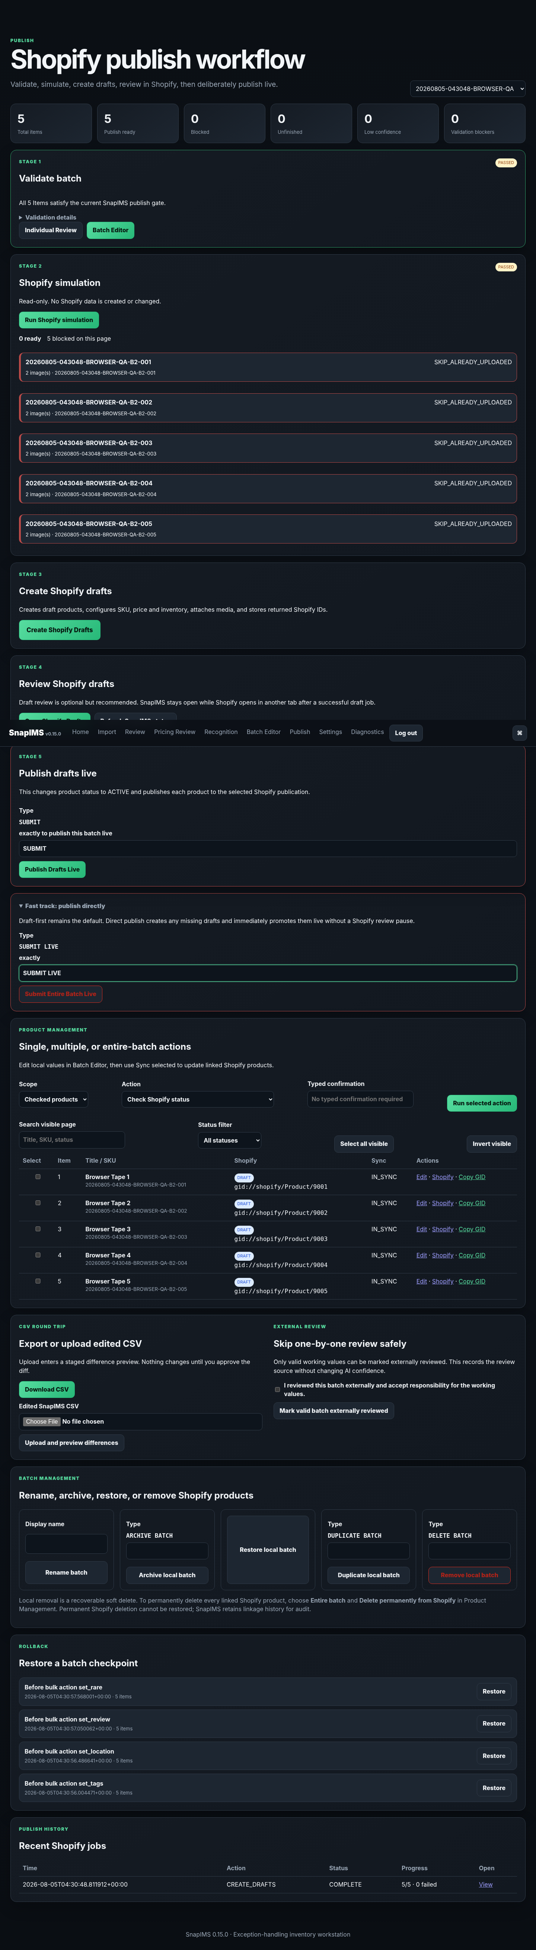
Full v0.15.0 publish workflow.

6. Conflict and product management
- Reconcile compares supported local and remote values and records a conflict when they differ.
- Keep SnapIMS pushes the supported local state to Shopify.
- Keep Shopify imports the supported remote state into SnapIMS.
- Archive is reversible; Delete is permanent and requires DELETE.
- Single-item, selected-item, and entire-batch scopes are explicit.

7. Recovery
Condition | Action
Interrupted Shopify job | Restart SnapIMS, reopen Publish, and resume/retry unfinished rows.
Expired token | No operator action normally; token refresh is automatic.
Missing publication | Return to Settings and select a publication before live publish.
Shopify rate limit/transport failure | Wait and retry failed rows; completed rows are skipped.
Wrong version/path | Run snapims status and reinstall from the intended extracted release.
Database problem | Stop SnapIMS, preserve the data directory, and restore only from a copied backup.

8. Diagnostics and CLI
snapims status
snapims doctor
snapims logs
snapims shopify status
snapims shopify test
snapims shopify refresh
snapims shopify jobs

9. Backup
snapims down
cp -a "$HOME/SnapIMS-data" "$HOME/SnapIMS-data-backup-$(date +%Y%m%d-%H%M%S)"

