SnapIMS Complete Operating Manual
Architecture, operations, recovery, and release acceptance
Active release v0.15.0 · inventory schema 16 / 16 · August 5, 2026
This guide describes the verified SnapIMS browser interface and operator workflow. Shopify draft creation is the default; live publication requires an explicit typed confirmation.

1. Operating model
Layer | Purpose
Source photos | Immutable operator originals
Import cache | Restart-safe decoding, QR interpretation, and thumbnails
Inventory database | Batches, items, controlled tags, history, and checkpoints
Recognition | Durable provider attempts and evidence
Review/Batch Editor | Human decisions and audited edits
Shopify jobs | Durable draft, live, sync, reconcile, archive, restore, and delete operations

2. Shopify state model
State | Meaning
Draft | Created in Shopify but not live
Published | Active and published to the selected publication
Archived | Inactive on Shopify
Deleted | Remote product permanently removed
Needs Sync | Local/remote state requires action
Conflict | Supported local and remote values differ

Shopify publish workflow
- Open Publish and select the working batch.
- Resolve all validation blockers. Live actions remain unavailable while blockers exist.
- Run Shopify Simulation. Simulation performs no Shopify write.
- Choose Create Shopify Drafts. SnapIMS uploads only publish-ready items and records Product, Variant, and Inventory Item GIDs.
- After success, SnapIMS opens Shopify draft products in a separate browser tab. The Publish page also provides Open in Shopify, Copy Product Link, and Copy Product GID controls.
- Review drafts when desired, then type SUBMIT and choose Publish Drafts Live.
- For deliberate direct publication, type SUBMIT LIVE. This bypass is not the default path.
Action | Required confirmation | Effect
Create Shopify Drafts | None after successful simulation | Creates unpublished Shopify products
Publish Drafts Live | SUBMIT | Activates products and publishes them to the selected publication
Publish Directly | SUBMIT LIVE | Creates drafts and then publishes them live
Archive | ARCHIVE | Makes selected Shopify products inactive
Restore Draft | RESTORE | Returns selected products to draft state
Delete | DELETE | Permanently deletes selected Shopify products
Keep Shopify | KEEP SHOPIFY | Imports the remote product snapshot into supported SnapIMS fields
Merge | MERGE | Applies the supported conflict merge operation
- Use checkboxes for selected-item operations; use the explicit entire-batch scope only when intended.
- Select All, Invert Selection, search, filtering, sorting, retry, reconciliation, archive, restore, and delete are available from the management section.
- Durable jobs show pending, running, retrying, complete, skipped, and failed rows with progress, elapsed time, ETA, and failure details.
- Restarting SnapIMS recovers unfinished jobs. Completed rows are not repeated.
- SKU reconciliation and stored Shopify GIDs prevent accidental duplicate creation.
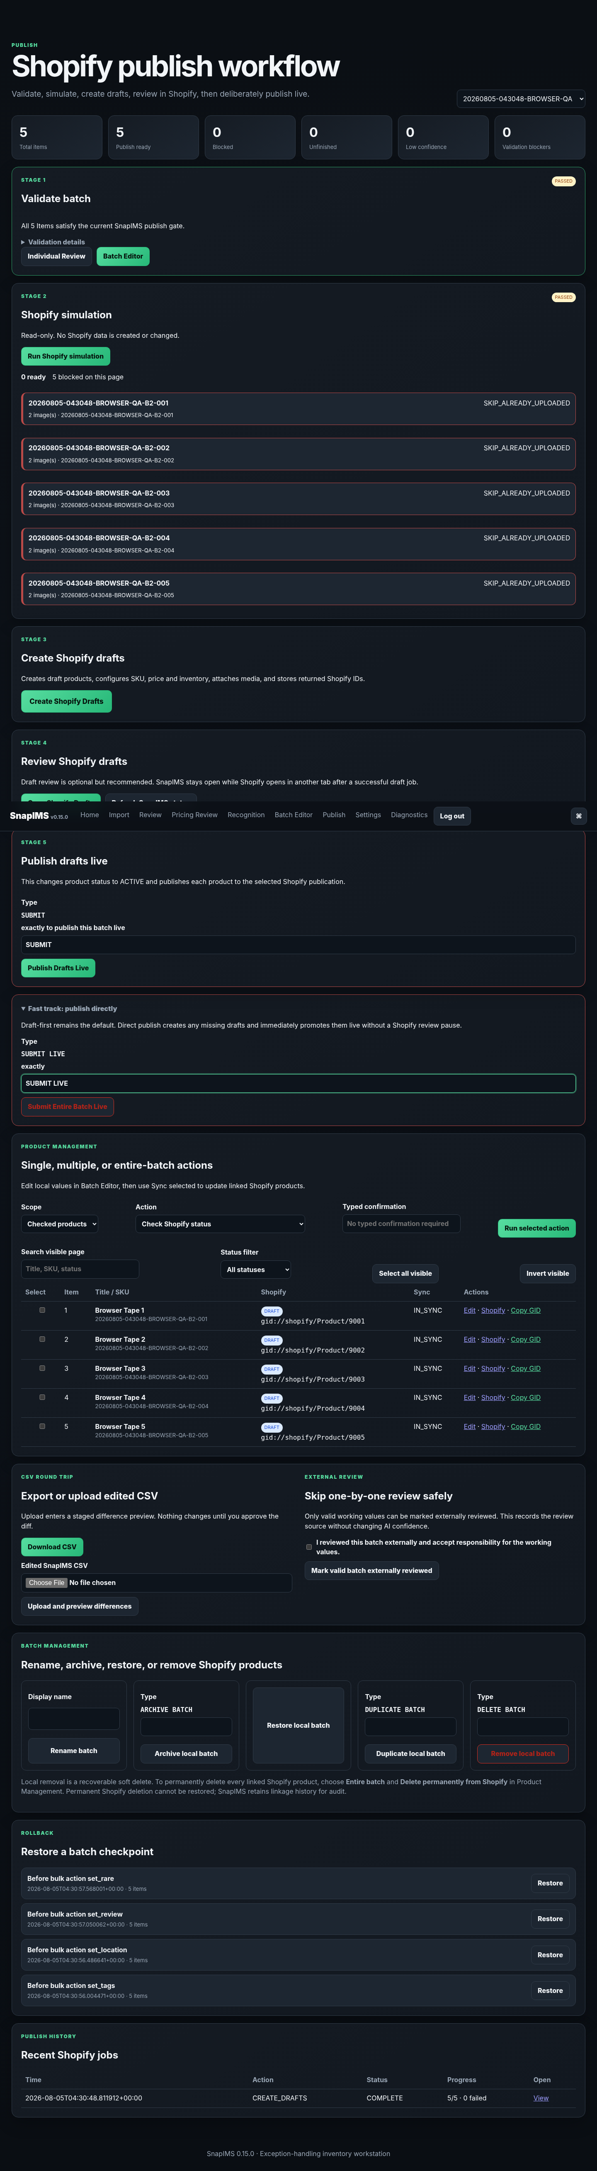
Desktop publish workflow browser evidence.
Publish workflow verified at a 390-pixel mobile viewport.

3. Durable jobs and idempotency
- Jobs and per-item stages are stored in schema 16.
- A completed item is not executed again after refresh or restart.
- Concurrent duplicate work is rejected or resolves to the existing durable job.
- Transient failures use bounded retry; authentication failure permits one token refresh and retry.
- SKU reconciliation and persisted Shopify GIDs prevent duplicate product creation.

4. Security
- Client Secret and access-token cache are encrypted and owner-only.
- Secrets are not written to logs, HTML, screenshots, browser storage, or audit details.
- All state-changing browser routes remain authenticated and CSRF-protected.
- Destructive or public-storefront actions require exact typed confirmation.
- Connection testing is read-only; live writes occur only from the Publish workflow.

5. Browser and automated verification
Evidence | Result
Automated suite | 299 passed, 3 skipped, 0 failed
Browser checks | 52 / 52 passed
Console/page errors | 0
Unexpected failed requests | 0
HTTP 500 responses | 0
Desktop Chromium | Pass through local relay
390 px mobile | Pass
Upgrade from v0.14.0 | Pass; schema 16; inventory preserved

6. External tests not claimed
Capability | Reason
Live owner-store product writes | No owner Shopify credentials were available in the sandbox; deterministic fakes covered mutations and state transitions.
Live OpenAI | No production API key in sandbox.
Native Firefox | Runtime unavailable.
Target 2012 Mac mini | Hardware unavailable.
Owner Cloudflare/Guacamole/xrdp | Infrastructure unavailable.
Real HEIC | HEIC runtime unavailable.

7. v1.0 acceptance
- Complete the real 20-tape Pixel pilot.
- Create and inspect real Shopify drafts, then publish a controlled live product and test archive/delete recovery decisions.
- Run live AI, real CSV round trip, restart durability, backup/restore, target-hardware soak, direct Firefox/Chromium walkthrough, and security review.
- Follow the final Operator Guide against the production browser UI and resolve every discrepancy.
- Do not label 1.0.0 while any Critical or High production blocker remains.

8. Evidence locations
- browser-evidence/v0.15.0/
- release-evidence/v0.15.0/
- TEST_RESULTS.md
- BROWSER_VERIFICATION.md
- ISSUE_TRACEABILITY_V0150.md
- V1_PRODUCTION_ACCEPTANCE_GAPS.md

