SnapIMS Operator Guide
Complete verified operator procedures
Active release v0.13.2 · August 4, 2026
SnapIMS is local-first inventory software. This guide describes the browser interface and command behavior verified for the active release.

1. Release identity and safety
The active release is v0.13.2 with inventory schema 15. The installer pins the command and user service to the extracted release so an older source tree cannot silently start against a newer database.
Identity | Expected
CLI version | 0.13.2
Home version | 0.13.2
Inventory schema | 15 / 15
Default data | ~/SnapIMS-data
Batch Home | ~/SnapIMS-data/batches

2. Installation and startup
unzip SnapIMS-v0.13.2-full-source.zip
cd SnapIMS-v0.13.2
chmod +x install_v0132.sh
./install_v0132.sh
export PATH="$HOME/.local/bin:$PATH"
snapims status
snapims up
Do not operate against an unexpected project path. Re-run the installer from the intended release if status shows a stale source path.

3. Import protocol
Folder beginning and folder end are automatic batch boundaries. NEXT ITEM is the only active daily QR command. START, END, LOCATION, RARE, REVIEW, and CONTINUE photographs are ignored legacy commands and produce one concise non-blocking warning.
Situation | Interpretation
No NEXT card | Valid one-Item batch
Leading NEXT | Ignored with warning
Consecutive NEXT | Collapsed with warning
Trailing NEXT | Empty Item ignored with warning
Only NEXT cards | No product photographs
Unrelated consumer QR | Product photograph
Legacy SnapIMS QR | Ignored; does not control grouping

4. Import corrections
- Treat as Product Photo
- Treat as NEXT ITEM
- Ignore Photo
- Split Item Before This Photo
- Merge With Previous Item
Corrections affect only SnapIMS interpretation. They survive refresh, navigation, restart, Preview reopening, and final Commit. Original filenames, timestamps, EXIF, and pixels are not modified.
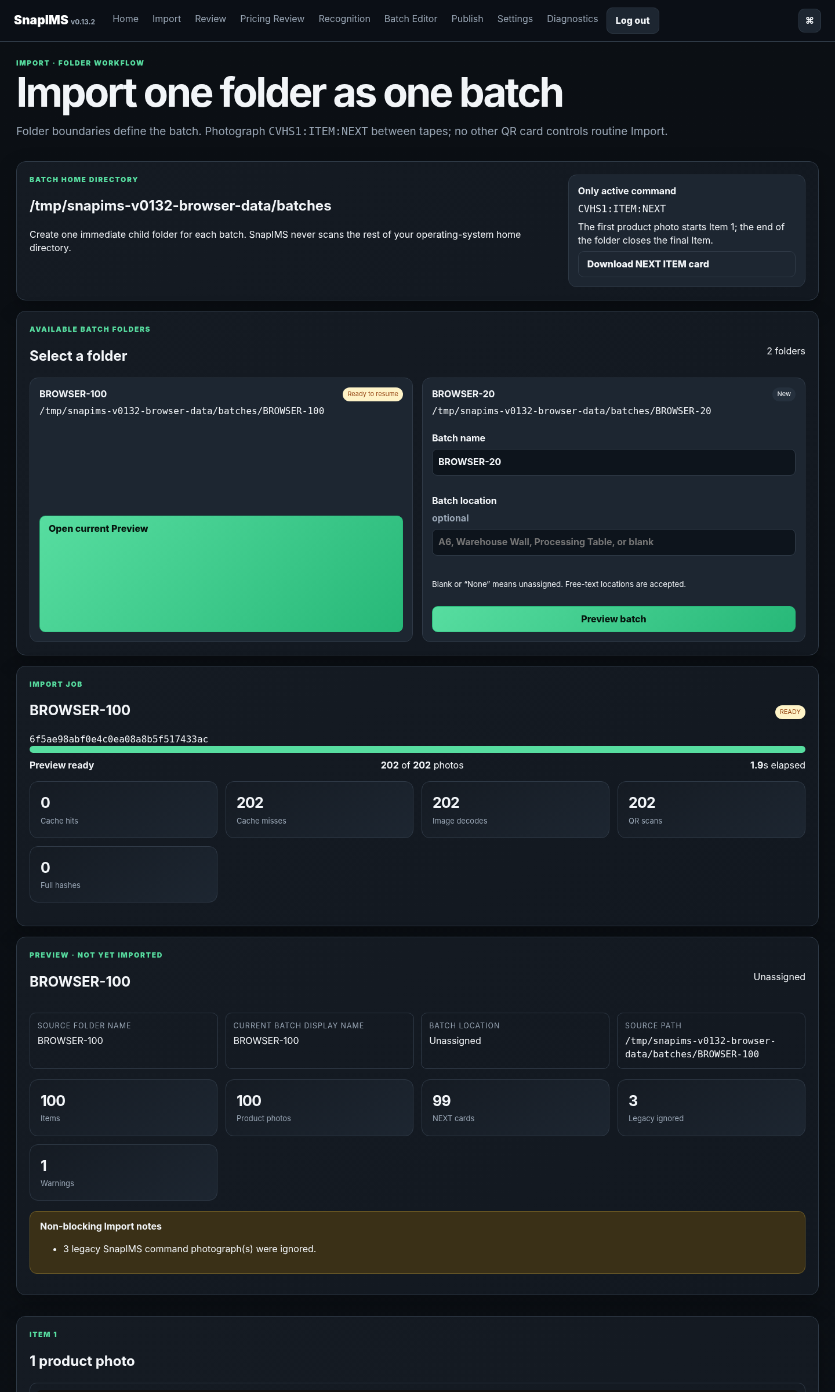
Verified 100-item Preview overview: exact grouping, durable progress, and one decode/scan per source image.
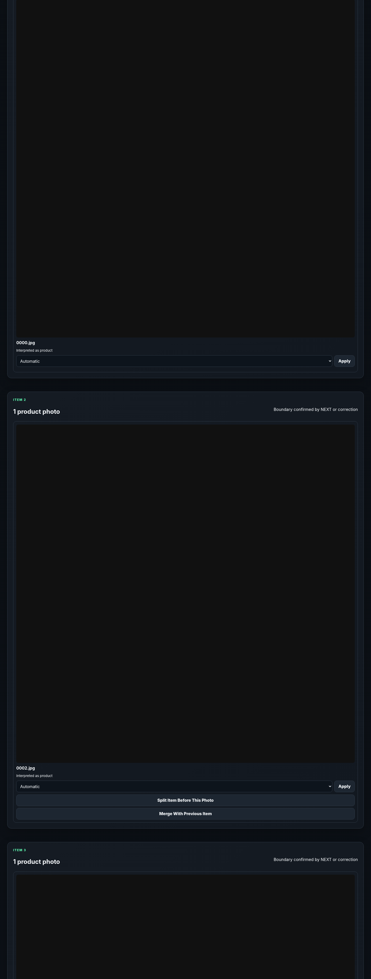
Interpreted Item cards expose focused photo corrections without modifying source files.
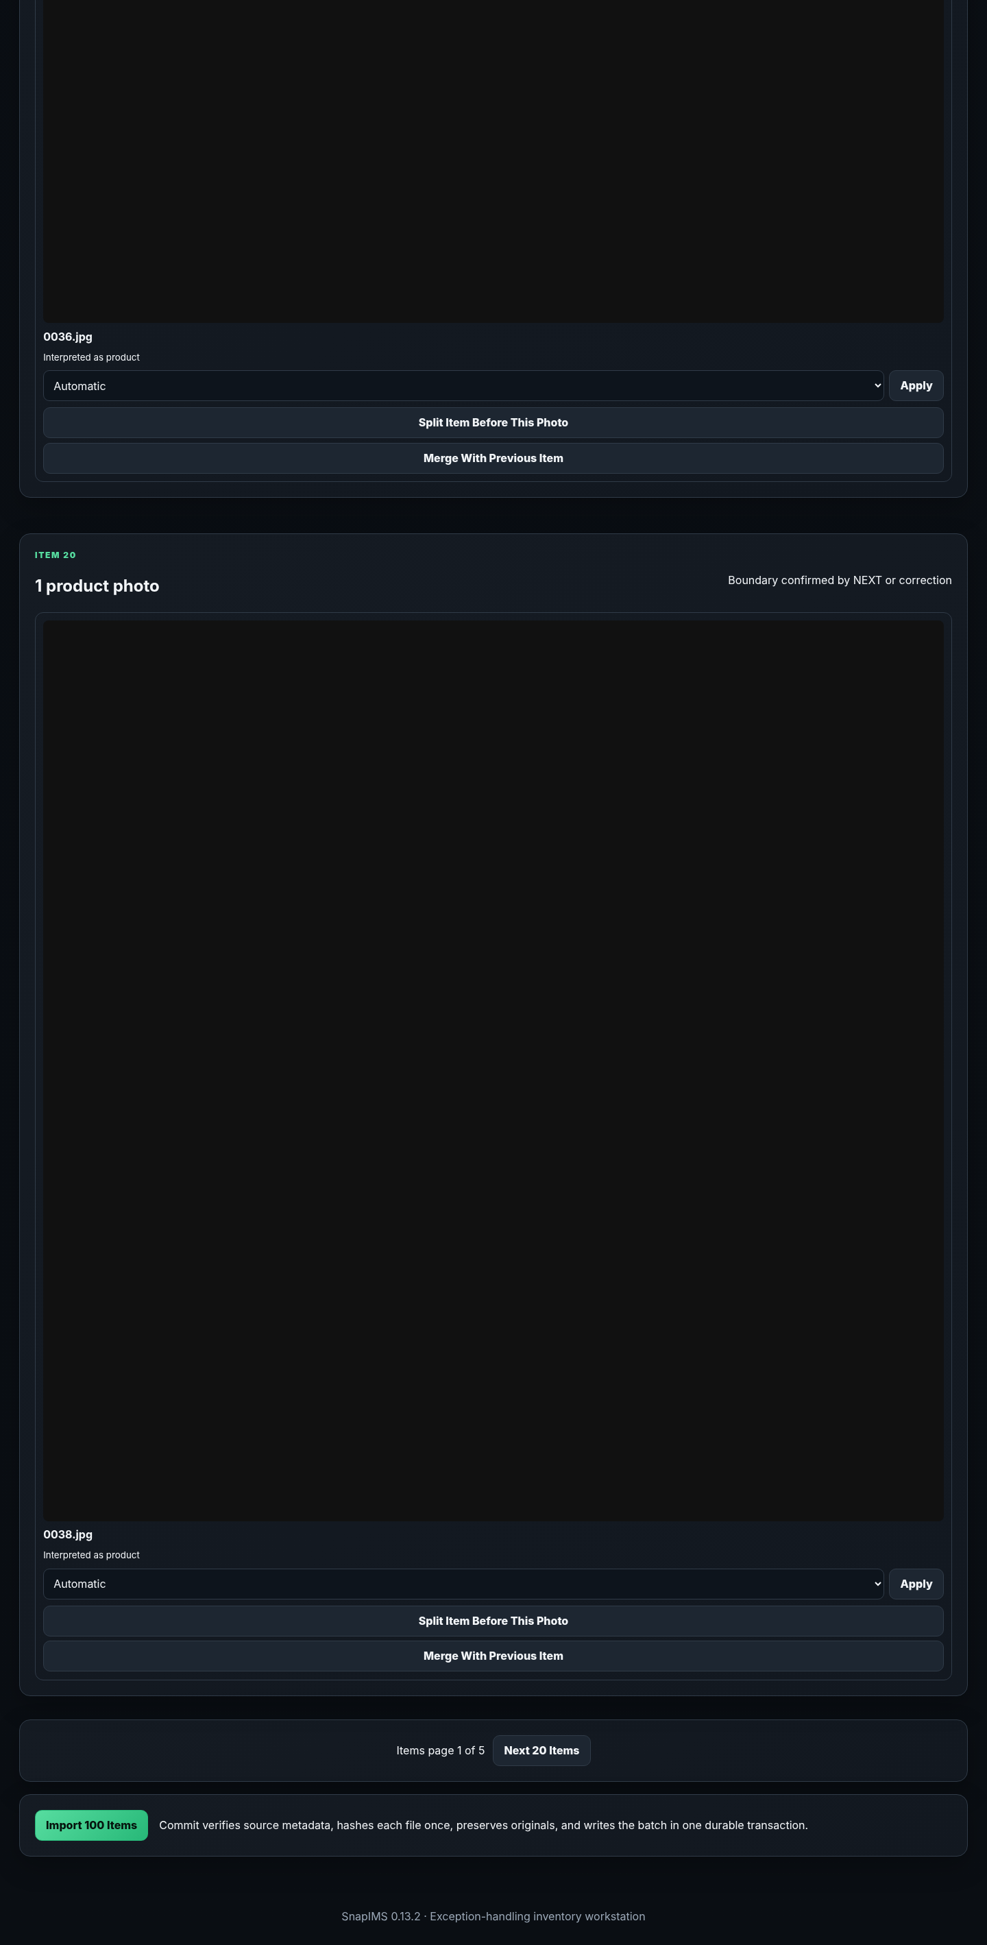
End of Preview and Commit controls.

5. Recognition
Use configured providers only. Test/mock provider output is blocked from Publish unless deliberately replaced by manual review. A missing or failed provider is displayed as blocked or failed rather than silently accepted.

6. Review
- Inspect the correct Item photo and immutable Item ID.
- Confirm or change Title, Price, Tags, Discount, Condition, Quantity, and location.
- Use Rare and Physical Review as operator decisions.
- Review stored evidence and uncertainty; SnapIMS does not invent explanations for missing evidence.
- Stale two-tab edits return HTTP 409 and preserve the accepted record.

7. Batch Editor
The editor is paged at 20–200 rows. Search, filter, and sort are server-bounded, and the loaded page retains fast spreadsheet-style editing.
Operation | Behavior
Fill Down Tags | Exact set/replace with validated immutable Tag IDs
Fill Down Location | Copies free text; blank/None becomes unassigned; history recorded
Fill Down Review/Rare | Copies true or false exactly
Append Tags | Adds tags without replacing existing tags
Hidden rows | Selections clear immediately
Keyboard | Horizontal movement crosses Tags; vertical movement keeps the field
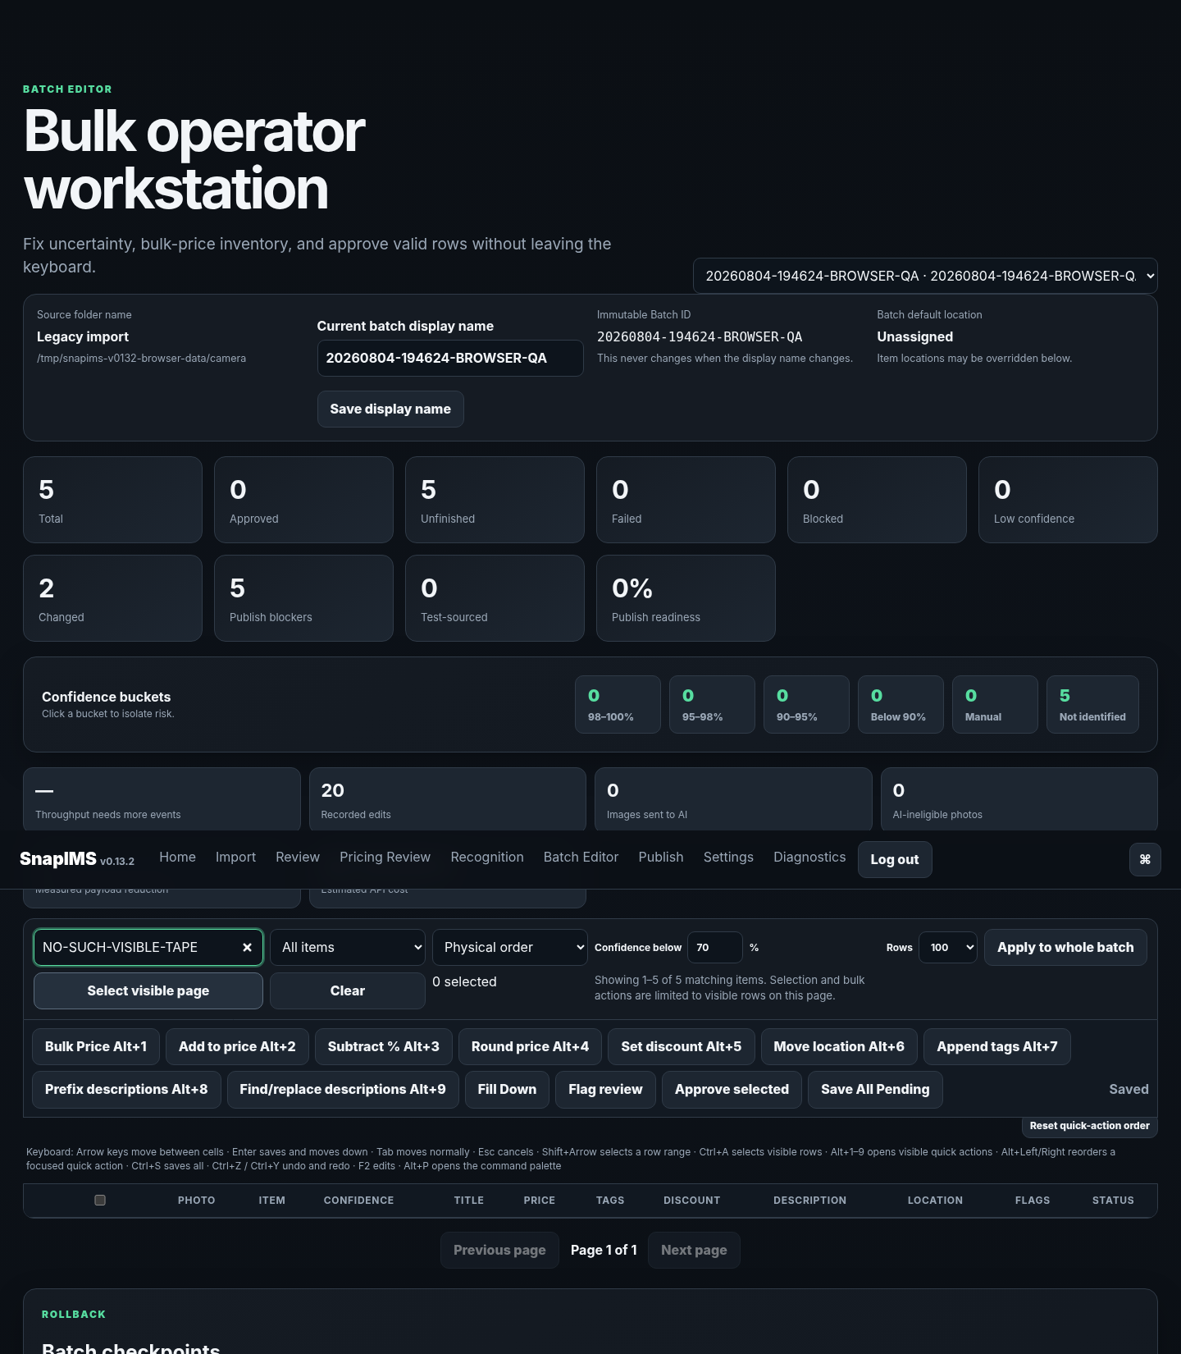
Desktop Batch Editor after the v0.13.2 consistency and paging fixes.
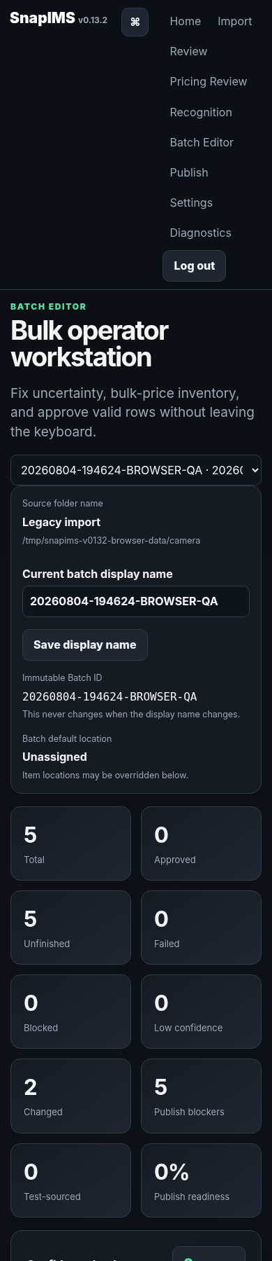
Mobile verification at 390 × 844.

8. CSV
- Export the intended batch CSV.
- Preserve Item ID values and header structure.
- Edit only supported values.
- Preview import differences before apply.
- Correct every validation error; failed staged imports remain all-or-nothing.
- Verify exported/imported row counts and an Item-ID sample.

9. Publish
The Publish page uses aggregate readiness counts. It does not dry-run all Items by default. Select simulation explicitly; simulation is paged. Live Shopify draft creation is guarded by valid configuration and explicit confirmation.

10. Recovery
Problem | Operator action
Wrong version/path | Run snapims status; re-run install_v0132.sh from the intended release.
Interrupted scan | Reopen Import; resume the durable folder job.
Duplicate tab/Commit | Open the existing job/result; do not create a new source folder copy.
Migration issue | Stop SnapIMS; preserve data; restore only from copied pre-schema-v15 backup.
API unavailable | Keep result blocked/failed; use Diagnostics; do not treat dummy evidence as production proof.

11. Shutdown and backup
snapims down
cp -a ~/SnapIMS-data ~/SnapIMS-data-backup-$(date +%Y%m%d-%H%M%S)

