SnapIMS Complete Operating Manual
Operations, diagnostics, recovery, and release readiness
Active release v0.13.2 · August 4, 2026
SnapIMS is local-first inventory software. This guide describes the browser interface and command behavior verified for the active release.

1. Product model
SnapIMS keeps immutable internal Batch and Item identities while allowing operator-visible batch names and locations to change. Source folders remain audit evidence and are never renamed by display-name edits.
Layer | Purpose
Source photos | Immutable operator originals
Import cache | Restart-safe dimensions, readability, QR result, thumbnail, optional hash
Inventory database | Batches, Items, history, controlled Tags, checkpoints
Recognition | Durable provider attempts/results and evidence
Review/Batch Editor | Human decisions and audited edits
Publish | CSV and guarded Shopify draft workflow

2. Performance design
- Folder list reads immediate child directories without opening every photograph.
- Preview runs as a background job and returns browser control immediately.
- Unchanged photographs are not decoded or QR-scanned again.
- Final preservation hashes are streamed at Commit and reused.
- Batch Editor and Publish use bounded database pages and aggregate summaries.
- SQLite connections close explicitly after every context.
Measured scenario | v0.13.2 sandbox result
20-item / 42-photo cold Preview | 479 ms
20-item warm Preview | 18 ms, 0 decodes, 0 scans
100-item / 202-photo cold Preview | 2,388 ms
100-item warm Preview | 40 ms
5,000-item Batch Editor | 430,721 bytes; 100 rows; 0.414 s relayed Chromium render
Full suite descriptors | 3 baseline; 166 peak; 7 final; 0 final SQLite

3. Complete workflow
- Start and verify release identity.
- Prepare one batch folder and NEXT separators.
- Preview and correct grouping.
- Commit immutable inventory records.
- Run Recognition or leave provider-blocked Items for manual work.
- Review evidence and commercial fields.
- Use paged Batch Editor for controlled mass edits.
- Verify CSV when used.
- Simulate and perform guarded Publish only when ready.
- Stop and back up.
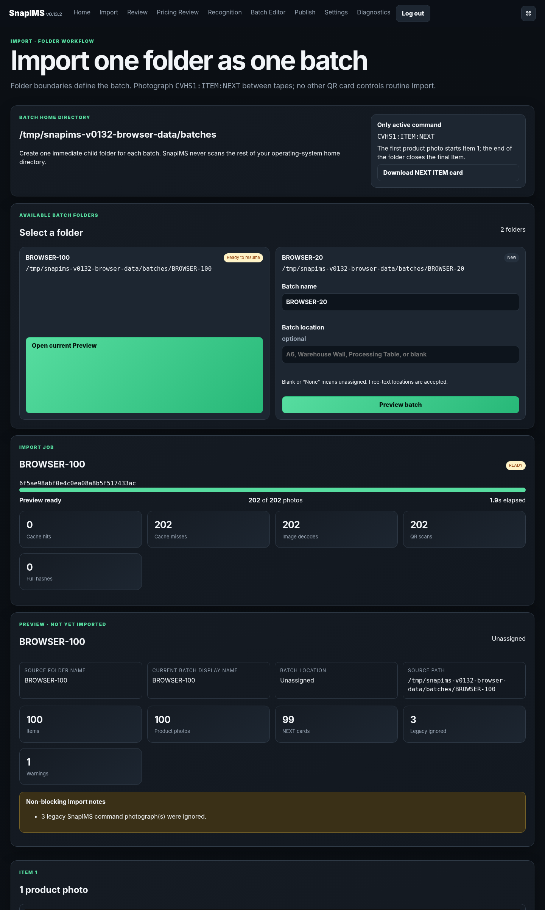
Import Preview overview from the v0.13.2 browser pass.
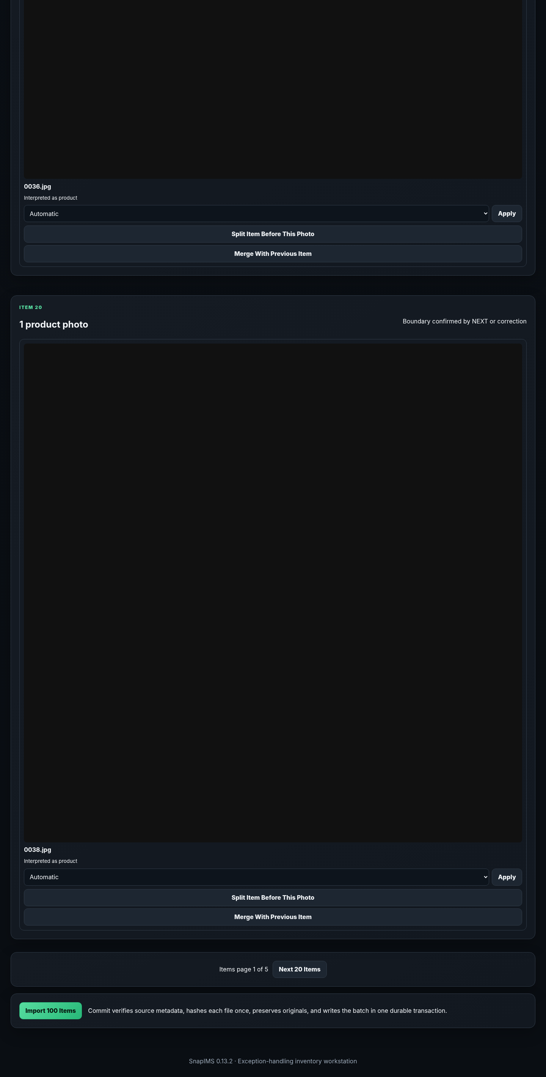
Import Commit controls from the v0.13.2 browser pass.
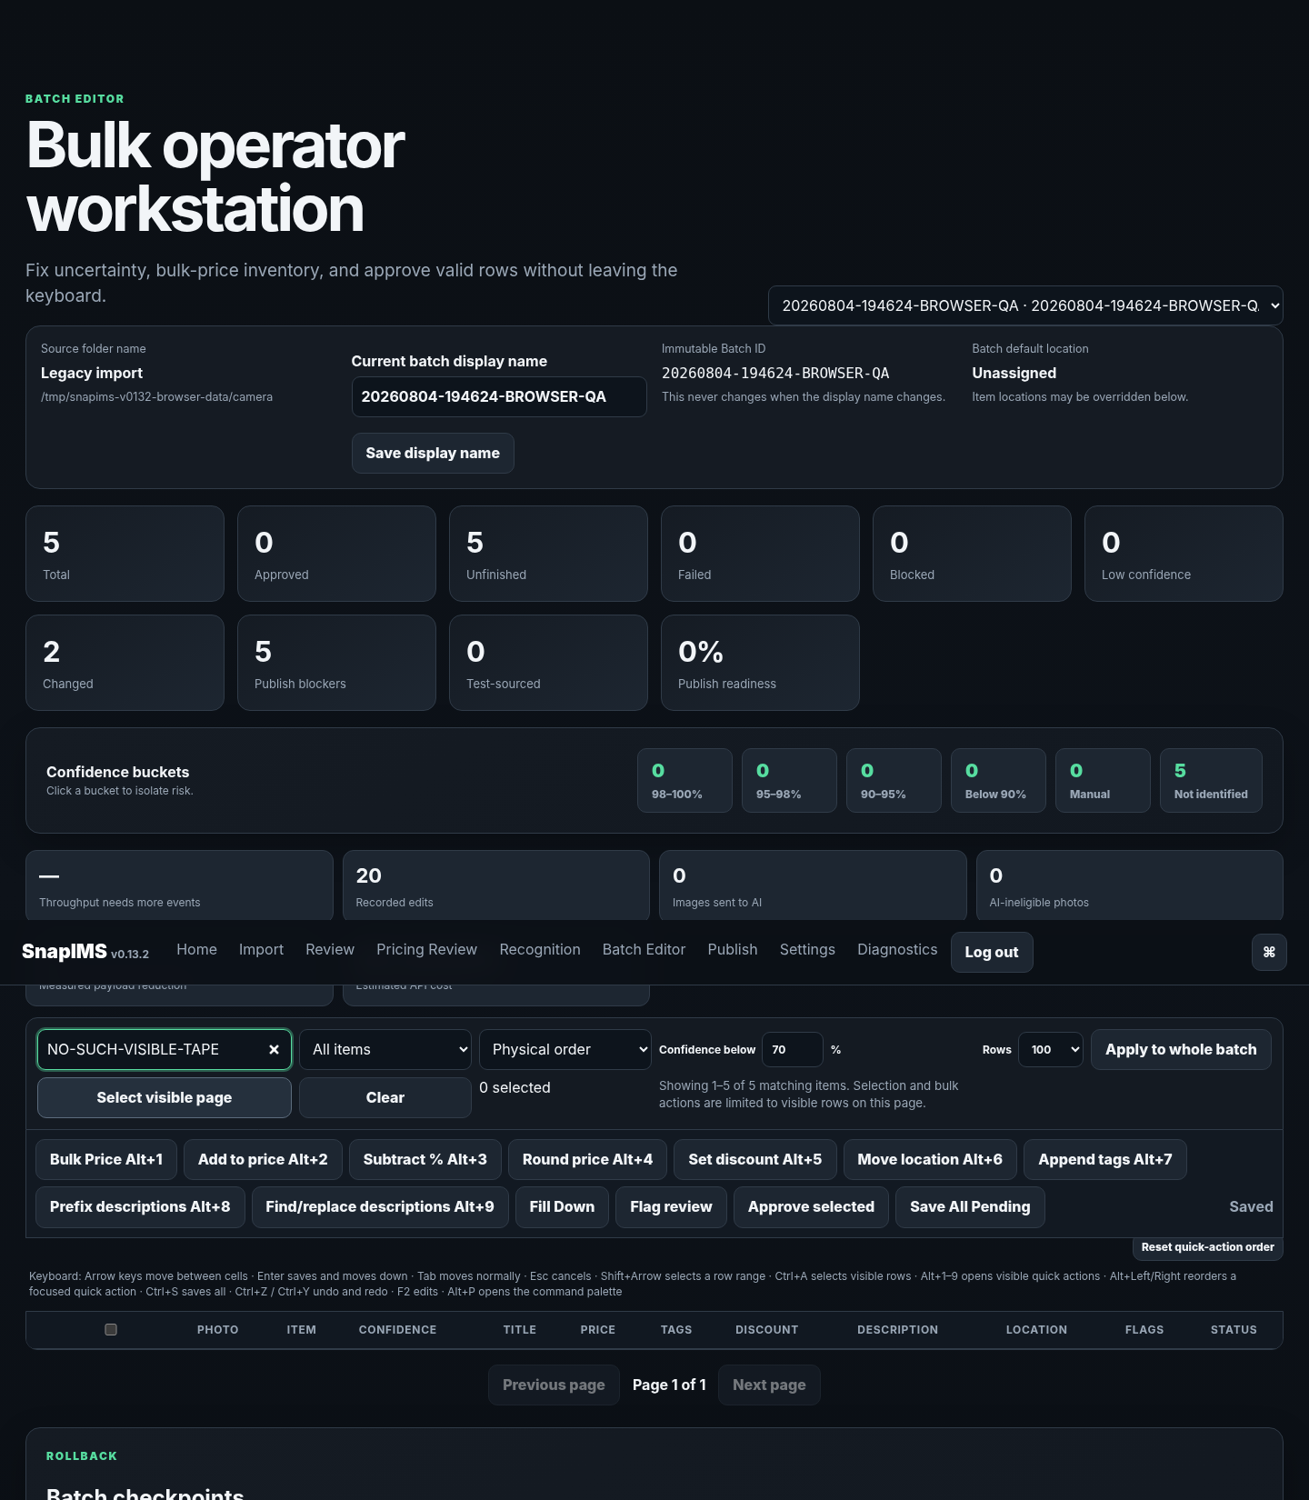
Batch Editor evidence from the v0.13.2 browser pass.

4. Audit and conflict rules
- Every accepted edit remains tied to the immutable Item ID.
- Location changes create location-history events.
- Bulk operations are atomic and checkpointed where required.
- Stale revisions are rejected rather than overwriting newer work.
- Duplicate Import Preview/Commit requests resolve to one durable job/result.
- A mixed application/schema version is refused before serving normal work.

5. Diagnostics
snapims doctor
snapims status
snapims logs
Status reports project path, Python executable, data directory, PID, version, and schema. External-service failures do not imply inventory database failure; read each component separately.

6. Security
- Configure authentication before public exposure.
- Keep secrets outside source control and verify owner-only secret-file permissions.
- Use CSRF-protected state changes and revoke sessions after credential changes.
- Treat Cloudflare, Guacamole, xrdp, and remote-shell exposure as separate deployment controls.

7. Production acceptance
v0.13.2 is pilot-ready, not v1.0.0. Before 1.0, complete the real 20-tape Pixel pilot, live AI, live Shopify draft, real CSV round trip, target-machine restart durability, direct Firefox/Chromium walkthrough, guide verification, security/deployment review, backup/restore drill, and zero-blocker review.

8. Skipped sandbox capabilities
Capability | Reason
Live OpenAI | No production API key
Live Shopify | No store/token
Native Firefox | Runtime unavailable
Direct localhost Chromium | Managed URLBlocklist
2012 Mac mini | Hardware unavailable
Cloudflare/Guacamole | Owner infrastructure unavailable
HEIC | pillow_heif unavailable

9. Evidence locations
- release-evidence/v0.13.2/
- browser-evidence/v0.13.2/
- TEST_RESULTS.md
- PERFORMANCE_REPORT.md
- ISSUE_TRACEABILITY_V0132.md
- V1_PRODUCTION_ACCEPTANCE_GAPS.md

