SnapIMS Day-to-Day Guide
First-time operator workflow
Active release v0.13.2 · August 4, 2026
SnapIMS is local-first inventory software. This guide describes the browser interface and command behavior verified for the active release.

1. Start SnapIMS
export PATH="$HOME/.local/bin:$PATH"
snapims up
snapims status
- Version must show 0.13.2.
- Inventory schema must show 15 / 15.
- Project path and Python executable must point to the current extracted release.
- Open http://127.0.0.1:8767/.

2. Prepare one batch folder
- Create one immediate child folder inside ~/SnapIMS-data/batches.
- Use the desired default batch name as the folder name.
- Put product photographs inside the folder in capture order.
- Photograph NEXT ITEM between tapes. The exact payload is CVHS1:ITEM:NEXT.
- Do not rename, recompress, or edit source photographs after Preview.
Blank or “None” location means unassigned. Any reasonable free-text location is allowed, including Processing Table or Warehouse Wall.

3. Preview and Commit
- Open Import and select the folder.
- Confirm the derived batch name.
- Enter a location or leave it unassigned.
- Select Preview batch. The page remains responsive and progress survives refresh.
- Verify the interpreted Items and warning list.
- Use only the focused correction controls when necessary.
- Select Commit Import once grouping is correct. Repeated Commit is safe and idempotent.
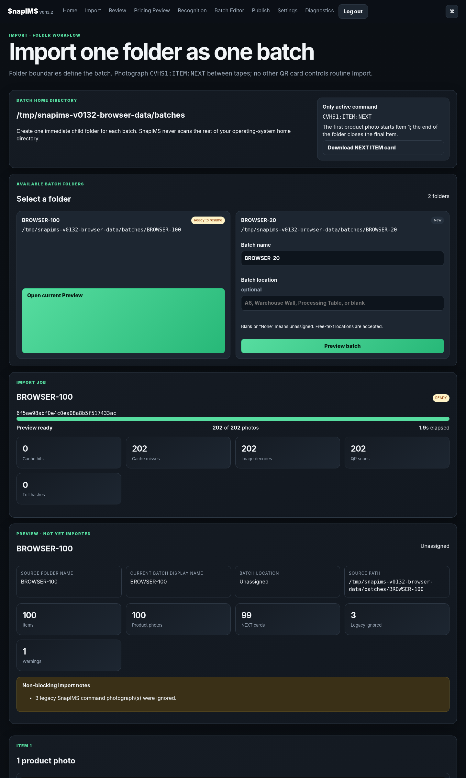
Import Preview overview with durable progress, measured scan counts, and the first interpreted Item.
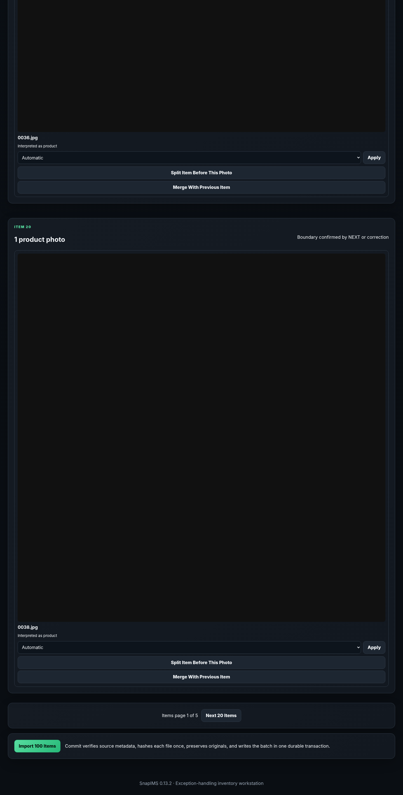
Final Preview controls and Commit Import action.

4. Recognition and Review
- Recognition may use live AI only when configured. Blocked or failed results are not successful results.
- Review title, price, tags, condition, Rare, Physical Review, and evidence before approval.
- Manual edits remain attached to immutable Item IDs.

5. Batch Editor
- The editor uses bounded pages and does not render an entire 5,000-item batch.
- Select destination rows, focus a source cell, then choose Fill Down.
- Fill Down supports Title, Price, Tags, Discount, Description, Location, Review, and Rare.
- Tags Fill Down replaces the destination tag set exactly. Append Tags is a different action.
- Rows hidden by search/filter are automatically deselected.
- ArrowLeft and ArrowRight move through the Tags editor.
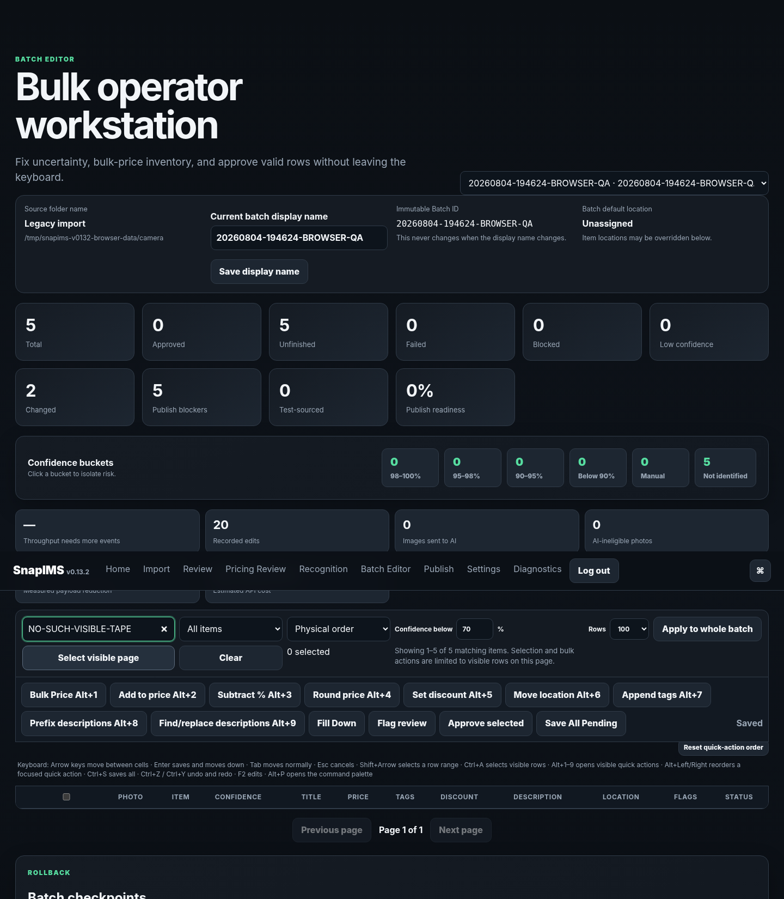
Desktop Batch Editor with controlled Tags, location, flags, paging, and selection-safe bulk actions.
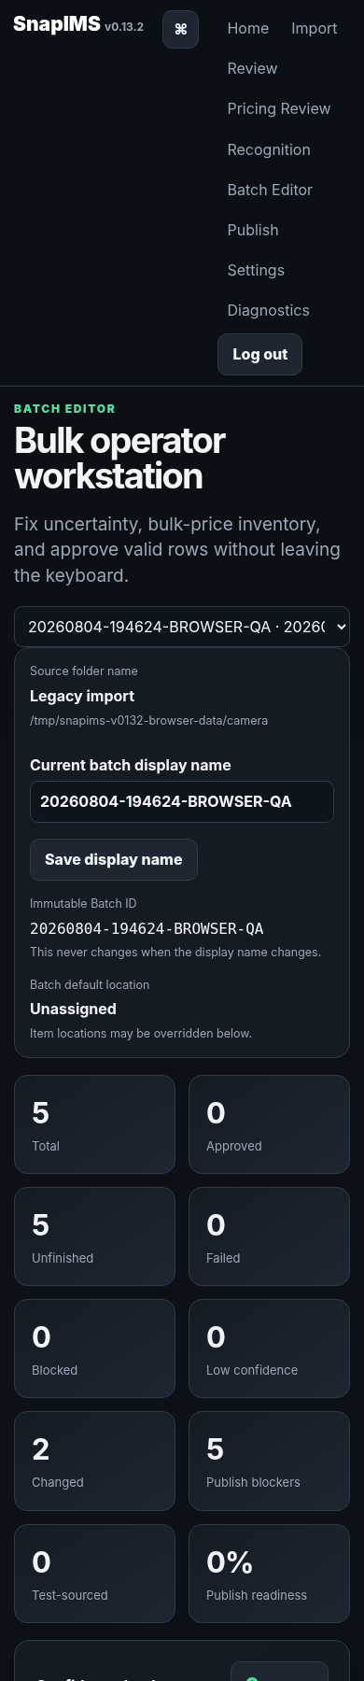
At 390 pixels, the page body fits the viewport and the wide editor grid scrolls horizontally.

6. Publish and finish
- Publish readiness is calculated with aggregate database queries.
- Shopify simulation is explicit and limited to the current page.
- Live Shopify action requires valid credentials and confirmation.
- Stop SnapIMS before an offline database backup.
snapims down

End-of-batch check
- Physical tape count matches Preview Item count.
- No NEXT photographs are attached to Items.
- Location is correct or intentionally unassigned.
- Titles, prices, tags, condition, flags, and quantity are verified.
- CSV and Shopify results were independently checked when used.

