**Host Organization**

AI Platform and Research, JD.com *

Institute of Automation, Chinese Academy of Sciences**

**Coordinators**

Hailin Shi*, Xiaobo Wang*, Xiangyu Zhu**, Yinglu Liu*, Hao Shen*.

**Coordinator Contacts**

Please feel free to send any question, comment, model or binary with a brief method description to Hao Shen at shenhao5@jd.com.

**Challenge Title**

Grand Challenges of 106-p Facial Landmark Localization.

**Call for participation**

The deep learning methods have been largely developed in facial landmark localization task, the performance of algorithm is continuously improved, and the requirements of practical applications are growing fast. However, there are still some key problems to solve. Facial features vary greatly from one individual to another. Even for a single individual, there is a large amount of variation due to the pose, expression, viewing angle, and illumination conditions. Here, we invite researchers and developers from academia and industry to participate in this competition and encourage further discussion on technical and application issues.

**Challenge Description**

Facial landmark localization serves as a key step for many face applications, such as face recognition, emotion estimation and face reconstruction. The objective of facial landmark localization is to predict the coordinates of a set of pre-defined key points on human face. As shown in the Figure1, 106-key-point landmarks enable abundant geometric information for face analysis tasks. The purpose of this competition is to promote the development of research on face landmark localization, especially dealing with the complex situations, *e.g.* large face poses, extreme expressions and occlusions.

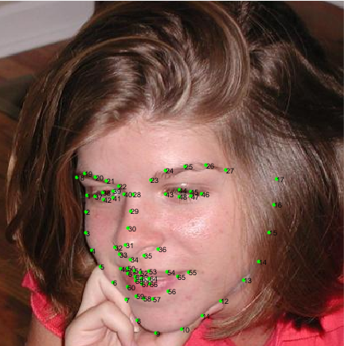 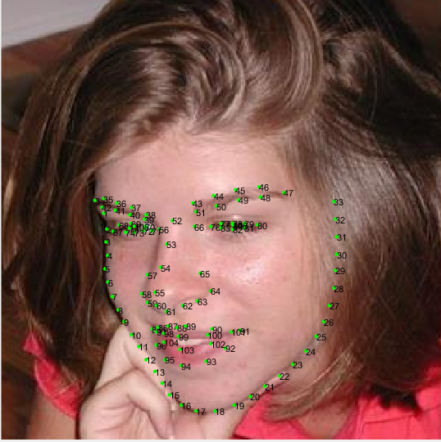

Figure1: The 68- and 106-key-point landmark examples.

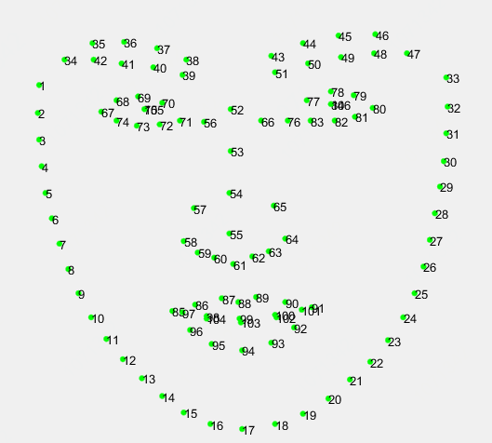

Figure2: The 106-key-point mark-up used for our annotations.

**Potential participants**

We sincerely invite researchers and developers in this list, from both academia and industry, for the Grand Challenges program.

* Institute of Computing Technology, Chinese Academy of Sciences
* Tsinghua University
* Beihang University
* Beijing Institute of Technology
* National University of Singapore
* University of Toronto
* The University of Melbourne
* Imperial College London
* University of Surrey
* University of California, Berkeley
* University of Pennsylvania
* California Institute of Technology
* Dartmouth College
* Carnegie Mellon University
* University of Southern California
* University of Florida

**Dataset/APIs/Library URL**

**Training dataset**

We collect an incremental dataset based on 300W [1], named **JD-landmark**, together with LFPW [2], AFW [3], HELEN [4] and IBUG [5], and re-annotate them with the mark-up of Fig 2 (106-key-point style). This dataset, containing about 11,400 faces, is applied as the training set. It is accessible to the participants (with landmark annotations).

**Test dataset 1 (validation)**

2000 web face images (containing large pose cases) are selected from open source web face database. The participants’ models will be evaluated on this set before the final evaluation.

**Test dataset 2 (final evaluation)**

It contains 2000 web face images as well, which is blind to participants throughout the competition. It will be used for the final evaluation.

**Evaluation Criteria**

Submissions are scored on the normalized mean error. NME is a common and suitable metric for facial landmark evaluation,

$$NME=\frac{1}{N}\sum_{k=1}^{N}{\frac{{||x_{k}- y_{k}||}_{2}}{d}}$$

where “*x*” denotes the ground truth landmarks for a given face, “*y*” denotes the corresponding prediction and “*d*” is the square-root of the area of ground truth bounding box, computed as $d=\sqrt{{width}_{bbox}* {height}_{bbox}}$. Finally, the cumulative curve corresponding to the percentage of test images of which the error is less than a specific value will be produced. These results will be returned to the participants for inclusion in their papers.

**Deadline of Submission**

* Challenge registration start: November 1, 2018
* Test 1 (Phase validation): from December 1, 2018 to April 1, 2019
* Test 2 (Phase final evaluation): Model&paper submission deadline: April 8, 2019
* Paper acceptance notification: April 22, 2019
* Final evaluation results announcement: April 22, 2019
* Camera-ready paper submission deadline: April 29, 2019

**Submission Guidelines**

* The homepage will be released by November 1.
* Participants should send binaries or models and with their trained algorithms corresponding simple operation method description to the organizers who will run each algorithm on Test1 (Phase validation) and Test2 (Phase final evaluation).
* Each binary should accept two inputs: input image (RGB with .jpg extension) and the coordinates of the bounding box. Bounding box should be a 4x1 vector [xmin, ymin, xmax, ymax] (please see Fig. 3). The output of the binary should be a 106 x 2 matrix with the detected landmarks. This matrix should be saved in the same format (.txt) and ordering as the one of the provided annotations.
* The organizers cannot publish the resulting txt of the participants without their consent. Before Deadline1, the participants can submit multiple times on Test set 1(but we don’t recommend to submit too much times), the ground truth of test1 and the test result will be announced on the website. Between Deadline1 and Deadline2, you can only submit the final results once, only one final submission (Test set 2) per team will be accepted. The ground truth of test2 will not be released.
* The authors acknowledge that if they decide to submit, the resulting curve might be used by the organizers in any related visualizations/results. The authors are prohibited from sharing the results with other contesting teams.

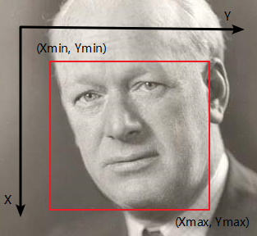

Figure 3: Coordinates of the bounding box.

**Additional Information**

* The dataset is available for non-commercial research purposes only.
* You agree not to reproduce, duplicate, copy, sell, trade, resell or exploit for any commercial purposes, any portion of the images and any portion of derived data.
* You agree not to further copy, publish or distribute any portion of annotations of the dataset. Except, for internal use at a single site within the same organization it is allowed to make copies of the dataset.
* We reserve the right to terminate your access to the dataset at any time.

**References**

[1] C. Sagonas, G. Tzimiropoulos, S. Zafeiriou, and M. Pantic.300 Faces in-the-Wild Challenge: The first facial landmark localization Challenge. InInternational Conference onComputer Vision - Workshops (ICCVW), pages 397–403, 2013.

[2] Belhumeur, P., Jacobs, D., Kriegman, D., Kumar, N.. ‘Localizing parts of faces using a consensus of exemplars’.  In Computer Vision and Pattern Recognition, CVPR. (2011).

[3] X. Zhu, D. Ramanan.‘Face detection, pose estimation and landmark localization in the wild’, Computer Visionand Pattern Recognition (CVPR) Providence, Rhode Island, June 2012.

[4] Vuong Le, Jonathan Brandt, Zhe Lin, Lubomir Boudev, Thomas S. Huang. ‘Interactive Facial Feature Localization’, ECCV2012.

[5] C. Sagonas, G. Tzimiropoulos, S. Zafeiriou, and M. Pantic. A semi-automatic methodology for facial landmark annotation. In CVPR, 2013.