**Dataset Description**

**Training dataset**: We collect an incremental dataset based on 300W [1][2], named **JD-landmark**, consisting of LFPW [3], AFW [4], HELEN [5] and IBUG [6], and re-annotate them with the mark-up of Fig.1 (106-key-point style). This dataset, containing about 11,400 faces, is applied as the training dataset (see Fig.2). It is accessible to the participants (with landmark annotations).

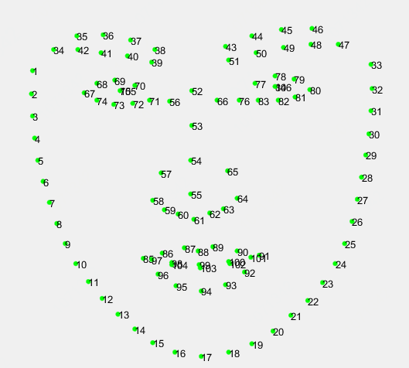

Figure1: The 106-key-point mark-up used for our annotations.

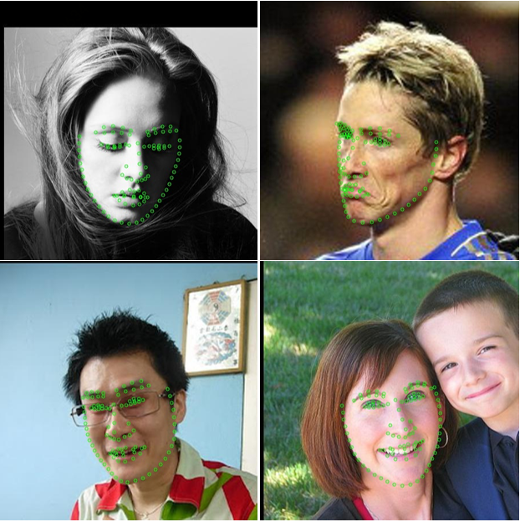

Figure2: Examples of training dataset

**Test dataset 1 (validation):** 2000 webface images (containing large face poses, extreme expressions and occlusions cases) are selected from open source webface database. The participants’ models will be evaluated on this set before the final evaluation. Note that we have appropriately selected or cropped each test image so that it includes only one major face (see Fig. 3).

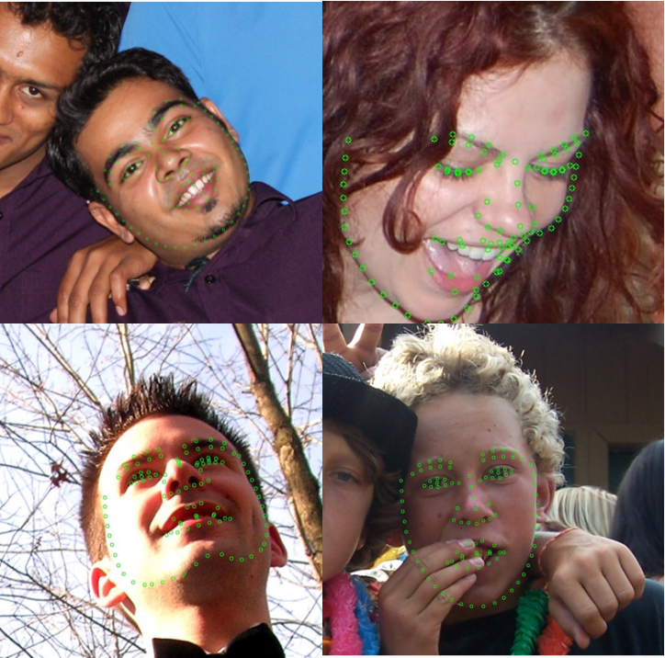

Figure3: Examples of Test dataset

**Test dataset 2 (final evaluation):** It contains 2000 webface images as well, which is blind to participants throughout the competition. It will be used for the final evaluation.

**Submission Guidelines**

* Participants could send binaries or models with the corresponding runtime environment and the algorithm description to the organizers ([facial_lmgc_icme@163.com](mailto:facial_lmgc_icme@163.com)). Each binary should detect the face and localize the facial landmarks, and we will not provide any face detection initializations in the test dataset.
* Before April 1st, 2019, the participants can submit the binaries multiple times (but we don’t recommend to submit too much times). The evaluation performance on Test dataset 1 will be returned to the participants via email and we will also report the top 5 performance on the website regularly. Besides, the Test dataset 1 will be released on April 1st, so that participants could optimize the algorithm and binaries based on it. During April 1st to April 8th, each team could only submit the binary once, and it will be taken as the final submission and evaluated on Test dataset 2.
* Each binary should accept two parameters as input and be executed like “ **./Binary_filename parameter1 parameter2**”. Here, parameter1 refers to the absolute path for the input file (.jpg) and parameter2 refers to the absolute path for the output file (.txt). The output file should report the number of key points along with the coordinates for each point (with integer format). The ordering should be the same as the provided annotation files. An example is shown in Fig.4. If multiple faces are detected by the algorithm, please just choose the major face as the output. If no face is detected, the output should be either an empty array or NaN and no txt file should be saved.

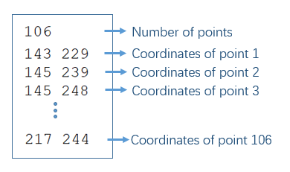

Figure 4: Example of output file

**Evaluation criteria**

Similar to 300W[1][2], submissions are evaluated on the cumulative errors distribution (CED) curve using the metric of Eq. (1), which is a common and suitable metric for facial landmark evaluation,

(1)

where “*x*” denotes the ground truth landmarks for a given face, “*y*” denotes the corresponding prediction and “” is the square-root of the area of ground truth bounding box, computed as . Finally, the cumulative curve corresponding to the percentage of test images of which the error is less than a specific value will be produced. These results will be returned to the participants for inclusion in their papers.

**Additional Information**

* The dataset is available for non-commercial research purposes only.
* You agree not to reproduce, duplicate, copy, sell, trade, resell or exploit for any commercial purposes, any portion of the images and any portion of derived data.
* You agree not to further copy, publish or distribute any portion of annotations of the dataset. Except, for internal use at a single site within the same organization it is allowed to make copies of the dataset.
* We reserve the right to terminate your access to the dataset at any time.

**References**

[1] C. Sagonas, G. Tzimiropoulos, S. Zafeiriou, and M. Pantic.300 Faces in-the-Wild Challenge: The first facial landmark localization Challenge. InInternational Conference on Computer Vision - Workshops (ICCVW), pages 397–403, 2013.

[2] C. Sagonas, E. Antonakos, G. Tzimiropoulos, S. Zafeiriou, and M. Pantic. 300 faces in-the-wild challenge: Database and results. IVC, 47:3–18, 2016. 3.

[3] Belhumeur, P., Jacobs, D., Kriegman, D., Kumar, N.. ‘Localizing parts of faces using a consensus of exemplars’.  In Computer Vision and Pattern Recognition, CVPR. (2011).

[4] X. Zhu, D. Ramanan.‘Face detection, pose estimation and landmark localization in the wild’, Computer Visionand Pattern Recognition (CVPR) Providence, Rhode Island, June 2012.

[5] Vuong Le, Jonathan Brandt, Zhe Lin, Lubomir Boudev, Thomas S. Huang. ‘Interactive Facial Feature Localization’, ECCV2012.

[6] C. Sagonas, G. Tzimiropoulos, S. Zafeiriou, and M. Pantic. A semi-automatic methodology for facial landmark annotation. In CVPR, 2013.