RNA_Seq data Analysis

Breast cancer Substage classification using Support Vector Machine. The analysis is done in some steps. First the whole RNA_seq and miRNA gene data is downloaded from TCGA web portal. Now
TCGA is not working any more. The data base is marged to GDC web portal. Same data can be downloaded from Genomic Data Commons (GDC) web portal.
The link is: https://gdc-portal.nci.nih.gov
After donloading the data it needs to pre process prior to classify. Processing steps are shown in the documents. Two different system of breast cancer classification is evaluated here.
1. Surveillance Epidemiology End Result (SEER)
2. Tumor Node Metastasis (TNM)

Here I used primary and advanced stage of breast-cancer patients sample for both system. Metastasis stage is not included here.

Step1: Download BRCA Clinical data

step 2:

Run Rcode named barcode_collection.R and Choose the file below.
nationwidechildrens.org_clinical_patient_brca.txt
there are lots of variables / columns. Check pathological stages of breast cancer. The output shows like
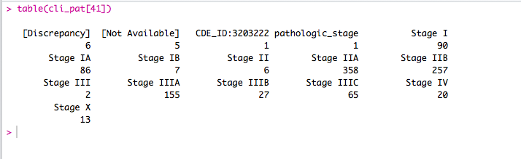
Figure1 : clinical information

Choose stages I, IIA, IIB and IIIA . These stages are chosen because of majority sample size.
Save the barcode of each stage in different txt file. For GDC web portal download all the four stages patients genedata. You can download any kind of data what you like . In this case I downloaded only RNA_Seq data.
Platform -Illumina HiSeq v2,
After you download all the data, save them in four different directory.

Step 3:
Run the module datacollection.R to fetch the gene data. This module takes only raw_count information. File name of each file is split in two parts. First part represents sample id and second part defines file extension. The whole matrix column name is replaced by file name as sample id such that we can find the duplicate sample. This module also checks whether any sample is taken 2 times. For example any sample can have more tumor information together with BRCA. Each filename looks like:

"unc.edu.00ee8acd-0841-4c85-a99a-8966a6828dd7.1150156.rsem.genes.results"
“ rsem.genes.results” is removed from the filename and taken as sample id.

So sample id looks like:
"unc.edu.00ee8acd-0841-4c85-a99a-8966a6828dd7.1150156"

Each file looks like below table. It has four variables. I took only raw_count .

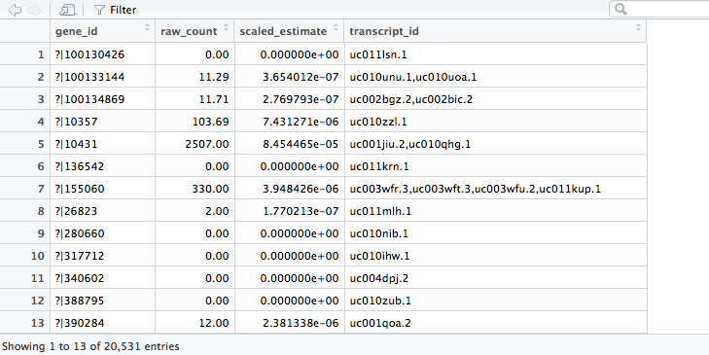
Figure 2: data file for each sample looks like this

Step 4:

Run the module data_integration.R .This module combines all stages of genedata in one big matrix. Where column represents sample id and row represents gene_id. It also creates one data set with equal length of sample id. Later on both of the data set will be used for classification.

Step 5:

Run module Zeros_remove.R . this module removes zero value column. That means gene raw_count zeros in all of the sample is meaningless. So removed from the data set. This module process 2 sets of data and save them in a different file such that we can get back original one if necessary.

Step 6.
Run split_gene_name/id.R to split gene name in 2 columns gene_id(numerical) and gene name. We need gene_id for Gene Ontology(GO) analysis(i.e separate protein coding and non-coding genes). It also makes 2 dataset for further use one with gene name and gene id . Other one without gene name. This one we will use to GO analysis.

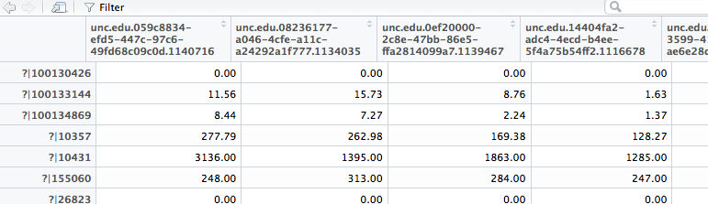
Figure3 : Original data
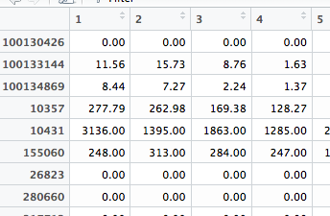
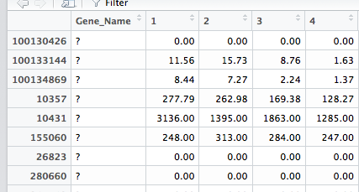

Figure 4 : 2 data set created

Step 7:
Run GO_Analysis.R to make 2 data set protein-coding and Non-coding RNA_seq data.
This module makes total 4 data set 2 for each data set since we have now 2 data sets created.
Module now load filtered_Gname_ID_data.Rdata to get protein coding and noncoding data. Later it will assign gene name as column name and sample number as row name. This way it will create four data sets. Namely : PCodingRNA and nonCodingRNA for each data sets.
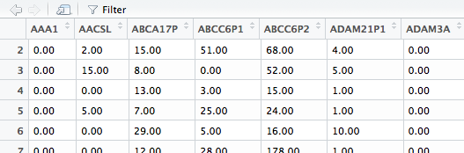

Figure 5: sample data of Non-codingRNA

Step 8:
Run S_S_plot_PCA.R. module. This module perform PCA and classify the data in 5 different PCA sets
then it will check which PCA set is better perform in SVM classifier. Select the number of PCA. Here PCA 15 is better . Since sensitivity and1-specificity are same.

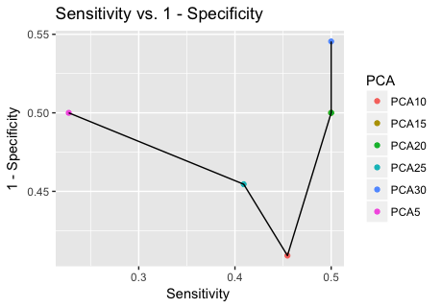

Step 9: Classification Results
unbalanced sample
gene sampled:
ProteinCoding gene = 4488
non-coding gene = 351

TNM system performance

5 fold LOOCV | Accuracy | Sd_error/Acc | sensitivity | Sd_error/sen | specificity | Sd_error/spc
ProteinCoding | 42.11 % | 0.017 | 26.88% | 0.003 | 76.06% | 0.001
non-coding | 42.42 % | 0.015 | 27.24% | 0.008 | 76.31 % | 0.001
miRNA | 45.14 % | 0.036 | 25.00% | 0.0000 | 75.00 % | 0.0000

SEER system performance

5 fold LOOCV | Accuracy | Sd_error/Acc | sensitivity | Sd_error/sen | specificity | Sd_error/spc
ProteinCoding | 57.41% | 0.020 | 59.00% | 0.031 | 55.97% | 0.028
non-coding | 51.91% | 0.015 | 54.44% | 0.024 | 49.21% | 0.015
miRNA

Balanced sample

TNM system performance

5 fold LOOCV | Accuracy | Sd_error/Acc | sensitivity | Sd_error/sen | specificity | Sd_error/spc
ProteinCoding | 29.48% | 0.0130 | 30.76% | 0.017 | 76.83% | 0.005
non-coding | 25.24% | 0.019 | 26.36% | 0.024 | 75.36% | 0.007
miRNA | 48.27 % | 0.019 | 29.20% | 0.009 | 77.91% | 0.004

SEER system performance

5 fold LOOCV | Accuracy | Sd_error/Acc | sensitivity | Sd_error/sen | specificity | Sd_error/spc
ProteinCoding | 58.78% | 0.012 | 56.67% | 0.025 | 60.83% | 0.032
non-coding | 53.40% | 0.018 | 56.93% | 0.0223 | 49.80% | 0.018
miRNA | 62.12% | 0.016 | 71.68% | 0.040 | 52.49% | 0.042

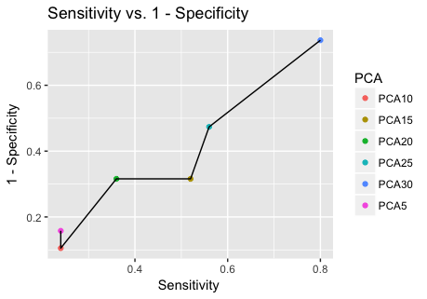

N.B: Data can be sent by email upon request
email: facihul@yahoo.com

