Integrating the Healthcare Enterprise



**IHE IT Infrastructure**

**Technical Framework Supplement**

**Care Services Discovery  
CSD**

**Draft in Preparation for Public Comment**

Date: April 30, 2013

Author: Derek Ritz, Ron Parker

Email: iti@ihe.net

**This is a supplement to the IHE ITI Technical Framework V6.0.** It is submitted for Public Comment between xxx and yyy, 2013. Comments are invited and may be submitted to the IHE forums at <http://forums.rsna.org/forumdisplay.php?f=511>. In order to be considered in development of the Trial Implementation version of the supplement comments must be received by yyy, 2013. Please use the Public Comment Template provided in the thread and submit comments by posting the completed template as an attachment to a Reply or New Thread.

This supplement describes changes to the existing technical framework documents and where indicated amends text by addition (bold underline) or removal (bold strikethrough), as well as addition of large new sections introduced by editor’s instructions to “add new text” or similar, which for readability are not bolded or underlined.

“Boxed” instructions like the sample below indicate to the Volume Editor how to integrate the relevant section(s) into the relevant Technical Framework volume:

Replace Section X.X by the following:

General information about IHE can be found at: [www.ihe.net](http://www.ihe.net)

Information about the IHE IT Infrastructure domain can be found at: <http://www.ihe.net/Domains/index.cfm>

Information about the structure of IHE Technical Frameworks and Supplements can be found at: <http://www.ihe.net/About/process.cfm> and <http://www.ihe.net/profiles/index.cfm>

The current version of the IHE Technical Framework can be found at: <http://www.ihe.net/Technical_Framework/index.cfm>

**CONTENTS**

Introduction 4

Open Issues and Questions 4

Closed Issues 6

*Volume 1 – Integration Profiles* 9

1.7 History of Annual Changes 9

2.1 Dependencies among Integration Profiles 9

2.2.X CSD Integration Profile 9

X CSD Integration Profile 9

X.1 Actors/ Transactions 11

X.1.1 Actors 12

X.1.1.1 CSD Directory 12

X.1.1.2 Provider Information Source 14

X.1.1.3 CSD Consumer 14

X.1.1.4 CSD Manager 14

X.1.1.5 CSD FreeBusy 15

X.2 HPD Integration Profile Options 15

X.3 Care Services Discovery (CSD) Process Flow 15

X.3.1 Use Cases 15

X.3.1.1 Care Services Discovery Use Cases 15

X.3.1.2 Provider Information Feed Transaction Use Cases 18

X.3.2 Detailed Interactions 20

X.3.2.1 Detail Interactions – Transactions 20

X.3.2.2 Detail Interactions – Entities and Attributes 22

********************* ONLY EDITED UP TO THIS POINT ********************************* 26

X.4 CSD Security Considerations 26

*Volume 2b - Transactions* 27

3.Y1 Provider Information Feed 27

3.Y1.1 Scope 27

3.Y1.2 Use Case Roles 27

3.Y1.3 Referenced Standard 28

3.Y1.4 Interaction Diagram 29

3.Y1.4.1 Provider Information Feed Request 29

3.Y1.4.1.1 Trigger Events 30

3.Y1.4.1.2 Message Semantics 30

3.Y1.4.1.2.1 HPD Schema Structure 30

3.Y1.4.1.2.2 HPD Schema Content 31

3.Y1.4.1.2.2.1 Object Classes 32

3.Y1.4.1.2.2.2 Individual Provider 35

3.Y1.4.1.2.2.3 Organizational Provider 38

3.Y1.4.1.2.2.4 Relationships 40

3.Y1.4.1.2.3 Status Code Values 41

3.Y1.4.1.3 Expected Actions 42

3.Y1.4.2 Provider Information Feed Response 42

3.Y1.4.2.1 Trigger Events 43

3.Y1.4.2.2 Message Semantics 43

3.Y1.4.2.3 Expected Actions 43

3.Y1.5 Security Considerations 43

3.Y1.5.1 Security Audit Considerations 43

3.Y1.5.1.1 Provider Information Source audit message: 44

3.Y1.5.1.2 Provider Information Directory audit message: 44

3.Y2 Provider Information Query 44

3.Y2.1 Scope 44

3.Y2.2 Use Case Roles 45

3.Y2.3 Referenced Standard 45

3.Y2.4 Interaction Diagram 46

3.Y2.4.1 Provider Information Query Request 46

3.Y2.4.1.1 Trigger Events 46

3.Y2.4.1.2 Message Semantics 46

3.Y2.4.1.3 Expected Actions 47

3.Y2.4.2 Provider Information Query Response 47

3.Y2.4.2.1 Trigger Events 47

3.Y2.4.2.2 Message Semantics 47

3.Y2.4.2.3 Expected Actions 48

3.Y2.5 Security Considerations – Nitin - TBD 48

<Appendix letter> Appendix_Name 48

# Introduction

This introduces the Care Services Discovery (CSD) profile. The CSD profile leverages the information models described in the Healthcare Provider Directory (HPD) profile, which supports queries against and management of healthcare provider public information in a directory structure. CSD additionally supports relational queries against a directory of care service locations and, optionally, queries for available time slots in a provider schedule.

Two categories of healthcare providers are included in the HPD profile.

* Individual Provider – A person who provides healthcare services, such as a physician, nurse, or pharmacist.
* Organizational Providers – Organizations that provide or support healthcare services, such as hospitals, Healthcare Information Exchanges (HIEs), Integrated Delivery Networks (IDNs), and Associations.

To the directory structure defined by HPD, CSD adds three new entities:

* Facility – A location which delivers care services, such as a rural clinic, a district hospital or a large referral hospital.
* FacilityService – A service, such as maternal care, surgery, or general primary care, which is being delivered and is available from a particular Facility, such as a rural clinic or district hospital.
* FreeBusy* – An (*optional) representation, using the common iCalendar format, of available, schedulable time slots when a particular Individual Provider is able to provide particular Services at a particular Facility (together defined as a FacilityService, see above).

The HPD profile includes two transactions and three actors. It is scoped to environments where a single Provider Information Directory is sufficient for providing responses to Provider Infromation Feeds and Provider Information Query transactions. The CSD profile extends HPD; it adds two new actors and three new transactions for a total of five each. The CSD profile expands the original scope of HPD to environments where multiple information directories might exist and to situations where queries are intended to discover care service locations in proximity to a defined geographic point and , optionally, available time slots within provider schedules at these particular care locations. Expanding on HPD’s directory focus, CSD also supports a way to query against the relationships between orgnaizations, facilities, services and providers.

## Open Issues and Questions

* CSD013:
* Should the implementers of a CSD service be required to develop/deploy a monolithic directory structure? Even if an LDAP query format is defined by this profile (as is the case with HPD, for instance), it does not require that the underlying data structure is an LDAP directory (there are LDAP to SQL translators, for example). What if a federation of independent registries are together filling the role of a CSD Directory actor? To support federation – the CSD Manager will need to know what is the address of each of the federated directories.
* CSD015:
* Should geocode be part of Address (preferred) or should it be a separate attribute, such as Position? Putting geocode within address, as a required element, puts a burden on existing deployments that may not have geocoded their addresses and it also is superfluous in cases such as “mailing” address (which may be PO box). Not requiring geocodes, however, undermines the ability to do any proximity calculations, which are key to the CSD value proposition.
* CSD018:
* There will be attributes which should be associated with Provider-Organization, Provider-Facility and Provider-FacilityService. If class associations are employed, three new “classes” will be created, one for each of these relations. This is good design, but there is becoming a proliferation of classes. Proliferation is a concern as it starts to introduce complexity of the profile. Should some functionality be shed in the interest of simplicity or does that just force implementers into workarounds?

## Closed Issues

* CSD001:
* Issue: Investigation of available specifications in this area identified the OMG ServD standard (in development). This specification usefully addresses a number of the use cases important to CSD but did not leverage the existing IHE HPD specification which is based on LDAP and its extensions (PWP, ISO/TS 21091).
* Resolution: (13-03-18) Based on the research that was done, it was decided that HPD could be expended to support the CSD use cases and that this approach was to be preferred.
* CSD002 (HPD004):
* Issue: Do we need to include “Provider Privileges at an organization” as an attribute to be defined in this standard?
* Resolution (13-03-18) – “Provider Privileges”, where these map to services, may be indicated by establishing a member-of relationship between an Individual Provider and a FacilityService. This is not directly analogous to admitting privileges and is not intended to be. Rather, it is intended to indicate where a clinician provides a specific service at a specific location. In this way, a CSD Consumer could query for all the FacilityServices for a specific provider.
* CSD003 (HPD007):
* Issue: How will we identify the limited number of locations of a provider, if the provider works at a subset of the locations of an organization?
* Resolution (13-03-18): As indicated above, an individual provider may have a member-of relationship with multiple FacilityService entities. The provider will inherit the address from these which can optionally be extended /overridden to indicate the “office hours” indicative of when the provider is available to provide the indicated services there.
* CSD004 (HPD008):
* Issue: How will global identifiers be handled? This discussion came up as a result of a discussion on NPI numbers.
* Resolution (3/15/10) – Each Organization, Provider, Facility, and FacilityService will have at least ONE globally unique identifier. It is anticipated that the mandatory unique identifier will be system-generated (e.g. a GUID).
* CSD005 (HPD009):
* Issue: Should the Validation attribute structure be included in the schema for the initial profile, or be extended in a later update of the profile? This attribute structure indicates whether or not validation of this information has been done (Flag), when the validation was done (Date), who did the validation (Source). The validation attribute structure can be included for multiple areas in the schema, but most importantly for overall validation of the Organization and Individual Provider attributes, the Relationship information, and the Certification, Specialty, and Degree information.
* Resolution (4/26/10): The validation attribute will NOT be included in the schema for the initial profile. It is assumed that the HPD actor will validate the feed. That needs to be clearly stated in the document (see section X.1.1.3). **NOTE: This mechanism to address the issue is directly referenced in the Use Cases.**
* CSD006 (HPD0010):
* Issue: Currently, language, as a multiple attribute, is associated with Individual Provider only. Should language be considered an attribute for Organizational Provider? A Use Case has not been defined for this.
* Resolution (4/26/10): Language should be considered an attribute for Organizational Provider as well as Individual Provider. A Use Case has been added to reflect this. **NOTE: this is an important CSD Use Case in a developing country context (languages spoken at a Facility).**
* CSD007 (HPD0011):
* Issue: How should addresses be defined so that the definition meets global needs?
* Resolution: (13-03-18): **To support the CSD Use Cases, it will be necessary (MUST) to support geocodes in the Address object.**
* CSD009 (HPD0016):
* Issue: Currently *Specialty Role* has been included as an attribute for Organizational Provider. Should this be kept?
* HPD0016 Resolution (4/07/10) - There is no Use Case for this, and the Specialty Role changes too frequently. Do not include it.
* CSD009 Resolution (13-03-18): Each Organization may have Facilities; these Facilities may have FacilityService entries. The relationship between Organization and FacilityService indicates what services are being offered by an Organization, albeit through two levels of a hierarchy.
* CSD008 (HPD0013):
* HPD0013 Issue: The following Category attributes do not have agreed to value definitions:
* Identifiers
* Addresses
* HPD0013Resolution (4/22/10):
* Identifiers – The values will be defined by national or regional organizations.
* Addresses – This profile only addresses three address types, each of which is a separately defined attribute in the auxiliary class (Billing Address, Mailing Address, and Practice Address).
* CSD008 Issue & Potential Resolution (13-03-18):
* The manageability of addresses is a concern. It is considered that, for CSD, a Facility MUST have a practice address. This Facility address MUST be inherited by any related FacilityService and may be constrained by the FacilityService (perhaps in the member-of entry?) only regarding business hours. Resolution (13-04-30): an association class is being used to model the relationship between Facility and Service.
* As above, where a provider has a relationship to a FacilityService, the practice address MUST be inherited and, likewise, may be constrained regarding business hours. Resolution (13-04-30): an association class models the relationship between Providers and FacilityServices.
* Related to this… should an Organization be prevented from having a Practice Address (or should it be ignored if it is there)? It is considered that this would be a useful constraint that would improve manageability. Resolution (13-04-30): only administrative addresses are modeled for Organizations.
* How will mobile clinics be handled? Are these facilities (likely YES). Is the address sufficiently flexible that a facility can have address as a required field but the construct can still be used to describe a mobile facility? Resolution (13-04-30): omit mobile facilities from this profile in this iteration. There are ways to add mobile clinics (later) be making address optional.
* CSD010 (HPD0018):
* Issue raised during a discussion of section 3.Y1.4.1 Provider Feed Request: As of 4/20/10 the profile reflects the decision made at the F2F in February that for a Provider Feed request, the only response provided by the HPD Actor would be an acknowledgement that the transaction has been received. Data administration issues such as data reconciliation, data validation, data integrity etc. associated with the Add/Update/Delete operations are considered back-end processes for the purpose of this profile and proposed to be addressed by the policies and procedures of the organization managing the HPD. The profile would not provide any guidance on any expected actions or back-end processes to be executed, or policies to be followed by the HPD actor. If that is the case then this transaction would be an optional transaction. This may have been misunderstood, or an invalid conclusion and needs re-addressing by the IHE committee.
* HPD0018 Resolution (4/26/10): This is a required transaction for the HPD Actor. The required actions for the HPD Actor are that the HPD Actor is required to have a policy to conform to LDAP specification for processing adds, deletes, and updates. The HPD Actor must have a policy to validate feeds and handle data integrity prior to publishing the date.
* CSD010 Issue: Will CSD support, via the Provider Feed (for example), management of Facility and FacilityService entries? Resolution (13-04-30): data management will not be supported in this iteration of the CSD profile.
* CSD011 (HPD024):
* HPD024 Issue: Use of Address Structure:
* First Option is to make an address as an attribute with syntax dstring *( "$" dstring ) similar to that of the postal code but additionally enforce format of “key=value” that allows for key to be of different kinds: address status and address components. This would allow adding new types without redefining the schema and allow us to search for &(status=primary, city=Nowehresville).
* Second option is to have two different attributes as LDAP Postal Address syntax to distinguish primary and other addresses. E.g. *hpdPrimaryProviderPracticeAddress* and *hpdProviderPracticeAddress.* In this option, the Address Status attribute is not maintained and assumes Primary Address as always active.
* Third option is to search based on a value stored in a subordinate Address object. In that case, we have to obtain that object and then perform a second search on the object's parent's DN to obtain the entire entry making provider search based on address inefficient.
* HPD024 Resolution (4/26/10): First Option
* CSD011 Issue: Will requiring inheritance of addresses (see CSD008) impair performance? If yes, is it “worth it” in order to improve manageability? Resolution (13-04-30): “class association” (UML modeling) of a native relational data design will address this issue.
* CSD012 (HPD025):
* HPD025 Issue: For "memberof" query, ex: find the organizations that this provider is a memberof. Who is responsible for defining how many "memberof" relationship levels should be searched, and returned. 1) Should the HPD always search and return all levels, 2) Should the HPD only search one level at a time, and have the Consumer request subsequent searches, 3) Should the consumer identify "up to" how many levels the HPD should search 4)Should the consumer identify "up to" what type of organization to search to.
* HPD025 Resolution (4/28/10): This is determined by the LDAP standards and will not be defined in this profile.
* CSD012 Issue: CSD imposes a member-of rigour regarding Organization > Facility > FacilityService and, potentially, the Provider member-of relationships to Facility and/or (or just or?) Facility and FacilityService. Does this require us to revisit HPD025? Resolution (13-04-30): Leverage the existing information models; recast these information models as an XSD and employ XQuery against this XSD as the query transaction language. **NOTE: a number of candidates were considered including: SPARQL, SQL, OCL, LDAP and XQuery. Previous issues with SQL caused this to appear to be a high risk option. SPARQL and OCL both have very low adoption in the marketplace. LDAP is problematic as a relational query approach for the reasons already outlined.**
* CSD014:
* Is it appropriate to constrain Services to be provided only at Facilities? There are cases where Organizations provide Services in the field (not thru facilities). Should there be a Service-Organization relationship and this ***may*** be provided at a Facility?
* Conversely, where a Service-Facility relationship exists, does a relationship to the Organization need to be explicit or can it be inherited through the Facility-Organization relationship? Basically – can a single Facility have more than Organization relationship? If yes, the Facility-Service-Organization relationship needs to be explicit; if not, then where multiple Organizations are operating out of a single Facility there will need to be a contrivance of multiple Facility IDs (which could be confusing). Resolution: a relationship will be modeled between FacilityService and Organization, independent of the relationship between Facility and Organization. This will be an optional relationship which ***may be*** leveraged to clarify the auspices under which specific services are being provided.
* CSD016:
* Experience from HPD implementers is negative regarding the ability of LDAP to support relationships. This will be compounded for CSD, as relationships are the key element of the CSD profile’s value proposition. A relational model is to be favoured, and to query this, a format such as SQL or XQuery will work much better than LDAP as the query language. Of these, XQuery will likely better fit with the returning of xml or JSON responses. Resolution: embrace XQuery for the CSD profile.
* CSD017:
* It will simplify things to make the Provider-Organization relationship mandatory; e.g. a Provider who is in private practice would at least have that relationship to a “private practice” organization entity where the administrative information may be maintained. There is a downside in that this could be burdensome (from an IT standpoint) for the many GPs who are in private practice (lots of data maintenance). Is this too much downside? Resolution: the Provider-Organization relationship will be mandatory.

*Volume 1 – Integration Profiles*

## 1.7 History of Annual Changes

Add the following bullet to the end of the bullet list in section 1.7

* Added the CSD Profile which supports a care services discovery service.

## 2.1 Dependencies among Integration Profiles

Add the following to Table 2-1

|  |  |  |  |
| --- | --- | --- | --- |
| HPD?? |  |  |  |

Add the following section to section 2.2

### 2.2.X CSD Integration Profile

Add Section X

# X CSD Integration Profile

This introduces the Care Services Discovery (CSD) profile which supports the discovery of healthcare organization, facility, service and provider information in a relational data structure. The scope of the profile includes these four aspects of care services, plus one optional capability:

* Provider – A person who provides healthcare services, such as a physician, nurse, or pharmacist.
* Organization – A body corporate that provides or supports healthcare services, such as a faith based organizations (FBOs), a government ministry of health (MOH), a Healthcare Information Exchange (HIE), an Integrated Delivery Network (IDN), an Association, etc.
* Facility – the site where care services are provided such as a district hospital, a rural clinic, a general practitioner’s (GP) office, a pharmacy, a lab, etc.
* FacilityService – a combinatorial entity indicating a particular Facility’s offering of a particular Service such as antenatal care, HIV voluntary testing and counselling, surgery, general primary care, oncology, pharmacy, diagnostic imaging, etc.
* FreeBusy* – an (*optional) representation, using the common iCalendar format, of available, schedulable time slots when a particular Individual Provider is able to provide particular Services at a particular Facility (together defined at a FacilityService, see above).

Information is maintained about each aspect of care service delivery. Organizational data includes contact person and administrative address. Information about a provider includes demographics, credential and specialty, optional FreeBusy information, plus the electronic endpoint information needed to facilitate trusted communication of protected patient data. Facility information incudes address, business hours plus the care services offered at the Facility.

In addition, information is also maintained regarding relationships. Principally, the following relationships are defined:

* Facilities associated with an Organization, and vice versa
* Services associated with a Facility (FacilityService)
* Providers associated with Organizations (facilities and services unspecified)
* Providers associated with Facilities (services unspecified)
* Providers associated with a FacilityService
* Optionally, available time slots (“FreeBusy”) for a provider to provide a service at a facility (FacilityService)

The CSD profile may be used to support simple queries regarding lists of providers, organizations, facilities and/or the relationships between these. A consumer may also query regarding the relationship between any of these and care services. Consumes may also employ the CSD profile to query regarding ***when*** specific ***providers*** and/or ***services*** are available, ***where*** these services are provided, and the ***proximity*** of these care locations to a specific geographic point.

It is intended that the Organization, Provider, Facility and FacilityService information shall come from authorized regional, state and/or national sources, as stewards of the most accurate and current data. Some identified sources are:

1. State licensing bureaus
2. National Associations
3. Commercial registries
4. Delivery Networks
5. Information Exchanges etc

The scope of this profile focuses initially on the minimum “foundational” attribute set required for supporting care services discovery, resulting in a usable work product as well as recommendations for future phase expansions. This profile is readily adaptable and scalable to production environments, needing to operate trusted provider directory services that link multiple endpoints spanning enterprise, regional, national, and global jurisdictions. This profile is extendable to information not necessarily explicitly defined in the profile.

## X.1 Actors/ Transactions

Figure X.1-1 shows the actors directly involved in the CSD Profile and the relevant transactions between them. Other actors that may be indirectly involved due to their participation in other related profiles, etc. are not necessarily shown.



Figure X.1-1. CSD Profile Actor Diagram

Table X.1-1 lists the transactions for each actor directly involved in the CSD Profile. In order to claim support of this Integration Profile, an implementation must perform the required transactions (labeled “R”). Transactions labeled “O” are optional. A complete list of options defined by this Integration Profile and that implementations may choose to support is listed in ITI TF-1: X.2.

Table X.1-1. HPD Integration Profile - Actors and Transactions

|  |  |  |  |
| --- | --- | --- | --- |
| Actors | Transactions | Optionality | Section in Vol. 2 |
| CSD Consumer | Provider Information Query | O | 3.Y1 |
|  | Care Services Consumer Query | R | 3.Y2 |
| CSD Manager | Provider Information Query | O | 3.Y1 |
|  | Care Services Consumer Query | R | 3.Y2 |
|  | Care Services Manager Query | R | 3.Y3 |
|  | Care Services FreeBusy Query | O | 3.Y4 |
| CSD Directory | Care Services Manager Query | R | 3.Y3 |
| CSD FreeBusy | Care Services FreeBusy Query | R | 3.Y4 |

### X.1.1 Actors

#### X.1.1.1 CSD Directory

The CSD Directory performs the function of processing an inbound Care Services Manager Query from the CSD Manager. These functions are described briefly below:

**Care Services Manager Query:** A CSD Directory responds to Care Services Manager Query requests from a CSD Manager on behalf of a CSD Consumer. The Care Services Manager Query request includes search criteria for organizations, providers, facilities, services at facilities and a definitioin of the type of information the CSD Manager is looking to receive in the response. The CSD Directory actor shall return zero, one, or more results based on the search criteria.

The CSD Directory can store the following kinds of information:

* Organizations
* Parent-child relationships between Organizations
* Facilities
* Relationships between Facilities and Organizations
* Services at Facilities (FacilityService)
* Providers
* Relationships between Providers and Organizations
* Relationships between Providers and Facilities or between Providers and FacilityServices

The following illustrates the (archetypal) logical relationships between CDS’s information entities. Other options can be supported.



Figure X.1.1.1-1. Archetypal CSD Logical InformationStructure

Although not illustrated in the figure, a CSD Directory actor may consist of (largely) unrelated Organizations, Facilities and/or Providers. Such a configuration would satisfy a rudimentary subset of the Use Cases described in section X.3.1.

Specific methods for acquiring information, and methods for maintaining that information, for a CSD Directory, may vary. These “back office” operations are out of scope for the CSD profile. It is a prerequisite that the CSD Directory possess validated, current information.

#### X.1.1.2 CSD Consumer

The CSD Consumer performs the following functions:

It makes a Provider Information Query (optional) or a Care Services Consumer Query request to the CSD Manager indicating certain query criteria in the request. The CSD Consumer includes, in that request, the response set of information that is being expected from a particular query.

The CSD Consumer actor receives a response to the Provider Information Query request (optional) or the Care Services Consumer Query from the CSD Manager actor. The CSD Consumer must be able to handle a response which can consist of zero, one, or more records matching the query criteria.

#### X.1.1.3 CSD Manager

The CSD Manager performs the following functions:

The CSD Manager receives an inbound Provider Information Query (optional) or a Care Services Consumer Query request from the CSD Consumer indicating certain query criteria in the request. The CSD Consumer includes, in that request, the response set of information that is being expected from a particular query.

Based on the inbound request from the CSD Consumer, the CSD Manager constructs one or more outbound Care Services Manager Query requests which are submitted to one or more CSD Directory actors.

The CSD Manager actor receives a response (or responses) to the Care Services Manager Query from the CSD Directory actor (or actors). The CSD Manager must be able to handle a response which can consist of zero, one, or more records matching the query criteria.

Based on the stipulations in the inbound request from the CSD Consumer, the CSD Manager collates and sorts the response(s) received from the one or more CSD Directories to whom it made requests on behalf of the CSD Consumer.

Optionally, the CSD Manager may construct and execute one or more Care Services FreeBusy Query requests which it submits to CSD FreeBusy actors to obtain available time slot information to augment the information query response received from the CSD Directory actor(s).

The CSD Manager constructs a collated and sorted response to the original inbound query request and returns this to the CSD Consumer. The request response may consist of zero, one or more records. If the inbound query as a Provider Information Query, the response is constructed to conform to the ITI-xx transaction response as defined in the HPD supplement.

#### X.1.1.4 CSD FreeBusy

The CSD FreeBusy performs the following functions:

The CSD FreeBusy actor receives an inbound Care Services FreeBusy Query request from the CSD Manager indicating certain query criteria in the request. The CSD Manager includes, in that request, the specific information that is being expected to be included in the query response.

The CSD FreeBusy actor constructs a response to the original inbound query request and returns this to the CSD Manager. The request response may consist of zero, one or more records.

## X.2 HPD Integration Profile Options

Options that may be selected for this HPD Integration Profile are listed in the table X.2-1 along with the actors to which they apply. Dependencies between options when applicable are specified in notes.

Table X.2-1 HPD - Actors and Options

| 1. Actor | 1. Options | 1. Vol & Section |
| --- | --- | --- |
| 1. CSD Consumer | *No options defined* | 1. - - |
| 1. CSD Manager | *No options defined* | 1. - - |
| 1. CSD Directory | *No options defined* | 1. - - |
| 1. CSD FreeBusy | *No options defined* | - - |

## X.3 Care Services Discovery (CSD) Process Flow

### X.3.1 Use Cases

#### X.3.1.1 Care Services Discovery Use Cases

There are two “sentinel” use cases for the CSD Profile: service availability and provider availability. These two use cases illustrate searching for services at a location where proximity is the most crucial attribute (nearest first, then soonest) and searching for a provider where the soonest available appointment time slot is the most crucial attribute (soonest available, then nearest).

**Use Case #1: Service Availablity**

* Mosa is a young pregnant woman who lives in a village in sub-Saharan Africa . Grace is a community health worker in Mosa’s village.
* During an antenatal care visit, Grace uses an mHealth application to note that Mosa’s blood pressure is elevated.
* Mosa should see a nurse. The mHealth application uses CSD to search for nearby clinics.
* Grace receives an SMS listing the **closest** facility and the day of the **next** maternal care clinic there.

The interactions between the various actors in this use case is shown in Figure X.3.1.1-1.

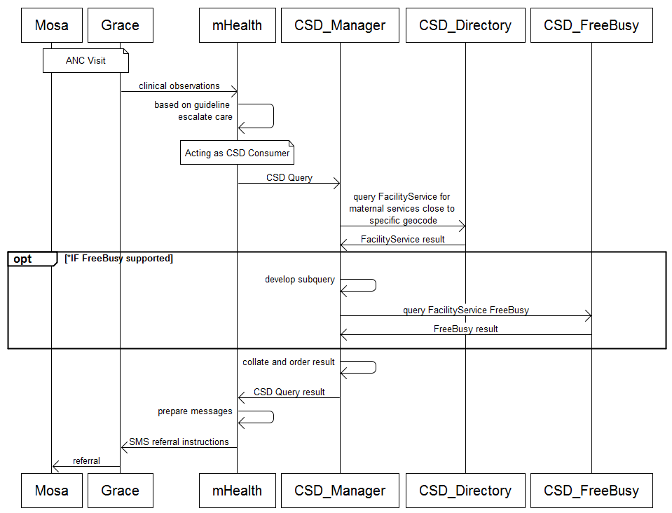

Figure X.3.1.1-1 Service Discovery Use Case Interaction Diagram

**Use Case #2: Provider Availablity**

* David Lambert sees his family physician, Dr. Black, regarding a recent knee injury.
* Dr. Black diagnoses the problem as a torn ACL and decides to refer David to an orthopedic surgeon.
* Dr. Black uses his EMR to invoke CSD to search for orthopedic surgeons.
* A list is returned sorted by available consult timeslot (soonest to latest) and by proximity to David’s home (closest to farthest).

The interactions between the actors for Use Case #2 are shown in Figure X.3.1.1-2

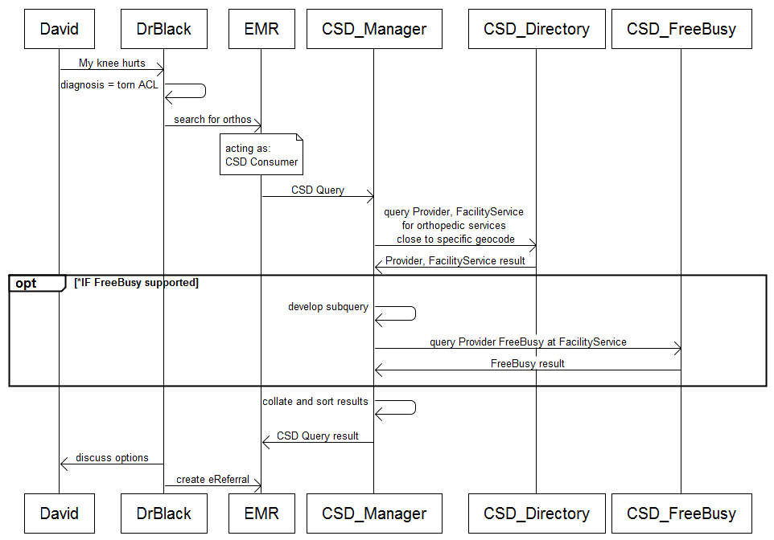

Figure X.3.1.1-2 Provider Discovery Use Case Interaction Diagram

***Other Provider Information Query Use cases which refine the requirements introduced above:***

**Provider Authorization and lookup during an emergency event:** During Hurricane Katrina, health care volunteers were turned away from disaster sites because there was no means available to verify their credentials. At an emergency site, the CSD service can be queried to quickly identify and grant permission to credentialed providers to enter the scene.

**Keeping agency provider information current:** A German government agency dealing with healthcare services for its constituents wishes to keep its agency’s healthcare provider information current. The agency determines that it will use the CSD service to access the most current provider information. The German agency only requires a subset of the CSD Directory available information. On a regular basis, the CSD Directory provides to the agency a list of the updated information needed.

**Providing Personal Health records to a new Primary Care Physician:** An individual has changed health plans. As a result that individual must change his Primary Care Physician. The individual has a Personal Health Record and would like to provide that information to his new Primary Care Physician. The individual needs to determine where to have the Personal Health Record transmitted to.

**Certificate Retrieval:** National regulations in many European countries require that an electronically transmitted doctor’s letter is encrypted in a way that only the identified receiver is able to decrypt it. In order to encrypt the letter, the sender has to discover the encryption certificate of the receiver.

**Language Retrieval:** An individual who only speaks Italian requires healthcare services at an Outpatient Clinic. That individual would like to be able to communicate with the Clinic personnel, if at all possible. The individual or his caregiver needs to determine which clinic supports Italian and provides the service that is required.

**Specific developing country use cases supported/assisted by the CSD Profile:**

The following list represents end-user requirements to be supported by the CSD Profile or supported by applications, such as GIS applications, assisted by the profile. This list is distilled from information gleaned from in-country meetings with Ministry of Health officials in Tanzania:

* Generate a full list of facilities, including GPS coordinates, sorted by region or district. Filter the list by specific Service or Services offered at the facility.
* ~~Add new facilities or edit existing ones.~~
* Search for facilities by facility name; view details about each facility (operational status, contact information, type), search by district, display the facility information on a map based on the GPS coordinates.
* Quantify facilities based on service levels and types, locations based on types and service levels, export these data via excel spreadsheet, understand providers for a given facility, understand resources for a given facility (ICT applications, beds, etc), catchment area viewing to determine levels of service provision for a geographic area, contextual metadata about facility types inline with view of facility attributes, potentially track other facilities outside of health facilities, filter map views by ownership type (to help look for collaborative opportunities), ability to make corrections through submitting change request.
* Filter facility by implementing partner, filter by service and region, submit change request from implementing partner (e.g. USAID), view data for filtered list one by one both as viewing one per site, and in context of all (map view of facilities based on their GPS coordinates), available mobile networks for facility, power source.
* Filter facilities by service, admin hierarchy, view in web application, along with facility details, and/or data export as excel… view resources for given facility, subservices provided by facilities (ie, maternal care within a facility)

The following list represents the two key use cases as articulated by the Rwanda Health Enterprise Architecture (RHEA) Provider Registry project:

1. This query takes in a unique ID for a provider and returns the enterprise ID associated with the provider who matches the given ID.

|  |  |
| --- | --- |
| **Primary Actor** | Interoperability Layer, potentially Point Of Care Application |
| **Pre-Conditions** | The application must be authenticated to the system |
| **Success Guarantee** | An enterprise id (EID) is returned to the requesting application |
| **Main Success Scenario** | 1. The actor submits a request with a given ID type and ID number 2. The system returns the EID |
| **Extensions** | 2.a The system does not find the provider and returns an error code. |

1. Queries for HC Professional using a variety of possible parameters. This transaction returns a list of all professionals that match the criteria specified in the query parameters. Otherwise, if an error occurred, then an error is returned.

|  |  |
| --- | --- |
| **Primary Actor** | Interoperability Layer, Point Of Care Application? |
| **Pre-Conditions** | The application must be authenticated to the system |
| **Success Guarantee** | An list of enterprise ids (EIDs) is returned to the requesting application |
| **Main Success Scenario** | 1. The actor submits a request with a given query parameters 2. The system returns a list of matching EIDs |
| **Extensions** | 2.a The system does not find the provider and returns an error code.  2.b The requested search parameters are invalid and returns an error code. |

### X.3.2 Detailed Interactions

#### X.3.2.1 Detail Interactions – Transactions

As described in Figure X.3.2.1-1, there are two main interactions. One is the CSD Consumer actor interacting with the CSD Manager actor. The other is the CSD Manager actor interacting with the CSD Directory (and optionally, with a the CSD FreeBusy actor) on behalf of the CSD Consumer.

* A CSD Consumer initiates a Provider Information Query (optional) or a Care Services Consumer Query request to the CSD Manager.
* The CSD Manager appropriately constructs a Care Services Manager Query and submits it to one or more CSD Directory actors, identifying search criteria and specifying the types of information the consumer is looking for.
  + The CSD Directory searches for content matching the search criteria and returns the types of information requested to the CSD Manager.
  + The CSD Directory actor may return zero, one, or many response elements depending on what is found to match the search criteria.
* The CSD Manager collates and sorts the response – optionally augments it with one or more Care Services FreeBusy Query requests to one or more CSD FreeBusy actors – and returns the collated and sorted request response to the CSD Consumer actor.

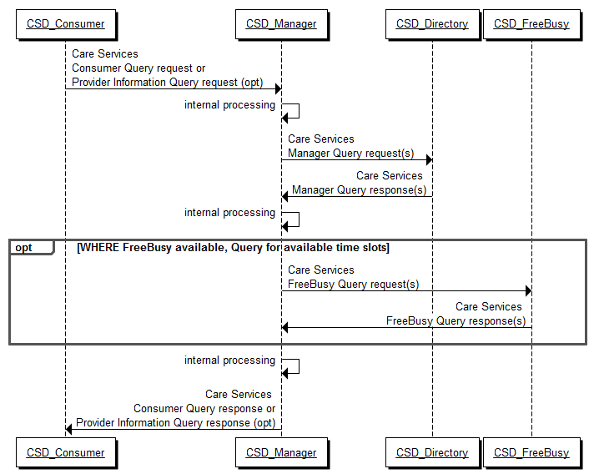

Figure X.3.2.1-1. Basic Process Flow in CSD Profile

#### X.3.2.2 Detail Interactions – Entities and Attributes

The following diagrams and related tables describe the entities and attributes which are discoverable using the Care Services Discovery profile. This profile deals with five entities:

1. Organization – Organizations are “umbrella” entities; these may be considered the administrative bodies under whose auspices care services are provided such as Healthcare Information Exchanges (HIEs), Integrated Delivery Networks (IDNs), Non-government Organizations (NGOs), faith-based organizations (FBOs) or even a one-physician family practice. An organization has a unique identifier and administrative attributes such as contact person, mailing address, etc. An organization may be related to a parent organization. (Table X.3.2.2-1)
2. Facility – Facilities are physical care delivery sites such as hospitals, clinics, health outposts, physician offices, labs, pharmacies, etc. A Facility has a unique identifier, geographic attributes (address, geocode), contact attributes, attributes regarding its hours of operation, etc.; each Facility is related to at least one Organization. (Table X.3.2.2-2)
3. FacilityService – A FacilityService identifies a particular care service provided at a specific facility. Both the service and the facility are uniquely identified. Examples might be surgical services provided at Hospital X, antenatal care services provided at Clinic Y or primary care services provided at GP Office Z. A FacilityService has contact attributes and attributes regarding hours of operation, etc.; each FacilityService is related to a uniquely identified Facility. (Table X.3.2.2-3)
4. Provider – A Provider is a person who provides healthcare services, such as a physician, nurse, or pharmacist. Providers have contact and demographic attributes, etc.; each Provider is related to at least one Organization, Facility or FacilityService. Specific attributes may be associated with the Provider relationship with any of these three entities (such as hours of operation, FreeBusy, etc.). (Table X.3.2.2-4)
5. FreeBusy – The optional FreeBusy service is able to return a list of schedulable (available) time slots for a FacilityService or for a Provider.

This means that the CSD profile may be used to execute the following queries:

1. What are the parent-child relationships between organizations and sub-organizations?
2. What providers are related to a specific organization and, conversely, what organization(s) is a specific provider related to?
3. What facilities are related to a specific organization and where are these facilities? Conversely, what organization(s) is a specific facility related to?
4. What services are available at a specific facility, and when are these services offered? Conversely, what is the list of facilities at which a specific service is offered and what are the service’s hours of operation at each of these facilities? Optionally, what are the schedulable time slots for a service at a facility?
5. Who are the providers associated with a specific organization, or facility, or service delivery at a facility? Optionally, what are the schedulable time slots for a provider?

**Organization**

The figure below depicts a logic model of the Organization entity. This logic model is based on:

* IHE Health Provider Directory (HPD) Profile Draft Supplement for Trial Implementation (August 19, 2011)
* ISO FDIS 21091-2012 Health informatics — Directory services for healthcare providers, subjects of care and other entities (by reference in the HPD profile)
* HL7v3 Standard: Healthcare, Community Services and Provider Directory, Release 1 (2010) – Appendix C HSD Data Dictionary

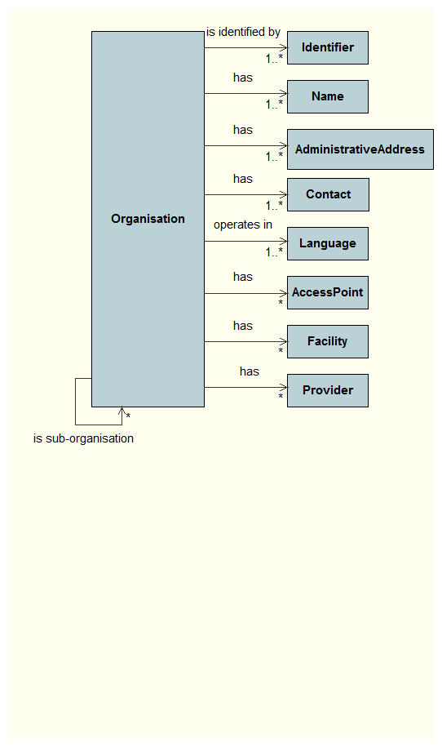

Figure X.3.2.2-1. Organization Logical Model

The figure above shows the data model as it pertains to an Organization. An organization will have at least one globally unique identifier, even if this is simply a system generated ID. There may be other identifiers.

An organization will have at least one name and may have more than one. It will have at least one administrative address (e.g. mailing address, delivery address), one set of contact details (which may include contact person, phone, email, fax number), and at least one identified operating language (language will be a coded value). An organization may have one or more defined access points (including, for example, a URI, PKI certificate details, etc.).

Organizations may have relationships to other entities. An organization may have a defined parent organization or it may, itself, be a parent to one or more sub-organizations. Additionally, there may be relationships between facilities and organizations and between providers and organizations.

The attributes of an Organization are described in Table X.3.2.2-1.

Table X.3.2.2-1 Organization Attributes

| Concept | Man-datory | Description |
| --- | --- | --- |
| Unique Entity Identifier | R | The unique entity identifier is a globally unique identifier for this organization. |
| Org Identifiers | O | An organization may have multiple other identifiers. Type values will be defined by national or regional organizations. |
| Org Type | R | The values for organization type will be defined by national or regional organizations. |
| Org Type Description | R | The definitions will be defined by national or regional organizations. See Org Type for more information. |
| Org Status | R | The organization’s status may be either Active/Inactive. |
| Org Primary Name | R | The organization’s name, for primary use, is a mandatory attribute. |
| Org other Names | O | Other optional names may be defined for the organization. |
| Org Contact | R2 | There must be at least one contact defined for the organization; it is a mandatory field. |
| Org Admin Address | R2 | . .This address type may be identified as billing, delivery, or mailing. There may be more than one administrative address. |
| Org Credentials | O | This is the list of credentials held by the organization. NOTE: degree is not a valid credential type for an Organization |
| Provider Language Supported | R | It is mandatory to identify that languages the organization is able to operate in. |
| Org Specialty | O | An organization may, optionally, indicate its specializations. |
| UDDI Business Entity URI | O | Electronic address information of an Organization. Points to businessEntity through businessKey value of the IHE Services Directory for Document Sharing (SDDS) |
| Encryption Certificate | O | If the organization has a PKI certificate, it may be specified here. |
| Org Business Phone | R2 | The main telephone number for the organization is specified, if known. |
| Org Fax | R2 | The main FAX number for the organization is specified, if known. |
| Parent organization | O | If the organization is a suborganization, the globally unique IDs of the parents is indicated here. If the organization is the “top” level organization, its own unique ID is indicated here. If this field is not specified, it is assumed that the organization is a top level organization. |
| Creation Date | R | Creation timestamp of this record. |
| Last Update Date | R | Last update timestamp of this record. |

**Facility**

The figure below depicts a logic model of the Facility entity. This logical model is based on the following:

* WHO draft guideline (2010): Creating a Master Health Facility List
* HL7v3 Standard: Healthcare, Community Services and Provider Directory, Release 1 (2010) – Appendix C HSD Data Dictionary

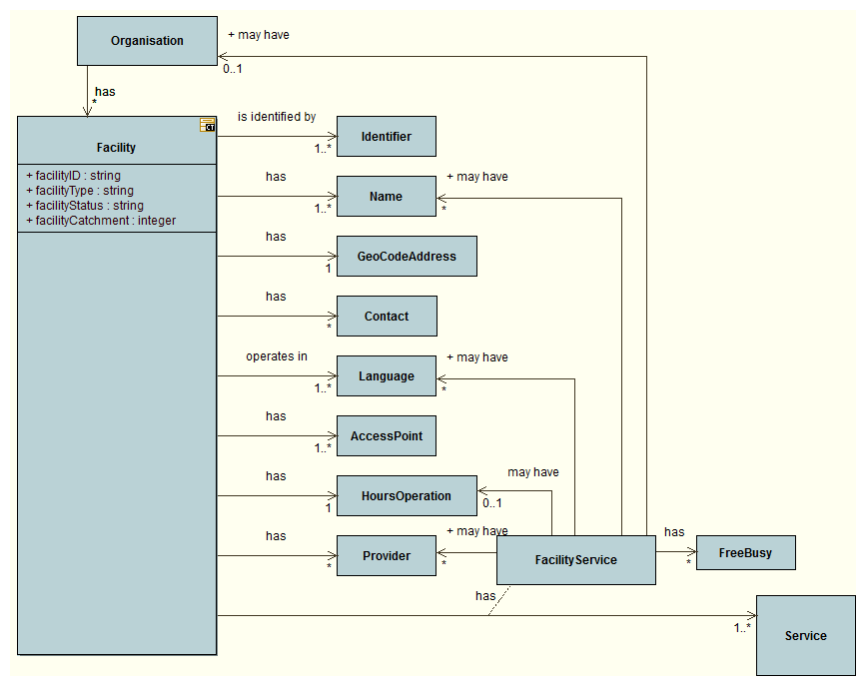

Figure X.3.2.2-2. Facility Logical Model

The figure above shows the data model as it pertains to a Facility. Facilities, as defined for the purposes of the CSD profile, are sites from which care services are delivered. A facility will have at least one globally unique identifier; there may be additional identifiers, too. A facility will have at least one, and perhaps more than one name. It will have one and only one care delivery address and this address will include a geocode. Each facility will have at least one set of contact details (which may include contact name, phone, email, fax number), and at least one identified operating language (language will be a coded value). A facility may have one or more defined access points (including, for example, a URI, PKI certificate details, etc.). Each facility will have defined hours of operation including planned shut-down times (for national holidays, for example, or during periods of re-construction or repair).

Each facility is related to at least one Organization. In a situation where multiple organizations are delivering services from the same physical location, each organization will have a separate FacilityService ID under which its services are being delivered (even though many of the other attributes, such as operating hours, may be the same). To be considered operational, a facility must have at least one FacilityService entity related to it. Additionally, there may be providers who have a relationship with the facility.

Table X.3.2.2-2 Facility Attributes

| Concept | Man-datory | Description |
| --- | --- | --- |
| Unique Entity Identifier | R | The unique entity identifier is a globally unique identifier for this facility. |
| Facility Identifiers | O | A facility may have multiple other identifiers. Type values will be defined by national or regional organizations. |
| Facility Type | R | The values for facility type will be defined by national or regional organizations. An example is the list of facility types included in the WHO draft guideline: Creating a Health Facility Master List (p. 12) found at: [www.who.int/healthinfo/systems/WHO_CreatingMFL_draft.pdf](http://www.who.int/healthinfo/systems/WHO_CreatingMFL_draft.pdf). |
| Facility Type Description | R | The definitions will be defined by national or regional organizations. See Facility Type for more information. |
| Facility Status | R | The facilty status is a coded value. The code system will be established by the implementing authority. Examples may be found on page 15 of the WHO draft guideline: Creating a Health Facility Master List (see above). |
| Facility Name | R | The facility’s name, for primary use, is a mandatory attribute. |
| Facility Known names | O | Other optional names may be defined for the facility. |
| Facility Address | R2 | The address must be indicated if known. More than one address may be specified, but the primary address must be indicated as such. |
| Facility Contact | R2 | There must be at least one contact defined for the facility, if known. |
| Facility Geocode | R | The facility’s geocoded point position must be indicated. This is intended to support display of the facility’s location by map/GIS applications and to enable calculation of the facility’s proximity to a known position. |
| Facility Language Supported | R | It is mandatory to identify the languages the facilit is able to operate in. |
| 1. Facility Access Points | 1. R2 | 1. Electronic access point inforamtion such as email address, URI, phone and FAX must be provided, if known. A PKI certificate may also be specified here. |
| Facility Org Parent | R | The facility must be related to at least one “parent” organization; there may be more than one parent organization for a facility. The facilityOrg indicates the relationship(s) via a reference to the orgID(s) of the parent. |
| Facility Operating Hours | R | The operating hours for the facility must be identified.This indicates the open hours, days of the week, and any shutdown periods (e.g. civic or national holidays, etc.). |
| Facility Service | R | The care services offered at the facility are indicated here.There must be at least one care service provided at the facility. This is a coded value; the code set is specified by the implementer. |
| Facility Provider | O | The providers associated with the facility are indicated here.There may be multiple providers with a relationship to a facility. |
| Creation Date | N/A | The creation timestamp for this record. |
| Last Update Date | N/A | The last update timestamp for this record. |

**FacilityService**

Figure X.3.2.2-2 shows the role played by the FacilityService entity in describing the relationship between a Facility and the Services it provides. If a Facility has multiple parent Organizations, the parent organization of the FacilityService is unambiguiously established by establishing a 1:1 relationship between the FacilityService and its parent Organization. Therefore, there is one FacilityService for each unique combination of Facility, Service and Organization.

By reference, each FacilityService entity inherits key attributes of the parent facility. If specified, the name, language, and operating hours indicated for a FacilityService will over-ride the inherited values associated with the Facility.

There may be Providers who have a relationship with the FacilityService entity. These Providers may have provider-specific operating hours associated with this relationship. Optionally, there may be one or more FreeBusy data associated with the FacilityService and also, separately, optional FreeBusy data may be associated with a specific provider’s delivery relationship with the FacilityService.

**Provider**

The figure below depicts a logic model of the Provider entity.

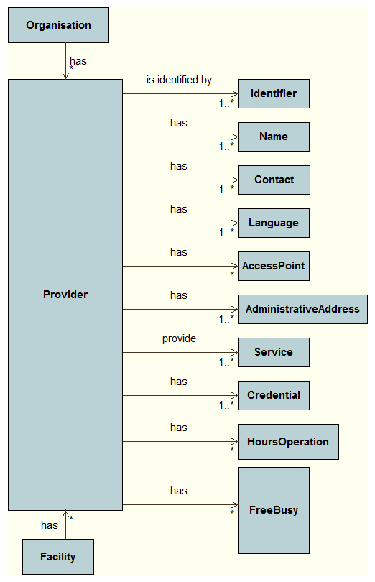

Figure X.3.2.2-4. Provider Logical Model

The figure above shows the data model as it pertains to a Provider entity. Each provider has at least one globally unique ID; the format of this ID is to be defined by the service implementers. Each provider will have at least one name and must have a defined relationship to at least one organization, facility or FacilityService. A provider must also have at least one identified service that it provides and at lesat one credential. Each provider has at least one address; this is an administrative address (e.g. mailing address or delivery address). Each provider will have at least one set of contact details (which may include contact name, phone, email, fax number), and at least one identified operating language (language will be a coded value). A provider may have one or more defined access points (including, for example, a URI, PKI certificate details, etc.).

A provider may have hours of operation associated with its relationships to organizations, facilities or FacilityServices. Optionally, FreeBusy data may also be associated with any of these relationships.

**FreeBusy**

to be done…

## X.4 CSD Security Considerations

This section references the non-normative section: A.10 Privacy & Security in ISO DTS 27527:2007 Health informatics – Provider identification.

Users of this profile should refer to relevant privacy legislation, codes of fair information practice and other guidelines so as not to breach personal privacy in their collection, use, storage and disclosure of provider information, including any consent requirements. Privacy legislation may require users to consider their particular set of circumstances (i.e. location and sector) and whether privacy legislation covers those circumstances. Provisions in health professional legislation and regulations shall also be considered when unique provider identifiers and any subsequent identifiable information is collected, stored and shared.

Individual provider identification details are personal information. These details shall be only collected where there is a legitimate need to identify providers and their personal and business information shall be maintained in a confidential manner.

It is also important to secure and safeguard the information to prevent unauthorized disclosure. Appropriate security measures shall be employed to protect the person-identifiable/sensitive information contained within each organization holding unique provider identifiers.

Consideration shall be given to who has access to unique identifiers (i.e. are they public numbers or privatesystem numbers) and actions to be taken in cases of fraud shall be considered. Any data matching and linkage procedures shall respect both privacy legislation and professional regulatory provisions.

**Data matching**

For provider identifiers to be linked, the identifying data about the provider needs to be matched. Data may be matched in one of two ways:

1. Deterministic matching—is where data is only matched where identifying information (such as family name, initial of first given name, date of birth and sex) are identical;
2. Probabilistic matching—is where weights are assigned to identifying data elements to identify whether two records are a true match, a non-match, or a highly probable match.

These techniques/approaches are not mutually exclusive. Errors can easily occur when matching data as there can be:

1. False non-matches or Type I Errors—which is failure to match identifying data which is associated with the same individual; these errors create duplicate records; or
2. False matches or Type II Errors—which is where records are matched but are in fact not associated with the same individual; these errors are called overlays.

Whenever data linkage involves the use of identifying personal information, providers shall ensure that this use of the information is permitted under the privacy laws that apply to them. If the information has been collected by the organization from the individual for the purposes of providing health care, and the linkage is being performed for this purpose, then ordinarily it will be permitted by such laws as it is being used for the purpose for which it was collected. When the information is being linked for other purposes, the legal authority to use the information in the manner proposed should be ascertained.

**Process of data linkage**

The selection of appropriate primary and secondary identifiers, and the configuration of provider match and reconcile parameters within a system shall be assessed individually by each health care establishment, based on the number and authenticity of sources, and the quality of the data collected for the identifier itself. Below is a partial list of questions that should be asked as part of the health care client identifier design process:

* What is the frequency of availability of each of the demographic fields being considered as identifiers?
* What is the level of trust of the data collected in the identifier field?
* How does each health care client identifier field rate in comparison to the other identifiers (for example, date of birth may have a greater weight than sex)?
* What is the resolution of the data? (eg month born versus full birthday, village born verus district)
* What is the reliability and consistency with which this identifier is present, and correct, for a given person?
* Is the data collected for this identifier a ‘free text’ field, or do users select from a predefined, codified set of reference data?

Below are some general recommendations for the weighting of certain identifiers:

* Family name should be weighted more heavily than given name, due to the variations that can occur with given name;
* First given name should be weighted more heavily than the second and subsequent given names (if second and subsequent given names are used);
* Date of birth should be weighted more heavily than sex.

And below are some general recommendations on the level and degree of person match:

* Weighted searches, particularly where large databases of provider details exist, often take up more system resources and can impact the system’s overall performance. It is generally best to do weighted searches only when necessary, and not on information received from authenticated sources;
* All systems should, if possible, make demographic data elements that are selected as provider identifiers required or mandatory fields. Users should pick the values for these fields from a codified ‘drop down’ list. Free text fields should be avoided.

Therefore, the configuration of an identification system to effectively identify health care providers, match them to existing health care client records and reconcile across multiple sources of provider information is individual to each health care entity. Often, the parameters selected and the configuration of the match and reconcile will not prove to be optimum from the initial design. It is critical that any configuration be tested thoroughly prior to implementation.

*Volume 2b - Transactions*

## To be done!

Go forward with the set of 5 document types; support XQuery generally… REQUIRE a set of XQueries to be supported for conformance testing purposes. These will be the ones that enable the use cases to be executed.

## 3.Y1 Provider Information Feed

This section corresponds to Transaction Y of the IHE IT InfrastructureTechnical Framework. Transaction Y is used by the Provider Information Source and Provider Information Directory actors.

This transaction is optional for the Provider Information Directory.

### 3.Y1.1 Scope

The Provider Information Feed specifies one or more of the following actions:

* An “Add” to add new provider entries
* A “Delete” to delete any existing provider entries
* An “Update” to modify or update any existing provider entries

Two categories of healthcare providers are included in the Provider Information Feed:

* Individual Provider – A person who provides healthcare services, such as a physician, nurse, or pharmacist.
* Organizational Providers – Organizations that provide or support healthcare services, such as hospitals, Healthcare Information Exchanges (HIEs), Integrated Delivery Networks (IDNs), and Associations.

### 3.Y1.2 Use Case Roles



Figure 3.Y1.2-1. Basic Process Flow for Provider Information Feed

**Actor:** Provider Information Source

**Role:** Sends add, update, and delete of provider information to the Provider Information Directory. Receives acknowledgements from the Provider Information Directory that the Provider feed transaction has been received.

**Actor:** Provider Information Directory

**Role:** Receives add, update, and delete information from the Provider Information Source. Performs data management operations as per its policies and procedures. Informs the Provider Information Source that this information has been received.

### 3.Y1.3 Referenced Standard

LDAP (Lightweight Directory Access Protocol), an open standard built on X.500 framework, is adopted by this profile as the minimal specifications for exchange standards of provider information. Furthermore, the International Organization for Standards (ISO) defined as ISO 21091 is referenced to define the attributes of health professionals and organizations to represent health care regulatory information, clinical credentials, multiple affiliations etc. By leveraging the ISO 21091 and underlying LDAP standard, the HPD profile designs the associated schema and transactions for the interoperability communication. The usage of standard LDAP schema would make the adoption of HPD by the HIT vendors easier and extensible with their existing implementations.

HPD Profile applies DSMLv2 to express LDAP requests and responses in SOAP bindings. DSMLv2 is a systematic translation of LDAP’s ASN.1 grammar (defined by RFC 2251) into XML-Schema. DSMLv2 provides advantages in the adoption of this transaction for an interoperable electronic exchange. First, tools for marshaling XML into SOAP messages are readily available, making development much easier. Second, firewalls are often configured to allow HTTP and HTTPS protocols to pass. This make it possible for DSML, carried in the HTTP or HTTPs protocol, to become the method for carrying provider information on the internet in an interoperable manner.

The Provider Information Feed transaction will conform to the following standard specifications:

* Health informatics — Directory services for health care providers, subjects of care, and other entities (ISO/TS 21091)
* IETF LDAP v3
* DSMLv2
* SOAP 1.2

### 3.Y1.4 Interaction Diagram

Provider Information Source

Provider Information Directory

Provider Information Feed

Request

Provider Information Feed Acknowledgement

#### 3.Y1.4.1 Provider Information Feed Request

The Provider Information Source initiates a Provider Information Feed Request message. The request includes Organizational Provider and/or Individual Provider information to be added, updated or deleted in a Provider Information Directory. Upon receiving the Provider Information Feed, the Provider Information Directory acknowledges to the source that the information has been received. The Provider Information Feed specifies one or more of the following actions:

* An “Add” to add new entries
* A “Delete” to delete any existing entries
* An “Update” to modify or update any existing entries

Shall the Provider Information Directory actor choose to support the Provider Information Feed transaction then the Provider Information Directory actor must support the implementation of Add/Update/Delete operations. However, these data administration operations that include data maintenance, data reconciliation, data validation, and data integrity checks are considered back-end processes by this profile and shall be executed as defined by the policies and procedures of the organization managing the Provider Information Directory. It is for this reason that the Provider Information Source is not notified of the Add/Update/Delete status.

The Provider Information Directory actor shall choose to publish Provider Information Feed, in all or in part, immediately or with delays, depending on the data and security policies and procedures of the Provider Information Directory. Once the provider information is published on a Provider Information Directory, it implies that the information has been validated and has rights to access by the Provider Information Consumer. In order to assure that updates were done successfully the Provider Information Source would need to become a Provider Information Consumer and execute a Provider Information Query.

##### 3.Y1.4.1.1 Trigger Events

This message is sent from a Provider Information Source actor to a Provider Information Directory actor when a Provider (Organizational or Individual) is to be added to the Provider Information Directory, or when provider information expected to be on the Provider Information Directory is to be updated, deactivated, or deleted.

##### 3.Y1.4.1.2 Message Semantics

Provider Information Feed request uses the SOAP based DSMLv2 batchRequest message to express a Provider Information Feed request through the following four LDAP operations:

1. An **add** operation for creating new provider entries in the Provider Information Directory as defined by **addRequest** type. A new entry must provide the distinguished name (DN) of the provider entry to be created and a set of attributes related to provider.
2. An **update** operation allows for updating an existing provider entry is defined by **modifyRequest** to update an existing entry by specifying the distinguished name (DN) of the entry to be modifed and a set of modifications to be applied. The modifications can consist of new attribute values or replacement of existing attribute values, or deletion of attribute values.
3. An **update** operation allows for updating an existing provider entry is defined by **modDNRequest** to rename the distinguished name of an existing entry. The rename entry must specify the distinguished name of the entry to be renames and the new distinguished name for the entry.
4. A **delete** operation for removing a provider entry from the Provider Information Directory as defined by **delRequest** type. The deleted entry only provides the distinguished name of the entry to be deleted.

The examples for Provider Information Feed are referenced in the following URL: <ftp://ftp.ihe.net/IT_Infrastructure/iheitiyr8-2010-2011/Technical_Cmte/Profile_Work/HPD/Public%20Comment/>

###### 3.Y1.4.1.2.1 HPD Schema Structure

The HPD schema defines LDAP *organizationalUnit* (OU) containers to organize the information on Providers. Object classes within OU represent Individual Provider, Organization Provider and Relationships that are managed using the schema from ISO/TS 21091 and LDAP.

The directory naming context will be o=HPD Owner, dc=HPD

There are nodes that are subordinate to dc=HPD.

* ou=Individual Provider – hcProfessional schema for storing individual provider information.
* ou=Organization Provider – hcRegulatedOrganization schema containing all organizational providers and their relevant information.
* ou=Relationship – a groupOfNames schema for holding the “member-of” relationships among providers. Groups holding the members that are related are represented by standard LDAP groupOfNames class. Each Group has a group owner organization that owns the relationship and has group members: Individual and Organization providers represented by member attributes, whose values are the DNs of the members themselves.

The Directory Information Tree for HPD is shown in the following diagram.



Figure 3.Y1.4.1.2.1 - 1 – HPD Directory Information Tree

###### 3.Y1.4.1.2.2 HPD Schema Content

This section describes the mapping of HPD data fields and ISO 21091/LDAP standard object classes used. The ISO 21091 schema is extended by this transaction to include HPD information that is not covered by ISO standard.

3.Y1.4.1.2.2.1 Object Classes

**HCProfessional:**

This is an object class defined by ISO 20191 standard to store information about Individual provider.

***Object Class:*** HCProfessional

***Superior Object Class:*** InetOrgPerson

***OID:*** 1.0.21091.1.2

***Object Class Type:*** Structural

**HCRegulatedOrganization**

This is an object class defined by ISO 20191 standard to store information about Organization provider.

***Object Class:*** HCRegulatedOrganization

***Superior Object Class:*** Organization

***OID:*** 1.0.21091.1.4

***Object Class Type:*** structural

**HPDProvider**

This transaction requires an Auxiliary object class HPDProvider to define additional provider attributes (for both Individual and Organizational Provider) that are not defined in the ISO 21091 schema. HPDProvider class cannot be created to have an instance by itself and places no restrictions to an existing directory schema. It is simply used to add a set of additional provider attributes to be “mixed-in” to HCProfessional and HCRegulatedOrganization object classes. This class has the *top* as its superior.

***Object Class:*** HPDProvider

***Superior Object Class:*** top

***OID:*** <TBD>

***Object Class Type:*** Auxiliary

***Optional attributes:***

| Attribute | *OID* | *Description* | *Syntax* | *Matching rules* | *Multi-Valued* |
| --- | --- | --- | --- | --- | --- |
| hpdProviderStatus | *TBD* | Maintain status of provider in directory | Directory String | Case Ignore Match | S |
| hpdProviderLanguageSupported | *TBD* | Languages thatt the provider supports  Recommended best practice is to use RFC 3066 [RFC 3066] which, in conjunction with ISO 639 [ISO639], defines two- and three-letter primary language tags with optional subtags. Examples include "en" or "eng" for English, "akk" for Akkadian, and "en-GB" for English used in the United Kingdom." | Directory String | Case Ignore Match, Case Ignore Substrings Match | M |
| hpdProviderBillingAddress | *TBD* | status=<primary, other, inactive>  $ streetNumber=1221  $ streetName=Circle Lane  $ city=Nowheresville  $ state=Some  $ postalCode=98765-4321  $ country=US  $ addr = 1221 Circle Lane Noweheresville Some 98765 US  **See NOTE 1 below** | Postal Address | Case Ignore Match, Case Ignore Substrings Match | M |
| hpdProviderMailingAddress | *TBD* | status=<primary, other, inactive>  $ streetNumber=1221  $ streetName=Circle Lane  $ city=Nowheresville  $ state=Some  $ postalCode=98765-4321  $ country=US  $ addr = 1221 Circle Lane Noweheresville Some 98765 US  **See NOTE 1 below** | Postal Address | Case Ignore Match, Case Ignore Substrings Match | M |
| hpdProviderPracticeAddress | *TBD* | status=<primary, other, inactive>  $ streetNumber=1221  $ streetName=Circle Lane  $ city=Nowheresville  $ state=Some  $ postalCode=98765-4321  $ country=US  $ addr = 1221 Circle Lane Noweheresville Some 98765 Us  **See NOTE 1 below** | Postal Address | Case Ignore Match, Case Ignore Substrings Match | M |
| memberOf | *TBD* | Group which provider is a member of | DN | Case Ignore Match | M |

**NOTE 1:**

If an address is included, then the $addr is required.

Country and State Code values are based on the ISO Standard 3166.

City values will be defined by national or regional organizations. An example of a possible list of City values may be found in the World Gazetteer. Reference URL: <http://www.commondatahub.com/city_source.jsp>

CDH GC05 – Cities in US and Canada

CDH GC06 – Large Cities in US and Canada

DCH GC07S- Large Cities in the world (population > 20,000)

**HPDProviderCredential**

***Object Class:*** HPDProviderCredential

***Superior Object Class:*** top

***OID:*** <TBD>

***Object Class Type:*** Structure

***Mandatory attributes:***

| Attribute | *OID* | *Description* | *Syntax* | *Matching rules* | *Multi-Valued* |
| --- | --- | --- | --- | --- | --- |
| credentialType | *TBD* | Type of Credential<degree, certificate, credential> | Directory String | Case Ignore Match | S |
| credentialName | *TBD* | Name of Credential, degree, or certification that belongs to provider.  Follows the ISO21091 naming format as that of the HCStandardRole:  credentialName@organization_domain_name  where credentialName is the standard name of the credential, and organization_domain_name is the domain name of the organization for those credentials local to the organization, or  credential@Locality  where credential is the standard name of the structural role if applicable to the Locality (i.e. state). | Directory String | Case Ignore Match | S |
| credentialNumber | *TBD* | Credential Identifier Follows the ISO 21091 UID format:  (Issuing Authority OID: ID)  The issuing authority OID could be used to identify the issuing agency, state and country. | Directory String | Case Ignore Match | S |

***Optional attributes:***

| Attribute | *OID* | *Description* | *Syntax* | *Matching rules* | *Multi-Valued* |
| --- | --- | --- | --- | --- | --- |
| Description | *TBD* | Additional information on the credential | Directory String | Case Ignore Match | S |
| credentialIssueDate | *TBD* | Date when credential was issued to the provider | Date | Case Ignore Match | S |
| credentialRenewalDate | *TBD* | Date when credential is due renewal | Date | Case Ignore Match | S |
| credentialStatus | *TBD* | The current status of credential: Active, Inactive, Suspended etc | Directory String | Case Ignore Match | S |

3.Y1.4.1.2.2.2 Individual Provider

Entries for Individual Provider in the Provider Information Directory use the attributes of HCProfessional object class that extends from inetOrgPerson object class. HPDProvider auxiliary object class is used to define additional attributes.

**Mapping**

| HPD Concept | LDAP Syntax | Object Class | Attribute within Object Class | Single/Multi Valued | Manda-  tory | Comments |
| --- | --- | --- | --- | --- | --- | --- |
| Unique Entry Identifier | String | inetOrgPerson | uid | S | R | RDN Format as defined by ISO 2191 section 9.2 (Issuing Authority Name:ID) |
| Provider “Identifiers” | String | HCProfessional | hcIdentifier | M | R | Format as defined by ISO 2191 (Issuing Authority:Type:ID:Status)  Type values will be defined by national or regional organizations.  Status is defined in section 3.Y1.4.1.2.3 |
| Provider Type | String | HCProfessional | hcProfession | M | R | The values will be defined by national or regional organizations. An example of possible types is the list of Individuals or Groups Values from the Healthcare Provider Taxonomy Published by the American Medical Association twice a year. An example of this document can be found at the following reference URL: http://www.adldata.com/Downloads/Glossaries/taxonomy_80.pdf. |
| Provider Type description | String | inetOrgPerson | Description | S | R | The definitions will be defined by national or regional organizations. See Provider Type for more information. |
| Provider Status | String | HPDProvider | hpdProviderStatus | S | O | Active/Inactive/Deceased/Retired |
| Provider Primary Name | String | inetOrgPerson | displayName | S | R | Use of language tag and HL7 Name Data Type (XCN) as per PWP Volume 2A Section 3.24; 3.24.5.2.3.1 |
| Provider Title | String | inetOrgPerson | Title | S | O | Use of language tag and HL7 Name Data Type (XCN) as per PWP Volume 2A Section 3.24; 3.24.5.2.3.1 |
| Provider First name | String | inetOrgPerson | givenName | M | R2 | Use of language tag and HL7 Name Data Type (XCN) as per PWP Volume 2A Section 3.24; 3.24.5.2.3.1 |
| Provider Middle Name | String | inetOrgPerson | initials | M | O | Use of language tag and HL7 Name Data Type (XCN) as per PWP Volume 2A Section 3.24; 3.24.5.2.3.1 |
| Provider Last Name | String | inetOrgPerson | Sn | M | R | Use of language tag and HL7 Name Data Type (XCN) as per PWP Volume 2A Section 3.24; 3.24.5.2.3.1 |
| Provider Known names | String | inetOrgPerson | Cn | M | R | Use of language tag and HL7 Name Data Type (XCN) as per PWP Volume 2A Section 3.24; 3.24.5.2.3.1 |
| Provider Language Supported | String | HPDProvider | hpdProviderLanguageSupported | M | O |  |
| Provider Gender | String | Natural Person | Gender | S | O | Using Natural Person auxillary class as defined in RFC 2985 |
| Provider e-mail address | String | inetOrgPerson | Mail | M | O |  |
| Encryption Certificate | Binary | HCProfessional | HcSigningCertificate | M | O | Base 64 encoded certificate |
| UDDI Business Entity URI | String | groupofURLs | labeledURI | S | O | Points to businessEntity through businessKey value of the IHE Services Directory for Document Sharing (SDDS) |
| Creation Date |  |  |  |  | N/A | This is an operation attribute that directory servers already maintains. |
| Last Update Date |  |  |  |  | N/A | This is an operation attribute that directory servers already maintains. |
| Provider Facility Name | String | inetOrgPerson | physicalDeliveryOfficeName | M | R2 |  |
| Provider Mailing Address | Postal Address | HPDProvider | hpdProviderMailingAddress | M | R2 | Mailing address |
| Provider Billing Address | Postal Address | HPDProvider | hpdProviderBillingAddress | M | O | Business billing address; |
| Provider Practice Address | Postal Address | HPDProvider | hpdProviderPracticeAddress | M | R2 | Practice address; |
| Provider Practice Organization | DN | HCProfessional | HcPracticeLocation | M | O | DN of organization the provider practices |
| Provider Business Phone | Telephone Number | inetOrgPerson | telephone | M | R2 | As per PWP volume 2A; 3.24 |
| Provider Mobile Phone | Telephone Number | inetOrgPerson | Mobile | M | R2 | As per PWP volume 2A; 3.24 Business Mobile |
| Provider Pager | Telephone Number | inetOrgPerson | Pager | M | R2 | As per PWP volume 2A; 3.24 |
| Provider Fax | Facsimile Telephone Number | inetOrgPerson | facsimileTelephoneNumber | M | R2 |  |
| Provider “Credential” | DN | HPDCredential | credentialName | M | O |  |
| Provider Specialty | String | HCProfessional | hcSpecialization | M | O | A major Grouping i.e. Dermatology, Oncology, Dental, Internal Med |
| Provider Relationship | DN | HPDProvider | memberOf | M | O | Groups to which this provider belongs; In search scenarios, it is desirable for a Provider Information Consumer to be able to determine which organizations this individual provider is a member of. |

3.Y1.4.1.2.2.3 Organizational Provider

**Object Classes: HCRegulatedOrganization, HPDProvider**

Entries for Organization Provider in the Provider Information Directory uses the attributes of HCRegulatedOrganization object class that extends from ‘Organization’ object class. HPDProvider object class is used to define additional attributes.

**Mapping**

| HPD Concept | LDAP Syntax | Object Class | Attribute within Object Class | Single/  Multi Valued | Man-datory | Comments |
| --- | --- | --- | --- | --- | --- | --- |
| Unique Entity Identifier | String | Organization | uid | S | R | RDN Format as defined by ISO 2191 section 9.2 (Issuing Authority Name:ID) |
| Org Identifiers | String | HCRegulatedOrganization | hcIdentifier | M | R | Format as defined by ISO 2191 (Issuing Authority:Type:ID:Status)  Type values will be defined by national or regional organizations.  Status is defined in section 3.Y1.4.1.2.3 |
| Org Type | String | Organization | businessCategory | S | O | The values will be defined by national or regional organizations. An example is the list of Non Individual Values from the Healthcare Provider Taxonomy Published by the American Medical Association twice a year. An example of this document can be found at the following reference URL: http://www.adldata.com/Downloads/Glossaries/taxonomy_80.pdf. |
| Org Type Description | String |  |  | S |  | The definitions will be defined by national or regional organizations. See Org Type for more information. |
| Org Status | String | HPDProvider | hpdProviderStatus | S | O | Active/Inactive |
| Org Name | String | HCRegulatedOrganization | HcRegisteredName | M | O | Use of language tag and HL7 Name Data Type (XCN) as per PWP Volume 2A Section 3.24; 3.24.5.2.3.1 |
| Org Known names | String | Organization | Cn | M | O | Use of language tag and HL7 Name Data Type (XCN) as per PWP Volume 2A Section 3.24; 3.24.5.2.3.1 |
| Org Contact | DN | HCRegulatedOrganization | ClinicalInformationContact | M | O | Clinical contacts; DN to HCProfessional entry |
| Org Practice Address | Postal Address | HPDProvider | hpdProviderPracticeAddress | M | R2 |  |
| Org Billing Address | Postal Address | HPDProvider | hpdProviderMailingAddress | M | O |  |
| Org Mailing Address | Postal Address | HPDProvider | hpdProviderMailingAddress | M | R2 |  |
| Org Credentials | DN | HPDCredential | credentialName | M | O | Degree is not a valid type for Organizational Provider |
| Provider Language Supported | String | HPDProvider | hpdProviderLanguageSupported | M | O | Language that the organization supports |
| Org Specialty | String | HCRegulatedOrganization | HcSpecialisation | M | O |  |
| UDDI Business Entity URI | String | groupofURLs | labeledURI | M | O | Electronic address information of an Organization. Points to businessEntity through businessKey value of the IHE Services Directory for Document Sharing (SDDS) |
| Encryption Certificate | Binary | HCRegulatedOrganization | HcSigningCertificate | S | O |  |
| Org Business Phone | Telephone Number | Organization | telephone | M | R2 |  |
| Org Fax | Facsimile Telephone Number | Organization | facsimileTelephoneNumber | M | R2 |  |
| Provider Relationship | DN | HPDProvider | Memberof | M | O | Groups to which this provider belongs; In search scenarios, it is desirable for a Provider Information Consumer to be able to determine which organizations this organization provider is a member of. |
| Creation Date | String |  |  | S | N/A | Operational Attribute |
| Last Update Date | Date |  |  | S | N/A | Operational Attribute |

3.Y1.4.1.2.2.4 Relationships

The HPD schema allows maintaing relationships between providers. The scope of this transaction considers one type of relationship; *Member Of*. Examples of this relationship are:

1. Hospitals, clinics, labs, other organization providers, and physicians are *members of* an HIE
2. A list of physicians *are members of* a hospital
3. A number of hospitals, practitioners are *members of* an Integrated Delivery Network
4. Departments or clinics are organizations which are *members of* a Hospital
5. A physician is *a member of* one or more organization providers

This means that the HPD schema can be used to feed the following:

1. What other organizational providers an organizational provider is *a member* of

* Attribute *memberOf* in the Organization schema (see section 3.Y1.4.1.2.2.3)

1. What other organizational providers are *members of* a particular organizational provider

* Through use of groupofNames schema (an LDAP standard object class)

1. What organizational providers an individual provider is *a member* of

* Attribute *memberOf* in the Individual Provider schema (see section 3.Y1.4.1.2.2.2)

1. What individual providers are *members of* a particular organizational provider

* Through use of groupofNames (an LDAP standard object class)

In the current schema, it is not possible to attach any extra information to the DN value to show the business reason for the relationship. It is also important to note that an Individual provider cannot be an owner to the group as an Organizational Provider or an Individual Provider shall not have a “member of” relationship with an Individual Provider.

Relationships in this transaction are represented by LDAP objects using the groupOfNames class. Owner attribute is used to represent Organization that owns the group, while member attribute represents Individual or Organization that belong to the owner organization. The owner and member attribute values are the DN of the respective entries of HCRegulatedOrganization and/or HCProfessional.

### 3.Y1.4.1.2.3 Status Code Values

This table defines the value sets for the different status attributes. Not all values are valid for each status attribute.

The first column lists the attribute. A “Y” in any other column in the row indicates that the value identified in the header of the row is valid for that attribute.

Active – The information related to this attribute is currently true.

An active Individual Provider is an Individual Provider who is currently a participant in the healthcare field as defined by the metadata about this Individual Provider

Inactive – The information related to this attribute was true at one time, but is currently not true.

An inactive Individual Provider is an Individual Provider who once participated in the healthcare field as defined by the metadata about this Individual Provider

Retired – The information related to this Individual Provider was true at one time. The Individual Provider is currently no longer working.

Deceased - The information related to this Individual Provider was true at one time. The Individual Provider is no longer living.

Revoked – An action was taken against the provider (Individual or Organizational) to remove the information related to this attribute, which was true at one time, but is currently no longer valid. This implies an action taken by someone other than the provider.

Suspended – An action was taken against the provider (Individual or Organizational) to put on hold the information related to this attribute, which was true at one time.

Primary – Most important, and still valid

Secondary – Valid, but not most important.

Table 3.Y1.4.1.2.1.14-1 – Status Code Category Values

| Status Attribute | Active | Inactive | Retired | Deceased | Revoked | Suspended | Primary | Secondary |
| --- | --- | --- | --- | --- | --- | --- | --- | --- |
| Individual Provider | Y | Y | Y | Y |  |  |  |  |
| Organizational Provider | Y | Y |  |  |  |  |  |  |
| Address |  | Y |  |  |  |  | Y | Y |
| Credential | Y | Y |  |  | Y | Y |  |  |
| Identifier | Y | Y |  |  | Y | Y |  |  |

##### 3.Y1.4.1.3 Expected Actions

Upon receiving the Provider Information Feed, it is expected that Provider Information Directory actor performs one or more of the following actions:

* An “Add” to add new entries
* A “Delete” to delete any existing entries
* An “Update” to modify or update any existing entries

The data administration operations that include data maintenance, data reconciliation, data validation, and data integrity checks are considered back-end processes by this profile and shall be executed as defined by the policies and procedures of the organization managing the Provider Information Directory.

The Provider Information Directory actor shall choose to publish Provider Information Feed, in all or in part, immediately or with delays, depending on the data and security policies and procedures of the Provider Information Directory. Once the provider information is published on a Provider Information Directory, it implies that the information has been validated and has rights to access by the Provider Information Consumer.

#### 3.Y1.4.2 Provider Information Feed Response

The Provider Information Directory responds to the an Provider Information Feed request by issuing an Provider Information Feed response, which is a simple acknowledgement that the request transaction has been received. The acknowledgements does not indicate to the Provider Information Source whether or not the Provider Information Feed request was successful.

##### 3.Y1.4.2.1 Trigger Events

This message is sent by a Provider Information Directory actor to the Provider Information Source actor whenever the Provider Information Directory actor receives an Add/ Update Prvider request irrespective of whether the request was processed successfully or not.

The Provider Information Directory actor maintenance activities to process the request are outside of the scope of this transaction.

##### 3.Y1.4.2.2 Message Semantics

Provider Information Feed response uses SOAP based DSMLv2 batchResponse message of LDAPResult element type to send acknowledgements for four LDAP operations: Add, Modify, Rename (modify DN) and Delete.

The resultCode for an acknowledgement shall be reported as “Acknowledged”. The response shall not contain any errorMessage element as any processing errors are currently no in scope. with no errorMessage. Any errors that occur prior to the processing of the Provider Information Feed shall be communicated via a SOAP Fault.

<xsd:complexType name="LDAPResult">  
 <xsd:complexContent>  
 <xsd:extension base="DsmlMessage">  
 <xsd:sequence>  
 <xsd:element name="resultCode" type="ResultCode"/>  
 <xsd:element name="errorMessage" type="xsd:string" minOccurs="0"/>  
 <xsd:element name="referral" type="xsd:anyURI" minOccurs="0" maxOccurs="unbounded"/>  
 </xsd:sequence>

</xsd:extension>  
 </xsd:complexContent>  
 </xsd:complexType>

The examples for Provider Information Feed are referenced in the following URL: <ftp://ftp.ihe.net/IT_Infrastructure/iheitiyr8-2010-2011/Technical_Cmte/Profile_Work/HPD/Public%20Comment/>

##### 3.Y1.4.2.3 Expected Actions

There is no expected action to be taken by the Provider Information Source once the response has been received.

##### 3.Y1.5 Security Considerations

No transaction specific security considerations.

##### 3.Y1.5.1 Security Audit Considerations

The profile recommends but does not require auditing for the Patient Information Feed. The actors involved shall record audit events according to the following:

##### 3.Y1.5.1.1 Provider Information Source audit message:

<To Be Determined>

##### 3.Y1.5.1.2 Provider Information Directory audit message:

<To Be Determined>

## 3.Y2 Provider Information Query

This section corresponds to Transaction Y2 of the IHE Technical Framework. Transaction Y2 is used by the Provider Information Consumer and Provider Information Directory actors.

### 3.Y2.1 Scope

This transaction supports the ability to lookup information about healthcare providers from a healthcare provider directory on the following:

* Individual Providers – A person who provides healthcare services, such as a physician, nurse, or pharmacist.
* Organizational Providers – Organizations that provide or support healthcare services, such as hospitals, Healthcare Information Exchanges (HIEs), Integrated Delivery Networks (IDNs), and Associations.
* Relationship between providers. The scope of this transaction considers one type of relationship; member of. Examples of this relationship are:

1. Hospitals, clinics, labs, other organization providers, and physicians are *members of* an HIE
2. A list of physicians *are members of* a hospital
3. A physician is *a member* in a list of organization providers

The summary of the current minimal foundational attributes that are in scope for this transaction are defined in table 3.Y1.3.1-1 above, in section 3.Y1.3.1. A provider directory entry shall contain all required attribues and some or all of the optional attributes. A Provider Information Directory actor shall be able to act on all of the attributes. A definition of the attributes can be found in Volume 1 of this supplement.

### 3.Y2.2 Use Case Roles



Figure 3.Y2.2-1. Basic Process Flow for Provider Information Query

**Actor:** Provider Information Consumer

**Role:** Sends lookup requests to the Provider Information Directory. Receives responses from the Provider Information Directory with information on zero to many Organization and Individual Providers.

**Actor:** Provider Information Directory

**Role:** Recieves lookup requests from the Provider Information Consumer. Fulfills those requests and returns requested information on zero to many Organization and Individual Providers.

### 3.Y2.3 Referenced Standard

These Reference Standards are identical to the ones listed in section 3.Y1.3 Reference Standard.

### 3.Y2.4 Interaction Diagram

Healthcare

Provider Directory

Lookup Provider Request

Provider

Directory Consumer

Lookup Provider Response

Figure 3.Y2.4-1 Basic Process Flow for Provider Information Query

#### 3.Y2.4.1 Provider Information Query Request

Provider Information Consumer initiates a Provider Information Query request to the Provider Information Directory. The Provider Information Query request includes search parameters and defines the response set that is expected to be returned.

##### 3.Y2.4.1.1 Trigger Events

This message is sent from a Provider Information Consumer actor to a Provider Information Directory actor when a Provider Information Consumer wishes to get additional information about an Individual or an Organizational Provider or a list of providers. The Provider Information Consumer will provide search information and identify the information that the Provider Information Consumer is interested in receiving in return.

##### 3.Y2.4.1.2 Message Semantics

Provider Information Query request uses the SOAP based DSMLv2 batchRequest message to express a query.

Query operation for looking up provider entries in the Provider Information Directory shall be done through the use of searchRequest operation. For querying individuals, the base object is HCProfessional and for querying organizations, the base object is HCRegulatedOrganization. The relationships can be looked up by querying the groupOfNames object.

The searchRequest allows specifying a list of attributes to be returned for matching query. If this list is empty or a special value of * is used, then all user attrubutes are returned. The request transaction shall suport all LDAP standard search filters.

This profile does not limit any restriction on the search scope, size limit, time limit or list of attributes. If needed, those can be constraint by the Provider Information Directory actor implementor.

The examples for Provider Information Feed are referenced in the following URL: <ftp://ftp.ihe.net/IT_Infrastructure/iheitiyr8-2010-2011/Technical_Cmte/Profile_Work/HPD/Public%20Comment/>

##### 3.Y2.4.1.3 Expected Actions

The Provider Information Directory actor shall search the directory for the providers that meet the criteria in the Provider Information Query request. Zero to many providers may be identified. The Provider Information Directory actor will build the Provider Information Query response transaction and return the result.

* If no providers are found then an empty response set will be returned.
* If one provider is found then one record will be returned.
* If more than one provider meets the criteria specified then the list of providers will be returned.

#### 3.Y2.4.2 Provider Information Query Response

The Provider Information Directory responds to the a Provider Information Query request initiated by the Provider Information Consumer. The Provider Information Directory will provide the response set requested. The response set may have a single or multiple providers that meet the query search criteria. If the Provider Information Directory cannot locate a Provider (list) that meets the Provider Information Query request identifying information, then a “No Record Found” response will be provided.

##### 3.Y2.4.2.1 Trigger Events

This message is sent from a Provider Information Directory actor once the directory search resulting from a Provider Information Query request has been completed.

##### 3.Y2.4.2.2 Message Semantics

Provider Information Feed response uses SOAP based DSMLv2 batchResponse message of searchResponse element type to send response for searchRequest.

The Provider Information Query Response shall contain the requestID to associate the response to the Provider Information Query Request.

The examples for Provider Information Feed are referenced in the following URL: <ftp://ftp.ihe.net/IT_Infrastructure/iheitiyr8-2010-2011/Technical_Cmte/Profile_Work/HPD/Public%20Comment/>

##### 3.Y2.4.2.3 Expected Actions

There is no defined expected action to be taken by the Provider Information Consumer once the response has been received.

The Provider Information Consumer can have many reasons for requesting the information. Please see Volume 1, X.3.1 for use cases describing some expected actions.

##### 3.Y2.5 Security Considerations – Nitin - TBD

No transaction specific security considerations.

<Appendix letter> Appendix_Name

*<Detailed cross transaction relationships or mapping details are described in an appendix in Volume 2>*

Facility table...

| Concept | Variable name | Man-datory | Description |
| --- | --- | --- | --- |
| Unique Entity Identifier | facilityID | R | The unique entity identifier is a globally unique identifier for this facility. It is expressed in the RDN Format as defined by ISO 2191 section 9.2 (Issuing Authority Name:ID) |
| Facility Identifiers | identifier | O | A facility may have multiple other identifiers. The format of these is defined by ISO 2191 (Issuing Authority:Type:ID:Status)  Type values will be defined by national or regional organizations.  Status is defined in section 3.Y1.4.1.2.3 |
| Facility Type | facilityType | R | The values for facility type will be defined by national or regional organizations. An example is thelist of facility types included in the WHO draft guideline: Creating a Health Facility Master List (p. 12) found at: [www.who.int/healthinfo/systems/WHO_CreatingMFL_draft.pdf](http://www.who.int/healthinfo/systems/WHO_CreatingMFL_draft.pdf). |
| Facility Type Description | facilityTypeDescription | R | The definitions will be defined by national or regional organizations. See Facility Type for more information. |
| Facility Status | facilityStatus | R | The facilty status is a coded value. The code system will be established by the implementing authority. Examples may be found on page 15 of the WHO draft guideline: Creating a Health Facility Master List (see above). |
| Facility Name | facilityName | R | The facility’s name, for primary use, is a mandatory attribute. Use of language tag and HL7 Name Data Type (XCN) as per PWP Volume 2A Section 3.24; 3.24.5.2.3.1 |
| Facility Known names | faciltiyOtherName | O | Other optional names may be defined for the facility. Use of language tag and HL7 Name Data Type (XCN) as per PWP Volume 2A Section 3.24; 3.24.5.2.3.1 |
| Facility Address | facilityAddress | R2 | The address must be indicated if known. |
| Facility Contact | facilityContact | R2 | The main contact for the organization is a mandatory field, if known. |
| Facility Geocode | facilityGeocode | R | The facility’s geocoded point position must be indicated. This is intended to support display of the facility on maps and to enable calculation of proximity to known positions. |
| Facility Language Supported | facilityLanguage | R | It is mandatory to identify at least the primary language the facilit is able to operate in. This is a coded value; the code system may be specified by the implementer. |
| Facility Phone | facilityPhone | R2 | Electronic access point inforamtion such as email address, URI, phone and FAX must be provided, if know. A PKI certificate may also be specified here. This is stored in a complex type called AccessPoint. |
| Facility FAX | facilityFAX | R2 | Electronic access point inforamtion such as email address, URI, phone and FAX must be provided, if know. A PKI certificate may also be specified here. This is stored in a complex type called AccessPoint. |
| Facility URI | facilityURI | R2 | Electronic access point inforamtion such as email address, URI, phone and FAX must be provided, if know. A PKI certificate may also be specified here. This is stored in a complex type called AccessPoint. |
| Facility PKI certificate | facilityPKI | R2 | Electronic access point inforamtion such as email address, URI, phone and FAX must be provided, if know. A PKI certificate may also be specified here. This is stored in a complex type called AccessPoint. |
| Facility email | facilityEmail | R2 | Electronic access point inforamtion such as email address, URI, phone and FAX must be provided, if know. A PKI certificate may also be specified here. This is stored in a complex type called AccessPoint. |
| Facility Org Parent | facilityOrg | R | the facility must be related to at least one “parent” organization; there may be more than one organization operating within a facility. The facilityOrg indicates the relationship(s) via a reference to the orgID. |
| Facility Operating Hours | facilityHours | R | The operating hours for the facility must be identified; this is a complex type indicating open hours, days of the week, and shutdown periods. |
| Facility Service | facilityService | R | There must be at least one care service provided at the facility. This is a coded value; the code set is specified by the implementer. It is a complex type. |
| Facility Provider | facilityProvider | O | There may be multiple providers with a relationship to this facility. Provider is a complex type. |
| Creation Date |  | N/A | Operational Attribute |
| Last Update Date |  | N/A | Operational Attribute |