
Travis Central Appraisal District
Appraisal Roll Extract Documentation
MS Access 2002 or earlier

Open “My Computer”
Open “Local Disk (C:)”
Right click, select New Folder
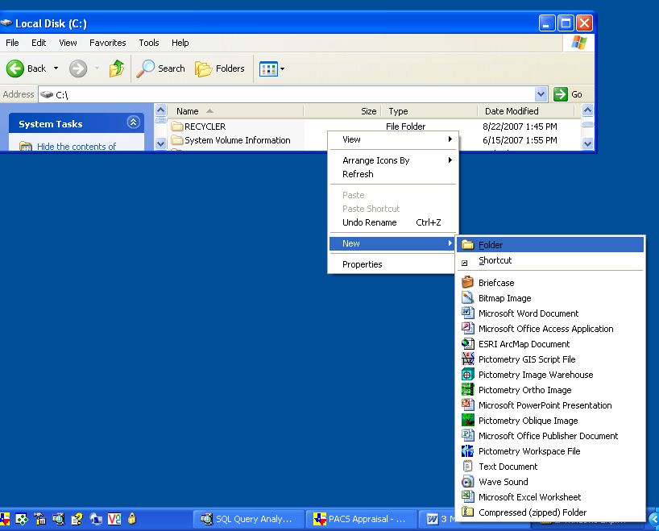

Name new folder “TCAD_DATA”
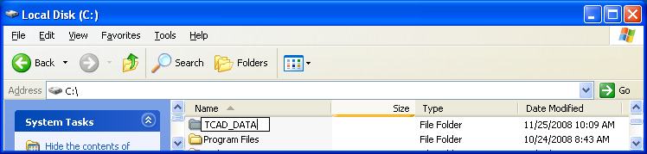

Create a second folder called TCAD_DB
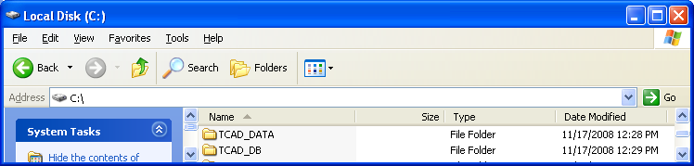

Insert CD into your CD drive, you should have the following files
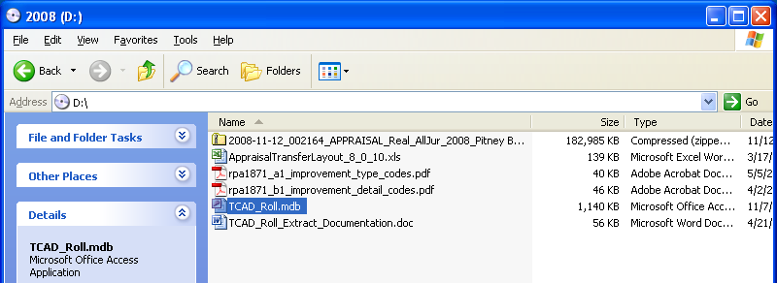

Drag and drop the TCAD_Roll.mdb file into your newly created TCAD_DB folder on your C: drive
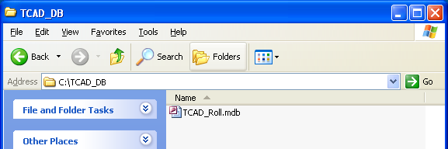

After the file is copied to the TCAD_DB folder, right click on the mdb file and select properties
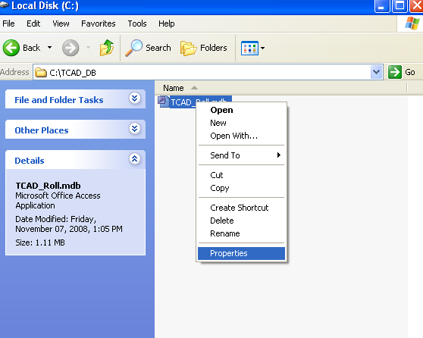

Make sure that the Read-only attribute is UNCHECKED.
“Apply to this folder, subfolders & files”
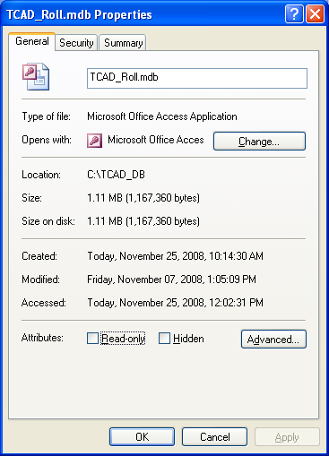

Drag and drop the zip file into your newly created TCAD_DATA folder
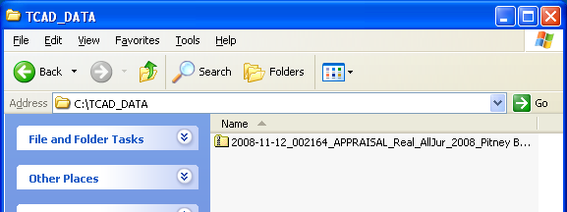

Using Microsoft Windows Compress/Extract

Right click, then Extract the zipped files to the TCAD_DATA folder
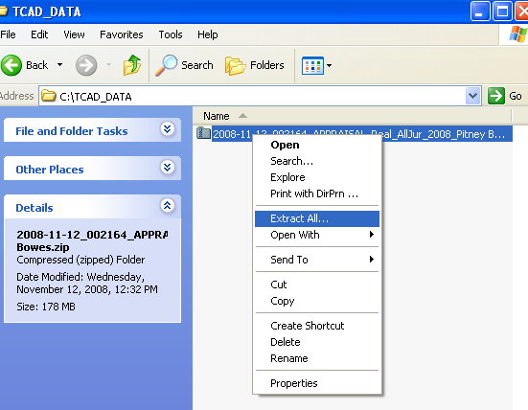

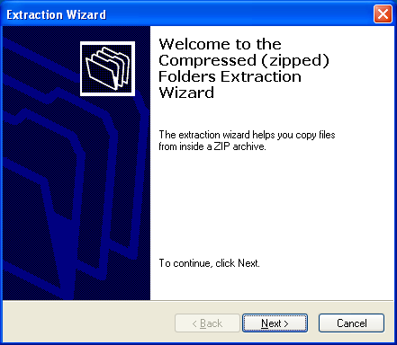

Extract to the TCAD_DATA folder
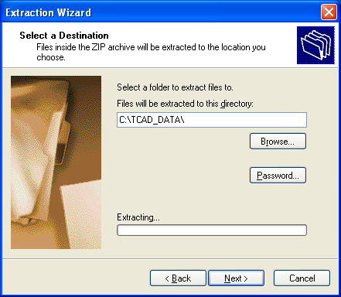

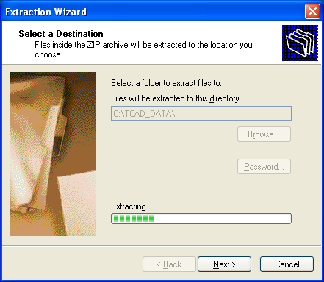

Finish
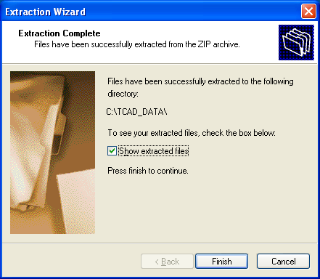

Your TCAD_DATA folder will then look like this:
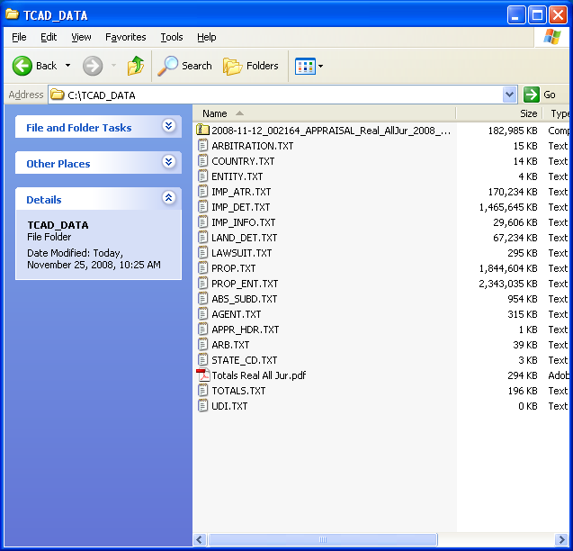
Using WinZip

Right Click and Open with WinZip
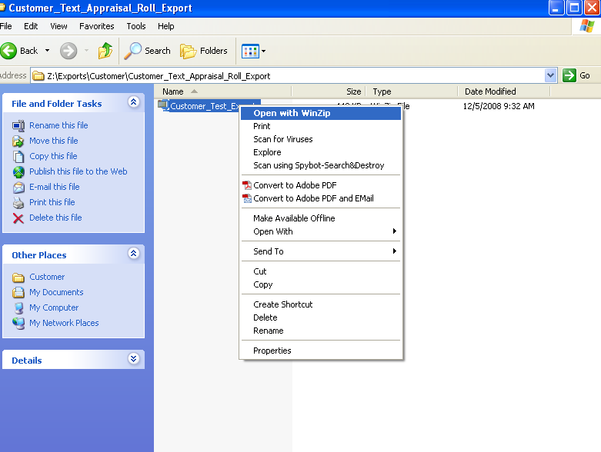

Click on Actions → Select All
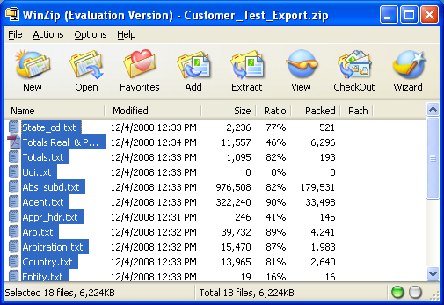
Navigate to the C:\TCAD_DATA folder, then click on EXTRACT
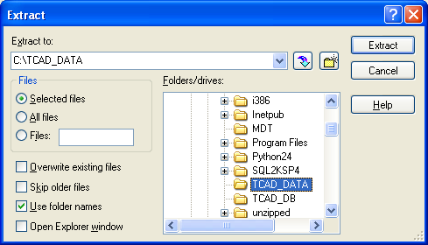

Your TCAD_DATA folder will then look like this:
Open the database
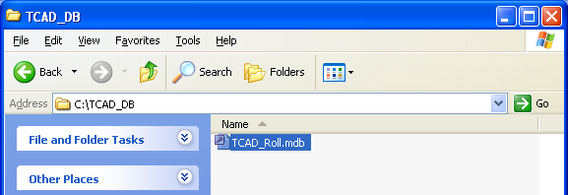

Click on close
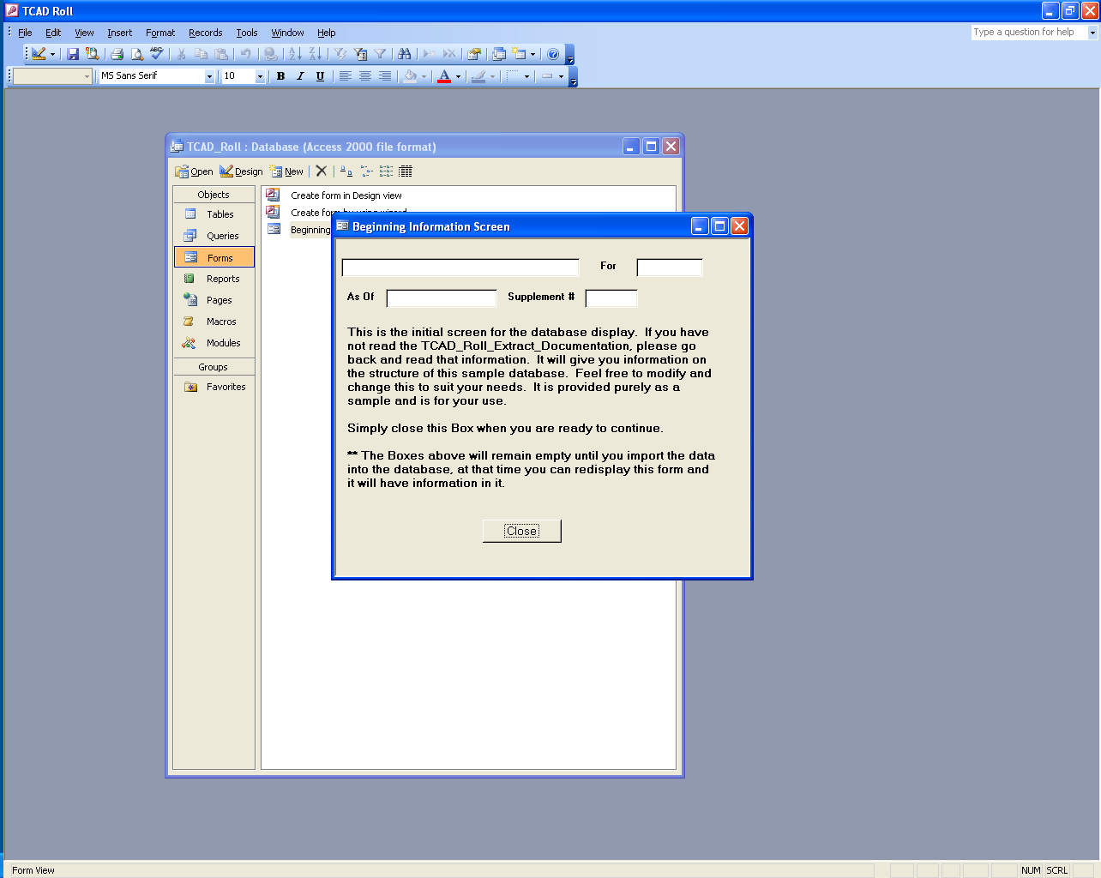
Click on the Macro tab on the left.
Double click on the M_Import_LIMITED_Table_Data

This macro will load the information that most people will use.

There are more tables associated with the database, but the size limitations of Microsoft Access limit the amount of data that can be loaded into Access. Tables that are not loaded into Access are:
AGENT.TXT
ARB.TXT
LAWSUIT.TXT
PROP_ENT.TXT
TOTALS.TXT

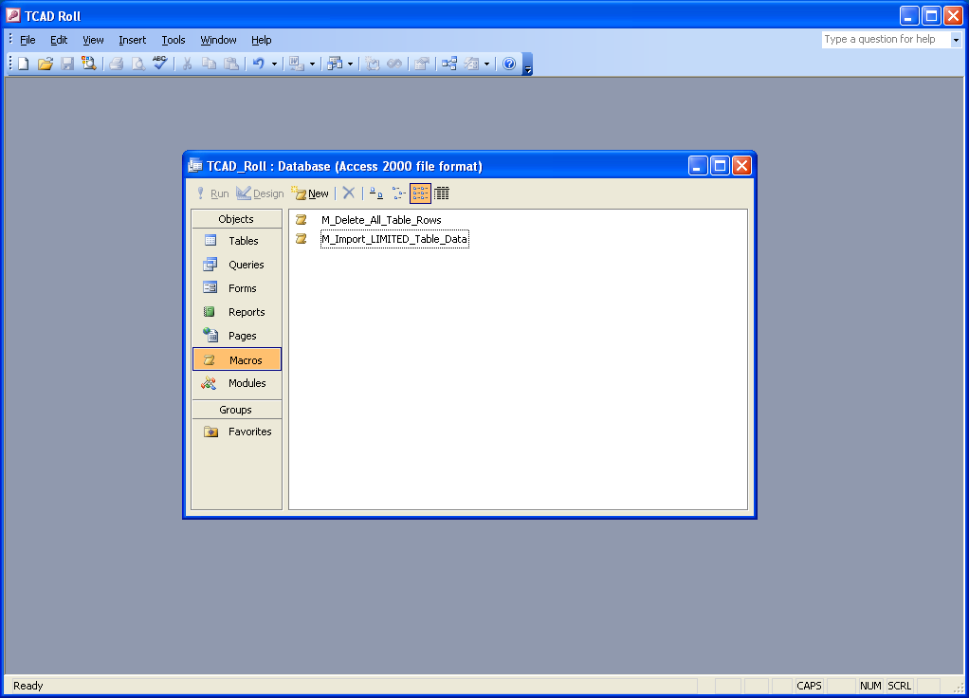

Once you click OK on this dialog box, it may take from 15 to 30 minutes to import.
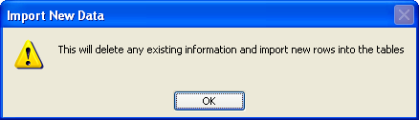

After the data is imported, the database is ready for you to query.

An example query is called: Q_Single_Family_Type_01_Addresses

If you receive an error upon trying to import new data, go to
Tools → Database Utilities → Compact and Repair Database

After this process completes, the re-run the M_Import_Limited_Table_Data

Custom Query information next page.
If you ordered a Custom Query:

Click on the Query Tab and double click on Q_CUSTOM QUERY
This will run the query to show your results. This may take a few minutes.
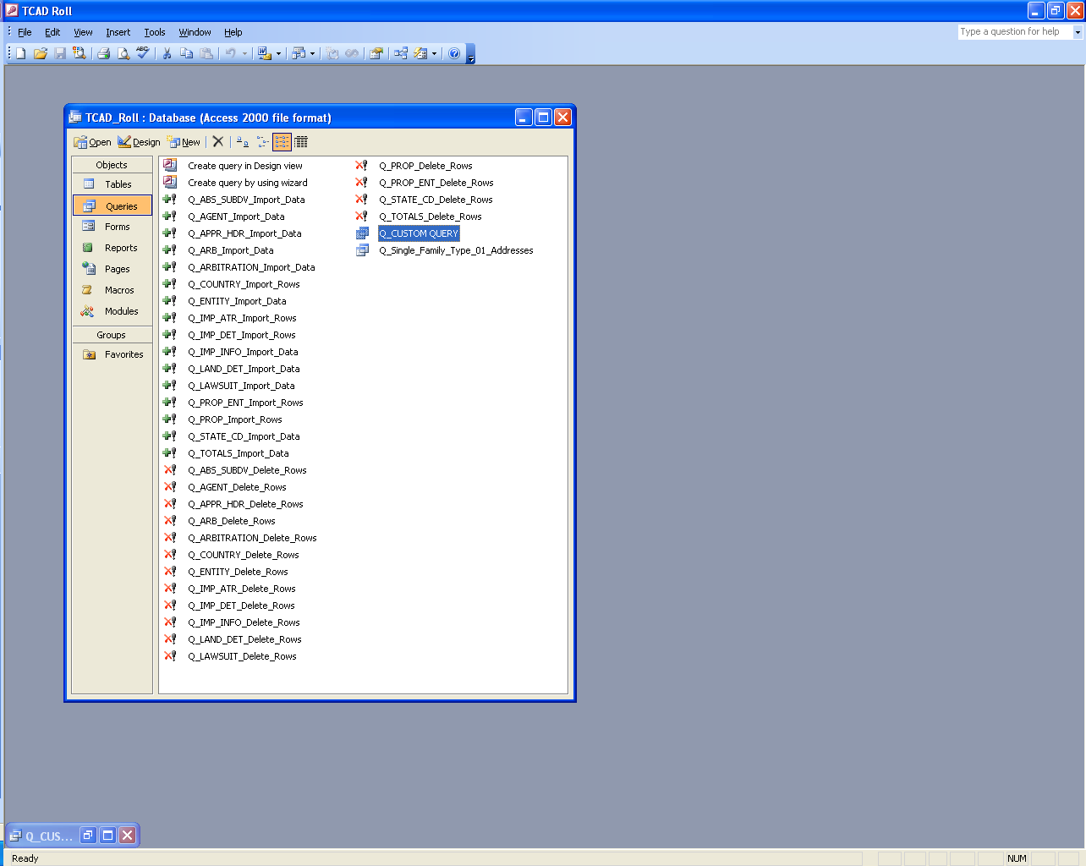

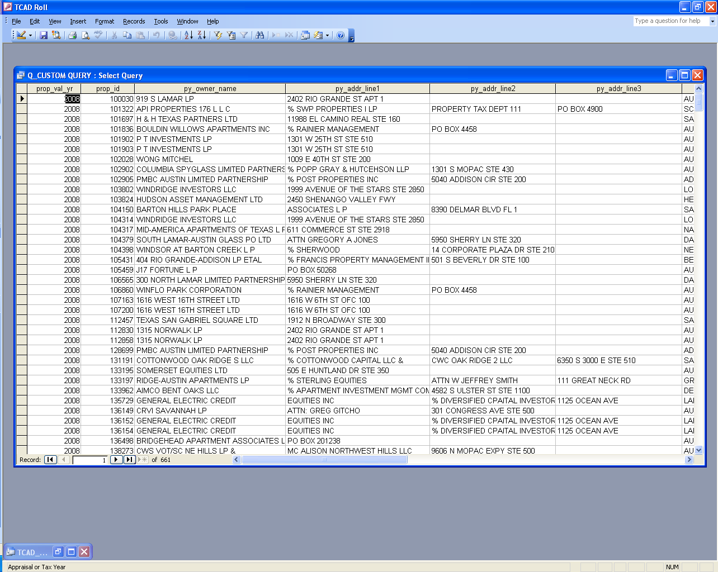
When you receive the query results you can export them to Excel:

File → Export →
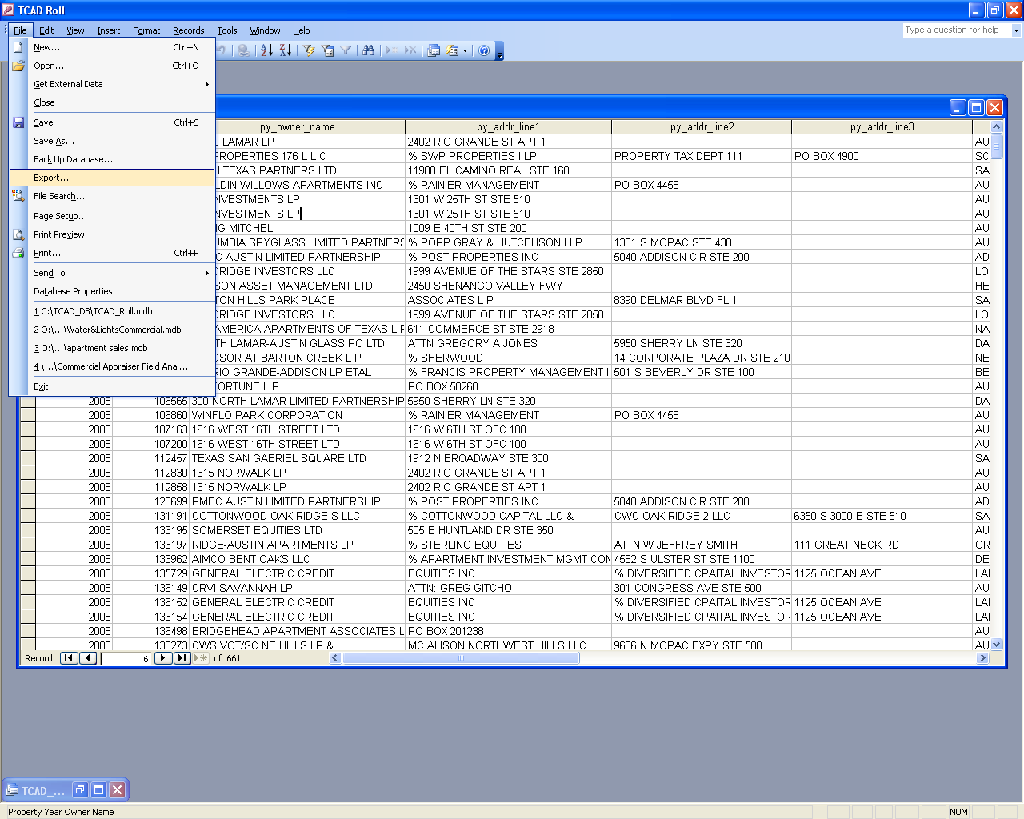

→ Save as type And select your version of Excel.
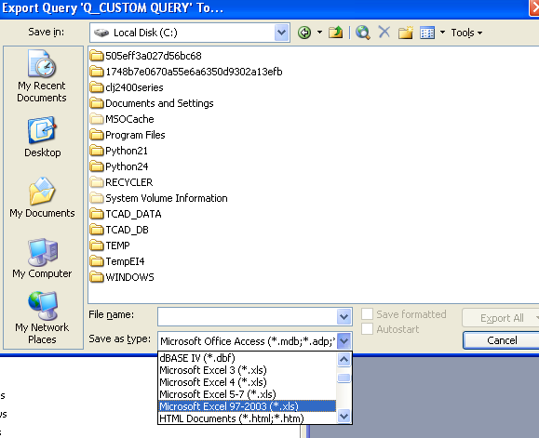
Most Common Fields that people normally want to use:
The EXCEL spreadsheet contains all of the fields. The fields are listed by file and in order of appearance.

PROP.txt
This file contains an entry for each taxable property on the system. It contains the base information about that property and will be the starting point for any processing that needs to take place. Normally you will match the records on the following fields: prop_id, prop_val_yr, sup_num. Any other matching will take place with additional fields within a specific file. Most of the matching will be a 1 to many relationship.
Prop_id Property id
Prop_type_cd Type of property R, P, MH, MN
Prop_val_yr Year of the file
Situs_street_prefx Situs information (Location of the property)
Situs_street
Situs_street_suffix
Legal_desc Legal Description
Abs_subdv_cd Code for the subdivision name in File: ABS_SUBD.txt
Hood_cd Neighborhood code for the appraisal staff’s valuation
Land_hstd_val Land homesite value (part that qualifies for homestead)
Land_non_hstd_val Land value for the rest of the land on a property
Imprv_hstd_val Improvement homesite value
Imprv_non_hstd_val Improvement rest of the value
Ag_use_val Ag use value (ag value the property is taxed on)
Ag_market Ag market value (market value of the ag land)
Appraised_val Market value – productivity loss = appraised value
Ten_percent_cap Cap adjustment value for homesteaded properties
Assessed_val Appraised value – homestead cap loss = assessed value
Deed_book_id Deed book id
Deed_book_page Deed book page
Deed_dt Deed date
Hs_exempt & others Exemption flags to indicate this property has them
Imprv_state_cd Improvement state code for highest valued improvement
Land_state_cd Land state code for highest valued land piece
Personal_state_cd Personal property state code for highest valued part
Land_acres Sum of land acres based on land segments
Entity_agent Tax Agent for the collection documents
Ca_agent Tax Agent for the appraisal district documents
Arb_agent Tax Agent for the appraisal review board documents
Dba Doing business as name field (name of business)
Market_value Sum of the market value into 1 field
Ref_id2 The old parcel number with 4 digit owner id
Situs_num Part of the situs stuff
Situs_unit
Appr_owner These fields are the current owner of the property
Sic_code Personal properties Standard Industrial code
Entities List of entity codes separated by commas (code description is in File: TOTALS.txt and has a record for each entity with a description)

PROP_ENT.txt
This file has an entry for each taxing entity on the property and the values associated with that entity. This file will take into account any % in entity that may exist on the property. This would be where a property is divided by a school district or something like that. The exemption values are also on this record.

TOTALS.txt
This file has an entry for each taxing entity on the system. The file has the totals for each entity. All of the different values are totaled on this file.

ABS_SUBDS.txt
This file has an entry for each subdivision id that is on the system. This can be used to get the subdivision name.

STATE_CD.txt
This file has an entry for each state code on the system. This code is used to define to the state the type of property. It is required on each property so the state can classify the property correctly. This file is simply a list of the codes and descriptions.

IMP_INFO.txt
This file has an entry for each improvement type that is on a property. This means that if there are 3 buildings on a property there will be 3 entries for that property id in this file.
Imprv_type_cd This is the type of building for this entry
Imprv_type_desc This is the description of the type code. This is also in the pdf file that is included on this cd
Imprv_homesite Flag to indicate a homesite improvement
Imprv_val Value of this improvement
Imprv_homesite_pct Homesite percentage in the case of duplexes, where the owner lives in part of the duplex

IMP_DET.txt
This file has an entry for each improvement detail line on an improvement. A detail line is what the appraisers use to value the property. Lines like 1st floor, porches, baths, pools, A/C, basement, etc. Each of the lines describes the building. This is where you would look for a specific detail. There are any number of detail lines associated with an improvement.
Imprv_det_type_cd Detail type code. This is the field to use based on the detail codes descriptions file (a pdf file on the cd). You can determine which codes are main areas and then sum them together to get the total square footage for an improvement.
Imprv_det_type_desc Detail type description.
Imprv_det_class_cd Detail class code describes the class of the detail line.
Yr_built Year the detail was built
Depreciation_yr Year the detail was depreciated to.
Imprv_det_area Area of details that need this field. Area to sum to get the total of the main area based on the type code.
Imprv_det_val Value of this detail.

IMP_ATR.txt
This file has an entry for each improvement attribute that a building has. This is an additional code that the appraisal staff used to help value the property. It is a field that uses a multiplier rather than a value; therefore, it does not have a value directly associated with it.

LAND_DET.txt
This file has an entry for each land record that is on the property. Most accounts have just 1 land record but some have more because they are broken up into multiple segments.
Land_type_cd This is the type of land segment that is being valued.
Land_type_desc This is the description of that land type.
Land_seg_homesite Flag to indicate a homesite land segment
Size_acres Size of this land segment, if there. Keep in mind that not all land segments have a size. A lot may or may not have a size.
Size_square_feet Size in square feet
Effective_front Frontage on the street for the segment, if used
Effective_depth Depth of the segment, if used
Land_seg_mkt_val Market value of this segment
Ag_apply Flag to indicate that ag is applied to this segment
Ag_value Ag value of this land segment
Land_homesite_pct Homesite percentage in the case of duplexes, where the owner lives in part of the duplex

AGENT.txt
This file has an entry for each tax agent that is on the system. This is the name and address of any tax agent that a property owner may have authorized to be responsible for their property. They are identified by id.

ARB.txt
This file has an entry for any protest that is currently active on the property in this file.
ARB_status This is the status of the protest. Keep in mind that if this record exists then the protest is active. If there is no record in this file, then either there was no protest or it is closed.

LAWSUIT.txt
This file has an entry for any property that is in the lawsuit process. If they currently have an active lawsuit then this file will have the property id in it.

COUNTRY.txt
This file has an entry for each abbreviation for the countries of the world in it. It will give you the country code and the name of the country. This file is used for mailing purposes.

FAQ

Just want address information based on value (both residential and commercial). You will only need the PROP.TXT table because it contains the current address info (appr_addr includes the appr_owner_name as the 1st line) and the market_value. There are multiple owner addresses in the file but the appr_addr is the current one at the time the file is created.

Just want address information and want to limit it to records that are current owner changes, then again use PROP.TXT and the deed_dt field from that file.

Just want address information and want to limit it to records that are land only type records. Again PROP.TXT file. Limit your search to real property. Look at the imprv_hstd_val and imprv_non_hstd_val and if they are both zero then you may have a land only record. However, you may also just have a record that someone has separated from their house or you may have an Ag record. To eliminate the Ag records look at the ag_use_val and ag_market and make sure they are both zero. You may still get some land that is separated from a house but there is no simple way to catch that.

Just want address information and want to limit it to single family records. This is the first one that will take more than 1 table. The PROP.TXT table for the address information and the IMP_INFO file for the imprv_type_cd. There is an Excel spreadsheet that also comes with this CD (Improvement Type Code List.xls) and from that list you can figure out what improvement types you might want to include in your process.
You can also use the state code if you want to be more general and that is also an Excel spreadsheet (PTD Codes.xls). This has some advantage in that you do not need to work with 2 tables to make this work (to some degree). The state code for the improvement is on the PROP.TXT file as imprv_state_cd. However, if the property has more than 1 improvement on it, the system will pick the highest valued improvement and use that state code on the PROP.TXT file. Therefore, if you have a single family dwelling state code and another type of improvement (different state code) that has more value, you will miss the single family dwelling.

Just want address information from a single entity (jurisdiction or taxing entity), but you ordered the entire database. Ok, the simplest way is to use the PROP.TXT file and the field called entities. This field is a list of the entity codes that are on that property and can be selected using Access for specific ones.

Just want address information for all property that have homestead exemptions. Again the PROP.TXT file and the field called hs_exempt. This will give you all of the people with homestead exemptions.

Just want address information for all of the property in a subdivision. Again the PROP.TXT file and the field called abs_subdv_cd. This field is the subdivision code and is the code for the subdivision name. This subdivision code is also in a table called ABS_SUBD.TXT. Using this table you can find in the description field the name that we have for the subdivision. Then you can use the code (same name as the one in the PROP.TXT file) and pull all of the records that have that subdivision code.

Just want address information for all of the property in a zip code. This one is much harder to accomplish. The zip code field of the appr_addr field in the PROP.TXT file has the mailing address zip code. Now, that is great but only will be useful if all of the people who are in our system are getting the mail at the address of where the property is at. This is not necessarily the case. If they are renting the property (we do not know or care if they are) then the mailing address for the tax information will probably not be the address of the property. Therefore, the mailing address zip code will not get you a letter to that property, only a letter to the owner.
Situs information may be a solution to some people’s problems with address of property. These fields (which are in the PROP.TXT file) contain the location address of the property. It does have a zip code; unfortunately we do not yet have zip codes on all of the location addresses. However, if you know the subdivisions and want to send a letter to all of the properties then you may want to combine a subdivision selection with a situs. If you can figure out where the city is (if there), then you might be able to come up with addresses for all of the properties. You need to keep in mind that for us the owner and legal are the most important parts of the mail. The situs plays in there but only for the address, not the city and zip (the name of the street is supposed to be unique within a 911 calling area).

