Corporate Social Responsibility (CSR) Data: Dataful’s Cleaning and Reconciliation Strategy

Corporate Social Responsibility (CSR) is increasingly becoming an important area of research, thereby increasing the need for granular CSR data. While the CSR portal of the Ministry of Corporate Affairs (MCA) provides CSR data, it has multiple issues as listed below. At Dataful, we realised this and have put in significant efforts to clean up, reconcile and provide accurate data.

Managing CSR filing data accurately is challenging because company information changes over time. As businesses grow, restructure, merge, or undergo changes in their legal status, their corporate identities may also change. If these changes are not properly accounted for, they can result in duplicate records and an inaccurate representation of unique companies.

Since there is no authoritative source that provides an exhaustive list of unique companies that have filed CSR reports, Dataful follows a systematic approach to identify and eliminate such duplications. By tracking corporate events—such as changes in business status, mergers, demergers, and other legal restructurings—Dataful reconciles historical records to create a consistent and reliable view of companies across time.

The sections below explain the methodology used to resolve these duplications.

Before discussing the approach, it is important to understand the circumstances under which a company's Corporate Identification Number (CIN) changes, as the CIN forms the basis for identifying and tracking legal entities over time.

When Does a Company's Corporate Identification Number (CIN) Change?
A CIN is a unique 21-character alphanumeric identifier assigned by the Ministry of Corporate Affairs (MCA) at the time of a company's incorporation. The CIN encodes information such as the company's listing status, industry classification (NIC), state of registration, year of incorporation, ownership type, and registration number. While a CIN generally remains unchanged throughout the life of a company, certain statutory changes require the MCA to issue a modified CIN.

The following events result in a change to a company's CIN:

1. Change in Listing Status
When an unlisted company becomes listed, or a listed company is delisted, the 1st character of the CIN changes from U (Unlisted) to L (Listed) or vice versa. This change is reflected by the MCA after the applicable listing or delisting process is completed under the relevant securities regulations.

2. Change in Registered Office from One State to Another
If a company shifts its registered office from one state to another, the state code in the CIN changes. Such a shift requires compliance with Section 13 of the Companies Act, 2013, including approval of the Regional Director and filing the prescribed forms under the Companies (Incorporation) Rules, 2014.

3. Conversion Between Private and Public Company
When a company converts from a private company to a public company, or vice versa, the company type component of its Corporate Identification Number (CIN) is updated to reflect the new legal classification. The conversion is governed by Section 14 of the Companies Act, 2013 and requires the issuance of a fresh Certificate of Incorporation by the Registrar of Companies.

4. Change in Principal Business Activity
If a company changes its principal business activity and the Ministry of Corporate Affairs (MCA) updates the corresponding National Industrial Classification (NIC) code, the Corporate Identification Number (CIN) is updated to reflect the revised business classification. However, a change in the company's object clause alone does not necessarily result in a change to the CIN unless the MCA also updates the company's principal business classification.

Changes That Do Not Result in a New CIN
The following corporate events do not alter a company's CIN:
- Change in company name (Section 13 of the Companies Act, 2013)
- Change in directors or key managerial personnel
- Increase or decrease in authorised or paid-up share capital
- Change in shareholding pattern
- Relocation of the registered office within the same state

Compliance Note: Under Section 12(3) of the Companies Act, 2013, every company is required to display its CIN on prescribed business letters, notices, official publications, invoices, letterheads, and other statutory documents. Whenever a CIN changes, companies should update their statutory records and notify relevant authorities and stakeholders to maintain regulatory compliance.

Dataful’s Data Cleaning Strategy

Dataful addresses duplication found in the official portal through several methods:

- Market Listing Reconciliation: The system identifies and merges records when a company’s listing status changes to ensure continuity

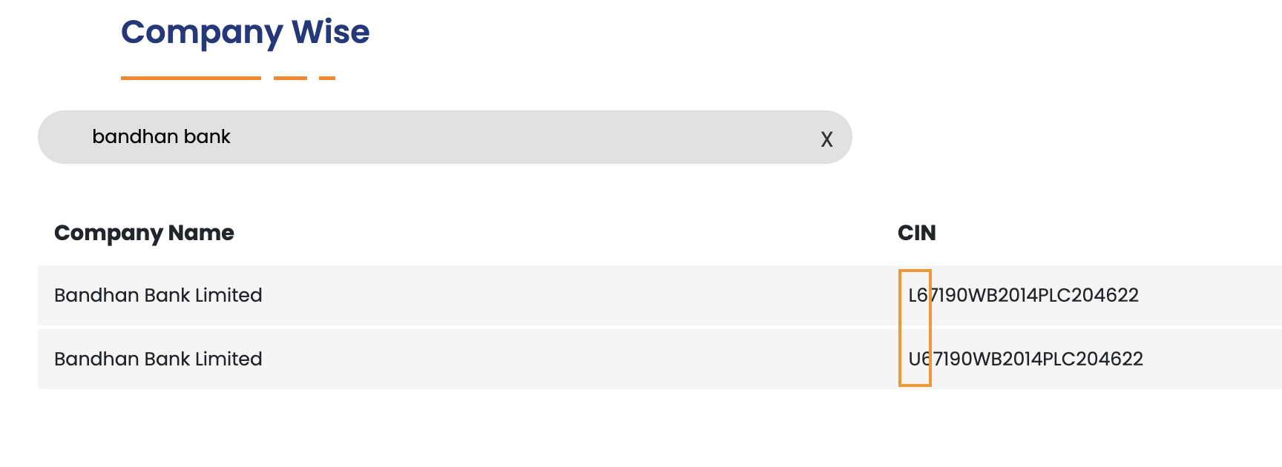
image_1: Repetition of Listed and Unlisted Entity

- Standardization: Dataful cleans unstructured or inconsistently formatted names to prevent duplicate entries, which are otherwise treated as separate entities on the CSR portal.
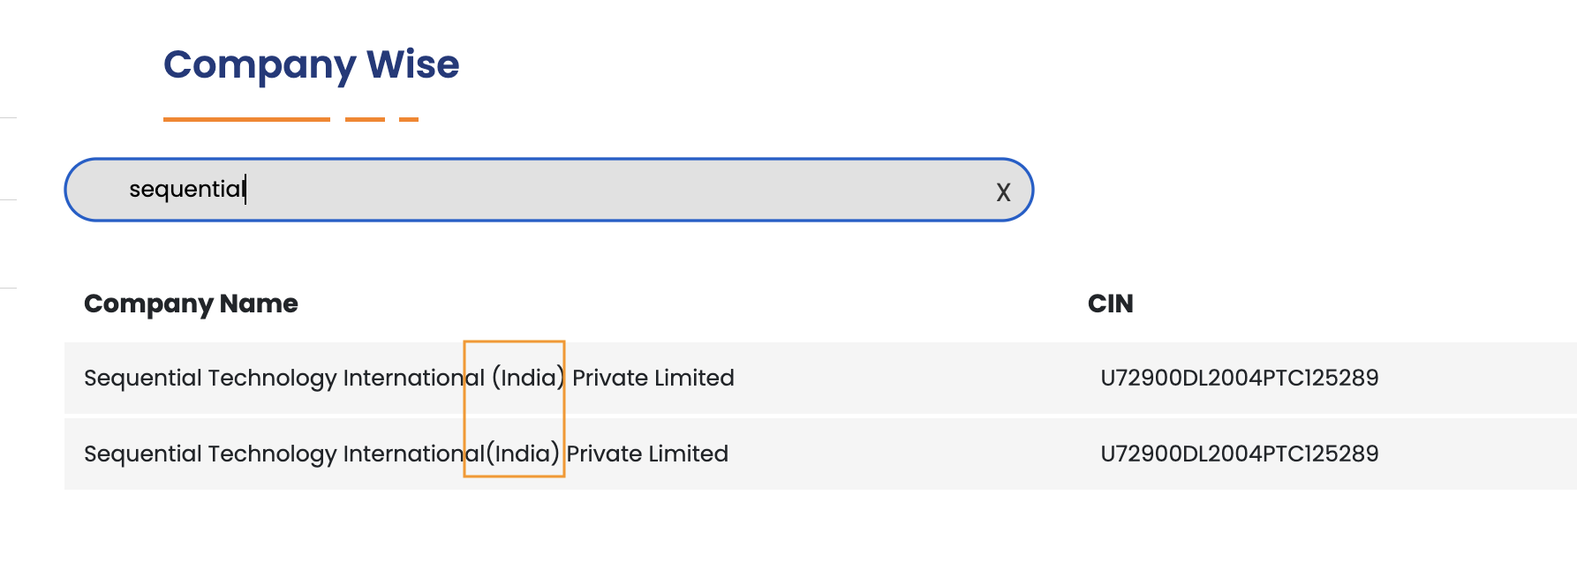

image_2: unstructured company name

- Entity Normalisation: Variations of the same company name (e.g., full versions vs. abbreviated versions) are grouped together as a single entity, to resolve duplicate entries in the CSR portal.

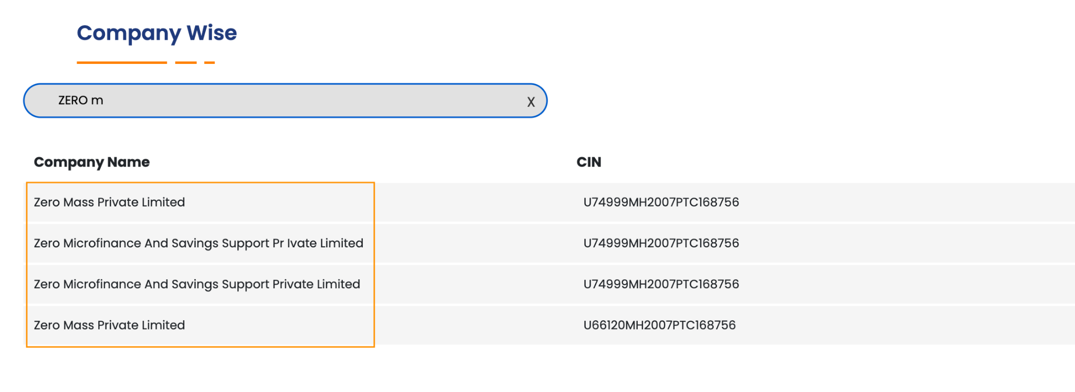
image_3: Zero Mass Private Limited was once again repeated with is full form Zero Microfinance And Savings Support Private Limited

- Merger Management:

- for merged companies: Dataful retains them as a single entity, i.e., after the merger, all historical and future data is associated with the successor company name.

For example, Bharti Infratel Limited officially merged with Indus Towers Limited on 19 November 2020. CSR data on Dataful includes only Indus Towers Limited throughout the historical data since Bharti Infratel Limited is redundant and does not exist anymore.

However, the official source reports data separately for both Bharti Infratel Limited and Indus Towers Limited, which can lead to duplication if they are not treated as a single entity throughout the entire time series.

- for demerged companies: Dataful retains them as separate entities, i.e., after the demerger, all future data is mentioned separately for both from the year of demerger

