SOWEASY + BUDDYBURST / TECHNICAL PROPOSAL
How it all works — the complete picture
Revised proposal, updated pricing, and a step-by-step map of every integration: Odoo, WooCommerce, and the product visualiser.

SECTION 1

Revised Proposal — Both Sites, £5,000
We understand the grant timeline is months away. So here's a payment structure that lets you start now without waiting for anything.

£5,000 total. Both sites. Done.
SowEasy stays on WordPress — we optimise, clean up, and properly integrate it. BuddyBurst goes on Commerceflo. Both live. Both working.

£3,000  On agreement — to kick off |  | £700  Month 1 — mid-build |  | £700  Month 2 — nearing delivery |  | £600  Month 3 — on go-live

And if the £700/£700/£600 schedule doesn't work right now — simply pay us the remaining £2,000 when your grant lands. No timeline pressure, no interest, no awkwardness. We'd rather you have a working system generating orders than wait months for a grant cycle. We're not going anywhere.

SowEasy — what stays  ✓ WordPress + WooCommerce (no migration)  ✓ All 700–800 existing trade accounts  ✓ Current product catalogue and content  ✓ Marketing Hub (file library — extended, not replaced)  ✓ Odoo as your ERP (finance, inventory, orders)  ✓ Domain, hosting, DNS — untouched  ✓ Login-gated trade portal structure |  | SowEasy — what we add  → Odoo ↔ WooCommerce live sync (orders, stock, customers)  → Customer-specific 3-tier B2B pricing via pricelists  → Product visualiser — logo-on-product preview  → Artwork upload at checkout (optional at launch)  → Online order flow (qty → address → date → submit)  → Net terms checkout — no online payment required  → Order confirmation + status visible to trade customer

SECTION 2

Odoo ↔ WooCommerce — How the Integration Actually Works
We use a proven, production-grade connector (Emipro's WooCommerce Odoo Connector, live since 2013, 10,000+ customers). Here is exactly what it does — nothing fabricated, sourced directly from the connector's documentation.

🛒  WooCommerce (SowEasy front end)  Your trade portal. Customers log in, browse, configure orders, and submit. WooCommerce stores the order and fires a webhook the moment it's placed. |  | ⚙️  Emipro Odoo WooCommerce Connector  Installed in Odoo. Acts as the bridge. Uses WooCommerce REST API credentials + webhook listeners. Syncs in both directions via queue system with error logs.
📦  Odoo (your ERP — stays as-is)  Finance, inventory, sales orders, warehouse — nothing changes in how Jeremy and your team use Odoo day to day. Orders simply appear as Sales Orders automatically. |  | 🔄  Webhook + Cron Jobs  Real-time order import via webhooks. Stock and product updates run on configurable schedules. Queue dashboard shows any failures with root-cause logs.

WHAT SYNCS — AND IN WHICH DIRECTION

DATA | DIRECTION | HOW | NOTES FOR SOWEASY
New Orders | WooCommerce → Odoo | Webhook (real-time) | Creates Sales Order in Odoo. Status: Processing or On Hold imported. Net terms — no payment gateway needed.
Order Status Updates | Odoo → WooCommerce | Manual / cron | When you mark dispatched in Odoo, status pushes back to WooCommerce so the customer can see it.
Tracking Numbers | Odoo → WooCommerce | Automatic | Export tracking numbers back to WooCommerce order — customer gets notification.
Stock Levels | Odoo → WooCommerce | Cron job (scheduled) | Odoo is master of stock. WooCommerce reflects it. Note: SowEasy currently hides stock — this remains optional/off.
Products + Variants | Both ways | Manual export / import | Matched by Internal Reference (Odoo) = SKU (WooCommerce). One-time setup, then maintained from Odoo.
Pricing (B2B tiers) | Odoo → WooCommerce | Pricelists | Each trade account gets a pricelist in Odoo. The connector pushes the right price per account to WooCommerce. This is how your 3-tier pricing works online.
Customer Data | Both ways | Import / sync | Existing 700–800 accounts: we import WooCommerce customers into Odoo and link them. New registrations sync automatically.
Refunds / Cancellations | Both ways | Webhook | Cancel in Odoo → cancels in WooCommerce (and vice versa). Credit notes generated correctly in Odoo accounting.

Honest constraints — what the connector does not do out of the box
⚠ Automated PO email reading into Odoo — this is a separate AI agent feature, not part of the connector. Jeremy at Amarot tried this; we'd build it differently using structured parsing, not open-ended AI. Scope for a later phase.
⚠ Artwork proof approval workflow — the connector handles orders; proof rounds need a separate approval flow (email-based or a simple portal page). We keep this lightweight at launch.
⚠ Real-time stock display on SowEasy — you've deliberately hidden stock levels. We keep this off. Connector only pushes stock to Odoo when orders land.
⚠ Odoo Online (cloud) is not supported — connector requires Odoo On-Premise or Odoo.sh. Your current setup with Jeremy should confirm which you're on.

SECTION 3

End-to-End Customer Journey — Order Flow
What your trade customers experience, and what happens in the background at each step.

1 |  | Distributor logs in to SowEasy  Existing WooCommerce B2B login. Their account is already linked to an Odoo customer record and a pricelist. No new credentials needed.  CUSTOMER ACTION WOOCOMMERCE

2 |  | Browses catalogue — sees their specific pricing  WooCommerce displays prices from the Odoo pricelist assigned to their account. A small distributor sees distributor pricing. Volume accounts see their tier. Handled by the connector's pricelist mapping — no custom code required.  CUSTOMER ACTION ODOO PRICELIST

3 |  | Uploads logo — sees it on the product instantly  On the product page, a "Customise this product" panel appears (powered by the DynamicMockups WordPress plugin). Customer uploads their logo or artwork. The plugin calls the DynamicMockups API, renders the logo onto the product mockup template, and shows a preview within seconds. No page reload.  CUSTOMER ACTION DYNAMICMOCKUPS

4 |  | Selects quantity, adds to cart  Cart stores: product SKU, quantity, artwork file reference, rendered mockup image. No payment details entered — this is a trade order on net terms.  CUSTOMER ACTION WOOCOMMERCE CART

5 |  | Checkout — delivery address + required date  Standard WooCommerce checkout, simplified. Fields: delivery address, required-by date, any notes. Payment method = "Invoice / Net Terms" (no card, no PayPal). Customer clicks Submit Order.  CUSTOMER ACTION WOOCOMMERCE CHECKOUT

6 |  | WooCommerce fires a webhook — order lands in Odoo  The moment the order is submitted, WooCommerce sends a webhook to Odoo. The connector creates a Sales Order automatically — customer, products, quantities, delivery address, required date, notes, artwork file link. Your team sees it in Odoo within seconds. No email, no manual entry.  AUTOMATIC ODOO SALES ORDER CREATED

7 |  | Your team processes the order in Odoo (as normal)  Odoo SO → confirm → pick/pack/ship. If artwork approval is needed, you email the proof as you do today — or at a later phase we add a portal page for digital sign-off. Tracking number entered in Odoo delivery.  YOUR TEAM IN ODOO

8 |  | Tracking number syncs back — customer sees status  When you mark the Odoo delivery as done and enter a tracking number, the connector pushes that back to WooCommerce. The customer's order page on SowEasy shows "Dispatched" with the tracking number. Automatic email notification to the customer.  AUTOMATIC WOOCOMMERCE ORDER UPDATED CUSTOMER NOTIFIED

SECTION 4

Product Visualiser — How DynamicMockups Works
This is the part Jamie asked about most specifically. Here is exactly what the tool does, what its WordPress plugin covers, and what the API does behind the scenes. Nothing invented here — this comes directly from DynamicMockups' own documentation at docs.dynamicmockups.com.

🖼️  What you set up once (admin)  For each product — Seedstick pack, seed packet, branded pot — you create one mockup template in the DynamicMockups web app. Upload a PSD or choose from 1,000+ library templates. Define the "print area" (where logos go). Assign it to the WooCommerce product. Done. |  | 🔌  WordPress Plugin (free, from WordPress repo)  Install "Dynamic Mockups" from the WordPress plugin repository. Connect to your DynamicMockups account. Plugin adds a "Create Mockups" button to each WooCommerce product. Also enables customer-facing personalisation on the product page. Tracks personalised orders in the WooCommerce order panel — "View Mockup" and "Download Print File" links per order line.

SCREENSHOT — PLUGIN ADMIN PANEL  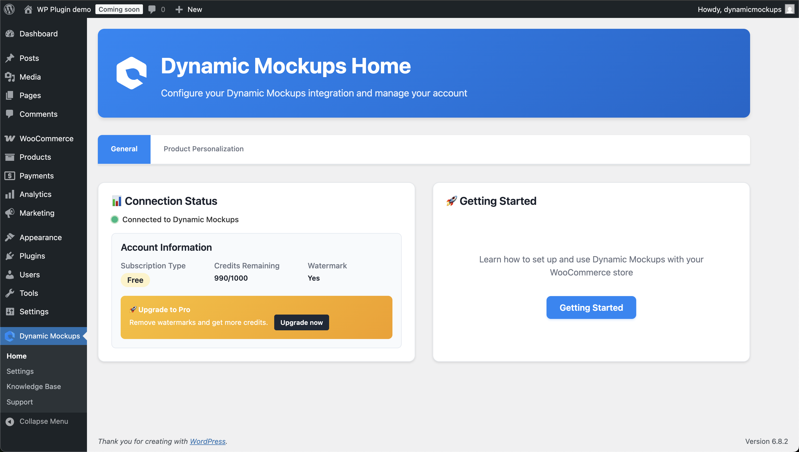  The Dynamic Mockups panel inside WordPress — once connected, shows your account status, remaining render credits, and access to General and Product Personalization settings. |  | SCREENSHOT — WOOCOMMERCE PRODUCT EDITOR  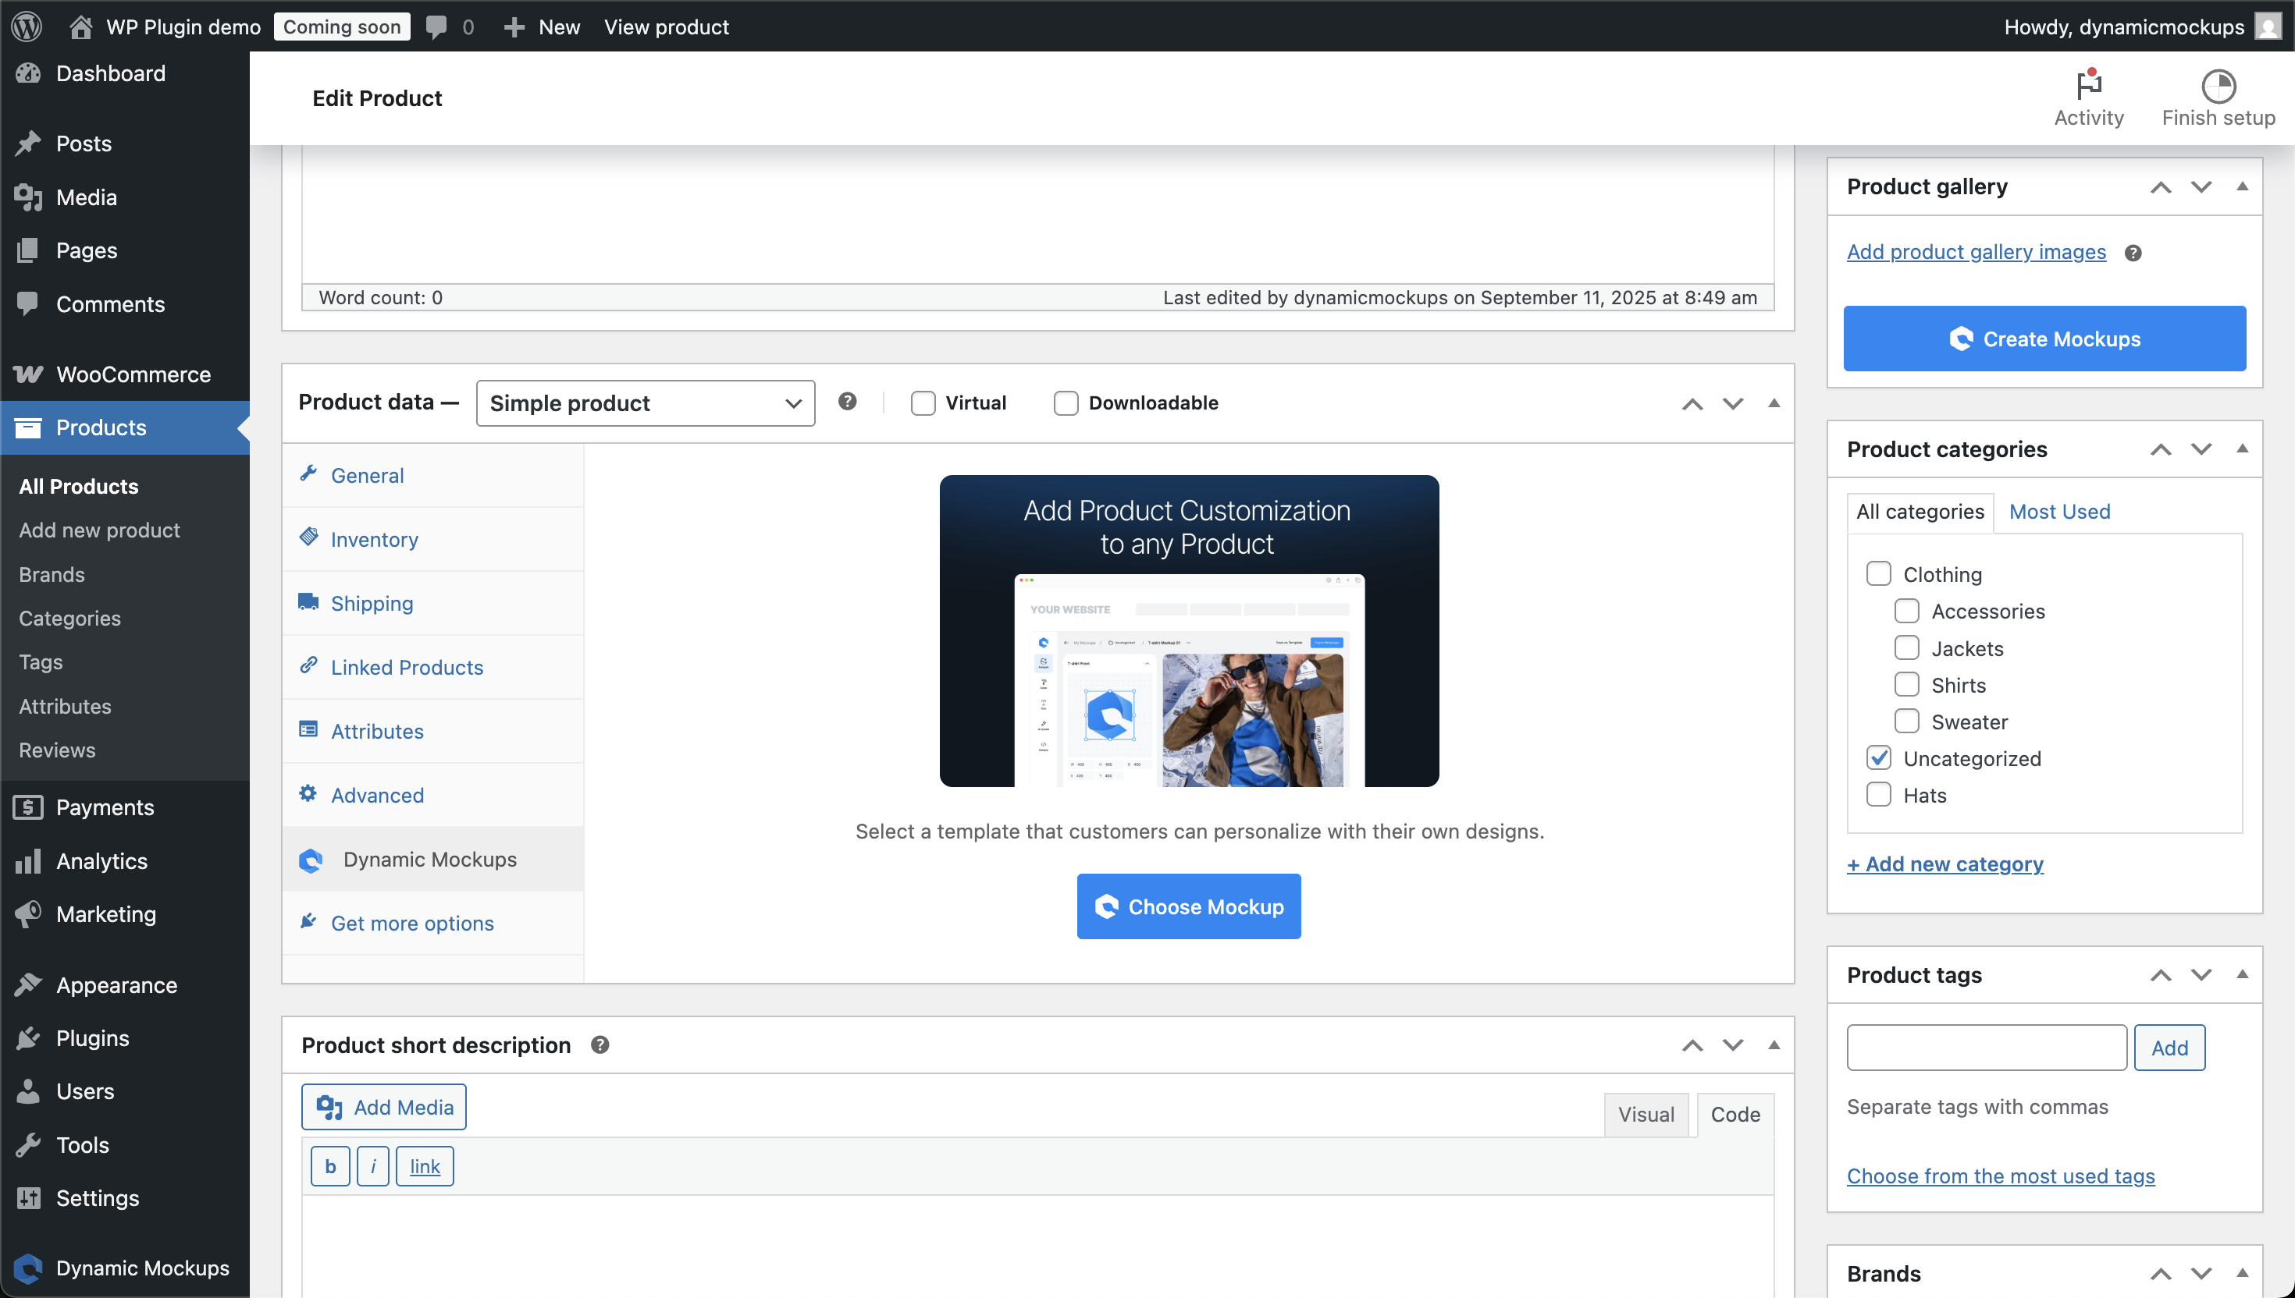  Inside the WooCommerce product editor — the Dynamic Mockups tab lets you assign a template to the product and enable customer personalisation with one click.

WHAT HAPPENS WHEN A CUSTOMER UPLOADS THEIR LOGO

1. Customer uploads logo on product page
PNG, JPG, or WebP. The DynamicMockups WordPress plugin handles the upload UI directly on the WooCommerce product page. No redirect, no third-party site.
2. Plugin calls the DynamicMockups Render API
A POST request to https://app.dynamicmockups.com/api/v1/renders is sent with the mockup template UUID (the product's template) and the customer's uploaded artwork URL. Takes under 2 seconds in normal conditions.
3. API renders the image and returns a URL
DynamicMockups Photoshop rendering engine places the logo into the print area on the product mockup, applies blending and positioning, and returns a URL of the rendered image. Output: PNG (default), JPG, or WebP. High resolution.
4. Customer sees the rendered preview — live on the page
The plugin displays the returned image on the product page. No page reload. Customer sees their logo on the Seedstick pack (or whatever product). They can re-upload a different logo, see the new preview, then proceed to cart.
5. Cart stores the personalised product + print file
The customised design is attached to the cart item. When the order is placed, WooCommerce stores both the rendered mockup image and the original print-ready file with the order.
6. Your team downloads the print file from the WooCommerce order
In the WooCommerce order panel, each personalised line item shows two links: "View Mockup" (the preview image) and "Download Print File" (the print-ready file). No more chasing artwork files on sub-£250 orders.

SCREENSHOT — MOCKUP TEMPLATE LIBRARY  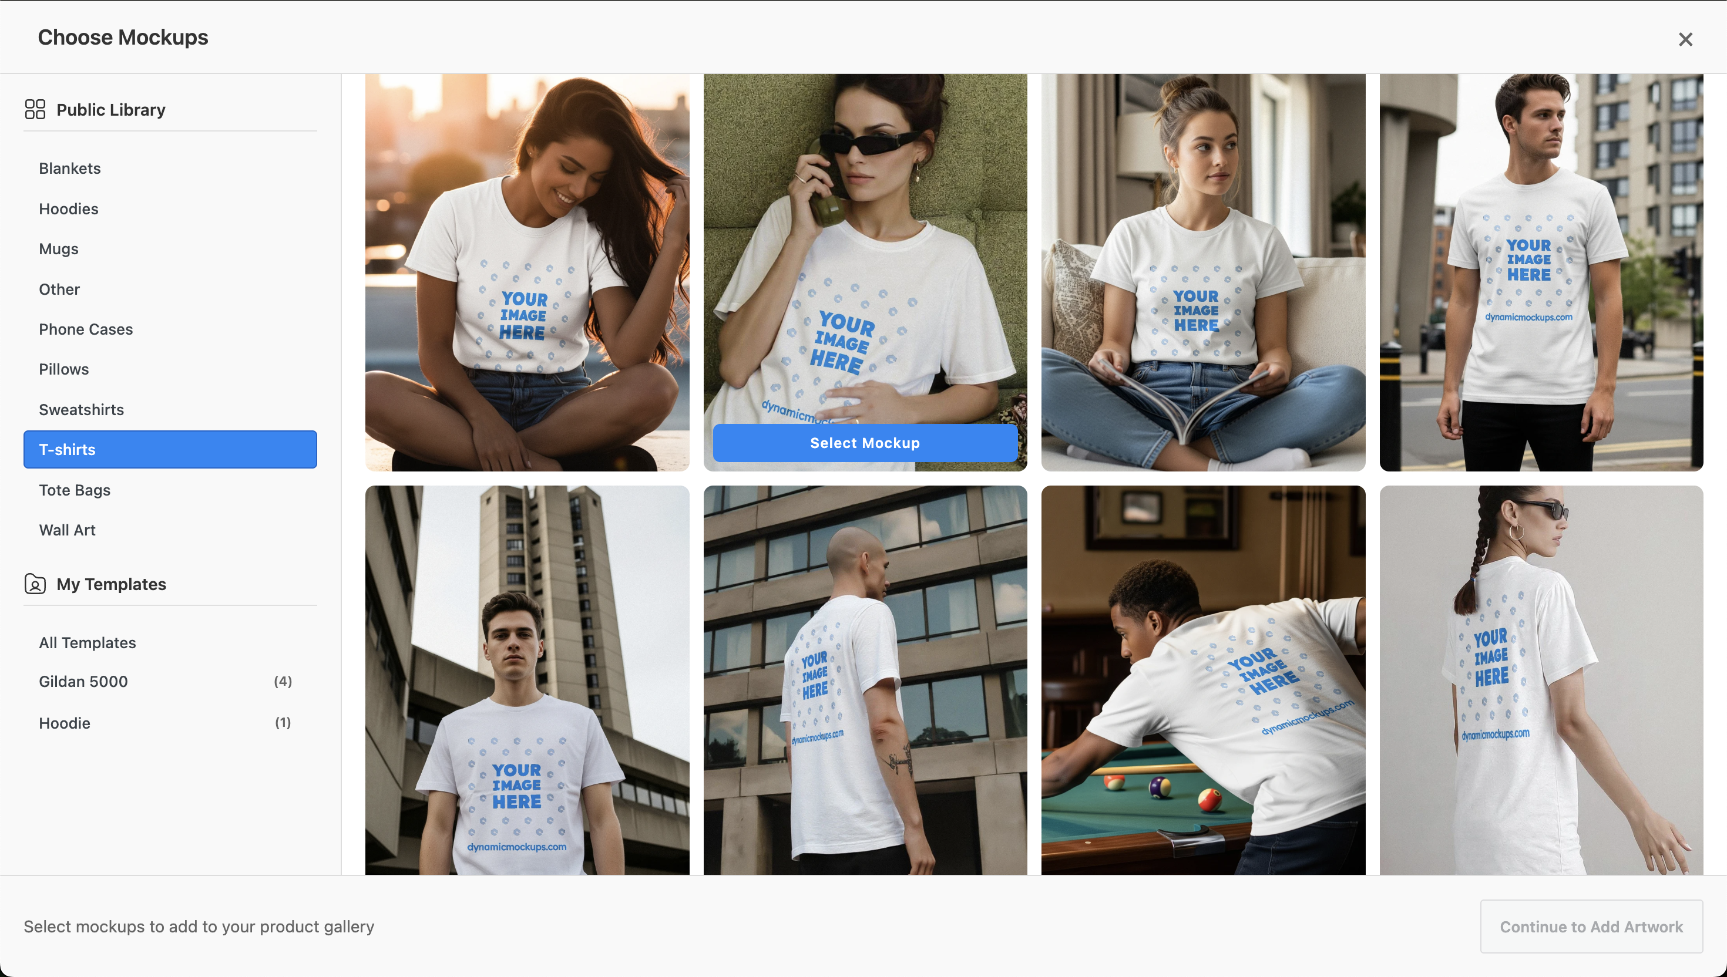  The template picker — 1,000+ professional templates organised by category (blankets, hoodies, mugs, tote bags, etc.). Admin picks one template per product. Customers see their logo on that template instantly. |  | SCREENSHOT — PERSONALISATION SETTINGS  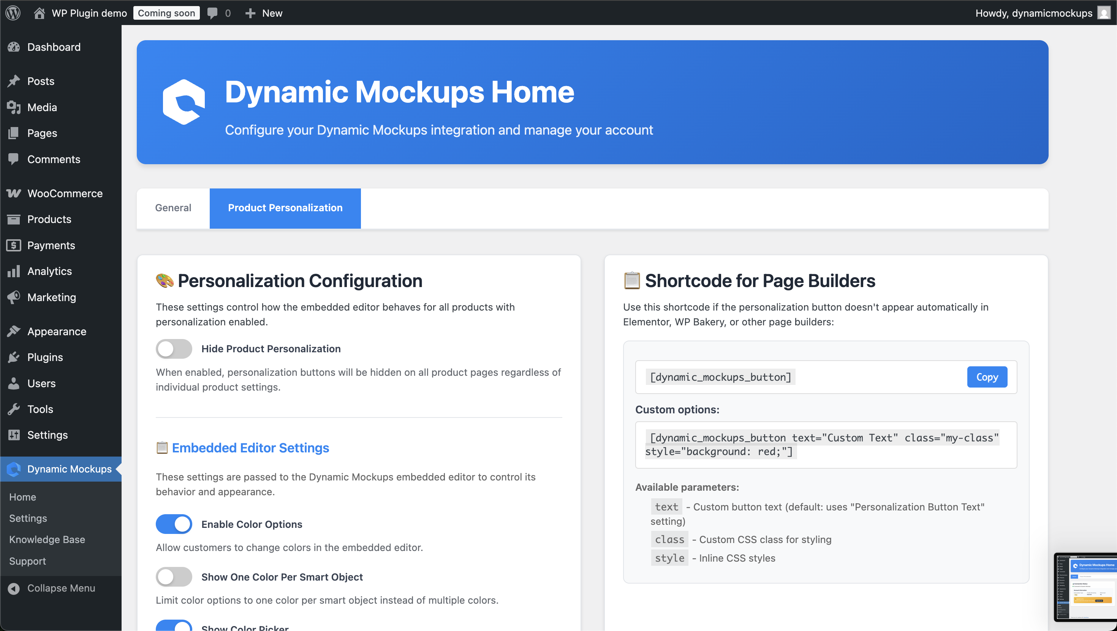  Personalization Configuration — per-product toggles, embedded editor settings (colour options, placement controls), and a shortcode for custom button placement in any page builder.

THE API CALL — WHAT IT LOOKS LIKE
// POST https://app.dynamicmockups.com/api/v1/renders
// This fires when a customer uploads their logo on SowEasy
{
"mockup_uuid": "[your-seedstick-template-uuid]", // set up once per product
"export_options": { "image_format": "png", "image_size": 1200 },
"smart_objects": [{ "uuid": "[print-area-uuid]",
"asset": { "url": "https://soweasy.com/uploads/logo.png", "fit": "contain" }
}]
}
// Response: { "data": { "export_path": "https://...rendered.png" }, "success": true }

DynamicMockups — what to know before you commit
⚠ Free plan: 50 renders. For a live trade store, you need a PRO plan (~$19/month). Included in our scope — we set this up for you.
⚠ The plugin produces a lifestyle-style preview (logo on product in a scene). It does not generate a print-ready press file from scratch — that's a different tool (like Zakeke). For sub-£250 self-service orders, a clean visual preview + the customer's original artwork file is all your print team needs.
⚠ Print-ready export: DynamicMockups does have a Render Print Files API (separate endpoint). We can enable this for orders that need a pre-masked print file. Worth discussing in the build phase.
⚠ Custom PSD templates: you can upload your own product PSDs (Seedstick pack artwork, branded pot artwork etc). Takes about 30 minutes per product template to set up.

SECTION 5

User Stories
Plain language — what each type of user gets from this build.

AS A SMALL TRADE DISTRIBUTOR (SUB-£250 ORDER)
I want to order branded Seedstick packs online without emailing anyone
I log into SowEasy, see my pricing, upload my logo, see it on the product, select quantity and delivery date, and submit. I get a confirmation email. I can track my order status. I don't have to wait for a quote email or chase anyone.

AS EMMA OR YOUR INTERNAL TEAM
I want sub-£250 orders to arrive in Odoo automatically so I don't have to type them in
When a trade customer submits an order on SowEasy, it appears as a Sales Order in Odoo within seconds. All the details are there — customer, products, quantities, delivery address, date needed, and a link to the artwork file. I confirm, pick, pack, ship. When I enter the tracking number in Odoo, the customer's SowEasy order updates automatically.

AS JAMIE (BUSINESS OWNER)
I want to know that Odoo stays as our system of record and nothing breaks
Odoo handles finance, inventory, and sales orders exactly as it does today. The WooCommerce connector pushes online orders in — Jeremy doesn't need to change how he works. Pricing lives in Odoo pricelists, stock lives in Odoo, and the connector keeps WooCommerce in sync. SowEasy is the front door; Odoo is still the business brain.

AS A LARGE CORPORATE MERCHANDISER (£20K+ ORDERS)
I don't use the online portal — and that's fine
These accounts stay manually serviced, handled offline. The portal is built for the 67 accounts below £250 per order, not for your white-glove top clients. Nothing about this build disrupts how you serve them.

SECTION 6

Delivery — What Happens When

PHASE | WHAT WE DELIVER | WHEN
Setup + Connector | Install Emipro WooCommerce Odoo Connector. Configure API credentials, map warehouses, map payment methods (net terms). Import existing WooCommerce customers into Odoo and link accounts. Set up pricelist mapping for existing B2B tiers. | Weeks 1–2
Products + Pricing | Match existing WooCommerce products to Odoo by SKU. Export pricing from Odoo pricelists. Test that logged-in distributor accounts see correct pricing on SowEasy. Validate order import via test orders. | Weeks 2–3
DynamicMockups Visualiser | Install WordPress plugin. Build mockup templates for priority products (start with top 5 SKUs by order volume). Configure print areas. Enable logo upload on product pages. Test full loop: upload → preview → add to cart → order stored with print file. | Weeks 3–4
Checkout + Order Flow | Configure net terms checkout. Delivery address + required-by date fields. Order confirmation emails. End-to-end test: order placed on SowEasy → Sales Order in Odoo → tracking pushed back → customer notified. | Week 4
BuddyBurst on Commerceflo | Parallel build: BuddyBurst as a DTC transactional site — samples, artwork upload, order placement, proof approval, order tracking. Built on Commerceflo. Separate to SowEasy. | Weeks 3–6
Testing + Handover | UAT with your team. Fixes. Documentation of how to add new products to the visualiser, how to manage the connector queue, what to do if a sync fails. Go live. | Week 6–7

ONE THING WE NEED FROM YOU TO START
Confirm which version of Odoo you're on (On-Premise or Odoo.sh) and that Jeremy is okay with us configuring the connector from the Odoo side. That's it. Everything else we handle.

