NUTUS USER MANUAL

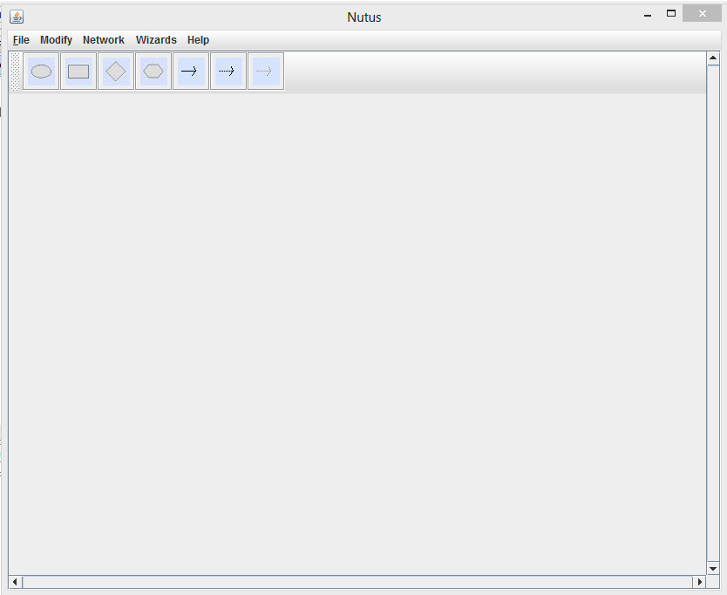
Chance Node
Model Update Link
Main Menu
Figure 1. Netus main window

1. Creating a basic Influence Diagram (ID).

Steps.
        - Add required nodes to the main window.
        - Update the states of nodes:
          - Right the node, select “properties”
          - Select the node type
          - Select the horizon
          - Enter the name of the node
          - Enter the states of the node
          - Click “Ok”

        - Create appropriate links between nodes:
          - Add a link node
          - Right the link node, select “properties”
          - Follow the on-screen instruction to create link

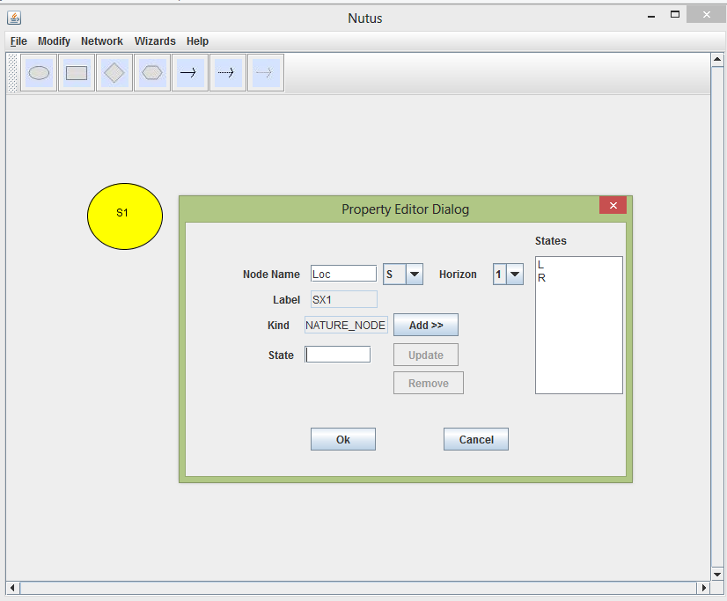
Chance node
Enter state and press “Enter key” or click “Add”
Figure 2. Shows the Property Editor Dialog for updating a node and its states.

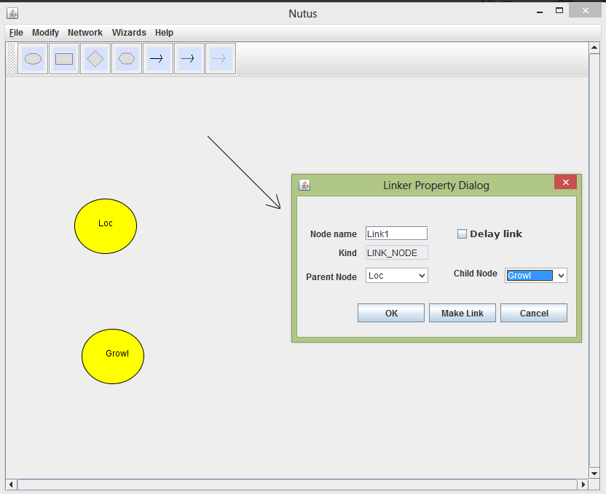
Figure 3. Shows the Linker Property Dialog for creating links. This display shows creating a link from the “Loc” node to “Growl” node.
        - Repeat the necessary steps to create the ID as shown in figure 4 below.

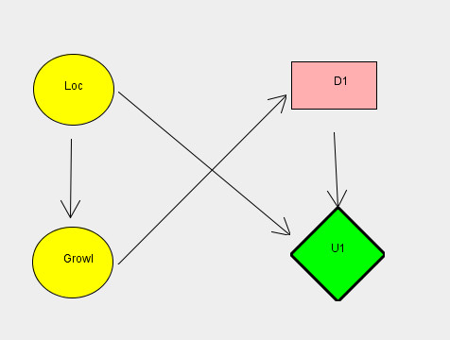
Figure 4. Shows a simple ID of the Tiger Problem.

        - Entering the Conditional Probability Distributions (CPDs) of the nodes
There are two ways of entering CPDs:
1) By manually entering the values in the CPT dialog table.
              - Right on the node, and select CPTable.
              - Enter the values in the table, and click “Ok”. The merit to this approach is that, data validation is done for you when the “Ok” button is clicked.

2) By right-clicking a node, and selecting import CPT, and then
              - Select the file that contains the CPT values to import
              - Click “Ok” to import.
NB: CPT values are delimited by commas

Caveat: The order of a node's CPT as shown in the corresponding CPT dialog table should be of same order as the data matrix in the file.

        - Saving the network
          - From the file menu, select save.
          - Browse to the location you wish to save the network
          - Choose the appropriate extension for the network created
          - Click “Save”

2. Creating a Dynamic Influence Diagram (DID)
Steps.
        - Create an ID first

        - Add temporal link to nodes as they would appear in the next time step
1. Add a normal link
2. Right click on the link to pop up the property editor
3. Make sure the “Delay Link” check box is checked.
4. Select the “Parent Node” and “Child Node” .
NB: If you wish to have a link between the same node, select the node as both parent and child.

        - Unroll the network
          - From the Network menu, select “Unroll” to unroll the network

    - Creating an Interactive Influence Diagram (IID)
The only information needed to create IID is how to add models to a model node
To assign models to a model node, do the following;
        - Immediately after adding a model node to the network, right click on the node, and select “Assign model from a file”
        - From the dialog box that pops up, select the appropriate files ( the saved networks) you wish to assign.
NB: To assign more than one model, select multiple files by ctrl-clicking on each file.
Should you repeat this assignment steps, the assign models would be overwritten with the new assignment.
        - Click “Ok”
        - The number of models assigned should be equal to the number of states of the model node. You do not have to do anything to ensure this constraint is met. This is automatically done by Nutus.

    - Flattening an IID to ID
      - Select any of the model node in the network
      - Right click on the selected model node, and click “Expand Model”
      - Save the network as ID.

    - Creating an Interactive Dynamic Influence Diagram (IDID)
Steps:
        - Create IID. An example is shown in Fig. 5a.
        - Add temporal links as demonstrated in in Fig.5b.
Demonstration: For clarity, we would add only three (3) temporal links, from ;
            - “Aj” to “Loc”
            - “Mod1” to “Mod1”
3) “Loc” to “Loc”

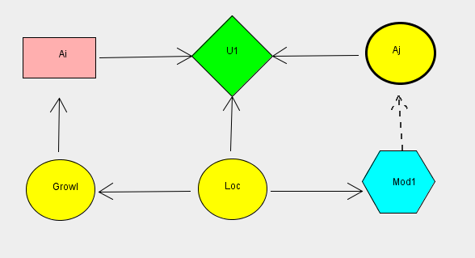
Figure 5a. Shows an IID of the Tiger Problem.
Model link

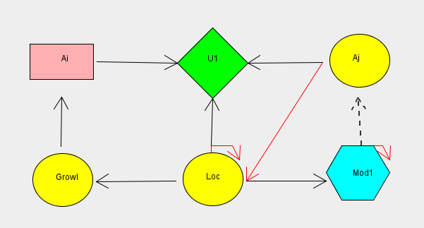
Figure 5b. Shows an IID of the Tiger Problem with temporal links (red arrow links).

        - Unroll the network as shown in Figure 5c.
          - From the “Network” menu click “Unroll”

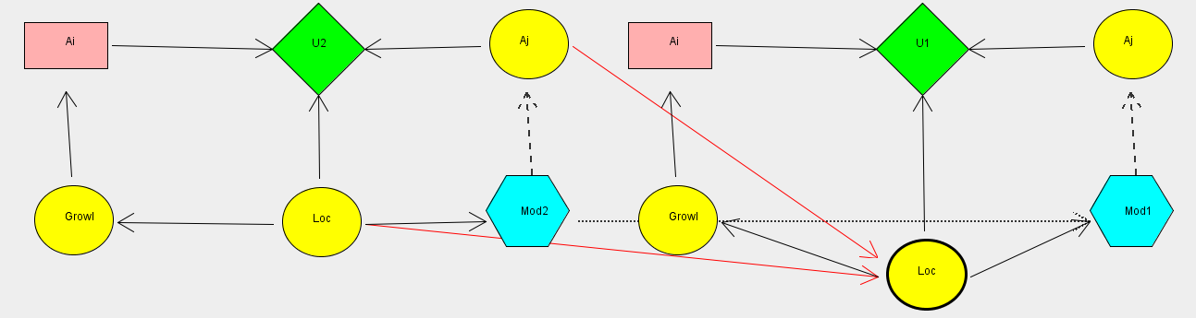

Figure 5c. Shows an IDID of the Tiger Problem with temporal links (red arrow links).

        - Transform the IDID to ID
          - Right click on a model node and select “Expand Model”

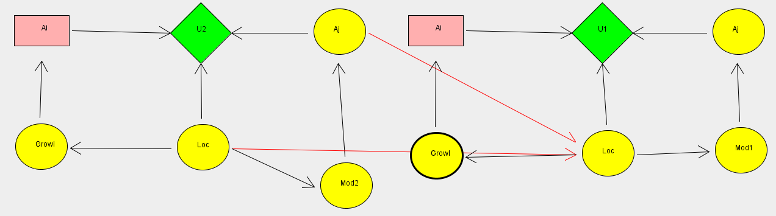
Figure 5d. Shows an IDID of the Tiger Problem transformed into an ID. The model node in Fig. 5C has been changed to a Chance node.

        - Save the Network.

