***COLLEGE OF COMPUTER STUDIES***

***Bachelor of Science in Information Technology***

***System Administration and Maintenance***

***Laboratory Work #3***

***Submitted by:***

*Acma, Florel Angelous D.*

*Santos. Genielyn Rose L.*

***Submitted to:***

*Mrs. Jasmine Almarinez MIT*

1. ***Create folders named after your surname in drive C or D, along with the required subfolders and sub-subfolders using DOS commands. Then, capture a screenshot of the directory tree, including the Command Prompt window.***

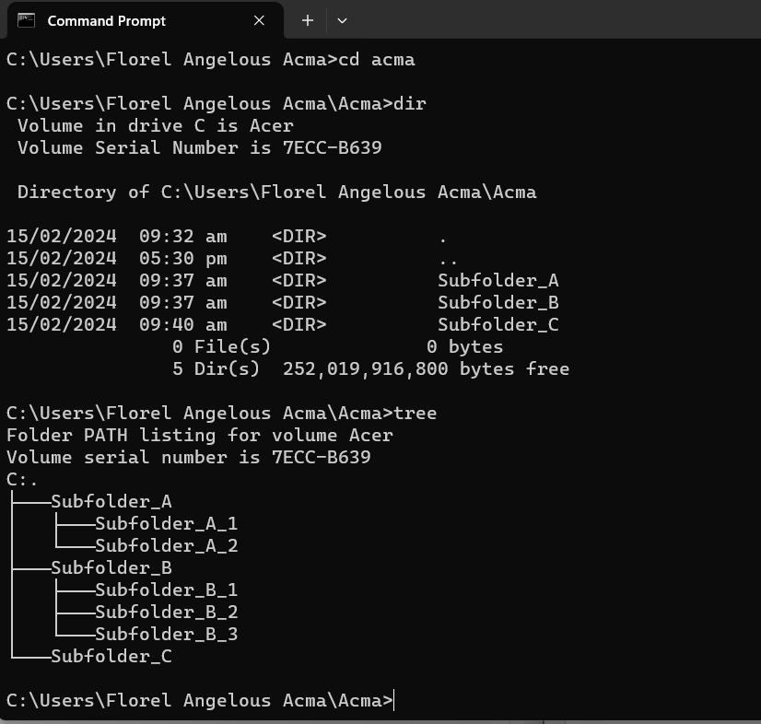

***2. Using only the command prompt (without using the UI), create text files as follows and capture screenshots of each text file along with the Command Prompt window:***

*1.txt: Subject for this semester  
2.txt: Your email address  
3.txt: Your class schedule  
4.txt: List of your top 5 best classmates  
5.txt: Mission and vision of CCS  
6.txt: Perpetual hymn  
7.txt: List of 10 DOS commands with descriptions*

*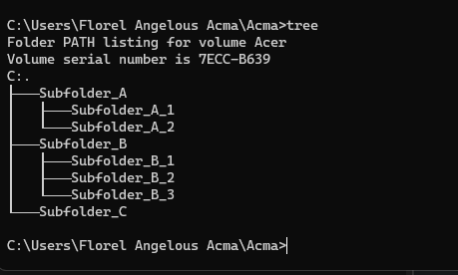  
  
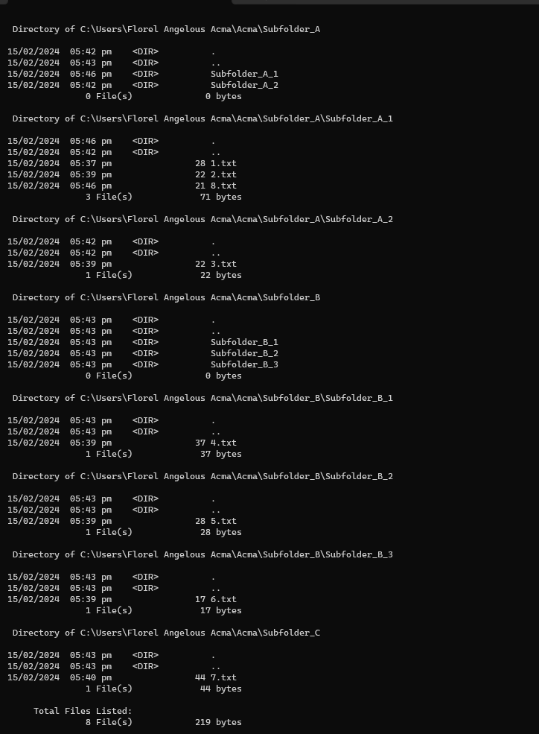*

1. ***Rename the folders as follows using Command Prompt, and capture screenshots of your commands along with the updated directory tree:***

*Folder-A: Class  
Folder-B: School  
Folder-C: Lessons*

