**//Q&A-林良誉-2021-05-09**

**一、event.stopPropagation()**

**（1）Definition and Usage**

The event.stopPropagation() method stops the bubbling of an event to parent elements, preventing any parent event handlers from being executed.

**（2）Example**

<https://www.w3schools.com/jquery/tryit.asp?filename=tryjquery_event_stoppropagation>

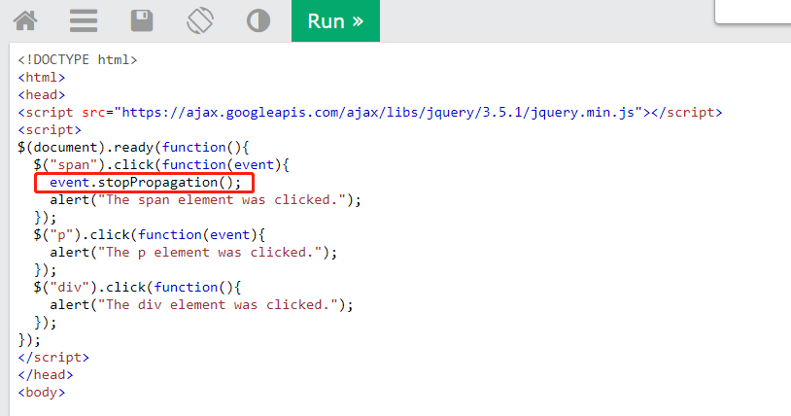

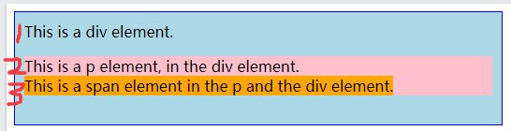

Note: Click on each of the elements above. When clicking on the div element, it will alert that the div element was clicked. When clicking on the p element, it will return both the p and the div element, since the p element is inside the div element. But when clicking on the span element, it will only return itself, and not the p and the div element (even though its inside these elements). The event.stopPropagation() stops the click event from bubbling to the parent elements.

Tip: Try to remove the event.stopPropagation() line, and click on the span element again (the click event will now bubble up to parent elements).

**（i）保留event.stopPropagation()**

此时点击3号元素span时，仅会触发span对应的弹窗，其父类2号p元素及1号div元素对应的弹窗不触发。

**（ii）注释event.stopPropagation()**

此时点击3号元素span时，会依次触发span、其父类2号p元素及1号div元素对应的弹窗。

**二、moveBy()**

**Question：**

使用Google chrome浏览器本地打开页面“HostObjects.html”时，触发的弹窗“HostObjectsPopUp.html”不移动

**Answer：**

运行时，moveBy()语句触发”Uncaught DOMException: Blocked a frame with origin "null" from accessing a cross-origin frame.“报错。

只要协议、域名、端口有任何一个不同，都被当作是不同的域。Chrome浏览器怕用户勿使用跨域模式泄露自己的个人信息，所以禁用跨域传值，此时弹窗的移动参数无法从domain1传到domain2中，所以弹窗没有移动。

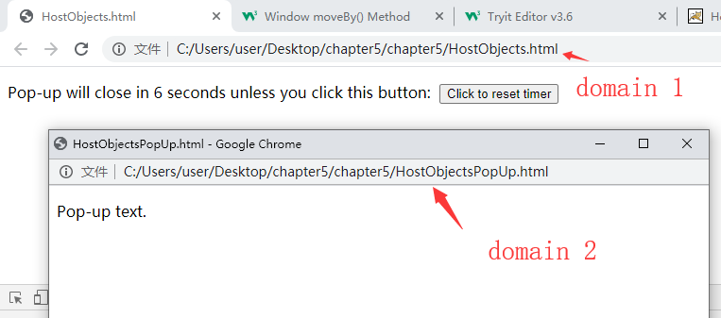

**Solution：**

（1）针对chrome浏览器设置：

（i）关闭所有的chrome浏览器。

（ii）新建一个chrome快捷方式，右键“属性”，“快捷方式”选项卡里选择“目标”，添加 --args --disable-web-security --user-data-dir=C:\MyChromeDevUserData

（iii）通过快捷方式打开谷歌浏览器

（2）使用其他浏览器，如Firefox。

（3）运行本地服务环境，在服务器中运行“HostObjects.html”时，触发的弹窗“HostObjectsPopUp.html”可以正常移动