Define a class **MyString** which derives from (is a derived class of) the standard class **string**. Given an object **x** of the class **MyString**, the following operations on **x** are allowed:

1. For an integer **n**, the expression **x-n** produces an object of **MyString** whose string is a copy of **x** but with each character shifted **backward** by **n** positions.
2. Similarly, the expression **x+n** produces an object of **MyString** whose string is a copy of **x** but with each character shifted **forward** by **n** positions.

Here below is an example,

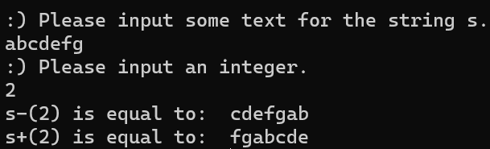

Please，write the complete code of **MyString**, which should include at least the following:

* The declaration of **MyString**.
* Definitions of the functions to overload the binary operators + and -.
* A constructor with a parameter of type **string**.
* A constructor with a parameter of type **const** **char\***.

**Hint：** you may need the following functions and features.

* + **this** pointer of the string class.
  + **size**() member function of the string class.
  + **at**(int i) member function of the string class. This function acquires the i-th elements in the string.