**How to use pan scanner**

1. Exucute PanScanner.exe and then click browse to select directory you want to scan.

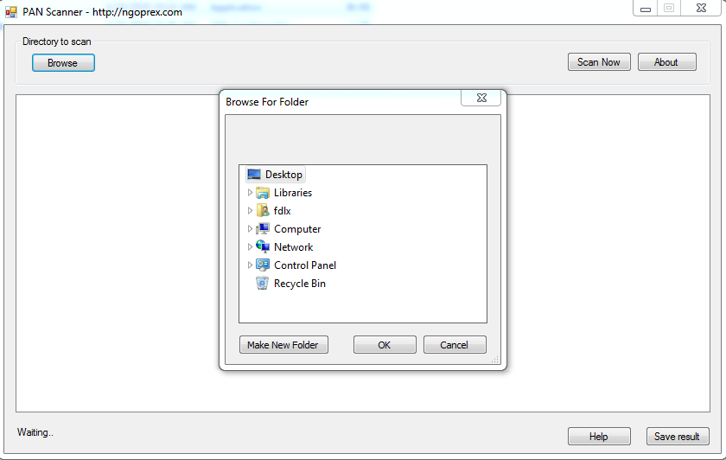

1. Then click scan now button to start scan, this tool will scan pan number pattern at every file content in current directory.

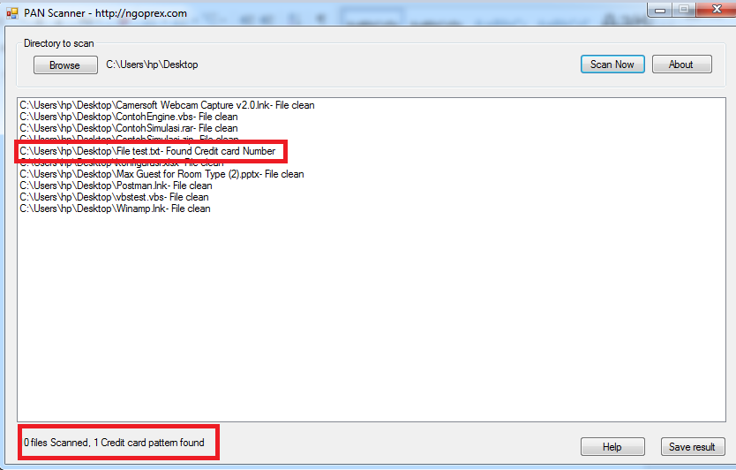

1. You can also save the scan result by clicking the Save result button.

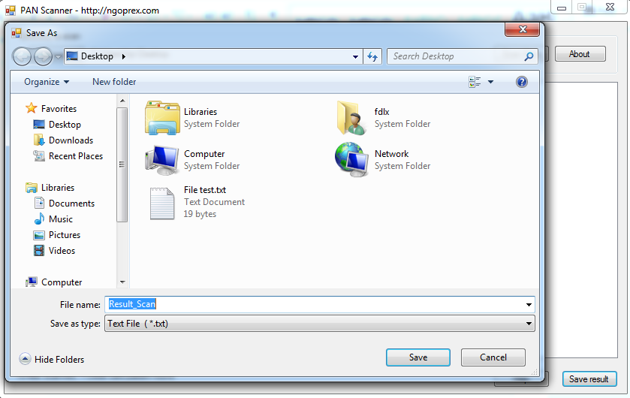

Always check the latest update at <https://ngoprex.com/free-downloads/>