**ikuai-cms调接口数据**

**说明：用jq调ajax接口**

**·首页**

**-banner图片，从接口获取**



**-接口地址：**

[**http://mock.shtodream.cn/mock/5fb25b208e13766542114e13/ikuai/banners**](http://mock.shtodream.cn/mock/5fb25b208e13766542114e13/ikuai/banners)

**-接口数据：**

1. **提交方式：post**

**2、返回值为json格式**

**3、字段解释：**

**·id_b为banner编号**

**·name_b为banner名称**

**·img_b为banner图片**

**4、json数据：**

{

0: {

"id_b": "0",

"img_b": "htps://www.ikuai8.com/templates/ikuaitemplate/images/index/20201029pc.jpg",

"name_b": "海外加速"

},

1: {

"id_b": "1",

"img_b": "https://www.ikuai8.com/templates/ikuaitemplate/images/index/netWork_pc.jpg",

"name_b": "智能组网"

}

}

**·产品——硬件产品——产品分类-交换机**

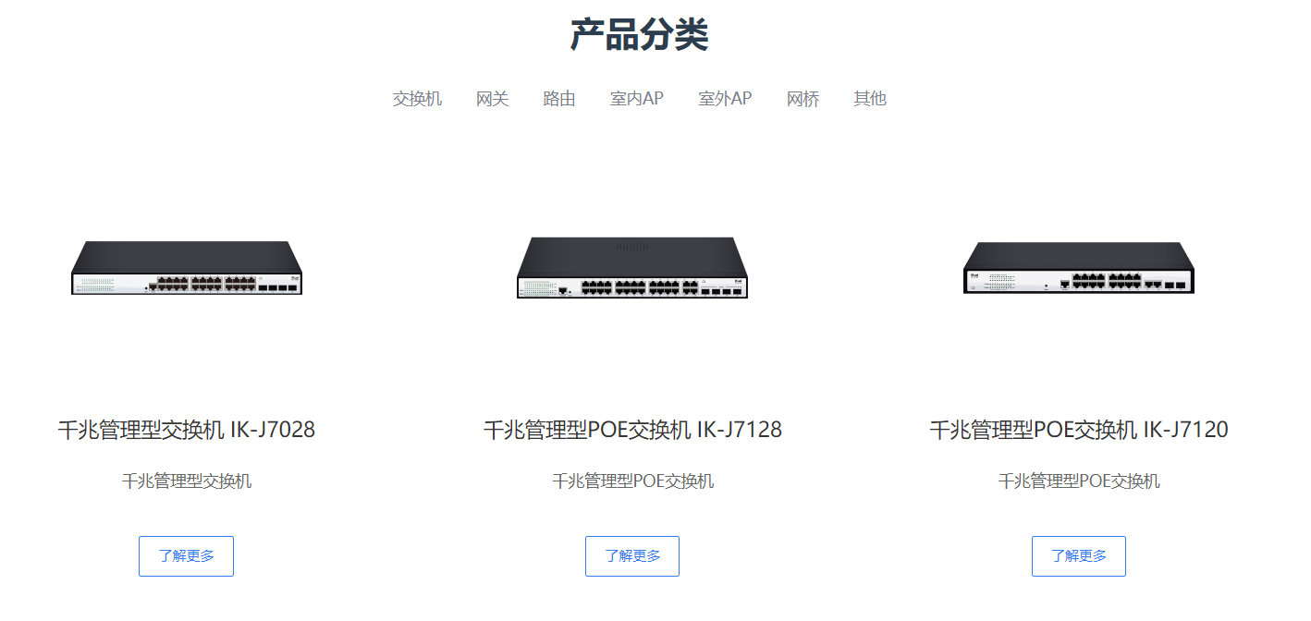

**-接口地址：**

**http://mock.shtodream.cn/mock/5fb25b208e13766542114e13/ikuai/product**

**-接口数据：**

1. **提交方式：post**

**2、返回值为json格式**

**3、字段解释：**

**·id_p为产品-交换机的图片编号**

**·title_p为交换机的型号**

**·img_p为交换机图片**

**·text_p为交换机说明**

**4、json数据：**

{

"data": {

0: {

"id_p": "1",

"img_p": "https://www.ikuai8.com/images/hardware_img/J7028.png",

"title_p": "千兆管理型交换机 IK-J7028速",

"text_p": "千兆管理型交换机"

},

1: {

"id_p": "2",

"img_p": "https://www.ikuai8.com/images/hardware_img/J7128.png",

"title_p": "千兆管理型POE交换机 IK-J7128",

"text_p": "千兆管理型POE交换机"

},

2: {

"id_p": "3",

"img_p": "https://www.ikuai8.com/images/hardware_img/J7120.png",

"title_p": "千兆管理型POE交换机 IK-J7120",

"text_p": "千兆管理型POE交换机"

},

3: {

"id_p": "4",

"img_p": "https://www.ikuai8.com/images/hardware_img/J7110.png",

"title_p": "千兆管理型POE交换机 IK-J7110",

"text_p": "8+2口POE交换机，支持网管功能"

},

4: {

"id_p": "5",

"img_p": "https://www.ikuai8.com/images/hardware_img/J3024S.png",

"title_p": "千兆交换机 IK-J3024S",

"text_p": "24千兆口交换机"

},

5: {

"id_p": "6",

"img_p": "https://www.ikuai8.com/images/hardware_img/J16.png",

"title_p": "POE交换机 IK-J16",

"text_p": "8+2口POE供电，支持MAC地址…"

}

}

}