JobSheet - Week 4 - Polymorphism

Nama: Muhammad Fadhil Arifin
NIM: 251524076
Kelas: 1C
Repo GitHub: https://github.com/fadhilarfnn/tekpro-Week-4.git

Instruksi Pengerjaan:
- Kerjakan 3 soal di bawah ini dengan melengkapi setiap kolom jawaban yang disediakan pada jobsheet ini.
- Jawaban setiap soal mencakup source code, screenshot hasil dari program yang ditampilkan full screen termasuk taskbar (tambahkan beberapa screenshot jika diperlukan), penjelasan permasalahan dan solusi yang dihadapi, nama teman yang membantu memecahkan masalah (opsional).
- Dikumpulkan pada Assignment Classroom sesuai dengan deadline yang tertera pada assignment tersebut.
- Format penamaan file jobsheet: W4_P_<Kelas 1X>_<3 Digit_NIM_Terakhir>.docx/pdf. Contoh: W3_P_1B_001.docx/pdf.
- Submit semua jawaban dalam bentuk file java pada repository GitHub masing-masing.

No. 1 Inheritance via Polymorphism (Another Type of Employee)
Soal Praktikum
Silahkan membaca soal pada file lampiran: 1-Polymorphism via Inheritance.pdf
Source Code
Kelas Staff
//********************************************************************
// Staff.java Author: Lewis/Loftus
//
// Represents the personnel staff of a particular business.
//********************************************************************
public class Staff
{
StaffMember[] staffList;
//-----------------------------------------------------------------
// Sets up the list of staff members.
//-----------------------------------------------------------------
public Staff ()
{
staffList = new StaffMember[8];
staffList[0] = new Executive ("Sam", "123 Main Line",
"555-0469", "123-45-6789", 2423.07);
staffList[1] = new Employee ("Carla", "456 Off Line",
"555-0101", "987-65-4321", 1246.15);
staffList[2] = new Employee ("Woody", "789 Off Rocker",
"555-0000", "010-20-3040", 1169.23);
staffList[3] = new Hourly ("Diane", "678 Fifth Ave.",
"555-0690", "958-47-3625", 10.55);
staffList[4] = new Volunteer ("Norm", "987 Suds Blvd.",
"555-8374");
staffList[5] = new Volunteer ("Cliff", "321 Duds Lane",
"555-7282");
staffList[6] = new Commission ("ayam", "123 empat", "123-45-6789", "123", 6.25, 0.2);
staffList[7] = new Commission ("ikan", "567 delapan", "123-45-6789", "123", 9.75, 0.15);
// Untuk pegawai commission pertama (index 6): jam kerja 35, total sales 400
((Commission)staffList[6]).addHours(35);
((Commission)staffList[6]).addSales(400);

// Untuk pegawai commission kedua (index 7): jam kerja 40, total sales 950
((Commission)staffList[7]).addHours(40);
((Commission)staffList[7]).addSales(950);
((Executive)staffList[0]).awardBonus (500.00);
((Hourly)staffList[3]).addHours (40);
}
//-----------------------------------------------------------------
// Pays all staff members.
//-----------------------------------------------------------------
public void payday ()
{
double amount;
for (int count=0; count < staffList.length; count++)
{
System.out.println (staffList[count]);
amount = staffList[count].pay(); // polymorphic
if (amount == 0.0)
System.out.println ("Thanks!");
else
System.out.println ("Paid: " + amount);
System.out.println ("-----------------------------------");
}
}
}

Kelas StaffMember
//********************************************************************
// StaffMember.java Author: Lewis/Loftus
//
// Represents a generic staff member.
//********************************************************************
abstract public class StaffMember
{
protected String name;
protected String address;
protected String phone;
//-----------------------------------------------------------------
// Sets up a staff member using the specified information.
//-----------------------------------------------------------------
public StaffMember (String eName, String eAddress, String ePhone)
{
name = eName;
address = eAddress;
phone = ePhone;
}
//-----------------------------------------------------------------
// Returns a string including the basic employee information.
//-----------------------------------------------------------------
public String toString()
{
String result = "Name: " + name + "\n";
result += "Address: " + address + "\n";
result += "Phone: " + phone;
return result;
}
//-----------------------------------------------------------------
// Derived classes must define the pay method for each type of
// employee.
//-----------------------------------------------------------------
public abstract double pay();
}

Kelas Volunteer
//********************************************************************
// Volunteer.java Author: Lewis/Loftus
//
// Represents a staff member that works as a volunteer.
//********************************************************************
public class Volunteer extends StaffMember
{
//-----------------------------------------------------------------
// Sets up a volunteer using the specified information.
//-----------------------------------------------------------------
public Volunteer (String eName, String eAddress, String ePhone)
{
super (eName, eAddress, ePhone);
}
//-----------------------------------------------------------------
// Returns a zero pay value for this volunteer.
//-----------------------------------------------------------------
public double pay()
{
return 0.0;
}
}

Kelas Employee
//********************************************************************
// Employee.java Author: Lewis/Loftus
//
// Represents a general paid employee.
//********************************************************************
public class Employee extends StaffMember
{
protected String socialSecurityNumber;
protected double payRate;
//-----------------------------------------------------------------
// Sets up an employee with the specified information.
//-----------------------------------------------------------------
public Employee (String eName, String eAddress, String ePhone,
String socSecNumber, double rate)
{
super (eName, eAddress, ePhone);
socialSecurityNumber = socSecNumber;
payRate = rate;
}
//-----------------------------------------------------------------
// Returns information about an employee as a string.
//-----------------------------------------------------------------
public String toString()
{
String result = super.toString();
result += "\nSocial Security Number: " + socialSecurityNumber;
return result;
}
//-----------------------------------------------------------------
// Returns the pay rate for this employee.
//-----------------------------------------------------------------
public double pay()
{
return payRate;
}
}

Kelas Executive
//********************************************************************
// Executive.java Author: Lewis/Loftus
//
// Represents an executive staff member, who can earn a bonus.
//********************************************************************
public class Executive extends Employee
{
private double bonus;
//-----------------------------------------------------------------
// Sets up an executive with the specified information.
//-----------------------------------------------------------------
public Executive (String eName, String eAddress, String ePhone,
String socSecNumber, double rate)
{
super (eName, eAddress, ePhone, socSecNumber, rate);
bonus = 0; // bonus has yet to be awarded
}
//-----------------------------------------------------------------
// Awards the specified bonus to this executive.
//-----------------------------------------------------------------
public void awardBonus (double execBonus)
{
bonus = execBonus;
}
//-----------------------------------------------------------------
// Computes and returns the pay for an executive, which is the
// regular employee payment plus a one-time bonus.
//-----------------------------------------------------------------
public double pay()
{
double payment = super.pay() + bonus;
bonus = 0;
return payment;
}
}

Kelas Hourly
//********************************************************************
// Hourly.java Author: Lewis/Loftus
//
// Represents an employee that gets paid by the hour.
//********************************************************************
public class Hourly extends Employee
{
private int hoursWorked;
//-----------------------------------------------------------------
// Sets up this hourly employee using the specified information.
//-----------------------------------------------------------------
public Hourly (String eName, String eAddress, String ePhone,
String socSecNumber, double rate)
{
super (eName, eAddress, ePhone, socSecNumber, rate);
hoursWorked = 0;
}
//-----------------------------------------------------------------
// Adds the specified number of hours to this employee's
// accumulated hours.
//-----------------------------------------------------------------
public void addHours (int moreHours)
{
hoursWorked += moreHours;
}
//-----------------------------------------------------------------
// Computes and returns the pay for this hourly employee.
//-----------------------------------------------------------------
public double pay()
{
double payment = payRate * hoursWorked;
hoursWorked = 0;
return payment;
}
//-----------------------------------------------------------------
// Returns information about this hourly employee as a string.
//-----------------------------------------------------------------
public String toString()
{
String result = super.toString();
result += "\nCurrent hours: " + hoursWorked;
return result;
}
}

Kelas Commission
public class Commission extends Hourly{
private double totalSales;
private double commissionRate;

public Commission(String eName, String eAddress, String ePhone, String socSecNumber, double rate, double commissionRate){
super(eName, eAddress, ePhone, socSecNumber, rate);
this.commissionRate = commissionRate;
}

public void addSales (double totalSales){
this. totalSales += totalSales;
}

public double pay(){
double totalpay = (commissionRate * totalSales) + super.pay();
totalSales = 0.0;
return totalpay;
}

public String toString(){
String result = super.toString();
result += "\nTotal sales:" + totalSales;
return result;
}
}

Kelas Firm
public class Commission extends Hourly{
private double totalSales;
private double commissionRate;

public Commission(String eName, String eAddress, String ePhone, String socSecNumber, double rate, double commissionRate){
super(eName, eAddress, ePhone, socSecNumber, rate);
this.commissionRate = commissionRate;
}

public void addSales (double totalSales){
this. totalSales += totalSales;
}

public double pay(){
double totalpay = (commissionRate * totalSales) + super.pay();
totalSales = 0.0;
return totalpay;
}

public String toString(){
String result = super.toString();
result += "\nTotal sales:" + totalSales;
return result;
}
}

Screenshot Hasil
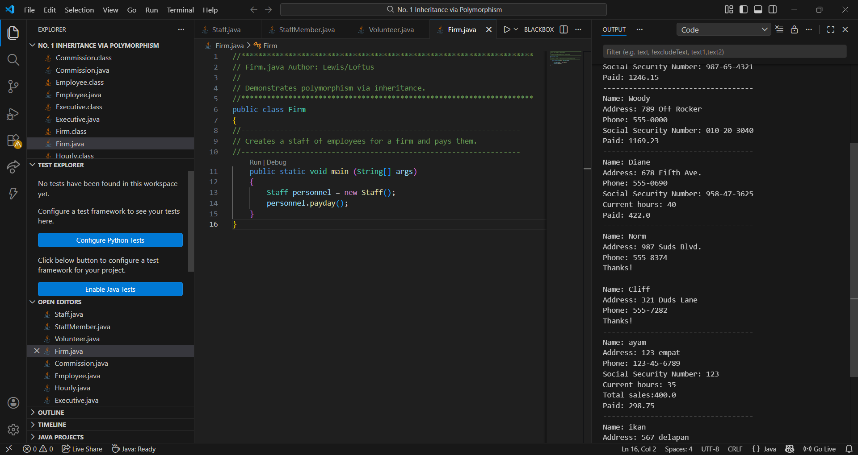
Penjelasan Permasalahan dan Solusi
Permasalahan: Perlu menambahkan tipe pegawai baru (Commission) yang gajinya gabungan antara upah per jam dan komisi penjualan, tanpa menulis ulang kode yang sudah ada. Selain itu, perlu mengakses method khusus pada objek yang disimpan dalam array bertipe induknya (StaffMember).
Solusi: Membuat kelas Commission yang extends Hourly, lalu menggunakan super() dan super.pay() agar tidak perlu menulis ulang logika gaji dasar. Untuk mengakses method khusus, dilakukan downcasting seperti ((Commission)staffList[6]).addSales(400)
Nama Teman Hal yang Dibantu (Opsional)

No. 2 Inheritance via Polymorphism (Painting Shapes)
Soal Praktikum
Silahkan membaca soal pada file lampiran: 2-Polymorphism via Inheritance.pdf
Source Code
Kelas Shape
public abstract class Shape {
private String ShapeName;

public Shape(String ShapeName){
this.ShapeName = ShapeName;
}

public abstract double area();

public String toString(){
return "Shape name: " + ShapeName;
}
}

Kelas Sphere
//*****************************************
// Sphere.java
//
// Represents a sphere.
//*****************************************
public class Sphere extends Shape
{
private double radius; //radius in feet
//----------------------------------
// Constructor: Sets up the sphere.
//----------------------------------
public Sphere(double r)
{
super("Sphere");
radius = r;
}
//-----------------------------------------
// Returns the surface area of the sphere.
//-----------------------------------------
public double area()
{
return 4*Math.PI*radius*radius;
}
//-----------------------------------
// Returns the sphere as a String.
//-----------------------------------
public String toString()
{
return super.toString() + " of radius " + radius;
}
}

Kelas Cylinder
public class Cylinder extends Shape{
private double heigth;
private double radius;

public Cylinder(double radius, double heigth){
super("lingkaran");
this.heigth = heigth;
this.radius = radius;
}

@Override
public double area(){
return Math.PI * radius * radius + 2 * Math.PI * radius * heigth;
}

@Override
public String toString(){
return super.toString() + " of radius " + radius + " and heigth " + heigth;
}
}

Kelas Rectangle
public class Rectangle extends Shape{
private double width;
private double length;

public Rectangle(double width, double length){
super("persegi panjang");
this.width = width;
this.length = length;
}

@Override
public double area(){
return width*length;
}

@Override
public String toString(){
return super.toString() + " of length " + length + " and width " + width;
}
}

Kelas Paint
//******************************************************
// Paint.java
//
// Represents a type of paint that has a fixed area
// covered by a gallon. All measurements are in feet.
//******************************************************
public class Paint
{
private double coverage; //number of square feet per gallon
//-----------------------------------------
// Constructor: Sets up the paint object.
//-----------------------------------------
public Paint(double c)
{
coverage = c;
}
//---------------------------------------------------
// Retu'rns the amount of paint (number of gallons)
// needed to paint the shape given as the parameter.
//---------------------------------------------------
public double amount(Shape s)
{
System.out.println ("Computing amount for " + s);
return s.area() / coverage;
}
}

Kelas PaintThings
//************************************************************
// PaintThings.java
//
// Computes the amount of paint needed to paint various
// things. Uses the amount method of the paint class which
// takes any Shape as a parameter.
//***********************************************************
import java.text.DecimalFormat;
public class PaintThings
{
//-----------------------------------------
// Creates some shapes and a Paint object
// and prints the amount of paint needed
// to paint each shape.
//-----------------------------------------
public static void main (String[] args)
{
final double COVERAGE = 350;
Paint paint = new Paint(COVERAGE);
Rectangle deck;
Sphere bigBall;
Cylinder tank;
double deckAmt, ballAmt, tankAmt;
// Instantiate the three shapes to paint
// Compute the amount of paint needed for each shape
// Print the amount of paint for each.
deck = new Rectangle(20, 35);
bigBall = new Sphere(15);
tank = new Cylinder(10, 30);
deckAmt = paint.amount(deck);
ballAmt = paint.amount(bigBall);
tankAmt = paint.amount(tank);
DecimalFormat fmt = new DecimalFormat("0.#");
System.out.println ("\nNumber of gallons of paint needed...");
System.out.println ("Deck " + fmt.format(deckAmt));
System.out.println ("Big Ball " + fmt.format(ballAmt));
System.out.println ("Tank " + fmt.format(tankAmt));
}
}

Screenshot Hasil
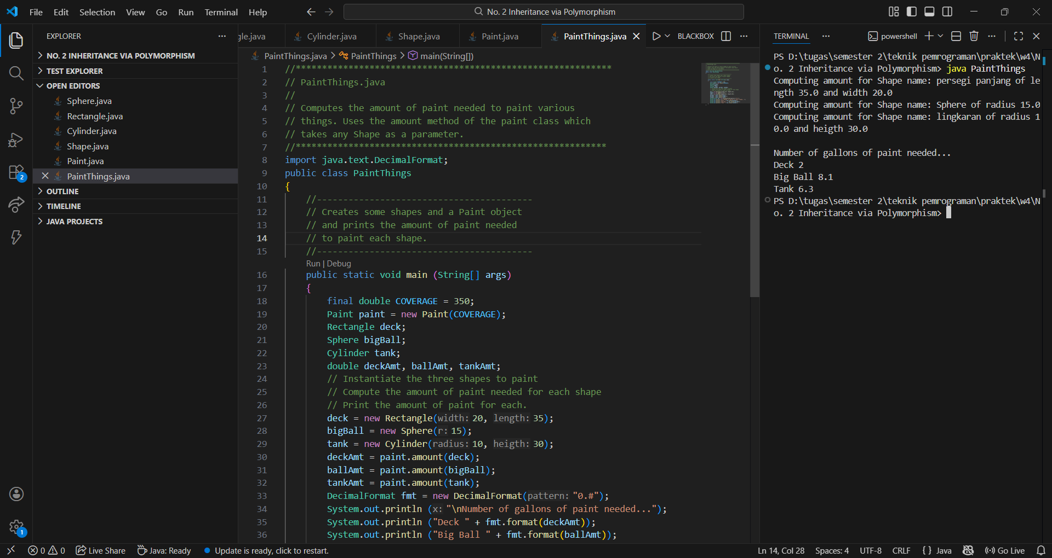
Penjelasan Permasalahan dan Solusi
Permasalahan: Perlu menghitung kebutuhan cat untuk berbagai bentuk (Sphere, Rectangle, Cylinder) yang masing-masing punya rumus luas berbeda, namun menggunakan satu method yang sama.
Solusi: Membuat abstract class Shape dengan abstract method area(). Setiap bentuk mengoverride area() sesuai rumusnya masing-masing. Kelas Paint cukup menerima parameter bertipe Shape, dan Java otomatis menjalankan area() yang sesuai saat program berjalan.
Nama Teman Hal yang Dibantu (Opsional)

No. 3 Polymorphic Sorting
Soal Praktikum
Silahkan membaca soal pada file lampiran: 3-Polymorphic Sorting.pdf
Source Code
Kelas Sorting
//********************************************************************
// Sorting.java Author: Lewis/Loftus
//
// Demonstrates the selection sort and insertion sort algorithms.
//********************************************************************
public class Sorting
{
//-----------------------------------------------------------------
// Sorts the specified array of objects using the selection
// sort algorithm.
//-----------------------------------------------------------------
public static void selectionSort (Comparable[] list)
{
int min;
Comparable temp;
for (int index = 0; index < list.length-1; index++)
{
min = index;
for (int scan = index+1; scan < list.length; scan++)
if (list[scan].compareTo(list[min]) < 0)
min = scan;
// Swap the values
temp = list[min];
list[min] = list[index];
list[index] = temp;
}
}
//-----------------------------------------------------------------
// Sorts the specified array of objects using the insertion
// sort algorithm.
//-----------------------------------------------------------------
public static void insertionSort (Comparable[] list)
{
for (int index = 1; index < list.length; index++)
{
Comparable key = list[index];
int position = index;
// Shift larger values to the right
while (position > 0 && key.compareTo(list[position-1]) > 0)
{
list[position] = list[position-1];
position--;
}

list[position] = key;
}
}
}

Kelas Numbers
// ******************************************************
// Numbers.java
//
// Demonstrates selectionSort on an array of integers.
// ******************************************************
import java.util.Scanner;
public class Numbers
{
// --------------------------------------------
// Reads in an array of integers, sorts them,
// then prints them in sorted order.
// --------------------------------------------
public static void main (String[] args)
{
Integer[] intList;
int size;
Scanner scan = new Scanner(System.in);
System.out.print ("\nHow many integers do you want to sort? ");
size = scan.nextInt();
intList = new Integer[size];
System.out.println ("\nEnter the numbers...");
for (int i = 0; i < size; i++)
intList[i] = scan.nextInt();
Sorting.selectionSort(intList);
System.out.println ("\nYour numbers in sorted order ascending ...");
for (int i = 0; i < size; i++)
System.out.print(intList[i] + " ");
System.out.println ("\n");
Sorting.insertionSort(intList);
System.out.println("\nYour numbers in sorted order descending ...");
for (int i = 0; i < size; i++)
System.out.print(intList[i] + " ");
System.out.println ("\n");
Sorting.insertionSort(intList);
}
}

Kelas Strings
import java.util.Scanner;

public class Strings {
public static void main(String[] args) {
String[] StrList;
int size;
Scanner scan = new Scanner(System.in);
System.out.println("How many Strings do you want to short?");
size = scan.nextInt();
StrList = new String[size];
System.out.println("Enter the Strings...");
for(int i = 0; i < size; i++){
StrList[i] = scan.next();
}
System.out.println();
Sorting.selectionSort(StrList);
System.out.println("your Strings in sorted order ascending...");
for(int i = 0; i<size; i++){
System.out.print(StrList[i] + " ");
}
System.out.println();
Sorting.insertionSort(StrList);
System.out.println("your Strings in sorted order descending...");
for(int i = 0; i<size; i++){
System.out.print(StrList[i] + " ");
}
System.out.println();
}
}

Kelas Salesperson
// *******************************************************
// Salesperson.java
//
// Represents a sales person who has a first name, last
// name, and total number of sales.
// *******************************************************
public class Salesperson implements Comparable
{
private String firstName, lastName;
private int totalSales;
//------------------------------------------------------
// Constructor: Sets up the sales person object with
// the given data.
//------------------------------------------------------
public Salesperson (String first, String last, int sales)
{
firstName = first;
lastName = last;
totalSales = sales;
}
//-------------------------------------------
// Returns the sales person as a string.
//-------------------------------------------
public String toString()
{
return lastName + ", " + firstName + ": \t" + totalSales;
}
//-------------------------------------------
// Returns true if the sales people have
// the same name.
//-------------------------------------------
public boolean equals (Object other)
{
return (lastName.equals(((Salesperson)other).getLastName()) &&
firstName.equals(((Salesperson)other).getFirstName()));
}
//--------------------------------------------------
// Order is based on total sales with the name
// (last, then first) breaking a tie.
//--------------------------------------------------
public int compareTo(Object other)
{
int result;
Salesperson otherPerson = (Salesperson) other;

result = this.totalSales - otherPerson.totalSales;
if(result == 0){
result = this.lastName.compareTo(otherPerson.getLastName());
if (result == 0) {
result = this.firstName.compareTo(otherPerson.getFirstName());
}
}
return result;
}

//-------------------------
// First name accessor.
//-------------------------
public String getFirstName()
{
return firstName;
}

//-------------------------
// Last name accessor.
//-------------------------
public String getLastName()
{
return lastName;
}
//-------------------------
// Total sales accessor.
//-------------------------
public int getSales()
{
return totalSales;
}
}

Kelas WeeklySales
// *************************************************************
// WeeklySales.java
//
// Sorts the sales staff in descending order by sales.
// ************************************************************
import java.util.Scanner;
public class WeeklySales
{
public static void main(String[] args)
{
Scanner scan = new Scanner(System.in);

System.out.println("How many sales do you want to sort?");
int size = scan.nextInt();
Salesperson[] salesStaff = new Salesperson[size];

System.out.println("Entaer the first name, lastname, and sales...");
for(int i = 0; i<size; i++){
System.out.println("sales ke-" + (i+1));
String firts = scan.next();
String last = scan.next();
int sales = scan.nextInt();
salesStaff[i] = new Salesperson(firts, last, sales);
System.out.println();
}
Sorting.insertionSort(salesStaff);
System.out.println ("\nRanking of Sales for the Week\n");
for (Salesperson s : salesStaff)
System.out.println (s);
}
}
Screenshot Hasil
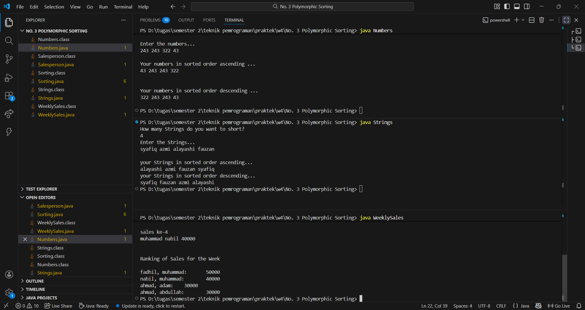
Penjelasan Permasalahan dan Solusi
Permasalahan: Numbers.java tidak bisa compile karena menggunakan int[] yang merupakan tipe primitif, sedangkan parameter selectionSort hanya menerima Comparable[] yang bertipe objek. Selain itu, method compareTo() di kelas Salesperson belum diisi sehingga pengurutan tidak bisa berjalan.
Solusi: Mengubah int[] menjadi Integer[] agar sesuai dengan parameter selectionSort. Lalu mengisi compareTo() menggunakan operasi pengurangan untuk membandingkan total sales, dan memanggil compareTo() milik String untuk membandingkan lastName dan firstName sebagai tiebreaker.
Nama Teman Hal yang Dibantu (Opsional)

