|  |
| --- |
| **SCR2043 OPERATING SYSTEMS** |

|  |  |  |  |  |  |  |
| --- | --- | --- | --- | --- | --- | --- |
| Name | : |  |  |  |  | Marks |
| Student ID | : |  |  |  |  |  |
| Section | : |  |  |  |  |  |

Instruction: Please do the following activities in sequence. Once completed, ask your lecturer / instructor to verify your results by putting his / her initial.

Please make sure the answer is always **start with low capital letter**.

|  |  |  |
| --- | --- | --- |
| **ATIVITY 1 :** | **BASIC LINUX COMMANDS** | **[10 Marks]** |

Write down instructions under command column.

**You need a terminal window to enter all your commands in sequence.**

|  |  |  |  |
| --- | --- | --- | --- |
|  | **Task** | **Command** |  |
| 1 | Check your current working directory | pwd |  |
| 2 | List the content of the directory | ls |  |
| 3 | Create a directory with your name. | mkdir Ayaz |  |
| 4 | Change working directory to the directory created in previous task 3. | cd Ayaz |  |
| 5 | To display your current directory now | pwd |  |
| 6 | Create 3 directories using your best friend’s name. | mkdir Lara  mkdir Warner  mkdir Anderson |  |
| 7 | List all created directories available. | ls |  |
| 8 | Create a directories (Water) under one of those directories created in task 5 without change working directory. | mkdir Water |  |
| 9 | Create a directories (Banana) under the other one of those directories created in task 5 without change working directory. | mkdir Banana |  |
| 10 | Change working directory to Banana | cd Banana |
| 11 | Create new directory Papaya under same directory with Banana. | mkdir Papaya |  |
| 12 | List all directories created under the parent of current working directory | ls |  |
| 13 | From current working directory, create new directory Durian under same directory with Water. | cd /home/mpk8/Ayaz/Water  mkdir Durian |  |
| 14 | Rename Water into another new name as Watermelon. | cd /home/mpk8/Ayaz  mv Water Watermelon |  |
| 15 | Remove the directories with no sub-directory created in task 5. | rm -r Ayaz |  |
| 16 | Return back to /home directory | cd ~ |  |
| 17 | Complete the file structure of the entire tasks done. (Hint: use tree command) | tree -a |  |

|  |  |  |
| --- | --- | --- |
| **ATIVITY 2 :** | **WRITING A PROGRAM / SOURCE CODE** | **[5 Marks]** |

This activity continuous from the previous activity 1. Write the command in the provided boxes.

1. Continuing from task (17) in activity 1, go directly to your Banana directory as your working directory.

Command:

1. By using a terminal, open a simple text editor provided in Ubuntu OS by typing the command either pico or nano. Create a file by using a name of fork1.c.

Command:

1. Type the following simple source code correctly. Use the menu given by the editor to do your task.

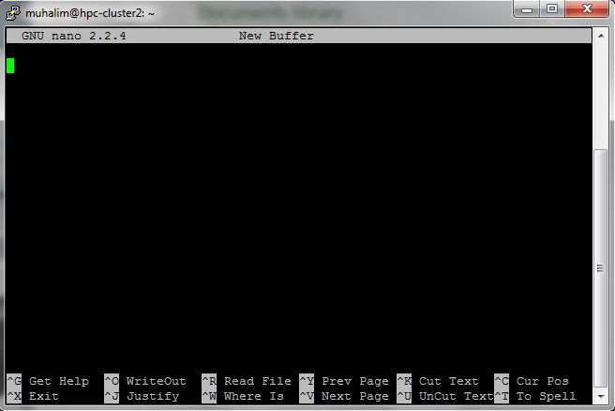

#include <stdio.h>

#include <unistd.h>

int main ()

{

int pid;

printf("\nHello World\n");

pid = fork();

if(pid != 0)

printf("I'm the Father and my son's PID is %d\n", pid);

else

printf("I'm the Son\n");

printf("Goodbye Cruel World\n\n");

}

*Source: http://www.osix.net/modules/article/?id=641*

1. Once you finished typing the source code, save the file using menu WriteOut with control button.
2. Make a copy of the file in the same directory with name fork2.c.

Command:

1. Make another copy of the fork2.c file into Durian directory with name fork3.c.

Command:

1. Move the fork2.c file in current directory into Papaya directory.

Command:

1. View the content of the file fork1.c without using the editor.

Command:

|  |  |  |
| --- | --- | --- |
| **ATIVITY 3 :** | **COMPILING THE PROGRAM / SOURCE CODE** | **[5 Marks]** |

This activity continuous from the previous activity 2. Write the command in the provided boxes. This activity will show the process of compiling the source code written in C programming language.

By using a terminal, change your working directory to Durian directory. You need to compile the fork3.c file in that directory.

Command:

To compile the source code, you need a compiling command for C programming, which is gcc. Compile the fork3.c file using that command.

Command:

Execute the output file generated in the directory. If you didn’t specify the output , a default filename of a.out will be produced

Command:

Re-compile the fork3.c, and do specify the output filename in the command as fork3result (use -o option).

Command:

Execute the specified output file generated in previous step.

Command:

From current working directory, compile the fork1.c file in Banana directory. Do specify the output filename as fork1result.

Command:

Execute the output file generated (fork1result.)

Command:

Remove the a.out file in related directory.

Command:

Redraw the final directories and files generated. (Hint: use tree command)

*.End of Lab1*