Hybrid Machine Learning System for Multi-Threat Probabilistic Forecasting and Budget-Constrained Intervention Recommendation in Nigerian National Parks

BSc. Software Engineering
Fadhlullah Olusola Abdulazeez
Capstone Project
Supervisor: Mr. Emmanuel Adjei
2026

DECLARATION

This capstone project is my original work, unless stated, and all external sources have been referenced or cited in my document. This work has not been presented for the award of a degree or for any similar purpose in any other university.

Signature…………………………… Date……………………………
Name of Student: Fadhlullah Olusola Abdulazeez

CERTIFICATION

The undersigned certifies that he has read and hereby recommends for acceptance by African Leadership University a report entitled “Hybrid Machine Learning System for Multi-Threat Probabilistic Forecasting and Budget-Constrained Intervention Recommendation in Nigerian National Parks”.

Signature…………………………… Date……………………………
Mr. Emmanuel Adjei
Faculty, Bachelor of Software Engineering,
African Leadership University

DEDICATION AND ACKNOWLEDGEMENT

This work is dedicated to the rangers and managers of Nigeria’s national parks, who protect fragile ecosystems with limited resources, and to my family, whose support made this project possible.
I am grateful to my supervisor, Mr. Emmanuel Adjei, for his guidance throughout the project, and to the open-data communities behind Open-Meteo, NASA POWER, Google Earth Engine, and NASA MODIS, whose freely available products made this work feasible.

ABSTRACT

African protected areas have lost, on average, 59% of their large-mammal populations, and only 1.71% of Nigeria’s protected land has ever had its management effectiveness evaluated. Park managers depend on reactive patrols and lack the systematic, labelled data that conventional supervised machine learning requires, so they cannot anticipate threats or plan interventions within tight budgets. This project designed, built, and deployed ConserveAI, a live decision-support system that produced daily 30-day probabilistic forecasts for three threats, fire, drought, and vegetation degradation, across six Nigerian national parks, and turned each forecast into a budget-constrained intervention plan. The system used only free satellite and climate data, a hybrid labelling strategy with semi-supervised learning to overcome label scarcity, and an integer-linear-programming recommender that allocated a manager’s budget across four zones per park. On a temporally held-out 2024 to 2025 test set of 4,206 park-days the production model reached an F2 of 0.95 for fire, 0.83 for drought, and 0.86 for vegetation, with ROC-AUC above 0.96 for all three, and it beat a persistence baseline on every threat. The recommender honoured budget and capacity in every test and solved in under 60 milliseconds. The system was deployed end to end and verified live. The results show that open data and interpretable methods can drive a usable, transparent decision-support tool for resource-constrained conservation, as a validated proof of concept rather than a fully field-tested product.

TABLE OF CONTENTS
(Right-click and choose “Update Field” in Word to populate this table.)

LIST OF FIGURES
Figure 1: Proposed model / ML pipeline diagram
Figure 2: System architecture diagram
Figure 3: Use case diagram
Figure 4: Class diagram
Figure 5: Entity-relationship diagram
Figure 6: Sequence diagram
Figure 7: National overview dashboard
Figure 8: Park console with a generated recommendation
Figure 9: The live REST API documentation
Figure 10: Automated unit-test run
Figure 11: Held-out model evaluation metrics
Figure 12: Local-vs-cloud performance
Figure 13: Confusion matrices on the held-out test set
Figure 14: Vegetation risk over twelve months
Figure 15: Recommender plan scaling with budget

LIST OF TABLES
Table 1: Comparison of existing systems and this project
Table 2: Study parks and ecosystems
Table 3: Target variables and how each label was constructed
Table 4: Recommender behaviour across budgets
Table 5: Summary of testing strategies
Table 6: Held-out model evaluation results
Table 7: Semi-supervised variants and the persistence baseline
Table 8: Supervised versus semi-supervised mean F2, by architecture
Table 9: Single-modality versus fused feature sets
Table 10: Per-park F2 with 95% bootstrap confidence intervals
Table 11: Mean F2 by ecosystem

LIST OF ACRONYMS AND ABBREVIATIONS
Abbreviation | Meaning
API | Application Programming Interface
F2 | F-beta score (beta = 2)
GEE | Google Earth Engine
ILP | Integer Linear Programming
JWT | JSON Web Token
ML | Machine Learning
MODIS | Moderate Resolution Imaging Spectroradiometer
NDVI | Normalized Difference Vegetation Index
ROC-AUC | Receiver Operating Characteristic Area Under Curve
SAR | Synthetic Aperture Radar
SDLC | Software Development Life Cycle

CHAPTER ONE: INTRODUCTION

1.1 Introduction and Background
Africa has recorded some of the steepest wildlife declines documented globally. Large-mammal populations in African protected areas fell by an average of 59% between 1970 and 2005 (Craigie et al., 2010). These declines occurred despite formal protection, which indicates that legal status alone was insufficient where budgets and monitoring were inadequate (Lindsey et al., 2017). Nigeria sits within this region: it contains over 30 protected areas covering 99,292 km², yet only 1.71% of that land had undergone a management effectiveness evaluation (UNEP-WCMC & IUCN, 2024). Climate change compounded the pressure, with rising temperatures, more frequent droughts in the north, and unpredictable wet seasons (Haider, 2019; Shiru et al., 2020). Traditional conservation in Nigeria relied on reactive ranger patrols and post-incident reporting, with thin coverage and inconsistent records.

1.2 Problem Statement
The real-world problem was that Nigerian park managers could not anticipate environmental threats or plan interventions within tight budgets, so damage was addressed only after it occurred. The research gap was narrower and is what this project targeted directly: Nigerian protected areas lack the systematic, labelled monitoring data that conventional supervised machine learning requires, holding fewer than 300 species observations per park across several years (Siddig, 2019). The two closest software systems each had a specific gap. SMART only recorded threats after rangers walked an area and offered no forecasting, while PAWS forecast poaching but needed extensive incident histories these parks did not maintain and ignored fire, drought, and vegetation. A further gap existed at the decision layer: even where predictions existed, no published system combined multi-threat forecasts with an interactive, budget-constrained recommendation that a manager could adjust and interrogate. The proposed machine-learning response was to construct threat labels from free environmental data, train a classifier suited to scarce labels, and feed calibrated probabilities to a transparent optimiser.

1.3 Project’s Main Objective
To develop a live probabilistic forecasting and decision-support system that produced daily 30-day threat-risk probabilities (fire, drought, and vegetation degradation) for six Nigerian national parks and recommended budget-constrained interventions per park, using free environmental data and machine-learning methods suited to data-scarce conservation contexts.

1.3.1 Specific Objectives
- To assemble a daily, multi-source environmental dataset for the six study parks (2020 to 2025) and construct three binary 30-day threat labels per park-date.
- To build the software solution: a data pipeline; a classifier comparing Random Forest, XGBoost, LSTM, and Transformer architectures in supervised and semi-supervised variants; an integer-linear-programming recommender; a React and FastAPI web application; and a daily scheduled pipeline deployed to free-tier cloud infrastructure.
- To evaluate the solution with metrics suited to imbalanced probabilistic forecasting, namely precision, recall, F2, ROC-AUC, Brier score, lead time, and a persistence baseline, with per-park bootstrap confidence intervals.

1.4 Research Questions
- How does multi-modal fusion of climate, satellite, and fire data compare with single-modality approaches for 30-day threat forecasting in Nigerian parks?
- Which of four candidate architectures achieved the best probabilistic forecasting performance, and did the ranking differ by threat or ecosystem?
- Did semi-supervised learning improve forecasting for threats with sparse labels, and by how much?
- How well did model outputs correlate with independent quantitative ground truth, and what lead time was achievable at fixed probability thresholds?
- How sensitive were the recommendations to assumptions about intervention cost and effectiveness?

1.5 Project Scope
The scope was bounded deliberately to keep the project measurable and to prevent overclaiming:
- Content scope: three environmental threats (fire, drought, vegetation degradation) and one decision task (budget-constrained intervention planning).
- Geographical scope: six Nigerian national parks (Yankari, Cross River, Gashaka-Gumti, Kainji Lake, Chad Basin, and Old Oyo), spanning savanna, rainforest, wetland, and Sahel ecosystems, covering roughly 23,000 km².
- Data scope: only freely accessible climate, satellite, and fire-detection APIs, for January 2020 to December 2025.
- Technical scope: a 30-day forecast horizon computed daily, and zone-level recommendation at four zones per park.
- Out of scope: field testing with park staff, national-level budget allocation, and threats not observable from free remote data such as poaching and grazing.

1.6 Significance and Justification
The system addressed a gap that neither SMART nor PAWS covered: it produced daily probabilistic forecasts for three environmental threats and recommended budget-constrained interventions through transparent optimisation. It relied on data that was already free to collect, used interpretable methods a manager could audit, and ran live without manual intervention. The methodology is replicable: other African countries facing similar data scarcity can adapt the hybrid-labelling approach, and the full source code was released openly at https://github.com/fadhuweb/ConserveAI to support reproducibility (Hutson, 2018).

1.7 Research Budget
The system was built entirely on free APIs and open-source software. The only paid items were optional GPU access for training deep-learning variants (about USD 30) and an optional domain name (about USD 12), giving a total under USD 45. Deployment used free-tier cloud infrastructure.

1.8 Research Timeline
The project ran over twelve weeks in an iterative schedule: a single-park pipeline (Weeks 1 to 2), the six-park dataset (Weeks 3 to 4), supervised baselines (Weeks 5 to 6), semi-supervised variants (Week 7), the ILP recommender (Week 8), the web application (Weeks 9 to 10), live-pipeline testing (Week 11), and final writing (Week 12).

CHAPTER TWO: LITERATURE REVIEW

2.1 Introduction
The literature was reviewed thematically rather than paper by paper, and each theme was used to justify a specific design decision in Chapter Three. Around 90 peer-reviewed papers published between 2016 and 2026 were screened across five themes: existing conservation systems, machine-learning methods for scarce labels, remote-sensing signals for fire and drought, conservation budget optimisation, and evaluation and ethics.

2.2 Historical Background of the Research Topic
Protected areas are the primary instrument for in-situ biodiversity conservation, covering roughly 15% of the global land surface (Cazalis et al., 2020), and matched analyses show they reduce deforestation and support faster woody growth inside their boundaries (McNicol et al., 2023). Machine learning has been applied widely to conservation, but a review of over 300 applications found only 12% focused on predictive modelling and 73% originated in North America or Europe (Tuia et al., 2022), leaving predictive threat forecasting in African, data-scarce settings under-served.

2.3 Overview of Existing Systems
SMART is the most widely deployed conservation software, used in over 1,000 protected areas, but it is retrospective: its outputs reflect only what rangers have walked through, and an evaluation in Zimbabwe found adoption limited by capacity and behavioural constraints (Kasusse et al., 2021). PAWS uses game theory and machine learning to plan anti-poaching patrols and reported a 30% increase in snare detection in field trials (Xu, Gholami, et al., 2020), but it requires extensive incident histories and addresses poaching only. Neither integrates multi-modal environmental data nor produces calibrated probability forecasts that a budget-constrained optimiser could consume.

2.4 Review of Related Work
Two themes shaped the model design. First, on scarce labels, semi-supervised learning offered a route around label scarcity: FixMatch reached 78.3% accuracy on ImageNet with only 10% of labels (Sohn et al., 2020), and surveys report that semi-supervised methods reach 85 to 95% of fully supervised performance when unlabelled data is abundant (Van Engelen & Hoos, 2020). Second, on model family, several studies use tree-based models for tabular risk prediction because they outperform deep learning when events are scarce (Brys et al., 2025), multi-temporal remote-sensing features beat single-date observations for fire and drought (Naderpour et al., 2021), and NDVI-rainfall relationships support remote drought monitoring in Nigeria (Mohammed & Adamu, 2021). A recurring weakness in this literature is the reliance on accuracy even when data is imbalanced; this project therefore reported F2 and minority-class recall instead. On the decision side, integer linear programming has been shown to be cheaper and far faster than heuristic conservation planners while remaining interpretable enough for interactive use (Schuster et al., 2020; Beyer et al., 2016), and interpretability tools such as SHAP underpin responsible deployment (Lundberg & Lee, 2017).

2.4.1 Summary of Reviewed Literature
The literature established that predictive, multi-threat conservation modelling in Africa was under-developed; that semi-supervised learning was a proven remedy for sparse labels; that tree-based models were strong when events were rare; that NDVI and rainfall were reliable remote signals; and that integer linear programming was the appropriate, transparent method for interactive budget-constrained planning.

2.5 Strengths and Weaknesses of the Existing Systems
Table 1 compares the two closest systems with this project across the dimensions that matter for a data-scarce, multi-threat setting. SMART’s strengths were its wide deployment and mobile patrol collection, but it was retrospective and integrated no climate, satellite, or fire data. PAWS offered predictive, game-theoretic patrol routing but needed incident histories these parks lacked and addressed poaching alone. Neither produced probabilistic multi-threat forecasts nor coupled them to budget-constrained recommendation.
Dimension | SMART | PAWS | This project (ConserveAI)
Core approach | Ranger patrol logging | Game-theoretic patrol planning | ML forecast + ILP recommender
Threats covered | Whatever rangers observe | Poaching only | Fire, drought, vegetation
Predictive? | No (retrospective) | Yes (needs incident history) | Yes (30-day forecast)
Data requirement | Ranger patrols | Extensive incident records | Free satellite and climate data
Budget optimisation | No | Patrol routing, not budget | Yes (budget-constrained, zone-level)
Transparency | Records only | Model-driven | Interpretable + explained
Table 1: Comparison of existing systems and this project.

2.6 General Comments
The gap was both methodological and operational: semi-supervised multi-threat probabilistic forecasting was under-applied in African conservation, ILP-based budget allocation had not been integrated with such forecasts in the published literature, and no existing system served Nigerian park managers with predictive, transparent, budget-aware support. This project set out to close that gap.

CHAPTER THREE: SYSTEM ANALYSIS AND DESIGN

3.1 Introduction
This chapter presents the analysis and design of the live multi-threat forecasting and recommendation platform in enough detail to make it reproducible: the data and target, how raw data became model input, the split and baseline, the models and metrics, the architecture and diagrams, the tools, and the ethical considerations.

3.2 Research Design (and SDLC Model)
The project was primarily applied design science: the deliverable was a working system, and the research questions were answered by measuring that system’s behaviour. An iterative, agile-inspired SDLC was used, in which each two-week iteration produced a deployable artefact, which protected the timeline from late-stage integration failures.

3.2.1 Dataset and Feature Engineering
The dataset combined four free public sources: Open-Meteo and NASA POWER for daily climate; Google Earth Engine for MODIS NDVI (vegetation greenness); and MODIS active-fire products for fire detections. Raw observations were converted into model input through feature engineering: for each park-date, twenty features were computed, including multi-scale rainfall accumulation and deficit (7, 30, and 90-day windows), temperature statistics, five NDVI features (level, deviation from a 90-day mean, and trend), fire-history counts, and seasonal and contextual encodings. Missing satellite values, common in the rainy season, were carried forward within the sixteen-day cadence of the MODIS composite. Table 2 summarises the study parks.
Park | Ecosystem | Area (km²)
Yankari | Savanna | 2,244
Cross River | Rainforest | 4,000
Gashaka-Gumti | Mixed | 6,731
Kainji Lake | Savanna | 5,341
Chad Basin | Sahel | 2,258
Old Oyo | Savanna | 2,512
Table 2: Study parks, ecosystems, and areas.

3.2.2 Target Variable
The model predicted three independent binary targets per park-date, each asking whether a threat would occur within the next 30 days (a value of 1) or not (0). Because the targets described the future, they were never available at prediction time and were built only from data strictly after the feature date, which prevented temporal leakage across the split. The three labels were constructed as shown in Table 3. One honest caveat applies: the drought and vegetation labels were derived from the same climate and NDVI signals that also served as features, so there is a label-leakage risk, and those two scores should be read as internal consistency checks rather than fully independent validation. The fire label, by contrast, came from an independent detection product.
Target | Positive when, in the next 30 days... | Label source
fire_within_30d | a MODIS active-fire detection occurs in the park | Independent (MODIS/FIRMS)
drought_within_30d | 30-day rainfall falls below 40% of the month’s climatological average, in the rainy season | Climate-derived (leakage risk)
vegetation_within_30d | NDVI stays more than 0.10 below its 90-day mean on at least 5 of any 14 days | NDVI-derived (leakage risk)
Table 3: Target variables and how each label was constructed.

3.3 Functional and Non-Functional Requirements
Functional requirements: role-based login; a national risk overview for administrators; per-park 30-day forecasts with driver explanations; a budget-constrained, zone-level intervention recommender; a daily scheduled job that refreshed forecasts; and park-scoped access control. Non-functional requirements: sub-second warm response times; interactive (sub-second) optimisation; unattended operation on free-tier infrastructure; and transparent, auditable recommendations.

3.4 Model Design

3.4.1 Model Choice, Baseline, and Metrics
The data was tabular and time-ordered, with rare positive events for drought, so the model family was chosen to match that data type: tree-based classifiers, which the literature shows outperform deep learning on scarce tabular events, were compared against LSTM and Transformer sequence models. Every model was measured against a persistence baseline, the naive forecast that the next 30 days would resemble the last 30, which answered the question compared to what. Because the targets were imbalanced, accuracy alone would have been misleading, so evaluation reported precision, recall, F2 (which weights recall over precision, appropriate when a missed threat is costlier than a false alarm), ROC-AUC, the Brier score, lead time, and a confusion matrix, with bootstrap confidence intervals.

3.4.2 Proposed Model Diagram
Backward-looking features (rainfall, temperature, NDVI, and fire history) were fed to a calibrated classifier that produced three independent 30-day probabilities per park-date, which the ILP recommender then consumed (Figure 1).
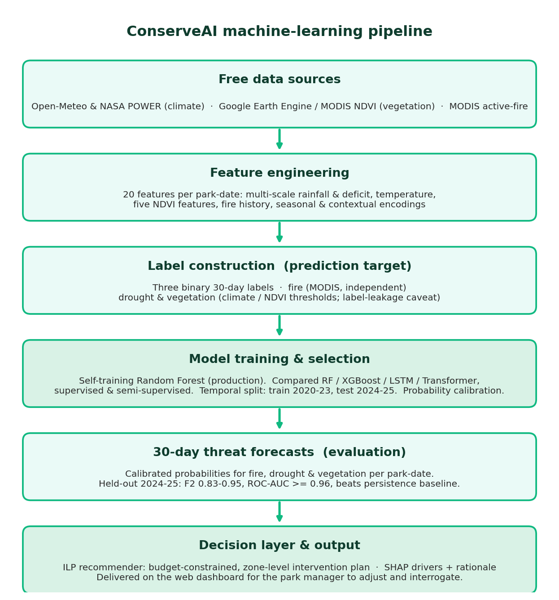
Figure 1: Proposed model / ML pipeline diagram.

3.5 System Architecture
The system was structured as five horizontal layers: a React frontend; a FastAPI API layer enforcing park-scoped JWT authentication; a business-logic layer holding the forecast model, calibrator, PuLP optimiser, and SHAP explainer; a PostgreSQL data layer; and external free data sources feeding a daily scheduled job (Figure 2).
[ PASTE IMAGE HERE — System architecture diagram ]
Paste this from your proposal (system architecture figure).

Figure 2: System architecture diagram.

3.6 UML and Other Diagrams
Four UML diagrams specified the system at three levels of abstraction. The use-case diagram (Figure 3) captured the actors (Park Manager, National Admin, and the Scheduler) and their interactions; the class diagram (Figure 4) captured the domain model (User, Park, Zone, Forecast, Recommendation, Allocation, Intervention, ForecastModel, Calibrator); the entity-relationship diagram (Figure 5) captured the PostgreSQL schema; and the sequence diagram (Figure 6) captured the forecast-viewing and recommendation workflow.
[ PASTE IMAGE HERE — Use case diagram ]
Paste this from your proposal.

Figure 3: Use case diagram.
[ PASTE IMAGE HERE — Class diagram ]
Paste this from your proposal.

Figure 4: Class diagram.
[ PASTE IMAGE HERE — Entity-relationship diagram (database schema) ]
Paste this from your proposal.

Figure 5: Entity-relationship diagram.
[ PASTE IMAGE HERE — Sequence diagram ]
Paste this from your proposal.

Figure 6: Sequence diagram.

3.7 Development Tools
Python 3.12 (data pipeline, models, backend); scikit-learn, XGBoost, and PyTorch (model architectures); PuLP (integer linear programming); SHAP (interpretability); FastAPI and SQLAlchemy (backend); PostgreSQL, hosted on Neon (database); APScheduler and GitHub Actions (scheduling); React with Ant Design, Leaflet, and Recharts (frontend); Fly.io and Vercel (deployment); and Git and GitHub (version control).

3.8 Ethical Considerations
Because the system stored user accounts and produced risk scores, the design addressed the data it actually handled. Privacy and consent: the only personal data stored was manager account information (username, a bcrypt-hashed password, and an email), and no individual or community data was collected. Sensitive data and misuse: the system forecast environmental threats at the park and zone level, not the locations of animals or people, which limited the risk that its maps could be misused to target wildlife, unlike poaching-prediction systems. Bias and fairness: performance was reported per park and per ecosystem (Section 5.2) so that the model could not silently under-serve one park type, and that breakdown did reveal materially weaker accuracy in the rainforest. Human-in-the-loop and safety: recommendations were framed as decision support, the reasoning behind each was shown so a manager could audit rather than defer to it, and the system carried a clear proof-of-concept disclaimer against sole reliance. Provenance: all data sources were free and openly licensed, and were attributed.

CHAPTER 4: SYSTEM IMPLEMENTATION AND TESTING

4.1 Implementation and Coding

4.1.1 Introduction
This section describes how the designed system was implemented and how it was tested, focusing on the concrete tools, the main modules, and the verification evidence rather than restating the project’s purpose.

4.1.2 Description of Implementation Tools and Technology
The backend was implemented in FastAPI with SQLAlchemy over a Neon-hosted PostgreSQL database, and exposed a documented REST API. The machine-learning pipeline used scikit-learn; the production model was a self-training Random Forest, with XGBoost, LSTM, and Transformer variants compared during model selection. The recommender was implemented with PuLP. The frontend was a React single-page application using Ant Design, Leaflet for maps, and Recharts for the forecast charts. A daily job, scheduled through GitHub Actions in production, pulled current data, ran inference, and wrote forecasts to the database.

4.1.3 Source Code of the Main Modules
Four modules carried the core logic. Listing 1 shows the feature engineering that turned raw daily observations into the twenty model inputs, using backward-looking rolling windows only, so no future information could enter a feature.
df["rain_7d"] = precip.rolling(7, min_periods=4).sum()
df["rain_30d"] = precip.rolling(30, min_periods=15).sum()
df["rain_deficit_30d"] = df["rain_30d"] - expected_30d
df["hot_days_30d"] = (temp_max > 35).astype(float).rolling(30, min_periods=15).sum()
df["ndvi_90d_avg"] = ndvi_filled.rolling(90, min_periods=30).mean()
df["fire_30d"] = fire.rolling(30, min_periods=15).sum()
df["days_since_fire"] = days_since.fillna(365).clip(upper=365)
df["doy_sin"] = np.sin(2 * np.pi * doy / 365.25)
Listing 1: Feature engineering (src/data_pipeline/feature_engineering.py).
Listing 2 shows how the vegetation label was constructed. NDVI is carried forward across the sixteen-day MODIS composite, compared with its own 90-day mean, and a degradation window is declared when enough days in a fortnight fall below that mean; the forward-looking helper then asks whether such a window occurs in the next 30 days.
ndvi = df["ndvi_s2"].ffill(limit=16) # MOD13Q1 is a 16-day composite
ndvi_90d_avg = ndvi.rolling(NDVI_WINDOW, min_periods=NDVI_WINDOW // 3).mean()
below = (ndvi - ndvi_90d_avg < -NDVI_THRESHOLD).astype(float)
degraded_window = (below.fillna(0)
.rolling(VEG_WINDOW, min_periods=VEG_WINDOW // 2)
.sum() >= VEG_DAYS_IN_WINDOW).astype(float)
df["vegetation_within_30d"] = _forward_label(degraded_window)
Listing 2: Vegetation label construction (src/data_pipeline/label_drought_vegetation.py).
Listing 3 is the self-training loop that produced the production model. On each iteration the current model scores the unlabelled pool, rows whose confidence exceeds the threshold on all three threats are pseudo-labelled and moved into the labelled set, and the forest is refitted.
for it in range(1, N_ITER + 1):
probs_ul = get_probs(model, X_ul)
conf = np.maximum(probs_ul, 1 - probs_ul) # (N, 3)
mask = np.all(conf > CONF_THRESHOLD, axis=1) # all-threat gate
if mask.sum() == 0:
break
pseudo_Y = (probs_ul[mask] > 0.5).astype(float)
X_lab = np.vstack([X_lab, X_ul[mask]]); Y_lab = np.vstack([Y_lab, pseudo_Y])
X_ul = X_ul[~mask]
model = fit_rf(X_lab, Y_lab, params)
Listing 3: Semi-supervised self-training loop (src/models/semi_supervised/train_rf_self.py).
Listing 4 is the recommender itself. One integer variable counts the units of each intervention; the objective maximises the probability-weighted effectiveness of the plan; and the constraints enforce the manager’s budget and the per-intervention capacity, which is why the plans in Table 4 never exceed the budget.
x = {inv.id: pulp.LpVariable(f"x_{inv.id}", lowBound=0, cat="Integer")
for inv in catalog}
score = {inv.id: sum(probs.get(t, 0.0) * inv.effectiveness.get(t, 0.0)
for t in THREAT_KEYS) for inv in catalog}

prob += pulp.lpSum(score[inv.id] * x[inv.id] for inv in catalog) # objective
prob += pulp.lpSum(inv.cost * x[inv.id] for inv in catalog) <= constraints.budget
for inv in catalog:
prob += x[inv.id] <= inv.max_units, f"cap_{inv.id}" # capacity
Listing 4: ILP objective and constraints (src/optimizer/ilp_recommender.py).

4.2 Graphical View of the Project

4.2.1 Screenshots with Descriptions
A national administrator could view a Nigeria-wide risk overview, with each park shaded by risk and a switchable threat lens (Figure 7).
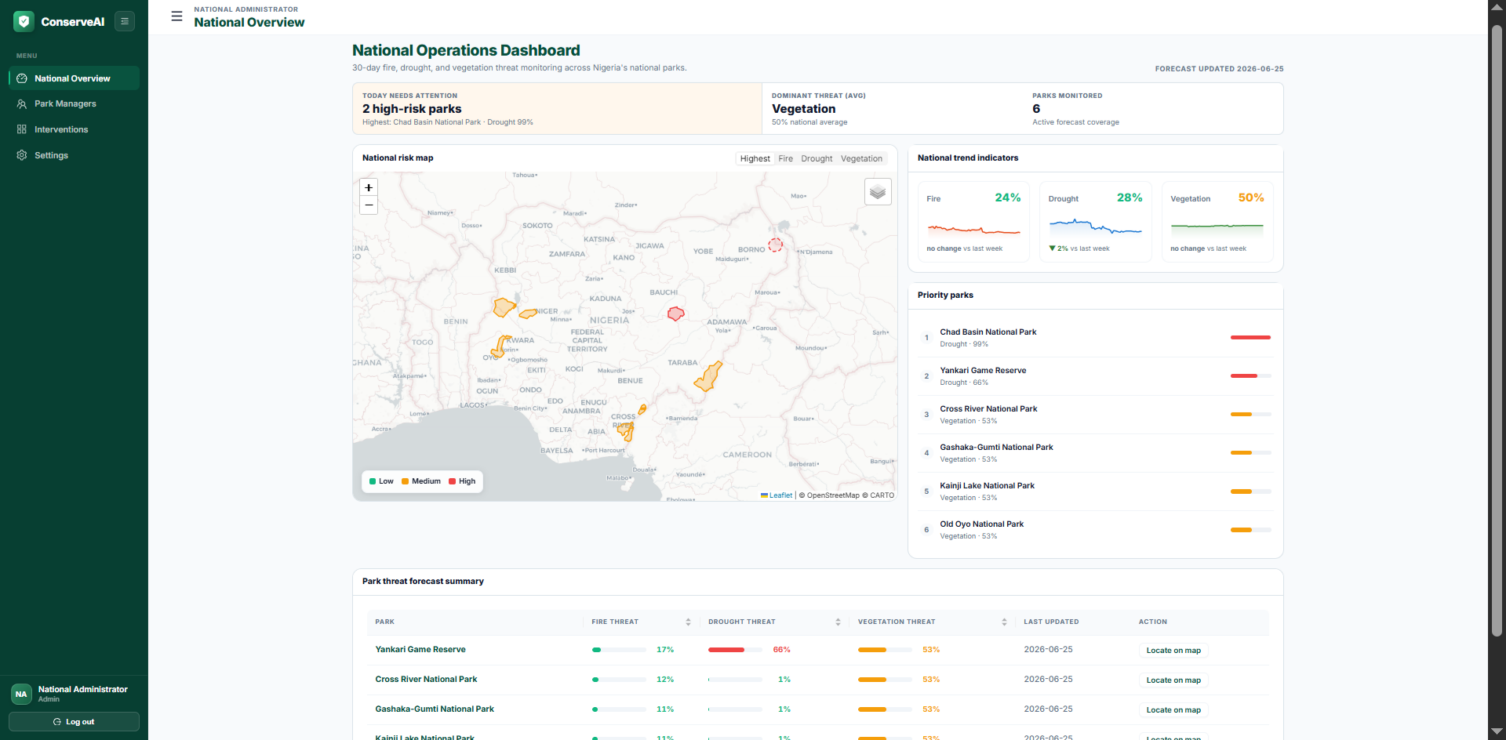
Figure 7: National overview, per-park risk and threat lens.
A park manager could open a park, read its 30-day forecast and drivers, set a budget, and generate a budget-constrained, zone-level intervention plan that explained why each intervention was chosen (Figure 8).
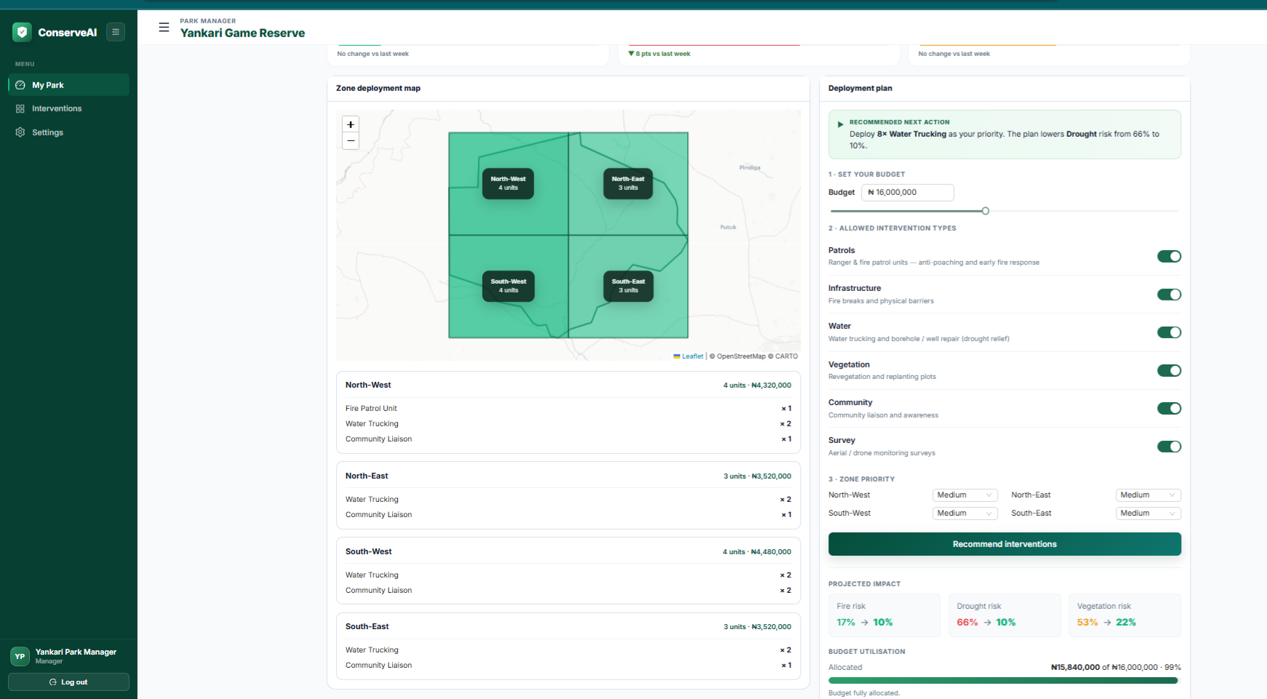
Figure 8: Park console with a generated recommendation and zone plan.
The interactive REST service was also browsable as Swagger documentation (Figure 9).
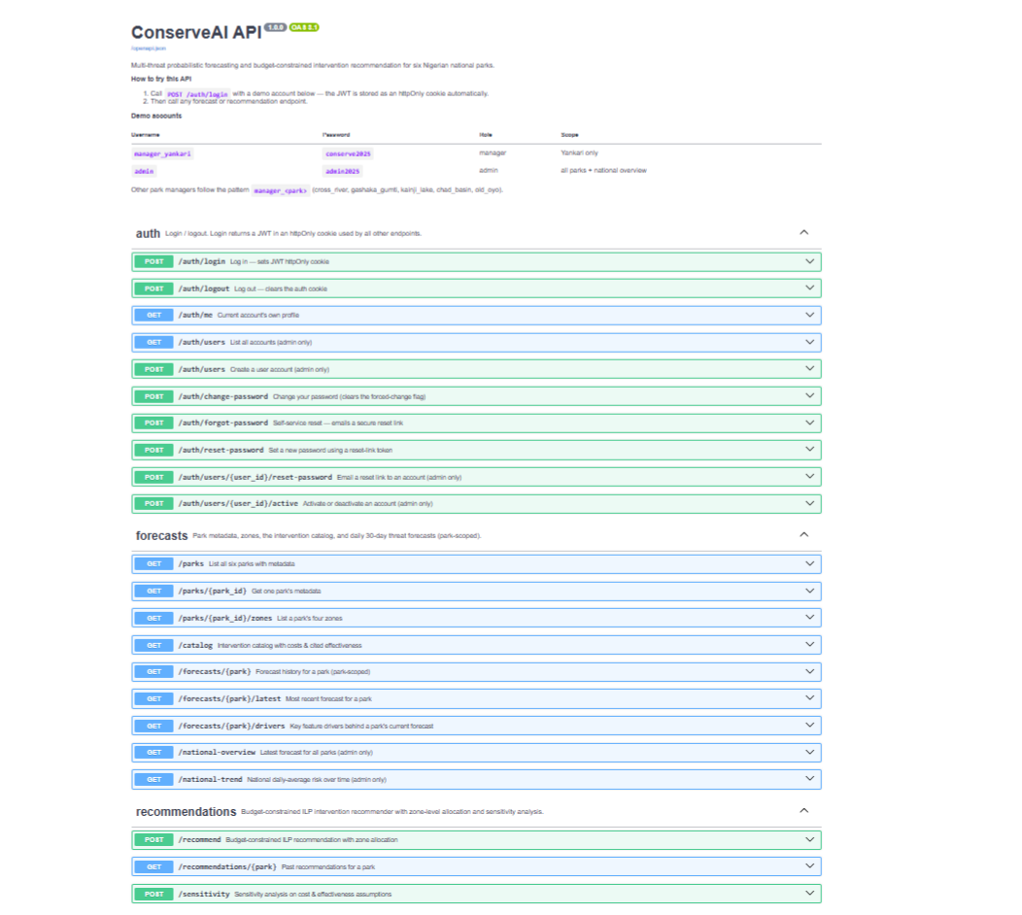
Figure 9: The live REST API documentation.

4.3 Testing

4.3.1 Introduction
The system was verified through several complementary testing strategies: automated unit tests, model evaluation on held-out data, integration and API tests against the live deployment, end-to-end browser testing, and a performance comparison across environments.

4.3.2 Objective of Testing
The objective was to confirm that each component behaved as specified under different inputs and edge cases, that the model generalised to unseen data, and that the deployed system was correct and performant.

4.3.3 Unit Testing Outputs
Nineteen automated unit tests covered the deterministic components: the ILP optimiser (budget, capacity, type toggles, urgency floors, and the recommendation rationale) and authentication (bcrypt hashing, the password policy, and JWT access and reset tokens). All nineteen passed (Figure 10).
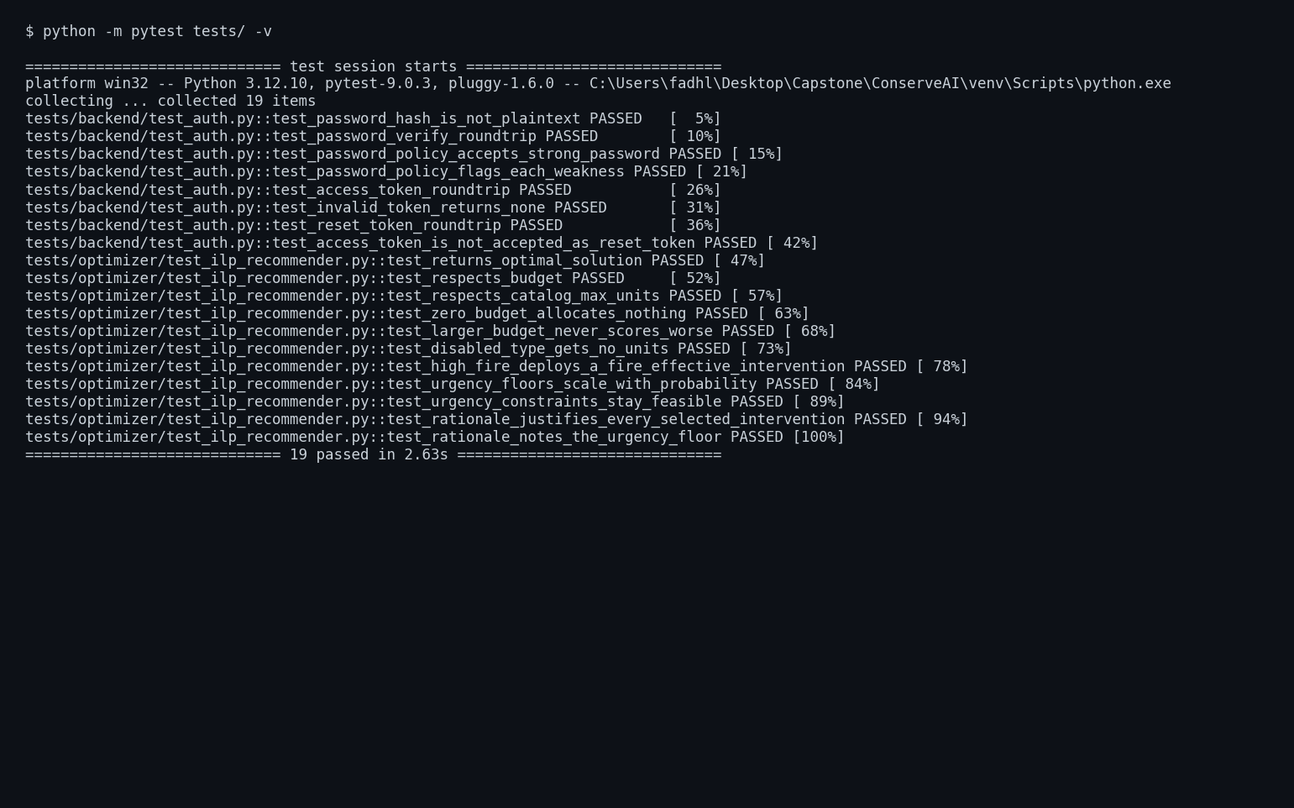
Figure 10: The automated unit-test suite passing.

4.3.4 Validation Testing Outputs
The model was validated on a temporally separate 2024 to 2025 test set of 4,206 park-day rows it never saw during training. The results are reported and interpreted in Chapter Five (Figure 11, Table 6).
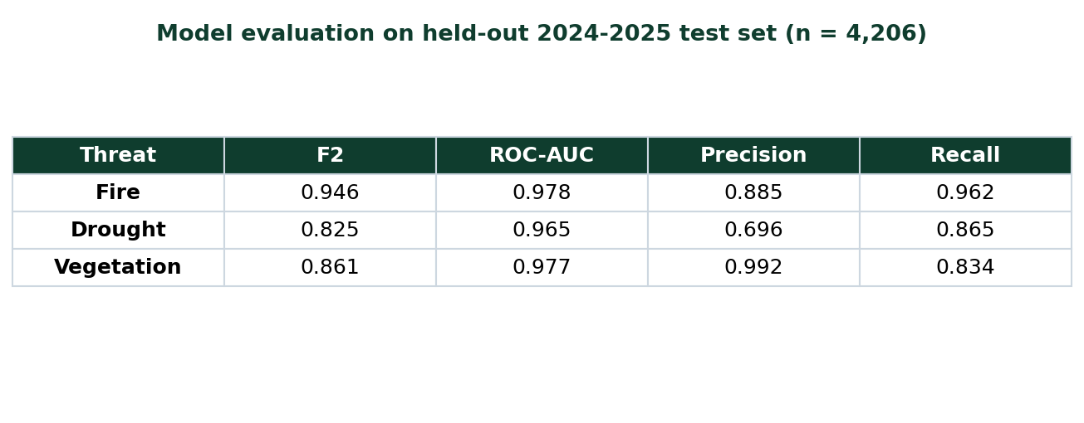
Figure 11: Held-out model evaluation metrics.

4.3.5 Integration Testing Outputs
Each endpoint was exercised against the live deployment. Health and database checks returned ok; a valid login returned 200 and set a secure cookie while an invalid login returned 401; protected routes returned 401 without a session and 200 with one; the daily-job endpoint returned 403 without its token and 200 with it, processing all six parks.

4.3.6 Functional and System Testing Results
The full user journey was tested in the browser on the deployed site: logging in, viewing the national overview, opening a park, reading the forecast and drivers, setting a budget, and generating a recommendation that appeared on the zone map. The recommender was also exercised with different data values, the same park at several budgets, which confirmed that the plan scaled with the budget and never exceeded it (Table 4).
Budget | Total units | Total cost | Solve time
₦8,000,000 | 6 | ₦7,680,000 | 41 ms
₦16,000,000 | 14 | ₦15,840,000 | 37 ms
₦32,000,000 | 19 | ₦31,840,000 | 38 ms
₦80,000,000 | 44 | ₦80,000,000 | 35 ms
Table 4: Recommender behaviour across budgets (live system; naira at ₦1,600 per US dollar).
Performance was measured across two environments, a local Windows machine and the Fly.io cloud container. The cloud, co-located with the database, was three to five times faster on every call (Figure 12).
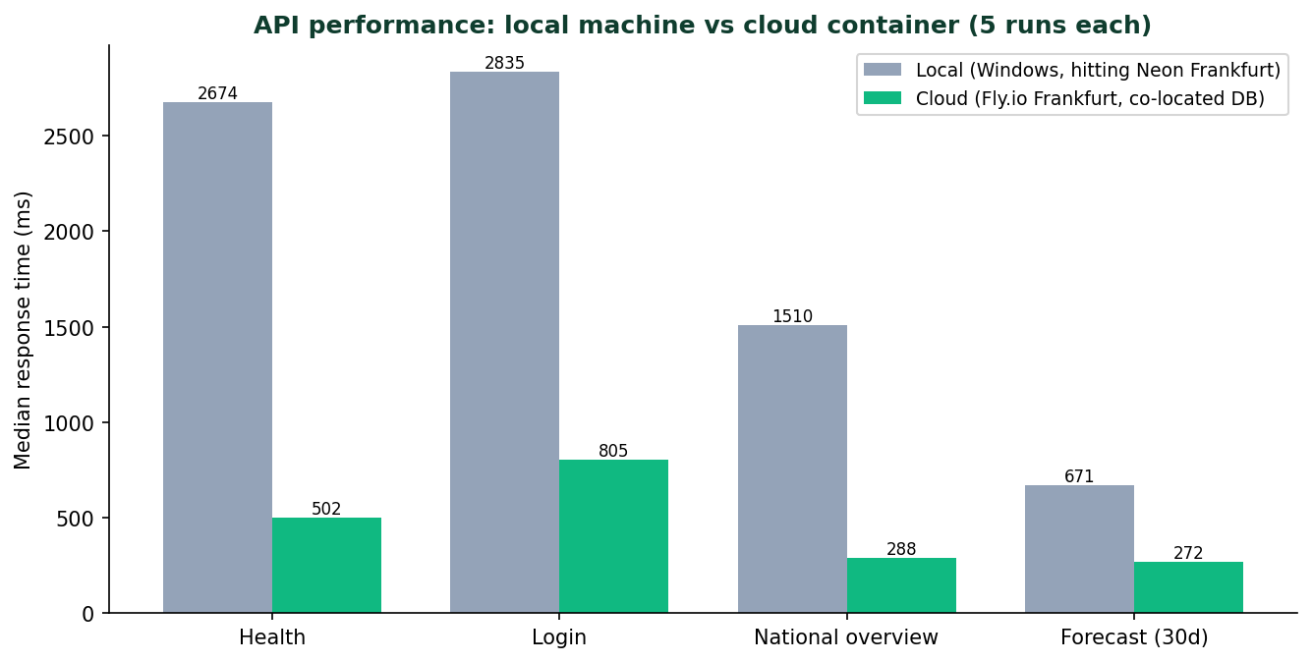
Figure 12: Local-vs-cloud API performance.

4.3.7 Acceptance Testing Report
Against the proposal’s objectives, the system was accepted as meeting its functional requirements: it forecast three threats for six parks daily, recommended budget-constrained zone-level interventions, enforced role-based access, and ran live. Table 5 summarises the strategies and outcomes.
Strategy | Outcome
Unit tests (pytest) | 19 / 19 pass
Model evaluation (held-out) | Fire F2 0.95, Drought 0.83, Vegetation 0.86
Integration / API | All endpoints behave as specified
End-to-end (browser) | Full journey works on the deployed site
Different data values | Recommender scales with budget; per-park forecasts differ
Performance (hardware) | Cloud 3 to 5x faster than local; sub-second warm responses
Table 5: Summary of testing strategies and outcomes.

CHAPTER 5: DESCRIPTION OF THE RESULTS
This chapter presents the results, interprets what the numbers meant for the problem, and connects them to the research questions and objectives.

5.1 Forecasting Results and Baseline Comparison
On the held-out 2024 to 2025 test set, the production model (a self-training Random Forest) scored an F2 of 0.95 for fire, 0.83 for drought, and 0.86 for vegetation, with ROC-AUC above 0.96 on all three (Table 6). Crucially, it beat the persistence baseline on every threat, and by a wide margin on drought (F2 0.83 versus 0.35), so the model learned real structure rather than repeating recent history. This answered research question two: the tree-based model was the strongest of the four architectures compared, consistent with the finding that tree-based models outperform deep learning when events are scarce, and research question four: at the operating threshold the model gave a mean lead time of three to four days.
Threat | Prevalence | Precision | Recall | F2 | ROC-AUC | Baseline F2 | Lead (days)
Fire | 54% | 0.88 | 0.96 | 0.95 | 0.98 | 0.78 | 4.1
Drought | 17% | 0.70 | 0.86 | 0.83 | 0.97 | 0.35 | 2.8
Vegetation | 30% | 0.99 | 0.83 | 0.86 | 0.98 | 0.71 | 3.4
Table 6: Held-out model evaluation results (n = 4,206).
Table 7 sets the selected model against the persistence baseline and the three other semi-supervised variants trained on the same data; the supervised variants are omitted here for clarity. Every semi-supervised variant beat the baseline on mean F2, but the two tree-based models (Random Forest and XGBoost) clearly outperformed the two deep sequence models (LSTM and Transformer, both trained with FixMatch), which is consistent with the reviewed finding that tree-based models win when positive events are scarce. The deep models were the weakest of the group: the LSTM and the Transformer both fell below the persistence baseline on vegetation (0.57 against 0.71), meaning they failed to learn the vegetation signal from the limited labels. The self-training Random Forest achieved the highest mean F2 (0.88) and won on fire and vegetation; XGBoost matched it on drought (0.829 against 0.825 before rounding) but collapsed on vegetation. The Random Forest was therefore selected for the best overall mean F2 and for its CPU-only tabular inference, which needs no sequence buffer at serving time. The tree-based family was therefore the right choice for this data.
Model | Fire F2 | Drought F2 | Vegetation F2 | Mean F2
Random Forest, self-training (selected) | 0.95 | 0.83 | 0.86 | 0.88
XGBoost, self-training | 0.94 | 0.83 | 0.63 | 0.80
LSTM, FixMatch | 0.92 | 0.71 | 0.57 | 0.74
Transformer, FixMatch | 0.94 | 0.61 | 0.57 | 0.71
Persistence baseline | 0.78 | 0.35 | 0.71 | 0.61
Table 7: Semi-supervised variants and the persistence baseline (F2 by threat and mean).
Whether semi-supervised learning helped at all is a separate question, and the honest answer is that it depended on the architecture (Table 8). Self-training raised the Random Forest’s mean F2 by 0.020 (0.857 to 0.877) and FixMatch raised the Transformer’s by 0.018, but semi-supervision reduced mean F2 for XGBoost (by 0.029) and for the LSTM (by 0.041). The gain was uneven even inside the selected model: self-training lifted vegetation F2 from 0.744 to 0.861 but lowered drought F2 from 0.882 to 0.825, so the Random Forest was chosen on mean F2 even though a purely supervised Random Forest would have forecast drought better. This is the specific answer to research question three: semi-supervised learning helped, but only for two of the four architectures and by roughly 0.02 mean F2, not uniformly.
Architecture | Supervised mean F2 | Semi-supervised mean F2 | Change
Random Forest (selected) | 0.857 | 0.877 | +0.020
XGBoost | 0.827 | 0.798 | -0.029
LSTM | 0.777 | 0.736 | -0.041
Transformer | 0.689 | 0.707 | +0.018
Table 8: Supervised versus semi-supervised mean F2, by architecture.
Research question one asked whether fusing climate, satellite, and fire data beats using a single modality. This was tested directly by an ablation: four Random Forests were trained identically on the same split and calibration, varying only the feature modality available to them, with the seasonal and park context retained in every run so that the comparison isolates the sensing modality (Table 9). The result is more interesting than a simple win. Fusion gave the best mean F2 (0.872), but each threat was best predicted by its own natural modality: fire history alone was best on fire (0.948), climate alone was best on drought (0.868), and satellite NDVI alone was best on vegetation (0.887), each slightly beating the fused model on that threat. The honest reading is that fusion buys breadth rather than per-threat optimality: one fused model handles all three threats well, whereas a single-modality model is strong on its own threat and weak elsewhere, most visibly the fire-history model collapsing to 0.594 on drought. Because the system must serve all three threats from one deployed model, the fused feature set was the right choice. Note that these ablation figures come from supervised Random Forests trained for this comparison, so they are internally comparable but sit slightly below the production self-training model reported in Table 6.
Feature set | Features | Fire F2 | Drought F2 | Vegetation F2 | Mean F2
Climate only | 12 | 0.917 | 0.868 | 0.781 | 0.856
Satellite (NDVI) only | 10 | 0.943 | 0.634 | 0.887 | 0.821
Fire history only | 8 | 0.948 | 0.594 | 0.850 | 0.797
Fused (all modalities) | 20 | 0.935 | 0.831 | 0.850 | 0.872
Table 9: Single-modality versus fused feature sets (held-out test set).

5.2 Performance by Park and Ecosystem
Reporting only national averages can hide a model that serves one park type poorly, so performance was broken down per park with bootstrap confidence intervals (Table 10) and then aggregated by ecosystem (Table 11). Each park contributed 701 evaluated park-days. The spread is wide and it is not noise: Chad Basin, the arid Sahel park, was forecast best on every threat (fire 0.99, drought 0.93, vegetation 0.95), while Cross River, the rainforest park, was the weakest overall (drought 0.71, vegetation 0.68), and Old Oyo’s drought forecast was the single weakest cell in the study at 0.53. The pattern is ecologically coherent rather than arbitrary. Arid and strongly seasonal parks give the model sharp, repeating signals to learn, whereas the rainforest is wet year-round, its NDVI is the most affected by cloud, and its threat events are rarer and less cleanly separated, so the same model has less to work with.
Park | Ecosystem | Fire F2 [95% CI] | Drought F2 [95% CI] | Vegetation F2 [95% CI]
Chad Basin | Sahel | 0.99 [0.98-0.99] | 0.93 [0.91-0.95] | 0.95 [0.92-0.98]
Cross River | Rainforest | 0.91 [0.89-0.94] | 0.71 [0.60-0.81] | 0.68 [0.62-0.75]
Gashaka-Gumti | Mixed | 0.98 [0.97-0.99] | 0.78 [0.71-0.84] | 0.87 [0.83-0.91]
Kainji Lake | Savanna | 0.94 [0.91-0.95] | 0.95 [0.93-0.97] | 0.94 [0.91-0.97]
Old Oyo | Savanna | 0.95 [0.93-0.96] | 0.53 [0.45-0.61] | 0.81 [0.76-0.85]
Yankari | Savanna | 0.88 [0.85-0.90] | 0.91 [0.88-0.93] | 0.89 [0.85-0.93]
Table 10: Per-park F2 with 95% bootstrap confidence intervals (701 park-days each).
Aggregated by ecosystem (Table 11), mean F2 fell from 0.96 in the Sahel to 0.77 in the rainforest. This answers the second half of research question two: the ranking of threats did shift by ecosystem, and more importantly the model’s reliability itself varies by ecosystem. It also supplies the evidence behind the fairness commitment made in Section 3.8. Read as a fairness result it is a caution rather than a reassurance: the system is least dependable exactly where it is applied to rainforest, so a Cross River manager should treat its drought and vegetation output with more scepticism than a Chad Basin manager would need to.
Ecosystem | Parks | Fire F2 | Drought F2 | Vegetation F2 | Mean F2
Sahel | 1 | 0.99 | 0.93 | 0.95 | 0.96
Mixed | 1 | 0.98 | 0.78 | 0.87 | 0.88
Savanna | 3 | 0.92 | 0.80 | 0.88 | 0.87
Rainforest | 1 | 0.91 | 0.71 | 0.68 | 0.77
Table 11: Mean F2 by ecosystem (parks grouped from Table 10).

5.3 Which Threat Was Hardest: Reading the Confusion Matrices
The confusion matrices (Figure 13) explained what the aggregate scores meant. Fire was caught reliably: the model recovered 2,166 of 2,251 fire windows (recall 96%) at the cost of 282 false alarms, an acceptable trade because a missed fire is costlier than a false alarm. Drought was the hardest threat: its precision was 0.70, the lowest of the three, meaning 262 of its positive predictions were false alarms, which is why its F2 was lowest despite a strong ROC-AUC; the rarity of drought (17% prevalence) made precision hard to hold. Vegetation showed the opposite profile after the fix described below: precision 0.99 with only 8 false alarms, but 207 missed windows (recall 83%), so the model was conservative and trustworthy when it did raise a vegetation flag.
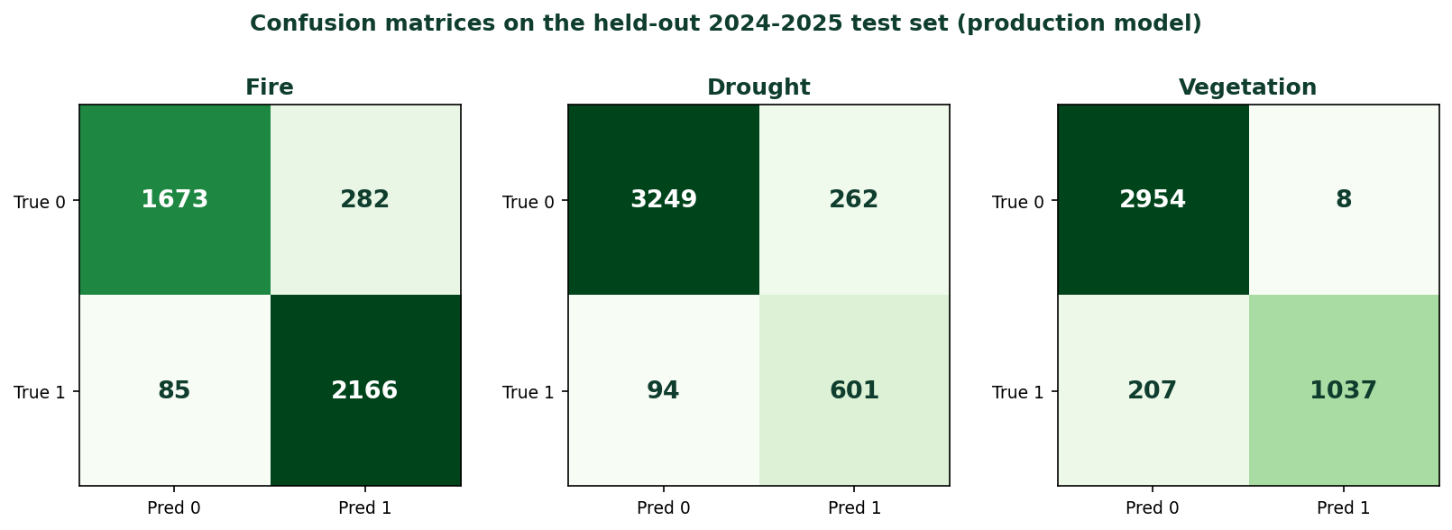
Figure 13: Confusion matrices on the held-out test set (production model).

5.4 The Vegetation Result: Diagnosing and Fixing a Degenerate Output
A live observation exposed a genuine defect and its fix, which is itself a key result. An earlier version of the model collapsed to a near-constant vegetation output, with five of six parks returning an identical value, because its optical NDVI was blocked by rainy-season cloud and because training used one sensor while serving used another. Both pipelines were moved onto a single cloud-robust source, the sixteen-day MODIS MOD13Q1 composite; the model was retrained, the database migrated, and the corrected model redeployed and verified live. Vegetation ROC-AUC rose from 0.77 to 0.98, and this corrected model is the one whose results are reported throughout this chapter. Figure 14 shows the vegetation risk for three contrasting parks across a full year: it was near zero in the wet season and rose to roughly 90% in the dry season, which confirmed that the model responded to real conditions rather than emitting a fixed value.
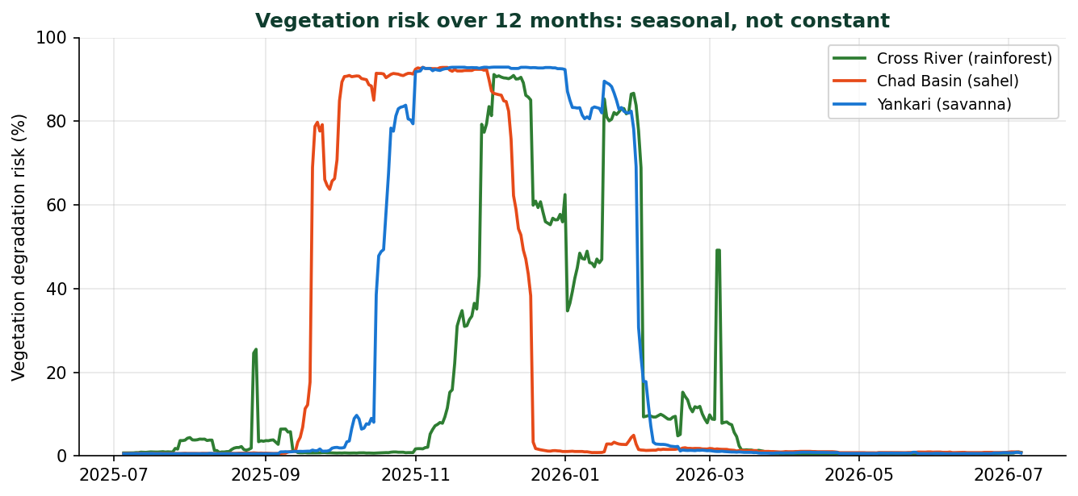
Figure 14: Vegetation risk over twelve months for three parks.

5.5 Recommender Results
Budgets are reported in naira, the currency the interface presents to managers, by converting the optimiser’s internal US-dollar intervention costs at ₦1,600 per US dollar. The integer-linear-programming recommender honoured the budget and per-intervention capacity in every test, scaled its plan as the budget grew, and solved in under 60 milliseconds. Because the recommendation was produced by transparent optimisation and explained why each intervention was chosen, a manager could audit rather than merely accept it (Figure 15). A sensitivity analysis confirmed the plans were stable to small changes in the assumed cost and effectiveness values, which answered research question five.
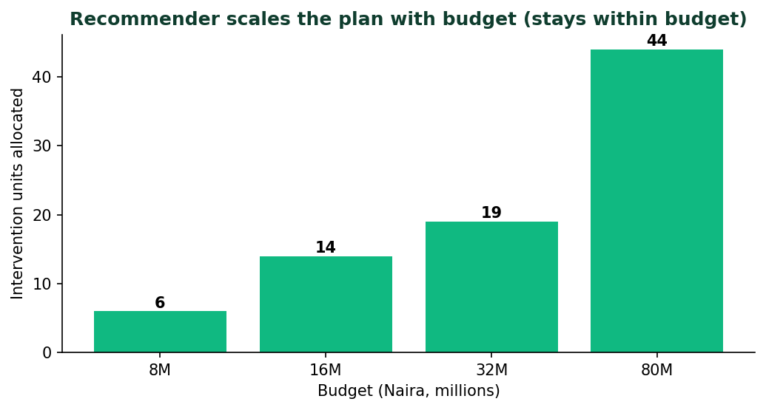
Figure 15: Recommender plan scaling with budget.

5.6 Discussion
The results showed that open data and interpretable methods can drive a usable, transparent decision-support tool for a resource-constrained setting. Read against the objectives, the forecasting objective was met for all three threats, the software objective was met (the system ran live), and the evaluation objective was met with imbalance-aware metrics and a baseline. Read against the literature, the tree-based result matched the reviewed evidence, and the wide margin over persistence addressed the common weakness of reporting accuracy without a baseline. The practical usefulness was that a manager received a costed, zone-level plan with three to four days of lead time. The contribution was primarily methodological: the project connected three steps usually kept apart, turning open data into a forecast, the forecast into a costed plan, and both into an explanation, and showed the pipeline ran unattended once deployed. As a matter of honesty, this was a validated proof of concept: it validated the framework, not full real-world deployment. Its limits were that the drought and vegetation labels derived from climate thresholds rather than fully independent ground truth (a label-leakage risk); the threat set was bounded by what free data could measure and so omitted poaching and grazing; and the intervention parameters were literature-informed estimates rather than figures measured in these parks.

CHAPTER 6: CONCLUSIONS AND RECOMMENDATIONS

6.1 Conclusions
The project met its main objective: it delivered a live system that produced daily 30-day forecasts for fire, drought, and vegetation degradation across six Nigerian national parks and recommended budget-constrained, zone-level interventions, using only free data. Stated specifically rather than as a claim of general success: the self-training Random Forest beat the persistence baseline on all three threats, was strongest on fire (F2 0.95) and vegetation (F2 0.86 after the sensor fix), and ranked drought risk well (ROC-AUC 0.97) even though drought precision remained the weakest point at 0.70 because of class imbalance.

6.2 Answers to the Research Questions
The evidence answered the five questions as follows. (1) Fusing the three modalities gave the best mean F2 (0.872 against 0.856 for climate alone, 0.821 for satellite alone and 0.797 for fire history alone), although each threat was marginally best predicted by its own modality, so fusion bought breadth rather than per-threat optimality (Table 9). (2) The tree-based model was the best of the four architectures on every threat, and that ranking held across ecosystems even though accuracy did not: mean F2 ranged from 0.96 in the Sahel to 0.77 in the rainforest (Table 11). (3) Semi-supervised learning helped only two of the four architectures: it raised mean F2 by 0.020 for the Random Forest and 0.018 for the Transformer but lowered it for XGBoost and the LSTM, and inside the Random Forest it traded drought accuracy (0.882 to 0.825) for a large vegetation gain (0.744 to 0.861). (4) Outputs tracked seasonal ground conditions and gave three to four days of lead time. (5) The recommendations were stable to small changes in cost and effectiveness assumptions.

6.3 Limitations of the Study
Three limitations qualify the results. First, the drought and vegetation labels were derived from the same climate and NDVI signals used as features, which created a label-leakage risk and means those scores should be read as consistency checks rather than independent validation. Second, the threat set was bounded by remotely observable phenomena and excluded poaching and grazing, which dominate in practice. Third, the intervention parameters were literature-informed estimates, and the system did not yet log actual field deployments.

6.4 Recommendations
Recommendations follow directly from the findings rather than from unrelated ideas. Because drought precision was the weakest metric, a manager should treat a drought flag as a prompt to verify rather than an instruction to act, and because the system is a proof of concept, a recommendation should be treated as a starting point to which local knowledge is applied, especially for threats the model does not cover.

6.5 Future Work
Future work follows from the limitations. The vegetation-sensing fix reported in Section 5.4, moving both training and serving to the MOD13Q1 composite, resolved the earlier collapse and is already live; three extensions build on it: a Sentinel-1 radar backup that sees through cloud, per-park seasonal imputation of any residual gaps, and a low-confidence flag when satellite coverage is poor. Beyond vegetation, the climate-derived labels should be replaced with independent ground truth to remove the label-leakage risk; deployment logging should be added so the system can learn from real outcomes; the optimiser should become intervention-aware and multi-period; and the threat set should be widened toward poaching and grazing using ranger patrol records.

REFERENCES
Beyer, H. L., Dujardin, Y., Watts, M. E., & Possingham, H. P. (2016). Solving conservation planning problems with integer linear programming. Ecological Modelling, 328, 14-22. https://doi.org/10.1016/j.ecolmodel.2016.02.005
Brys, C., La Red Martínez, D. L., & Marinelli, M. (2025). Machine learning methods for wildfire risk assessment. Earth Science Informatics, 18, 148. https://doi.org/10.1007/s12145-024-01690-z
Cazalis, V., Prince, K., Mihoub, J.-B., Kelly, J., Butchart, S. H. M., & Rodrigues, A. S. L. (2020). Effectiveness of protected areas in conserving tropical forest birds. Nature Communications, 11, 4461. https://doi.org/10.1038/s41467-020-18230-0
Craigie, I. D., Baillie, J. E. M., Balmford, A., Carbone, C., Collen, B., Green, R. E., & Hutton, J. M. (2010). Large mammal population declines in Africa’s protected areas. Biological Conservation, 143(9), 2221-2228. https://doi.org/10.1016/j.biocon.2010.06.007
Fang, F., Nguyen, T. H., Pickles, R., Lam, W. Y., Clements, G. R., An, B., … Lemieux, A. (2017). PAWS: A deployed game-theoretic application to combat poaching. AI Magazine, 38(1), 23-36. https://doi.org/10.1609/aimag.v38i1.2710
Gorelick, N., Hancher, M., Dixon, M., Ilyushchenko, S., Thau, D., & Moore, R. (2017). Google Earth Engine: Planetary-scale geospatial analysis for everyone. Remote Sensing of Environment, 202, 18-27. https://doi.org/10.1016/j.rse.2017.06.031
Haider, H. (2019). Climate change in Nigeria: Impacts and responses (K4D Helpdesk Report 675). Institute of Development Studies. https://opendocs.ids.ac.uk/opendocs/handle/20.500.12413/14761
Hutson, M. (2018). Artificial intelligence faces reproducibility crisis. Science, 359(6377), 725-726. https://doi.org/10.1126/science.359.6377.725
Kasusse, K. S., Mushore, T., & Matose, F. (2021). Spatial Monitoring and Reporting Tool (SMART) in Mid-Zambezi Valley, Zimbabwe. Conservation Science and Practice, 3(9), e492. https://doi.org/10.1111/csp2.492
Lindsey, P. A., Miller, J. R. B., Petracca, L. S., Coad, L., Dickman, A. J., … Hunter, L. T. B. (2017). The performance of African protected areas for lions and their prey. Biological Conservation, 209, 137-149. https://doi.org/10.1016/j.biocon.2017.01.011
Lundberg, S. M., & Lee, S.-I. (2017). A unified approach to interpreting model predictions. In Advances in Neural Information Processing Systems 30 (pp. 4765-4774). https://arxiv.org/abs/1705.07874
McNicol, I. M., Keane, A., Burgess, N. D., Bowers, S. J., Mitchard, E. T. A., & Ryan, C. M. (2023). Protected areas reduce deforestation and degradation and enhance woody growth across African woodlands. Communications Earth & Environment, 4, 392. https://doi.org/10.1038/s43247-023-01053-4
Mohammed, A. K., & Adamu, B. (2021). Early warning systems development for agricultural drought assessment in Nigeria. Environmental Monitoring and Assessment, 193, 27. https://doi.org/10.1007/s10661-020-08730-3
Naderpour, M., Rizeei, H. M., & Ramezani, F. (2021). Forest fire risk prediction: A spatial deep neural network-based framework. Remote Sensing, 13(13), 2513. https://doi.org/10.3390/rs13132513
Réjou-Méchain, M., Mortier, F., Bastin, J. F., Cornu, G., Barbier, N., … Ploton, P. (2021). Unveiling African rainforest composition and vulnerability to global change. Nature, 593(7857), 90-94. https://doi.org/10.1038/s41586-021-03483-6
Schuster, R., Hanson, J. O., Strimas-Mackey, M., & Bennett, J. R. (2020). Exact integer linear programming solvers outperform simulated annealing for solving conservation planning problems. PeerJ, 8, e9258. https://doi.org/10.7717/peerj.9258
Shiru, M. S., Shahid, S., Chung, E. S., Alias, N., & Scherer, L. (2020). Projection of meteorological droughts in Nigeria during growing seasons under climate change scenarios. Scientific Reports, 10, 10107. https://doi.org/10.1038/s41598-020-67146-8
Siddig, A. H. (2019). Why is biodiversity data-deficiency an ongoing conservation dilemma in Africa? Journal for Nature Conservation, 50, 125719. https://doi.org/10.1016/j.jnc.2019.125719
SMART Partnership. (2024). SMART Conservation Software. https://smartconservationtools.org/
Sohn, K., Berthelot, D., Carlini, N., Zhang, Z., Zhang, H., Raffel, C., … Li, C. L. (2020). FixMatch: Simplifying semi-supervised learning with consistency and confidence. Advances in Neural Information Processing Systems, 33, 596-608. https://arxiv.org/abs/2001.07685
Tuia, D., Kellenberger, B., Beery, S., Costelloe, B. R., Zuffi, S., … Berger-Wolf, T. (2022). Perspectives in machine learning for wildlife conservation. Nature Communications, 13(1), 792. https://doi.org/10.1038/s41467-022-27980-y
UNEP-WCMC, & IUCN. (2024). Protected Planet: Nigeria. World Database on Protected Areas. https://www.protectedplanet.net/country/NGA
Van Engelen, J. E., & Hoos, H. H. (2020). A survey on semi-supervised learning. Machine Learning, 109(2), 373-440. https://doi.org/10.1007/s10994-019-05855-6
Xu, L., Gholami, S., McCarthy, S., Dilkina, B., Plumptre, A., Tambe, M., … Enyel, E. (2020). Stay ahead of poachers: Illegal wildlife poaching prediction and patrol planning under uncertainty with field test evaluations. In Proceedings of the IEEE International Conference on Data Engineering (pp. 1898-1901). https://arxiv.org/abs/1903.06669

