Da380 Project Report

Scenario Description
In this project, we developed a predictive maintenance system to enhance the operational efficiency of various machines. The purpose of this system is to predict and schedule maintenance activities before unexpected failures occur, thereby reducing downtime and associated costs. We focused on six machine types: CNC Machines, Conveyor Belts, Robotic Arms, Turning Machines, Lathe Machines, and Hydraulic Presses. Each machine's failure rate, maintenance time, and associated costs were considered to create three distinct scenarios, each reflecting different operational conditions. The assumptions made include consistent operating hours and a direct correlation between failure time random numbers (RNs) and machine failures.

Data Collection
In this project, instead of collecting data, we opted to randomly generate the required data for the simulation. This approach was chosen due to the unavailability of real-world data, making it impractical to gather actual data. The randomly generated data includes variables such as failure rates, maintenance times, and costs associated with different machine types across three scenarios. These values were carefully generated to reflect plausible operational conditions, ensuring that the simulation results would still offer meaningful insights into predictive maintenance strategies.

Simulation Model
The simulation model was designed to replicate the failure and maintenance processes of the machines within the manufacturing facility. The model incorporates a failure process where each machine type has a predefined failure rate, and the time until failure is simulated using random numbers. Failure time is calculated by multiplying the random number by 1000 and dividing it by the failure rate. Upon failure, machines are taken offline for a duration equal to the maintenance time, during which maintenance costs and downtime costs are calculated. Maintenance scheduling is determined by either performing maintenance immediately upon failure or following a predefined schedule based on cumulative failure time and operating hours. The simulation was implemented in Excel using various formulas and functions, such as IF() and SUM(), to calculate failure times, make maintenance decisions, and determine costs.

Experimentation and Analysis
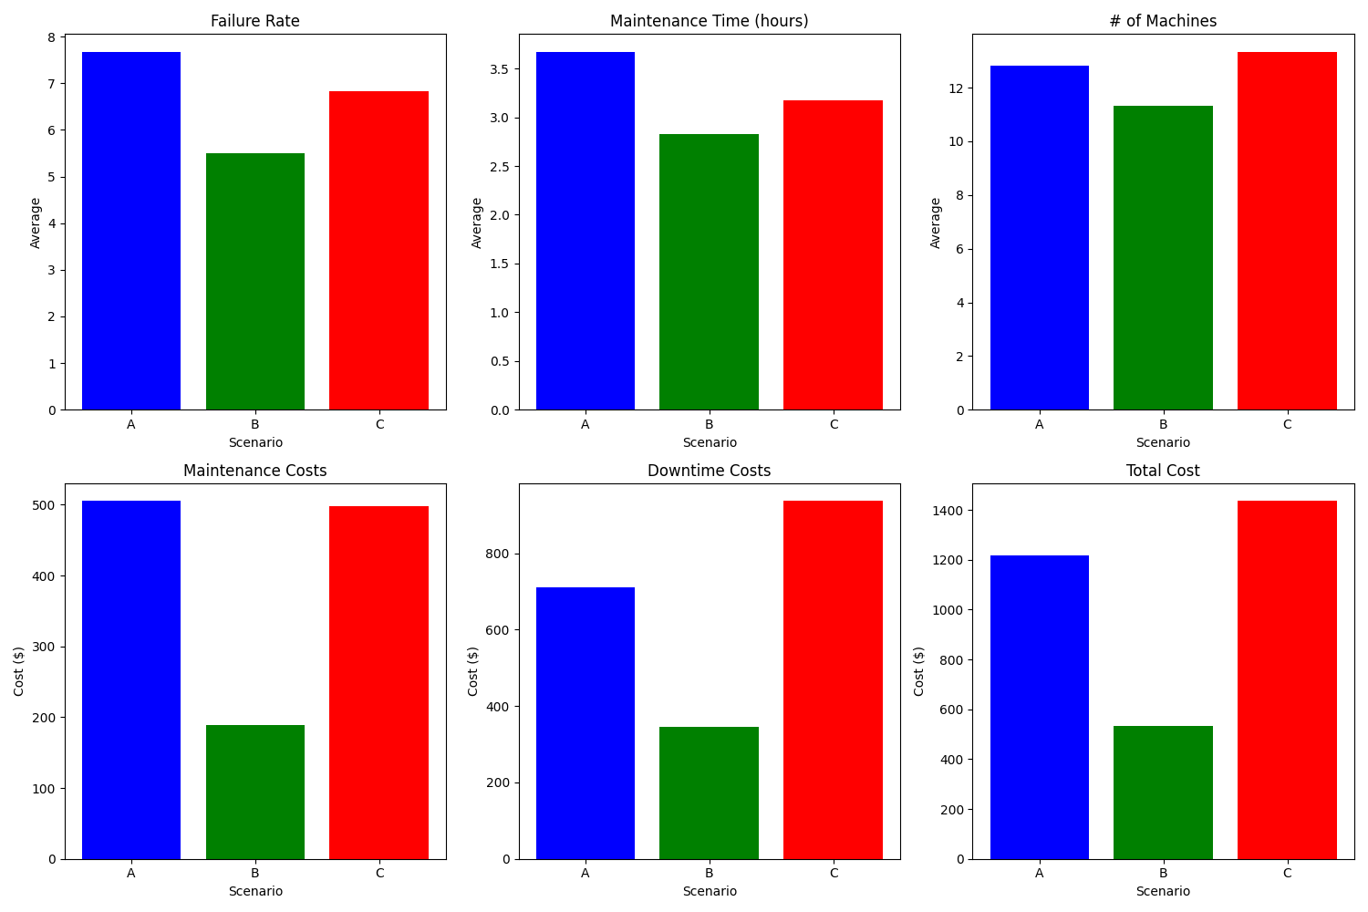
The simulation was run for three different scenarios (A, B, and C), each featuring different machine types and operational parameters. In Scenario A, the average failure rate was 7.67, the average maintenance time was 3.67 hours, and the total cost amounted to $1216.67. Scenario B, which emerged as the most cost-effective, had an average failure rate of 5.50, an average maintenance time of 2.83 hours, and a total cost of $534.63. Scenario C, which had the highest total cost of $1435.13, featured an average failure rate of 6.83, with a higher downtime cost being the primary contributor. These results suggest that Scenario B's lower failure rates and maintenance times resulted in reduced overall costs, while Scenario C incurred higher costs due to extended downtime and higher downtime costs.

Conclusions and Insights
The simulation revealed that Scenario B was the most cost-effective, with the lowest total cost due to its combination of lower failure rates and efficient maintenance scheduling. Scenario A, although less expensive than Scenario C, had higher costs due to frequent machine failures and longer downtimes. Scenario C, while having moderate failure rates, was the most expensive due to the high costs associated with downtime and maintenance. These findings underscore the importance of optimizing maintenance schedules and reducing machine failures to minimize operational costs.

Recommendations
To improve the predictive maintenance system, it is recommended to focus on reducing failure rates through preventive measures and optimizing maintenance schedules to minimize downtime. Investing in better quality parts or more frequent inspections could further reduce the frequency of machine failures. Additionally, leveraging advanced predictive algorithms could enhance the accuracy of failure predictions, leading to more efficient maintenance planning.

Limitations and Future Work
The simulation model has certain limitations, including the assumption of consistent operating hours and the use of random numbers to simulate failure times, which may not fully capture the complexity of real-world operations. Future work could involve incorporating more detailed machine behavior models, considering varying operating conditions, and exploring the impact of different maintenance strategies. Further research could also focus on integrating real-time data from machines to enhance the predictive accuracy of the maintenance system.

References
online resources on Excel-based simulation techniques.

Appendices
The appendices include Appendix A, which contains the file of the Excel simulation model.

