Double pendulum

Fadi Ayoub

2025/2026

About the project:
This project investigates the dynamics of a double pendulum. A double pendulum is a pendulum made up of two masses, connected together by ropes, and it moves in a very complex way.
The research focused on the influence of the system’s initial angles of the pendulums. A mathematical model based on nonlinear differential equations was developed, and a computer simulation was created to simulate the pendulum’s real-time behavior. The simulation allows control and modification of the system’s initial values in order to study their effect on the pendulum’s chaotic motion and to compare the model’s predictions with the setup.

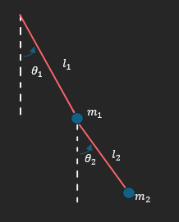
Physical and mathematical background
We have a double pendulum, consisting of
two masses connected by two rigid rods, one of which is connected to the other. The first mass hangs from a fixed pivot point, and the second mass hangs from the first mass.
This system is a classic example of a nonlinear dynamical system, and its motion is often chaotic, meaning small changes in the initial conditions can lead to completely different results over time.
To describe the motion of the system, we will define:
M₁ M₂ as the masses of the first and second arms of the pendulum
L₁ L₂ As the lengths of the two rods
θ₁ θ₂ As the angles of each arm from the vertical
We will place the origin point (0,0) at the upper axis of the pendulum.
We will define the y-axis as pointing upward, and use trigonometry to write expressions for the positions.
$$x_{1}=L_{1}\sin\left(θ_{1}\right)$$
$$y_{1}=-L_{1}\cos\left(θ_{1}\right)$$
$$x_{2}=x_{1}+L_{2}\sin\left(θ_{2}\right)$$
$$y_{2}=y_{1}-L_{2}\cos\left(θ_{2}\right)$$
Velocity is the derivative of position with respect to time:
$${\dot{x}}_{1} = {\dot{θ}}_{1} ·L_{1} ·cos \left(θ_{1}\right)$$
$${\dot{x}}_{2}={\dot{x}}_{1} +{\dot{θ}}_{2} ·L_{2} ·cos \left(θ_{2}\right)$$
$${\dot{y}}_{1}= {\dot{θ}}_{1} ·L_{1}· sin \left(θ_{1}\right)$$
$${\dot{y}}_{2} = {\dot{y}}_{1} + {\dot{θ}}_{2} ·L_{2}·sin \left(θ_{2}\right)$$
The potential energy of the system
$$V=V₁+V₂$$
$$V₁=M₁·g·h$$
$$=-M₁·g·L₁·cos \left(θ₁\right)$$
$$V₂=M₂·g·h$$
$$=-M₂·g·\left(L₁·cos \left(θ₁\right)+L₂·cos \left(θ₂\right)\right)$$
$$V=-M₁·g·L₁·cos \left(θ₁\right)-M₂·g·\left(L₁·cos \left(θ₁\right)+L₂·cos \left(θ₁\right)\right)$$
where $g$is the gravitational acceleration ($9.8 {\text{m/s}}^{2}$)
and the kinetic energy is given by:
$$T=T₁+T₂$$
$$T₁=½·M₁·{v₁}^{2}$$
$$T₂=½·M₂·{v₂}^{2}$$
$${v₁}^{2}={\dot{x₁}}^{2}+y{̇₁}^{2}$$
$${v₂}^{2}={\dot{x₂}}^{2}+y{̇₂}^{2}$$
$$T₁=\left(1/2\right)·M₁·\left({\dot{θ₁ }}^{2}·{L₁}^{2}·cos^{2}\left(θ₁\right)+{\dot{θ₁ }}^{2}·{L₁}^{2}·sin^{2}\left(θ₁\right)\right)$$
$$=\left(1/2\right)·M₁·{\dot{θ₁ }}^{2}·{L₁}^{2}$$
$$T₂=\left(1/2\right)·M₂·\left[{\left(\dot{θ₁ }·L₁·cos\left(θ₁\right)+\dot{θ₂}·L₂·cos\left(θ₂\right)\right)}^{2}+{\left(\dot{θ₁ }·L₁·sin\left(θ₁\right)+\dot{θ₂}·L₂·sin\left(θ₂\right)\right)}^{2}\right]$$
$$=\left(1/2\right)·M₂·\left[\dot{θ_{1}^{2}}·{L₁}^{2}+\dot{θ_{2}^{2}}·{L₂}^{2}+2·\dot{θ₁ }·\dot{θ₂}·L₁·L₂·cos\left(θ₁-θ₂\right)\right]$$
$$T=T₁+T₂$$
$$T=\left(1/2\right)·M₁·{\dot{θ₁ }}^{2}·{L₁}^{2}+\left(1/2\right)·M₂·\left[{\dot{θ₁ }}^{2}·{L₁}^{2}+{\dot{θ₂}}^{2}·{L₂}^{2}+2·\dot{θ₁ }·\dot{θ₂}·L₁·L₂·cos\left(θ₁-θ₂\right)\right]$$To analyze the motion of a double pendulum—a system known for its complexity and sensitivity to initial conditions—it is useful to use a method that simplifies the process of deriving the equations of motion. One effective method for this is the Euler-Lagrange method from analytical mechanics.

The Euler-Lagrange method is a powerful tool in classical mechanics, used to derive the motion of physical systems. Instead of focusing on forces, as in the Newtonian method, it is based on energy—and specifically on the difference between kinetic and potential energy, called the Lagrangian function. By applying this principle to the general coordinates of the system, the equations that describe its behavior can be systematically derived. In the case of the double pendulum, this method provides an efficient and clear way to describe the complex and sometimes chaotic motion of the two connected masses.
The Lagrangian is finally given by T - V, that is:
$$L = \left(1/2\right)·M₁·{\dot{θ₁ }}^{2}·{L₁}^{2}+(1/2) ·M₂· [\dot{θ₁ }²·L₁² + \dot{θ₂}²·L₂² + 2·\dot{θ₁}·\dot{θ₂}·L₁·L₂·cos (θ₁ - θ₂)] + M₁·g · L₁· cos (θ₁) + M₂·g·(L₁· cos (θ₁) + L₂· cos (θ₂)$$Now we need to solve the Euler-Lagrange equation for both θ₁ and θ₂:
$$\frac{∂L}{∂θ} -\frac{d}{dt}\frac{∂L}{∂\dot{θ}} = 0$$

For θ₁ we get:
$$\frac{∂L}{∂θ₁}=\frac{1}{2}·M₂·\left[-2·\dot{θ₁}·\dot{θ₂}·L₁·L₂·sin\left(θ₁-θ₂\right)\right]-M₁·g·L₁·sin\left(θ₁\right)-M₂·g·L₁·sin\left({\dot{θ}}_{1} \right)$$

Which we simplify to:
$$\frac{∂L}{∂θ₁}=-\dot{θ₁}\dot{{·θ}_{2} }·M_{2}·L_{1}·L_{2}·sin\left(θ_{1}-θ_{2}\right)-\left(M_{1}+M_{2}\right)·g·L_{1}·sin\left(θ_{1}\right)$$

And now for the second:
$$\frac{∂L}{∂\dot{θ₁ }}=M_{1}·\dot{θ₁}·{L_{1}}^{2}+1/2·M_{2}·\left[2·\dot{θ₁}·{L_{1}}^{2}+2·L_{1}·{\dot{θ₂}·L}_{2}·\cos\left(θ_{1}-θ_{2}\right)\right]$$
Which simplifies to:
$$\frac{∂L}{∂\dot{θ^{1}}}=\left(M_{1}+M_{2}\right)·\dot{θ₁ }·{L_{1}}^{2}+M_{2}\dot{{·θ}_{2} }{·L}_{1}·L_{2}·\cos\left(θ_{1}-θ_{2}\right)$$

Now its derivative with respect to time:
$$\frac{d}{dt}\frac{∂L}{∂\dot{θ₁ }}=\left(M_{1}+M_{2}\right)·\ddot{θ_{1}}·{L_{1}}^{2}+M_{2}·L_{1}·L_{2}·\left[\ddot{θ_{2}}·\cos\left(θ_{1}-θ_{2}\right)-\dot{θ_{2} }·\dot{θ₁ }·\sin\left(θ_{1}-θ_{2}\right)+\dot{θ_{2}^{2}}·\sin\left(θ_{1}-θ_{2}\right)\right]$$
And in the end we get this equation:
$$0=-\dot{θ₁ }\dot{{·θ}_{2} }·M_{2}·L_{1}·L_{2}·\sin\left(θ_{1}-θ_{2}\right)-\left(M_{1}+M_{2}\right)·g·L_{1}·sin\left(θ_{1}\right)-\left(M_{1}+M_{2}\right)·\ddot{θ_{1}}·{L_{1}}^{2}-M_{2}·L_{1}·L_{2}·\left[\ddot{θ_{2}}·\cos\left(θ_{1}-θ_{2}\right)-\dot{θ_{2} }·\dot{θ₁ }·\sin\left(θ_{1}-θ_{2}\right)+\dot{θ_{2}^{2}}·\sin\left(θ_{1}-θ_{2}\right)\right]$$
Which we can simplify to:[1]
$$0=\left(M_{1}+M_{2}\right)g\sin\left(θ_{1}\right)+\left(M_{1}+M_{2}\right)L_{1}\ddot{θ_{1}}+M_{2}L_{2}\ddot{θ_{2}}\cos\left(θ_{1}-θ_{2}\right)+M_{2}L_{2}\dot{θ_{2}^{2}}\sin\left(θ_{1}-θ_{2}\right)$$
)(We call this equation (1)
Now we do the same for:θ₂
$$\frac{∂L}{∂θ_{2}}=\frac{1}{2}·M_{2}·\left[2·{\dot{θ}}_{1}·\dot{θ_{2}}·L_{1}·L_{2}·sin\left(θ_{1}-θ_{2}\right)\right]-M_{2}·g·L_{2}·sin\left(θ_{2}\right)$$

Let's simplify this to:
$$\frac{∂L}{∂θ_{2}}=M_{2}·{\dot{θ}}_{1}·\dot{θ_{2}}·L_{1}·L_{2}·sin\left(θ_{1}-θ_{2}\right)-M_{2}·g·L_{2}·sin\left(θ_{2}\right)$$
Now for the second:
$$\frac{∂L}{∂{\dot{θ}}_{2}}=½·M_{2}·\left[2·\dot{θ_{2}}·L_{2}^{2}+2·{\dot{θ}}_{1}·L_{1}·L_{2}·cos\left(θ_{1}-θ_{2}\right)\right]$$

Let's simplify this to:
$$\frac{∂L}{∂{\dot{θ}}_{2}}=M_{2}·{\dot{θ}}_{2}·L_{2}^{2}+M_{2}·{\dot{θ}}_{1}·L_{1}·L_{2}·cos\left(θ_{1}-θ_{2}\right)$$

Now its derivative with respect to time:
$\frac{d}{dt}\frac{∂L}{∂{\dot{θ}}_{2}}=M_{2}·{\ddot{θ}}_{2}·L_{2}^{2}+M_{2}L_{1}L_{2}\left[\ddot{θ_{1}}·cos\left(θ_{1}-θ_{2}\right)-\dot{θ_{1}^{2}}·sin\left(θ_{1}-θ_{2}\right)+{\dot{θ}}_{1}·{\dot{θ}}_{2}·sin\left(θ_{1}-θ_{2}\right)\right]$

And now the equation we get from θ₂:
$$0=M_{2}·{{\dot{θ}}_{2}L}_{2}{\dot{θ}}_{1}L_{1}\sin\left(θ_{1}-θ_{2}\right)-M_{2}·g·L_{2}·sin\left(θ_{2}\right)-M_{2}·\ddot{θ_{2}}·L_{2}^{2}-M_{2}·L_{1}·L_{2}\left[\ddot{θ_{1}}·cos\left(θ_{1}-θ_{2}\right)-\dot{θ_{1}^{2}}·sin\left(θ_{1}-θ_{2}\right)+{\dot{θ}}_{1}·{\dot{θ}}_{2}·sin\left(θ_{1}-θ_{2}\right)\right]$$

Let's simplify this to:
$$0=M_{2}·L_{2}\dot{θ_{1}^{2}}L_{1}\sin\left(θ_{1}-θ_{2}\right)-M_{2}·g·L_{2}·sin\left(θ_{2}\right)-M_{2}·\ddot{θ_{2}}·L_{2}^{2}-M_{2}·L_{2}\ddot{θ_{1}}L_{1}\cos\left(θ_{1}-θ_{2}\right)$$
And further simplified to [1]:
$$0=\dot{θ_{1}^{2}}L_{1}\sin\left(θ_{1}-θ_{2}\right)-g\sin\left(θ_{2}\right)-\ddot{θ_{2}}L_{2}-\ddot{θ_{1}}L_{1}\cos\left(θ_{1}-θ_{2}\right)$$
(We call this equation (2))
And now we have the two necessary equations for the double pendulum.
A very important point to emphasize is that the small-angle approximation cannot be used here, which means these equations are not solvable analytically. This approximation is a simplifying assumption often used in physics to make the analysis of certain systems easier, such as a simple pendulum.
However, it cannot be applied to a double pendulum because it is a nonlinear and chaotic system. Here are several reasons why:
- Nonlinearity: In a simple pendulum, the restoring force (the force that brings the pendulum back to equilibrium) is directly proportional to the angle the pendulum makes with the vertical. This allows the use of the small-angle approximation ((\sin \theta \approx \theta) for small angles) to simplify the equations of motion. In a double pendulum, however, the restoring forces are not linearly proportional to the angles, leading to nonlinear equations of motion. Therefore, the small-angle approximation, which assumes linearity, is invalid in this case.
- Chaos: A double pendulum is a chaotic system, meaning it is extremely sensitive to initial conditions. Even tiny changes in the starting positions or velocities of the pendulum can lead to completely different trajectories. This chaotic behavior arises from the complex, nonlinear interactions between the two pendulum arms. The small-angle approximation assumes deviations from the vertical are small and the system behaves linearly—which is not true for a double pendulum.
- Complex dynamics: The motion of a double pendulum involves multiple coupled differential equations, which are extremely difficult to solve analytically. These equations cannot be easily simplified into a linear approximation as with a simple pendulum.
4. These are the equations for theta second derivative 1 and theta second derivative 2, so we can solve this numerically:[2]
$$\ddot{θ_{1}} = \frac{-g\left(2M_{1}+M_{2}\right)sin\left(θ_{1}\right)-M_{2}gsin\left(θ_{1}​-2θ_{2}\right) -2\sin\left(θ_{1}-θ_{2}\right)M_{2}(\dot{θ_{2}^{2}}L_{2}+\dot{θ_{1}^{2}}L_{1}\cos\left(θ_{1}-θ_{2}\right))}{L_{1}(2M_{1}+M_{2}- M_{2}cos\left({2θ}_{1}-{2θ}_{2}\right))}$$

$$\ddot{θ_{2}}=\frac{2\sin\left(θ_{1}-θ_{2}\right)(\dot{θ_{1}^{2}}L_{1}\left(M_{1}+M_{2}\right)+g\left(M_{1}+M_{2}\right)+M_{2}\dot{θ_{2}^{2}}L_{2} \cos\left(θ_{1}-θ_{2}\right))}{L_{2}(2M_{1}+M_{2}- M_{2}cos\left({2θ}_{1}-{2θ}_{2}\right))}$$

Research Question
At what values ​​of initial angles do chaotic motion appear in the system, such that tiny changes in these angles cause erratic and unpredictable behavior over time?
Code Description
(1Initialization and Input Reception:
In this code there is no direct input from the user (like input()), but the settings are made directly in the code:
g = 9.81
M1 = M2 = 1.0
L1 = L2 = 1.0
• The physical variables defined:
g: acceleration due to gravity.
M1, M2: masses of the pendulums.
L1, L2: lengths of the pendulums.
• The initial conditions for each simulation are also defined below:
theta_degrees = [...]
delta = np.deg2rad(0.1)
- A range of starting angles for the pendulums (in degrees) is chosen, and these are converted to radians for use in trigonometric functions.
• A small delta difference was also chosen to identify chaotic phenomena (small initial change).
2. Numerical solution using Euler's method:
• The function simulate_double_pendulum_euler() is responsible for calculating the motion of the double pendulum numerically.
def simulate_double_pendulum_euler(...):
- Uses Euler's method — a simple method for solving differential equations by calculating the difference in small time steps.
- Solution process:
- Define arrays for the angles and velocities of each pendulum over time.
- For each time step:
- Calculate the angular accelerations of the two pendulums (complex equations that depend on the angles and velocities)
- Update velocity based on acceleration.
- Update angle based on velocity.
- Save the values.

(3. Comparing solutions using graphs:
• After performing each pair of simulations (Sim A) and (Sim B) with a small difference in the initial angle, we compare the results graphically:
fig, axs = plt.subplots(...)
...
ax.plot(x2_a, y2_a, label='Sim A')
ax.plot(x2_b, y2_b, label='Sim B')
- What dose the graphs show?
- The trajectory of the second pendulum tip for each of the simulations.
- If the paths diverge greatly, this indicates chaos.
- Why is it important?
- Visualizing the differences allows us to see whether the system is sensitive to initially small changes — a basic principle of chaotic systems.
- If the distance between the tracks exceeded 0.1 meter:
dist = np.sqrt(...)
separation_indices = np.where(dist > 0.1)[0]
• A black dividing point (line or X) was painted to mark when the chaos began.
Results and Conclusions Regarding the Research Question:
Results:
A series of numerical simulations were performed to identify the onset of chaotic behavior in a double pendulum system. The initial angles θ1 and θ2 were systematically varied, and chaos was detected by adding a small perturbation of 0.01 radians to the two initial angles and examining the distance between the trajectories that emerged over time. A threshold of 0.1 was used to define the onset of chaotic separation between the trajectories.
Onset of Chaos as a Function of the Initial Angles:
The onset of chaos was found to be strongly related to the magnitude of the initial angles. For situations where both angles were less than or equal to 75°, the system exhibited stability and showed no signs of chaos. In contrast, when one or both angles crossed 90°, chaotic behavior consistently emerged
for example:
When $θ_{1}={30}^{∘}$, chaos did not appear until $θ_{2}={105}^{∘}$, but it appeared at $θ_{2}={120}^{∘}$.
- When $θ_{1}={60}^{∘}$, the transition to chaos occurred between $θ_{2}={90}^{∘}$(no chaos) and $θ_{2}={105}^{∘}$(chaos).
- For $θ_{1}={75}^{∘}$, chaos appeared already at $θ_{2}={90}^{∘}$.
- When $θ_{1}$was ${90}^{∘}$or ${120}^{∘}$, chaos appeared for all tested values of $θ_{2}$.
The effect of the sum of the angles and the connections between them:
The findings indicate that the sum of the angles θ1 + θ2 alone is not a reliable predictor of the emergence of chaos. For example:
• The combination (θ1 = 60°, θ2 = 90°) did not show chaos,
• compared to the combination (θ1 = 30°, θ2 = 120°) where chaos was observed,even though the sum of the angles in both is equal to 150°. This finding emphasizes that the chaos stems from
• the individual values ​​and their interaction, and not just the total sum.
Relative importance of $θ_{1}$compared to $θ_{2}$:
It appears that the upper angle, $θ_{1}$, has a greater influence on the onset of chaos. When $θ_{1}={90}^{∘}$or ${120}^{∘}$, chaos appeared in all cases—even when $θ_{2}$was small. In contrast, large values of $θ_{2}$alone were not enough to produce chaos unless $θ_{1}$was medium or large.
This finding reinforces the understanding that $θ_{1}$, which governs the motion of the upper pendulum and thus affects the entire system, is the primary factor in the system’s instability.

Conclusions:
The onset of chaos depends on the initial angles.
Chaotic behavior in the double pendulum system is highly sensitive to the initial conditions, especially the values of $θ_{1}$and $θ_{2}$. The system remains stable for small angles (up to 75°), but chaos consistently appears when one or both angles approach or exceed 90°.
The sum of the angles alone does not determine chaos.
The total $θ_{1}+θ_{2}$does not reliably predict the onset of chaos. Different combinations of angles with the same sum can produce different outcomes—some stable, others chaotic—indicating that the interaction between the angles is more important than their total sum.
has a greater influence on the onset of chaos.
It appears that the angle of the first pendulum, $θ_{1}$, has a stronger effect on the appearance of chaos. When $θ_{1}$is large (90° or higher), chaos occurs even for relatively low values of $θ_{2}$. This indicates that the motion of the upper pendulum, which directly affects the second mass, is critical for destabilizing the system.
Effect of symmetry in the initial angles:
The results show that the system tends to be more stable when the initial angles of both pendulums are equal or very close. For example, the combination $(θ_{1}={60}^{∘},θ_{2}={60}^{∘})$led to stable motion without signs of chaos, whereas similar values where one angle was higher (e.g., $θ_{1}={60}^{∘},θ_{2}={45}^{∘}$) already exhibited chaotic behavior. This suggests that symmetry between the angles may contribute to internal balance in the system and reduce the mutual dynamic effects that cause instability.
Stable regions at low and medium angles:
For $θ_{1}≤{60}^{∘}$and $θ_{2}≤{90}^{∘}$, the system generally remains non-chaotic, indicating a relatively stable region in phase space. These findings can be useful for designing experiments or devices intended to avoid chaotic behavior.
Here is an example of a stable graph and a chaotic graph.
In both cases, there is one large angle, but one is chaotic and the other is stable, demonstrating that $θ_{1}$is more important than $θ_{2}$.
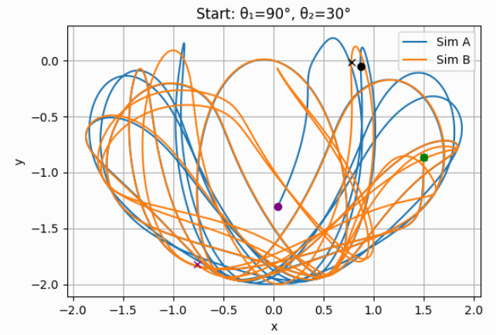
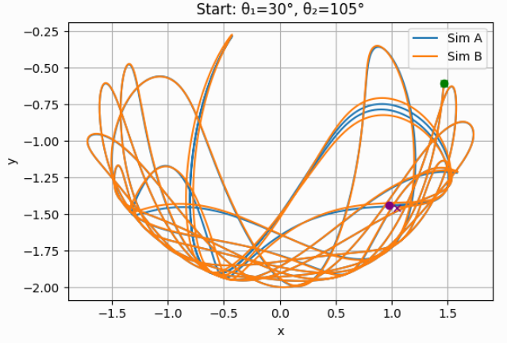

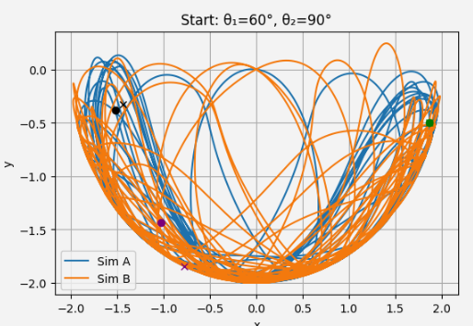
This is an example of how symmetry in angles is important and causes less chaos in a system:
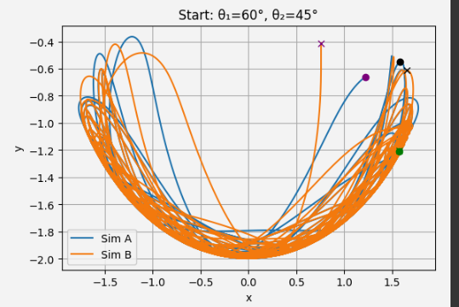

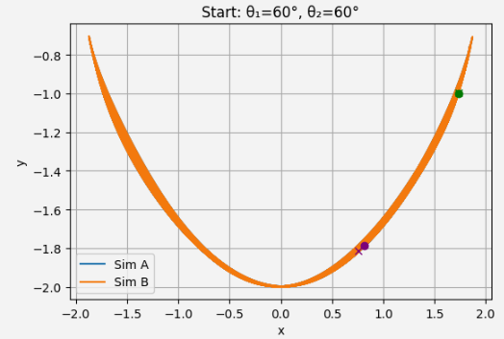

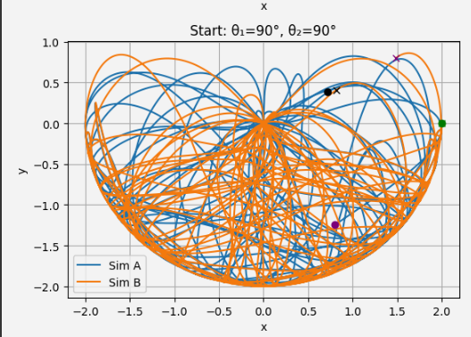
This is an example of how if θ₁ is greater than 90 degrees, the system will always be chaotic, regardless of whether there is symmetry in the angles or whether θ₁ is equal to 0 degrees:
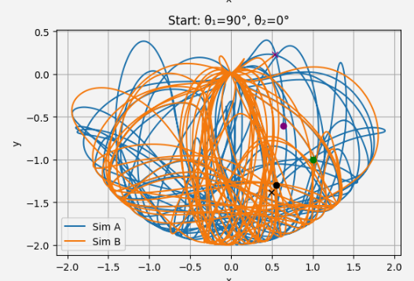

The experiment:
Background:
A physical experiment was conducted with a double pendulum system, with the aim of examining when chaotic behavior begins to appear as a result of the influence of the starting angles of the two pendulums (θ₁ and θ₂). Chaos was identified based on visual observation of motion trajectories that exhibited increasing deviation, clear non-periodicity, and increased sensitivity to slight changes in the starting angles. Method for determining the initial angles:
To set the initial angles, a direct angle-measuring device was not used; instead, a geometric method based on the Pythagorean theorem was applied:
- The upper pendulum had a length of 24 cm.
- The lower pendulum had a length of 20 cm.
In each experiment, the pendulum was manually moved to a specific position along the X or Y axis. The distance from the lowest point was measured, and the angle was calculated using:
$$θ={cos⁡}^{-1}(\frac{y}{L})\text{or}θ={sin⁡}^{-1}(\frac{x}{L})$$
where $L$is the length of the rod, and $x$or $y$is the measured distance.

Experimental results:
Main observations:
- Clear chaos appeared when:
  - $θ_{1}={30}^{∘},θ_{2}={120}^{∘}$
  - $θ_{1}={60}^{∘},θ_{2}={120}^{∘}$
  - θ₁ = 75°, θ₂ = 15°
- Partial/ borderline chaos was observed for:
- $θ_{1}={75}^{∘},θ_{2}={120}^{∘}$
- Stable (non-chaotic) behavior was observed for:
- $θ_{1}={75}^{∘},θ_{2}={75}^{∘}$
- Strong and clear chaos appeared whenever:
- $θ_{1}={90}^{∘},θ_{2}=0^{∘}$and $θ_{2}={90}^{∘}$

Conclusions:
Chaos depends on the initial angles:
The findings show that chaotic behavior in a double pendulum is highly influenced by the initial angles of both pendulums. The larger $θ_{1}$or $θ_{2}$is, the higher the likelihood of chaos. However, a high value in just one angle is not sufficient—the combination of both angles determines the outcome.
$θ_{1}$has a greater influence on the onset of chaos:
When $θ_{1}$(the upper pendulum) was large, chaos appeared even if $θ_{2}$was small. In contrast, high values of $θ_{2}$alone did not necessarily lead to chaotic behavior. This indicates that $θ_{1}$, which governs the initial motion of the entire system, has a dominant effect in creating instability.
The sum of the angles does not predict chaos:
It was found that the sum of the angles alone is not a reliable measure. For example:
- The combination $({60}^{∘},{90}^{∘})$was stable.
- In contrast, $({30}^{∘},{120}^{∘})$was chaotic, even though in both cases the sum is 150°.
Effect of symmetry in the initial angles:
The system tends to be more stable when the initial angles of the two pendulums are equal or very close. For example:
- $({75}^{∘},{75}^{∘})$led to stable motion.
- In contrast, $({75}^{∘},{15}^{∘})$showed chaos, even though $θ_{2}$was much smaller, which might be expected to reduce chaos, but instead produced stronger chaotic behavior.
- Additional physical factors:
It should be noted that a real physical system differs from an ideal mathematical model:
- The mass is not concentrated at a single point but distributed along the rods, which differs from what was assumed in our simulations.
- Air resistance also plays a role—it can slow down certain motions, alter the rate at which chaos develops, and sometimes slightly stabilize the system.
- Observations were made over only 5 seconds, whereas the simulation was run for about 50 seconds to eliminate numerical errors.
This illustrates that $θ_{1}$is more important than $θ_{2}$, as a large value of $θ_{1}$(over 60°) causes more chaos than a large value of $θ_{2}$(over 90°).
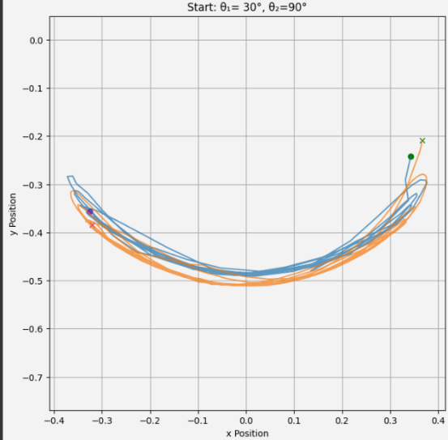
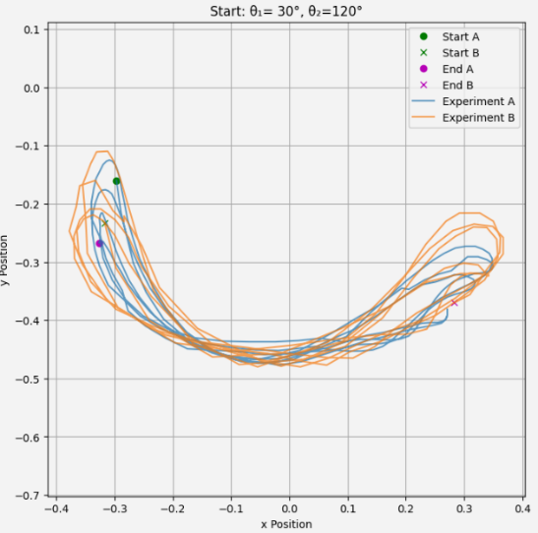

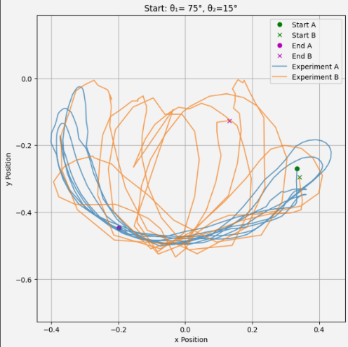

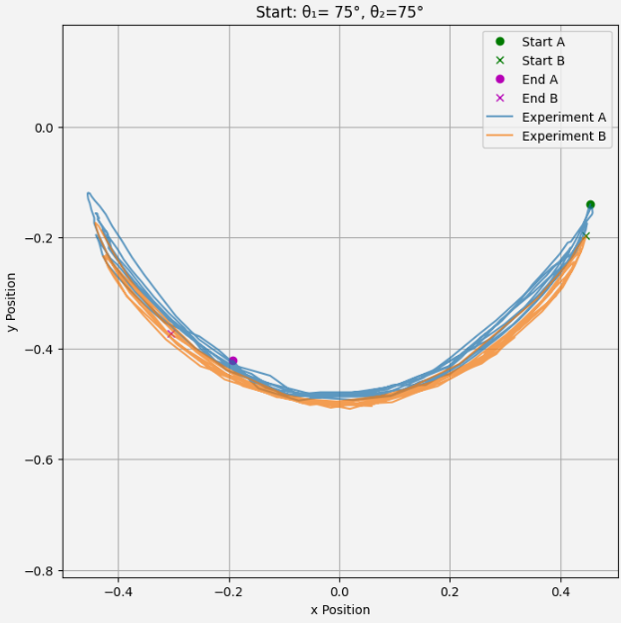
This is an example of how symmetry in angles causes less chaos even in an experiment, with the two 75-degree angles causing less chaos than θ₁ of 75 degrees and θ₂ of 15 degrees, even though a higher angle generally causes more chaos:
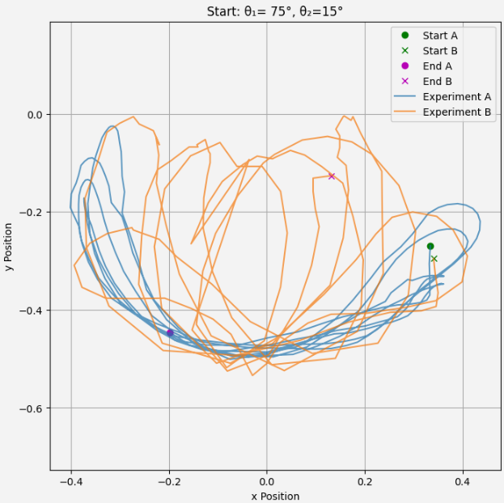
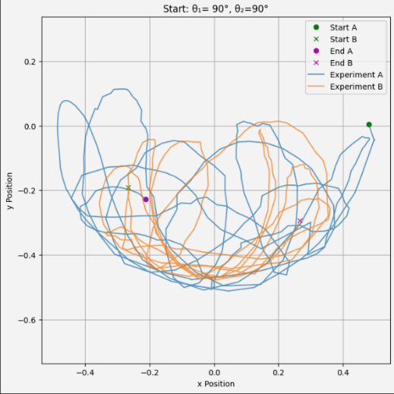
This is an example of how if θ₁ is greater than 90 degrees, the system will always be chaotic, regardless of whether there is symmetry in the angles or whether θ₁ is equal to 0 degrees:
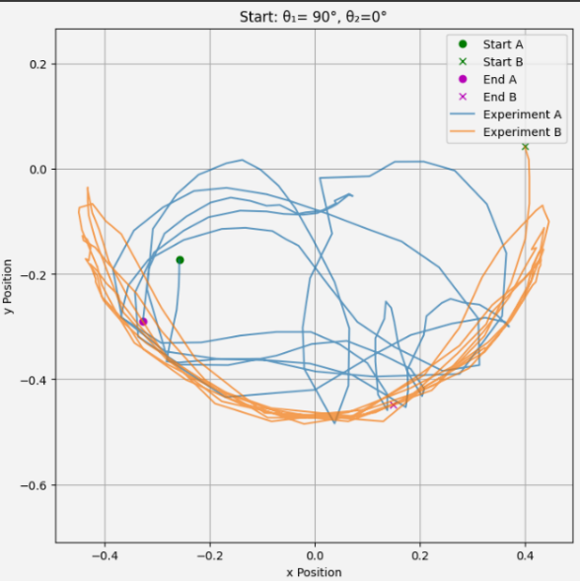

Summary:
The project investigated the relationship between the initial angles in a double pendulum system and the emergence of chaotic motion, focusing on the fact that small changes in the initial angles can lead to unpredictable and complex behavior over time. Using numerical simulations using the Euler method, precise calculations of the pendulum motion were performed under different initial conditions, with an emphasis on the sensitivity of the system to small changes of about 0.1 degrees in the initial angles θ₁ (the upper pendulum) and θ₂ (the lower pendulum). Comparing the trajectories of the second pendulum between simulations with these small differences made it possible to identify the beginning of the separations between the trajectories, which emphasize the emergence of chaotic behavior. The findings showed that the emergence of chaos is strongly related to the size of the initial angles, especially to the angle θ₁ of the upper pendulum. When θ₁ was below about 75°, the system generally remained stable and produced predictable motion, with little dependence on the value of θ₂. However, when θ₁ approached or exceeded 90°, chaotic motion consistently emerged, even in cases where θ₂ was relatively small. In contrast, high values ​​of θ₂ alone did not guarantee the emergence of chaos without a high value of θ₁. This finding emphasizes the dominant influence of the upper angle on the dynamics of the entire system. It also turned out that the sum of the angles θ₁ + θ₂ alone is not a reliable predictor of the emergence of chaos, as different combinations with the same angle sum led to different results – some stable and some chaotic. In addition, symmetry between the initial angles was found to contribute to higher stability, with angles close to or equal reducing the level of chaos compared to asymmetric pairs of angles.
In a physical experiment performed with a real double pendulum, similar results were discovered: here too, the angle θ₁ was the main factor in the emergence of chaos. However, the experiment also observed additional effects such as the distribution of weight along the rods and air resistance conditions, which affected the behavior of the system to some extent, but did not eliminate the general trends. In conclusion, the project emphasizes the high sensitivity of the double pendulum system to the initial conditions and identifies θ₁ as the main influencer on the stability of the system and the emergence of chaotic behavior, alongside the importance of the interaction between the angles and the symmetry between them in reducing instability.

Sources
[1]: https://scienceworld.wolfram.com/physics/DoublePendulum.html?trk=public_post_comment-text
[2]:
https://www.myphysicslab.com/pendulum/double-pendulum-en.html

Attache
Equation :(2)
$$0=\dot{θ_{1}^{2}}L_{1}\sin\left(θ_{1}-θ_{2}\right)-g\sin\left(θ_{2}\right)-\ddot{θ_{2}}L_{2}-\ddot{θ_{1}}L_{1}\cos\left(θ_{1}-θ_{2}\right)$$
Equation :(1)
$$0=\left(M_{1}+M_{2}\right)g\sin\left(θ_{1}\right)+\left(M_{1}+M_{2}\right)L_{1}\ddot{θ_{1}}+M_{2}L_{2}\ddot{θ_{2}}\cos\left(θ_{1}-θ_{2}\right)+M_{2}L_{2}\dot{θ_{2}^{2}}\sin\left(θ_{1}-θ_{2}\right)g$$
Now we solve for $\ddot{θ_{2}}$:
$$\ddot{θ_{2}}L_{2}=\dot{θ_{1}^{2}}L_{1}\sin\left(θ_{1}-θ_{2}\right)-g\sin\left(θ_{2}\right)-\ddot{θ_{1}}L_{1}\cos\left(θ_{1}-θ_{2}\right)$$
$$\ddot{θ_{2}}=\frac{\dot{θ_{1}^{2}}L_{1}\sin\left(θ_{1}-θ_{2}\right)-g\sin\left(θ_{2}\right)-\ddot{θ_{1}}L_{1}\cos\left(θ_{1}-θ_{2}\right)}{L_{2}}$$
Now we will solve for:(1)
$$0=\left(M_{1}+M_{2}\right)g\sin\left(θ_{1}\right)+\left(M_{1}+M_{2}\right)L_{1}\ddot{θ_{1}}+M_{2}L_{2}\cos\left(θ_{1}-θ_{2}\right)⋅\ddot{θ_{2}}+m_{2}L_{2}\dot{θ_{2}^{2}}\sin\left(θ_{1}-θ_{2}\right)$$
$$0=\left(M_{1}+M_{2}\right)g\sin\left(θ_{1}\right)+\left(M_{1}+M_{2}\right)L_{1}\ddot{θ_{1}}+\frac{M_{2}L_{2}\cos\left(θ_{1}-θ_{2}\right)\left(\dot{θ_{1}^{2}}L_{1}\sin\left(θ_{1}-θ_{2}\right)-g\sin\left(θ_{2}\right)-\ddot{θ_{1}}L_{1}\cos\left(θ_{1}-θ_{2}\right)\right)}{L_{2}}+M_{2}L_{2}\dot{θ_{2}^{2}}\sin\left(θ_{1}-θ_{2}\right)$$
Simplify the terms that include L₂:
$$0=\left(M_{1}+M_{2}\right)g\sin\left(θ_{1}\right)+\left(M_{1}+M_{2}\right)L_{1}\ddot{θ_{1}}+M_{2}\cos\left(θ_{1}-θ_{2}\right)\left(\dot{θ_{1}^{2}}L_{1}\sin\left(θ_{1}-θ_{2}\right)-g\sin\left(θ_{2}\right)-\ddot{θ_{1}}L_{1}\cos\left(θ_{1}-θ_{2}\right)\right) + M_{2}L_{2}\dot{θ_{2}^{2}}\sin\left(θ_{1}-θ_{2}\right)$$
Now we will arrange all the terms with $\ddot{θ_{1}}$on one side.
$\ddot{θ_{1}}\left(\left(M_{1}+M_{2}\right)L_{1}-{M_{2}L_{1}cos\left(θ_{1}-θ_{2}\right)}^{2}\right)= -\left(M_{1}+M_{2}\right)g\sin\left(θ_{1}\right)- M_{2}\cos\left(θ_{1}-θ_{2}\right)\dot{θ_{1}^{2}}L_{1}\sin\left(θ_{1}-θ_{2}\right) + M_{2}g\sin\left(θ_{2}\right)cos\left(θ_{1}-θ_{2}\right) - M_{2}L_{2}\dot{θ_{2}^{2}}\sin\left(θ_{1}-θ_{2}\right)$
$$\ddot{θ_{1}} = \frac{-\left(M_{1}+M_{2}\right)g\sin\left(θ_{1}\right)- M_{2}\cos\left(θ_{1}-θ_{2}\right)\dot{θ_{1}^{2}}L_{1}\sin\left(θ_{1}-θ_{2}\right) + M_{2}g\sin\left(θ_{2}\right)cos\left(θ_{1}-θ_{2}\right) - M_{2}L_{2}\dot{θ_{2}^{2}}\sin\left(θ_{1}-θ_{2}\right)}{L_{1}(\left(M_{1}+M_{2}\right)-{M_{2}cos\left(θ_{1}-θ_{2}\right)}^{2})}$$
Now we will use:
$$cos(2α) = 2\cos^{2}{(α) -1}$$
$$\frac{cos(2α) +1}{2}= \cos^{2}{(α) }$$

To rewrite the denominator as:
$$L_{1}(\left(M_{1}+M_{2}\right)-{M_{2}cos\left(θ_{1}-θ_{2}\right)}^{2}) =L_{1}\frac{2M_{1}+M_{2}- M_{2}cos\left({2(θ}_{1}-θ_{2}\right)}{2}$$

We can also attach these members:
$$- M_{2}\cos\left(θ_{1}-θ_{2}\right)\dot{θ_{1}^{2}}L_{1}\sin\left(θ_{1}-θ_{2}\right)- M_{2}L_{2}\dot{θ_{2}^{2}}\sin\left(θ_{1}-θ_{2}\right)= -\sin\left(θ_{1}-θ_{2}\right)M_{2}(L_{2}\dot{θ_{2}^{2}}+\dot{θ_{1}^{2}}L_{1}\cos\left(θ_{1}-θ_{2}\right))$$
So now the equation is:
$$\ddot{θ_{1}} = \frac{-\left(M_{1}+M_{2}\right)g\sin\left(θ_{1}\right)+ M_{2}g\sin\left(θ_{2}\right)cos\left(θ_{1}-θ_{2}\right) -\sin\left(θ_{1}-θ_{2}\right)M_{2}(L_{2}\dot{θ_{2}^{2}}+\dot{θ_{1}^{2}}L_{1}\cos\left(θ_{1}-θ_{2}\right))}{L_{1}\frac{2M_{1}+M_{2}- M_{2}cos\left({2(θ}_{1}-θ_{2}\right)}{2}}$$
$$\ddot{θ_{1}} = \frac{-2g\left(M_{1}+M_{2}\right)\sin\left(θ_{1}\right)+ {2M}_{2}g\sin\left(θ_{2}\right)cos\left(θ_{1}-θ_{2}\right) -2\sin\left(θ_{1}-θ_{2}\right)M_{2}(L_{2}\dot{θ_{2}^{2}}+\dot{θ_{1}^{2}}L_{1}\cos\left(θ_{1}-θ_{2}\right))}{L_{1}(2M_{1}+M_{2}- M_{2}cos\left({2θ}_{1}-2θ_{2}\right))}$$
We can rewrite some of the masses to group them together using the identity:
$$\cos\left(a\right)sin⁡(b)=(\sin\left(a+b\right)-\sin\left(a-b\right))$$
$${2M}_{2}g\sin\left(θ_{2}\right)cos\left(θ_{1}-θ_{2}\right)={2M}_{2}g\frac{​sin(θ_{1})-sin(θ_{1}​-2θ_{2})}{2}$$
Now we will group the similar elements:
$$-2g\left(M_{1}+M_{2}\right)\sin\left(θ_{1}\right)+ M_{2}(gsin\left(θ_{1}\right)-sin\left(θ_{1}​-2θ_{2}\right))= -g\left(2M_{1}+M_{2}\right)sin\left(θ_{1}\right)-M_{2}gsin\left(θ_{1}​-2θ_{2}\right)$$
To get the final equation for theta 1 second derivative:
$$\ddot{θ_{1}} = \frac{-g\left(2M_{1}+M_{2}\right)sin\left(θ_{1}\right)-M_{2}gsin\left(θ_{1}​-2θ_{2}\right) -2\sin\left(θ_{1}-θ_{2}\right)M_{2}(\dot{θ_{2}^{2}}L_{2}+\dot{θ_{1}^{2}}L_{1}\cos\left(θ_{1}-θ_{2}\right))}{L_{1}(2M_{1}+M_{2}- M_{2}cos\left({2θ}_{1}-{2θ}_{2}\right))}$$
And now, to solve for theta 2 second derivative, we will use the equation we prepared earlier and substitute theta 1 second derivative into it:it:
$$\ddot{θ_{2}}=\frac{\dot{θ_{1}^{2}}L_{1}\sin\left(θ_{1}-θ_{2}\right)-g\sin\left(θ_{2}\right)-\ddot{θ_{1}}L_{1}\cos\left(θ_{1}-θ_{2}\right)}{L_{2}}$$
$$\ddot{θ_{2}}=\frac{\dot{θ_{1}^{2}}L_{1}\sin\left(θ_{1}-θ_{2}\right)-g\sin\left(θ_{2}\right)-\frac{-g\left(2M_{1}+M_{2}\right)sin\left(θ_{1}\right)-M_{2}gsin\left(θ_{1}​-2θ_{2}\right) -2\sin\left(θ_{1}-θ_{2}\right)M_{2}(\dot{θ_{2}^{2}}L_{2}+\dot{θ_{1}^{2}}L_{1}\cos\left(θ_{1}-θ_{2}\right))}{L_{1}(2M_{1}+M_{2}- M_{2}cos\left({2θ}_{1}-{2θ}_{2}\right))}L_{1}\cos\left(θ_{1}-θ_{2}\right)}{L_{2}}$$
We can get rid of L1 here and start simplifying:
$\ddot{θ_{2}}=\frac{\dot{θ_{1}^{2}}L_{1}\sin\left(θ_{1}-θ_{2}\right)(2M_{1}+M_{2}- M_{2}cos\left({2θ}_{1}-{2θ}_{2}\right))-g\sin\left(θ_{2}\right)(2M_{1}+M_{2}- M_{2}cos\left({2θ}_{1}-{2θ}_{2}\right))+(g\left(2M_{1}+M_{2}\right)sin\left(θ_{1}\right)+M_{2}gsin\left(θ_{1}​-2θ_{2}\right) +2\sin\left(θ_{1}-θ_{2}\right)M_{2}(θ_{2}^{2}L_{2}+\dot{θ_{1}^{2}}L_{1}\cos\left(θ_{1}-θ_{2}\right)))L_{1}\cos\left(θ_{1}-θ_{2}\right)}{L_{2}(2M_{1}+M_{2}- M_{2}cos\left({2θ}_{1}-{2θ}_{2}\right))}$

Now we multiply by cos(θ1−θ2) and open most of the brackets:
$$(g\left(2M_{1}+M_{2}\right)sin\left(θ_{1}\right)+M_{2}gsin\left(θ_{1}​-2θ_{2}\right) +2\sin\left(θ_{1}-θ_{2}\right)M_{2}(\dot{θ_{2}^{2}}L_{2}+\dot{θ_{1}^{2}}L_{1}\cos\left(θ_{1}-θ_{2}\right)))\cos\left(θ_{1}-θ_{2}\right)=$$
$$g\left(2M_{1}+M_{2}\right)sin\left(θ_{1}\right)\cos\left(θ_{1}-θ_{2}\right)+M_{2}gsin\left(θ_{1}​-2θ_{2}\right)\cos\left(θ_{1}-θ_{2}\right) +2\sin\left(θ_{1}-θ_{2}\right)\cos\left(θ_{1}-θ_{2}\right)M_{2}(\dot{θ_{2}^{2}}L_{2}+\dot{θ_{1}^{2}}L_{1}\cos\left(θ_{1}-θ_{2}\right)))$$
$$2\sin\left(θ_{1}-θ_{2}\right)\cos\left(θ_{1}-θ_{2}\right)M_{2}\left(θ_{2}^{2}L_{2}+\dot{θ_{1}^{2}}L_{1}\cos\left(θ_{1}-θ_{2}\right))= 2\sin\left(θ_{1}-θ_{2}\right)\cos^{2}{(}θ_{1}-θ_{2}\right)M_{2}\dot{θ_{1}^{2}}L_{1}+2\sin\left(θ_{1}-θ_{2}\right)M_{2}\dot{θ_{2}^{2}}L_{2} \cos\left(θ_{1}-θ_{2}\right))$$
Now we'll simplify each part of the equation, starting with this:
$$\dot{θ_{1}^{2}}L_{1}\sin\left(θ_{1}-θ_{2}\right)(2M_{1}+M_{2}- M_{2}cos\left({2θ}_{1}-{2θ}_{2}\right))+2\sin\left(θ_{1}-θ_{2}\right)\cos^{2}{(}θ_{1}-θ_{2})M_{2}\dot{θ_{1}^{2}}L_{1}=\dot{θ_{1}^{2}}L_{1}\sin\left(θ_{1}-θ_{2}\right)(2M_{1}+M_{2}- M_{2}cos\left({2θ}_{1}-{2θ}_{2}\right)+2M_{2}\cos^{2}{(}θ_{1}-θ_{2}))$$
$$2M_{1}+M_{2}- M_{2}cos\left({2θ}_{1}-{2θ}_{2}\right)+2M_{2}\cos^{2}{(}θ_{1}-θ_{2})=2M_{1}+M_{2}- M_{2}{(2cos}^{2}{(}θ_{1}-θ_{2})- 1)+2M_{2}\cos^{2}{(}θ_{1}-θ_{2}) =2M_{1}+M_{2}- M_{2}{2cos}^{2}{(}θ_{1}-θ_{2})+M_{2} +2M_{2}\cos^{2}{(}θ_{1}-θ_{2})=2(M_{1}+M_{2})$$
$$\dot{θ_{1}^{2}}L_{1}\sin\left(θ_{1}-θ_{2}\right)(2M_{1}+M_{2}- M_{2}cos\left({2θ}_{1}-{2θ}_{2}\right)+2M_{2}\cos^{2}{(}θ_{1}-θ_{2}))=2\dot{θ_{1}^{2}}L_{1}\sin\left(θ_{1}-θ_{2}\right)(M_{1}+M_{2})$$
Now we simplify the part that includes g
$$-g\sin\left(θ_{2}\right)\left(2M_{1}+M_{2}- M_{2}cos\left({2θ}_{1}-{2θ}_{2}\right)\right)+g\left(2M_{1}+M_{2}\right)sin\left(θ_{1}\right)\cos\left(θ_{1}-θ_{2}\right))+M_{2}gsin\left(θ_{1}​-2θ_{2}\right)\cos\left(θ_{1}-θ_{2}\right))=g(=-\sin\left(θ_{2}\right)\left(2M_{1}+M_{2}- M_{2}cos\left({2θ}_{1}-{2θ}_{2}\right)\right)+\left(2M_{1}+M_{2}\right)sin\left(θ_{1}\right)\cos\left(θ_{1}-θ_{2}\right))+M_{2}sin\left(θ_{1}​-2θ_{2}\right)\cos\left(θ_{1}-θ_{2}\right))$$
We use the identity we used earlier for the cosine:
$$-\sin\left(θ_{2}\right)\left(2M_{1}+M_{2}- M_{2}cos\left({2θ}_{1}-{2θ}_{2}\right)\right) =-sin\left(θ_{2}\right)\left(2M_{1}+M_{2}- M_{2}(1-2\sin^{2}\left(θ_{1}-θ_{2}\right)\right)==-sin\left(θ_{2}\right)\left(2M_{1}+M_{2}- M_{2}+{2M}_{2}\sin^{2}\left(θ_{1}-θ_{2}\right)\right)==-sin\left(θ_{2}\right)\left(2M_{1}+{2M}_{2}\sin^{2}\left(θ_{1}-θ_{2}\right)\right)$$
And now we open the brackets and arrange the terms that include M1 and M2.
$$-sin\left(θ_{2}\right)\left(2M_{1}+{2M}_{2}\sin^{2}\left(θ_{1}-θ_{2}\right)\right)+ \left(2M_{1}+M_{2}\right)sin\left(θ_{1}\right)\cos\left(θ_{1}-θ_{2}\right))+M_{2}sin\left(θ_{1}​-2θ_{2}\right)\cos\left(θ_{1}-θ_{2}\right))=-2M_{1}sin\left(θ_{2}\right) -{2M}_{2}\sin^{2}\left(θ_{1}-θ_{2}\right)\sin\left(θ_{2}\right)+2M_{1}sin\left(θ_{1}\right)\cos\left(θ_{1}-θ_{2}\right))+ M_{2}sin\left(θ_{1}​-2θ_{2}\right)\cos\left(θ_{1}-θ_{2}\right)+M_{2}sin\left(θ_{1}\right)\cos\left(θ_{1}-θ_{2}\right)) ={2M}_{1}\left(sin\left(θ_{1}\right)\cos\left(θ_{1}-θ_{2}\right))-\sin\left(θ_{2}\right)\right)+M_{2}(sin\left(θ_{1}\right)\cos\left(θ_{1}-θ_{2}\right)+sin\left(θ_{1}​-2θ_{2}\right)\cos\left(θ_{1}​-θ_{2}\right)-2\sin^{2}\left(θ_{1}-θ_{2}\right)\sin\left(θ_{2}\right)) )$$
Now we will simplify the part of M2 and use:
$$\sin\left(a\right)+\sin\left(b\right)=2sin\left(\frac{a+b}{2}\right)\cos{(\frac{a-b}{2})}⁡$$
$$sin\left(θ_{1}\right)\cos\left(θ_{1}-θ_{2}\right)+sin\left(θ_{1}​-2θ_{2}\right)\cos\left(θ_{1}​-θ_{2}\right)=2\sin\left(θ_{1}-θ_{2}\right)cos⁡(θ_{2})\cos\left(θ_{1}​-θ_{2}\right)$$
$$2\sin\left(θ_{1}-θ_{2}\right)\cos\left(θ_{2}\right)\cos\left(θ_{1}​-θ_{2}\right)-2\sin^{2}\left(θ_{1}-θ_{2}\right)\sin\left(θ_{2}\right))= 2\sin\left(θ_{1}-θ_{2}\right)(\cos\left(θ_{2}\right)\cos\left(θ_{1}​-θ_{2}\right)-sin⁡(θ_{1}-θ_{2})\sin\left(θ_{2}\right)$$
Now we will use:
$$\cos\left(a\right)\cos\left(b\right)-\sin\left(a\right)\sin\left(b\right)=cos⁡(a+b)$$
So we get:
$$\cos\left(θ_{2}\right)\cos\left(θ_{1}​-θ_{2}\right)-\sin\left(θ_{1}-θ_{2}\right)\sin\left(θ_{2}\right)=cos⁡(θ_{1})$$
Now for the M1 part we will use:
$$\sin\left(a\right)\cos\left(b\right)-\cos\left(a\right)\sin\left(b\right)=sin⁡(a-b)$$

$$\sin\left(a\right)\cos\left(b\right)-sin⁡(a-b)=\cos\left(a\right)\sin\left(b\right)$$

$$sin \left(θ_{1}\right)\cos\left(θ_{1}-θ_{2}\right)-\sin\left(θ_{2}\right)=\cos\left(θ_{1}\right)sin\left(θ_{1}-θ_{2}\right)$$
so, the equation is:
$$g\left(2M_{1}\cos\left(θ_{1}\right)sin\left(θ_{1}-θ_{2}\right)+2M_{2}\cos\left(θ_{1}\right)sin\left(θ_{1}-θ_{2}\right)\right)=2sin\left(θ_{1}-θ_{2}\right)g(M_{1}+M_{2})$$
So the full equation for theta 2 second derivative is:
$$\ddot{θ_{2}}=\frac{2\dot{θ_{1}^{2}}L_{1}\sin\left(θ_{1}-θ_{2}\right)\left(M_{1}+M_{2}\right)+2sin\left(θ_{1}-θ_{2}\right)g\left(M_{1}+M_{2}\right)+2\sin\left(θ_{1}-θ_{2}\right)M_{2}\dot{θ_{2}^{2}}L_{2} \cos\left(θ_{1}-θ_{2}\right)}{L_{2}(2M_{1}+M_{2}- M_{2}cos\left({2θ}_{1}-{2θ}_{2}\right))}$$
$$\ddot{θ_{2}}=\frac{2\sin\left(θ_{1}-θ_{2}\right)(\dot{θ_{1}^{2}}L_{1}\left(M_{1}+M_{2}\right)+g\left(M_{1}+M_{2}\right)+M_{2}\dot{θ_{2}^{2}}L_{2} \cos\left(θ_{1}-θ_{2}\right))}{L_{2}(2M_{1}+M_{2}- M_{2}cos\left({2θ}_{1}-{2θ}_{2}\right))}$$

