N-GRAMS
N-Grams is a word prediction algorithm using probabilistic methods to predict next word after observing N-1 words. Therefore, computing the probability of the next word is closely related to computing the probability of a sequence of words.

- Simple (Unsmoothed) N-grams
The simplest probabilistic model for word prediction can be assigning equal probability to each word. So suppose that there are N words in a language, then the probability of any word following another word would be 1/N. However, this approach ignores the fact that some words are more frequent than the others in languages.
An improvement to the model above would be assigning the probability of a word w_{i} following the word w_{i-1} is the probability of the word w_{i} itself. For example, word “the” occurs 7% in Brown corpus, and “rabbit” occurs at a frequency of 1/10.000. Then, for any word, the probability of the next word being “the” is %7. However, this ignores that in some contexts, occurrence of the “rabbit” after a word is much more probable than occurrence of “the”. For instance, “rabbit” following the word “white” seems much more logical than the word “the” following “white”.
- Markov Assumption
The idea above shows that some words are more probable to follow a word in certain contexts.
It would be accurate to know all the words up to the word that we are trying to predict, but it would be inefficient to know entire history, because we can encounter infinitely many sequence of sentences and the history we know would have never occurred before. Therefore, we will approximate the history by only a few words.
Bigram, also called Markov assumption, assumes that we can predict the probability of the future word by only looking at the last word encountered. We can generalize bigram to trigram (looking last two words in the past), and to N-gram (looking N-1 words in the past). Thus the general equation for the conditional probability of the next word in a sequence would be;
P(w_{n}| w₁^{n-1}) ≈ P(w_{n} | w_{n-N+1}^{n-1}) ,where word sequence w₁, w₂, ... , w_{n-1} is represented as w₁^{n-1}.
The simplest way to estimate the probabilies is to use Maximum Likelihood Estimation (MLE),
based on taking counts from the corpus and normalizing them to lie in the interval [0,1]. For example to compute the bigram probability of word y following x is to count the bigrams c(xy) from the corpus and normalize it with the number of bigrams that starts with x.
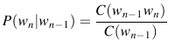

In the denominator, C(w_{n-1}) represents the count of bigrams starting with w_{n-1} because the bigrams starting with w_{n-1} is equal to the number that w_{n-1} occurs in our corpora. The general equation for estimating probability for a MLE N-gram is;
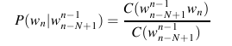

An example of a table showing bigram counts is below.
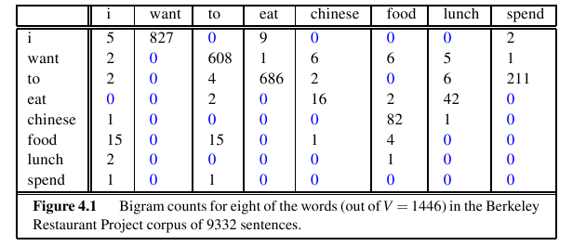

Count of the occurrence of the words in corpora are;
We can observe two things from this table;
- The bigram (“i”,”want”) occurred 827 times in the corpora. So according to the formula, the probability of the word “want” following “i” is 827 / 2533.
- The matrix is sparse, meaning it has a lot of zeros in it, even the words selected are coherent with each other.
Now we can find the probability of a sentence using bigrams;
P(<s> I want English food </s>) = P(I | <s>) . P(want | I) . P(english | want) . P(food | english) . P(</s> | food)
Note: <s> denotes start of a sentence and </s> denotes end of a sentence.
- Smoothing
As it can be seen from the above table, most of the table are filled with zeros. Because our
corpora is limited, most word sequences are assigned to zero probability even they should have a non-zero probability. The MLE estimation gives accurate results when the sequences are frequent in our training data, but it does not give good results in zero probability sequences and the sequences with low frequency. Another problem is perplexity, a metric used for evaluation of N-grams, does not work when there are zero probability sequences in our data. Therefore, we will modify MLE to collect some probability mass from high frequency sequences, and distribute it to zero frequency sequences. This modification is called Smoothing.
  - Add-One Smoothing
The add-one smoothing is a very simple smoothing algorithm, that increments all
frequencies by one, and normalizes the probability according to these addition. However, it does not perform well and mentioned here to understand the basics of smoothing.
Normally, the probability of the occurrence of a word is given below, where c_{i} is the count of the word_{i} and N is the total number of words;
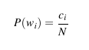

When we increment each distinct word's count by 1, we must normalize it accordingly. Because we incremented V (number of distinct words,Vocabulary) words, we must add it to the denominator to normalize the equation.
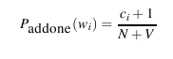

However, instead of changing both numerator and denominator, it is more convenient to define a new count variable, which we can find the probability by simply dividing to N as the usual way.
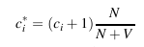

The form of the equation of count above when applied to bigrams is;
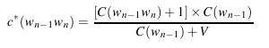

Again we must divide the add-one count to C(w_{n-1}), the number of occurrences of the last word, to find the probability P*(w_{n} | w_{n-1}), meaning the probability of w_{n} following the word w_{n-1}.
The problem with add-one discounting is most of the probabilities are discounted excessively, sometimes a factor of 10.
  - Good-Turing Discouning
The motivation behind Good-Turing discounting is to estimate the count of things you have never seen by using the count of the thing that you have seen once, which is called singletons. Good-Turing intuition is to use the frequency of the singletons to estimate the probability mass that is to be assigned to zero-count bigrams. In order to compute the frequency of singletons, we need to count N_{c} which is the count of all N-grams that occur c times. So, N₀ would correspond to number of bigrams that has been never seen, N₁ corresponds to number of singletons and so on..
The MLE count for the N_{c} is c. In Good-Turing estimate, the new count is,which is a function of N_{c+1};
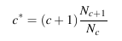

The formula above assumes that we know N₀, that is the number of bigrams we have never seen. Actually, we can calculate it by the following way. Suppose our vocabulary is of size V, then the number of all possible bigrams with this vocabulary is V². We know how many bigrams we have seen, so V²- (number of bigrams known) is the N₀.
In practice, the Good-Turing count is not used for all counts because most of the time, frequently seen words gives reliable probabilities. Therefore, a threshold k is defined and c* is used only for the c's that are smaller than k. Then, the correct equation with the k value becomes;
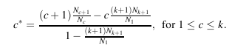

This introduction of k also means to treat counts lower than k like zero count bigrams. However, Good-Turing is not used solely in N-gram implementations, it is generally used with back-off and interpolation algorithms.
- BACKOFF
Like discounting algorithms, backoff algorithms are used to solve the problem of zero
frequency N-grams. The intuition behind backoff algorithms is look for a (N-1)-gram if there is no N-gram for the specific word sequence. For example, if we do not have an example of particular trigram w_{n-2} w_{n-1} w_{n} to compute P(w_{n} | w_{n-2} w_{n-1}), then we can use the bigram probability P(w_{n} | w_{n-1}). Similarly, if we can not compute P(w_{n} | w_{n-1}), we can look to the unigram P(w_{n}).
In backoff algorithms, if we backoff to lower order N-gram if we have zero count for the higher order N-gram. The backoff algorithm was first introduced by Katz, and the equation for Katz Backoff Model for trigrams is;
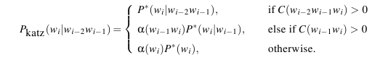
We can notice that discounted probabilities used in the equation, which used c* instead of c. The probability that is calculated with this count is slightly less than MLE, and this is because we need to save a probability mass to distribute among lower N-grams. α is used for distributing the probability mass evenly to the lower order N-grams.
  - Practical Issues in Backoff Language Models
Because the probabilities are in the interval [0,1], multiplying enough probabilities would cause an
arithmetic underflow. We can store the probabilities of the N-grams as log probabilities to prevent underflow, because the small numbers in linear space is not small in log space, and multiplying in linear space corresponds to adding in log space. An instance would be;
p1 × p2 × p3 × p4 = exp(log p1 + log p2 + log p3 + log p4)
The backoff models are generally stored in ARPA format, and the format of each N-gram is;
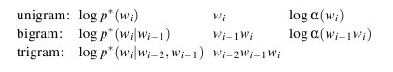

An instance of an ARPA file is;
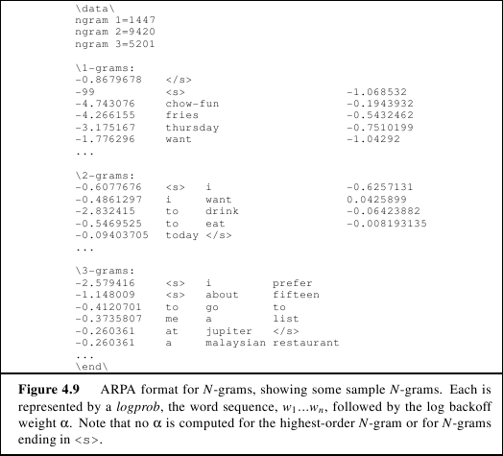

Given such an ARPA format, we can use the equation of P_{katz} given above to compute a probability of a trigram.
  - Details of computing α and P*
Computing α: First we need to compute the total left-over probability from the N-gram to N-1
grams and denote it as β. In English, the total left-over probability is 1 minus the sum of all discounted probabilities of the N-gram. Mathematically;
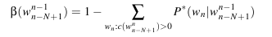

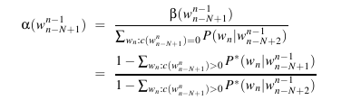
Because α is a distribution function, we need to normalize it by the total probability of the N-1 grams. The complete equation of α is;

And these are specifications if the lower order N-grams' count is 0.
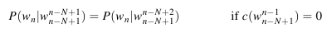

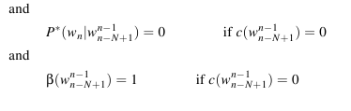

  - Interpolation
The alternative to the backoff algorithms is to use interpolation, where we use the information from
lower N-grams even the higher order N-gram count is nonzero. In linear interpolation for example, we estimate the probability of a trigram using unigram, bigram, and trigram probabilities, each weighted by λ. Depending on the choice, we can use more sophisticated λ's, which is trained and calculated as a function of context. Formula of the probability using interpolation is;
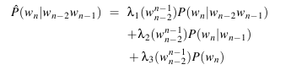

REFERENCES
Jurafsky, D. and Martin, J. (2006). An introduction to speech recognition, computational linguistics and natural language processing, Draft.

