**KLASIFIKASI PENGGUNAAN LENSA KACAMATA DENGAN ALGORITMA NAIVE BAYES PADA MATLAB**



**DISUSUN OLEH**

|  |  |
| --- | --- |
| NURUL FADILAH | 1461600144 |
|  |  |
|  |  |

**UNIVERSITAS 17 AGUSTUS 1945 SURABAYA  
2018**

1. **Data Set**

Dataset yang digunakan adalah dataset Lenses yang diberi nama lenses.csv yang diambil dari [**https://archive.ics.uci.edu/**](https://archive.ics.uci.edu/)

Database tersebut digunakan sebagai Data Train dan memiliki 4 atribut, yaitu :

* Age of the patient : (1) young, (2) pre-presbyopic, (3) presbyopic
* Spectacle prescription : (1) myope, (2) hypermetrope
* Astigmatic : (1) no, (2) yes
* Tear production rate : (1) reduced, (2) normalI

Dataset Lenses ini memiliki class Distribution yang ada pada kolom terakhir dan bernilai :

1 : the patient should be fitted with hard contact lenses,

2 : the patient should be fitted with soft contact lenses,

3 : the patient should not be fitted with contact lenses.

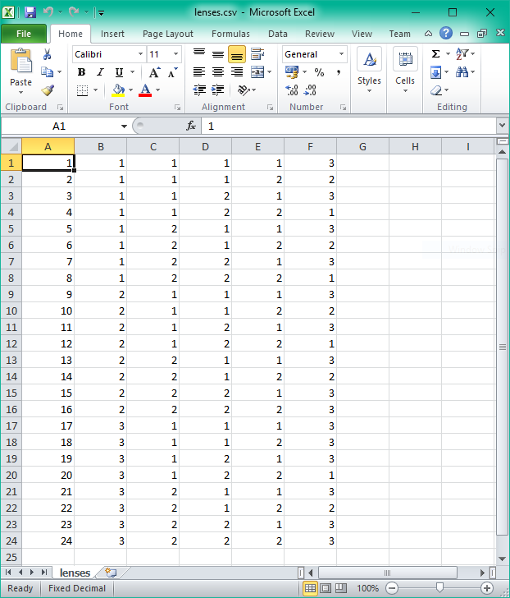

**Gambar 2. Dataset Lenses.csv**

1. **Analisis**

Penelitian ini menggunakan Matlab dan Algoritma Naïve Bayes untuk mengklasifikasikan jenis lensa kacamata.

Berdasarkan logika dari perhitungan Naïve Bayes itu sendiri kemudian algoritmanya diimplementasikan ke dalam Matlab.

Berikut ini contoh perhitungan manual dari Algoritma Naïve Bayes :

Contoh dari dataset diatas, kemudian dicari class dari data test sebagai berikut :

Usia = 2

Spectacle Prescription = 2

Astigmatic = 1

Tear Production Rate = 1

Langkah 1 :

mengitung jumlah *class/ label* :

$$P \left( Class=Hard Contact Lens \right)=\frac{4}{24}$$

$$P \left( Class=Low Contact Lens \right)=\frac{5}{24}$$

$$P \left( Class=No Contact Lens \right)=\frac{15}{24}$$

Langkah 2 :

menghitung jumlah kasus yang sama dengan *class* yang sama :

$$P \left(usia=2 \right| Class=Hard Contact Lense)=1/4$$

$$P \left(usia=2 \right| Class=Low Contact Lense)=2/5$$

$$P \left(usia=2 \right| Class=No Contact Lense)=5/15$$

$$P \left(Spectacle Prescription=2 \right| Class=Hard Contact Lense)=1/4$$

$$P \left(Spectacle Prescription=2 \right| Class=Low Contact Lense)=2/5$$

$$P \left(Spectacle Prescription=2 \right| Class=No Contact Lense)=8/15$$

$$P \left(Astigmatic=1 \right| Class=Hard Contact Lense)=0/4$$

$$P \left(Astigmatic=1 \right| Class=Low Contact Lense)=5/5$$

$$P \left(Astigmatic=1 \right| Class=No Contact Lense)=7/15$$

$$P \left(Tear Production Rate=1 \right| Class=Hard Contact Lense)=0/4$$

$$P \left(Tear Production Rate=1 \right| Class=Low Contact Lense)=0/5$$

$$P \left(Tear Production Rate=1 \right| Class=No Contact Lense)=12/15$$

Langkah 3 :

Kalikan semua hasil variable *Hard Contact Lens, Low Contact Lens, No Contact Lens*

$$Hard Contact Lens=\left\{P \left(usia=2 \right| Class=Hard Contact Lense\right).P \left(Spectacle Prescription=2 \right| Class=Hard Contact Lense).P \left(Astigmatic=1 \right| Class=Hard Contact Lense).P \left(Tear Production Rate=1 \right| Class=Hard Contact Lense)\}=\frac{1}{4}.\frac{1}{4}.\frac{0}{4} .\frac{0}{4}=0$$

$$Low Contact Lens=\left\{P \left(usia=2 \right| Class=Low Contact Lense\right).P \left(Spectacle Prescription=2 \right| Class=Low Contact Lense).P \left(Astigmatic=1 \right| Class=Low Contact Lense).P \left(Tear Production Rate=1 \right| Class=Low Contact Lense)\}=\frac{2}{5}.\frac{2}{5}.\frac{5}{5} .\frac{0}{5}=0$$

$$No Contact Lens=\left\{P \left(usia=2 \right| Class=No Contact Lense\right).P \left(Spectacle Prescription=2 \right| Class=No Contact Lense).P \left(Astigmatic=1 \right| Class=No Contact Lense).P \left(Tear Production Rate=1 \right| Class=No Contact Lense)\}=\frac{2}{15}.\frac{8}{15}.\frac{7}{15} .\frac{12}{15}=0,0265$$

Langkah 4 :

Bandingkan hasil class *Hard contact lens, Soft contact lens, No contact lense* .

Karena hasil yang paling besar adalah hasil dari ( P | No Contact Lens ) maka keputusannya adalah **No Contact Lens.**

Berikut ini merupakan source code dari Algoritma Naive Bayes tersebut

**Isi code dari Button Klasifikasi adalah sebagai berikut :**

% --- Executes on button press in pushbutton1.

function pushbutton1_Callback(hObject, eventdata, handles)

% hObject handle to pushbutton1 (see GCBO)

% eventdata reserved - to be defined in a future version of MATLAB

% handles structure with handles and user data (see GUIDATA)

age = str2double(get(handles.usia,'String'));

sp = str2double(get(handles.specpres,'String'));

ast = str2double(get(handles.astigmatic,'String'));

tear = str2double(get(handles.tear,'String'));

%baca dataset

line=1;

data=xlsread('lenses.csv',strcat('A',num2str(line),':F',num2str(line)));

while(isempty(data)==0)

line=line+1;

data=xlsread('lenses.csv',strcat('A',num2str(line),':F',num2str(line)));

end

line=line-1;

[file_data]=xlsread('lenses.csv',strcat('A1:F',num2str(line)))

%step 1

[data_class]=xlsread('lenses.csv',strcat('F1:F',num2str(line)))

%[class]=[data_class(1,1)]

num_hard_lenses=0

index=1;

for index=1:24

if [data_class(index,1)]==1

num_hard_lenses=num_hard_lenses+1

end

end

num_soft_lenses=0

index=1;

for index=1:24

if [data_class(index,1)]==2

num_soft_lenses=num_soft_lenses+1

end

end

num_no_lenses=0

index=1;

for index=1:24

if [data_class(index,1)]==3

num_no_lenses=num_no_lenses+1

end

end

P_hard_lenses = num_hard_lenses/24

P_soft_lenses = num_soft_lenses/24

P_no_lenses = num_no_lenses/24

%step 2

%age

num_age_hard_lenses=0

index=1;

for index=1:24

if [file_data(index,2)]==age && [file_data(index,6)]==1

num_age_hard_lenses=num_age_hard_lenses+1

end

end

num_age_soft_lenses=0

index=1;

for index=1:24

if [file_data(index,2)]==age && [file_data(index,6)]==2

num_age_soft_lenses=num_age_soft_lenses+1

end

end

num_age_no_lenses=0

index=1;

for index=1:24

if [file_data(index,2)]==age && [file_data(index,6)]==3

num_age_no_lenses=num_age_no_lenses+1

end

end

P_age_hard_lenses = num_age_hard_lenses/num_hard_lenses

P_age_soft_lenses = num_age_soft_lenses/num_soft_lenses

P_age_no_lenses = num_age_no_lenses/num_no_lenses

%spectacle prescription

num_specpres_hard_lenses=0

index=1;

for index=1:24

if [file_data(index,3)]==sp && [file_data(index,6)]==1

num_specpres_hard_lenses=num_specpres_hard_lenses+1

end

end

num_specpres_soft_lenses=0

index=1;

for index=1:24

if [file_data(index,3)]==sp && [file_data(index,6)]==2

num_specpres_soft_lenses=num_specpres_soft_lenses+1

end

end

num_specpres_no_lenses=0

index=1;

for index=1:24

if [file_data(index,3)]==sp && [file_data(index,6)]==3

num_specpres_no_lenses=num_specpres_no_lenses+1

end

end

P_specpres_hard_lenses = num_specpres_hard_lenses/num_hard_lenses

P_specpres_soft_lenses = num_specpres_soft_lenses/num_soft_lenses

P_specpres_no_lenses = num_specpres_no_lenses/num_no_lenses

%astigmatic

num_ast_hard_lenses=0

index=1;

for index=1:24

if [file_data(index,4)]==ast && [file_data(index,6)]==1

num_ast_hard_lenses=num_ast_hard_lenses+1

end

end

num_ast_soft_lenses=0

index=1;

for index=1:24

if [file_data(index,4)]==ast && [file_data(index,6)]==2

num_ast_soft_lenses=num_ast_soft_lenses+1

end

end

num_ast_no_lenses=0

index=1;

for index=1:24

if [file_data(index,4)]==ast && [file_data(index,6)]==3

num_ast_no_lenses=num_ast_no_lenses+1

end

end

P_ast_hard_lenses = num_ast_hard_lenses/num_hard_lenses

P_ast_soft_lenses = num_ast_soft_lenses/num_soft_lenses

P_ast_no_lenses = num_ast_no_lenses/num_no_lenses

%tear production rate

num_tear_hard_lenses=0

index=1;

for index=1:24

if [file_data(index,5)]==tear && [file_data(index,6)]==1

num_tear_hard_lenses=num_tear_hard_lenses+1

end

end

num_tear_soft_lenses=0

index=1;

for index=1:24

if [file_data(index,5)]==tear && [file_data(index,6)]==2

num_tear_soft_lenses=num_tear_soft_lenses+1

end

end

num_tear_no_lenses=0

index=1;

for index=1:24

if [file_data(index,5)]==tear && [file_data(index,6)]==3

num_tear_no_lenses=num_tear_no_lenses+1

end

end

P_tear_hard_lenses = num_tear_hard_lenses/num_hard_lenses

P_tear_soft_lenses = num_tear_soft_lenses/num_soft_lenses

P_tear_no_lenses = num_tear_no_lenses/num_no_lenses

%step 3

P_hard_lenses = P_age_hard_lenses*P_specpres_hard_lenses*P_ast_hard_lenses*P_tear_hard_lenses

P_soft_lenses = P_age_soft_lenses*P_specpres_soft_lenses*P_ast_soft_lenses*P_tear_soft_lenses

P_no_lenses = P_age_no_lenses*P_specpres_no_lenses*P_ast_no_lenses*P_tear_no_lenses

%step 4

keputusan = 0;

value = 0;

if P_hard_lenses > P_soft_lenses

keputusan = 1

value = P_hard_lenses

else

keputusan = 2

value = P_soft_lenses

end

if value > P_no_lenses

keputusan = keputusan

value = value

else

keputusan = 3

value = P_no_lenses

end

switch keputusan

case 1

set(handles.hasil,'String','Hard Contact Lense');

case 2

set(handles.hasil,'String','Low Contact Lense');

case 3

set(handles.hasil,'String','No Contact Lense');

end

**Isi code dari Button Reset adalah sebagai berikut :**

% --- Executes on button press in reset.

function reset_Callback(hObject, eventdata, handles)

% hObject handle to reset (see GCBO)

% eventdata reserved - to be defined in a future version of MATLAB

% handles structure with handles and user data (see GUIDATA)

set(handles.usia,'String','');

set(handles.specpres,'String','');

set(handles.astigmatic,'String','');

set(handles.tear,'String','');

set(handles.hasil,'String','');

Berikut ini merupakan GUI dari program ini :

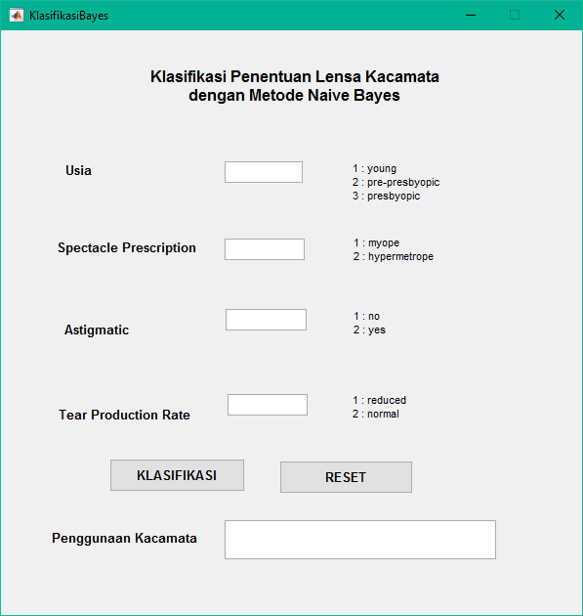

Contoh implementasi pada program dengan data test data baru :

