

HarmonIEEE, Ist Floor, Cherian's Square, Ambujavilasam Rd, Thiruvanamthapuram, Kerala 695001 ieeekerala.org

✉ ieeeks.keralasection@gmail.com

Payment - Self Declaration
Spent an amount of Rs. 196/- (Rupees One Hundred and Ninety Six only) toward TA expenses in connection with AKIASSC (event) organised by IEEE-IA/IE/PELS Jt. Chapter at UKFCET Paripally from July 11 to July 13, 2025.
The details are given below.
Expense details | Amount
Bus fare:  - From Kottarakkara to Paripally  - From Paripally to Kottarakkara  - From Kottarakkara to Erumeli  - From Erumeli to Kanjirappally | ₹38  ₹38  ₹91  ₹29
Auto fare: Nil
Train fare: Nil
Total amount to be reimbursed: Rs. 196/-

(Rupees One Hundred and Ninety Six only)

Date: 10/12/25
Place: Kottayam

Name: Alan Biju
Signature: 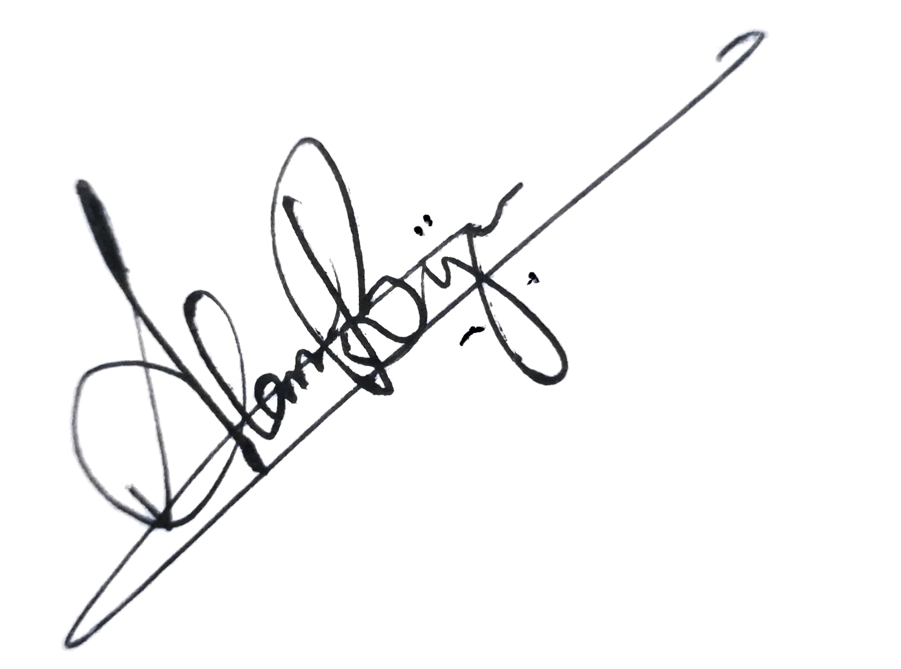

Payment shall be made to the below mentioned Bank Account.

NAME of the Volunteer | Amount to be reimbursed (₹) | Account Details
Alan Biju | 196 | Account Name: Alan Biju  Account No: 0844053000001871  Bank and branch: South Indian Bank  IFSC : SIBL0000844

IEEE - " Advancing technology for humanity "

