https://www.wbdg.org/space-types/

Table of Contents

1. Constraints 9

1.1. Business commitment to partners 9

1.2. Business commitment to customers 9

1.3. Cost: Limited budget 9

1.4. Ethics 9

1.5. Design 9

1.6. Geographical 9

1.7. Physical: Size or space 9

1.8. Time 9

1.9. Human Resources 9

1.10. Legal 9

1.11. Capacity 9

1.12. Speed 9

1.13. Functionality 9

1.14. Methodology 9

1.15. Risk Tolerance: Amount of risk willing to take 9

1.16. Technical: such as platform that must be used 9

1.17. Quality 9

2. Sectors 9

2.1. Agriculture 9

2.2. Arts 9

2.3. Banking 9

2.4. Computer Science 9

2.5. Craft 9

2.6. Education 9

2.7. Engineering 9

2.8. Environment 9

2.9. Graphic Design 9

2.10. Hospitality 9

2.11. Industry 9

2.12. Insurance 9

2.13. Journalism 9

2.14. Media 9

2.15. Pharmacy/Medical 9

2.16. Sales 9

2.17. Sports or Gaming 9

2.18. Tourism 9

2.19. TV/Radio 9

3. Collaboration Category 9

3.1. Sponsor 9

3.2. Investor 10

3.3. Coaching/Training/Consulting 10

3.4. Equipment Provider 10

3.4.1. Vehicles 10

3.4.1.1. Wagons 10

3.4.1.2. Bicycles 10

3.4.1.3. Motorcycles 10

3.4.1.4. Cars 10

3.4.1.5. Trucks 10

3.4.1.6. Buses 10

3.4.1.7. Small boats 10

3.4.2. Electronic 10

3.4.2.1. Television 10

3.4.2.2. DVD player 10

3.4.2.3. Laptop 10

3.4.2.4. Desktop computer 10

3.4.2.5. Mobile phone 10

3.4.2.6. IPOD 10

3.4.2.7. IPAD 10

3.4.2.8. Camera 10

3.4.2.9. Fan 10

3.4.2.10. Oven 10

3.4.2.11. Washing machine 10

3.4.2.12. Game console 10

3.4.2.13. Printer 10

3.4.2.14. Scanner 10

3.4.2.15. Radio. 10

3.5. Space Provider 10

3.5.1. Atrium 10

3.5.2. Auditorium 11

3.5.3. Automated Data Processing: Mainframe 11

3.5.4. Automated Data Processing: PC System 11

3.5.5. Cafeteria 11

3.5.6. Child Care 12

3.5.7. Clinic 12

3.5.8. Health Unit 12

3.5.9. Conference 12

3.5.10. Classroom 12

3.5.11. Computer Lab 13

3.5.12. Firing Range 13

3.5.13. Food Service 13

3.5.14. General Storage 13

3.5.15. Kitchen 13

3.5.16. Laboratory: Dry 14

The Dry Laboratory space type is a laboratory space that is specific to work with dry stored materials, electronics, and/or large instruments with few piped services. 14

3.5.17. Laboratory: Wet 14

3.5.18. Library 14

3.5.19. Light Industrial 15

3.5.20. Printing 15

3.5.21. Laundry 15

3.5.22. film processing 15

3.5.23. vehicle repair garages 15

3.5.24. building maintenance shops 15

3.5.25. metal work 15

3.5.26. millwork 15

3.5.27. cabinetry work 15

3.5.28. Loading Dock 15

3.5.29. Lobby 15

3.5.30. Mail Center 16

3.5.31. Office 16

3.5.32. Office Enhanced 16

3.5.33. Parking: Basement 17

3.5.34. Parking: Surface 17

3.5.35. Physical Fitness (Exercise Room) 17

3.5.36. Place of Worship 17

3.5.37. Playground 17

3.5.38. Storage – Shelf 18

3.5.39. Storage – Stacked 18

3.5.40. Warehouse : 18

3.6. Access to Customer 19

3.7. Employment 19

3.8. Marketing Services 19

3.9. Research Services 19

3.10. Networking 19

4. Employment 19

4.1. Accountant 19

4.2. Actor 19

4.3. Actuary 19

4.4. Administrator 19

4.5. Agent 19

4.6. Agricultural Worker 19

4.7. Air Traffic Controller 19

4.8. Ambulance Officer 19

4.9. Architect 19

4.10. Art Director 19

4.11. Artist 19

4.12. Athlete 19

4.13. Auditor 19

4.14. Baker 19

4.15. Barista 19

4.16. Bartender 19

4.17. Board Member 19

4.18. Business Analyst 19

4.19. Chef 19

4.20. Childcare Worker 19

4.21. Civil Servant 19

4.22. Cleaner 19

4.23. Company Worker 19

4.24. Computer Scientist 19

4.25. Construction Worker 19

4.26. Consultant 19

4.27. Cook 19

4.28. Copywriter 19

4.29. Courier 19

4.30. Craftsperson 19

4.31. Curator 19

4.32. Customer Service Representative 19

4.33. Dentist 19

4.34. Designer 19

4.35. Doctor 20

4.36. Driver 20

4.37. Economist 20

4.38. Electrician 20

4.39. Entrepreneur 20

4.40. Equipment Operator 20

4.41. Executive Manager 20

4.42. Farmer 20

4.43. Film Maker 20

4.44. Firefighter 20

4.45. Fisherman 20

4.46. Fitness Trainer 20

4.47. Flight Attendant 20

4.48. Florist 20

4.49. Freelancer 20

4.50. Gardener 20

4.51. Hair Stylist 20

4.52. Home Care Aid 20

4.53. Homemaker 20

4.54. Hospitality Worker 20

4.55. Housekeeper 20

4.56. Information Technology Professional 20

4.57. Investor 20

4.58. Journalist 20

4.59. Laborer 20

4.60. Lawyer 20

4.61. Librarian 20

4.62. Maintenance Worker 20

4.63. Manager 20

4.64. Manufacturing Worker 20

4.65. Marketing Professional 20

4.66. Mathematician 20

4.67. Mechanic 20

4.68. Medical Professional 20

4.69. Merchant 20

4.70. Midwife 20

4.71. Military Personnel 20

4.72. Musician 20

4.73. Nanny 20

4.74. Nurse 20

4.75. Office Clerk 21

4.76. Office Worker 21

4.77. Optician 21

4.78. Performance Artist 21

4.79. Photographer 21

4.80. Pilot 21

4.81. Police Officer 21

4.82. Politician 21

4.83. Professor 21

4.84. Railroad Engineer 21

4.85. Researcher 21

4.86. Retail Employee 21

4.87. Retiree 21

4.88. Rigger 21

4.89. Sailor 21

4.90. Salesperson 21

4.91. Scientist 21

4.92. Sea Captain 21

4.93. Secretary 21

4.94. Self-Employed 21

4.95. Small Business Owner 21

4.96. Social Worker 21

4.97. Software Developer 21

4.98. Spokesperson 21

4.99. Statistician 21

4.100. Stay-At-Home Parent 21

4.101. Student 21

4.102. Surgeon 21

4.103. Surveyor 21

4.104. Tailor 21

4.105. Teacher 21

4.106. Technician 21

4.107. Tradesperson 21

4.108. Trainer 21

4.109. Translator 21

4.110. Truck Driver 21

4.111. Tutor 21

4.112. Unemployed 21

4.113. Veterinarian 21

4.114. Videographer 21

4.115. Waiter 22

4.116. Waste Collector 22

4.117. Writer 22

4.118. Zoologist 22

1. Constraints
   1. Business commitment to partners
   2. Business commitment to customers
   3. Cost: Limited budget
   4. Ethics
   5. Design
   6. Geographical
   7. Physical: Size or space
   8. Time
   9. Human Resources
   10. Legal
   11. Capacity
   12. Speed
   13. Functionality
   14. Methodology
   15. Risk Tolerance: Amount of risk willing to take
   16. Technical: such as platform that must be used
   17. Quality
2. Sectors
   1. Agriculture
   2. Arts
   3. Banking
   4. Computer Science
   5. Craft
   6. Education
   7. Engineering
   8. Environment
   9. Graphic Design
   10. Hospitality
   11. Industry
   12. Insurance
   13. Journalism
   14. Media
   15. Pharmacy/Medical
   16. Sales
   17. Sports or Gaming
   18. Tourism
   19. TV/Radio
3. Collaboration Category
   1. Sponsor
   2. Investor
   3. Coaching/Training/Consulting
   4. Equipment Provider
      1. Vehicles
         1. Wagons
         2. Bicycles
         3. Motorcycles
         4. Cars
         5. Trucks
         6. Buses
         7. Small boats
      2. Electronic
         1. Television
         2. DVD player
         3. Laptop
         4. Desktop computer
         5. Mobile phone
         6. IPOD
         7. IPAD
         8. Camera
         9. Fan
         10. Oven
         11. Washing machine
         12. Game console
         13. Printer
         14. Scanner
         15. Radio.
   5. Space Provider
      1. Atrium

Commercial and public buildings including [offices](https://www.wbdg.org/building-types/office-building), [health care facilities](https://www.wbdg.org/building-types/health-care-facilities), [libraries](https://www.wbdg.org/building-types/libraries), hotels, [courthouses](https://www.wbdg.org/building-types/federal-courthouse-1), [educational facilities](https://www.wbdg.org/building-types/educational-facilities), etc.

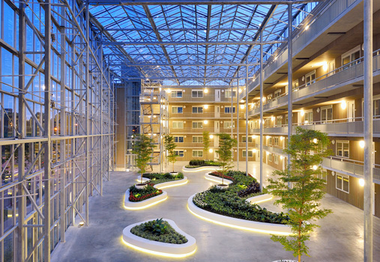

* + 1. Auditorium

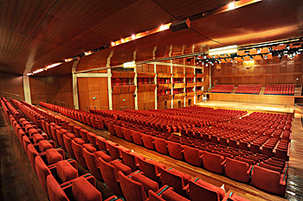

* + 1. Automated Data Processing: Mainframe

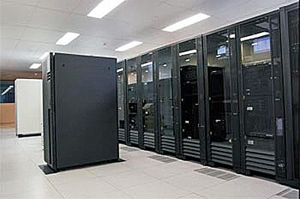

* + 1. Automated Data Processing: PC System

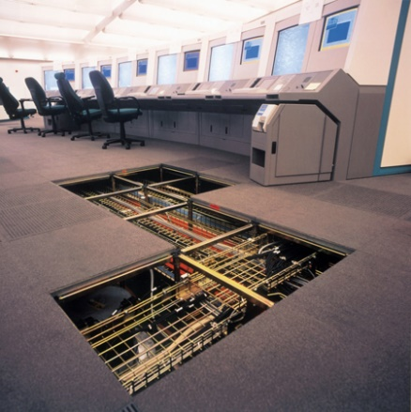

* + 1. Cafeteria

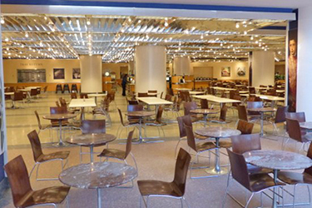

* + 1. Child Care



* + 1. Clinic
    2. Health Unit

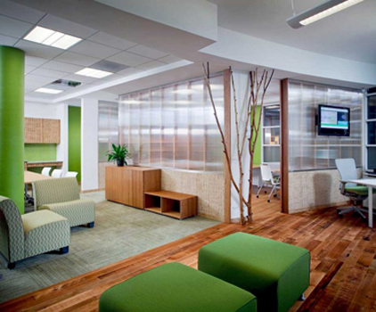

* + 1. Conference

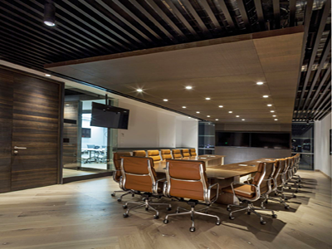

* + 1. Classroom

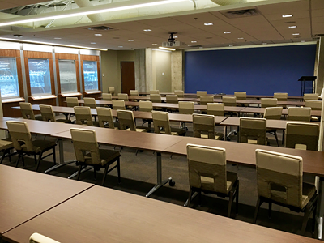

* + 1. Computer Lab

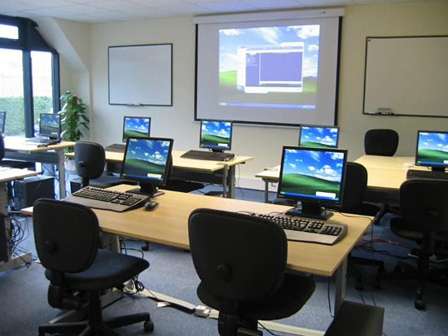

* + 1. Firing Range

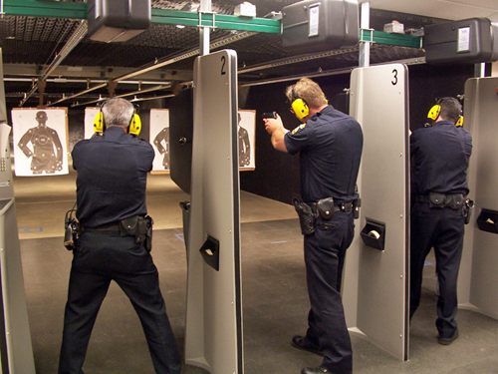

* + 1. Food Service
    2. General Storage
    3. Kitchen

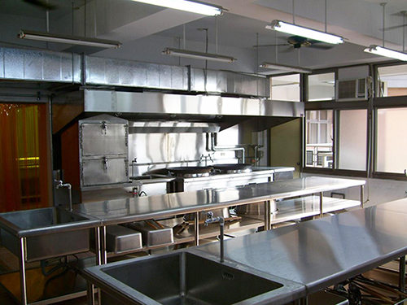

* + 1. Laboratory: Dry

The Dry Laboratory space type is a laboratory space that is specific to work with dry stored materials, electronics, and/or large instruments with few piped services.

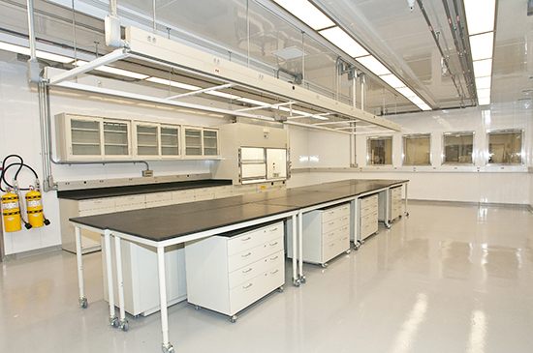

* + 1. Laboratory: Wet

Wet Laboratory space types are defined as laboratories where chemicals, drugs, or other material or biological matter are tested and analyzed requiring water, direct ventilation, and specialized piped utilities.

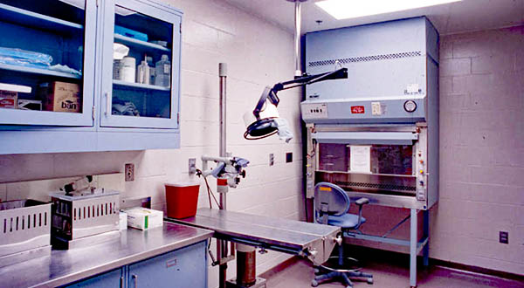

* + 1. Library

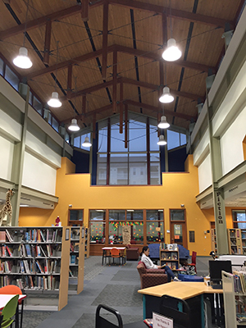

* + 1. Light Industrial
    2. Printing

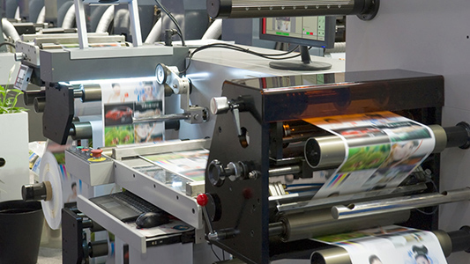

* + 1. Laundry
    2. film processing
    3. vehicle repair garages
    4. building maintenance shops
    5. metal work
    6. millwork
    7. cabinetry work
    8. Loading Dock

Loading docks are the arrival and departure point for large shipments brought to or taken from a building by trucks and van

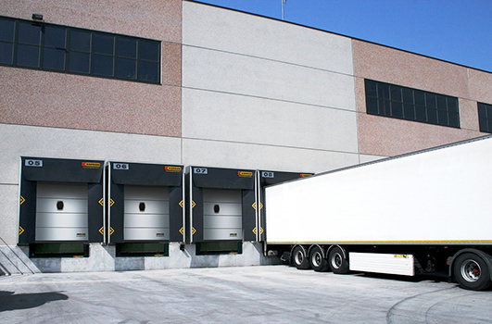

* + 1. Lobby

The lobby space type includes foyers, entries to halls, and security screening areas at or near the entrance to a building or demarcated space, and are meant to welcome and direct tenants and visitors, control access, and provide exit ways from buildings.

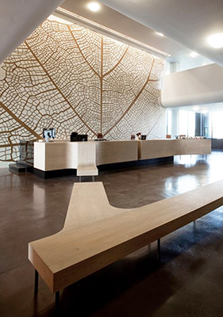

* + 1. Mail Center
    2. Office



* + 1. Office Enhanced

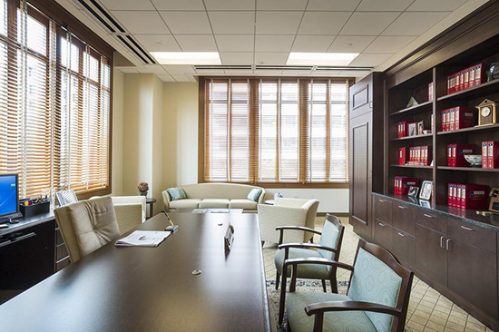

* + 1. Parking: Basement

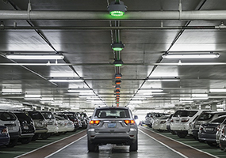

* + 1. Parking: Surface

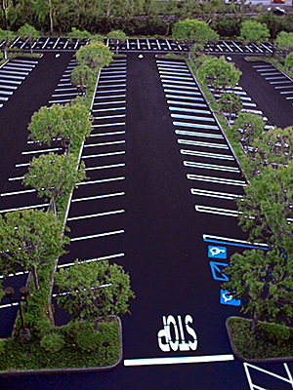

* + 1. Physical Fitness (Exercise Room)
    2. Place of Worship
    3. Playground

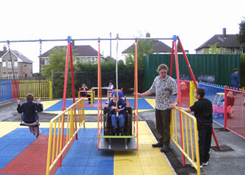

* + 1. Storage – Shelf

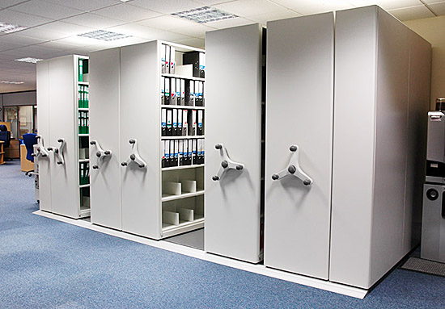

* + 1. Storage – Stacked

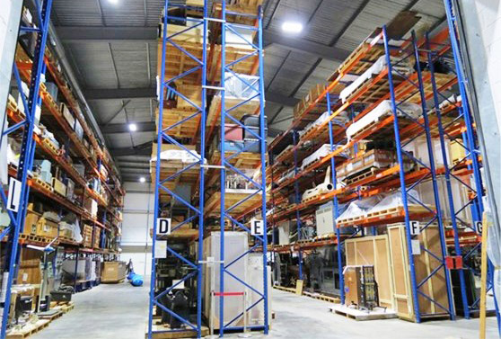

* + 1. Warehouse :

The Warehouse space type is designed to store goods and materials, as well as to allow for the regular circulation of occupants, vehicles, and machinery that are typically associated with the handling of these goods and materials.

* 1. Access to Customer
  2. Employment
  3. Marketing Services
  4. Research Services
  5. Networking

1. Employment
   1. Accountant
   2. Actor
   3. Actuary
   4. Administrator
   5. Agent
   6. Agricultural Worker
   7. Air Traffic Controller
   8. Ambulance Officer
   9. Architect
   10. Art Director
   11. Artist
   12. Athlete
   13. Auditor
   14. Baker
   15. Barista
   16. Bartender
   17. Board Member
   18. Business Analyst
   19. Chef
   20. Childcare Worker
   21. Civil Servant
   22. Cleaner
   23. Company Worker
   24. Computer Scientist
   25. Construction Worker
   26. Consultant
   27. Cook
   28. Copywriter
   29. Courier
   30. Craftsperson
   31. Curator
   32. Customer Service Representative
   33. Dentist
   34. Designer
   35. Doctor
   36. Driver
   37. Economist
   38. Electrician
   39. Entrepreneur
   40. Equipment Operator
   41. Executive Manager
   42. Farmer
   43. Film Maker
   44. Firefighter
   45. Fisherman
   46. Fitness Trainer
   47. Flight Attendant
   48. Florist
   49. Freelancer
   50. Gardener
   51. Hair Stylist
   52. Home Care Aid
   53. Homemaker
   54. Hospitality Worker
   55. Housekeeper
   56. Information Technology Professional
   57. Investor
   58. Journalist
   59. Laborer
   60. Lawyer
   61. Librarian
   62. Maintenance Worker
   63. Manager
   64. Manufacturing Worker
   65. Marketing Professional
   66. Mathematician
   67. Mechanic
   68. Medical Professional
   69. Merchant
   70. Midwife
   71. Military Personnel
   72. Musician
   73. Nanny
   74. Nurse
   75. Office Clerk
   76. Office Worker
   77. Optician
   78. Performance Artist
   79. Photographer
   80. Pilot
   81. Police Officer
   82. Politician
   83. Professor
   84. Railroad Engineer
   85. Researcher
   86. Retail Employee
   87. Retiree
   88. Rigger
   89. Sailor
   90. Salesperson
   91. Scientist
   92. Sea Captain
   93. Secretary
   94. Self-Employed
   95. Small Business Owner
   96. Social Worker
   97. Software Developer
   98. Spokesperson
   99. Statistician
   100. Stay-At-Home Parent
   101. Student
   102. Surgeon
   103. Surveyor
   104. Tailor
   105. Teacher
   106. Technician
   107. Tradesperson
   108. Trainer
   109. Translator
   110. Truck Driver
   111. Tutor
   112. Unemployed
   113. Veterinarian
   114. Videographer
   115. Waiter
   116. Waste Collector
   117. Writer
   118. Zoologist
2. School
   1. School of Business
   2. School of Arts and Sciences
   3. School of Engineering
   4. School of Pharmacy
   5. School of education
3. FAMILY STATUS
   1. Single
   2. Married
   3. Divorced
   4. Separated
   5. Widowed