Dokumentasi API

Terdapat 2 level :
1. admin : memiliki hak akses keseluruhan (CRUD)
2. public : read only, berdasarkan token dan user yang di daftarkan oleh admin

Terdapat 3 Auth Katagori :
1. Admin : auth menggunakan token, berdasarkan level yang terenkripsi dan hanya untuk level admin
2. private : auth menggunakan token,
3. publicapi : untuk login user, dan mendapatkan token

note:
token akan valid dalam waktu 1 jam, setelah itu anda harus login kembali untuk mendapatkan token yang baru atau dapat menggunakan autologin yang akan di bahas pada halaman …………….

Login

Method : post
URI : api/login
level : public
Input : email, password
input dapat berupa json,form-data atau x-www-form-urlencoded
Return :
- condition : [success/fail]
- message
- token
- data (name,email,created_at,updated_at)
Contoh :

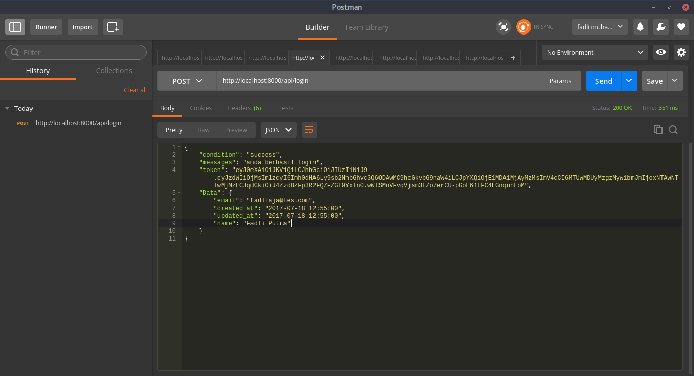

Contoh PHP

<?php
$url = "http://localhost:8000/api/login";

$postdata = "email=fadliaja@tes.com";
$postdata .= "&password=fadli123";

$ch = curl_init($url);

curl_setopt($ch, CURLOPT_POST, true);
curl_setopt($ch, CURLOPT_POSTFIELDS, $postdata);

curl_setopt($ch, CURLOPT_RETURNTRANSFER, true);

$result = curl_exec($ch);

echo $result;

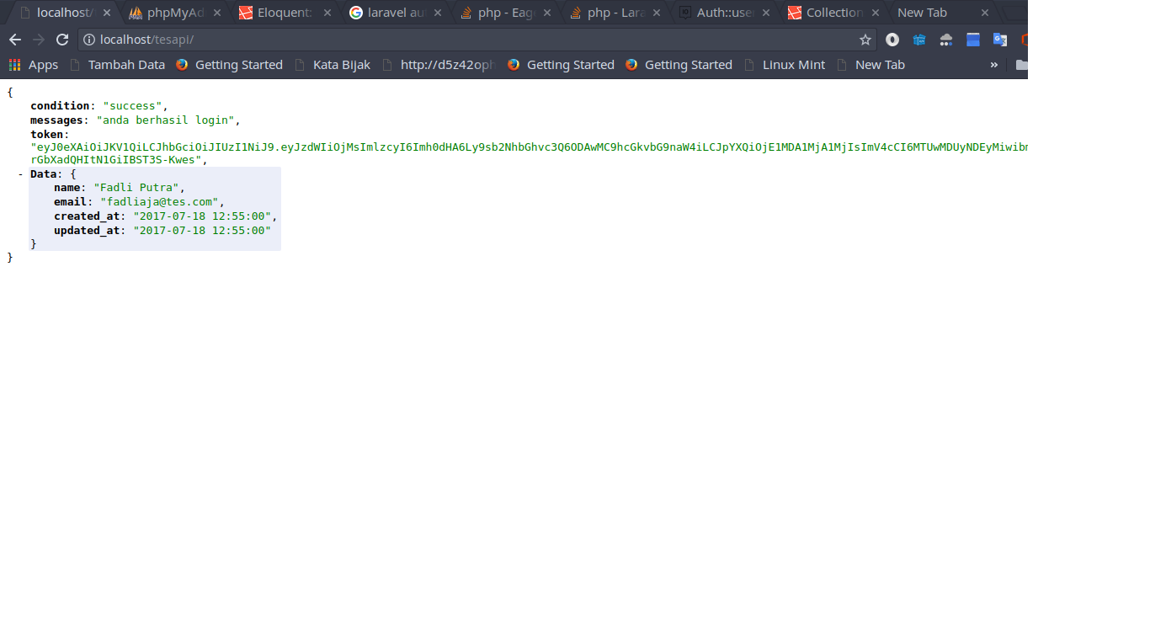

Register

Register hanya bisa di lakukan oleh admin saja
Method : post
URI : api/register
Level : admin
header :
- Authorization Bearer ….your….token….
- Content-Type : application/x-www-form-urlencoded

Body : name,email, password, level[admin/public]

return :
- condition : success/fail
- token
- data(name,email,level)

Contoh :

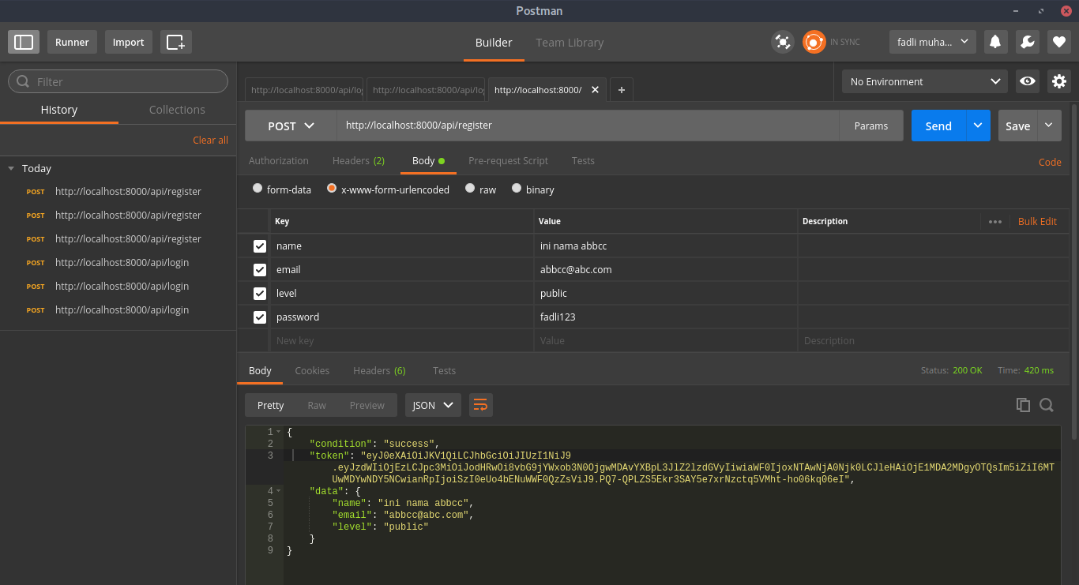

Contoh PHP

<?php

$url = "http://localhost:8000/api/register";

$token = "Bearer ....";

$headers = [
"Content-Type: application/x-www-form-urlencoded",
"Authorization: $token"
];

$postdata = "email=aabb@aa.com";
$postdata .= "&name=ini abc";
$postdata .= "&level=admin";
$postdata .= "&password=123456789";

$ch = curl_init($url);

curl_setopt($ch, CURLOPT_HTTPHEADER, $headers);

curl_setopt($ch, CURLOPT_POST, true);
curl_setopt($ch, CURLOPT_POSTFIELDS, $postdata);

curl_setopt($ch, CURLOPT_RETURNTRANSFER, true);

$result = curl_exec($ch);

echo $result;

Upload Gambar

Method : post
URI : api/picture/upload
Type : Admin
header :
- Authorization Bearer ….your….token….
- fotm-data

Body :
- image
- alt(optional)
- title(optional)

Return :
- original (condition, messages,location)
- compress (condition,messages,location)

Contoh :

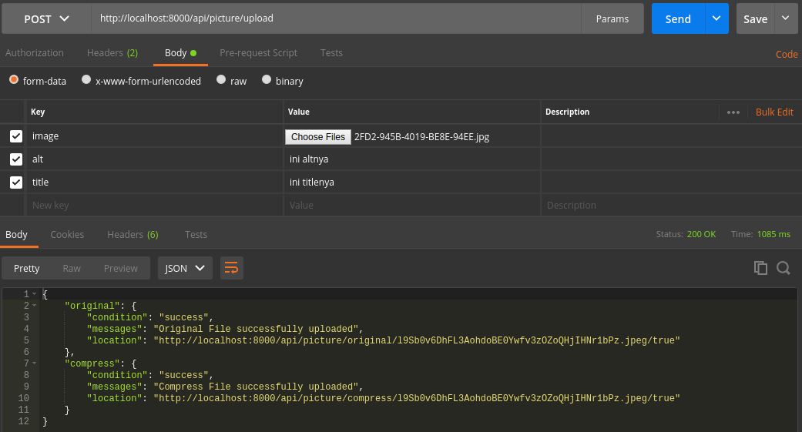

Contoh PHP

<form method="POST" action="" enctype="multipart/form-data">
<input type="file" name="image">
<br />
<input type="text" name="alt">
<br />
<input type="text" name="title">
<br />
<input type="submit" name="kirim">
</form>
<?php

if(isset($_POST['kirim'])){

$url = "http://localhost:8000/api/picture/upload";

$token = "bearer ...your....token";

$headers = [
"Authorization: $token"
];

$postdata = [
"image" => new CurlFile($_FILES['image']['tmp_name']),
"alt" => $_POST['alt'],
"title" => $_POST['title']
];

$ch = curl_init($url);

curl_setopt($ch, CURLOPT_HTTPHEADER, $headers);

curl_setopt($ch, CURLOPT_POST, true);
curl_setopt($ch, CURLOPT_POSTFIELDS, $postdata);

curl_setopt($ch, CURLOPT_RETURNTRANSFER, true);

$result = curl_exec($ch);
echo "<pre>";
echo $result;
echo "</pre>";

}

Mendapatkan Gambar Original / Compress

Method : GET
URI : /api/picture/all/original Atau /api/picture/all/compress
Contoh Pagingation :
- /api/picture/all/original?page=2
- /api/picture/all/compress?page=2
Level : public
Return :
- condition
- image_base_url
- pagination
contoh :
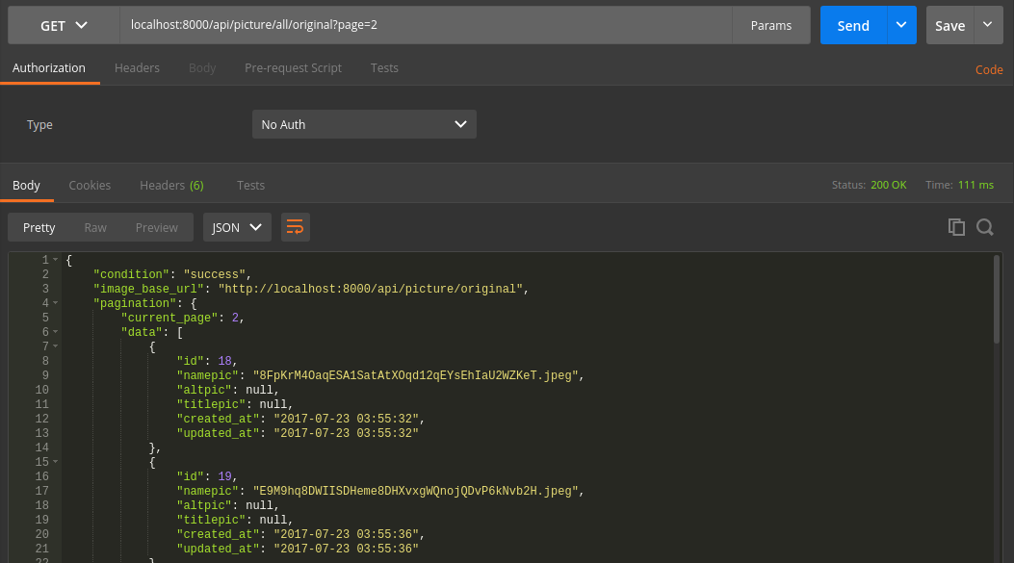

Contoh php
<?php

$url = "localhost:8000/api/picture/all/original?page=1";

$ch = curl_init($url);

curl_setopt($ch, CURLOPT_HTTPGET, 1);
curl_setopt($ch, CURLOPT_RETURNTRANSFER, true);

$result = curl_exec($ch);

echo $result;

Mendapatkan Spesifik Gambar

Method : GET
URI :
- /api/picture/original/{name} => untuk menampilkan format picture
- /api/picture/original/{name}/json => untuk menampilkan dengan format json
- /api/picture/compress/{name} => untuk menampikan format picture
- /api/picture/compress/{name}/json => untuk menampikan dengan format json
Return :
- url
- alt
- title
- created_at
Contoh :
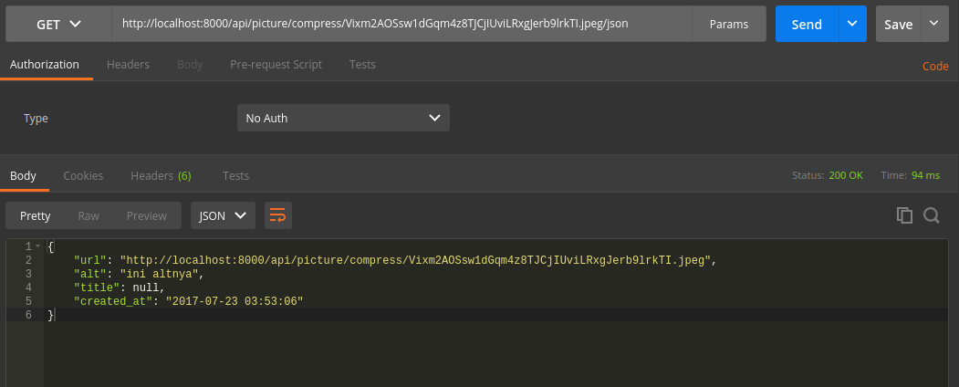

contoh php
<?php

$url = "http://localhost:8000/api/picture/compress/Vixm2AOSsw1dGqm4z8TJCjIUviLRxgJerb9lrkTI.jpeg/json";

$ch = curl_init($url);

curl_setopt($ch, CURLOPT_HTTPGET, 1);
curl_setopt($ch, CURLOPT_RETURNTRANSFER, true);

$result = curl_exec($ch);

$output = json_decode($result,true);

echo $output['url'];

Atau

<?php

$url = "http://localhost:8000/api/picture/compress/Vixm2AOSsw1dGqm4z8TJCjIUviLRxgJerb9lrkTI.jpeg";

$ch = curl_init($url);

curl_setopt($ch, CURLOPT_HTTPGET, 1);
curl_setopt($ch, CURLOPT_RETURNTRANSFER, true);

$result = curl_exec($ch);

echo $result;

Delete Image
Method : Delete
URI : /api/picture/delete/{namapic}
Level : Admin
header :
- Authorization Bearer ….your….token….

Contoh :

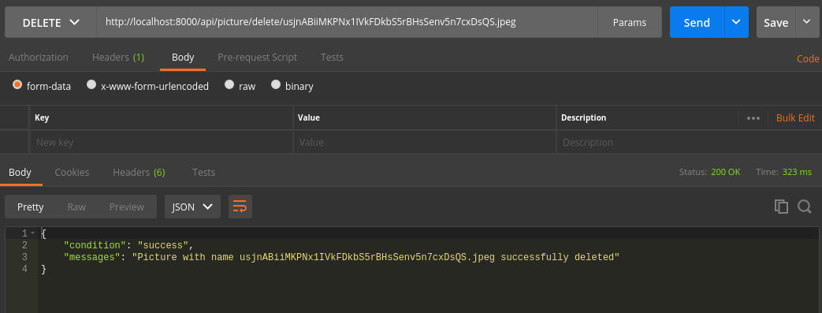
Contoh PHP :

<?php

$url = "http://localhost:8000/api/picture/delete/NFjfZf1YLUo55iC08OCmMlRmrI7yZ2I5hilrf64h.gif";
$token = "Bearer ....your....token";

$headers = [
"Authorization: $token"
];

$ch = curl_init($url);

curl_setopt($ch, CURLOPT_HTTPHEADER, $headers);
curl_setopt($ch, CURLOPT_CUSTOMREQUEST, "DELETE");
curl_setopt($ch, CURLOPT_RETURNTRANSFER, true);

$result = curl_exec($ch);
$result = json_decode($result);
curl_close($ch);

var_dump($result);

