FOUNDATIONS OF THE MACHINE LEARNING PIPELINE
Comprehensive Take-Home Exam Preparation Study Guide

1. AI and Machine Learning Fundamentals
At its core, Artificial Intelligence (AI) represents the broad, overarching scientific field focused on building computer systems capable of performing complex tasks that conventionally require human intelligence. This encompasses diverse actions including speech recognition, strategic decision-making, answering contextual questions, and suggesting personal recommendations.
Machine Learning (ML) is a distinct subset of AI that serves as the engine powering its digital brain. Instead of relying on explicit, rigid, step-by-step programming instructions, machine learning uses statistical algorithms to analyze vast datasets, identify complex patterns, and make independent predictions or decisions. Machine learning is fundamentally a data-to-decision process that generalizes rules from examples.
Deep Learning (DL) represents a further, specialized subset of machine learning. Deep learning utilizes multi-layered neural networks inspired by the physiological structures of the human brain. These layered architectures enable models to extract and learn highly complex, non-linear hierarchical patterns directly from raw data.
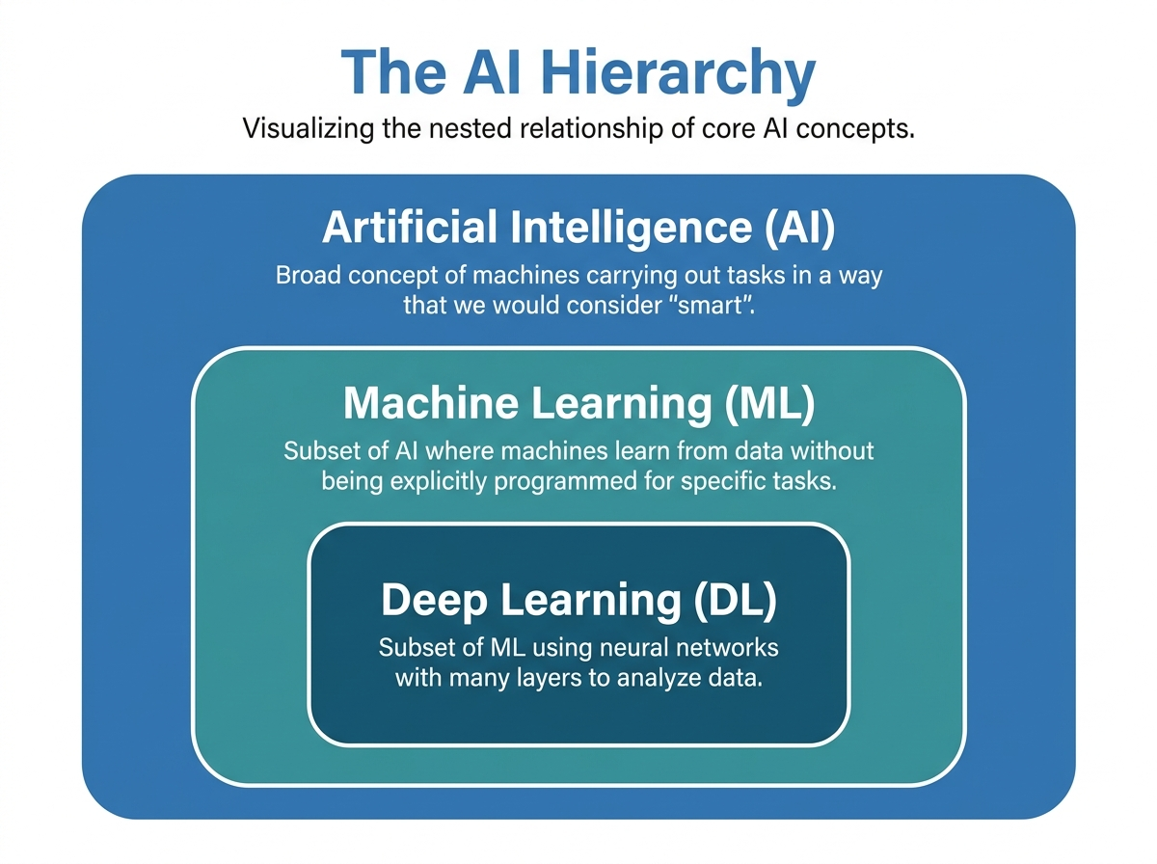
Figure 1.1: Hierarchical Structure of AI, Machine Learning, and Deep Learning Subsets
To make these concepts intuitive, think of the following culinary analogy:
• The Ingredients = Data: The raw fuel that feeds the system. Just as a dish needs ingredients, ML requires high-quality data to learn.
• The Chef = Algorithm: The set of rules and mathematical calculations that process ingredients and extract structural patterns.
• The Dish = Model: The final, usable outcome. The model is a mathematical mapping function that takes raw inputs and generates structured decisions or predictions.

The Three Pillars of Data Quality
The performance of any machine learning model is directly constrained by the data it utilizes. Under the principle of "garbage in, garbage out," a model cannot overcome a flawed, highly biased, or corrupted dataset. True data quality rests on three non-negotiable pillars:
Pillar | Core Definition | Primary Focus & Action Items
1. Accuracy | The dataset represents physical reality as closely and truthfully as possible. | Eliminate reporting errors, prevent false records, and ensure target values are verified and correct.
2. Relevance | The features (inputs) must directly relate to the prediction target. | Avoid adding noisy or completely unrelated features which mislead the learning algorithm and degrade training.
3. Cleanliness | Raw data is standardized, normalized, and complete. | Deduplicate observations, repair formatting errors, resolve missing values, and handle outlier values programmatically.

★ STUDY NOTE: DATA QUALITY OVER QUANTITY
• More data generally improves performance because it covers edge cases and uncovers subtle relationships.
• However, more data ONLY helps if it is high quality. Adding millions of noisy features works against your model's accuracy.

2. The Five-Stage Machine Learning Pipeline
A machine learning model is not a standalone mathematical calculation. Rather, it is the result of a rigorous, multi-stage pipeline designed to turn raw observations into maintainable, live decision systems. Crucially, this pipeline is highly iterative: when evidence is weak at any stage, teams must loop back to earlier steps to adjust inputs, collect new data, or retrain parameters.
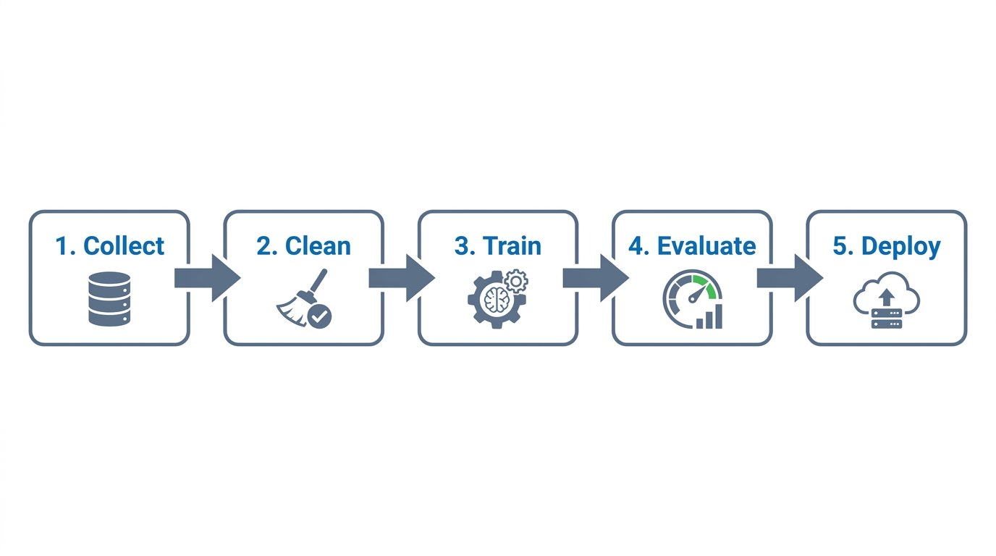
Figure 2.1: The 5 Connected Stages of the Machine Learning Lifecycle
Pipeline Stage | What Happens (Key Process Elements) | Key Output Deliverable
1. Collect | Define the target variable, unit of analysis, and target window. Gather representative data and document data provenance. Proactively check permissions, privacy, sampling bias, and label quality. | Documented dataset & clear problem statement
2. Clean | Make raw inputs consistent. Resolve duplicate records, missing values, typos, and formatting differences. Standardize formats and units. Document an audit trail of all transformations to ensure reproducibility. | Clean data & detailed transformation audit trail
3. Train | Fit model parameters. Set aside an untouched test set. Preprocessing configurations must be learned only from the training set to prevent leakage. Establish baseline metrics and tune hyperparameters using validation split. | Versioned candidate model & configuration
4. Evaluate | Thoroughly measure model generalization capabilities. Inspect accuracy, precision, recall, F1-scores, and the confusion matrix. Assess performance across critical demographic data slices before release. | Evidence of strengths & model limitations
5. Deploy | Integrate the model into a live application or API service (MLOps). Package preprocessing logic with the model. Monitor latency, service failures, statistical drift (data & concept), and fairness over time. | Maintainable service & feedback loop

★ EXAM FOCUS: REPRODUCIBLE PIPELINES
• Strict Repeatability: Every single data cleaning and preprocessing step must be documented and coded as a repeatable transformation.
• Baselines: Never evaluate a model in a vacuum. Compare model performance against a simpler baseline (e.g., Naïve Bayes or a simple average) to verify the complexity is adding real value.

3. The Four Paradigms of Machine Learning
Machine learning is divided into distinct operational paradigms based on the type of data available and the nature of the learning task. Understanding these paradigms is central to selecting the correct algorithm for any practical application.
Paradigm | Goal / Learning Mechanism | Data Nature | Common Algorithms & Methods
Supervised | Learn an explicit mapping function from features to a target label based on historical examples. Predict outputs for unseen cases. | Labeled Data (Features + Targets) | • Classification: Logistic Regression, Decision Trees, SVM, Naïve Bayes, k-NN, Random Forests  • Regression: Linear Regression
Unsupervised | Identify hidden underlying structures, relationships, or patterns in data without a predefined target variable. | Unlabeled Data (Features only) | • Clustering: k-means, Hierarchical, DBSCAN  • Association Rules: Market-Basket Co-occurrence  • Dimension Reduction: PCA
Reinforcement | An autonomous agent learns to make a sequence of optimal decisions via trial-and-error by taking actions in an environment to maximize cumulative reward. | Feedback-driven (State, Action, Reward) | • Q-learning  • SARSA  • Monte Carlo Methods  • Actor-Critic Frameworks
Semi-Supervised | Fuses supervised and unsupervised methods. Leverages a small set of expensive labeled data alongside a large pool of unlabeled data. | Partially Labeled | • Label Propagation  • Graph-based learning  • Self-training algorithms

★ CORE DISTINCTIONS FOR THE EXAM
• Classification vs. Regression: Supervised tasks are split by target type. Classification predicts discrete categories (e.g., Spam vs. Not Spam). Regression predicts continuous numeric values (e.g., predicting real estate prices).
• Reinforcement Learning Policy: The policy is the internal decision strategy the agent uses to map states to optimal actions, balancing exploration (trying new things) and exploitation (using known paths).

4. Diagnostics, Drift, and Responsible AI
Building a model is only half the battle. Maintaining, diagnosing, and deploying models ethically and reliably represents the core focus of modern MLOps (Machine Learning Operations). Below, we outline the mathematical diagnostics and post-deployment safeguards required for success.

Overfitting vs. Underfitting
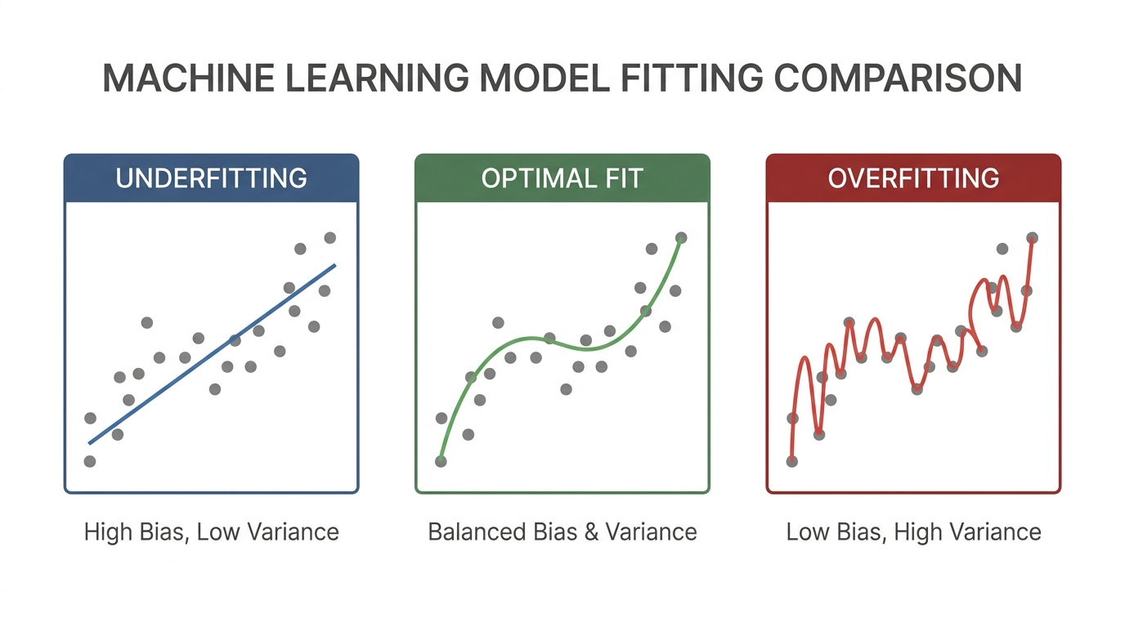
Figure 4.1: Visual Comparison of Underfitting, Optimal Fit, and Overfitting in Data Modeling
Overfitting occurs when a model is overly complex relative to the data. It memorizes the training noise and details rather than extracting the underlying pattern. This results in incredibly low error rates on training data, but massive error rates on validation/test data (high variance).
Underfitting occurs when a model is too simple to capture the underlying signal. It fails to learn the patterns even on the training data, resulting in poor performance on both training and test data (high bias, systematic error).
To resolve overfitting: use regularization, simplify model architecture, engineer better features, acquire more training data, or perform honest cross-validation. To resolve underfitting: increase model complexity, loosen regularization constraints, or feed more informative features.

Post-Deployment Monitoring: Concept vs. Data Drift
Once a model is deployed to an API or service, its environment is dynamically changing. Over time, performance will decay due to drift:
• Data Drift: The statistical distribution of the input features shifts over time, but the underlying decision logic remains constant. (Example: An e-commerce site experiences a sudden surge in traffic from a completely new demographic group).
• Concept Drift: The statistical relationship between the input features and the target variable changes over time. (Example: A predictive model for spam emails fails because spammers develop completely new tactics and vocabularies that shift what constitutes 'spam').

Responsible ML: Representativeness vs. Fairness
Ethics in machine learning requires separating terms that are often casually conflated in general business discussion:
• Representativeness: Refers to whether your dataset accurately mirrors the demographic groups, variations, and frequency distributions of the actual physical population. Poor representativeness leads to severe sampling bias.
• Fairness: Refers to active algorithmic governance to ensure your model's prediction error rates (e.g., false negative rates or false positive rates) are equalized and minimized across different demographic groups, preventing systemic discrimination.

5. High-Yield Exam Preparation Checklist
Review the checklist items below. Each bullet matches a foundational exam question:
[ ] ML is fundamentally a branch of AI where algorithms learn patterns from examples.
[ ] Deep Learning uses nested, multi-layered neural networks inspired by the human brain to detect highly non-linear, hierarchical relationships in raw, high-dimensional datasets.
[ ] Data is the ingredients, algorithms are the chef, and the resulting mathematical function is the dish (the model).
[ ] The five sequential pipeline stages are: Collect → Clean → Train → Evaluate → Deploy.
[ ] Provenance tracking ensures we document the origin, licensing, and lineage of datasets to prevent legal, quality, and regulatory risks.
[ ] Data standardization during the Cleaning stage transforms features to a uniform scale, ensuring no single feature disproportionately dominates distance calculations or fitting calculations.
[ ] Always split raw data into Train, Validation, and Test sets before adjusting parameters to prevent data leakage.
[ ] Data evaluation must use unseen data. If a model is evaluated on its own training set, it is a dishonest metric that masks overfitting.
[ ] In supervised classification, precision and recall measure different error types. Inspect both (using a confusion matrix) based on the cost of specific errors (e.g., blocking valid emails vs. missing harmful spam).
[ ] Continuous monitoring in production is required to track concept drift (shifting target relationships) and data drift (shifting input feature distributions).
[ ] Unsupervised PCA reduces dimensions while preserving as much of the original, important variance as possible.
[ ] In Reinforcement Learning, the policy governs the balance between exploration (searching alternatives) and exploitation (acting on known reward structures).
[ ] Semi-supervised learning is the ideal choice when obtaining expert manual labeling is extremely slow or cost-prohibitive, combining small labeled datasets with large unlabeled datasets.
[ ] Overfitting displays low training error but high test error (high variance/memorization); Underfitting shows high training error and high test error (high bias/systematic failure).
[ ] Differentiate Representativeness (ensuring diverse demographic cohorts are included in data collections) from Fairness (governing algorithmic predictions to avoid systemic disparities in error rates).

