Analysis – User Stories

* User directly must choose how many players will be playing
* After the program ran, the user can’t quit the application other than pressing the close button
* Users then need to type in player names
* The first player will pick from the provided game mode by typing in the letters in bracket
* Before playing, deck will be shuffled
* The users need to pick from provided cards, or type in 99 to draw a card and skip
* Text arrangement could be better
* The current player will be notified what card was played earlier and its stats
* The user will choose a better stat from the previous card
* Some invalid inputs will trigger the program to retry without any message
* When a player has a Geophysicist and a Magnetite card, they instantly win the game
* When all the cards in the deck has been used, previously used cards will be moved into the deck
* Players who has emptied their hands win and will leave the game

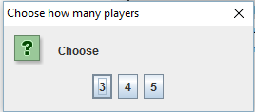Analysis – Testing

First Box. User greeted with 3 buttons to choose how many players are participating

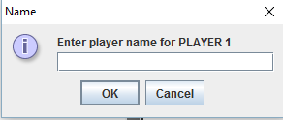

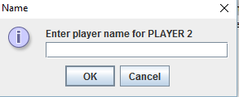

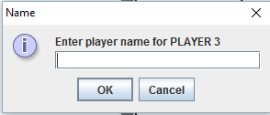

Players need to type in their name

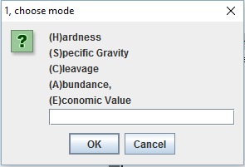

First player pick the gamemode. With error checking

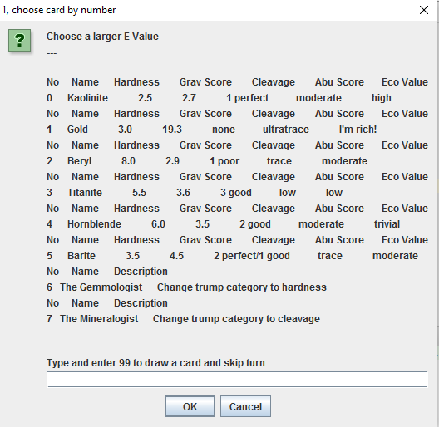

First player choose what card he want to put in first. He can skip the turn to draw a card

Analysis – UML

