**2221551212 - Digital Image Processing Homework-1**

**Skeleton Image Enhancement:**

Our goal in this first homework is to give the digital image of human skeleton in **figure. 1** more detail, using enhancement methods.



Figure 1 Skeleton Original

To achieve that, we may combine between many methods, on the image given, like sharpening it and bringing out more of the skeletal detail. And we will utilize the Laplacian to highlight fine detail, and the gradient to enhance prominent edges.

In the next steps I will explain every stage to get a more detailed digital image of a human skeleton.

**The “Sobel” algorithm:**

In the following code we will read and double the image giving, besides using the Sobel Algorithm, to detect edges in the vertical direction, horizontal direction, or both.

Figure 2 Code for Soble Algorithm

The Sobel operator performs a 2-D spatial gradient measurement on an image and so emphasizes regions of high spatial frequency that correspond to edges. Typically, it is used to find the approximate absolute gradient magnitude at each point in an input grayscale image.

The next image is going to show the result in the original image after being treated by the Sobel method.

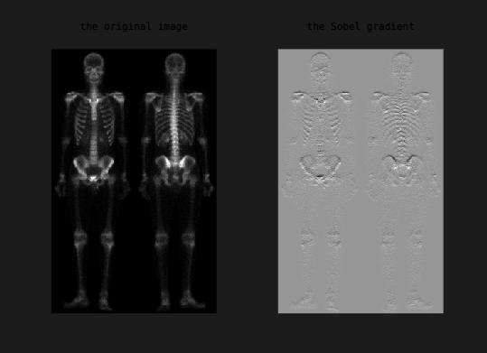

Figure 3 Result after Sobel Method

**Average Filtering:**

filtering is a method of 'smoothing' images by reducing the amount of intensity variation between neighboring pixels.

The following code will show the steps to get an image with a reduced amount of intensity.

Figure 4 code (average filtering)

As a result, the following figure given is how our Sobel image is, after using the average filtering on it.

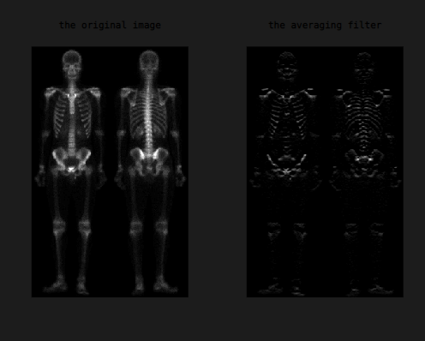

Figure 5 Using average filtering on a Sobel image

**Laplacian filter**

Laplacian is a linear operator. It is a 2-D [isotropic](https://homepages.inf.ed.ac.uk/rbf/HIPR2/isotrop.htm) measure of the 2nd [spatial derivative](https://homepages.inf.ed.ac.uk/rbf/HIPR2/spatdom.htm) of an image. The Laplacian of an image highlights regions of rapid intensity change and is therefore often used for edge detection.

The following code is the next step to treat the image given in Figure 5.

Figure 6 Code for Laplacian Filter

The following figure is representing the original image and the other is the image of the figure 5 after the average filter combining with the Laplacian filter.

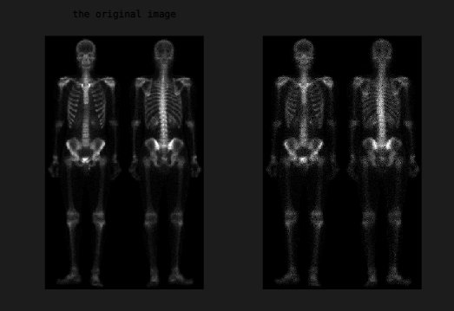

Figure 7 the Laplacian filter on the average filtered image

**Sharper image and the sum of the product**

Sharping the original image by adding Laplacian filtered on it, so the result would give us:

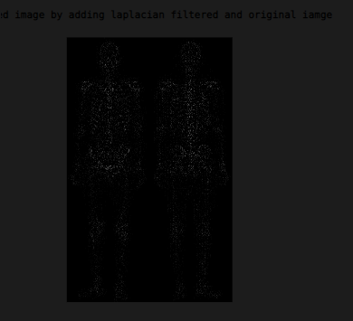

Figure 8 Sharped image

The code in Matlab for sharpening the image is:

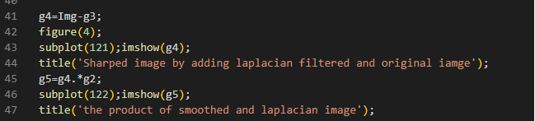

Figure 9 code for sharped image

Next part is going to be the product of the last result (Figure 8) and the Laplacian image (Figure 7). Which will be the smoothed image(Figure 10)

Figure 10 Smoothed image

After that we will add the last product that we calculated in Figure 9 to the original image (Figure 1)

So the result would be, as in the following figure.

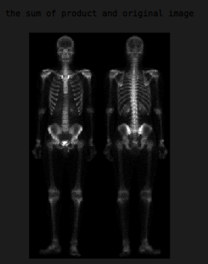

Figure 11 Sharping image

Combine the sharping and the gradient operation (Final result):

As a final result we will combine gradient operation (gamma) with the sharping image (Figure 11), the following code represent that combination.

Figure 12 Code for the gradient operation

For the result the next figure will present our final result from combining all this methods to get more detailed digital image.

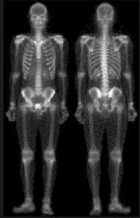

Figure 13 Final result