Lab 6 – Docker-swarm
Manage cluster of machines

We're going to build a cluster of Docker servers using Docker Swarm. You have 3 Docker servers:
  - 1 manager
  - 2 workers

Cluster initialization
- Initialize the swarm cluster from the manager host using its IP from the same range than the 2 workers:
docker swarm init --advertise-addr = 192.168.205.10
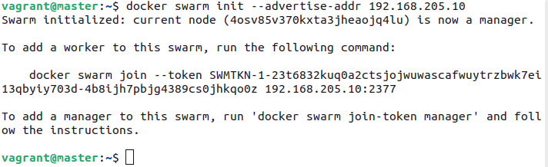
  - What does this command generate?
  - Check that the cluster has been created and that the manager is the single member.
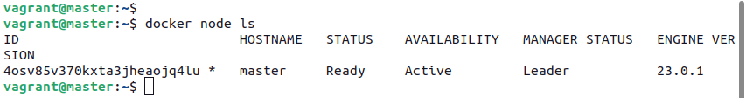
  - What is the token generated by this command used for? Display the 2 tokens.
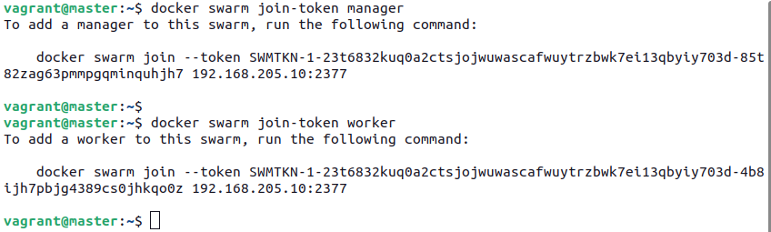
- Join worker1 and worker2 VMs to the cluster (as workers).
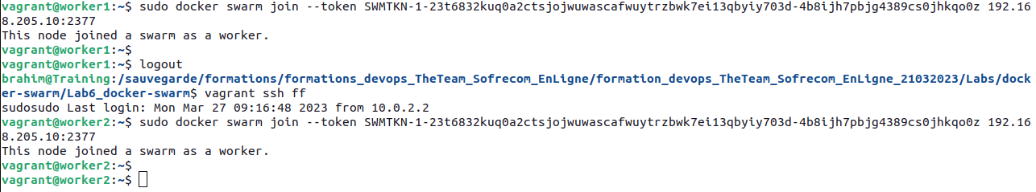
  - Check that the 2 workers are in the cluster and that they are ready.
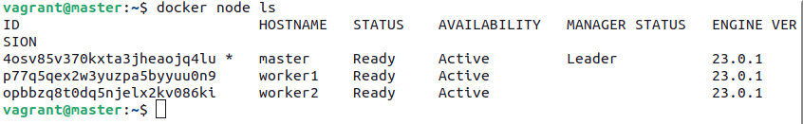
- What networks are created following cluster initialization.
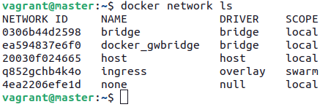

  - Describe them.
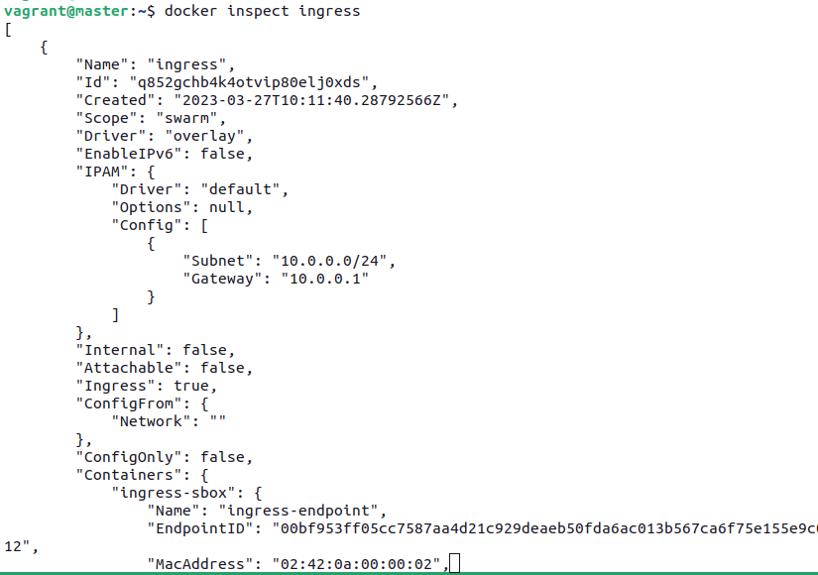

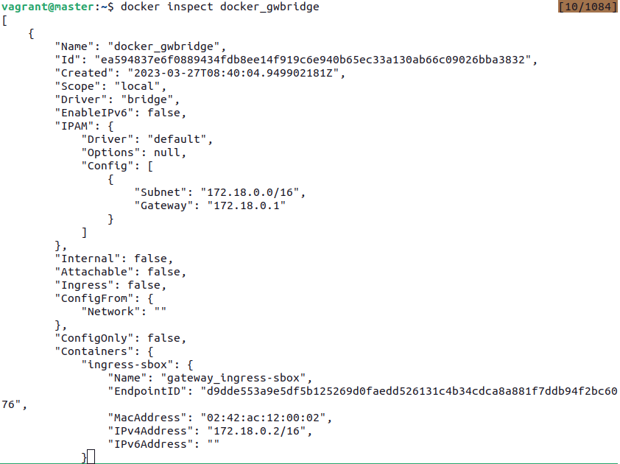
Launch of the Dockercoins application on Swarm
- Create an overlay network to isolate all services of the application.
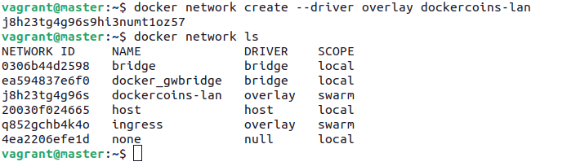
  - View details of our network
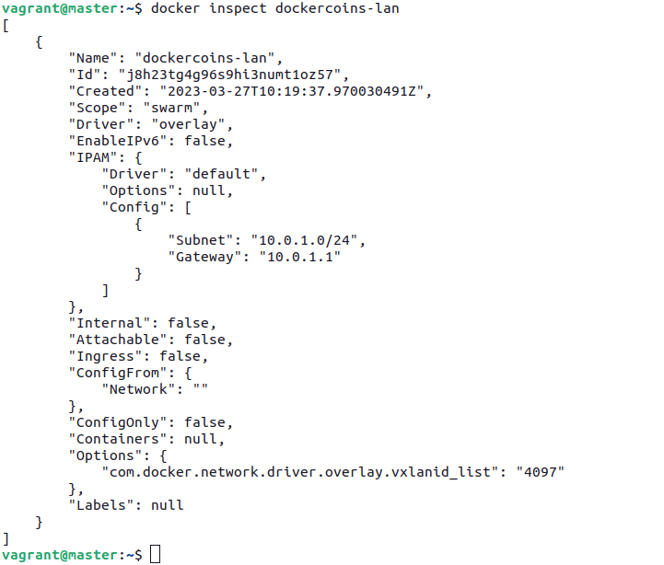

- Create the service running the redis database.
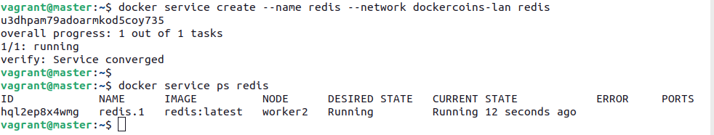
  - Wait until the server is in "running"
  - Once redis is ready, run the hasher, rng, and worker services.

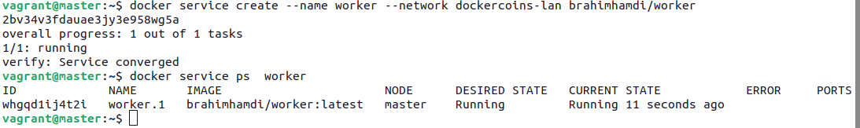
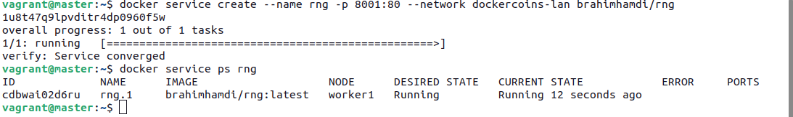
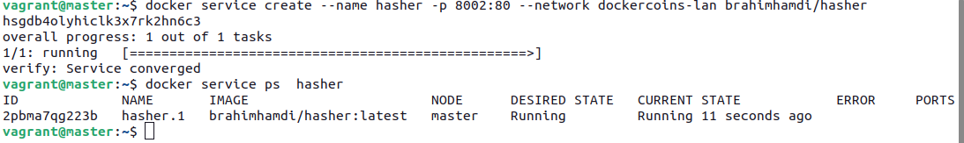
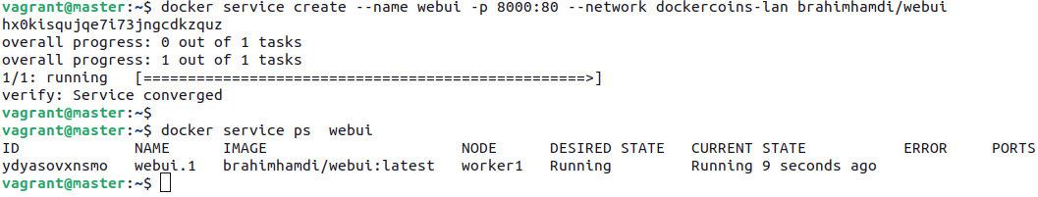
  - Check that these services are "running".
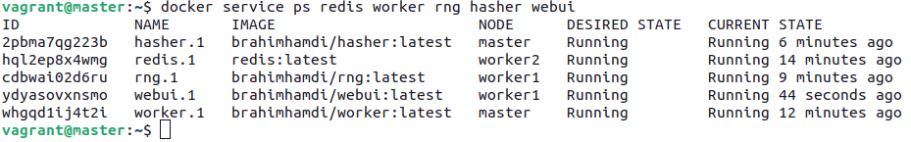
  - Give the IP address of each container as well as the node on which it is run.

Scaling on the swarm
- scale out the worker service to 10 replicas.
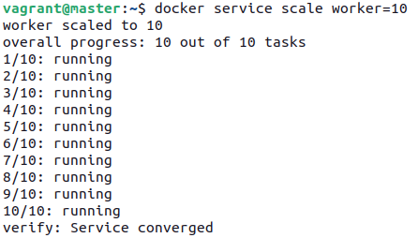

  - Once all the replicas are "running", display the webui. What is the rate of generation of dockercoins?
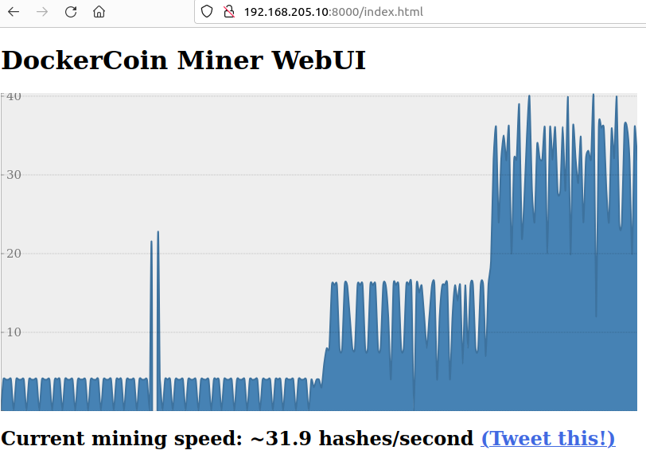

- We want to run exactly one rng instance on each host. Unfortunately, this scheduling mode cannot be activated / deactivated for a existing service.
So, we have to start by removing the existing rng service, then recreate it with global scheduling
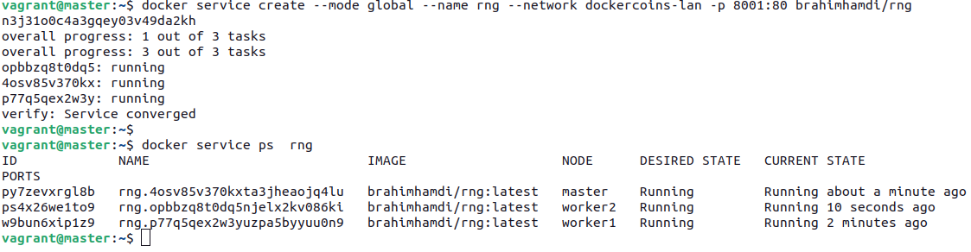
- Check that only one instance of rng is running on each node.
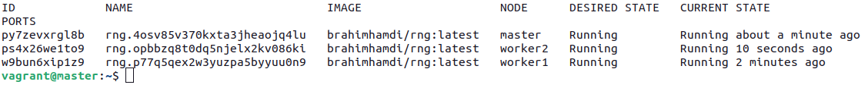
  - Open the webui, what is the Dockercoins generation speed?
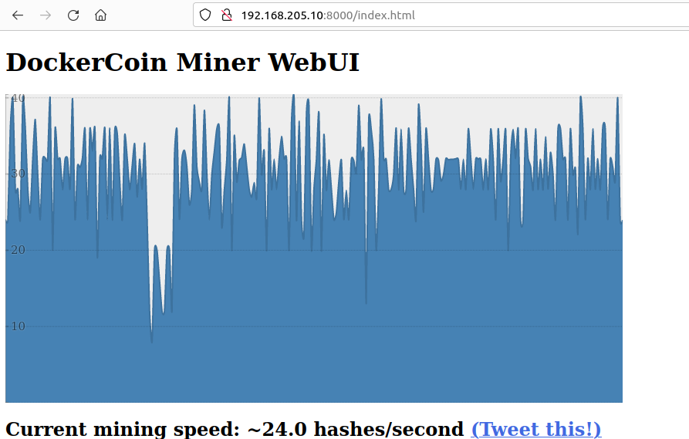
  - Remove all services of the application.
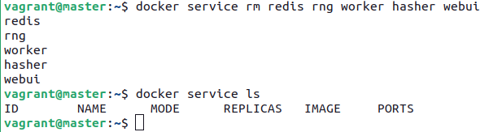

Docker stack
- Now we will combine docker swarm and docker compose to be able to deploy on the cluster using docker-compose.yml file.
  - Check that all services running
