Lab 7 - Kubernetes

Initialize cluster
- To free up resources, stop all vagrant VMs in devop-lab environment.
  - Clone the following Git repository :
https://github.com/brahimhamdi/k8s-lab
  - In k8s-lab directory, execute following command to deploy k8s vagrants VMs :
vagrant up

- Kubernetes is already installed on all vagrant VMs. On master VM, initialize the cluster.
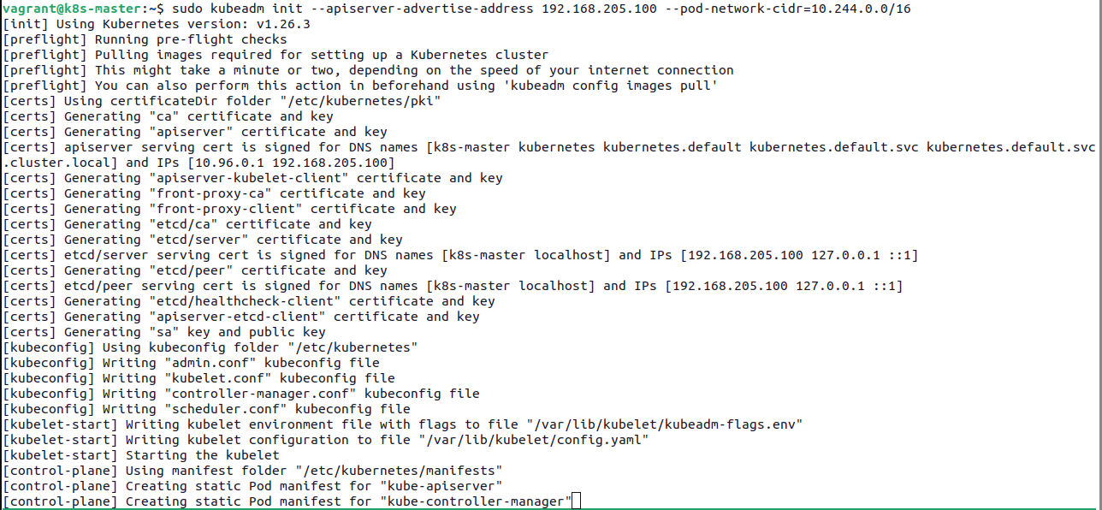
  - Is there any errors ? How to resolve these errors ? Nbre CPU <2, mém <1.7 Go, swap enable
  - If no errors, what’s the output of the initializing command ? Join command
  - Apply flannel yaml file.
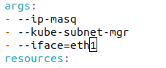

- Check the cluster info.
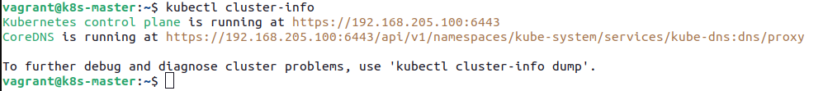
  - How kubernetes components looks like ?
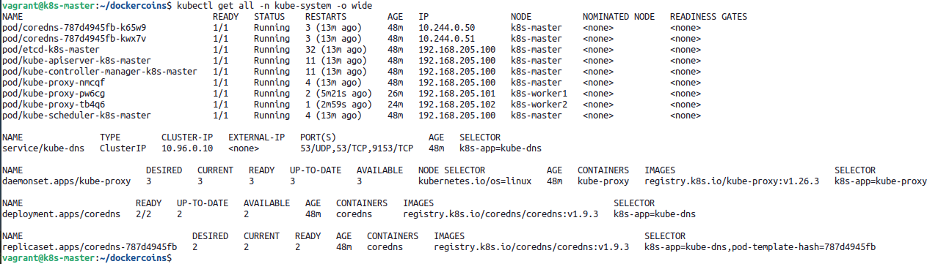
  - What is the IP address of DNS systems ?
- Join all nodes to the cluster.
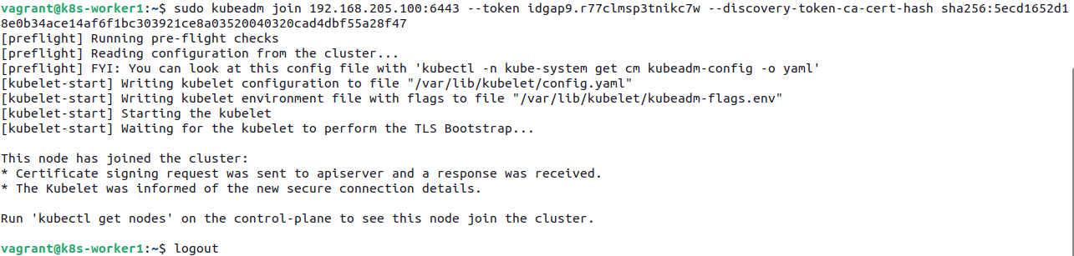
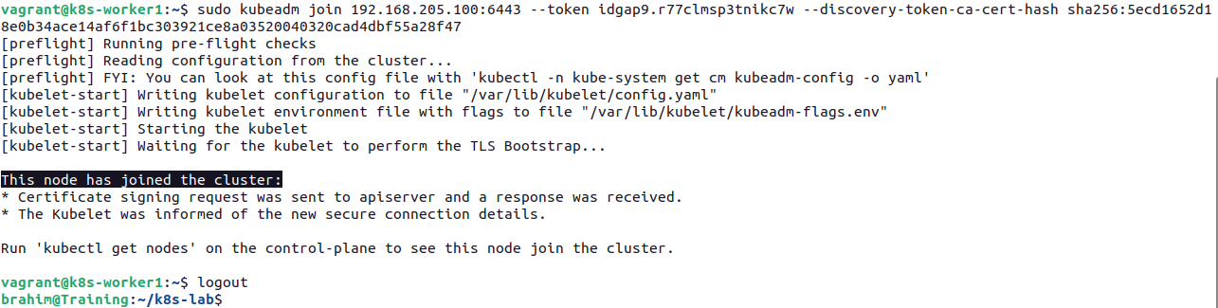
  - On the master, check that all nodes are ready on the cluster.
Manage pods
- Create a yaml file for a hasher pod.
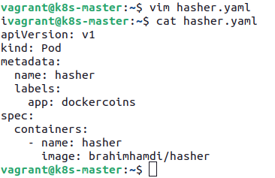

- Apply the yaml file.

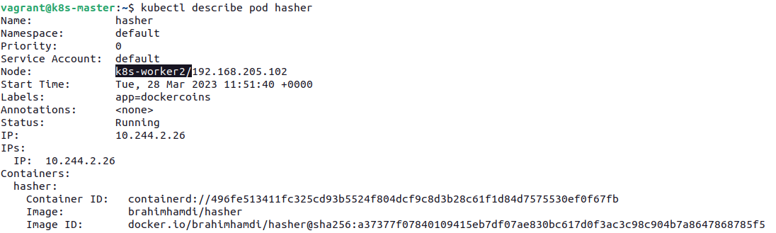
  - On which node the pod is created ?
  - What is the pod’s IP address ?
  - What is the container’s name and ID ?
  - What is the image’s name and ID ?

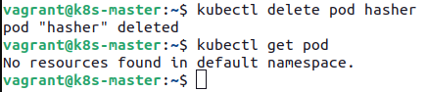
- Remove the pod from the cluster.

Manage deployments and services
- Create yaml file to describe dockercoins application deployment.
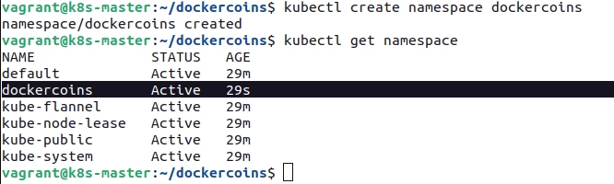
apiVersion: apps/v1
kind: Deployment
metadata:
name: worker
spec:
replicas: 1
selector:
matchLabels:
app: dockercoins
tier: worker
template:
metadata:
name: worker
labels:
app: dockercoins
tier: worker
spec:
containers:
- name: worker
image: brahimhamdi/worker
---
apiVersion: apps/v1
kind: Deployment
metadata:
name: rng
spec:
replicas: 1
selector:
matchLabels:
app: dockercoins
tier: rng
template:
metadata:
name: rng
labels:
app: dockercoins
tier: rng
spec:
containers:
- name: rng
image: brahimhamdi/rng
---
apiVersion: apps/v1
kind: Deployment
metadata:
name: hasher
spec:
replicas: 1
selector:
matchLabels:
app: dockercoins
tier: hasher
template:
metadata:
name: hasher
labels:
app: dockercoins
tier: hasher
spec:
containers:
- name: hasher
image: brahimhamdi/hasher
---
apiVersion: apps/v1
kind: Deployment
metadata:
name: redis
spec:
replicas: 1
selector:
matchLabels:
app: dockercoins
tier: redis
template:
metadata:
name: redis
labels:
app: dockercoins
tier: redis
spec:
containers:
- name: redis
image: redis
---
apiVersion: apps/v1
kind: Deployment
metadata:
name: webui
spec:
replicas: 1
selector:
matchLabels:
app: dockercoins
tier: front
template:
metadata:
name: webui
labels:
app: dockercoins
tier: front
spec:
containers:
- name: webui
image: brahimhamdi/webui
---
apiVersion: v1
kind: Service
metadata:
name: rng
spec:
selector:
app: dockercoins
tier: rng
type: ClusterIP
ports:
- port: 80
targetPort: 80
---
apiVersion: v1
kind: Service
metadata:
name: hasher
spec:
selector:
app: dockercoins
tier: hasher
type: ClusterIP
ports:
- port: 80
targetPort: 80
---
apiVersion: v1
kind: Service
metadata:
name: redis
spec:
selector:
app: dockercoins
tier: redis
type: ClusterIP
ports:
- port: 6379
targetPort: 6379
---
apiVersion: v1
kind: Service
metadata:
name: webui
spec:
selector:
app: dockercoins
tier: front
type: NodePort
ports:
- port: 80
targetPort: 80
nodePort: 30001

- Apply the yaml file and check the application.
