Lab2 - Vagrant
Lab environment setup
- Make sure all the required softwares are installed :
  - Git
  - Vagrant
- Clone the git repository : https://github.com/brahimhamdi/devops-lab
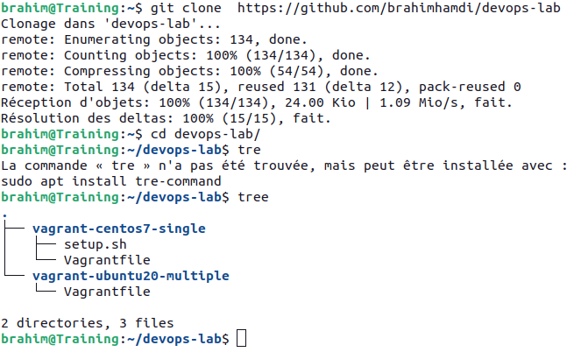

Vagrant with one node
- cd to : devops-lab/vagrant-centos7-single
  - Describe the content of Vagrantfile file .
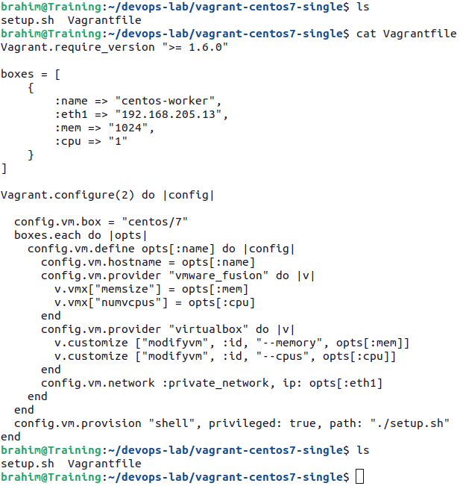

- Start and provision the vagrant environment with the command :
vagrant up
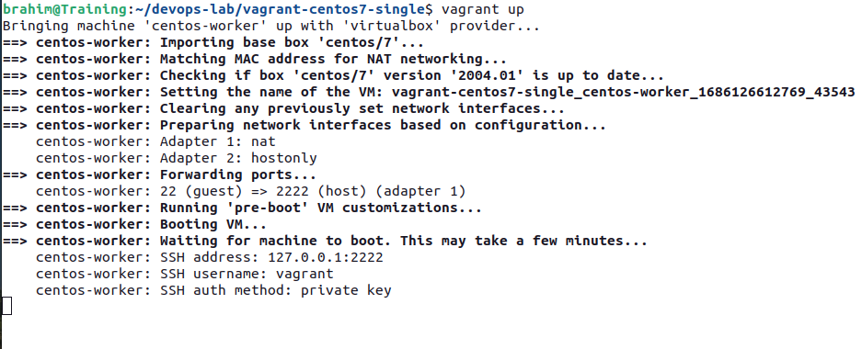

- Output status of the vagrant machine with command :
vagrant status
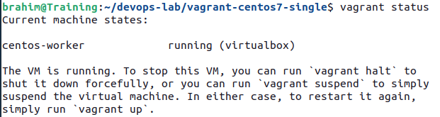
  - What is the VM hash ?
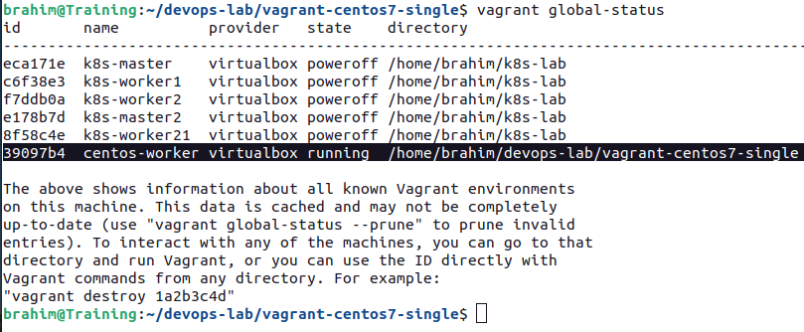
- Connect to the VM with SSH
vagrant ssh or vagrant ssh <hash>
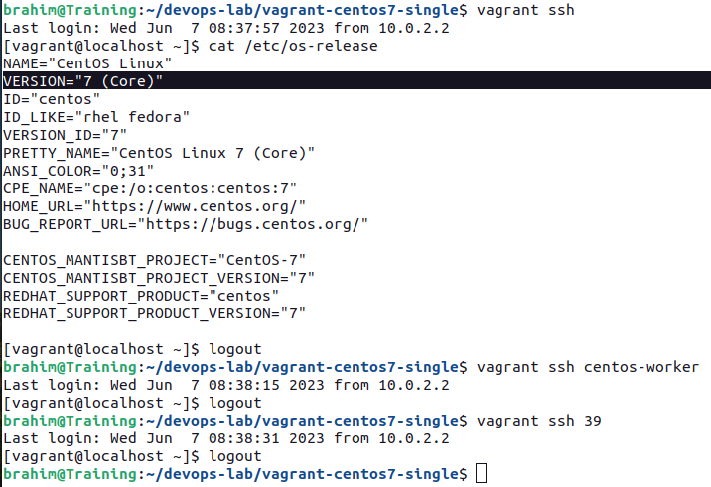

  - What is the authentication method ? Keys pair : public + private
  - What is the name and path of private key ?
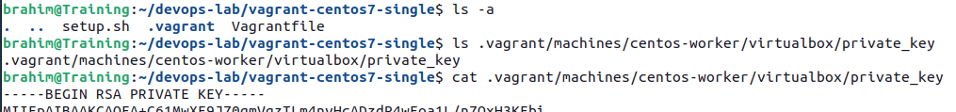
- Exit and stop the vagrant VM with the command:
vagrant halt or vagrant halt <hash>
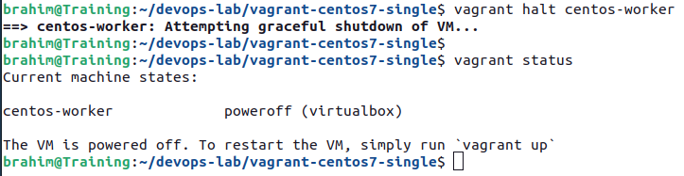
Vagrant with multi-nodes
- cd to ls devops-lab/vagrant-ubuntu20-multiple/
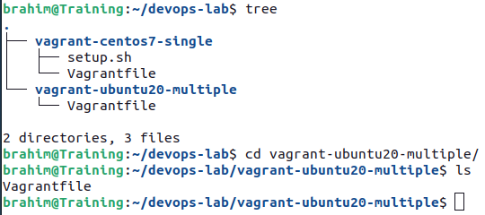

  - Describe the content of Vagrantfile file.
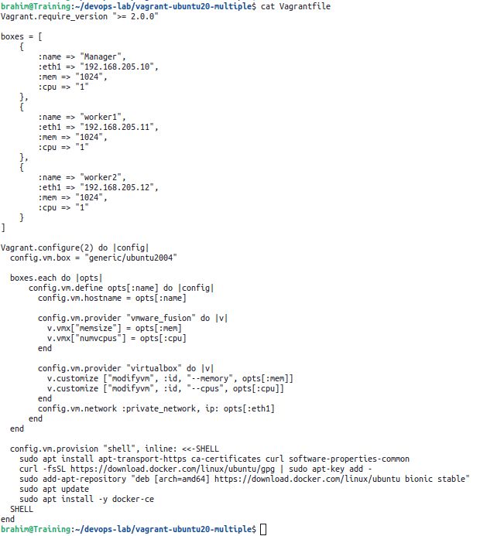
  - What is the difference between this Vagrantfile and that described in question 4 ?
- Start and provision the vagrant environment.

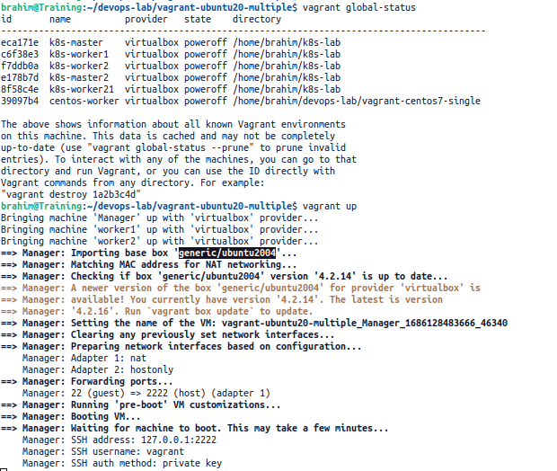
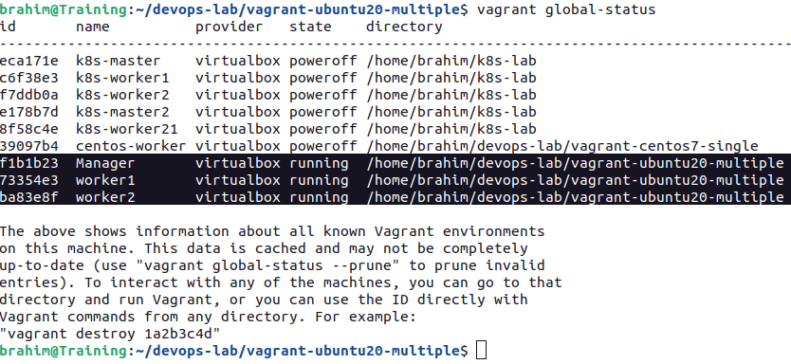

- Connect to each vagrant VM via SSH.
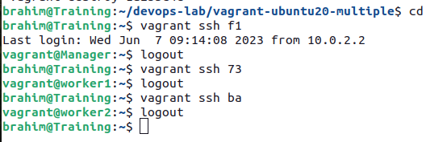

- Exit and stop the each vagrant VM.
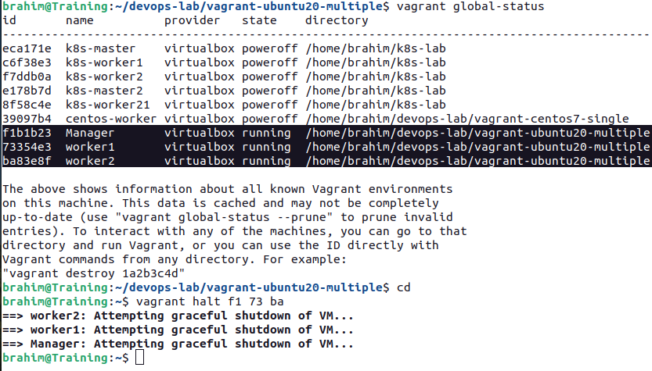
Other vagrant commands
- Output global status Vagrant environments.
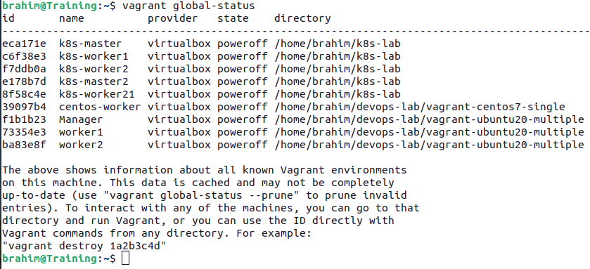

- Stop and destroy all traces of the centos7 single-node vagrant machine.
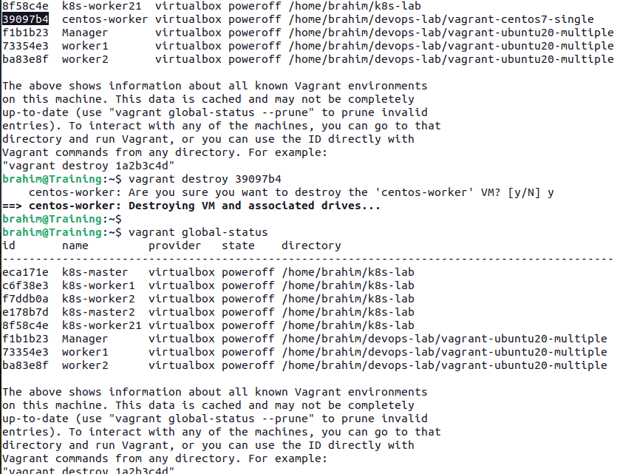
  - Is centos7 box deleted too ? List the vagrant boxes.
