**A Survey on Communication Technologies and Applications for Smart Cities**

Hüseyin Fadullah Güngör

ABSTRACT*:*

This paper addresses the communication technologies and application for Smart Cities. Smart City, it is a very famous word for these days and very significant especially for the future. The World population has increased up to 7.7 billion, and majority of these people live in urban areas. Therefore, we need to have a better understanding on this topic. The purpose of this article is to give you a very well overview on a given topic. The first part will be the introduction part, and smart city concept will be defined. After that there will be some given examples of existing applications and systems. So that, you can compare how much your city is smart. Then, technical approaches will be discussed, later existing solutions will be compared in a table format. Afterwards, open research issues will be mentioned. And finally, in conclusion part we will summarize the survey.

1. **INTRODUCTION**

A smart city is a basically an urban area that utilizes many different kinds of digital data collection sensors in order to provide information which then will be used to conduct assets and resources productively. This smart city concept uses Information and Communication Technology (ICT). ICT is used in smart cities in order to increase quality, interactivity, productivity and contact between local people and administrators of the city. And also ICT causes costs and resource consumption to be reduced.

Smart city applications are created to check urban streams and take into consideration constant reactions.

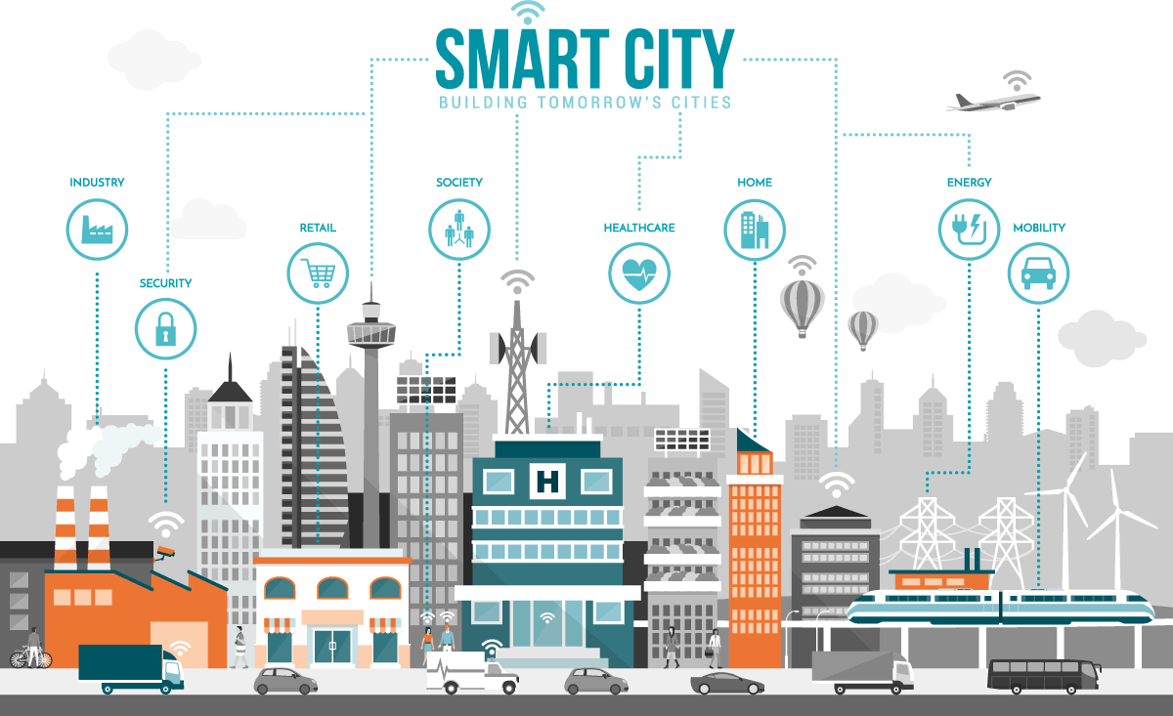

Figure 1: Smart Cities and Buildings

1. **APPLICATIONS AND EXISTING SYSTEMS**

With the development of technology, sensors and ICT concepts, there are so many existing systems and applications in our cities. And this makes them smart city. In the following, I will give some examples of smart city applications.

* **SMS System:**

This is a sms system that warmly welcomes outcomer visitors and it also informs them about important places of that city and important phone calls in case of an emergency.

Figure 2: Smart City SMS System

* **Information Kiosks:**

This kiosks devices are designed for the interactive orientation and information of the citizens. The kiosks have a touch screen and the desired point to be visited (Historical places, Prioritized points, Restaurants, General information about the city etc.) can be selected from the screen and the route to be followed can be seen. Again with the help of these kiosks, citizens can access information such as news, weather, road conditions, exchange rates.

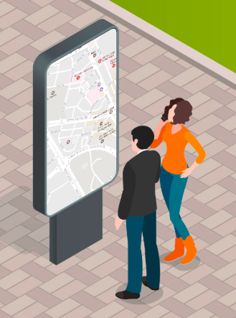

Figure 3: Information Kiosks

* **Traffic Control Centre:**

In different points of the city, signalization system, traffic measurement system, traffic monitoring camera system and so on are established. With the help of these intelligent transportation systems, traffic data are obtained.

So that, the continuity of traffic flow, effective use of road network capacity, real time monitoring of traffic for 24 hours, and control from a single center are provided.

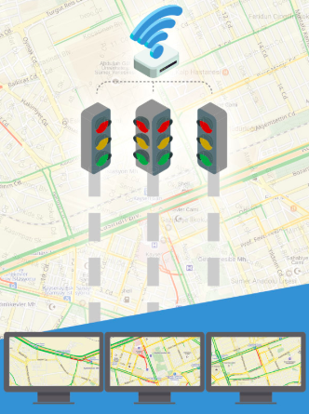

Figure 4: Traffic Control Centers

* **Ambulance Passing Priority:**

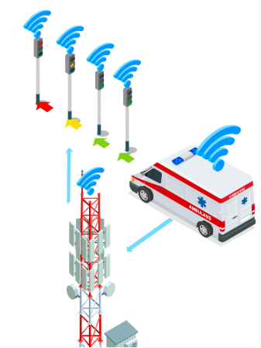The system that provides ambulance passing priority is an application that helps the ambulance to reach the hospital in the fastest way without wasting time in the traffic. The GPS and sensors used with the dynamic intersection management follow the position of the ambulance in real time, which has the advantage of crossing, and when these vehicles approach any signalized intersection, the lights at the relevant intersection provide a green light in the direction towards the hospital direction. In this way, the ambulances leave the signalized intersection with minimum delay time to reach their destination as soon as possible.

Figure 5: Ambulance Passing Priority

* **Bicycle Road and Station:**

Users can find the closest bicycle stops to them, and thanks to the system, the number of available bicycles at the stop and the fullness of the stops can be obtained with this system.

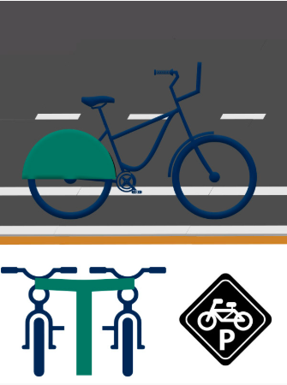

Figure 6: Bicycle Road and Station

* **Smart Energy Poles:**

This system collects solar energy and transfer this energy to the USB port. These smart poles, allows citizens to charge their mobile phones for free. And they are not fed from the grid, but they produce and store their own energy with the solar panels on it. In smart poles, electronic devices can be charged at network speed.

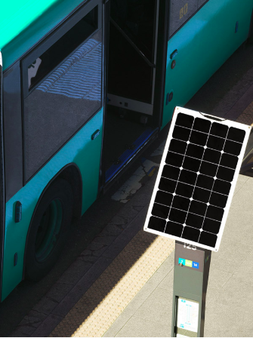

Figure 7: Smart Energy Poles

* **Smart Lighting:**

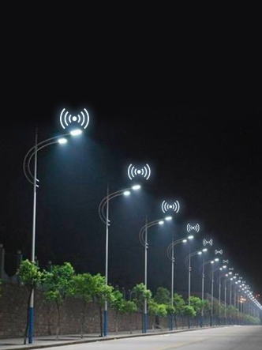In the lighting of the city, smart cities determined to increase energy efficiency and sustainabilit. On the other hand, to reduce transaction costs is their priority. They focused on improving the liveliness and efficiency of the city and in this direction, they develop the lighting plan and take the necessary steps. As an example, fully automatic and economical luminaires are used in smart cities.

Figure 8: Smart Lighting System

* **Energy From Solid Waste:**

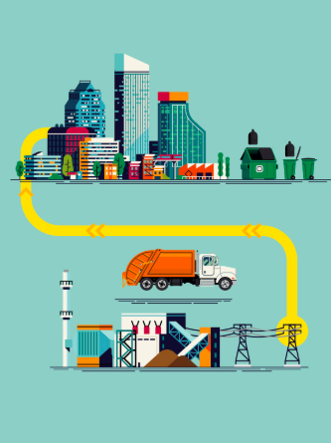Energy is produced by using the latest technology from the solid wastes collected in the city. Thanks to the system in the facility, environmental pollution is prevented and human health is protected and energy production is made. This has also contribution to the economy.

Figure 9: Energy from Solid Waste

* **Smart Bus Stations:**

In the scope of the smart bus stop application, the QR code and bus station numbers are mounted on the stands. Citizens waiting at the station will get some information after installing the Smart City application on their mobile devices (Smart Phone, Tablet) using the square code application on the stop sign. By reading those codes via their devices, they will learn where the bus is, busses passing through that station and approximate time for bus to come to the station. In addition, on the map where the bus stop location is located, the approaching buses are offered to citizens in real time.

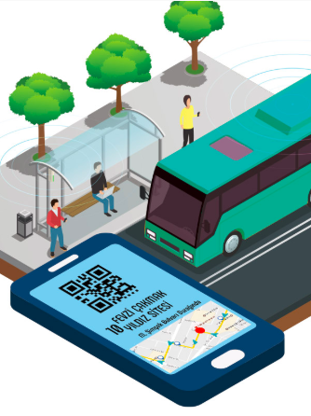

Figure 10: Smart Bus Stations

* **COMPARISON OF EXISTING SOLUTIONS FOR BUS STATIONS:**

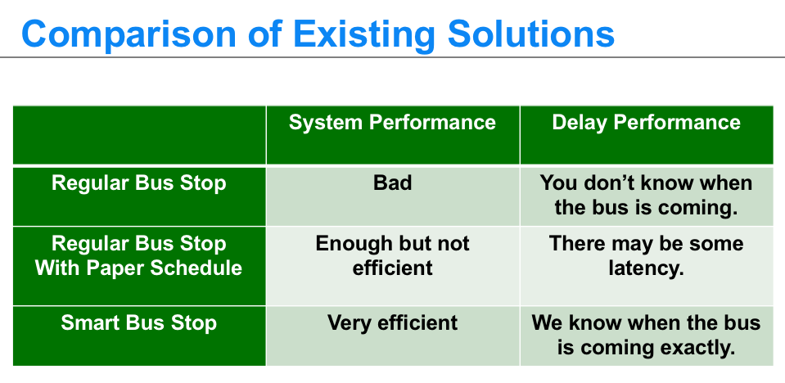

Table 1: Comparisons of Bus Stations

**III. TECHNICAL APPROACHES**

1. **System and Network Architecture**

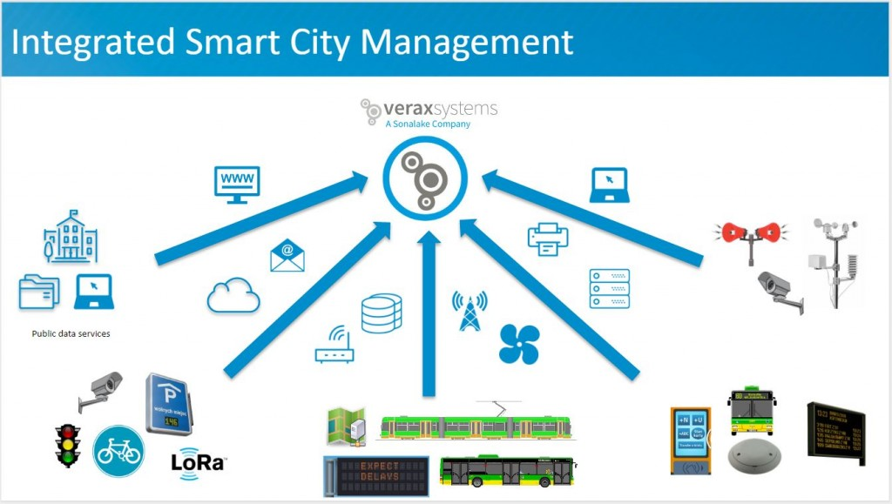In smart cities, all components will be integrated with each other using service orientation. It is a very large sclae distributed system and consequently, it is decentralized and very complex. In smart cities, there are a lot of data that used while taking an action. These data are collected via different sensors. These sensors are located in relevant but different points of the city.

Figure 11: Smart City System Architecture

## **Communication Protocols**

Sensors that collect information, communicates with each other via different kinds of communication protocols. In the following, we will examine each of these communication protocols and discuss their pros and cons.

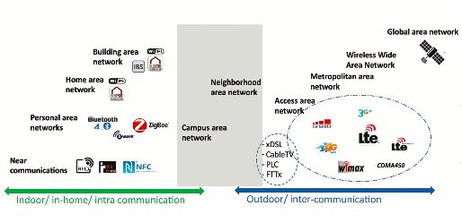

Figure 12: Communication Protocols

* **MOBILE**

In order to have a wireless communication, electromagnetic waves are utilize to convey signals. But these electromagnetic waves need line of sight. Because of our World's shape, it is very difficult to have long distance communications. To be able to solve this trouble, people built some antennas and stations in different places of the World. Signals that generated from mobile devices, goes to space and communication satallites. These satallites direct signals where they are supposed to go.

* **WIFI**

WiFi is another wireless communication protocol and it is also known as WLAN( Wireless Local Area Network). Standarization code of WiFi is IEEE 802.11. It is a wireless so that it gives ability for more than one mobile devices to use internet via wireless connection. Since the connection is supplied by an access point, it allows us to go around in a specific area . In this day and time, WiFi has a vital importance in our lives.

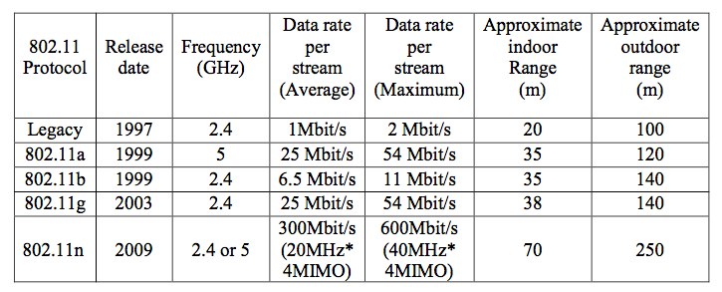

Table 2: 802.11 Standards, W. Mengdi, 2017

* **BLUETOOTH**

Bluetooth is also a wireless communication protocol used to exchange data between devices. Number of devices can be from 2 to up to 8. There is a master and slave relationship among devices. Bluetooth technology performs better in short range distances. In order to share data between devices, first they need to be paired. After this progress is done, data exchange can be made.

* **ZIGBEE**

ZigBee is another wireless communication protocol that used in these time. And standardization code of Zigbee is 802.15.4. The name Zigbee comes from bees’ dance. It was founded in May 2003, and it was started to be used in June 2005. As an advantage compared to Wifi, it doesn't need high level power consumption. As another positivity of it is that its cost is very less when we compare with Bluetooth’s or Wifi’s. But as a negative side of, Zigbee’s data range is very low compared to two of them.

* **RFID**

RFID is a wireless communication protocols where data exchange is supplied via radio frequencies. So the name RFID, stands for Radio Frequency Identification. There are two main devices in this communication technology which are tag and reader. RFID, provides data exchange without any establishing mechanical connection.

* **NFC**

NFC is another wireless communication protocol like Bluetooth or Wifi. It stands for Near Field Comminucation. But unlike other communication protocols, NFC range is very short, approximately less than 10 cm.

## 

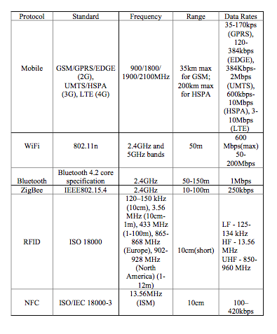**IV. COMPARISON OF COMMUNICATION PROTOCOLS:**

Table 3: Communication Protocols Comparison, W. Mengdi, 2017

# **V. Open Research Issues:**

Although, smart city concepts are becoming very vital in our daily life, there are still some concerns about it. Therefore, there are some challenges we have to face.

* + Since different platforms, environments and various kinds of sensors are used in smart cities, this can cause to interoperability problems.
  + More connection is more vulnerabilities. Therefore, if a hacker seize the system, he will have ability to ruin everything.

# **VI. CONCUSİON:**

In this survey, we gave you a general idea about smart cities. Increasing population and ongoing urbanization globally leads to cities become smart cities. It is all about using enormous sources of information gathered from city’s variety points, and taking an action accordingly. It also allows us monitoring and controlling systems remotely. So, smart city concept is described and then existing systems and applications are introduced in order to have better understanding. After that, as a technical approach, system architecture and communication protocols are discussed and compared those communication protocols. Last but not least, open research issues are mentioned.

References

[1] F. Theoleyre, T. Watteyne, G. Bianchi, G. Tuna, V. Cagri Gungor, A. Pang, “Networking and Communications for Smart Cities Special Issue Editorial”, March 2015.

[2] W. Mengdi, “WIRELESS COMMUNICATION TECHNOLOGIES IN INTERNET OF THINGS”, Sep. 2016.

[3] R. Novotný, R. Kuchta , J. Kadlec, “Smart City Concept, Applications and Services”, 2014

[4] I. Yaqoob, I. Hashem, Y. Mehmood, A. Gani, S. Mokhtar, S. Guizani “Enabling Communication Technologies for Smart Cities”, Jan. 2017

[5] L. Hao, X. Lei, Z. Yan, Y. ChunLi “The application and Implementation research of Smart City in China”, July 2012

[6] S. Mohanty, “Everything You Wanted to Know About Smart Cities”, July 2016

[7] V. Albino, U. Berardi, R. Dangelico, “Smart Cities: Definitions, Dimensions, Performance, and Initiatives”, 2015

[8] M. Airaksinen, M. Kokkala, “Smart City- Research Highlights”, 2015

[9] R. Dubbeldeman, S. Ward, “Smart Cities”, Nov. 2015

[10] N. Falkner, “Smart Cities”, 2015

[11] McKinsey Global Institute, “Smart Cities: Digital Solutions For A More Livable Future”, June 2018

[12] National League of Cities, “Trends in Smart City Development”, 2016