Name: Fadwa Khalil

Course: CSCI S-65G Introduction to Mobile Application Development Using Swift and iOS

Date: June 27, 2016

1.  (10 Points) Create a Tabbed View Project and rename First and SecondViewControllers to be Simulation and InstrumentationViewControllers, respectively.  Verify that project compiles and runs in the simulator

**Answer:**

I created a Tabbed View Project and renamed the two View Controllers by doing the following:

1. Renaming the two View Controllers from the Navigation
2. Renaming the two code form the Editor Area (Comments and Class Name)
3. Renaming the Class name from the Storyboard Interface Builder / First and Second Scenes

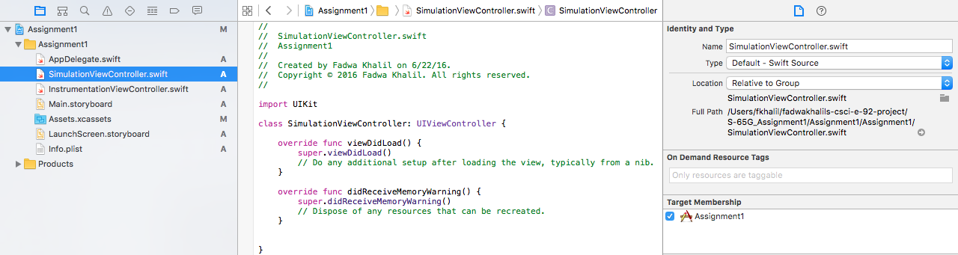

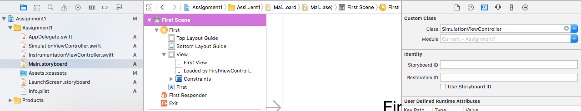

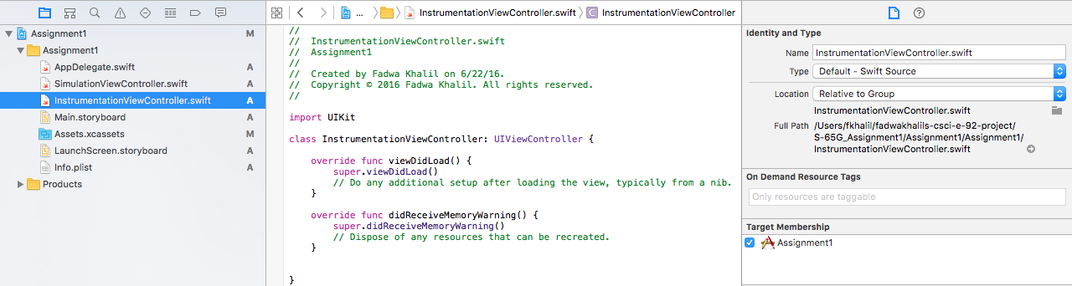

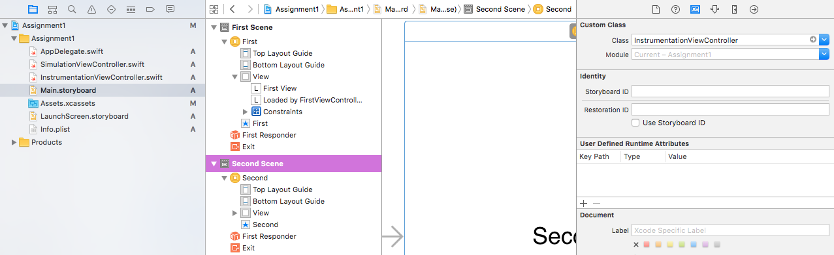

I then modified the Label Text for each to make it easier to follow the Views when compiling and running the project.

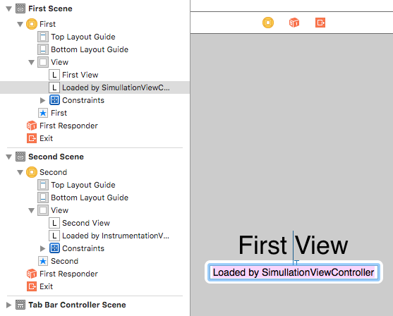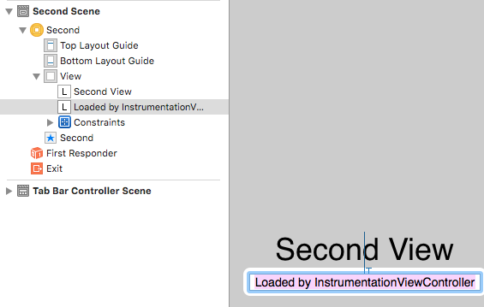

I then built and ran the Project, and this is what I got:

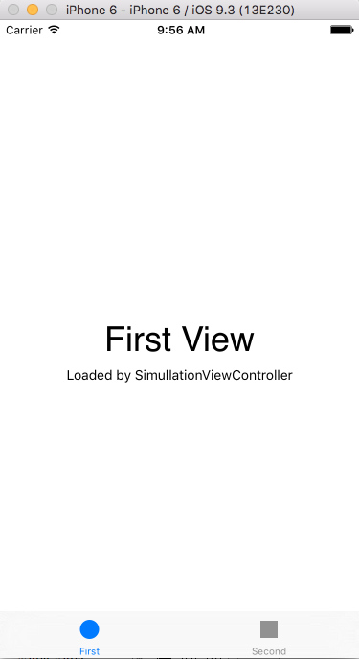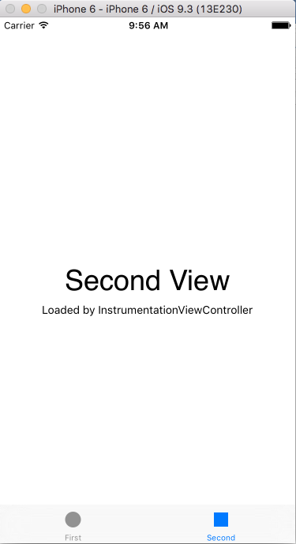

I made sure I have no warnings for each scene and no errors in the debug area.



2.  (40 points) Remove the unwanted text from the SimulationController scene and replace with a UIView which:

* has a light blue background color  (you pick  the shade of blue)



* maintains a square aspect ratio

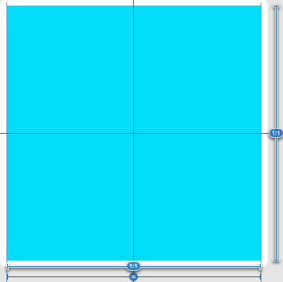 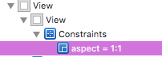

* stays both vertically and horizontally centered in the container

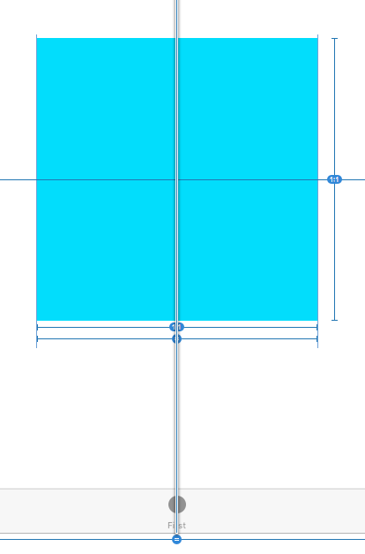 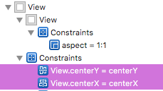

* fills 80% of the shorter of the vertical or horizontal axis in either orientation for all size classes, taking account of the tab at the bottom
* has the name LifeGrid in the Scene pane

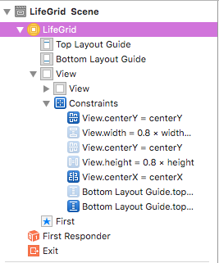

* neither the status bar nor the tab bar should not be obscured in any way
* Verify that the view behaves as specified on both an iPhone and iPad configuration

All iphones size class – Portrait – wCompact - hRegular

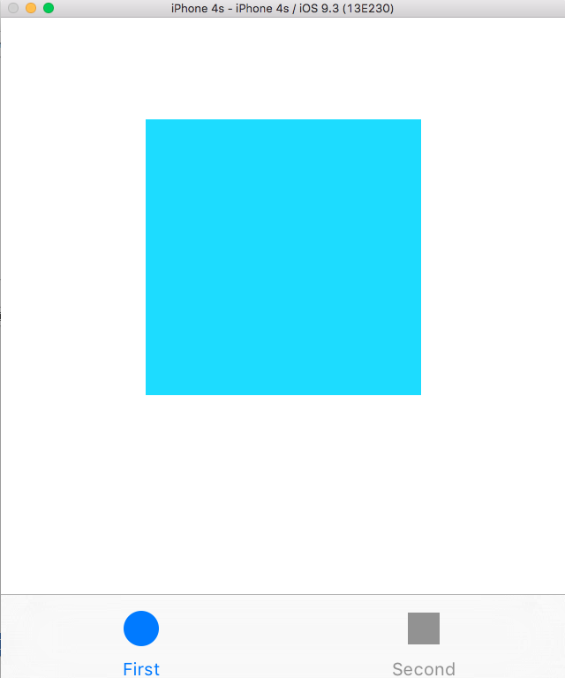 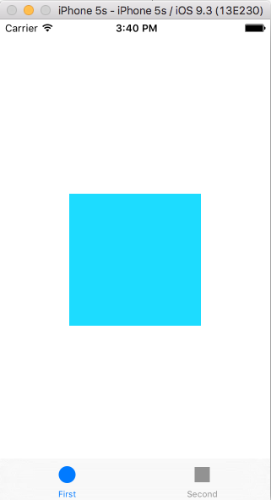

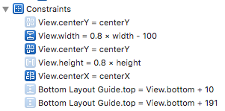

All iphones size class – Landscape – wAny - hCompact

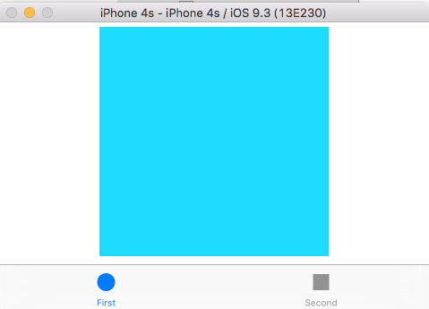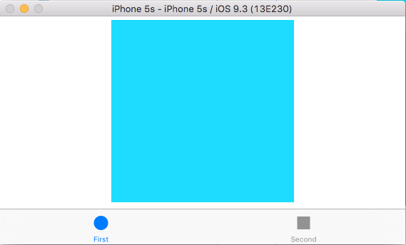

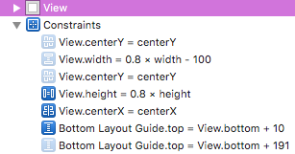

All ipads size class – any orientation – wRegular – hRegular

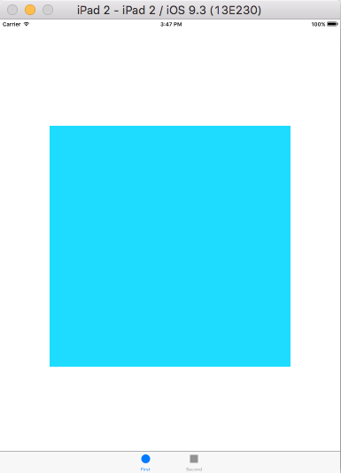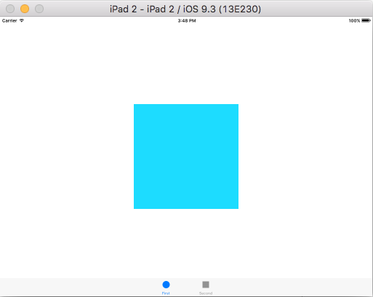

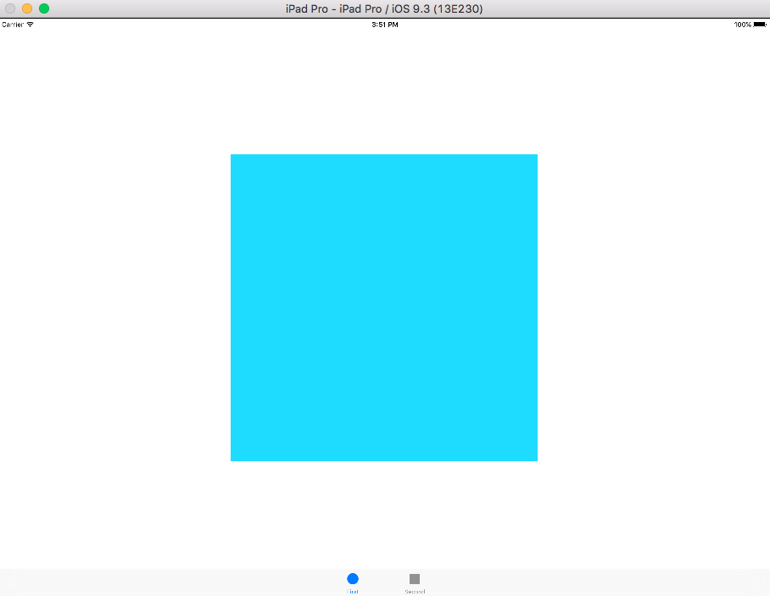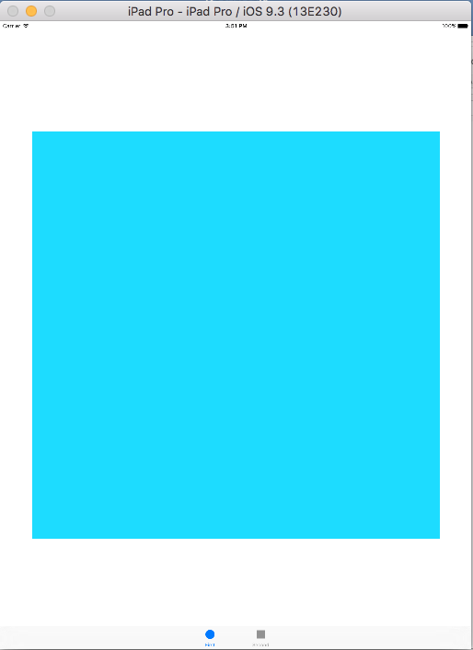

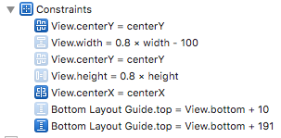

3.  (30 points) Remove the unwanted text from the Instrumentation Tab and replace with two views which

* are identically sized and
* split the screen into two equal sections and
* are stacked vertically when in portrait orientation on any device and aligned horizontally when in landscape orientation for an iPhone 5S

All iphones size class – Portrait – wCompact – hRegular

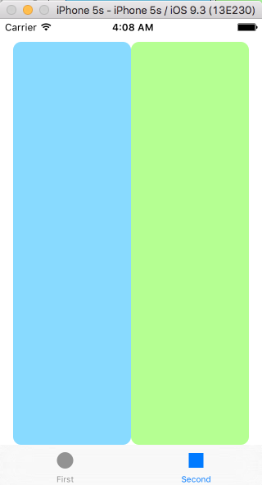 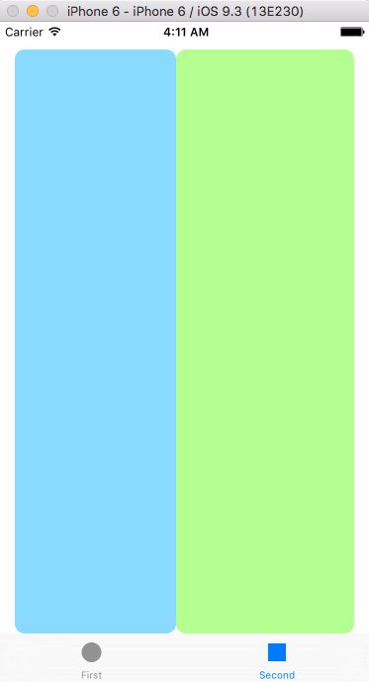 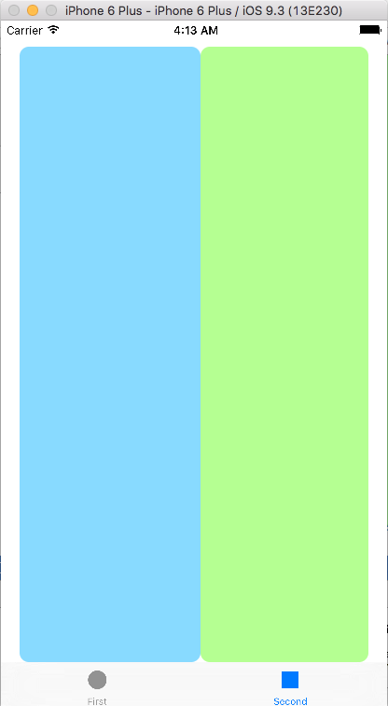

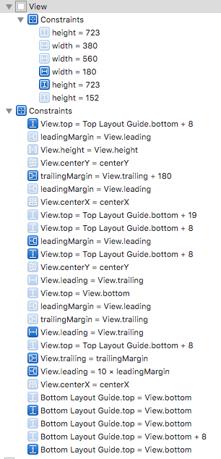

All ipad size class – Portrait – wRegular – hRegular

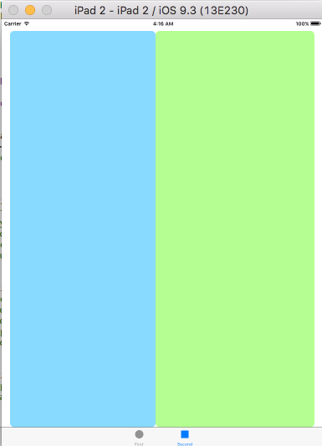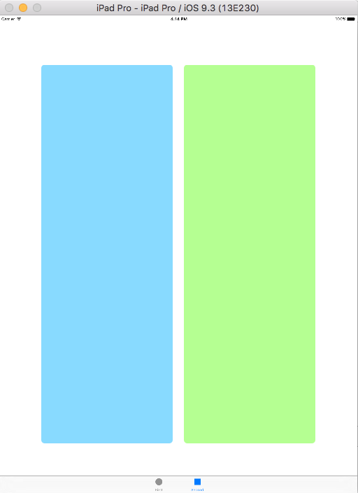

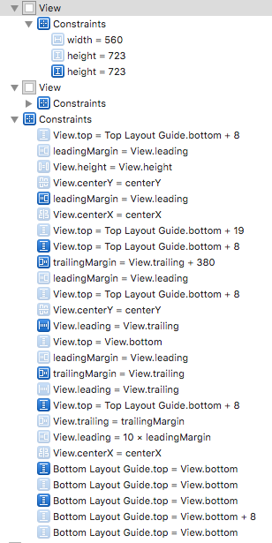

iphones 5s size class – Landscape – wRegular – hCompact

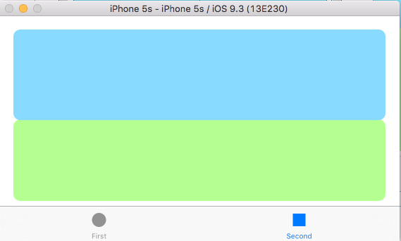

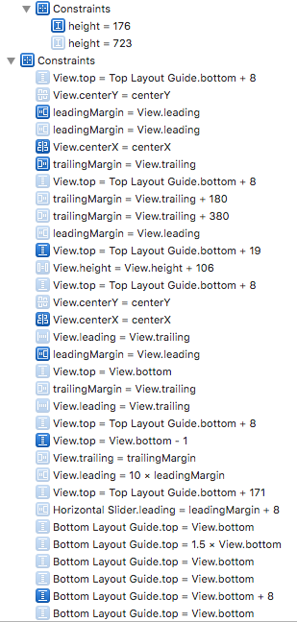

* the top (or left) should have a background of light blue
* the bottom (or right) view should have a background of light green
* each view should have a rounded corner with a radius of 10
* and neither the status bar nor the tab bar should not be obscured in any way

4. (20 points) Add a textfield, 2 sliders and a button to the blue box from 4.  Arrange the sliders vertically and label them "Grid Size" and "Frames/second".  Label the textfield: Generation and the button Reset.  Constrain all so that they look well in any orientation and on any device.

Answer:

All iphones size class – Portrait – wCompact – hRegular

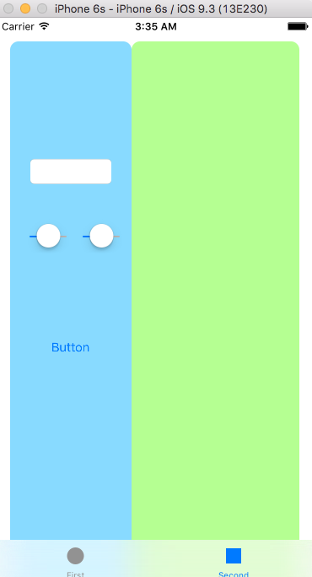 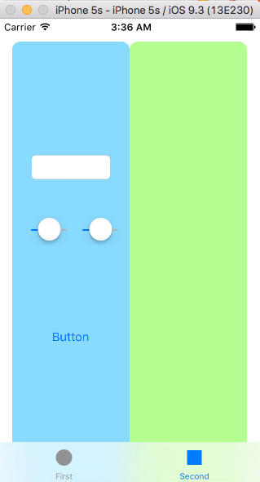

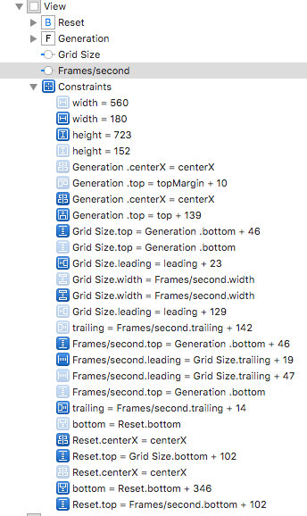

All iphones size class – Landscape – wAny – hCompact

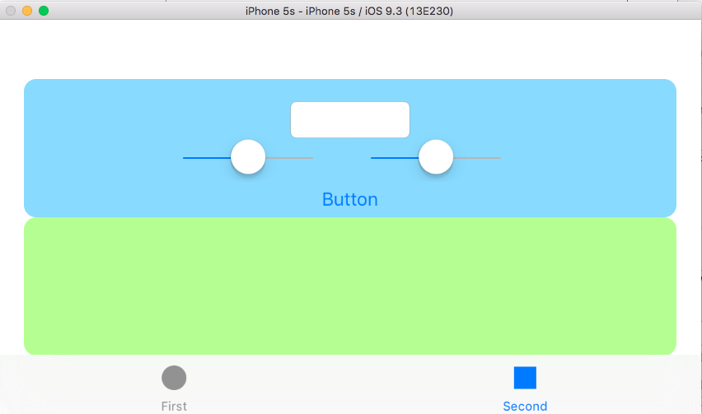 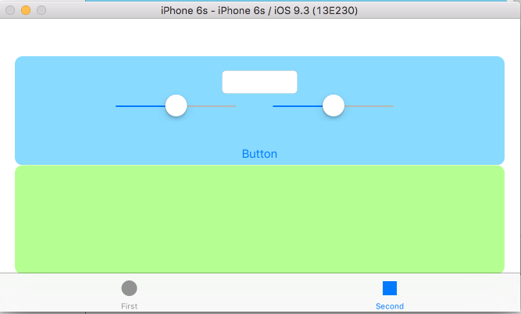

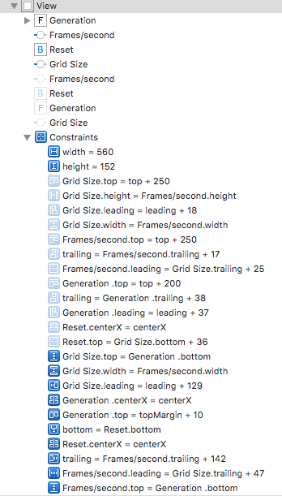

All ipad size class – Portrait – wRegular – hRegular

