Faculty of Computer Science and Information Technology
AXIOM
An AI-Powered Real Estate Platform for the Egyptian Market
Submitted by:
# | ID | Name
1 | 42210130 | Baher Mohamed
2 | 42210128 | Shrouk Saber
3 | 42210137 | Youssef Mohamed
4 | 42210165 | Abanoub Attia
5 | 42210106 | Ehab Ashraf
6 | 42210101 | Abdelrahman Wael
7 | 42210136 | Fady Alber

A dissertation submitted in partial fulfillment of the requirements for the degree of Bachelor of Computer Science and Information Technology.
Supervised by:
Dr. Bahaa Mohamed
Egypt 2025

Committee Report
We certify that we have read this graduation project report as examining committee, examined the students in its content, and that in our opinion it is adequate as a project document for AXIOM.
Role | Name | Signature | Date
Chairman
Supervisor | Dr. Bahaa Mohamed
Examiner

Intellectual Property Right Declaration
This is to declare that the work under the supervision of Dr. Bahaa Mohamed having title AXIOM was carried out in partial fulfillment of the requirements of Bachelor of Science in Computer Science and is the sole property of Ahram Canadian University and the respective supervisor. It may be considered or used for extension, enhancement, product development, adoption for commercial or organizational usage, and related purposes only with the permission of the University and respective supervisor.
Names:
- Baher Mohamed
- Shrouk Saber
- Youssef Mohamed
- Abanoub Attia
- Ehab Ashraf
- Abdelrahman Wael
- Fady Alber
Supervisor: Dr. Bahaa Mohamed

Anti-Plagiarism Declaration
This is to declare that the above publication produced under the supervision of Dr. Bahaa Mohamed and having title AXIOM is the sole contribution of the authors. No part has been reproduced illegally or used as plagiarism. Referenced parts have been used to support the argument and have been cited properly. The authors accept responsibility for any violation if proven.
Names:
- Baher Mohamed
- Shrouk Saber
- Youssef Mohamed
- Abanoub Attia
- Ehab Ashraf
- Abdelrahman Wael
- Fady Alber

Acknowledgement
The project team expresses sincere gratitude to Dr. Bahaa Mohamed for supervision, guidance, and continuous support throughout the project. The team also thanks the Faculty of Computer Science and Information Technology for providing the academic environment in which the project was planned, implemented, reviewed, and documented. Appreciation is extended to everyone who helped test, review, and discuss the AXIOM platform during its development.

Abstract
AXIOM is an AI-powered real estate platform designed for the Egyptian market. The platform addresses fragmented housing discovery, low trust in informal listing channels, the difficulty of finding shared housing, and the need for faster personalized search. The current implementation consists of a Next.js 16 frontend, a FastAPI backend, Supabase Auth and PostgreSQL with pgvector, local Ollama AI services, and Stripe payment integration. The system uses a unified listing model for rent, sale, and shared housing, with user ownership represented by owner_id and seller trust represented by an admin-granted verified seller badge. AXIOM provides natural-language search, chatbot support, recommendations, AI description generation, amenity validation, fraud-risk scoring, WhatsApp lead capture, viewing requests, shared-housing applications, booking payments, owner subscription plans, and an admin moderation console. This report documents the motivation, related work, planning, requirements, design, implementation, testing, limitations, and future work of AXIOM V2.

Table of Contents
- Chapter 1: Introduction
- Chapter 2: Background and Previous Work
- Chapter 3: Planning and Analysis
- Chapter 4: Design
- Chapter 5: Implementation
- Chapter 6: Testing
- Conclusion
- Future Work
- References
- Appendix A: Corrections from the Early Report

List of Figures
- Figure 3.1: AXIOM V2 project Gantt chart
- Figure 4.1: AXIOM V2 entity relationship diagram
- Figure 4.2: Relational schema mapping
- Figure 4.3: Code-grounded class diagram
- Figure 4.4: Use-case diagram
- Figure 4.5: User activity diagram
- Figure 4.6: Admin activity diagram
- Figure 4.7: User sequence diagram
- Figure 4.8: Admin sequence diagram
- Figure 4.9: Listing, booking, and subscription state diagram
- Figure 5.1: Software architecture and component diagram
- Figure 6.1: Testing and verification map

List of Tables
- Table 2.1 Competitor and platform gap analysis
- Table 3.1 Feasibility and estimated cost
- Table 3.2 Functional requirements
- Table 3.3 Non-functional requirements
- Table 3.4 User characteristics
- Table 4.1 Risks and mitigation strategy
- Table 4.2 Use-case scenarios
- Table 5.1 Implementation stack
- Table 5.2 Main implementation modules
- Table 5.3 User interface route map
- Table 6.1 Backend test coverage
- Table 6.2 Unit-test evidence mapped to AXIOM modules
- Table 6.3 Integration testing flows
- Table 6.4 Manual system test cases

List of Abbreviations and Acronyms
Abbreviation | Meaning
AI | Artificial Intelligence
API | Application Programming Interface
CRUD | Create, Read, Update, Delete
DB | Database
EGP | Egyptian Pound
JWT | JSON Web Token
LLM | Large Language Model
NLP | Natural Language Processing
RAG | Retrieval-Augmented Generation
RLS | Row Level Security
SSE | Server-Sent Events
UI | User Interface

Chapter 1: Introduction

1.1 Overview
AXIOM is an AI-powered real estate platform built for the Egyptian market. It supports the discovery and management of rental listings, sale listings, and shared-housing opportunities. The current implementation is a modern full-stack system that combines a Next.js frontend, a FastAPI backend, Supabase services, local Ollama AI inference, pgvector-based retrieval, and Stripe payments.
The platform is designed around a unified user model. A normal user can browse, save, apply, book, and publish listings. The system does not use separate buyer and seller account roles; instead, seller trust is represented by a verified seller badge granted by an administrator. This design simplifies the user experience while preserving trust controls.

1.2 Motivation
- Housing search in Egypt is fragmented across portals, social media groups, informal contacts, and physical agents.
- Users often struggle to determine whether a listing is current, accurate, safe, or fairly priced.
- Students, expats, and people relocating between cities need shared-housing options and compatibility signals.
- The 2025 rental-law context increased pressure on rental-market clarity, digital traceability, and trustworthy information.
- AI can reduce search effort by interpreting natural language, recommending listings, assisting owners, and supporting fraud review.

1.3 Objective
The objective of AXIOM is to provide a trustworthy digital platform for housing discovery and listing management in Egypt. The project combines structured real estate data, AI-assisted discovery, shared-housing compatibility, booking support, owner subscriptions, and administrator moderation.

1.4 Aim
The aim is to reduce user search friction, improve trust in listing quality, support shared-housing decisions, and provide a maintainable software architecture that can evolve into a production real estate platform.

1.5 Scope
The functional scope includes public search, listing details, user accounts, favorites, WhatsApp lead capture, viewing requests, shared-housing applications, rent/shared-housing bookings, subscriptions, AI search, AI chat, AI recommendations, AI description generation, fraud-risk support, dashboard management, and admin moderation.
The technical scope includes a web frontend, REST/SSE backend APIs, Supabase authentication and PostgreSQL, vector search, local LLM inference, Stripe integration, signed uploads, and deployment preparation.
The user scope includes guests, authenticated users, verified sellers, administrators, and external systems such as Stripe, Supabase, and Ollama.

1.6 General Constraints
- The backend depends on Supabase credentials and service-role access.
- AI features depend on local Ollama availability and configured models.
- Stripe flows require configured secret keys, publishable keys, and webhook forwarding in local development.
- Some public frontend pages read directly from Supabase and therefore depend on correct public policies.
- The platform must avoid stale early-design assumptions such as separate account roles or separate shared-unit entities.

1.7 Organization of the Dissertation
Chapter 2 presents background and previous work. Chapter 3 covers planning, feasibility, requirements, and analysis. Chapter 4 presents system design and diagrams. Chapter 5 explains implementation modules and user interface results. Chapter 6 discusses testing, limitations, conclusion, and future work.

Chapter 2: Background and Previous Work

2.1 Background
Digital real estate platforms have become central to housing discovery, yet the Egyptian market still contains many informal search paths. Users frequently combine portal browsing, social-media posts, phone calls, and personal referrals. This creates friction and reduces confidence. AXIOM addresses this by combining structured listings, trust badges, admin approval, AI search, and localized contact behavior through WhatsApp.
Shared housing is a special challenge. Traditional property portals usually describe units but rarely describe resident lifestyle, compatibility, quietness, guest policies, or roommate expectations. AXIOM therefore models shared housing as a listing category with additional resident and lifestyle fields.

2.2 Previous Work
Table 2.1 Competitor and platform gap analysis
Platform | Main focus | Gap addressed by AXIOM
Dubizzle Egypt | Large classifieds marketplace | Broad inventory but limited AI matching and limited shared-housing compatibility
Aqarmap | Egypt-focused real estate search | Strong local inventory but not centered on AI assistant or roommate compatibility
Property Finder Egypt | Regional property portal | Professional listings but limited local shared-housing fit analysis
Bayut Egypt | Regional portal with Egyptian listings | Useful structured listings but no AXIOM-style owner AI workflow
Sakneen | Egyptian prop-tech search | Digital browsing but not a unified booking/subscription/AI trust workflow
Weetas | Regional property portal | Curated property data but weaker student/shared-housing specialization
Student.com | Global student accommodation | Student-focused but not tailored to Egyptian local listings and owners
HousingAnywhere | International rentals | Useful relocation model but less localized to Egyptian trust/contact behavior
Uniplaces | Student accommodation platform | Verified student housing but not an Egyptian real estate marketplace
AmberStudent | Global student housing | Strong student housing focus but not local owner listing management in Egypt

2.3 Summary and Gaps
- Most competitors support listing discovery but do not combine public search, owner dashboard, admin moderation, and AI trust support in one project.
- Most platforms lack roommate compatibility and shared-housing resident profiles.
- General portals focus on filters, while AXIOM also supports natural-language search and chatbot discovery.
- AXIOM uses local AI services and pgvector-based retrieval, giving the project a clear technical AI layer.
- The current platform includes booking fees and subscription monetization, while still keeping sale listings as lead-generation flows.

Chapter 3: Planning and Analysis

3.1 Planning
The project was planned as a full-stack web system with six major tracks: product research, interface design, database design, frontend implementation, backend implementation, AI/payments integration, and testing/deployment preparation.

3.1.1 Feasibility Study and Estimated Cost
Table 3.1 Feasibility and estimated cost
Area | Feasibility | Estimated development cost/status
Technical | Feasible using Next.js, FastAPI, Supabase, Ollama, and Stripe | Open-source stack plus cloud/service configuration
Operational | Feasible with admin approval and verification workflows | Requires moderation process and policy ownership
Economic | Feasible through owner plans and booking fees | Basic EGP 199/month, Pro EGP 499/month, booking fee default EGP 2000
Schedule | Feasible in graduation timeline with phased implementation | Implementation completed with deployment infrastructure ready
Risk | Feasible with known dependency risks | Requires configured Supabase, Stripe, and Ollama environments

3.1.2 Gantt Chart
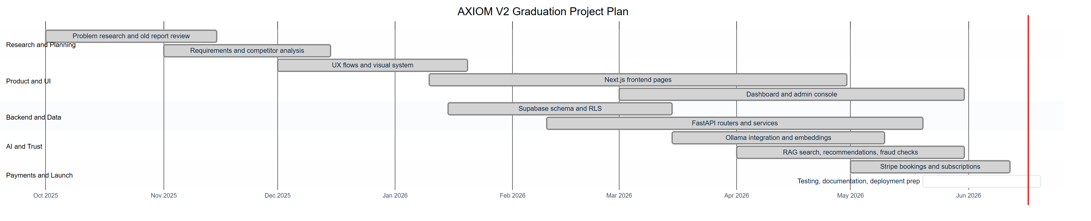
Figure 3.1: AXIOM V2 project Gantt chart. The plan separates research, UI design, database work, frontend and backend implementation, AI integration, payments, testing, and deployment preparation.

3.2 Analysis and Limitations of Existing Systems
Existing systems provide useful property browsing but frequently leave gaps in trust, shared-housing compatibility, owner workflow, and AI-assisted discovery. Many platforms separate user browsing from listing management and do not provide transparent moderation flows. AXIOM addresses these limitations through a unified user dashboard, administrator review, verification badges, fraud-risk scoring, and AI search.

3.3 Need for a New System
The need for AXIOM arises from the combination of market fragmentation, trust challenges, shared-housing complexity, and user expectations for fast intelligent search. A new system is justified because solving these problems requires integration across frontend UX, backend business rules, database modeling, AI services, and payment workflows.

3.4 Analysis of the New System

3.4.1 User Requirements
- Users must be able to browse listings without unnecessary friction.
- Users must be able to save listings, contact owners, request viewings, apply to shared housing, and book rental/shared listings.
- Owners must be able to create category-specific listings and manage dashboard activity.
- Admins must be able to approve/reject listings, verify sellers, and manage core platform entities.

3.4.2 System Requirements
- The system must validate Supabase JWTs on protected backend endpoints.
- The system must store unified listing records with category-specific optional fields.
- The system must support vector and text retrieval for AI search and chat.
- The system must handle Stripe PaymentIntent and Checkout webhook events.

3.4.3 Domain Requirements
- All prices are represented in EGP unless explicitly configured otherwise.
- Listings must support Egyptian cities, neighborhoods, compound names, and local contact behavior.
- Shared housing must include lifestyle and resident information.
- Sale listings are contact/lead-generation flows in the current code, not online payment flows.

3.4.4 Functional Requirements
Table 3.2 Functional requirements
ID | Requirement | Description
FR-01 | Auth | Users can sign up, log in, use OAuth/OTP flows, and manage profiles.
FR-02 | Listing search | Guests and users can browse and filter active listings.
FR-03 | AI search/chat | Users can search naturally and chat with the AI assistant.
FR-04 | Listing creation | Authenticated users can create rent, sale, and shared-housing listings.
FR-05 | Moderation | Admins can approve, reject, and review risky listings.
FR-06 | Shared housing | Users can view housemates and submit applications.
FR-07 | Bookings | Users can pay a flat fee for rent/shared-housing bookings.
FR-08 | Subscriptions | Owners can start trials and subscribe to Basic/Pro plans.
FR-09 | Leads | WhatsApp lead capture records user contact actions.
FR-10 | Dashboard | Users manage listings, favorites, bookings, applications, viewings, and profile.

3.4.5 Non-Functional Requirements
Table 3.3 Non-functional requirements
ID | Quality | Description
NFR-01 | Security | Protected endpoints require JWT validation; admin uses separate token flow.
NFR-02 | Maintainability | Frontend pages, API clients, backend routers, and services are separated by feature.
NFR-03 | Performance | Public listing pages use paginated queries; AI RAG uses hybrid retrieval.
NFR-04 | Reliability | AI and fraud paths use fail-soft/fail-open behavior where appropriate.
NFR-05 | Usability | Category-specific forms reduce irrelevant fields and improve owner workflow.
NFR-06 | Scalability | Supabase/PostgreSQL, pgvector, and service-layer routers support future growth.

3.5 Advantages of the New System
- One listing model covers rent, sale, and shared housing.
- AI assists discovery, owner productivity, and trust review.
- Admin approval improves platform quality.
- WhatsApp contact matches local communication behavior.
- Subscriptions and booking fees create a realistic monetization path.

3.6 User Characteristics
Table 3.4 User characteristics
User type | Characteristics | System support
Guest | Explores available properties before committing | Public search, detail pages, AI discovery
Authenticated user | Browses, saves, contacts, applies, books, and manages profile | Dashboard, favorites, leads, viewings, applications, bookings
Owner/verified seller | Publishes listings and manages demand | AddListingModal, subscription caps, AI descriptions, booking/application inboxes
Admin | Protects system quality and manages data | Admin dashboard, listing moderation, fraud review, user verification, CRUD tools

Chapter 4: Design

4.1 Design and Implementation Constraints
- The implementation must preserve the single role model of user and admin.
- Listing ownership must use owner_id rather than legacy ownership names.
- Shared housing must be represented as a listing category.
- Payment diagrams must reflect current code: flat booking fee, single platform Stripe account, no owner payout.
- AI diagrams must distinguish public AI endpoints from internal embedding and fraud services.

4.2 Assumptions and Dependencies
AXIOM depends on Supabase for authentication, PostgreSQL data, storage, and vector-enabled database functionality. It depends on Ollama for local LLM and embedding services. It depends on Stripe for payment and subscription events. It assumes admin moderation is part of the operating model.

4.3 Risks and Risk Management
Table 4.1 Risks and mitigation strategy
Risk | Impact | Mitigation
AI service unavailable | AI search/chat/description may fail | Use fail-soft responses and fallback search behavior
Payment webhook not forwarded locally | Successful payments may not immediately create bookings | Use sync-payment fallback and configure Stripe CLI
Schema drift | Code may use statuses not present in a fresh database | Verify live enum values and apply migrations before deployment
Fake or poor-quality listings | Reduces trust | Use pending status, admin approval, verification, and fraud scoring
Public direct reads misconfigured | Pages may fail or leak data | Review Supabase RLS policies and public query scopes

4.4 Data Design

4.4.1 Entity Relationship Diagram
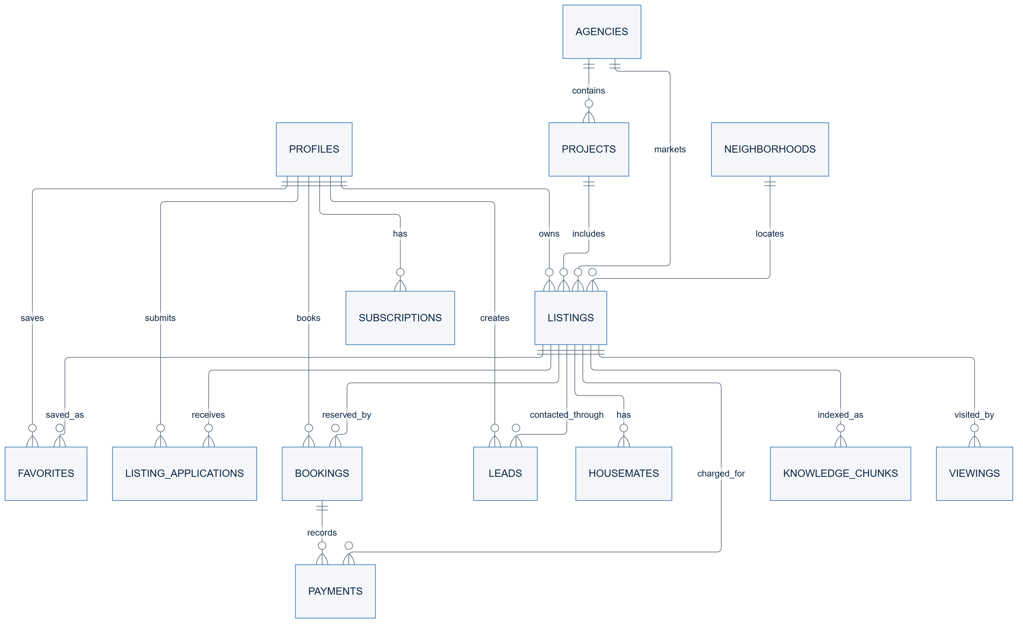
Figure 4.1: AXIOM V2 entity relationship diagram. The ERD shows profiles, unified listings, shared-housing related records, bookings, payments, subscriptions, leads, knowledge chunks, and public platform entities.

4.4.2 Relational Schema Mapping
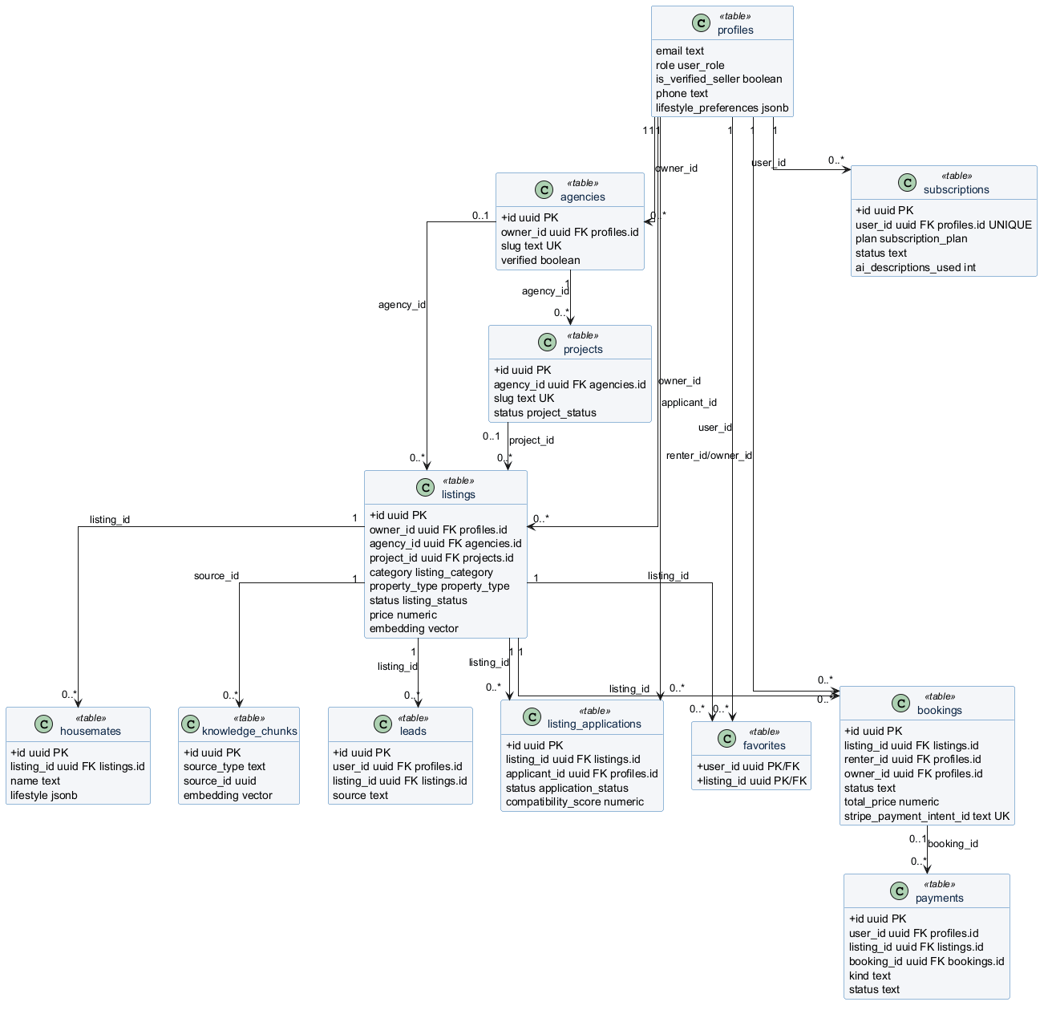
Figure 4.2: Relational schema mapping. The relational schema is derived from Supabase migrations and backend SQL files.

4.5 Class Diagram
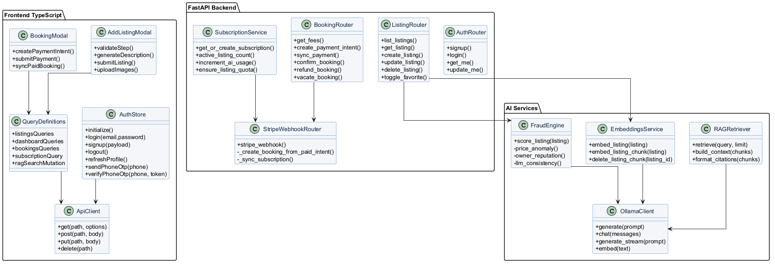
Figure 4.3: Code-grounded class diagram. The class diagram summarizes frontend stores/components, backend routers, and AI service classes found in the code.

4.6 Use-Case Design

4.6.1 Use-Case Diagram
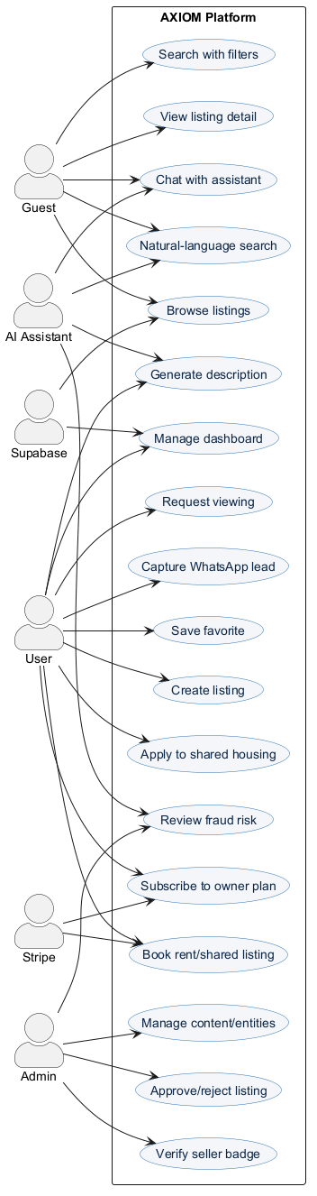
Figure 4.4: Use-case diagram. The diagram models public discovery, user workflows, AI services, Stripe payment/subscription use cases, and admin moderation.

4.6.2 Use-Case Scenarios
Table 4.2 Use-case scenarios
Use Case | Name | Actors | User/System Action | Exceptions
UC-A01 | Browse and search listings | Guest/User | User enters criteria; system returns matching active listings. | No matches; AI unavailable; invalid filters.
UC-A02 | View listing detail | Guest/User | System loads listing data, images, owner contact, housemates when shared housing, and similar listings. | Listing missing, inactive, or not visible.
UC-A03 | Create listing | User | User completes AddListingModal; backend creates a pending listing and starts fraud/embedding tasks. | Quota exceeded, missing required fields, upload failure.
UC-A04 | Approve or reject listing | Admin | Admin reviews details and approves to active or rejects with a reason. | Invalid admin token, listing no longer pending.
UC-A05 | Generate listing description | User, AI Assistant | Frontend calls /api/ai/description; backend checks quota and uses Ollama/RAG context. | AI unavailable, quota exceeded.
UC-A06 | Book rental/shared listing | User, Stripe | Backend validates listing, creates PaymentIntent, webhook creates booking and payment ledger. | Payment canceled, listing locked, sale listing requested.
UC-A07 | Apply to shared housing | User, AI Assistant | Backend validates capacity and duplicate status, inserts application, and may compute compatibility. | Not shared housing, already applied, owner applying to own listing.
UC-A08 | Capture WhatsApp lead | User | Backend records or reuses a lead and returns a wa.me URL. | No phone number or invalid source.
UC-A09 | Subscribe to owner plan | User, Stripe | Backend creates Stripe Checkout session or trial; webhook syncs subscription row. | Missing Stripe config, canceled checkout, duplicate trial.
UC-A10 | Review fraud risk | Admin, AI Assistant | System shows fraud queue; admin marks reviewed or moderates listing. | AI failed open, stale listing.

4.7 Activity Diagrams
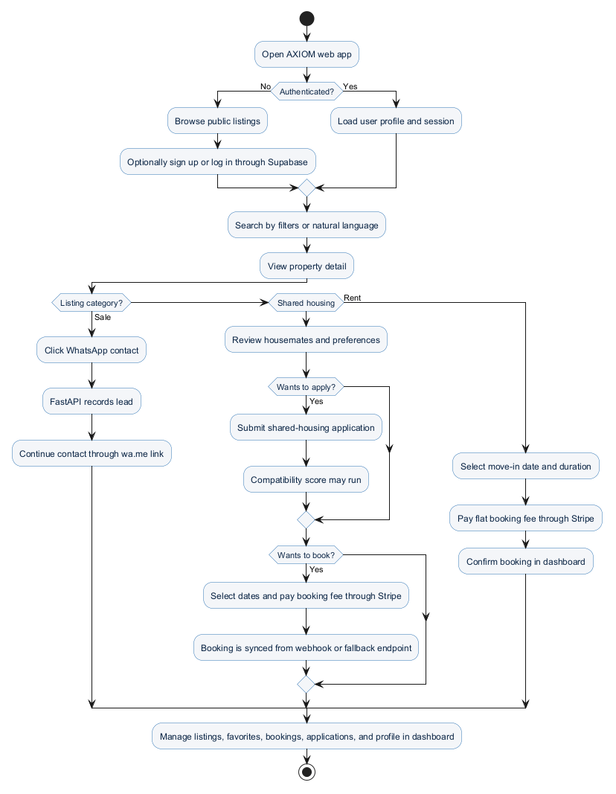
Figure 4.5: User activity diagram. The user activity flow shows browsing, authentication, AI/search discovery, property detail, payment/contact/application decisions, and dashboard management.
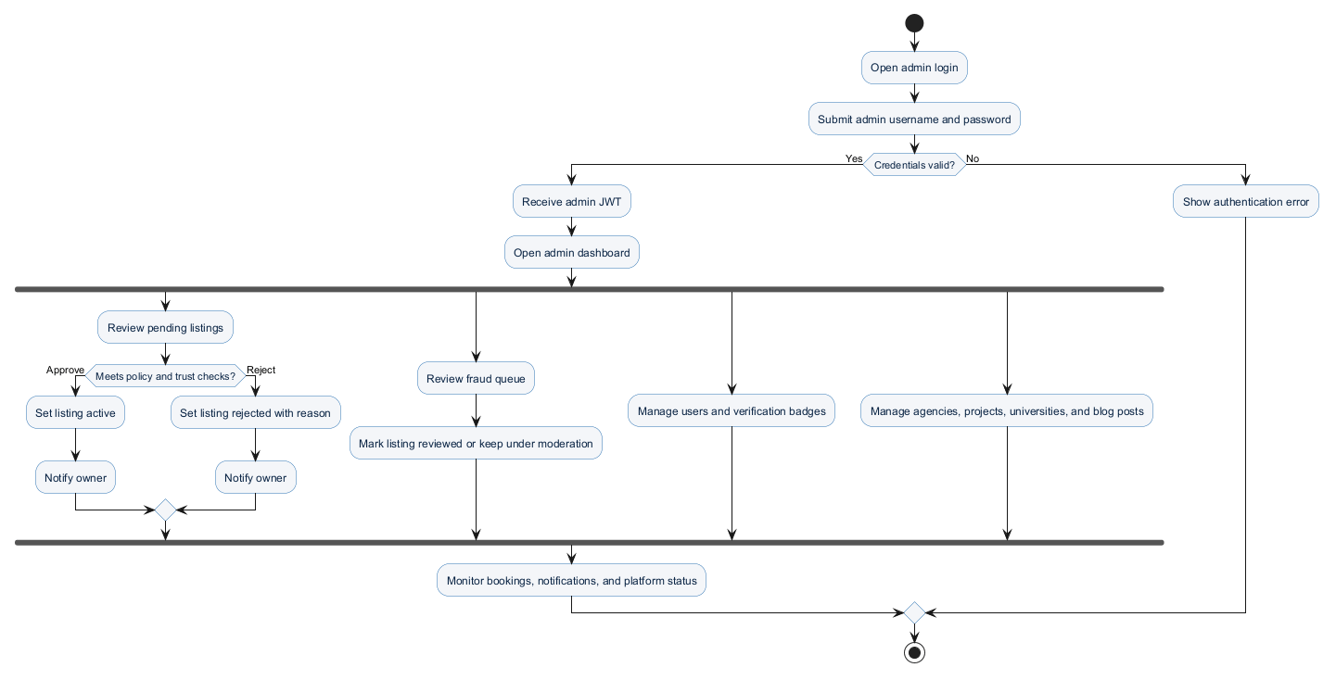
Figure 4.6: Admin activity diagram. The admin activity flow shows login, listing moderation, fraud review, verification, content management, and operational monitoring.

4.8 Sequence Diagrams
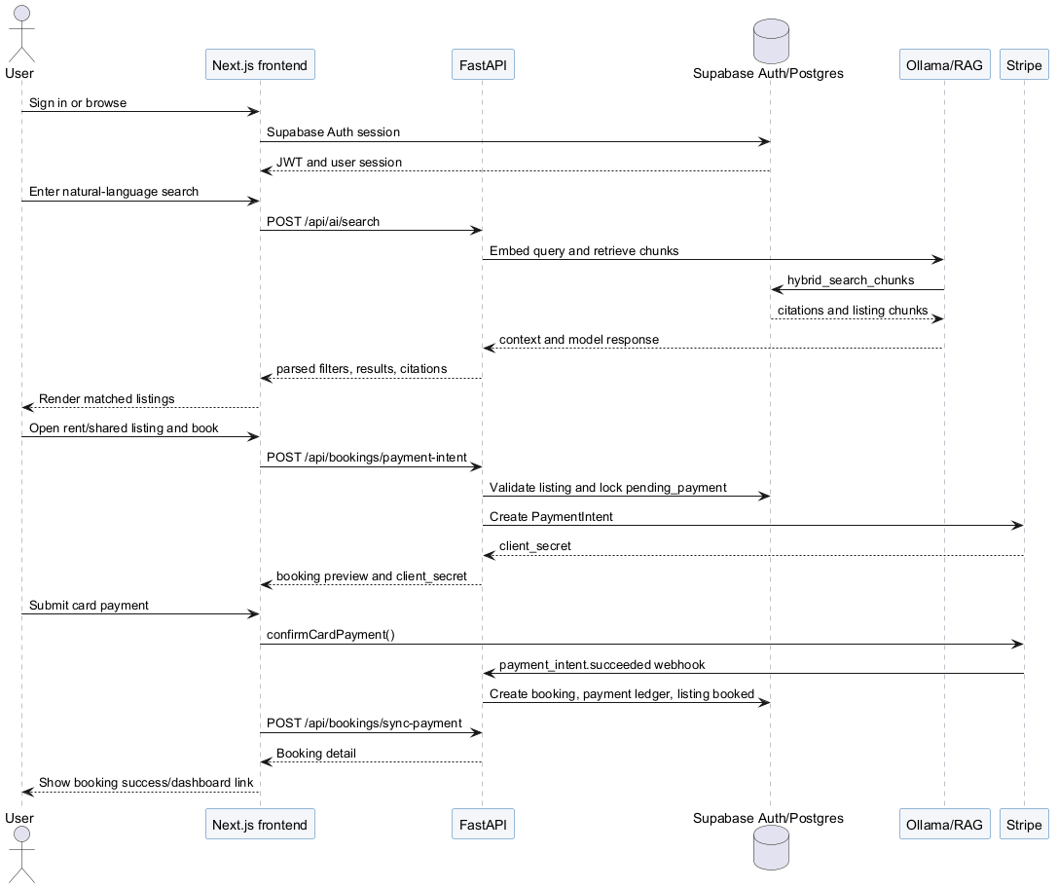
Figure 4.7: User sequence diagram. The sequence diagram follows Supabase auth, AI search/RAG, Stripe booking payment, webhook sync, and booking success.
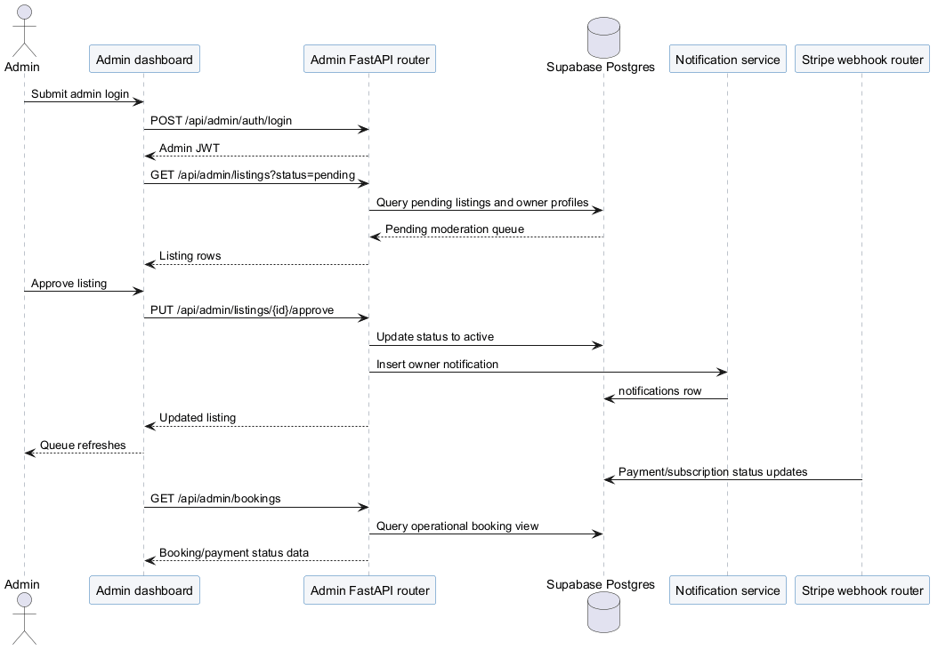
Figure 4.8: Admin sequence diagram. The admin sequence covers admin authentication, moderation queue loading, listing approval, notifications, and booking visibility.

4.9 State Diagram
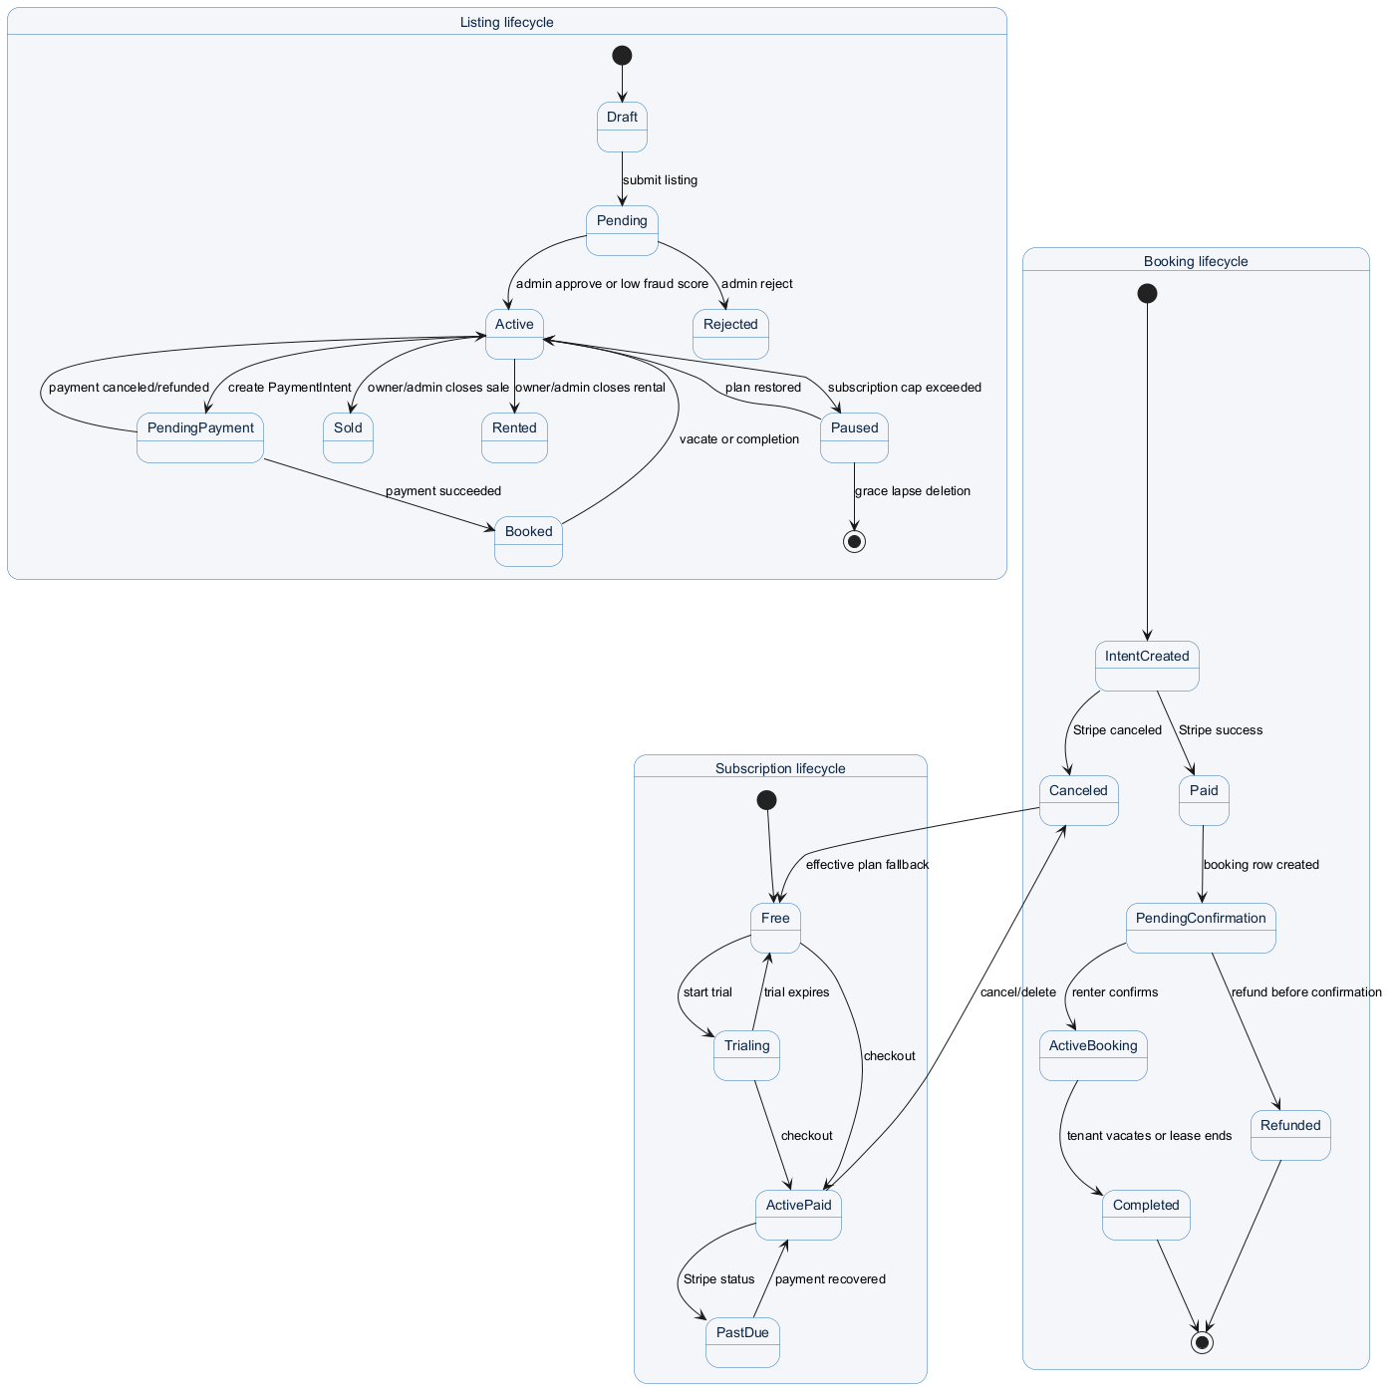
Figure 4.9: Listing, booking, and subscription state diagram. The state diagram captures listing moderation and payment states, booking states, and subscription states.

Chapter 5: Implementation

5.1 Software Architecture
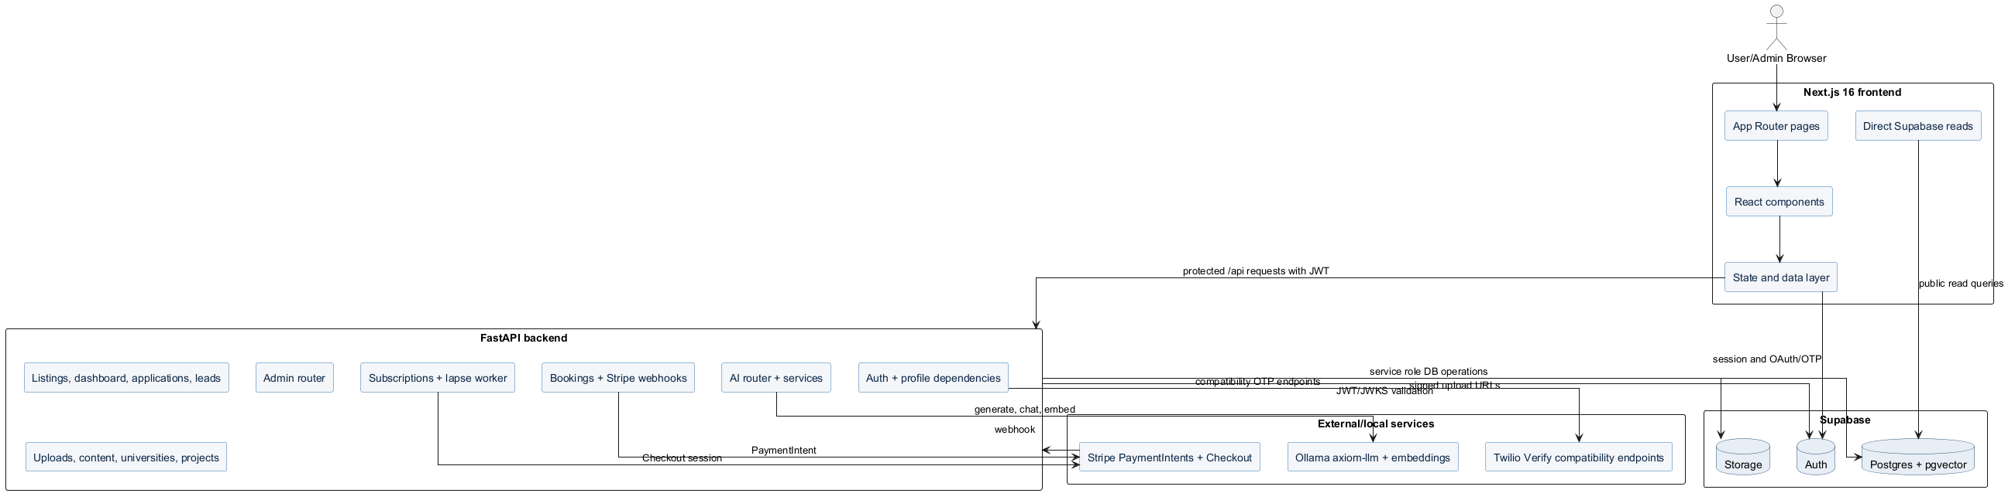
Figure 5.1: Software architecture and component diagram. The component diagram shows the Next.js frontend, FastAPI backend, Supabase services, Ollama, Stripe, and deployment boundary.

5.2 Implementation Stack
Table 5.1 Implementation stack
Layer | Technology | Implementation evidence
Frontend | Next.js 16, TypeScript, Tailwind, Framer Motion, shadcn-style UI | frontend/src/app, frontend/src/components
Server state | TanStack Query | frontend/src/lib/queries.ts
Client state | Zustand | frontend/src/stores/authStore.ts
Backend | FastAPI | backend/app/main.py and feature routers
Database | Supabase PostgreSQL, pgvector | docs/schema and backend/sql migrations
Authentication | Supabase Auth JWT | backend/app/dependencies.py
AI | Ollama, RAG, embeddings, fraud scoring | backend/app/ai
Payments | Stripe PaymentIntents and Checkout | backend/app/bookings, backend/app/subscriptions

5.3 Key Modules
Table 5.2 Main implementation modules
Module | Files | Role
Auth | authStore.ts, auth/router.py, dependencies.py | Supabase session handling, profile sync, JWT validation
Listings | listings/router.py, AddListingModal.tsx | Unified listing creation, search, details, updates, favorites
Shared housing | applications/router.py, shared-housing components | Applications, housemates, compatibility data
AI/RAG | ai/router.py, rag.py, embeddings.py, ollama_client.py | Search, chat, recommendations, descriptions, validation, retrieval
Fraud | ai/fraud.py, admin/router.py | Risk scoring and admin review support
Bookings/Stripe | bookings/router.py, stripe_webhooks/router.py, BookingModal.tsx | Flat booking fee, PaymentIntent, booking sync, refund/vacate
Subscriptions | subscriptions/*.py, pricing/page.tsx | Plan caps, AI quota, Stripe Checkout, lapse handling
Leads | leads/router.py, WhatsAppCTA.tsx | WhatsApp lead capture and admin lead visibility
Admin | admin/router.py, admin/dashboard/page.tsx | Moderation, verification, content and entity management

5.4 User Interface
Table 5.3 User interface route map
Route | Purpose | Current implementation
/ | Homepage | Server page composed from public sections
/find-homes | Listing search | Client page with Supabase query filters and grid/list views
/property/[id] | Listing detail | Server detail page for rent, sale, and shared housing
/shared-housing | Shared housing search | Client search and filtering experience
/dashboard | User workspace | Tabs for listings, bookings, applications, favorites, viewings, and profile
/pricing | Owner plans | Subscription state, trial, checkout, cancellation
/admin/dashboard | Admin console | Live moderation, CRUD, fraud, bookings, content

5.5 Results and Discussion
The implementation demonstrates a complete modernized version of the original project idea. The platform includes all core user workflows needed for discovery, trust, shared housing, listing management, AI assistance, payments, subscriptions, and admin operations. The architecture also preserves important deployment boundaries: public browsing can read Supabase directly, while protected workflows go through FastAPI business rules.
The project is strongest in its integration of domain-specific requirements. Shared housing is not treated as a generic property; it has resident and lifestyle information. AI is not only a chatbot; it supports search, recommendations, owner descriptions, validation, and fraud scoring. Payments are not a future assumption; booking fees and subscriptions are implemented, while sale listing payment is intentionally excluded in the current code.

Chapter 6: Testing

6.1 Unit Testing in AXIOM APIs and Services
Unit testing in AXIOM focuses on validating individual backend functions, router behaviors, service decisions, and edge cases before they are combined into complete user workflows. The project uses pytest for the FastAPI backend and verifies frontend correctness through TypeScript compilation. This testing approach is important because AXIOM depends on several moving parts: Supabase authentication, listing rules, AI fallbacks, booking payments, owner subscriptions, WhatsApp leads, and admin moderation.
The purpose of unit testing in the project is to confirm that each feature behaves correctly for expected inputs, handles invalid inputs safely, preserves business rules during refactoring, and avoids accidental regressions in high-risk flows such as payment creation, AI fallback behavior, seller verification, and listing approval.
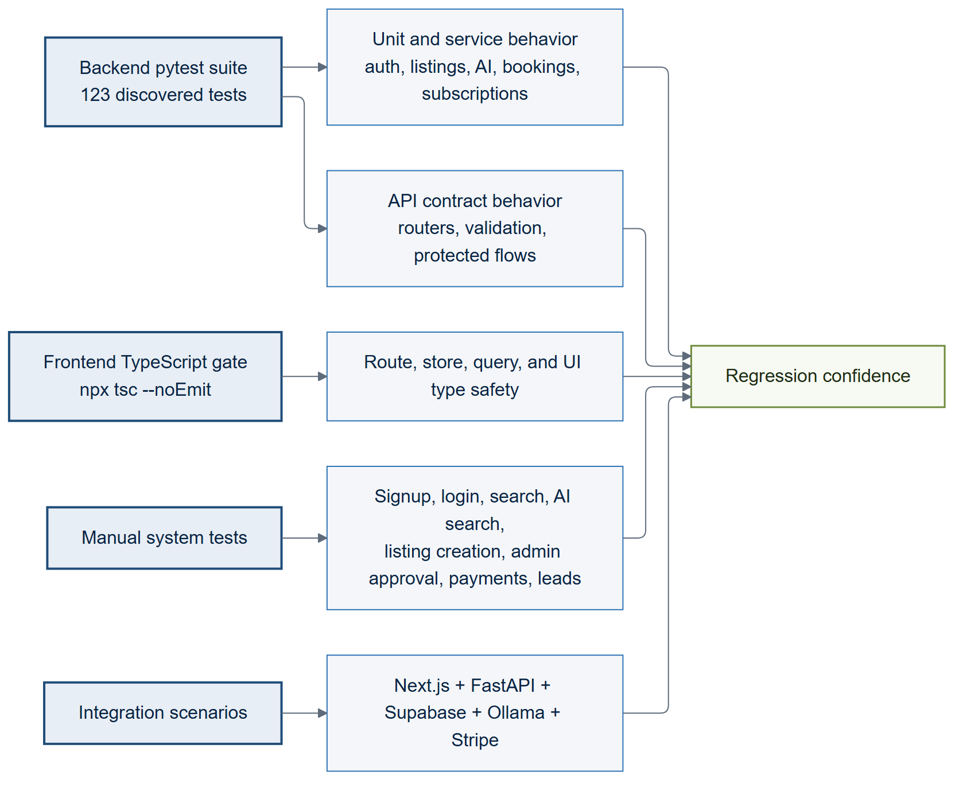
Figure 6.1: Testing and verification map. The map summarizes the verification evidence used for AXIOM: backend pytest tests, frontend TypeScript checking, integration scenarios, and manual system test cases.

6.1.1 Backend Test Coverage
Table 6.1 Backend test coverage
Test file | Tests | Coverage focus
test_admin.py | 6 | Admin stats, auth protection, listing update, fraud review
test_agencies.py | 5 | Agency list/detail/projects/listings
test_ai.py | 36 | AI search, chat, RAG, descriptions, recommendations, fraud, compatibility
test_applications.py | 3 | Shared-housing application create/auth/category checks
test_auth.py | 9 | Signup, login, profile, phone sync
test_blog.py | 4 | Published blog list/detail behavior
test_bookings.py | 5 | Flat fee behavior, sale rejection, PaymentIntent amount
test_dashboard.py | 2 | Unified dashboard response shape
test_leads.py | 5 | WhatsApp lead capture and duplicate handling
test_listings.py | 20 | Listing create/list/detail/update/delete/favorite/filter/sort
test_notifications.py | 3 | Notification list and read state
test_ollama_client.py | 4 | Ollama client health and fallback handling
test_projects.py | 2 | Project endpoint behavior
test_subscriptions.py | 9 | Plan caps, trial behavior, AI quota, listing pause selection
test_uploads.py | 2 | Signed upload URL behavior
test_validate_amenity.py | 8 | AI amenity validation and normalization
Total discovered | 123 | Backend pytest suite

6.1.2 Unit-Test Evidence by Module
Table 6.2 Unit-test evidence mapped to AXIOM modules
Module | Example files | What is verified
Authentication | test_auth.py | Signup compatibility, login behavior, profile access, and phone/profile synchronization.
Listings | test_listings.py | Create/list/detail/update/delete behavior, filters, sorting, favorites, owner checks, and active listing visibility.
AI and RAG | test_ai.py, test_ollama_client.py, test_validate_amenity.py | Natural-language search, chat, recommendations, RAG fallbacks, descriptions, compatibility, fraud scoring, Ollama client handling, and amenity validation.
Shared housing | test_applications.py | Application creation, authentication requirements, shared-housing category validation, and duplicate/capacity rules.
Bookings and payments | test_bookings.py | Flat platform fee behavior, sale-listing rejection for paid bookings, and Stripe PaymentIntent amount calculation.
Subscriptions | test_subscriptions.py | Plan limits, trial behavior, AI description quota, and listing pause selection when caps are exceeded.
Admin and moderation | test_admin.py | Admin-only access, dashboard statistics, listing update behavior, and fraud review support.
Supporting modules | test_agencies.py, test_blog.py, test_dashboard.py, test_leads.py, test_notifications.py, test_projects.py, test_uploads.py | Public/content endpoints, dashboard aggregation, WhatsApp leads, notifications, projects, agencies, and signed uploads.

6.2 Integration Testing
Integration testing checks that independently tested modules work together as complete product workflows. In AXIOM this means verifying that the Next.js frontend, FastAPI backend, Supabase Auth/PostgreSQL, Ollama AI services, and Stripe payment events exchange data correctly. The most important integration points are authentication, listing lifecycle, AI retrieval, booking payments, subscriptions, and dashboard aggregation.
Table 6.3 Integration testing flows
Integration flow | Combined components | Expected result
Authentication and profile load | Next.js auth store, Supabase Auth, FastAPI JWT dependencies, profiles table | A valid session loads the correct profile and protected routes reject unauthenticated requests.
Listing submission and moderation | AddListingModal, FastAPI listings router, Supabase listings table, fraud/embedding tasks, admin router | A submitted listing starts as pending, receives AI/background processing, and becomes active only after approval or permitted auto-approval.
AI search and chat | Frontend AI UI, FastAPI AI router, RAG retriever, pgvector knowledge_chunks, Ollama | Natural-language requests return structured results or fail softly with a usable response.
Shared-housing application | Property detail page, applications router, listings/housemates/application tables, notifications | A user can apply only to valid shared-housing listings with capacity and no duplicate application.
Rent/shared booking payment | Booking modal, bookings router, Stripe PaymentIntent, stripe webhook router, bookings/payments tables | The platform fee is calculated by the backend and payment/webhook events synchronize booking and ledger records.
Owner subscription | Pricing page, subscriptions router, Stripe Checkout, webhook sync, subscription cap services | Trial or paid plan state updates plan limits and AI description quota.
WhatsApp lead capture | Property CTA, leads router, leads table, wa.me redirect | A contact action records a lead before the user continues to WhatsApp.
Unified dashboard | Dashboard page, dashboard router, listings/bookings/applications/favorites/viewings/profile tables | The dashboard returns a consistent user workspace view across all relevant records.

6.3 Manual System Testing
Manual testing is used to verify complete user-visible workflows that are difficult to prove through isolated unit tests alone. The following table is prepared in the same structure used by the reference graduation report: each case records the scenario, actions, expected result, actual result, and status. The actual-result column should be filled during the final demo rehearsal after running the frontend, backend, Supabase, Ollama, and Stripe test environment together.
Table 6.4 Manual system test cases
Test Case ID | Scenario | Test steps | Expected result | Actual result | Status
TC_SIGNUP_001 | Sign up | Open signup, enter valid name/email/password/phone data, submit. | Account and profile are created; user can enter the app. | To be recorded in final manual run. | Prepared
TC_LOGIN_002 | Login | Open login, enter valid credentials, submit. | Authenticated user session starts and dashboard is reachable. | To be recorded in final manual run. | Prepared
TC_SEARCH_003 | Find homes | Open /find-homes, apply city/category/price filters. | Only matching active listings are displayed. | To be recorded in final manual run. | Prepared
TC_AI_SEARCH_004 | AI search | Enter a natural-language request such as a budget/location/preference query. | AI endpoint returns relevant listings or a graceful fallback. | To be recorded in final manual run. | Prepared
TC_CREATE_LISTING_005 | Create listing | Open dashboard, complete the add-listing wizard for rent/sale/shared housing. | Listing is saved with pending status and appears in owner dashboard. | To be recorded in final manual run. | Prepared
TC_ADMIN_APPROVE_006 | Admin approval | Open admin dashboard, review pending listing, approve it. | Listing status changes to active and appears on public pages. | To be recorded in final manual run. | Prepared
TC_BOOKING_007 | Booking payment | Open a rent/shared listing, start booking, complete Stripe test payment. | PaymentIntent and booking/payment records are synchronized. | To be recorded in final manual run. | Prepared
TC_LEAD_008 | WhatsApp lead | Click WhatsApp contact on a listing detail page. | Lead is recorded and user continues to WhatsApp URL. | To be recorded in final manual run. | Prepared
TC_SUBSCRIPTION_009 | Owner subscription | Open pricing, start trial or checkout Basic/Pro plan. | Subscription/trial state updates and plan limits are available. | To be recorded in final manual run. | Prepared
TC_LOGOUT_010 | Logout | Click logout from the authenticated UI. | Session is cleared and protected pages require login again. | To be recorded in final manual run. | Prepared

6.4 Frontend and Static Verification
The required frontend verification command is `npx tsc --noEmit` inside the `frontend` directory. This confirms that the TypeScript application, route components, query contracts, stores, API types, and UI props compile without type errors. It is not a replacement for browser end-to-end testing, but it is the current automated frontend gate documented for the project.

6.5 Limitations and Future Testing Enhancements
- Live Supabase schema must be checked for all status enum values used by the latest code.
- Some legacy conversation/message schema remains even though the current contact flow uses WhatsApp leads.
- The agency subscription stub is separate from the current owner Basic/Pro subscription system.
- Frontend automated browser tests are not documented as a complete suite; TypeScript is the required frontend gate and Playwright/Cypress coverage should be added for final production confidence.
- Manual test cases should be executed during the final demo rehearsal and updated with actual results and screenshots.
- Deployment infrastructure is prepared, but production deployment still requires environment and service configuration.

Conclusion
AXIOM V2 successfully modernizes the original real estate platform idea into a full-stack AI-assisted system. It replaces the early role-split design with a unified user model, a category-driven listing schema, and a stronger trust workflow. The implementation combines Next.js, FastAPI, Supabase, Ollama, pgvector, and Stripe to support property discovery, shared housing, AI search, owner productivity, payments, subscriptions, and admin moderation. The result is a practical and extensible foundation for a real Egyptian real estate platform.

Future Work
- Apply and verify all remaining live Supabase migrations, especially status enum values.
- Deploy the frontend and backend to production hosting with rotated keys and secure environment variables.
- Expand automated frontend end-to-end testing for booking, dashboard, and admin workflows.
- Add richer owner analytics and notification workflows.
- Improve multilingual Arabic/English coverage across AI prompts and UI surfaces.
- Extend fraud detection with more market data and reviewer feedback loops.

References
- AXIOM V2 repository source files: frontend/src, backend/app, docs/schema, backend/sql, backend/tests.
- Supabase documentation, Auth, PostgreSQL, Storage, and pgvector concepts: https://supabase.com/docs
- FastAPI documentation: https://fastapi.tiangolo.com/
- Next.js documentation: https://nextjs.org/docs
- Stripe documentation for PaymentIntents, Checkout, and webhooks: https://docs.stripe.com/
- Ollama documentation: https://ollama.com/
- Dubizzle Egypt: https://www.dubizzle.com.eg/
- Aqarmap: https://aqarmap.com.eg/
- Property Finder Egypt: https://www.propertyfinder.eg/en/
- Bayut Egypt: https://www.bayut.eg/en/
- Sakneen: https://sakneen.com/
- Weetas: https://www.weetas.com/
- Student.com: https://www.student.com/
- HousingAnywhere: https://housinganywhere.com/
- Uniplaces: https://www.uniplaces.com/
- AmberStudent: https://amberstudent.com/
- Egypt 2025 rental-law context as discussed in the early project report and project motivation.

Appendix A: Corrections from the Early Report
The early report was used for structure and motivation only. The technical content was corrected to match AXIOM V2.
Early report design | Current report correction
Title and product identity | Use AXIOM as the project title and current product name.
Separate account classes | Use a single user/admin role model with verified seller badge.
Legacy owner naming | Use owner_id for listing ownership.
Separate property and shared-unit entities | Use one listings table with category values.
PHP/MySQL stack | Use Next.js, FastAPI, Supabase PostgreSQL, pgvector, Ollama, and Stripe.
AI optional/future | Document implemented AI search, chat, recommendations, compatibility, descriptions, validation, embeddings, and fraud scoring.
Payments future/out of scope | Document implemented rent/shared-housing booking fee and owner subscriptions; sale listings remain contact-only.
Inquiry/contact workflow | Document WhatsApp leads, viewing requests, applications, bookings, and dashboard tabs.

