Memory Allocation

3rd CSE Operating-System Structures

Fady Fares Abdel Ahad Sobhy

Sec: 2

Contents

2 How to use the memory allocator 2

2.1 Open memory allocator.exe 2

2.2 enter no. of holes then press on the button “Enter holes” 3

2.3 enter process size to be allocated 4

3 Restrictions and assumptions 5

3.1 you must enter the holes number (non-zero number) in order to proceed to the new form 5

3.2 you must enter all the data in the hole form 5

3.3 Hole size 6

3.4 adding process 6

3.5 Hole concatenation 6

4 Test case 8

4.1 Holes entered 8

4.2 P0 of size =10 using first fit 9

4.3 P1 of size =10 using best fit 9

4.4 P1 of size =10 using worst fit 10

4.5 P3 of size =20 using best fit 11

4.6 P4 of size =40 using worst fit 12

4.7 P5 of size =40 using first fit 13

4.8 P6 of size =50 using first fit 14

4.9 pressing on button “Clear memory” 15

# How to use the memory allocator

## Open memory allocator.exe

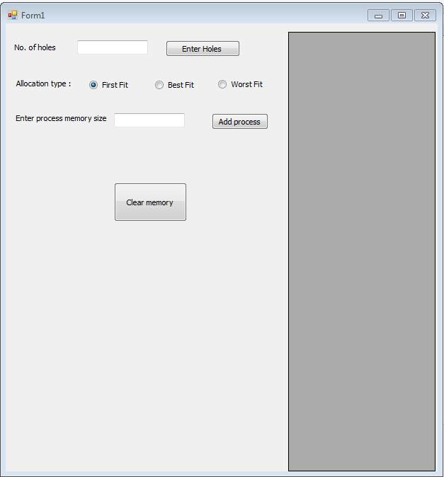

## enter no. of holes then press on the button “Enter holes”

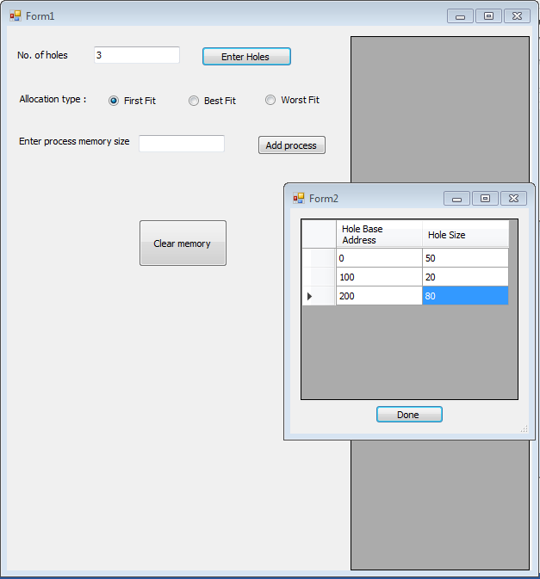

* A new form will be opened with the specified number of holes to enter the holes base address and size.
* When you finish filling the holes’ data press on the button “Done” and close that form.
* Memory shape will appear with the specified holes.

## enter process size to be allocated

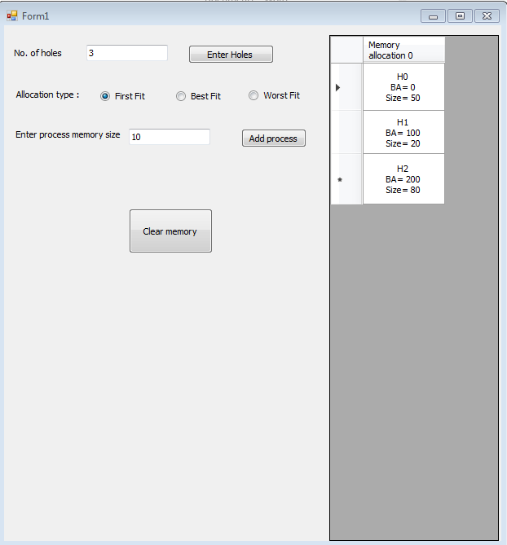

* Choose one of the allocation type that you would like to allocate this process according to.
* Then press on the button “Add process”.
* You can change the allocation type each time you enter a process size.
* You can press “Clear memory” any time to reset the memory to its initial state (last modified holes state).
* You can enter another holes no and press on the button “Enter Holes” any time.

# Restrictions and assumptions

## you must enter the holes number (non-zero number) in order to proceed to the new form

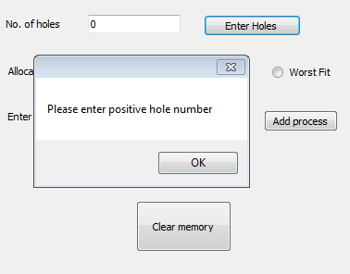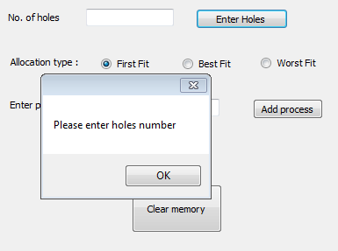

## you must enter all the data in the hole form

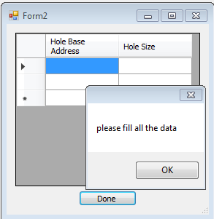

* If you pressed on the button “Done” before finishing filling all the data this warning will appear.
* Don’t close this form until you have finished filling the data otherwise the program won’t work properly.
* Noted that when this form is opened any holes entries will be cleared so make sure to fill all the data again and press on the button “Done”.

## Hole size

Using linear equation to realize the cell size according to the hole size will allow you to enter holes size ranging from (0 – 1000) with good looking scale but if you went further than that it cell size may be too big to see.  
The Eq. is: Cell height = (Hole Size) x 0.15 + 50.

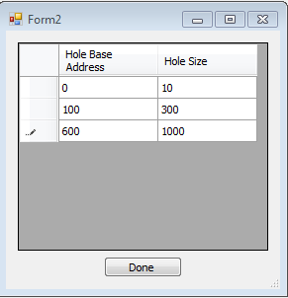 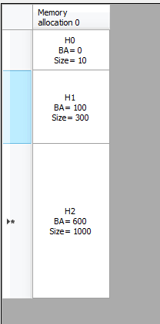

## adding process

* Assumption is made that the process will be entered in the first memory holes’ addresses so you might see that the process will take the base address of the hole and the base address of the hole is updated according to the size of the process.
* Process is in grey cell color.
* When a hole is filled with processes it will be deleted.

## Hole concatenation

* Feel free to enter the holes data in any order and don’t bother yourself with base address and size calculations.
* Overlapping holes will be concatenated into one hole.
* Ex1: 3 over lapping holes (entered in reverse base address order or any other order)

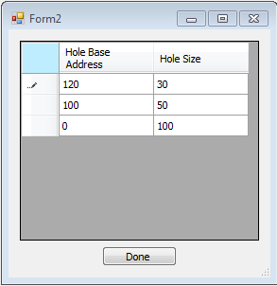 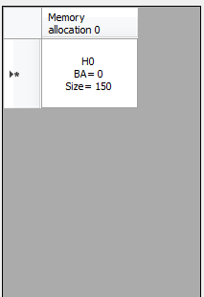

* Ex2: 1 hole is part of another and both overlapping with the third hole

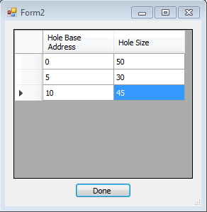 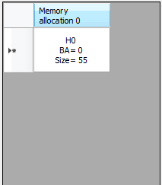

# Test case

## Holes entered

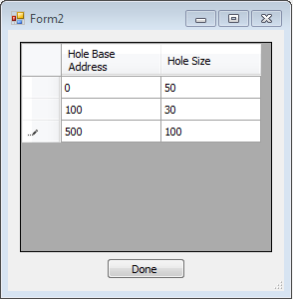

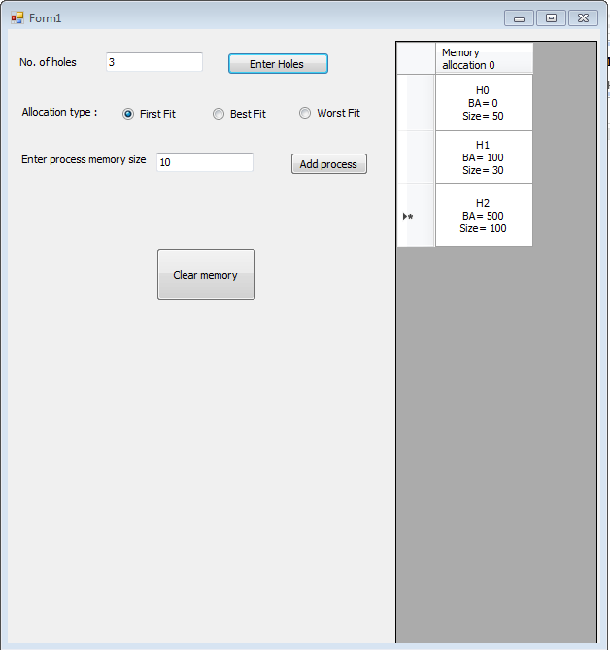

## P0 of size =10 using first fit

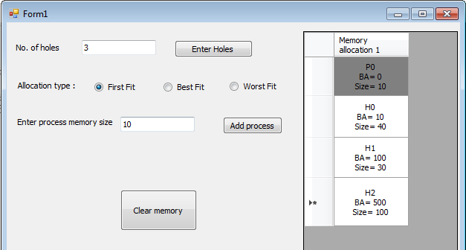

## P1 of size =10 using best fit

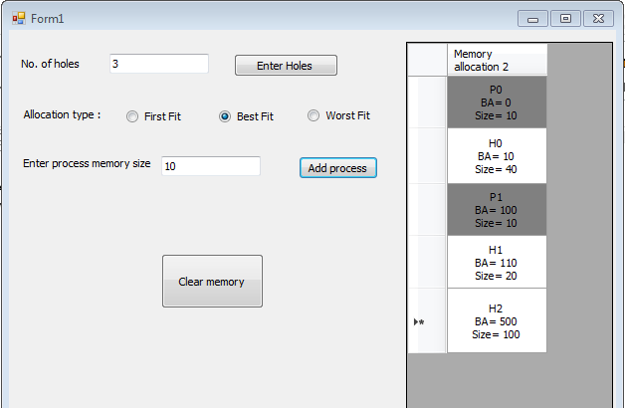

## P1 of size =10 using worst fit

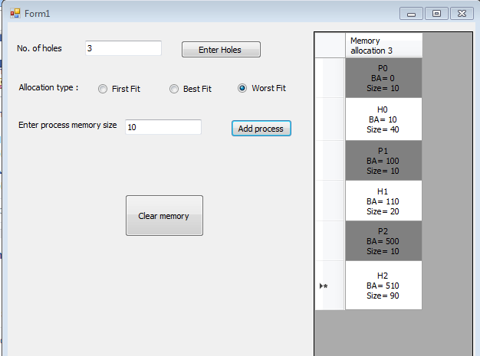

## P3 of size =20 using best fit

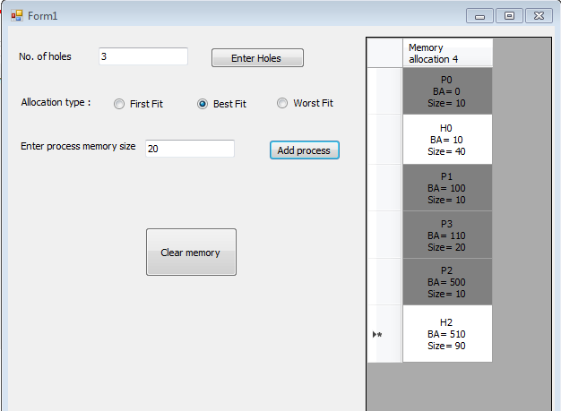

## P4 of size =40 using worst fit

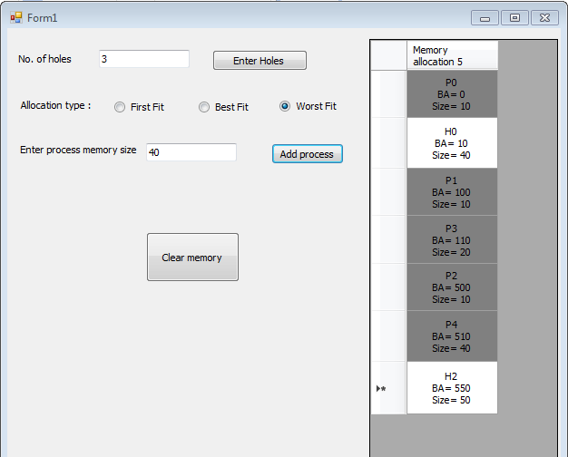

## P5 of size =40 using first fit

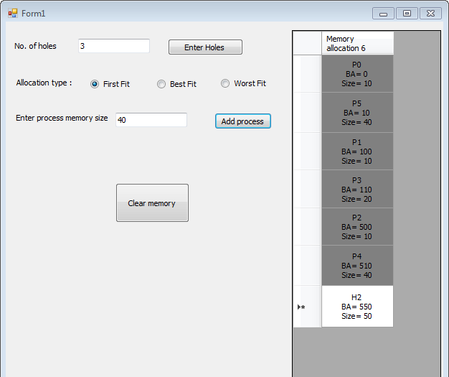

## P6 of size =50 using first fit

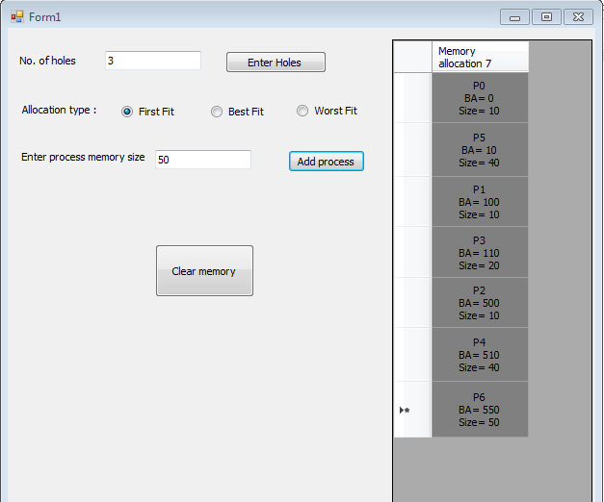

## pressing on button “Clear memory”

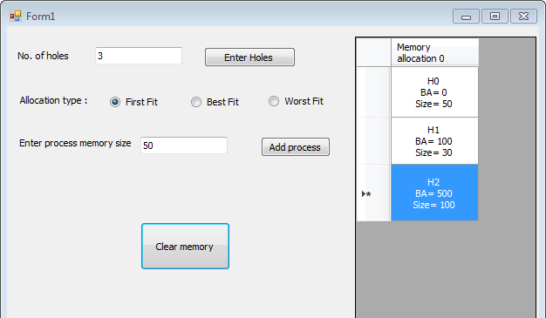

* you can press that button at any time through the program.