2015

STUDENT ACTIVITIES

DATABASE SYSTEMS CSE421

|  |  |
| --- | --- |
| Name | Section |
| Reem Medhat Ernest | 2 |
| Rizk Tawfik Rizk | 2 |
| Fady Fares Abdel Ahad | 2 |
| Sameh Mamdouh | 2 |
| Mark Magdy Antoun | 2 |
| Ahmed Mohamed Abdelmageed | 1 |

Table of Contents

Project description 3

Software used 3

ER Diagram 4

Assumptions 5

Relational Schema 6

Tables names and constrains 6

Campaign 6

campaign_location 7

committee 7

Member 7

Participant 7

Professor 8

registered_in 8

sa_committee 8

Sponsor 8

sponsored_by 9

student 9

student_activity 9

track 9

track_campaign 10

university 10

SQL Statements 11

Queries 11

activity.php 11

addCampaign.php 11

addMember.php 11

AddSA 11

campaigns.php 11

index.php 12

login.php 12

register.php 12

SA-cmd 12

Report 12

Insert 13

Admin-cmd 13

SA-cmd 13

Forms 14

Login 14

Index 14

Dashboard 15

Activities 16

Events 16

Student activity 17

Add new committee 18

Add new track 18

Add new member 19

Add campaign 19

Admin view 20

Add activity 20

Register the activity to a new location (university). 21

Generate reports 21

# Project description

It is required to design a database for student activities in a certain university to help students keep track of new student activities and their different committees and tracks and to help student activity supervisors enroll new students to their activities. And to help student affairs department to enroll new student activity in the university. It is also required to design a web application that uses this database. The web application has three views:

1. Student view: can view different student activities with their tracks and committees
2. Student activity head view: can enroll any participant or member to his activity, adding tracks and committees to his student activity.
3. Database admin: can enroll new student activities.

# Software used

* Xampp
* PhpmyAdmin
* Dreamwaver
* Illustrator
* Notepad++

# ER Diagram

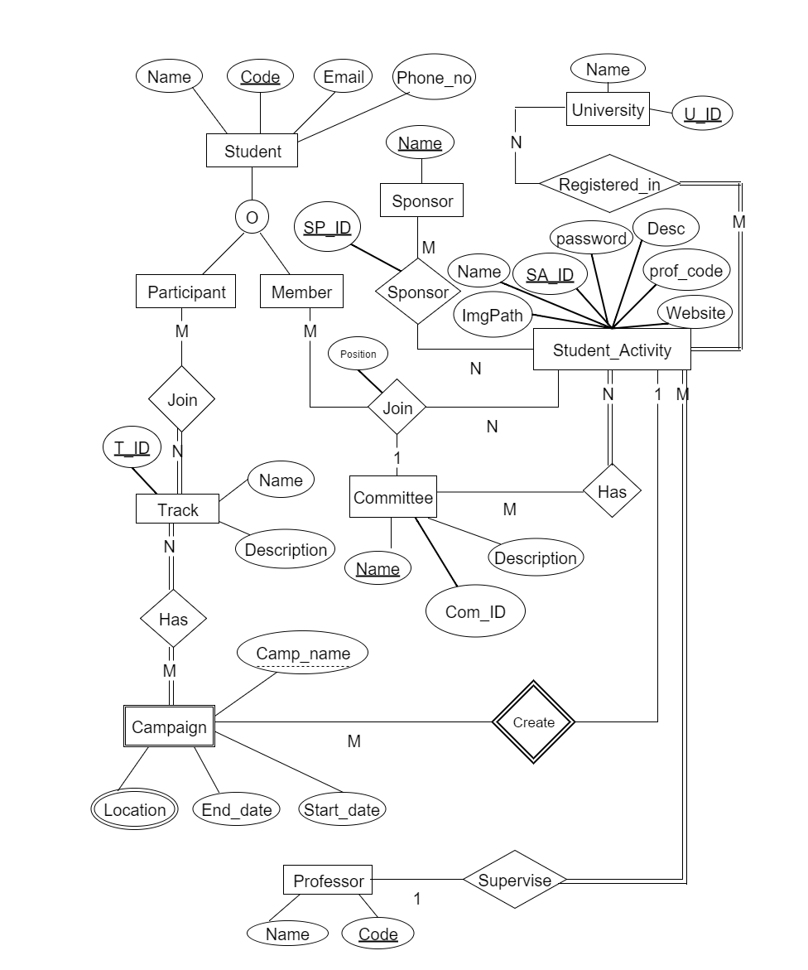

# Assumptions

* Student may enroll in one or more student Activities.
* Student activity must be in at least one university.
* Student activity must be tracked by only one Dr.
* Students who enroll in student activities must be participants or members or both.
* Participants & members of any student activity must be undergraduate.
* Each student activity has many committees.
* Member has to be in only one committee.
* Participant in a student activity has to be in only one track.
* Each student activity can make a campaign.
* Each campaign has many tracks.
* Each student activity may has one or more sponsor.
* Each campaign must have at least one location.
* Each committee has multiple positions.
* Each member has to be in only one position.

# Relational Schema

## Tables names and constrains

### Campaign

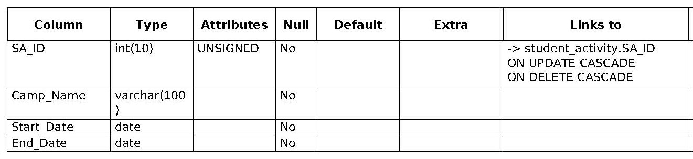

* PK(SA_ID,Camp_Name).

### campaign_location

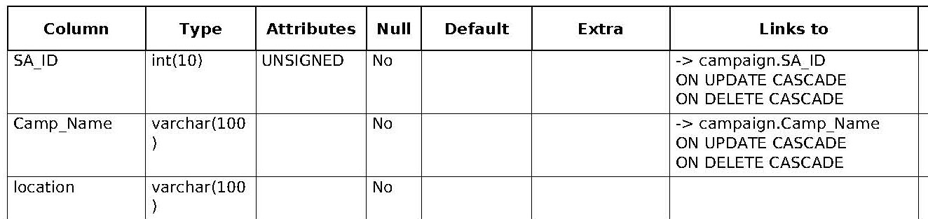

* PK (SA_ID,Camp_Name,location).

### committee

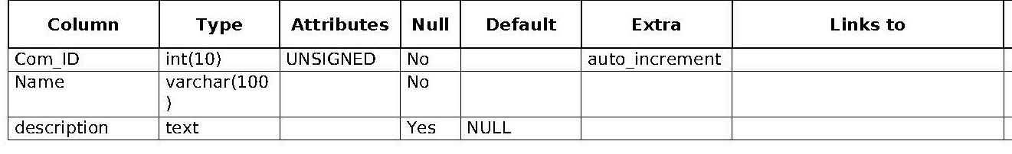

* PK(Com_ID).

### Member

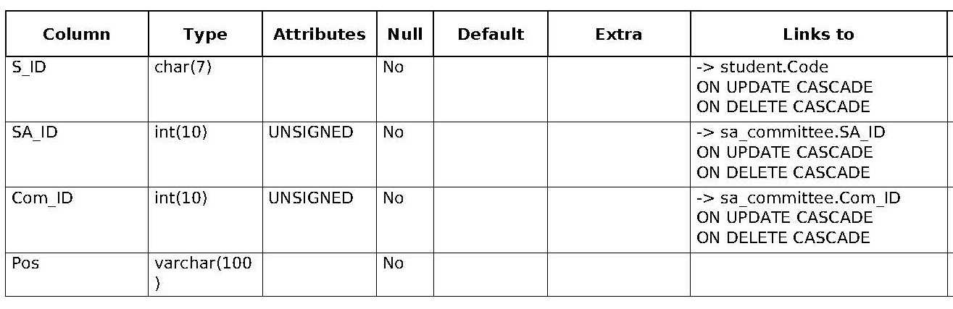

* PK(S_ID,SA_ID).

### Participant

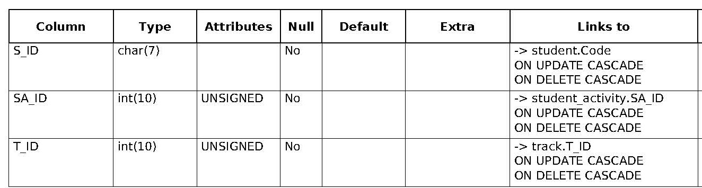

* PK(S_ID,SA_ID).

### Professor

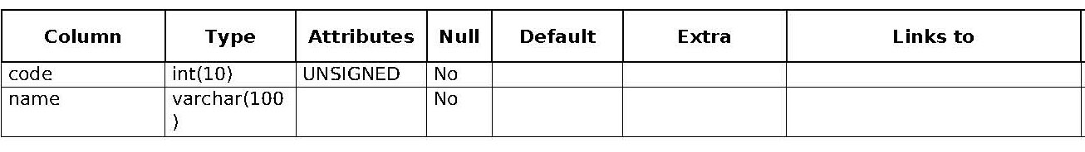

* PK(code).

### registered_in

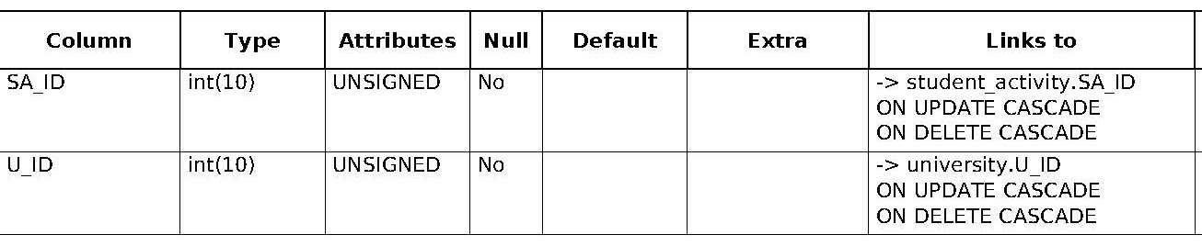

* PK(SA_ID,U_ID).

### sa_committee

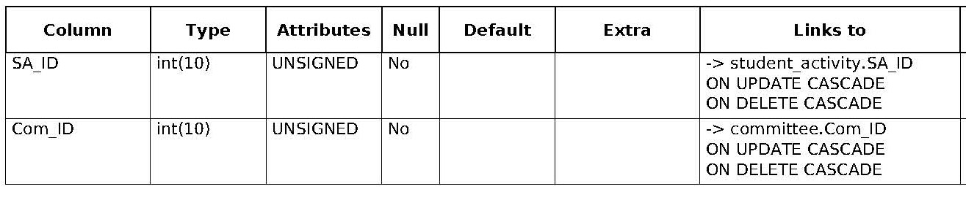

* PK(S_ID,SA_ID).

### Sponsor

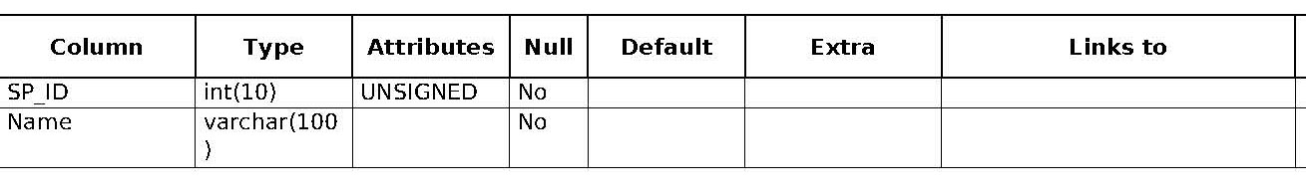

* PK(SP_ID).

### sponsored_by

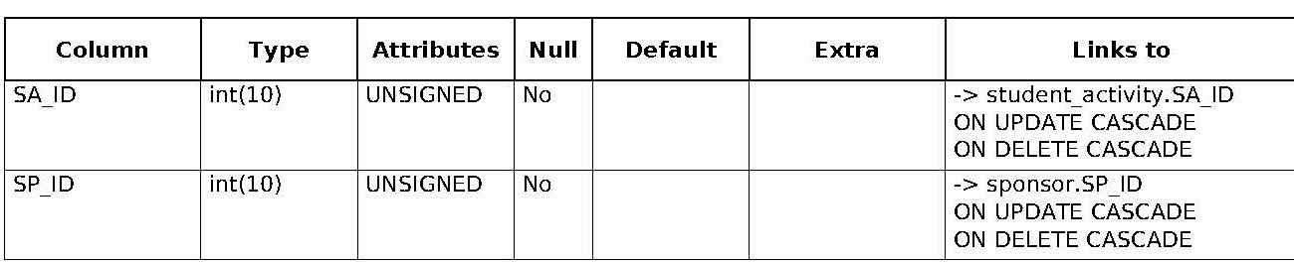

* PK(SP_ID,SA_ID).

### student

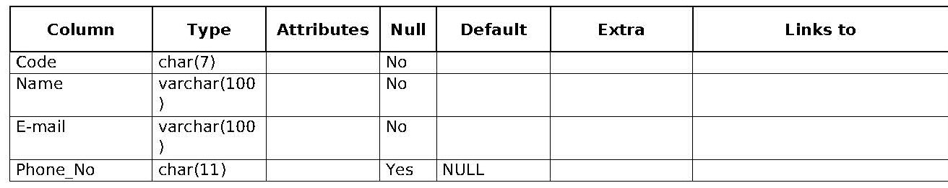

* PK(code).

### student_activity

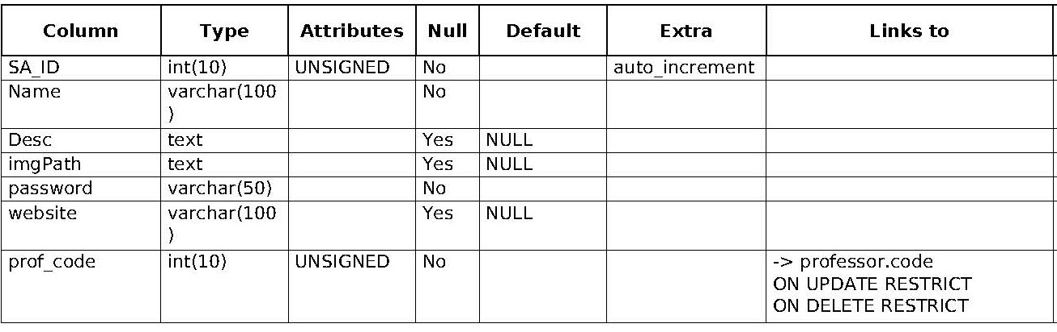

* PK(SA_ID).

### track

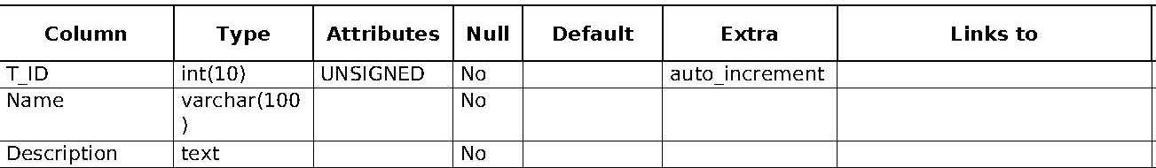

* PK(T_ID).

### track_campaign

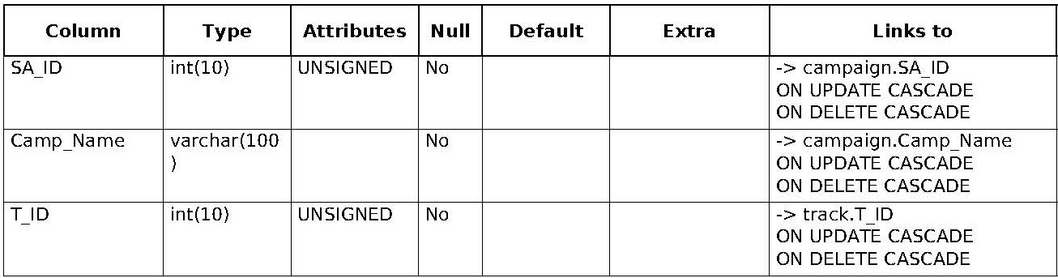

* PK(SA_ID,Camp_Name,T_ID).

### university

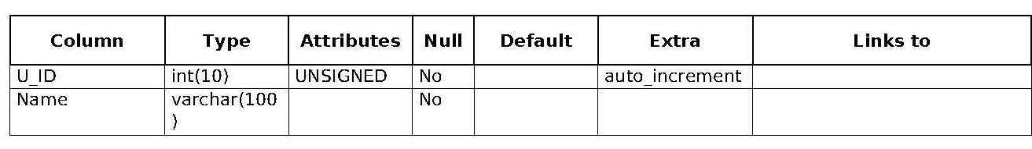

* PK(U_ID).

# SQL Statements

## Queries

### activity.php

* SELECT `student`.`Name` as SName,`Code`,`E-mail`,`Phone_No`,`committee`.`Name` as   CName,`Pos`   
  FROM `student`,`committee`,`member`   
  WHERE `committee`.`Com_ID`=`member`.`Com_ID` AND `student`.`Code`=`member`.`S_ID` AND `member`.`SA_ID`=$SA_ID
* SELECT `campaign`.`Camp_Name`,`Start_Date`,`End_Date`,`location`   
  FROM `campaign`,`campaign_location`  
  WHERE `campaign`.`Camp_Name`=`campaign_location`.`Camp_Name`  AND `campaign`.`SA_ID`=$SA_ID
* SELECT COUNT(*) AS total   
  FROM `campaign`;  
  WHERE `SA_ID`=$SA_ID
* SELECT COUNT(*) AS total   
  FROM `member`  
  WHERE `SA_ID`=$SA_ID

### addCampaign.php

* SELECT *   
  FROM `track`

### addMember.php

* SELECT `committee`.`Com_ID`,`Name`   
    FROM `committee`,`sa_committee`   
   WHERE `committee`.`Com_ID`=`sa_committee`.`Com_ID` AND `SA_ID`=".$_SESSION['SA_admin']

### AddSA

* SELECT `code`,`name`   
   FROM `professor`
* SELECT *                                       
  FROM `university`

### campaigns.php

* SELECT student_activity.SA_ID,student_activity.Name,campaign.Camp_Name,campaign_location.location,campaign.Start_Date,campaign.End_Date,student_activity.imgPath FROM `student_activity`,`campaign`,`campaign_location` WHERE `student_activity`.`SA_ID`=`campaign`.`SA_ID` AND `campaign`.`SA_ID`=`campaign_location`.`SA_ID` AND `campaign`.`Camp_Name`=`campaign_location`.`Camp_Name`

### index.php

* SELECT `SA_ID`, `Name`, `imgPath` FROM `student_activity` ORDER BY RAND() LIMIT 3
* SELECT student_activity.SA_ID,student_activity.Name,campaign.Camp_Name,campaign_location.location,campaign.Start_Date,campaign.End_Date,student_activity.imgPath FROM `student_activity`,`campaign`,`campaign_location` WHERE `student_activity`.`SA_ID`=`campaign`.`SA_ID` AND `campaign`.`SA_ID`=`campaign_location`.`SA_ID` AND `campaign`.`Camp_Name`=`campaign_location`.`Camp_Name` ORDER BY RAND() LIMIT 3

### login.php

* SELECT `SA_ID` FROM `student_activity` WHERE `Name`='$user' AND `password`='$pass'

### register.php

* SELECT `Name`, `SA_ID`   FROM `student_activity`
* SELECT `name`, `U_ID`   FROM `university`

### SA-cmd

* SELECT `Code` FROM `student` WHERE `Name` = '$student'
* SELECT `Com_ID` FROM `committee` WHERE `Name` = '$com'
* SELECT `Com_ID` FROM `committee` WHERE `Name`='$comname'

### Report

* SELECT COUNT(*) as total ";  
  FROM `student`
* DROP VIEW IF EXISTS `students_in_activities`  
  CREATE VIEW `students_in_activities` AS ";  
  (SELECT  `S_ID`,`SA_ID` FROM `member`) UNION (SELECT DISTINCT `S_ID`,`SA_ID` FROM `participant` )
* SELECT COUNT(DISTINCT `S_ID`) as total ";  
  FROM `students_in_activities`
* SELECT COUNT(DISTINCT `S_ID`) as total ";  
  FROM `member`
* SELECT COUNT(DISTINCT `S_ID`) as total "; FROM `participant`
* SELECT COUNT(*) as total ";  
  FROM `student_activity`
* SELECT `SA_ID`, COUNT(*) as total ";  
  FROM `students_in_activities` ";  
  GROUP BY `SA_ID`
* SELECT `Name`   
  FROM `student_activity`   
  WHERE `SA_ID` = $sa_id

## Insert

### Admin-cmd

* INSERT INTO `student_activity`(`SA_ID`, `Name`, `Desc`, `imgPath`, `password`, `website`, `prof_code`) VALUES (NULL,'$name','$desc',NULL,'$password','$web','$prof_code')
* UPDATE `student_activity` SET `imgPath`='".$uploadResult['value']."' WHERE `SA_ID`=$index
* INSERT INTO `registered_in`(`SA_ID`, `U_ID`) VALUES ('$index','$uni')
* "INSERT INTO `db_project`.`registered_in`(`SA_ID`, `U_ID`) VALUES ('".$_POST['st_act']."', '".$_POST['univ']."')

### SA-cmd

* INSERT INTO `member`(`S_ID`, `SA_ID`, `Com_ID`, `Pos`) VALUES ('$code','".$_SESSION['SA_admin']."','$com','$pos')
* INSERT INTO `track`(`T_ID`,`Name`,`Description`) VALUES (NULL,'$tname','$description')
* INSERT INTO `committee`(`Com_ID`,`Name`,`Description`) VALUES (NULL,'$comname','$description')
* INSERT INTO `sa_committee`(`SA_ID`, `Com_ID`) VALUES ('".$_SESSION['SA_admin']."','$id')
* INSERT INTO `campaign`(`SA_ID`, `Camp_Name`, `Start_Date`, `End_Date`) VALUES ('".$_SESSION['SA_admin']."','$name','$start','$end')
* INSERT INTO `campaign_location`(`SA_ID`, `Camp_Name`, `location`) VALUES
* "INSERT INTO `track_campaign`(`SA_ID`, `Camp_Name`, `T_ID`) VALUES

# Forms

Our website is built with simple, elegant and responsive design to view it on several devices.

## Login

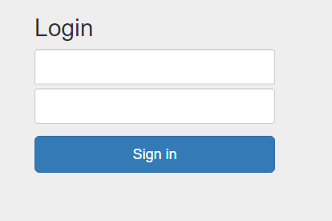

* Login is required for student activity head (with registered username and password inserted by the admin) and database admin with fixed username: Admin and password: 0159.
* Student doesn’t need to login.
* Admin login by going directly to “login.php” page.
* Student activity head will be initially viewing student view and can be redirected to the login page by pressing on “I’m Student Activity” button.

## Index

We know that your time is valuable so with the aid of navigation bar you can go anywhere through the website easily and in no time.

* It’s split into 3 main parts :
  + Dashboard: where you can see all activities and events in a glance and you can press more to see all.
  + Activities: where you can see all the activities available
  + Events: where you can see all events posted by any student activity.
  + It’s mainly for the student view and is used in other views as well.

### Dashboard

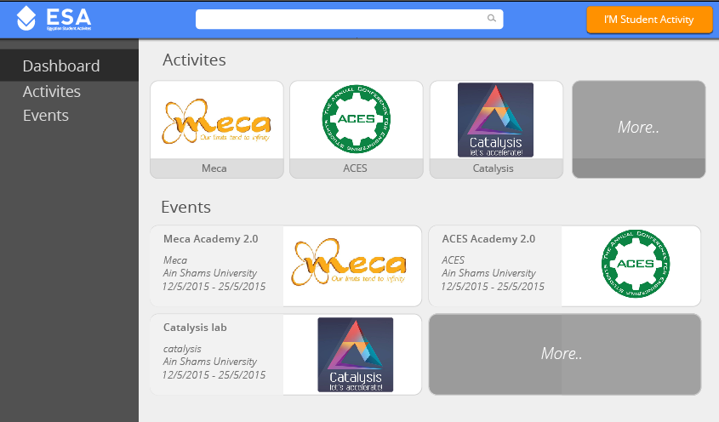

* Pressing on “I’m student activity” will redirect you to the login page.
* Pressing on any event or activity will redirect you to the details page.

### Activities

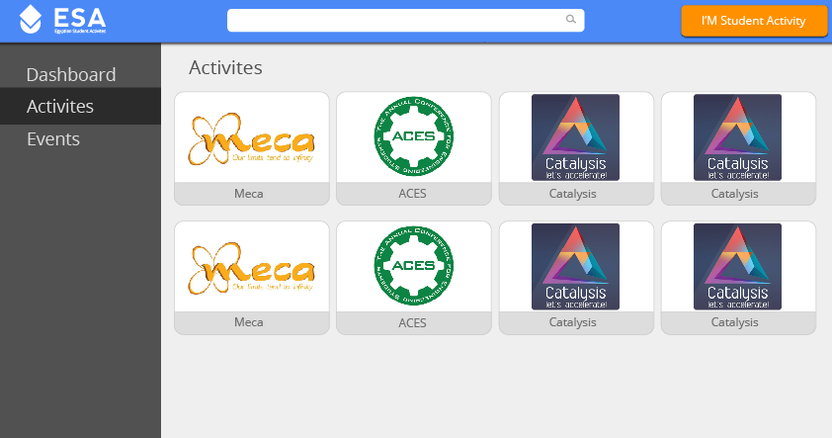

* Pressing on any activity will redirect you to the details page.

### Events

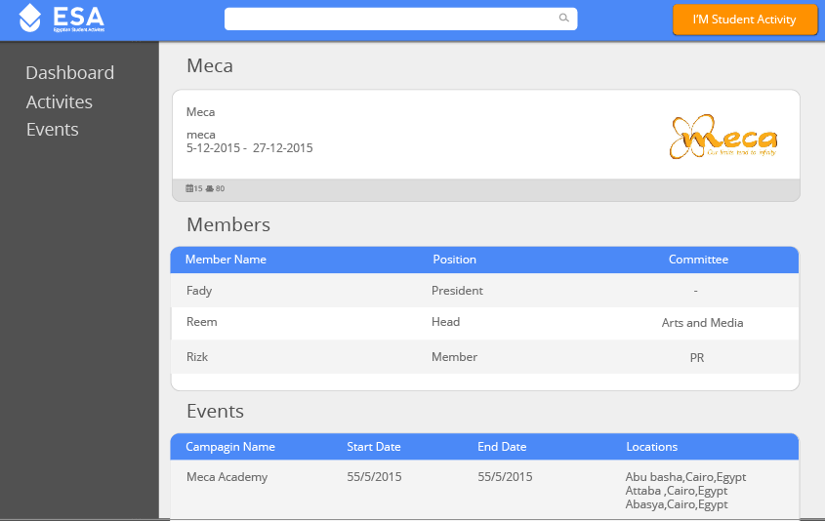

* Pressing on any event will redirect you to the details page.

## Student activity

This is your activity home page and you can easily find all members and events and add or delete any of them.

* By pressing on “+New Committee” you will be redirected to special form to add your committee details.
* By pressing on “+New track” you will be redirected to special form to add your track details.
* By pressing on “+New Member” you will be redirected to special form to add your member details.
* By pressing on “+New Event” you will be redirected to special form to add your event details.
* Notice that 2 new buttons are added to your view:
* Home button: you can press it anytime to get back to this page.
* Logout button: so that you end this session.

### Add new committee

### Add new track

### Add new member

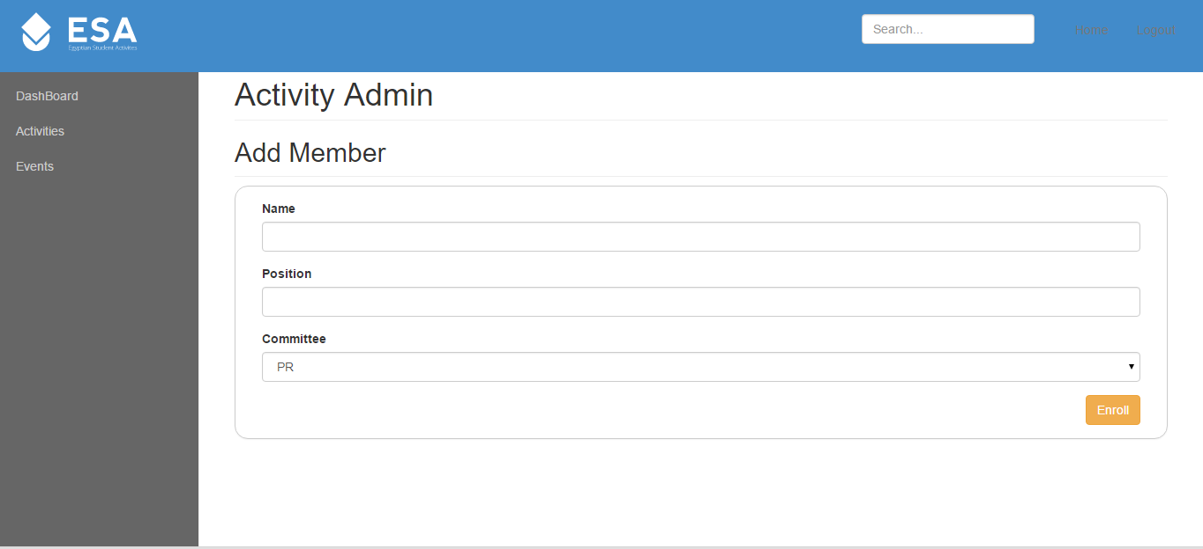

Add new participant

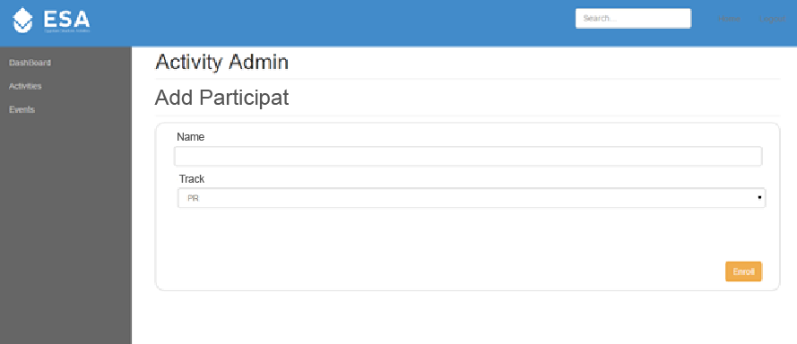

* You should select one of the committees associated by your student activity.

### Add campaign

* You should insert each location separated by enter.

## Admin view

### Add activity

* You must enter the name and a password for the new activity.
* You can use “Generate Password” to give you random password.
* You should upload your logo
* You must select one professor and initial location for the activity.
* You can add a website link.

### Register the activity to a new location (university).

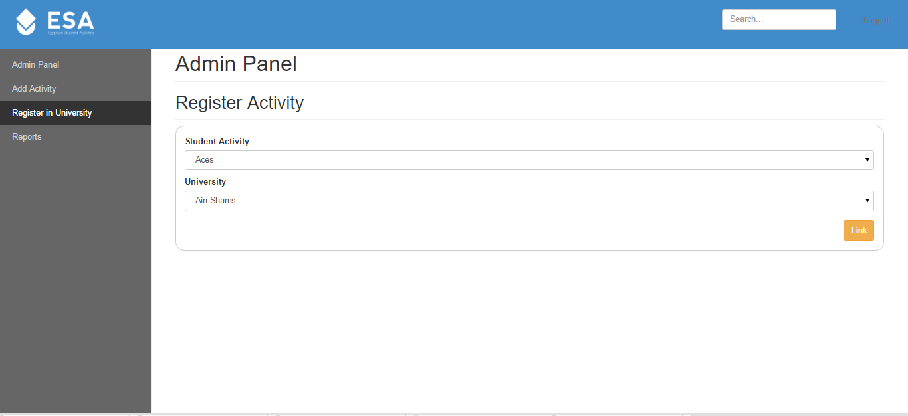

### 

### Generate reports

