1. **Overall Description**

**2.1. Product Perspective**

The current attendance management process in universities faces challenges in terms of efficiency, accessibility, and user experience. There is a need for a comprehensive solution that addresses these issues and leverages advancements in web technology, mobile applications, and AI. The proposed system aims to overcome existing limitations by providing a streamlined and user-friendly approach to attendance management, enhancing accessibility, and offering improved interfaces for a more efficient and satisfactory user experience.

**2.2. Product Functions**

The attendance management system will encompass a variety of functions to facilitate efficient operation:

**1. Verification Mechanisms:**

- Verification of fingerprint

- Verification of Face recognition

- Scanning QR code

**2. Dashboard Display:**

- Display a dashboard tailored for Professor and Student roles

**3. Course Management:**

- Add a new course

- Update existing course details

- Delete a course

**4. Lecture Management:**

- Add a new lecture

- Update existing lecture details

- Delete a lecture

**5. QR Code Generation:**

- Generate QR codes for various purposes

**6. User Authentication:**

- Sign up for a new account

- Log in to the system

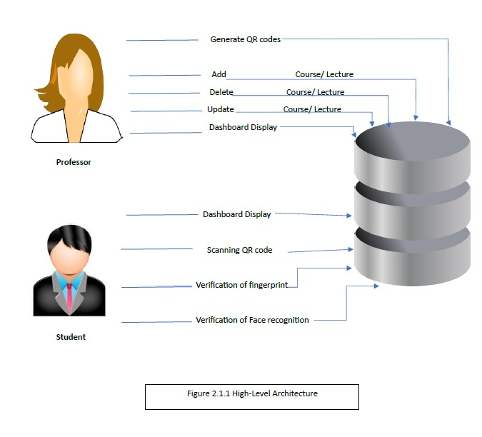

Fig (1): User Authentication

**Functional Requirements**

1. **Verification Mechanisms:**

| **Function #1** | **Details** |
| --- | --- |
| **Input** | **Biometric input (fingerprint), Facial image, QR code image** |
| **Output** | **Verification result (True/False), Decoded information (for QR code)** |
| **Process** | **Biometric matching process (for fingerprint and facial recognition), Scanning process (for QR code)** |

1. **Dashboard Display:**

| **Function #2** | **Details** |
| --- | --- |
| **Input** | **User role (Professor/Teaching Assistant/Student)** |
| **Output** | **Customized dashboard for the specified user role** |
| **Process** | **Data retrieval and presentation** |

1. **Course Management:**

| **Function #3** | **Details** |
| --- | --- |
| **Input** | **Course details, Course ID and updated details (for updates and deletions)** |
| **Output** | **Confirmation of successful addition, update, or deletion** |
| **Process** | **Database update** |

1. **Lecture Management:**

| **Function #4** | **Details** |
| --- | --- |
| **Input** | **Lecture details, Lecture ID and updated details (for updates and deletions)** |
| **Output** | **Confirmation of successful addition, update, or deletion** |
| **Process** | **Database update** |

1. **QR Code Generation:**

| **Function #5** | **Details** |
| --- | --- |
| **Input** | **Data for QR code** |
| **Output** | **Generated QR code** |
| **Process** | **QR code generation algorithm** |

1. **User Authentication:**

| **Function #6** | **Details** |
| --- | --- |
| **Input** | **User details (for sign up), User credentials (for log in)** |
| **Output** | **Confirmation of successful registration (for sign up), Access granted or denied (for log in)** |
| **Process** | **User registration process (for sign up), Authentication process (for log in)** |

**2.3. User Classes and Characteristics**

**2.3.1 User Classes**

There are two user levels in smart attendance System.

I. Professor

II. Student

**2.3.2 Characteristics of User Classes**

**Professor:-**

Professors engaging with the attendance management system are expected to possess a moderate to high level of technical proficiency. This proficiency enables them to navigate the system effectively and leverage its features for course management, attendance tracking, and data analysis. A key requirement for professors is the ability to customize their dashboard, tailoring it to emphasize functionalities relevant to their responsibilities. This includes tools for data analysis and reporting, allowing professors to derive valuable insights from attendance records and monitor student participation. Additionally, professors should have comprehensive capabilities for managing courses and lectures within the system. Professors are also equipped with the functionality to generate QR codes. This feature empowers them to create QR codes for various purposes, such as facilitating attendance tracking during lectures or generating unique identifiers for course-related activities. The QR code generation capability adds a valuable tool to the professor's toolkit for efficient and secure management of attendance and course-related tasks.

**Student: -**

Students interacting with the attendance management system prioritize a user-friendly interface that simplifies the process of accessing attendance records, course information, and relevant updates. Their dashboard should provide a comprehensive overview of their courses, attendance status, and upcoming lectures. Students may benefit from functionalities such as QR code scanning for attendance tracking during lectures. To enhance the user experience, customizable **notification preferences** would allow students to receive alerts tailored to their individual needs and preferences.

**2.4. Operating Environment**

**Hardware Requirements:**

* The system should be compatible with commonly used computing devices such as laptops, desktops, and tablets.
* Minimum hardware specifications include a modern processor, sufficient RAM, and suitable storage capacity for efficient performance.

**Software Requirements:**

* The system is compatible with major operating systems, including Windows, macOS, and Linux.
* Web browser compatibility should include but is not limited to Google Chrome, Mozilla Firefox, and Microsoft Edge.
* Mobile applications are designed for compatibility with Android operating systems.

**Networking:**

* Reliable internet connectivity is required for accessing the system's web-based functionalities.
* The system should be compatible with standard networking protocols for data transmission.

**Display Devices:**

* Professors should have access to display devices such as monitors or TVs with sufficient screen size and clarity.
* The display devices may be equipped with projectors to enhance visibility in larger classrooms.

**Connectivity:**

* Ensure compatibility with common display interfaces such as HDMI or VGA for seamless connectivity between the system and the display devices.

**QR Code Visibility:**

* Consider factors such as font size, color contrast, and resolution to ensure QR codes are clearly visible to students, even in varying lighting conditions.

**2.5. Design and Implementation Constraints:**

* **Compatibility:** the system must be compatible with a variety of web browsers and operating systems.
* **Security:** stringent security measures must be implemented to protect sensitive student data and ensure the integrity of attendance records.
* **Scalability:** the system should be scalable to accommodate growth in the number of users and volume of attendance data.

**2.6. User Documentation:**

**2.6.1. User Manual:**

* ***The user manual shall be provided to guide users on how to use the System effectively.***
* ***The manual shall include step-by-step instructions for:***

1. Logging in and accessing the system.
2. Marking on attendance records.
3. Viewing attendance records.
4. Any other relevant functionalities.

The manual shall be written in clear, concise and simple understandable language.

**2.6.2. Online Help:**

* An online help system shall be integrated within the System for quick access to assistance.
* The help system shall provide contextual guidance and explanations for various features and functionalities.

**2.7 Assumptions and Dependencies:**

* The successful operation of the Smart Attendance System depends on reliable internet connectivity within the institution.
* The system must support English language.
* The system must work on different smart devices and different browsers.