3. External Interface Requirements

3.1 User Interfaces

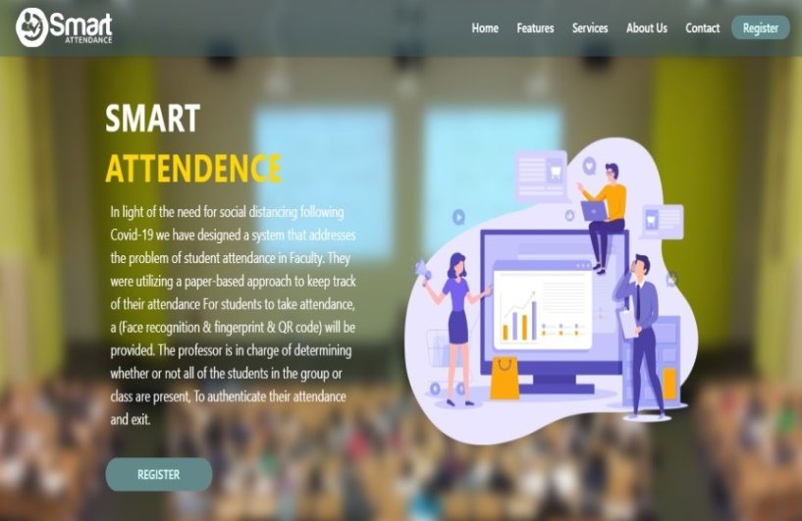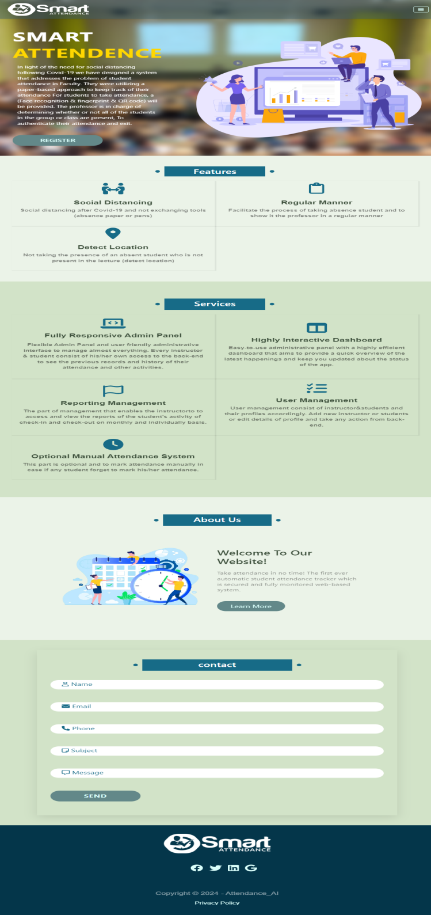**3.1.1. Web design**

Fig (2): Intro page

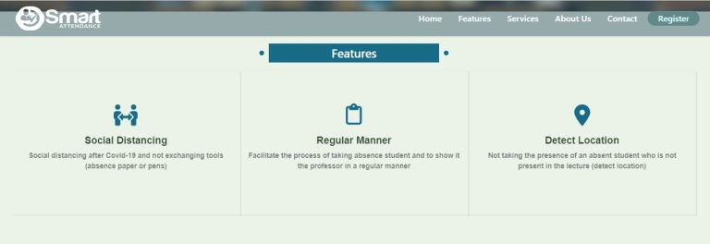Fig (3): First page

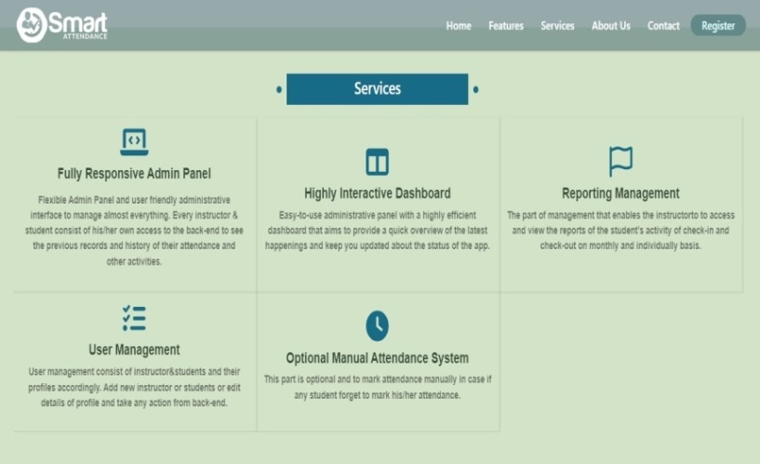Fig (4): Features

Fig (5): Service

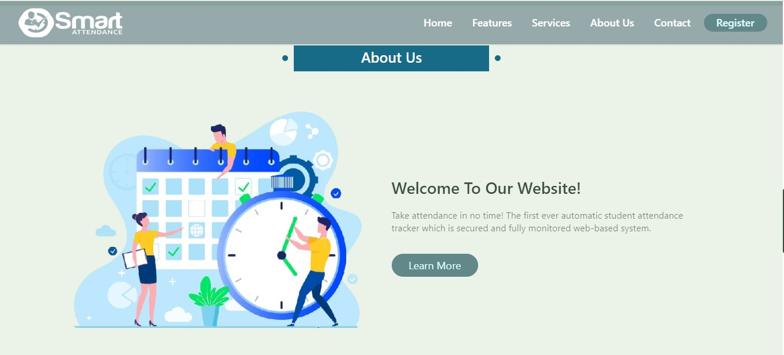

Fig (6): First about us

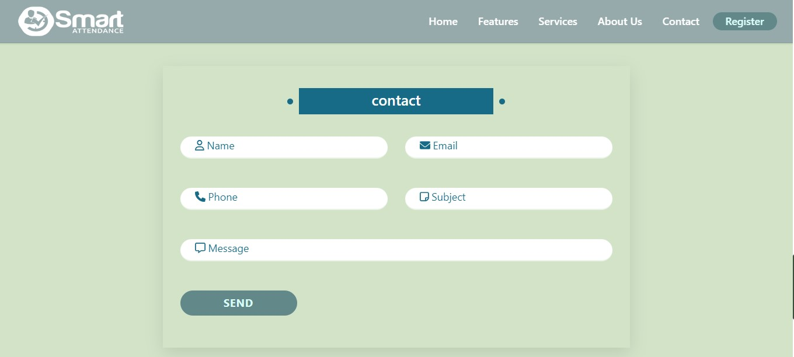

Fig (7): First contact



Fig (8): Footer

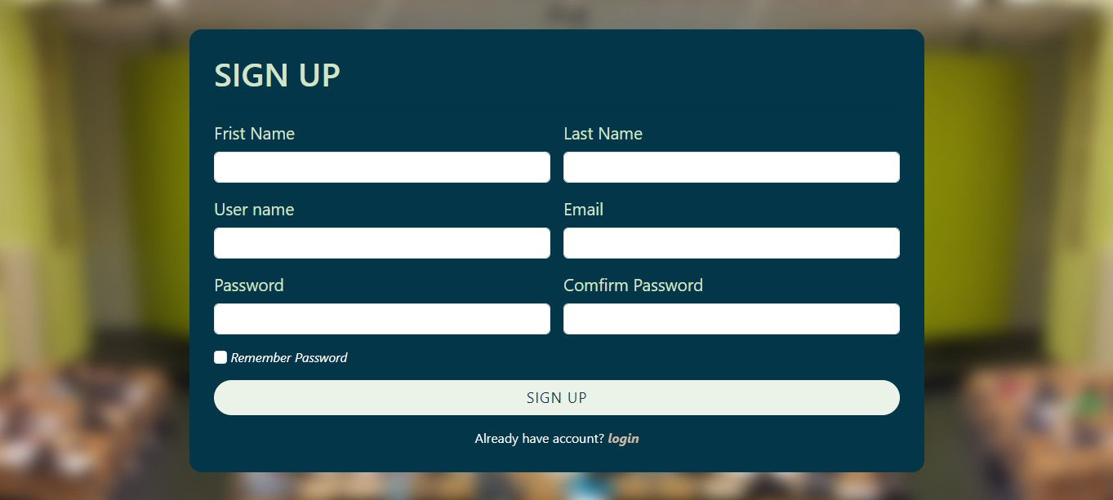

Fig (9): Sign up page

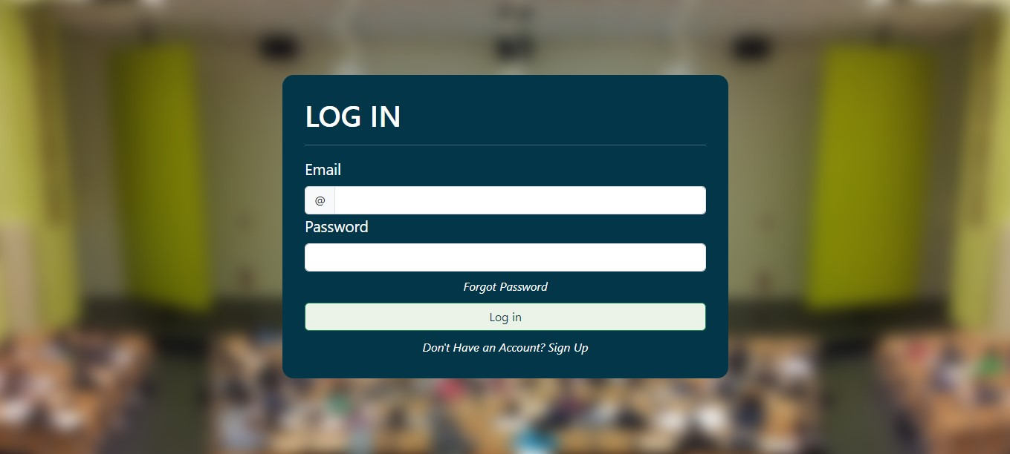

Fig (10): Log in page

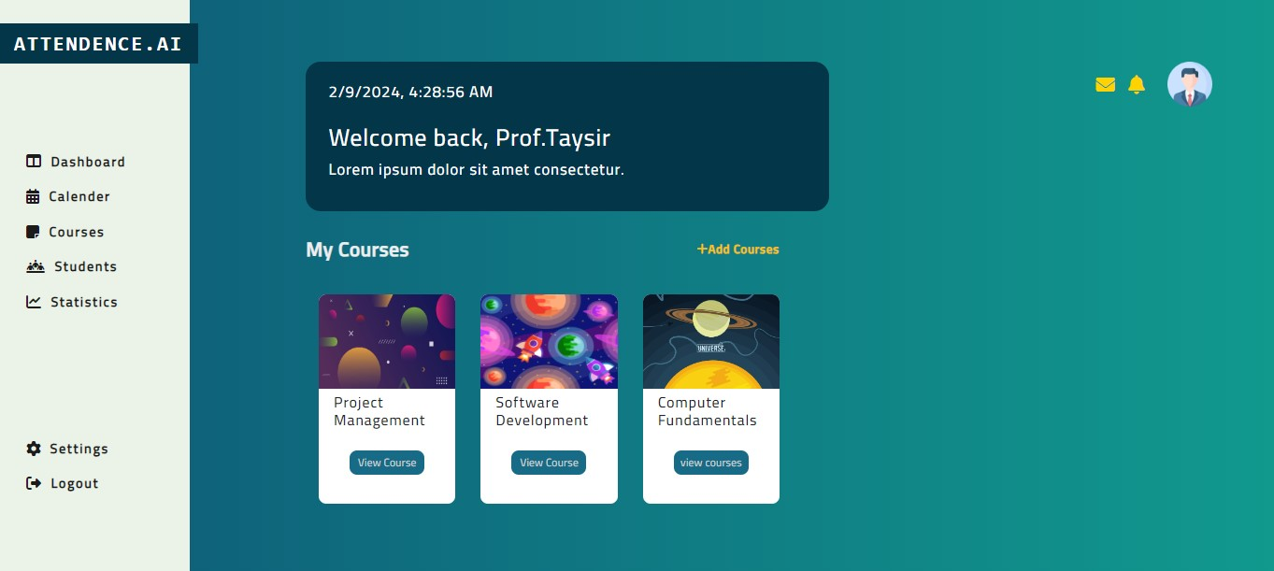

Fig (11): main page

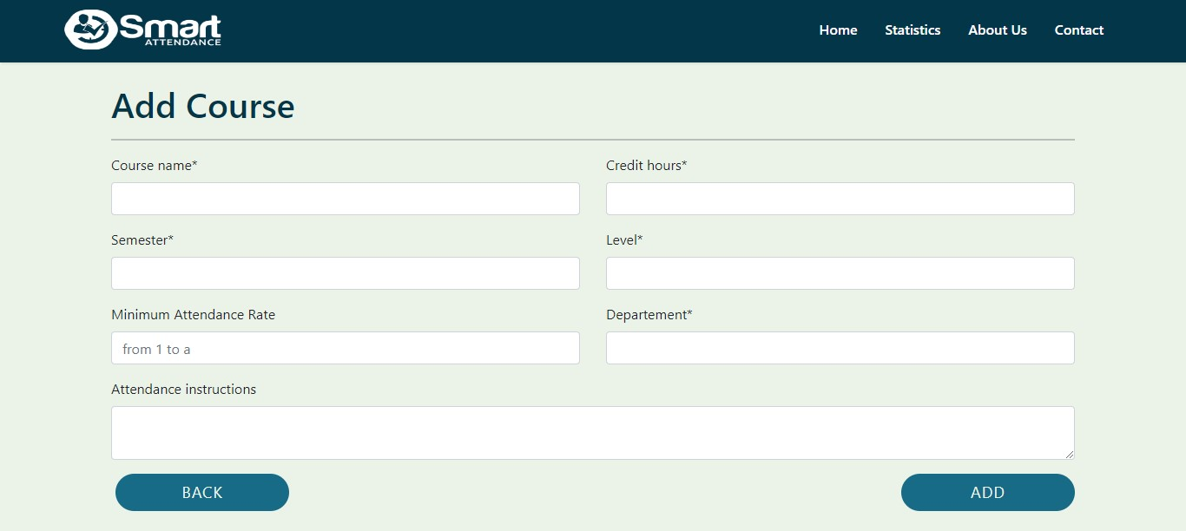

Fig (12): Add course

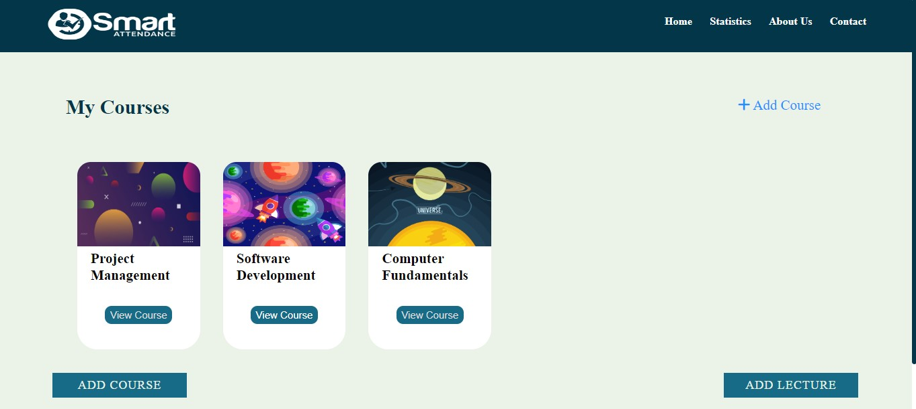

Fig (13): View course

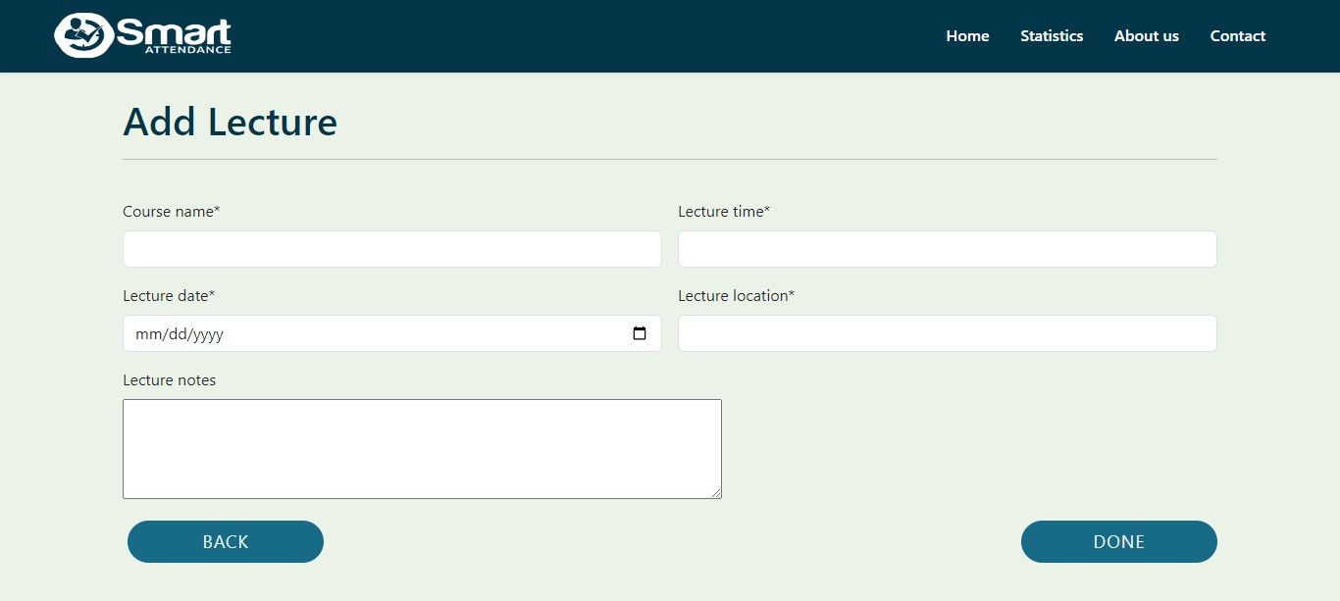

Fig (14): Add lecture

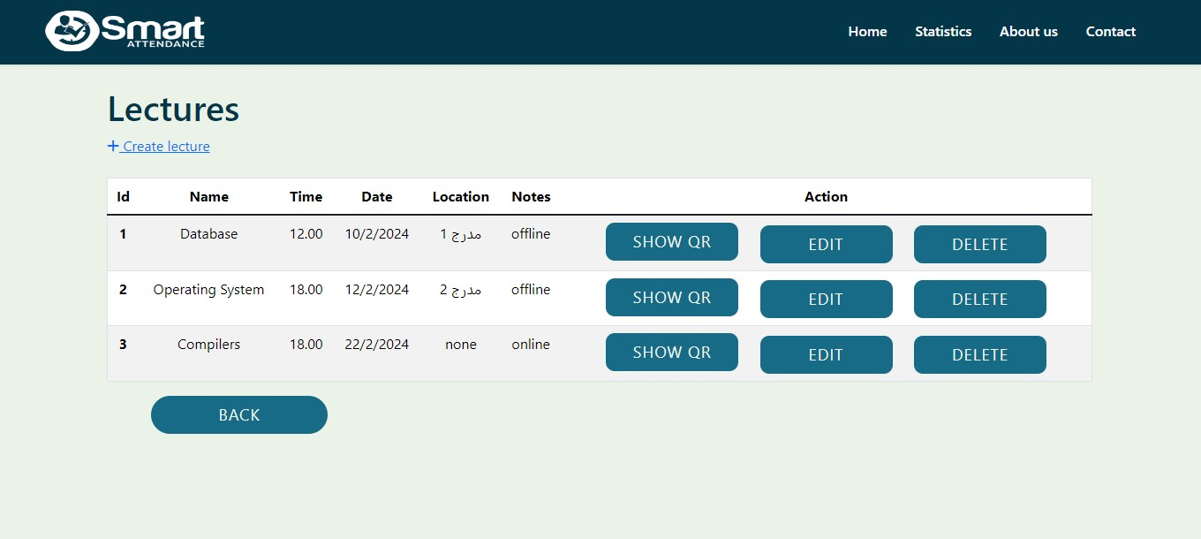

Fig (15): View lecture

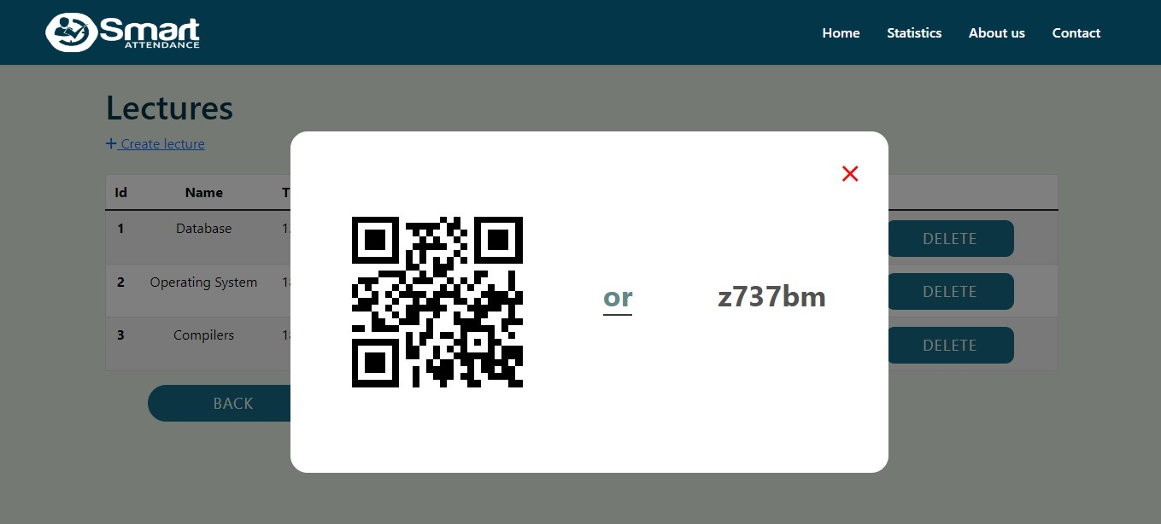

Fig (16): Show QR code

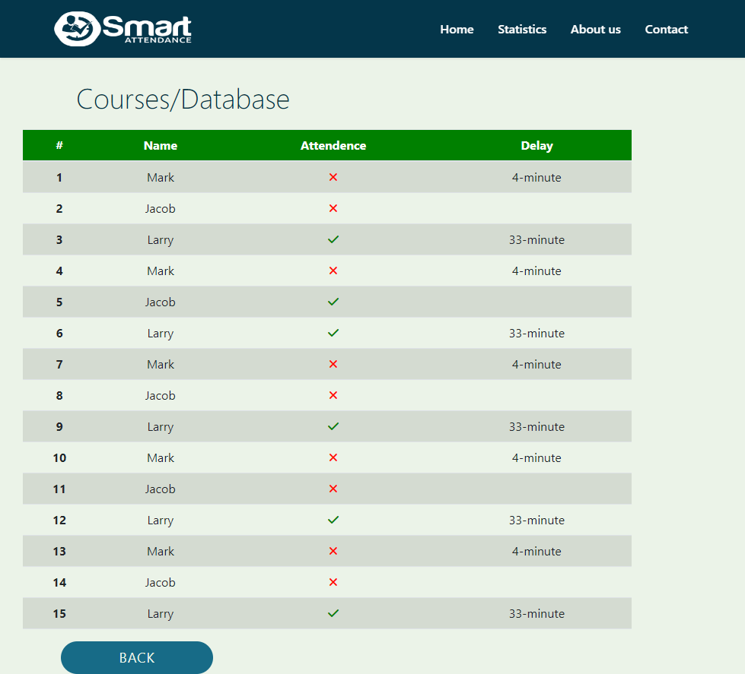

Fig (17): Show sheet

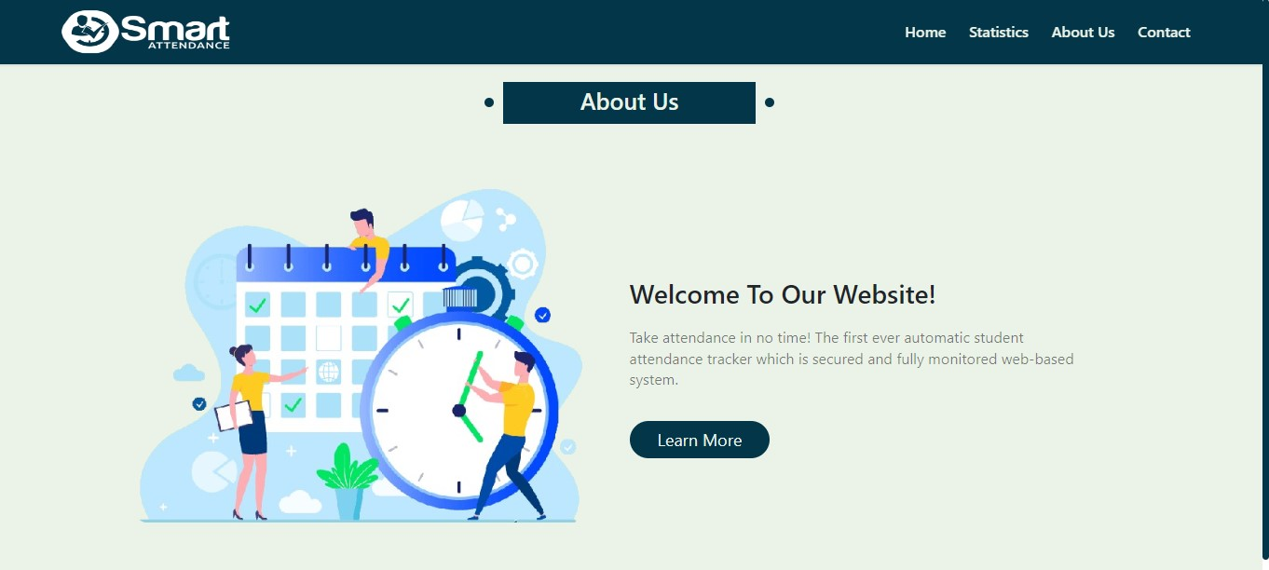

Fig (18): About page

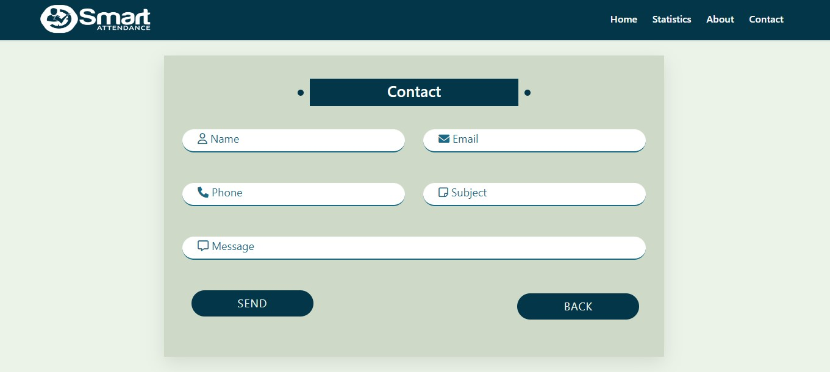

Fig (19): Contact page

**3.1.2. Mobile app**

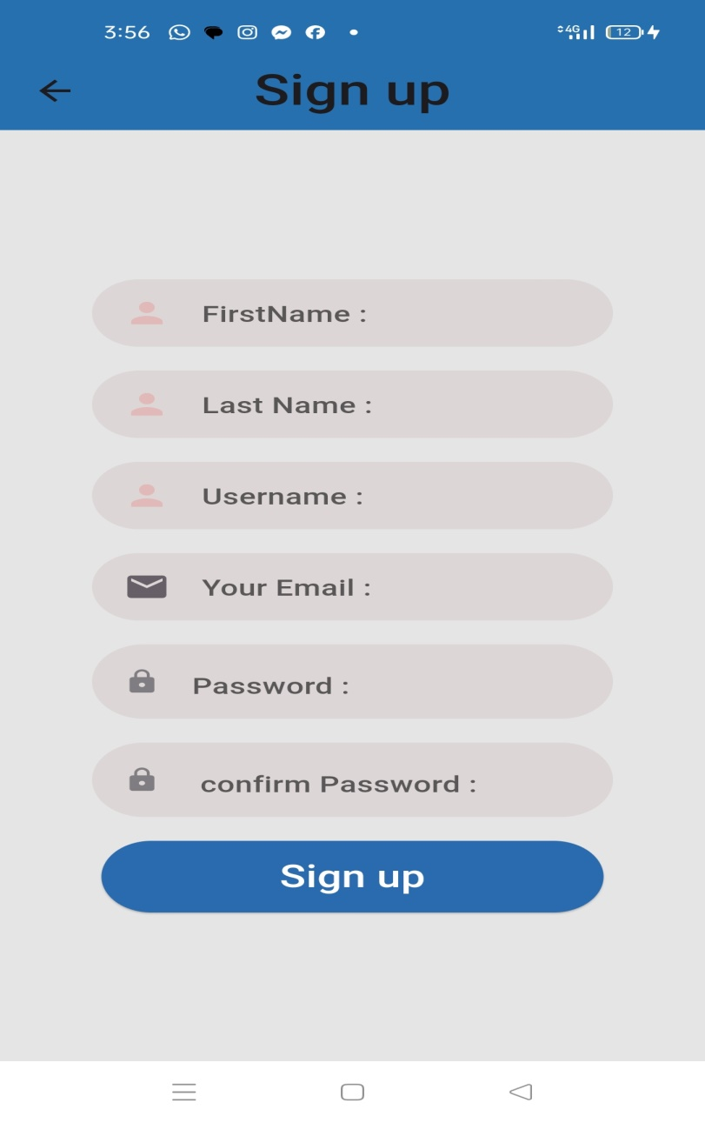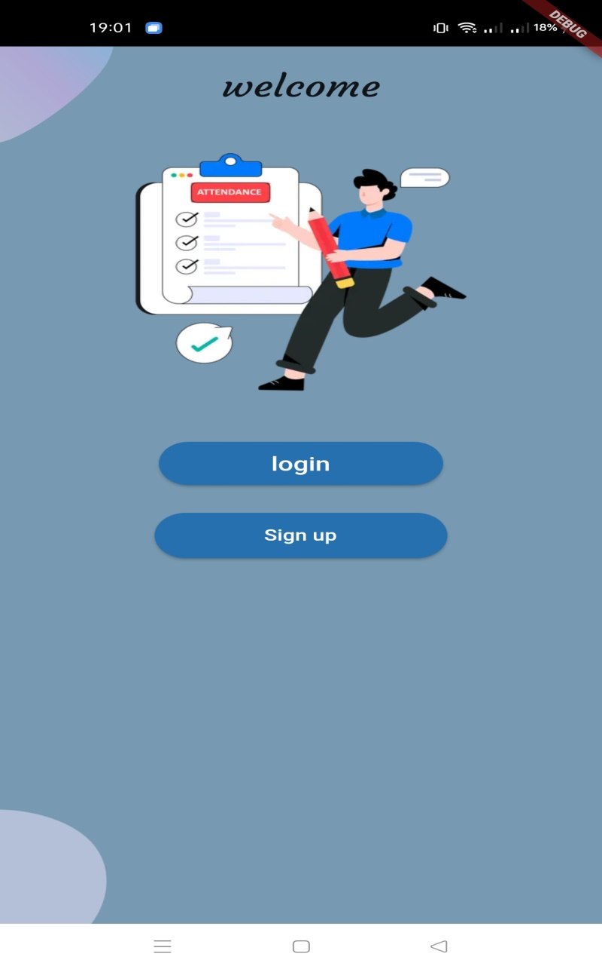

Fig (20): Welcome Fig (21): Sign up

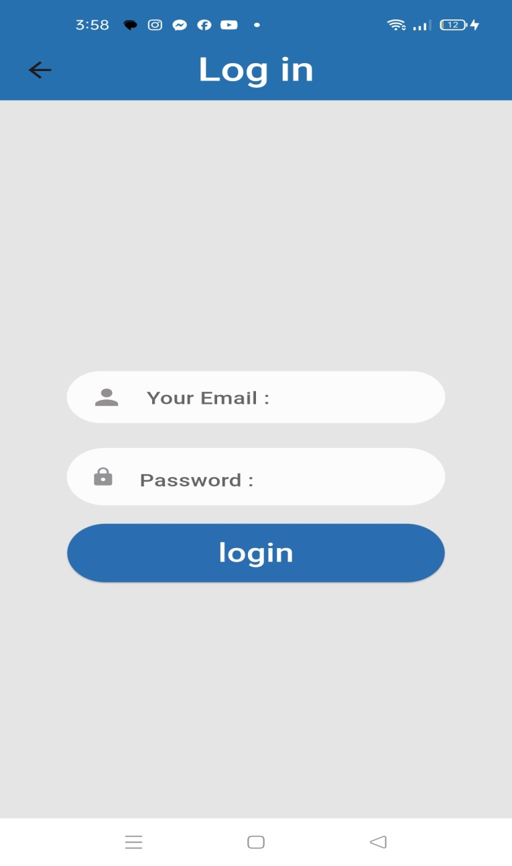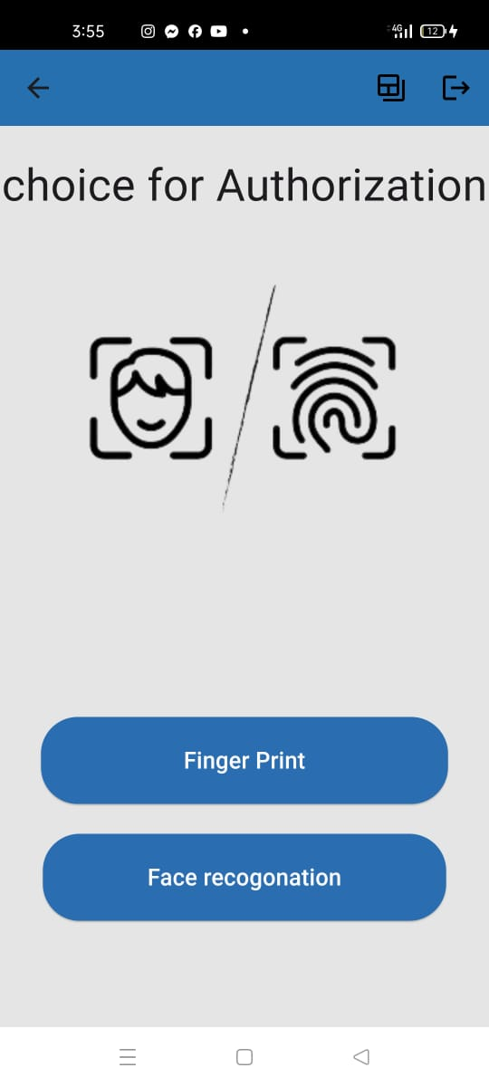

Fig (22): Log in Fig (23): Main page

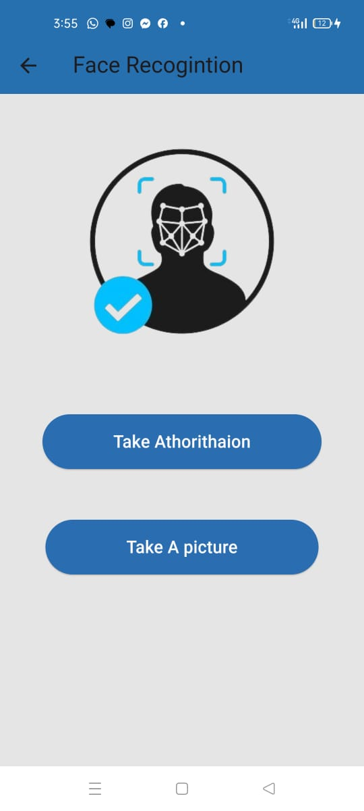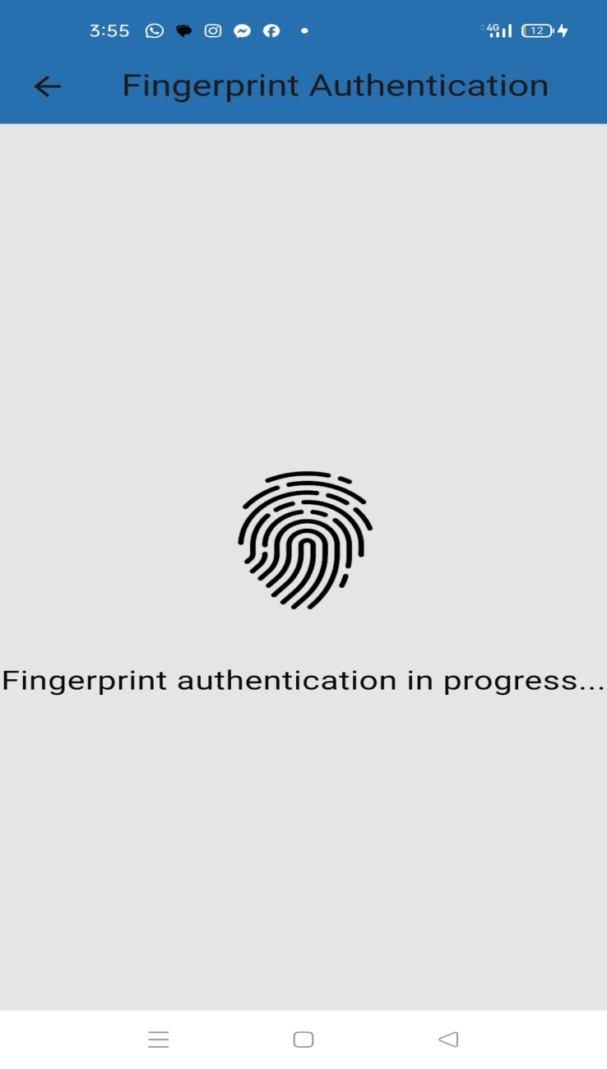

Fig (24): Face recognition Fig (25): Fingerprint

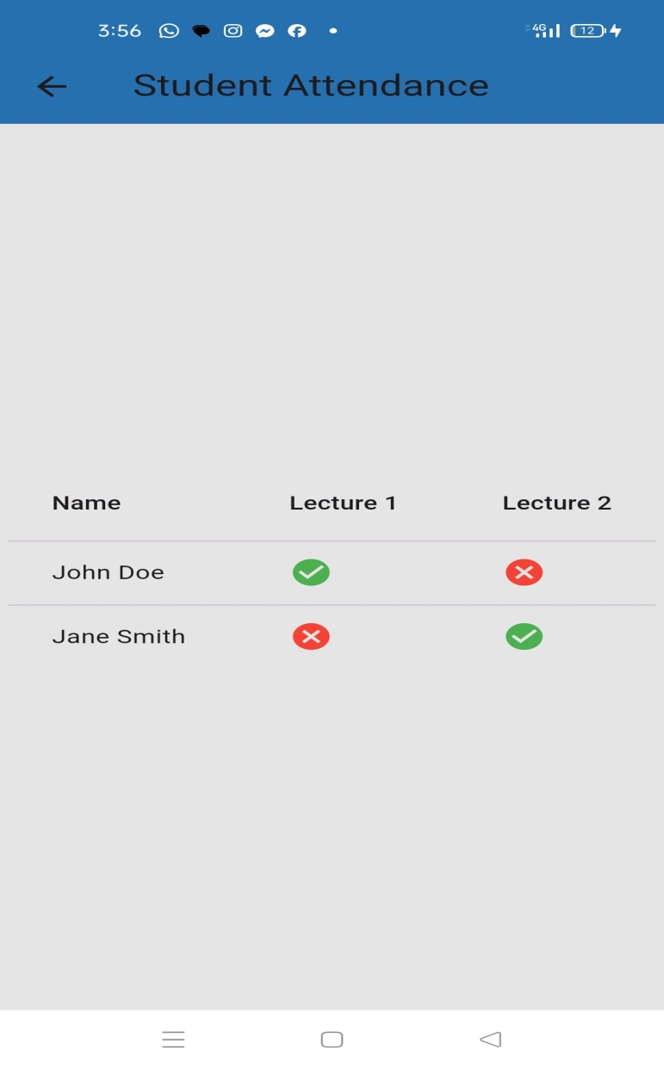

Fig (26): Dashboard

3.2 Hardware Interfaces:

The requirements of the desktop computer where the system going to be installed. The requirements of a smartphone that has a camera or fingerprint and installing the application for the student to be able to attend.

3.3 Software Interfaces:

The computer this software going to be install need to have windows 10 operating system. On that Windows platform .Net 7.0 will be installed and that will be the platform the particular software will be run. There will be Microsoft SQL Server Management Studio 2018 that should be installed. The operating system for Mobile devices should be Android. Web

3.4 Communications Interfaces:

When a student scans the QR code after verifying the identity using the fingerprint or facial recognition feature, it will be registered with the professor in the attendance

table.