

**Faculty of engineering - Shoubra**

**Benha University**

**Research Article / Research Project / Literature Review**

in fulfillment of the requirements of

|  |  |
| --- | --- |
| **Department** | **General** |
| **Division** | **-** |
| **Academic Year** | **2019-2020 preparatory** |
| **Course name** | **Computer** |
| **Course code** | **ECE001** |

**Title: -**

**Build a website on recent computer engineering topics**

By:

|  |  |  |  |
| --- | --- | --- | --- |
|  | Name | Edu mail | B.N |
| 1 | Eslam Hamed Mahmoud | Eslam195191@feng.pu.edu.eg | 19 |

**Approved by:**

|  |  |
| --- | --- |
| Examiners committee | Signature |
|  |  |
|  |  |
|  |  |
|  |  |
|  |  |

**Research objectives**

I have chosen this topic from research because the Corona virus affects the world today and threatens the lives of people and greatly affects people and we must be more careful in dealing with those around us .

Corona virus is one of the most dangerous diseases that has spread throughout the ages as the World Health Organization considered it a global epidemic .

**Abstract**

The research aims to study (Corona’s pandemic and its impact on the world) The Corona pandemic caused many problems within Egyptian organizations. He chose one of those organizations in which problems occurred and then chose one of the administrative problems that occurred and used the scientific method to identify that problem while reviewing the most important methods that can Use it to tackle that problem and use one of them to tackle the problem with your personal opinion (WHO)

Corona virus is one of the most dangerous diseases derived from corona viruses that invaded the entire world and which negatively affects human health and sometimes it may lead to death, so this disease has affected a great impact on all global systems.

**Introduction**

Corona virus (Covid disease-19) is an infectious disease caused by the last virus that was discovered from the strain of corona viruses and it is an ancient strain with known characteristics as it is similar in its characteristics with severe colds. However, there was no knowledge of this new virus and its disease before its outbreak in Wuhan, China, in December 2019.

Covid-19 has now turned into a pandemic that affects many countries of the world (1) because it caused many deaths around the world and because it is widespread as it is transmitted between countries of the world ... so it is natural that his pandemic such an epidemic can affect Negatively on the systems of all countries .. including the educational system, the industrial system, as well as the health system and other systems .. Although this effect is constantly increasing, those systems are in constant research to find some solutions to eliminate this negative impact and confront the disease With all the resources until it is finally eradicated ... But we must ask about some important questions, for example: What are the origins of corona? What are the reasons for its spread? What are the symptoms of infection and what are the ways of transmission? Who are most vulnerable to injury ?? How did the Corona virus affect the global and Egyptian health system from the administrative side?

How did the Egyptian health system address this epidemic?

What is the role of the individual in protecting himself and society ?? These are common questions whose answers will be discussed in this paper

**Literature Review**

* ***What are the origins of corona?***

Corona virus is one of the members of a large family called the Corona family .. this family lives inside the bodies of different animals such as bats, pigs and some wild birds and others..and scientists discovered this family in the sixties .. scientists discovered four members of this family, but symptoms These viruses were harmless and their symptoms were closer to the common cold and man immune managed to overcome these viruses .. But there were some rebel individuals in that family and one of them appeared in November 2002 and it is sars-cov-1

Which afflicted a large number of individuals and the death rate was estimated at about 10% of the proportion of injuries, but man immunity managed to overcome it after it affected about 8000 people .. But the family’s rebellion did not end, in 2012 another type of rebellion, Mers- cov, which affected a large number of people, was estimated at 2494, but the death rate increased to (35%) .. until the last known individual rebel from this lineage appeared in November 2019, which is

 covid-19 For the first time for a case with severe pneumonia in Wuhan, east China .. Scientists suspect that some of the bats transmitted this virus to an animal called an anteater that appeared recently as food in one of the Chinese markets, and gradually moved in China to an outbreak in most countries of the world but The danger of this virus lies in its rapid spread, and although the death rate is very small, it starts from (1%) to (3%), because it is the most dangerous among the members of its strain.

And the research is still based on finding solutions to this epidemic .. Despite its seriousness, the health system is working in full swing so that it can overcome this pandemic.

* ***Causes of spread of the Corona virus:***

Scientists have found that the most important reasons for increasing the spread of the disease are approaching and crowding .. Also, the transmission of respiratory droplets from one person to another through the air is one of the reasons for the increased spread and contact with one of the injured .. Therefore, failure to follow the necessary steps that the health system recognizes may lead Because he suffers from the disease, which leads to a high rate of transmission of infection to another person and that is the mechanism of spreading the disease .. Therefore we must be careful and adhere to the instructions.

* ***Corona virus symptoms:***

Since the beginning of the emergence of the covid-19 virus in the Chinese city of Wuhan and its spread in many countries of the world, there have been many continuous reports of the World Health Organization in which you talk about the symptoms of this virus, where the World Health Organization clarified that the most common symptoms are: fever (when it exceeds Body temperature (37.8 ° C), persistent dry cough (not accompanied by any phlegm), extreme fatigue and fatigue. The person with the virus may experience a lot of pain and aches in the body, severe nasal congestion or severe sore throat. These symptoms are usually slight and then gradually increase. , Since it takes on average 5 to 6 days for these symptoms to appear since a person is infected with the virus, and it can also take a maximum (14 days).

Some people become infected and are carriers of the virus without showing all of these symptoms strongly. Most people who are infected with the virus recover (80%) without having to go to hospital, but according to medical reports announced by health organizations, symptoms of the virus can increase the risk for one person Out of every 5 people who have HIV, this person has difficulty breathing, severe headache, loss of smell or taste, chest pain, and the risk of infection with the virus increases in the elderly and children; Because of the immune deficiency and some people who suffer from other chronic health problems such as: heart diseases, diseases that affect the lungs, diabetes, and high blood pressure.

Anyone who has an infection with minor symptoms (fever, cough and fatigue) or severe symptoms (shortness of breath, difficulty breathing, and headache) can pass the infection on to other people, so all people with any symptoms should receive full medical care, if you are in the stage of symptoms Light, you do not necessarily need to go to the hospital and seek care there. Rather, you must isolate yourself in a closed room and do not mix with those around you and follow the directions urged by the World Health Organization and avoid touching the surrounding surfaces. But if you are in the stage of severe symptoms then you should hurry to go to the hospital to receive There is a quarantine period (14 days with full care).

* ***How it is transmitted and the infection spread***

The method that causes the transmission of the virus is the spray that is sprinkled from the nose or mouth of the infected person when coughing. This spray adheres to the things and surfaces surrounding the infected person, which leads to the injury of other people when they touch these things or surfaces and then touch the eye, nose or mouth, and to avoid infection it must Move away at least one meter from the affected person.

The virus is transmitted directly and indirectly, direct transmission is through droplets from the patient when coughing or sneezing, and indirect transmission is through contact with people or surfaces or eating foods that contain the virus.

And direct contact with animals may lead to infection with the virus, as well as eating foods without cooking such as meat and eggs. Also, sharing food and drink tools also caused the transmission of the Covid-19 virus.

To avoid injury, be careful not to touch the hand of the shopping cart in malls and shops, as well as door handles and public transport handles such as the metro and elevator buttons or in the touch of ATMs or paper and metal coins, so it is important to keep washing hands with soap and water or cleaning them with an antiseptic to rub hands.

***Screenshot :***

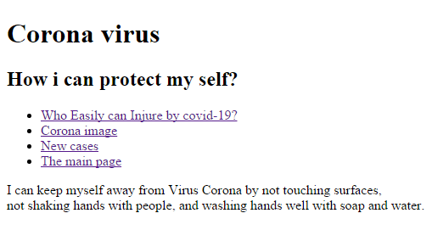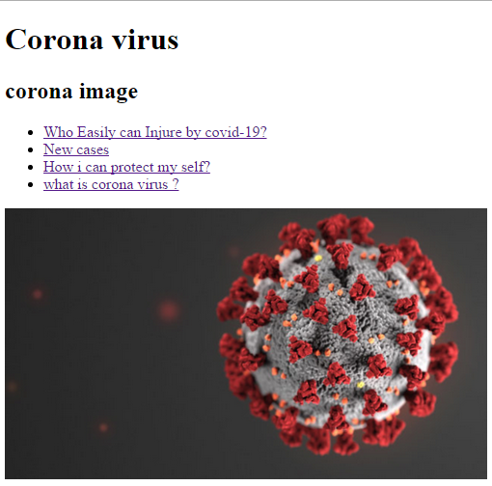**The Pages :**

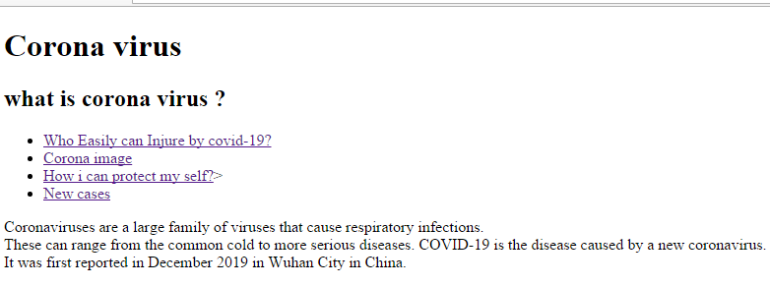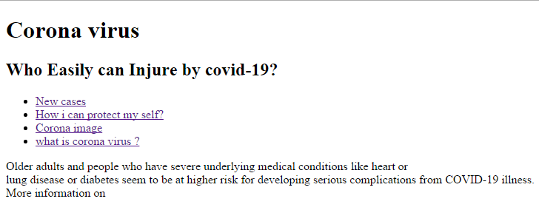

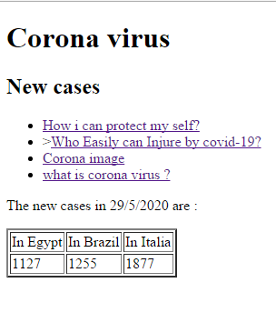

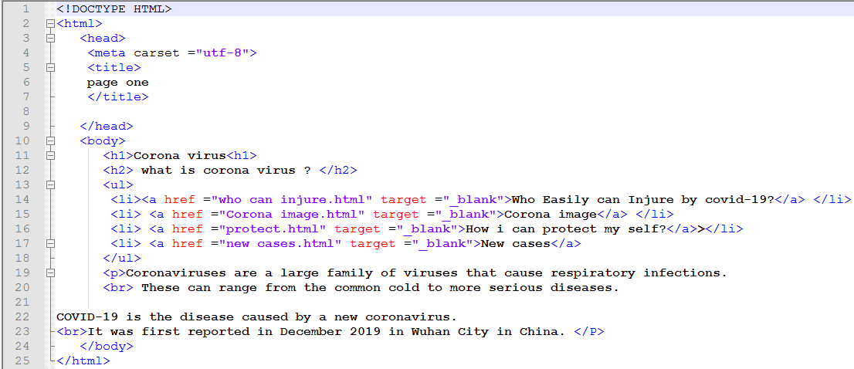The source code:

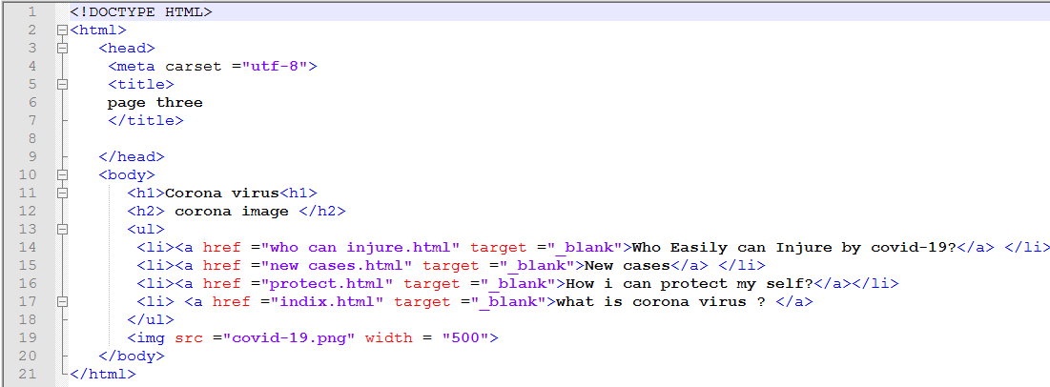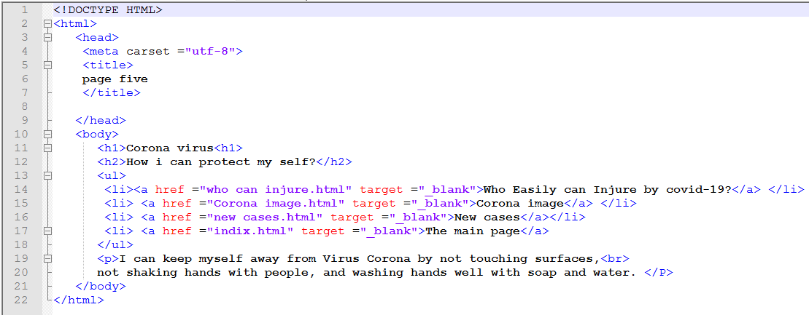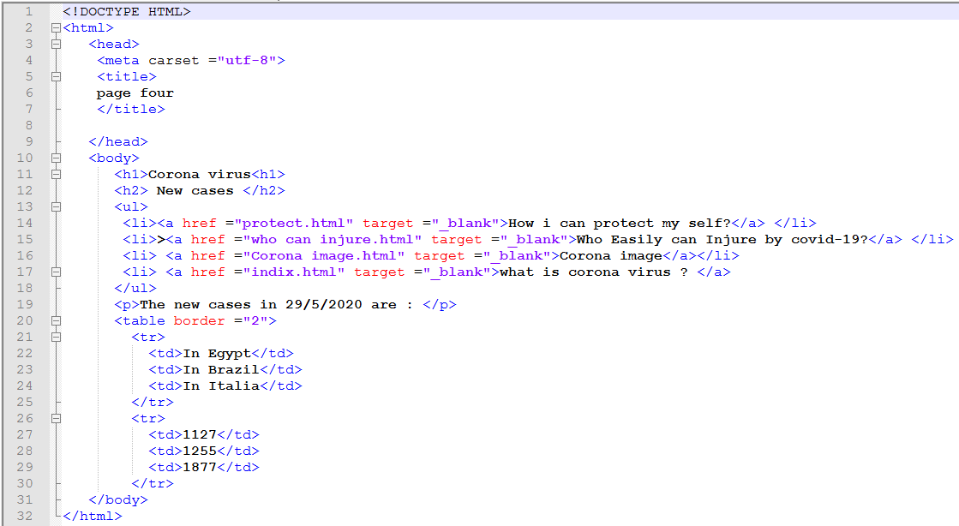

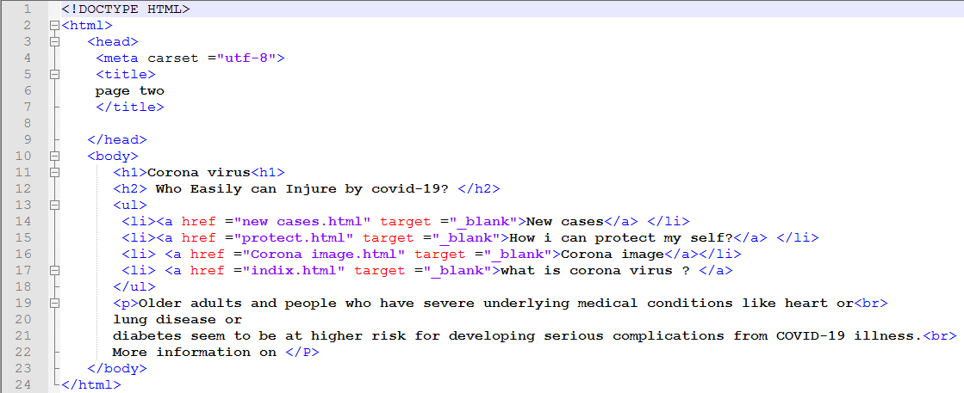

**Results and discussion**

I see that the Corona virus is one of the worst problems facing mankind at the present time. The virus has left its mark in all forms of life. It has stopped many daily activities for us and the economies of many countries around the world. For every country, I have to take strict and exceptional measures every day to reduce the number of infections with this virus around the world and reduce the spread of infection, such as: closing borders, closing restaurants and suspending prayer in all places of worship and canceling gatherings, so we must each follow the instructions recommended by the World Health Organization such as: washing Hands regularly, wearing masks, sterilizing the surfaces around us continuously, leaving a distance of at least 1 meter between each of us, adhering to the home quit and disembarking in times of extreme necessity only, and reducing family gatherings.

* ***Guidance and recommendations for animal-human interaction***

In order to answer the two main questions (what is the source of exposure of human cases of coronavirus infection causing the syndrome?

The respiratory acquired in the Middle East outside health care facilities, and what is the animal reservoir of this virus.) The following investigations are needed: Investigations aimed at identifying the possible source of exposure to human cases, which It may provide information needed for public health interventions, and research studies to identify the original animal source (sources)

Accordingly investigations are the original animal (for viral and subsequent viral development in human cases. It should be determined To enhance understanding and control of Corona virus infection that causes the respiratory syndrome in the Middle East.

**Conclusions**

According to the World Health Organization, one of the most important basic measures for protection against the Corona virus is personal hygiene.

1) Wash your hands thoroughly with soap and water, or rub them with alcohol, thus killing the viruses that may be stuck on your hands.

2) Try not to touch your eyes, nose, or mouth, as hands touch many surfaces and viruses can be stuck with them, and from here the virus can penetrate your body.

3) When you sneeze or cough, use a tissue, and if you do not have a tissue, use your elbow to mute sneezing or coughing.

**References**

1. <https://www.ekb.eg/> EKB
2. <https://www.who.int/ar/emergencies/diseases/novel-coronavirus-2019/advice-for-public/q-a-coronaviruses>

World Health Organization, 2020

1. <https://www.niaid.nih.gov/diseases-conditions/coronaviruses>

National Institute of Allergy and Infectious Diseases

1. <https://www.who.int/ar/news-room/commentaries/detail/modes-of-transmission-of-virus-causing-covid-19-implications-for-ipc-precaution-recommendations>

World Health Organization, 2020

1. [**https://www.who.int/ar/emergencies/diseases/novel-coronavirus-2019/advice-for-public/q-a-coronaviruses**](https://www.who.int/ar/emergencies/diseases/novel-coronavirus-2019/advice-for-public/q-a-coronaviruses)

World Health Organization , 2020

5-6) <https://news.un.org/ar/story/2020/03/1051321>

United nations News

1. <https://www.bbc.com/arabic/science-and-tech-51802018>

BBC

1. <https://www.sis.gov.eg/Story/198955/%D8%A5%D8%AD%D8%B5%D8%A7%D8%A6%D9%8A%D8%A7%D8%AA-%D9%81%D9%8A%D8%B1%D9%88%D8%B3-%D9%83%D9%88%D8%B1%D9%88%D9%86%D8%A7-%D9%81%D9%8A-%D8%A7%D9%84%D8%B9%D8%A7%D9%84%D9%85?lang=ar>

information General Association

1. [**https://www.care.gov.eg/EgyptCare/index.aspx**](https://www.care.gov.eg/EgyptCare/index.aspx)

Egypt Care

**Layout and formatting**

**(Guide, don’t include this page in your research)**

Use this template

**Paper:** A4

**Margins:** 2.5 cm all from top and bottom

**1.**9 cm from left and right

**Line spacing:** 1.5

**Font:** Time New Roman

**Font size:** 14 (Except headings)

**No of pages:**Between 5 and 10 pages (Not including cover)