**Cairo University  
Faculty of Computers and Artificial Intelligent** 

**Software Requirement Analysis**

Personalized Medical Records

|  |  |  |
| --- | --- | --- |
| No. | Name | ID |
| 1 | Husam Alhussein Abozide | 20226182 |
| 2 | Fady Milad Morius | 20226119 |
| 3 | Nadeen Nasser Badie | 20226109 |
| 4 | Amr Mostafa | 20226140 |
| 5 | Youssef Mahmoud Hussein | 20225071 |
| 6 | Mohammad Sobhy | 20226092 |

Personalized medical records

**Functional Requirements:**

1- **User Registration and Authentication**:

* Users should be able to create accounts and log in securely to access their medical records.
* Authentication methods like email verification and password encryption should be implemented for security.

2- **Medical Profile Creation:**

* Users should be able to create comprehensive medical profiles including personal details, medical history, and insurance information.

3-**Data Input and Management:**

* Users should be able to input various types of medical data such as prescriptions, medications taken, doctors visited, diagnostic reports (X-rays, CT scans, MRIs), blood pressure readings, hospital/clinic visits, and blood test results.

4-**Provide Tips and Warnings:**

* Health-Care Providers should be able to send tips and recommendation to patients to improve their health records
* The app should provide warnings and send alerts based on the user's health condition, medication interactions and abnormal health readings.

5- **Reminder and Notification System:**

* The app should have a reminder system for medication schedules, doctor appointments, and follow-ups.
* Users should receive notifications for upcoming appointments, prescription refills, and health check-ups.

6- **Feedback and Support:**

* Users should have the option to provide feedback and report issues within the app.
* Customer support channels such as in-app chat or email should be available for assistance and inquiries.

**Non-functional Requirements:**

|  |  |
| --- | --- |
| Requirement | Description |
| **Performance** | * The app should respond immediately to user interactions to ensure good user experience. * That can be accomplished by storing frequently accessed data for quicker retrieval **(Caching mechanism)**. * Response time for any common actions in the app should be   1 second |
| **Robustness** | * The app should be reliable and minimizes downtime by remain functioning under disturbances to ensure data integrity using back-up power supplies like UPS. * Exception handling: Handle unexpected errors to prevent system crashes. * Downtime of the system should not be more than 10 hours per year. |
| **Usability** | * The app should be smooth and easy to use for all the users of the system. * Create easy, user-friendly interfaces. * The number of steps to do any functionality in the app should not exceed 3 steps. |
| **Scalability** | * The app should be able to support the growing number of users, but at the same time maintain the app performance. * Adding more servers to handle the increasing load. * The app should be able to handle 500,000 users in parallel. |
| **Compatibility** | * The app should be compatible with multiple operating systems and devices, like mobile phones, PCs, tablets, web browsers. This will also improve the app usability and accessibility. * Using open-source libraries and Frameworks. * The app will be tested on all the platforms: iOS, macOS, Android, Windows, to ensure the performance and functionalities consistency. |
| **Data recovery** | * The app should do data backups regularly to be able to recover the data to prevent data loss. * Replicate data to a second server for faster recovery. * The app should do daily backups with a recovery point objective (RPO) of less than 24 hours. |

**Use Case Model**

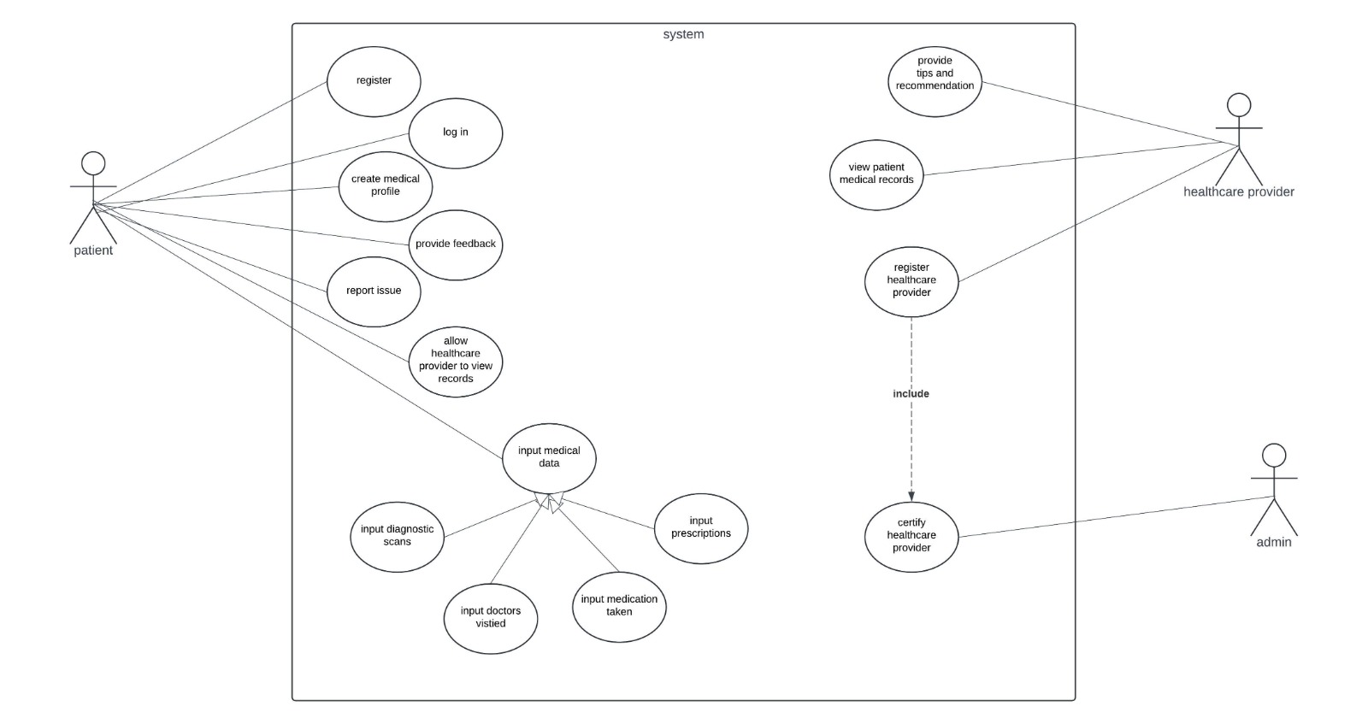

**User Stories:**

1. As a patient I want to create a medical profile on the medical records system so that I can be able to add my personal details , medical history and access all the system functionalities.

**Acceptance Criteria :**

• I want to be able to access and modify my medical profile at any time

• System allows me to upload any medical documents

• My personal and medical information should be securely stored.

1. As a patient, I want to input different types of medical data so that I can keep track of my health history and manage my healthcare more effectively.

**Acceptance Criteria:**

* I can enter medical data such as prescriptions, medications, doctor visits, diagnostic reports, blood pressure readings, hospital visits, and blood test results.
* I can provide details such as date, time, and notes for each entry.
* The system securely stores the data for future reference.
* I can easily access and review my medical data whenever I want.

3-As a health care provider want to be able to be sent daily reports and tips about my medical health records so that I can be able to improve their health condition and monitor medical changes

**Acceptance Criteria :**

* I can access medical records for patients.
* I can upload reports and tips
* I edit patients’ medical records.

4-As a user, I want to be able to securely create an account and log in to access my medical records, so that I can maintain the privacy and security of my personal health information

**Acceptance Criteria:**

* Users can securely create accounts by providing email addresses and strong passwords.
* Email verification is required for account activation.
* Passwords are encrypted to ensure security.
* Users receive email verification links to confirm their email addresses.
* After successful registration, users can log in using their email and password.
* A secure password reset process is available in case of forgotten passwords.
* Upon logging in, users can access their personalized medical records dashboard to manage their health information securely.

5-As a user, I want to have the ability to provide feedback, report issues, and seek assistance within the app, so that I can easily communicate my concerns and receive support when needed.

**Acceptance Criteria:**

* The app includes a dedicated section for users to provide feedback and report issues.
* Accessing the feedback and issue reporting feature is straightforward from the app's main menu or settings.
* Users can easily submit feedback or report issues with an intuitive interface, including options to attach relevant information.
* Upon submission, users receive confirmation messages acknowledging their feedback or issue reports.

6-As a health care provider want to be able to be set medication reminders for patients so that I can be able to improve their health condition and monitor medical changes

**Acceptance Criteria :**

* I can access medical records for patients.
* I can set reminders for patients’ medications
* I edit patients’ medical records.

**Use Case Tables:**

Table 1:

|  |  |  |
| --- | --- | --- |
| Use Case Name: | Report Issue | |
| Actors: | Patient | |
| Purpose: | The patient reports an issue that he encountered in the system | |
| Overview: | A patient requests the report an issue and then chooses the issue type (Technical, Usability, etc.). When submitted, the system sends the report to the system admins. | |
| Type: | Essential | |
| Pre-conditions: | The patient should be registered in the system | |
| Post-conditions: | The issue report is sent to a system admin. | |
| Special requirements: | The admins must receive the issue report within 1 minute. | |
| **flow of events** | | | |
| **ACTOR ACTION** | | **SYSTEM RESPONSE** | |
| 1. The patient chooses the Report Issue tab | | 1. The system outputs a pop-up screen for the user to write in. | |
|  | | 1. Provides a drop-down list for the user to choose the issue. | |
| 1. Chooses the issue type and writes an extra description if necessary. | |  | |
| 1. The patient submits the report. | | 1. The system saves the report and sends it to the admin responsible for user reports. | |
| **Alternate flow of events** | | | |
| **Step 4:** If the user’s issue is not in the drop-down list, the system provides a text field for the user to write his own issue. | | | |

Table 2:

|  |  |  |
| --- | --- | --- |
| Use Case Name: | Register | |
| Actors: | Patient | |
| Purpose: | To allow patients to create an account in the app to access and manage their medical records. | |
| Overview: | This use case describes the process by which a patient register for a new account on the Personalized Medical Records app. | |
| Type: | Essential | |
| Pre-conditions: | None | |
| Post-conditions: | User has registered an account in the app | |
| Special requirments: | None | |
| **flow of events** | | | |
| **ACTOR ACTION** | | **SYSTEM RESPONSE** | |
| 1. Patient opens the Personalized Medical Records app. | |  | |
| 2. Patient selects the "Register" option. | |  | |
|  | | 3. System presents the registration form, prompting the patient to enter required information. | |
| 4. Patient fills out the registration form with personal details (e.g., name, email, date of birth). | |  | |
| 5.Patient creates a username and password for their account. | |  | |
| 6. Patient submits the registration form. | |  | |
|  | | 7.System validates the information provided by the patient. | |
|  | | 8. System creates a new account for the patient. | |
|  | | 9. System notifies the patient that the registration was successful and prompts them to log in. | |
| **Alternate flow of events** | | | |
| **Line 7:** a. If the email provided by the patient is already associated with an existing account. Return to step 3  b. If the chosen username is already taken. return to step 3  c. If any required information is missing or invalid. Return to step 3  **Line 8:** a. If there is an error during account creation (e.g., database failure). Return to step 3 | | | |

Table 3:

|  |  |  |
| --- | --- | --- |
| Use Case Name: | Medical Profile Creation | |
| Actors: | Patient | |
| Purpose: | Create a medical profile on the medical records system. | |
| Overview: | Allows patients to add personal details, medical history, and access system functionalities. | |
| Type: | Functional | |
| Pre-conditions: | User must log in. | |
| Post-conditions: | Medical profile is created and can be accessed at any time. | |
| Special requirements: | Data must be securely stored. | |
| **flow of events** | | | |
| **ACTOR ACTION** | | **SYSTEM RESPONSE** | |
| 1. User logs in to the system | |  | |
|  | | 2. Displays the dashboard. | |
| 3. User selects "Create Medical Profile" | |  | |
|  | | 4. Displays the medical profile creation form | |
| 5.User enters personal and medical information | |  | |
|  | | 6. Allows user to upload medical documents and save the profile. | |
| **Alternate flow of events** | | | |
| 1. User decides to cancel profile creation | |  | |
|  | | 2. The system cancels the profile creation process and returns the user to the dashboard without saving any changes | |

Table 4 :

|  |  |  |
| --- | --- | --- |
| Use Case Name: | **Provide Tips and Warnings** | |
| Actors: | Patient, Health-Care Providers | |
| Purpose: | Provide User with feedback , tips and warnings | |
| Overview: | This use case enables health-Care Providers to send tips and recommendation to patients to improve their health records and provide warnings and send alerts based on the user's health condition, medication interactions and abnormal health readings. | |
| Type: | essential | |
| Pre-conditions: | The patient must have an active medical account with medical records. | |
| Post-conditions: | User receives relevant health tips that could potentially improve their health records | |
| Special requirements: |  | |
| **flow of events** | | | |
| **ACTOR ACTION** | | **SYSTEM RESPONSE** | |
| 1.Health-Care Providers request access for patient’s medical records | |  | |
|  | | 2.System provides access for patient’s medical records | |
| 3.Health-Care Providers analyses data | |  | |
| 5.Generate Report and medical tips and set medication reminders | |  | |
|  | | 5.The system sends report and tips to the patient. | |
| **Alternate flow of events** | | | |

Table 5:

|  |  |  |
| --- | --- | --- |
| Use Case Name: | Input Medical Data | |
| Actors: | Patient | |
| Purpose: | To allow users to input various types of medical data into the application | |
| Overview: | This use case enables users to add different types of medical information such as prescriptions, medications taken, doctors visited, diagnostic reports (X-rays, CT scans, MRIs), blood pressure readings, hospital/clinic visits, and blood test results into the app. | |
| Type: | essential | |
| Pre-conditions: | The user must be logged into the application. | |
| Post-conditions: | The entered medical data is saved and associated with the user's profile | |
| Special requirements: | Data input forms must be intuitive and easy to use. | |
| **flow of events** | | | |
| **ACTOR ACTION** | | **SYSTEM RESPONSE** | |
| 1.User selects the option to input medical data. | |  | |
|  | | 2.System prompts the user to choose the type of medical data they want to input | |
| 3.User fills in the required information in the input form | |  | |
|  | | 4.System validates the entered data for completeness and correctness | |
| 5.User submits the input form | |  | |
|  | | 6.System saves the entered medical data and confirms successful submission | |
| 7.User exits the input medical data feature | |  | |
|  | | 8.System returns the user to the main menu or the previous screen | |
| **Alternate flow of events** | | | |
| If the user cancels the input process at any step:  The system cancels the input operation and returns the user to the main menu or the previous screen without saving any entered data. | | | |

Table 6:

|  |  |  |
| --- | --- | --- |
| Use Case Name: | Provide feedback | |
| Actors: | User | |
| Purpose: | To allow users to communicate concerns and receive support | |
| Overview: | Users can provide feedback and seek assistance within the app to communicate their concerns and receive support when needed | |
| Type: | Primary | |
| Pre-conditions: | User must have access to the app | |
| Post-conditions: | Feedback or issue report is submitted; Assistance is provided if requested | |
| Special requirments: | None | |
| **flow of events** | | | |
| **ACTOR ACTION** | | **SYSTEM RESPONSE** | |
| 1. User selects “provide feedback” from the menu | |  | |
| 1. User writes their feedback. | |  | |
| 1. User selects "Seek Assistance" | |  | |
|  | | 1. The system displays all the assistance method of the support team | |
| 1. User chooses the most suitable method. | |  | |
| 1. User contacts the support team. | |  | |
| **Alternate flow of events** | | | |
| 1-If the user cancels the feedback/assistance request the system redirects to the home page.  2-If the user encounters an error while submitting feedback the system redirects to the home page.  3-Support team is unavailable, system prompts the user to enter the details of the issue, then the system sends it to the support team to contact the user when available. | | | |

DFD Level-0 (Context diagram):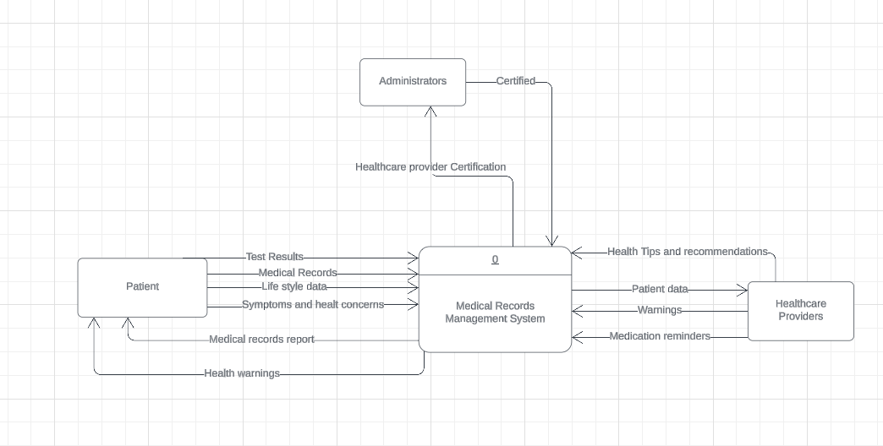

DFD Level-1:

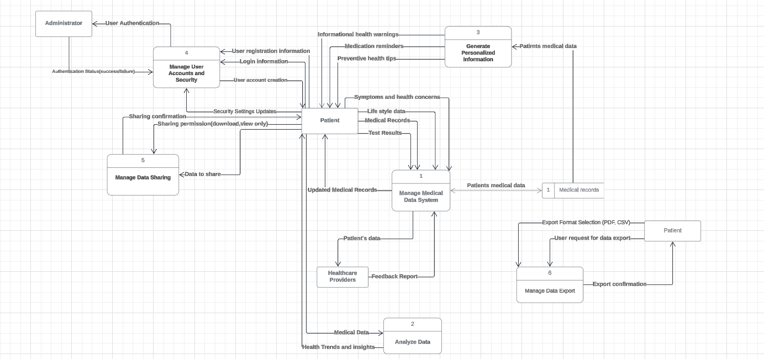

DFD Level-2:

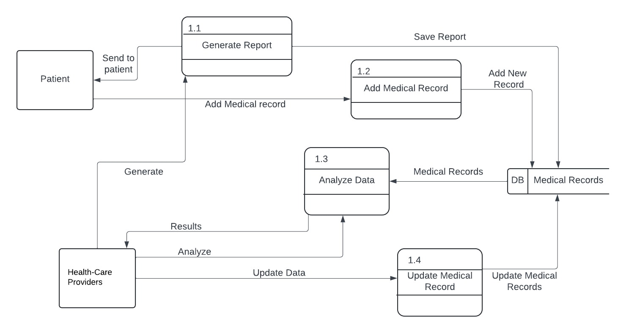 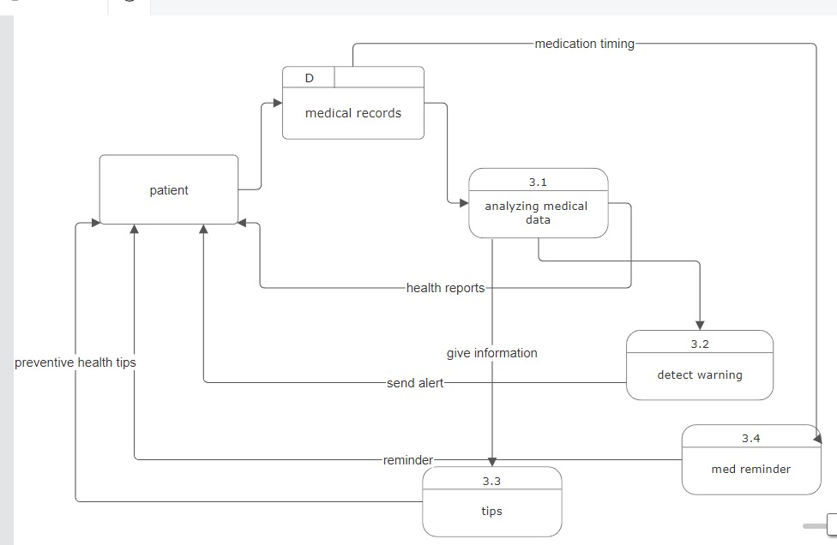

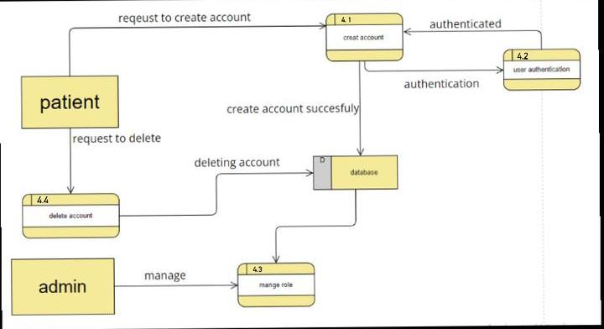

|  |  |
| --- | --- |
| Name | Task |
| Husam Abozide | * Non-functional requirements  * Use-case table ‘1’  * DFD level-0 (Context diagram)  * DFD level-1  * Part of Use-case model  * Document review |
| Amr Mostafa | * Functional requirements  * Use-case table ’6’  * User story ‘3’  * DFD level-2 (1) * Document review and edit |
| Nadeen Nasser | * Use-case model  * Use-case table ‘2’  * Document review and editing  * User story ‘5’ |
| Fady Milad | * Use-case table ‘3’  * User story ‘2’  * DFD level-2 (3) * Document review and edit |
| Mohammad Sobhy | * Use-case table ‘4’  * User story ‘4’  * DFD level-2 (3) |
| Youssef Mahmoud | * Use-case table ‘5’  * User story ‘1’  * DFD level-2 (2)  * Document review and edit |