

Git-RS
Internal Architecture Documentation
Visual Guide to Git Object Model, DAG Structure, and Write-Tree Algorithm
Fady | June 2025

Table of Contents
Right-click the TOC and select "Update Field" to refresh page numbers

1. Git Object Model Overview 3
2. The Git DAG: Directed Acyclic Graph 5
3. Complete Object Relationships 7
4. Write-Tree Algorithm Data Flow 9
5. Directory-to-Tree Transformation 11
6. Content-Addressable Storage 13
7. Complete Commit Creation Flow 15

1. Git Object Model Overview
Git's architecture is built on a surprisingly simple yet powerful abstraction: four object types that form a Directed Acyclic Graph (DAG). Understanding these objects and their relationships is fundamental to understanding how Git stores, retrieves, and versions your code.
At the heart of Git's design is content-addressable storage. Every piece of data — whether it's a file's contents, a directory listing, or a commit snapshot — is stored as an object identified by the SHA-1 hash of its content. This means identical content always produces the same hash, enabling automatic deduplication across the entire repository history.

The Four Object Types
Git defines four fundamental object types that work together to represent your entire project history:
• Blob (Binary Large Object): Stores the raw content of a file. Blobs contain only data — no filename, no permissions, no metadata. A blob is purely a snapshot of what a file contained at a specific point in time.
• Tree: Represents a directory. A tree object contains a sorted list of entries, where each entry maps a filename to either a blob (for files) or another tree (for subdirectories). Tree entries include file modes (100644 for regular files, 040000 for directories) and the SHA-1 hash of the referenced object.
• Commit: Represents a snapshot of the project at a specific point in time. A commit object points to a root tree object (the complete directory structure), references zero or more parent commits, and contains metadata including author, committer, timestamp, and commit message.
• Tag: A human-readable label pointing to a specific commit. Annotated tags are themselves objects containing the tagger information, message, and reference to a commit. Lightweight tags are simply refs — pointers stored as files.
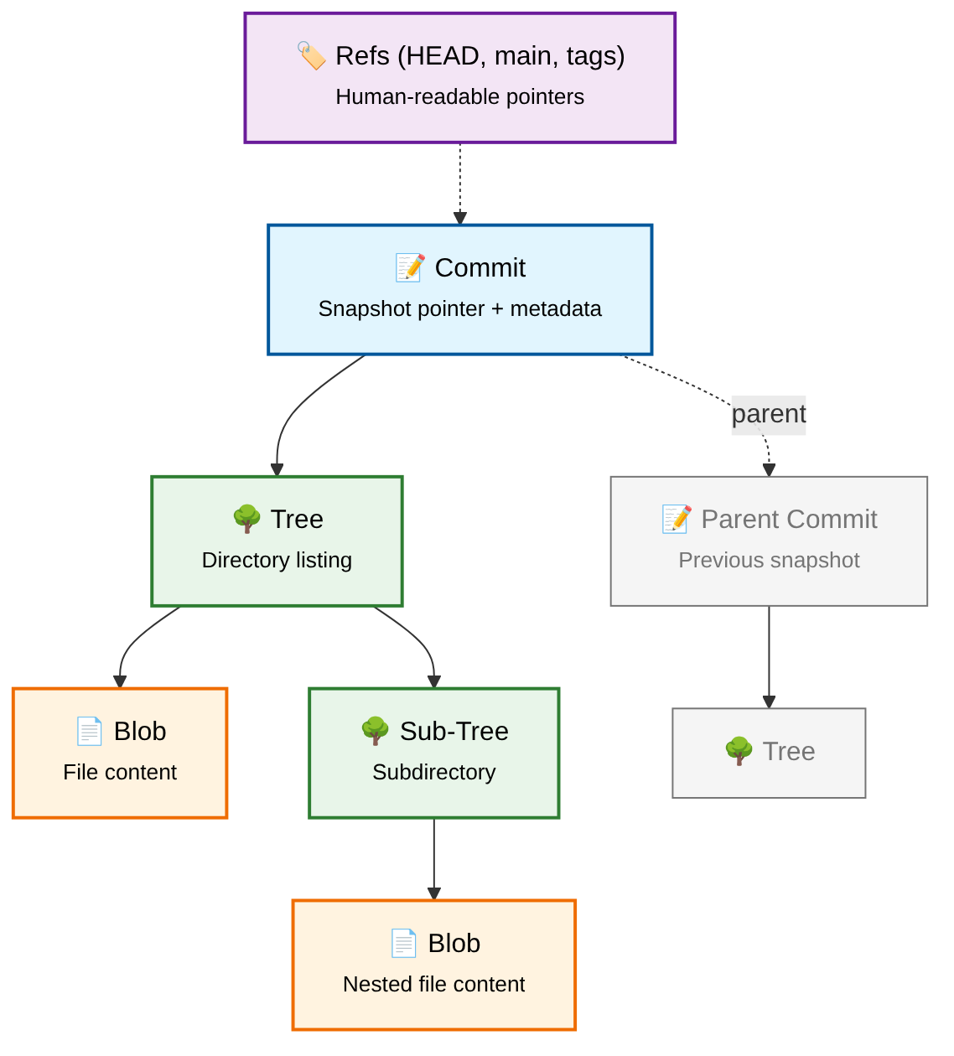
Figure 1: High-level overview of Git's object model. Commits point to trees, trees reference blobs and other trees, forming a directed acyclic graph. Refs (HEAD, branches, tags) provide human-readable entry points into the graph.
The diagram above illustrates the core relationships: a commit references a root tree that represents the complete project state. That tree, in turn, references blobs (file contents) and sub-trees (subdirectories). Each commit also links to its parent commit(s), creating the history chain. What makes this structure powerful is that it's immutable — once written, an object never changes. This immutability is what makes Git's history reliable and verifiable.

2. The Git DAG: Directed Acyclic Graph
Git stores project history as a Directed Acyclic Graph (DAG), a mathematical structure where nodes (commits) are connected by directed edges (parent pointers) such that no cycles exist. This design is the foundation of Git's branching and merging capabilities.
In a DAG, each commit node points backward to its parent commit(s). An initial commit has no parents; a regular commit has one parent; a merge commit has two or more parents. Because edges only point backward in time, you can never follow a chain of parent pointers and loop back to the starting commit — hence the structure is acyclic.

DAG Evolution Across Commits
The diagram below shows how the DAG grows as development progresses. Starting from an initial commit (C1), each new commit adds a node and an edge. When a branch occurs, a commit gains multiple children. When branches merge, a new commit is created with multiple parents, joining divergent histories back together.
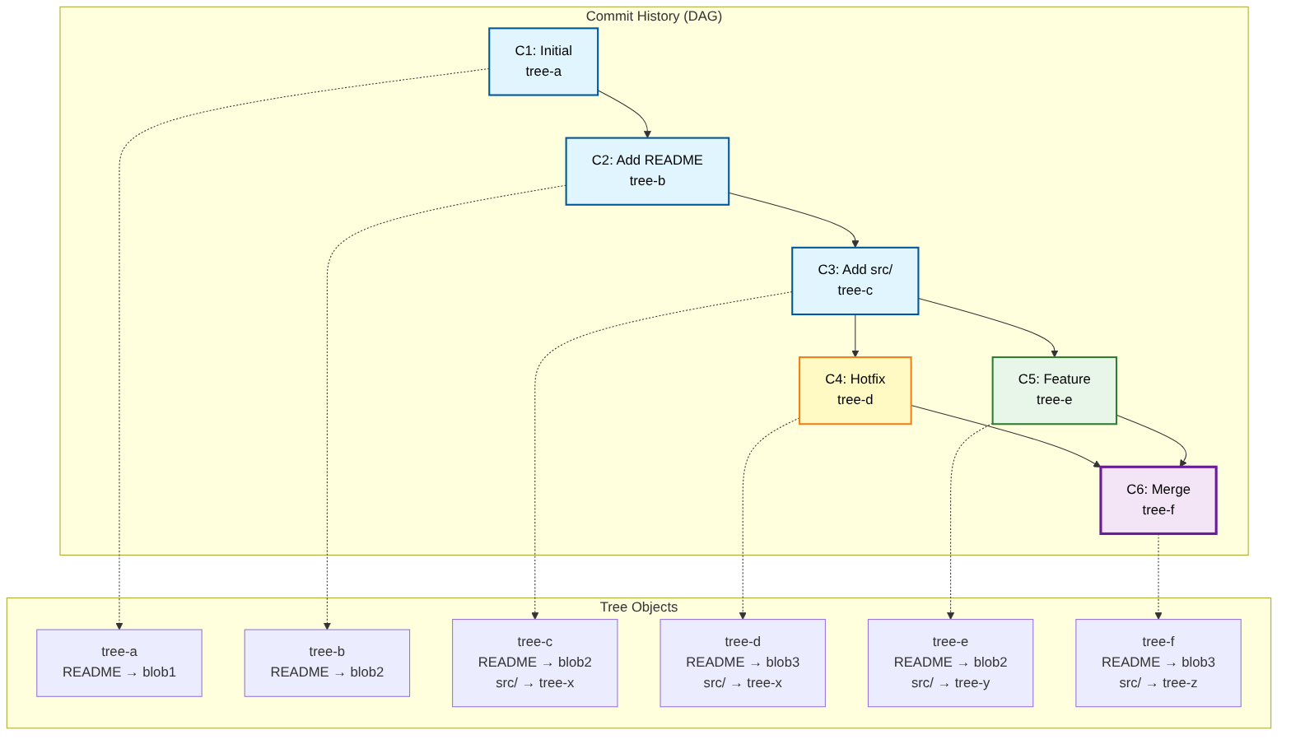
Figure 2: DAG evolution showing commits (C1-C6), branching, and merging. Each commit references a unique tree object representing the complete project snapshot at that point in time.

Key Properties of the Git DAG
The DAG structure provides several critical properties that make Git powerful:
• Immutable History: Once a commit is created, it never changes. The SHA-1 hash of a commit includes the hash of its tree, parent hashes, and all metadata. Any modification would produce a completely different hash, effectively creating a new commit rather than altering the existing one.
• Content Deduplication: Because objects are content-addressed, identical files across different commits or branches share the same blob object. Git only stores a file's full content once, even if it appears in thousands of commits. This makes Git remarkably space-efficient despite storing complete snapshots.
• Efficient Branching: A branch in Git is simply a mutable pointer to a commit. Creating a branch requires only writing a 40-character hash to a file — no copying of data, no duplication of history. This is why Git branches are lightweight and instantaneous.
• Reliable Merging: The DAG structure provides a clear mathematical framework for merging. Git can find the common ancestor (merge base) of any two commits by walking the DAG, and the merge algorithm uses this information to combine changes correctly.

3. Complete Object Relationships
This section presents a comprehensive view of Git's object model, showing all relationships between the four object types, the references layer, and how they interconnect to form a complete version control system. This detailed diagram reveals the full complexity of Git's storage architecture.
The diagram is organized into four conceptual layers: the References Layer at the top provides human-readable entry points; the Commit Layer contains snapshot metadata; the Tree Layer represents directory structures; and the Blob Layer stores actual file content. Each layer depends on the layers below it, creating a strict hierarchy of dependencies.
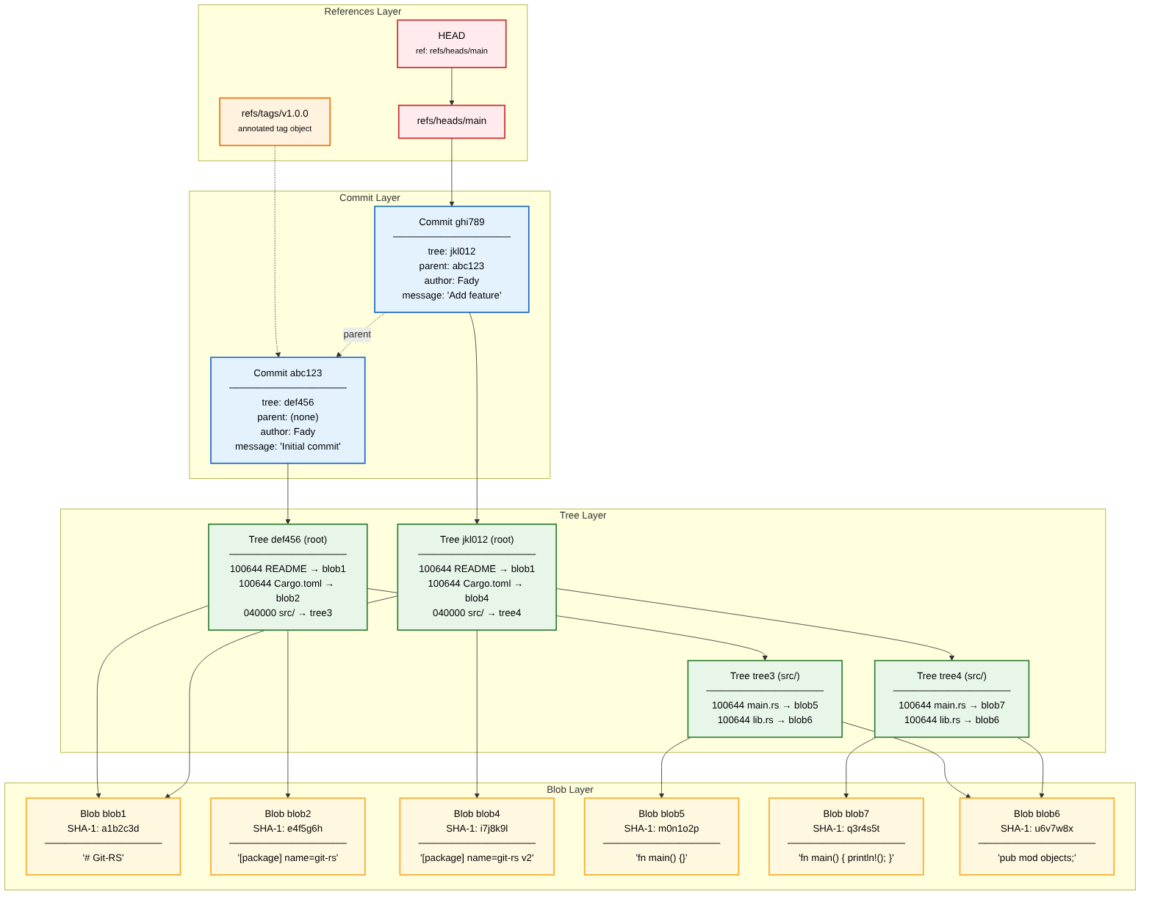
Figure 3: Comprehensive object relationship diagram showing all four object types across four conceptual layers. Solid arrows indicate direct references (stored within the object); dashed arrows indicate the parent commit chain.

References: Human-Readable Entry Points
The SHA-1 hashes that identify Git objects are cryptographically secure but human-unfriendly. References provide memorable names for specific commits:
• HEAD: A special reference that points to the currently checked-out commit. Usually HEAD contains a symbolic reference like 'ref: refs/heads/main', meaning it points to the main branch. In a detached HEAD state, HEAD directly contains a commit hash.
• Branches (refs/heads/*): Mutable pointers that advance automatically when new commits are made. The main branch is simply a file containing the hash of the latest commit on that line of development.
• Tags (refs/tags/*): Fixed pointers to specific commits. Annotated tags are full objects containing tagger information, a message, and a reference to a commit. Lightweight tags are simply refs — plain text files containing a commit hash.

Object Storage Format
Every Git object is stored as a compressed file in .git/objects/. The storage format is consistent across all object types: object_type + " " + content_length + \0 + content. This entire string is zlib-compressed and written to a file whose path is derived from the SHA-1 hash of the uncompressed content. The first two characters of the hash form the directory name, and the remaining 38 characters form the filename.

4. Write-Tree Algorithm Data Flow
The write-tree command is one of Git's core plumbing commands. It takes the contents of the index (staging area) and creates a tree object from it, returning the hash of that tree. Understanding this algorithm is essential for understanding how Git snapshots directory structures.
The algorithm is inherently recursive: to create a tree for a directory, you must first create trees for all subdirectories. The base case is a directory containing only files — these are hashed directly into blobs. The recursive case handles subdirectories by calling write-tree on each subdirectory and including the resulting tree hash in the parent tree's entries.
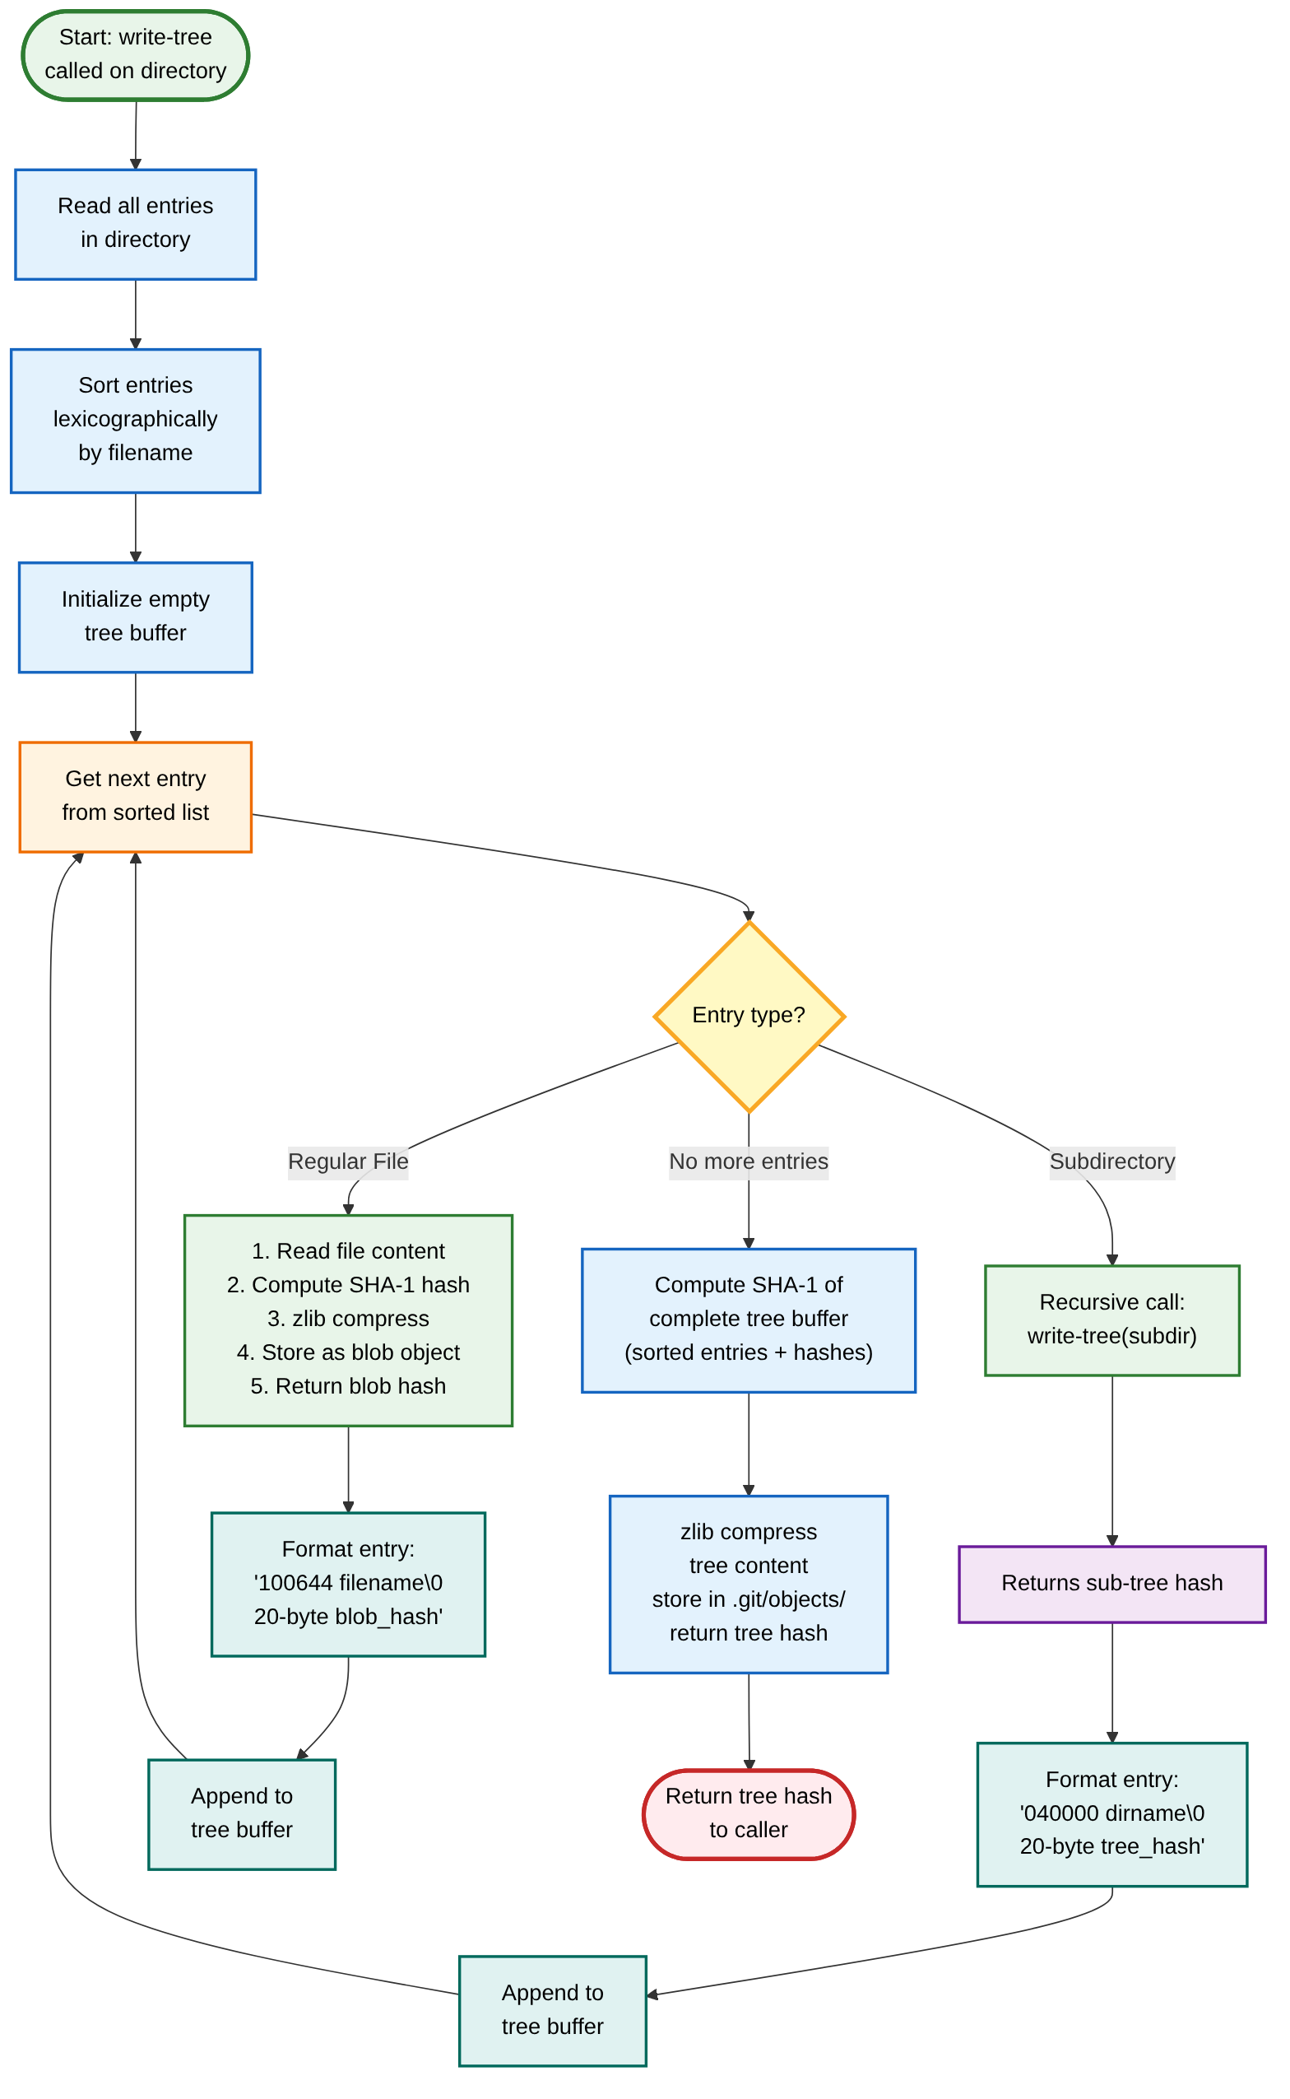
Figure 4: Complete data flow of the write-tree algorithm. The process reads directory entries, sorts them lexicographically, and recursively processes subdirectories before constructing the parent tree object.

Algorithm Step-by-Step
The write-tree algorithm executes the following steps in order:
- Read Directory Entries — Scan the target directory and collect all entries (files and subdirectories). The .git directory is always excluded from this scan.
- Sort Entries — Sort all entries lexicographically by filename. This sorting is critical — it ensures that the same directory always produces the same tree hash, regardless of the order in which the filesystem returns entries. Without sorting, tree hashes would be non-deterministic.
- Process Each Entry — For each entry in sorted order, determine its type. Regular files are hashed as blob objects. Subdirectories trigger a recursive call to write-tree, which returns the subtree's hash.
- Format Tree Entries — Each entry is formatted as: mode + space + filename + null byte + 20-byte binary hash. The mode is '100644' for regular files and '040000' for directories.
- Compute Tree Hash — Concatenate all formatted entries and compute the SHA-1 hash of 'tree ' + total_length + \0 + concatenated_entries.
- Store and Return — Compress the tree content with zlib and write it to .git/objects/XX/YYYY... where XX is the first two characters of the hash. Return the full hash to the caller.

Critical Implementation Detail: Sorting
The lexicographic sorting of tree entries is not merely a convenience — it is essential for Git's content-addressed model to work. Consider a directory containing files 'a.txt' and 'b.txt'. If the filesystem returns them in order ['b.txt', 'a.txt'], and we process them without sorting, the resulting tree buffer will be different from processing them as ['a.txt', 'b.txt']. Different buffers produce different SHA-1 hashes, which means the same directory content would appear as different objects depending on filesystem behavior. By sorting entries before hashing, Git ensures deterministic, platform-independent tree hashes.

5. Directory-to-Tree Transformation
This section visualizes the transformation from a working directory on your filesystem to the corresponding Git objects stored in .git/objects/. This mapping is the core of how Git captures and preserves project state.
The transformation is lossless in the sense that every file becomes a blob containing its exact contents, and every directory becomes a tree containing references to its contents. However, it is also structural — filenames live in trees, not blobs, which means renaming a file produces a new tree but reuses the existing blob (since the content hasn't changed).
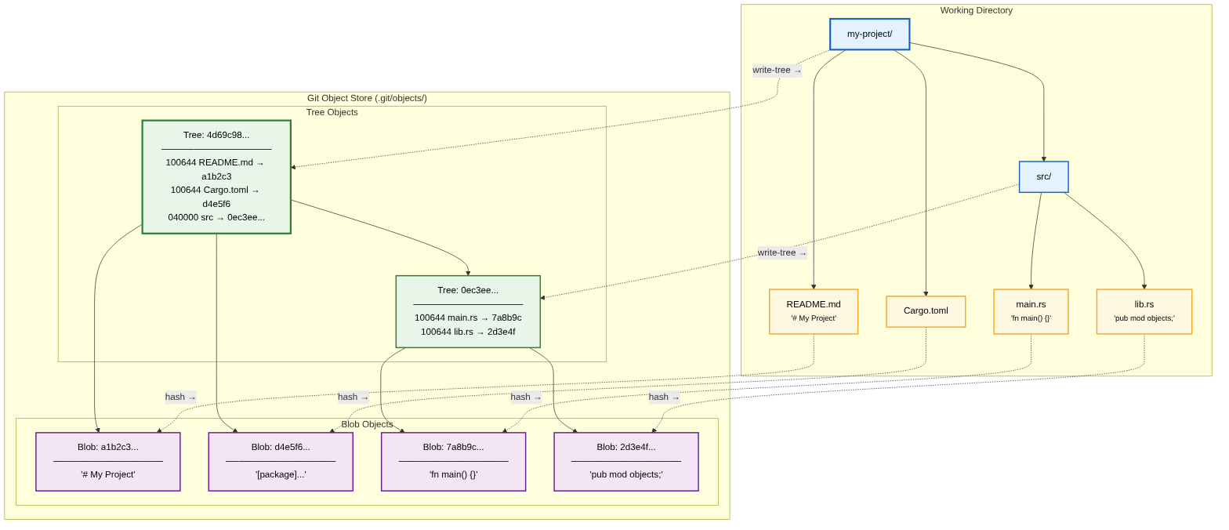
Figure 5: Visual mapping from working directory (left) to Git object store (right). Each file becomes a blob; each directory becomes a tree. Dashed arrows show the correspondence between filesystem entries and their Git object representations.

The Transformation Process
When you run git add followed by git write-tree, Git performs the following transformation on your working directory:
• Files Become Blobs: Each regular file is read, prefixed with a header ('blob ' + size + \0), and hashed with SHA-1. The content is zlib-compressed and stored in .git/objects/. The filename is not part of the blob — only the content matters.
• Directories Become Trees: Each directory becomes a tree object containing one entry per child (file or subdirectory). Each entry contains the mode, name, and SHA-1 hash of the corresponding blob or subtree.
• Root Directory Becomes Root Tree: The top-level directory of the project becomes the root tree, which is referenced directly by a commit object. This root tree, through its recursive structure of sub-trees and blobs, contains a complete snapshot of the entire project.

Practical Example
Consider a project with a README.md file and a src/ directory containing main.rs and lib.rs. After git add . and git write-tree, the following objects are created: three blobs (for README.md, main.rs, and lib.rs), two trees (one for src/ referencing the two Rust file blobs, and one root tree referencing the README blob and the src tree), and the tree hash returned by write-tree is the hash of the root tree.

6. Content-Addressable Storage
Content-addressable storage is the foundational concept that makes Git's architecture possible. Instead of identifying files by their location or name, Git identifies every piece of data by the cryptographic hash of its content. This simple idea has profound implications for how Git stores, deduplicates, and verifies data.
Git uses SHA-1 (Secure Hash Algorithm 1) to compute 160-bit hashes, represented as 40-character hexadecimal strings. While SHA-1 is no longer considered secure for cryptographic purposes, it remains perfectly suitable for Git's use case of content addressing and integrity verification. The probability of an accidental hash collision is astronomically low — effectively zero for all practical purposes.
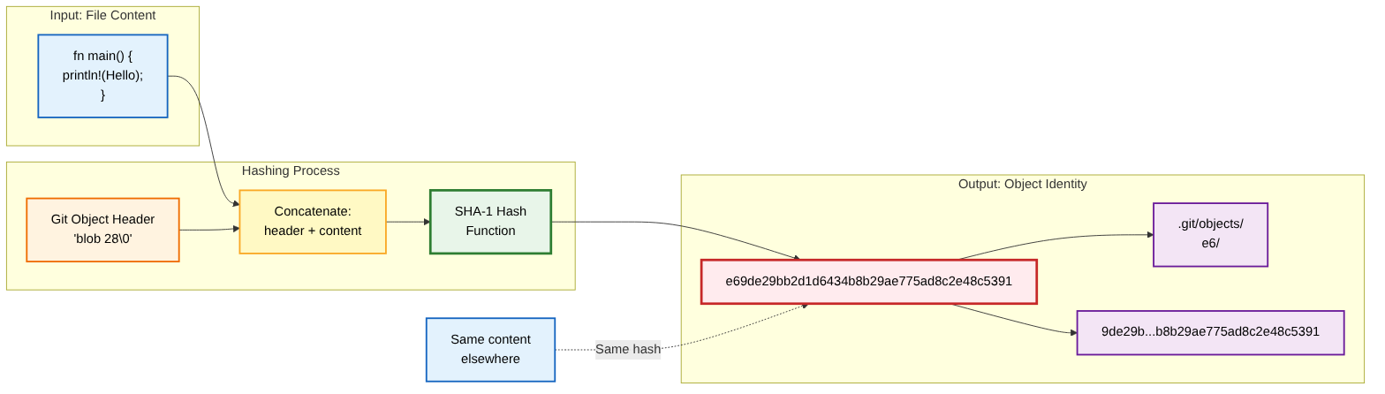
Figure 6: The content-addressable storage mechanism. File content is prefixed with a type header, hashed with SHA-1, and stored at a path derived from the hash. Identical content always produces the same hash, enabling automatic deduplication.

The Hashing Process
When Git stores an object, it follows a precise algorithm:
- Prepare Content — Read the raw content of the file (for blobs) or construct the content (for trees, commits, and tags).
- Add Header — Prefix the content with a header indicating the object type and size: 'type size\0'. For example, a blob containing 'hello' would have the header 'blob 5\0'.
- Compute Hash — Calculate the SHA-1 hash of the entire string (header + content). This 40-character hex string becomes the object's unique identifier.
- Compress — Compress the entire string using zlib compression. This typically reduces storage size by 50-80% for text files.
- Store — Write the compressed data to .git/objects/XX/YYYYYYYYYYYYYYYYYYYYYYYYYYYYYYYYYYYYYYYY, where XX is the first two characters of the hash and YYYY... is the remaining 38 characters.

Benefits of Content Addressing
• Automatic Deduplication: If two files have identical content, they produce the same hash and share the same storage. Git stores the content only once, regardless of how many times it appears in the repository history.
• Integrity Verification: Because the hash is computed from the content, any corruption or tampering would produce a hash mismatch. Git can detect data corruption by simply recomputing the hash of stored objects.
• Efficient Comparison: To check if two files are identical, Git compares their hashes rather than their contents. This is extremely fast — comparing two 40-character strings instead of potentially megabytes of data.

7. Complete Commit Creation Flow
This final section presents the end-to-end data flow from modified files in the working directory to a permanent commit in the Git repository. Understanding this complete pipeline ties together all the concepts from previous sections and shows how Git's individual components work together to create a versioned snapshot.
The commit creation process is divided into five distinct stages, each transforming data from one representation to another. This pipeline is the essence of what happens when you run git commit — Git executes these stages automatically, but understanding the plumbing commands (add, write-tree, commit-tree, update-ref) gives you complete control over the process.
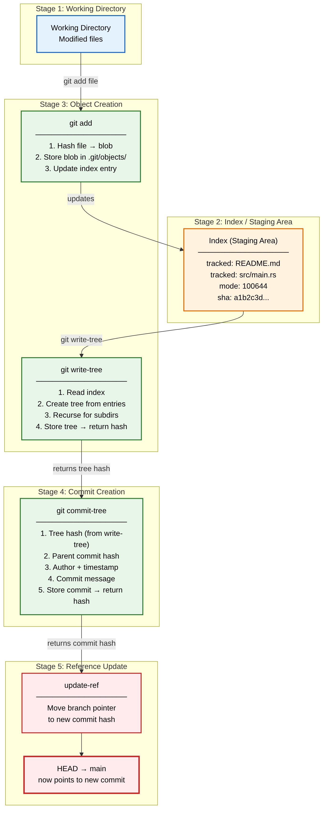
Figure 7: End-to-end data flow from working directory to committed snapshot. Five stages transform modified files through the index, object creation, commit assembly, and reference update to produce a permanent entry in the repository history.

The Five Stages of Commit Creation
Stage 1 — Working Directory: This is where you edit files using your preferred editor. The working directory contains the actual files you work with, in their uncompressed, human-readable form. Git considers these files in one of four states: untracked, modified, staged, or committed.
Stage 2 — Index (Staging Area): When you run git add, Git computes the blob hash of the file's content, stores the blob in .git/objects/, and adds an entry to the index. The index is a binary file (.git/index) that maps filenames to blob hashes, acting as a proposed next tree. It allows you to selectively choose which changes to include in the next commit.
Stage 3 — Object Creation: Running git write-tree reads the index and constructs tree objects from it, producing a root tree hash. If any entries in the index reference directories, write-tree recursively creates the necessary subtree objects. This stage transforms the flat index into a hierarchical tree structure.
Stage 4 — Commit Creation: The git commit-tree command takes the tree hash from write-tree, adds parent commit hash(es), author/committer information with timestamps, and the commit message. It hashes this content as a commit object and stores it, returning the commit hash.
Stage 5 — Reference Update: Finally, git update-ref moves the current branch pointer to the new commit hash. HEAD is updated to point to this branch, and the commit is now a permanent part of the repository history, accessible by its hash or through the branch reference.

Practical Verification
You can observe this entire pipeline manually using Git's plumbing commands. Start with a clean repository, create or modify files, then run each plumbing command individually: git update-index to stage files, git write-tree to create the tree, git commit-tree to create the commit, and git update-ref to move the branch pointer. This exercise reveals that Git's porcelain commands (add, commit) are simply convenient wrappers around these fundamental operations.


Git-RS
A from-scratch Git implementation in Rust
Built for understanding. Designed for reliability.
June 2025

