FACULTY OF COMPUTER SCIENCE AND INFORMATION TECHNOLOGY
Capital University formerly Helwan University
CPU SCHEDULING ALGORITHMS
A Comparative Study of Round Robin and Shortest Job First (Non-Preemptive)

1. Introduction
This project implements and compares two fundamental CPU scheduling algorithms — Round Robin (RR) and Shortest Job First Non-Preemptive (SJF) — using a Python-based simulation tool. The tool accepts dynamic process input, renders Gantt charts, computes key performance metrics, and provides a side-by-side comparison summary. The goal is to explore the trade-off between algorithmic fairness (RR) and scheduling efficiency (SJF) across multiple workload types.

2. Project Objective
The project aims to:
- Implement both RR and SJF (Non-Preemptive) algorithms correctly in Python.
- Visualise execution through Gantt charts for each algorithm.
- Compute and compare Waiting Time (WT), Turnaround Time (TAT), and Response Time (RT).
- Stress-test the implementation using carefully designed workload scenarios.
- Validate all user input and handle invalid entries gracefully.

3. Algorithms Overview

3.1 Round Robin (RR)
Round Robin is a preemptive, time-sharing algorithm. Each process receives a fixed time quantum in cyclic order. When the quantum expires, the process is preempted and moved to the back of the ready queue. This guarantees no process starves, making RR inherently fair. The time quantum is the key tuning parameter: too small increases context-switch overhead; too large degrades toward FCFS behaviour.

3.2 Shortest Job First – Non-Preemptive (SJF)
SJF selects the process with the smallest burst time from all currently available processes. Once selected, the process runs to completion without interruption. SJF achieves the theoretically minimum average waiting time among non-preemptive algorithms, but may cause starvation of long processes when shorter jobs continuously arrive.

3.3 Fairness vs. Efficiency
Property | Round Robin | SJF (Non-Preemptive)
Fairness | High – all processes cycle | Low – shorter jobs prioritised
Avg. Waiting Time | Higher | Lower (optimal)
Starvation Risk | None | Possible for long jobs
Context Switches | High | Low
Best For | Interactive systems | Batch processing

4. System Features
- Dynamic process input — any number of processes with customisable PID, arrival time, and burst time.
- Gantt chart visualisation for both RR and SJF results.
- Per-process and average metrics: Waiting Time, Turnaround Time, Response Time.
- Side-by-side comparison summary highlighting which algorithm performs better per metric.
- Graphical User Interface (GUI) for intuitive data entry and results review.
- Full input validation with descriptive error messages before any computation runs.

5. Input Validation
- Negative or zero burst time → rejected; burst time must be > 0.
- Negative arrival time or non-numeric arrival value → rejected.
- Time quantum ≤ 0 → rejected; must be a positive integer.
- Duplicate process IDs → rejected; all IDs must be unique.
- Empty process list → simulation blocked until at least one process is entered.

6. Algorithm Logic

6.1 Round Robin
- Sort all processes by arrival time. Initialise a FIFO ready queue and set the clock to 0.
- Enqueue any process whose arrival time ≤ current clock and that has not yet been added.
- Dequeue the front process; execute it for min(remaining burst, quantum). Advance the clock.
- If remaining burst > 0, re-enqueue it after adding any newly arrived processes.
- On completion, record Completion Time; compute WT, TAT, and RT.
- Log each execution interval to the Gantt chart. Repeat until the queue is empty.

6.2 SJF (Non-Preemptive)
- Sort processes by arrival time. Set clock to the first process's arrival time.
- From all arrived, incomplete processes, select the one with the smallest burst time (tie-break: earliest arrival).
- If no process is ready, advance the clock to the next arrival.
- Execute selected process to completion. Advance clock by its full burst time.
- Record Completion Time, WT, TAT, and RT. Append a single contiguous Gantt block.
- Repeat until all processes are complete.

7. Time Complexity
Algorithm | Time Complexity | Space Complexity | Context Switches
Round Robin | O(n log n + B/q) | O(n) | High – per quantum
SJF (Non-Preemptive) | O(n log n) | O(n) | Low – per completion

Where n = number of processes, B = total burst time, q = time quantum. Both algorithms require O(n log n) for the initial sort. Round Robin's scheduling events are bounded by O(B/q); SJF uses a min-heap for O(log n) selection per scheduling decision. In practice, context-switching overhead dominates Round Robin's real-world cost under small quanta.

8. Metrics Explanation
Metric | Formula | Description
Waiting Time (WT) | WT = TAT − Burst Time | Time spent waiting in the ready queue
Turnaround Time (TAT) | TAT = Completion Time − Arrival Time | Total time from submission to completion
Response Time (RT) | RT = First CPU Time − Arrival Time | Time until first CPU execution begins

Averages of WT, TAT, and RT across all processes are used in the final comparison summary. SJF minimises average WT by design; RR typically achieves better average RT by cycling through all processes in the first round.

9. Test Scenarios

9.1 Test Scenario 1 – Basic Mixed Workload
A general-purpose baseline: short, medium, and long burst times with varied arrival times.

Process ID | Arrival Time (ms) | Burst Time (ms) | Notes
P1 | 0 | 5 | Short job
P2 | 1 | 3 | Short job
P3 | 2 | 8 | Long job
P4 | 3 | 6 | Medium job

Round Robin Results (Quantum = 3)
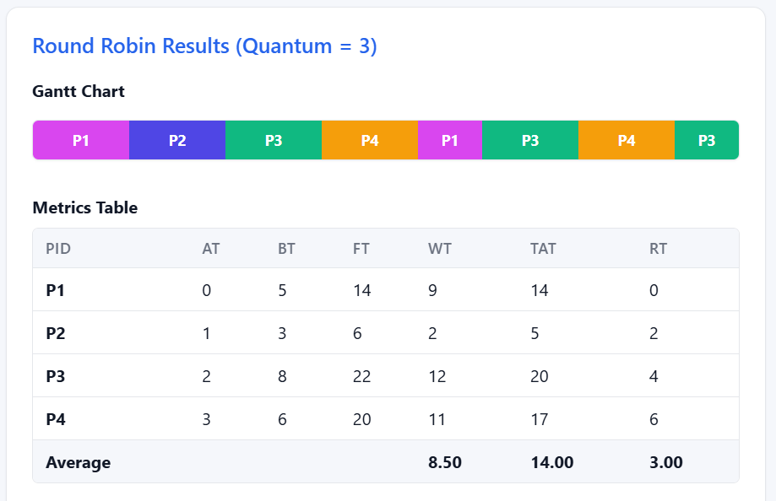
Figure 9.1a – Round Robin Gantt Chart & Metrics (Scenario 1, Q = 3)

SJF Non-Preemptive Results
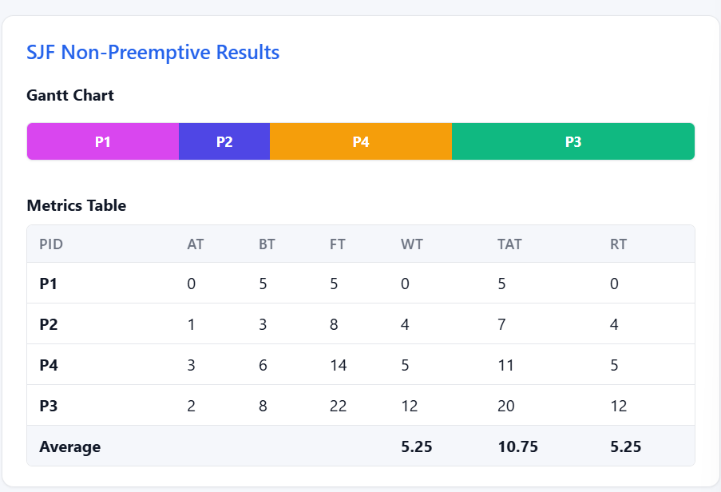
Figure 9.1b – SJF Gantt Chart & Metrics (Scenario 1)

Dynamic Comparison Summary
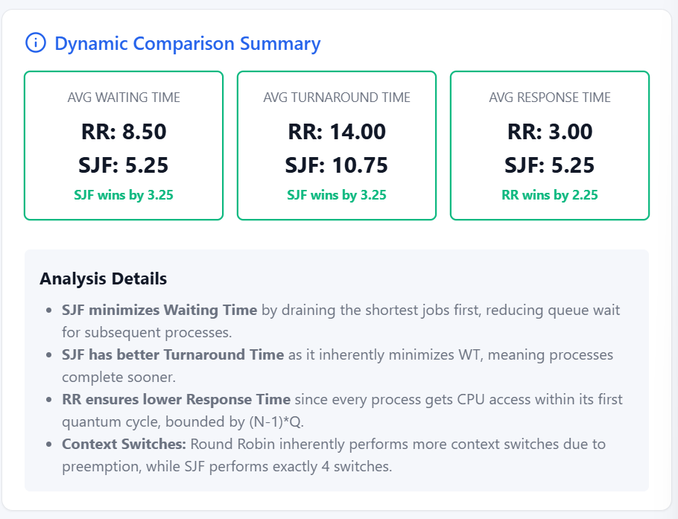
Figure 9.1c – Comparison Summary (Scenario 1)

Scenario Conclusion
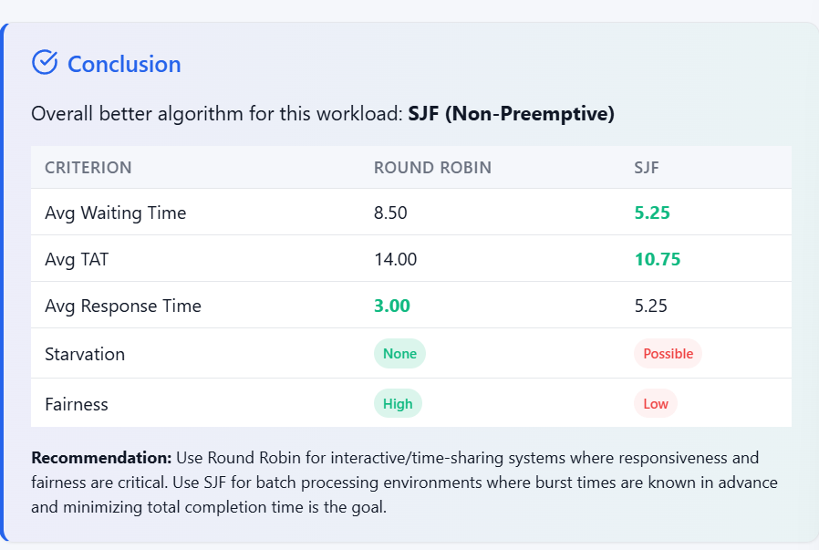
Figure 9.1d – Conclusion View (Scenario 1)

Conclusion: SJF achieves lower average WT by executing shorter jobs first. RR distributes CPU time evenly, resulting in better response times for all processes.

9.2 Test Scenario 2 – Short-Job-Heavy Workload
Workload dominated by very short jobs with one long outlier (P1). Tests how SJF exploits this distribution and whether RR handles P1 fairly.

Process ID | Arrival Time (ms) | Burst Time (ms) | Notes
P1 | 0 | 10 | Long outlier
P2 | 1 | 2 | Short
P3 | 2 | 1 | Shortest
P4 | 3 | 1 | Shortest
P5 | 4 | 2 | Short

Round Robin Results (Quantum = 2)
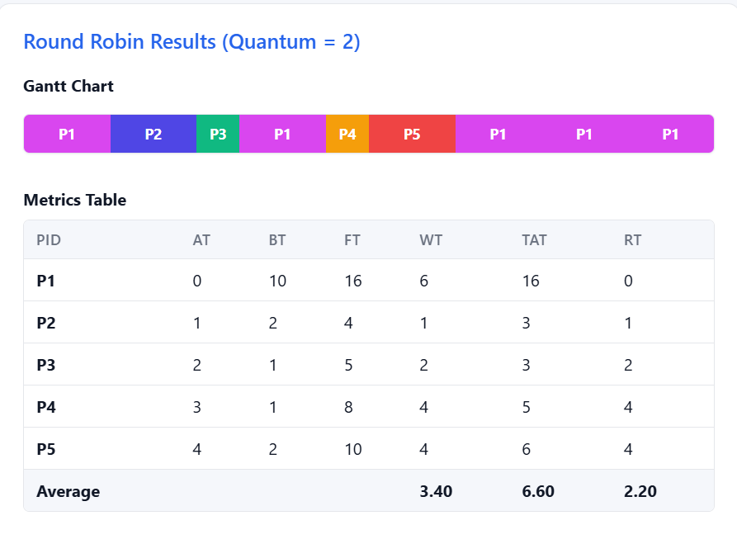
Figure 9.2a – Round Robin Gantt Chart & Metrics (Scenario 2, Q = 2)

SJF Non-Preemptive Results
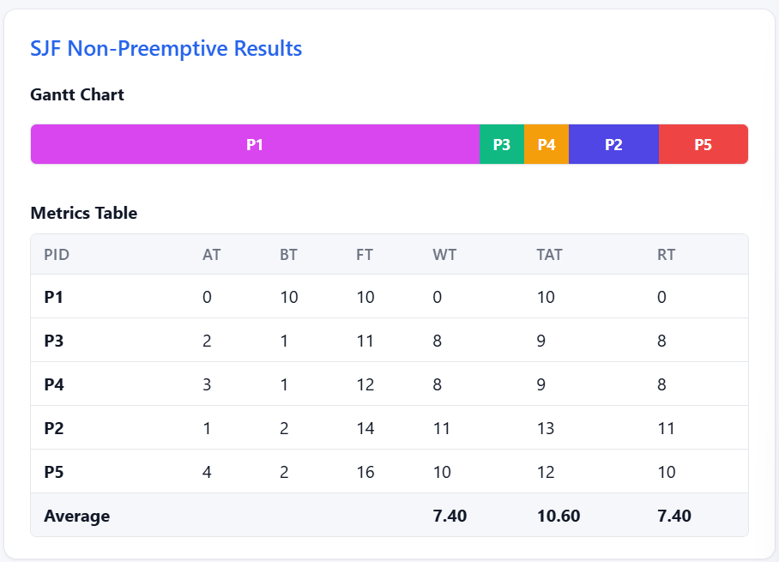
Figure 9.2b – SJF Gantt Chart & Metrics (Scenario 2)

Dynamic Comparison Summary
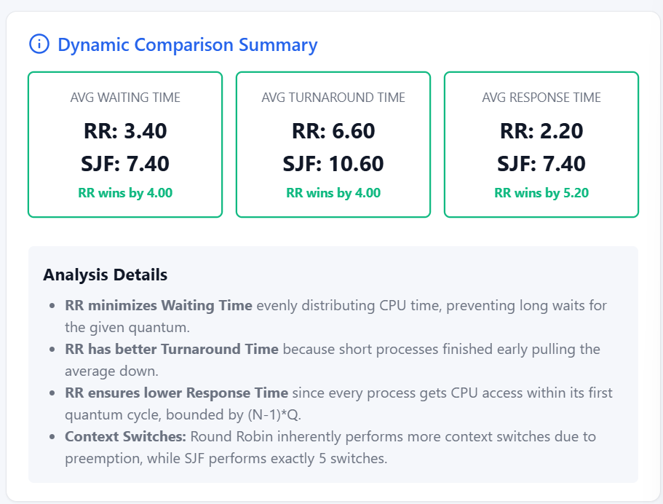
Figure 9.2c – Comparison Summary (Scenario 2)

Scenario Conclusion
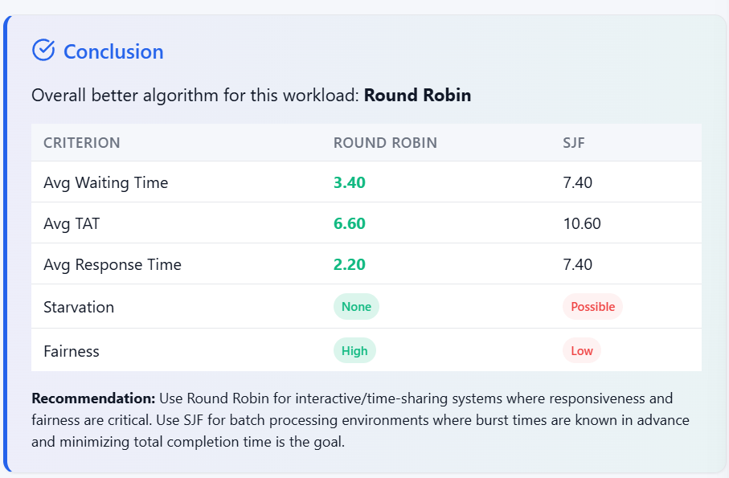
Figure 9.2d – Conclusion View (Scenario 2)

Conclusion: SJF clears the short jobs quickly, minimising average WT. However, P1 is deferred until all short jobs finish — demonstrating starvation risk. RR keeps P1 progressing throughout, improving its individual waiting time.

9.3 Test Scenario 3 – Fairness Evaluation Case
All processes have identical burst times and arrive simultaneously. Both algorithms should produce comparable turnaround times; the key difference is scheduling order and response time.

Process ID | Arrival Time (ms) | Burst Time (ms) | Notes
P1 | 0 | 8 | Equal burst
P2 | 0 | 8 | Equal burst
P3 | 0 | 8 | Equal burst
P4 | 0 | 8 | Equal burst

Round Robin Results (Quantum = 4)
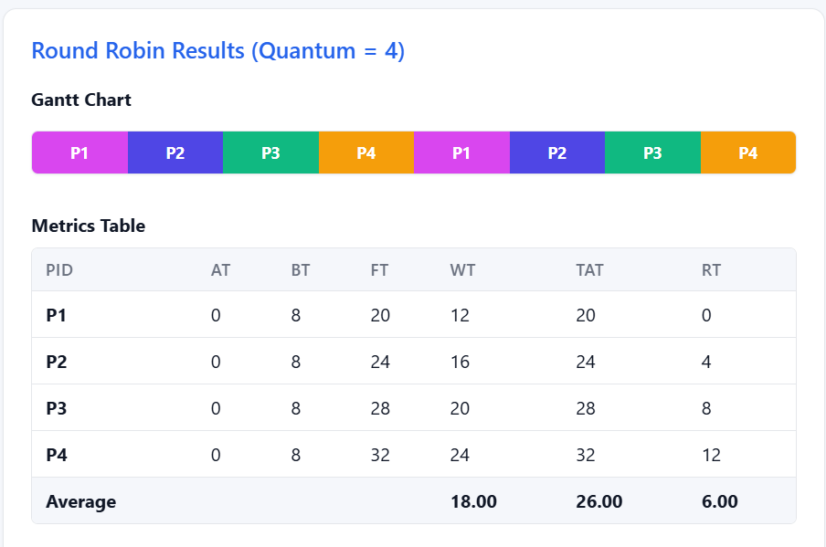
Figure 9.3a – Round Robin Gantt Chart & Metrics (Scenario 3, Q = 4)

SJF Non-Preemptive Results
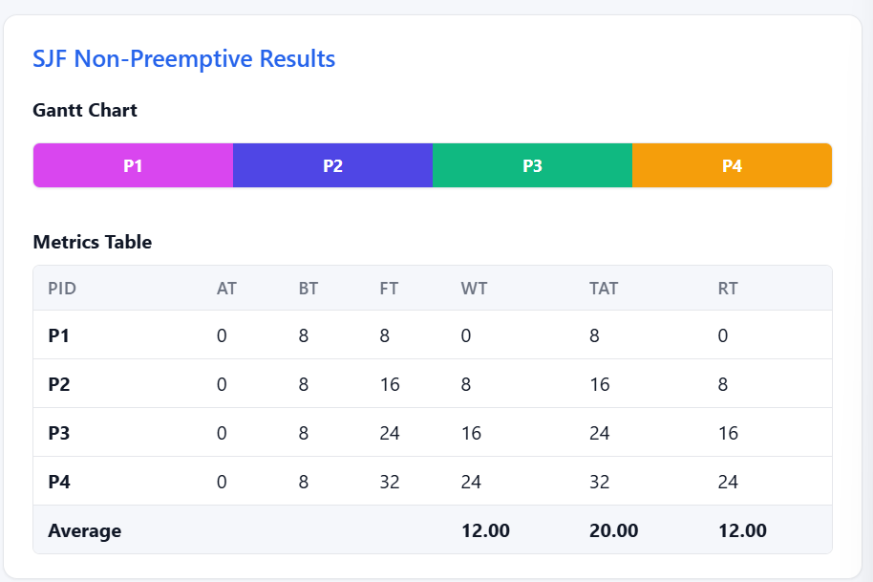
Figure 9.3b – SJF Gantt Chart & Metrics (Scenario 3)

Dynamic Comparison Summary
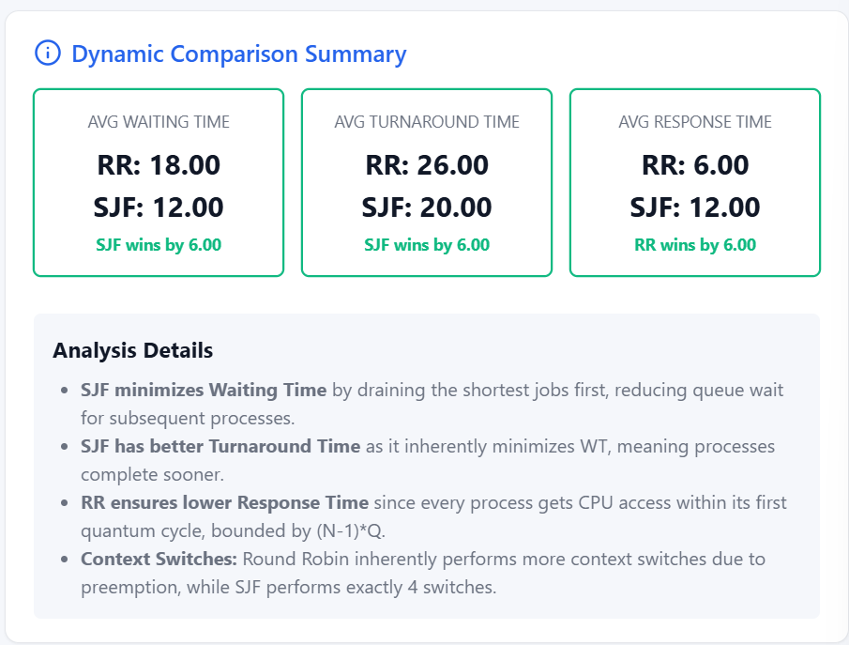
Figure 9.3c – Comparison Summary (Scenario 3)

Scenario Conclusion
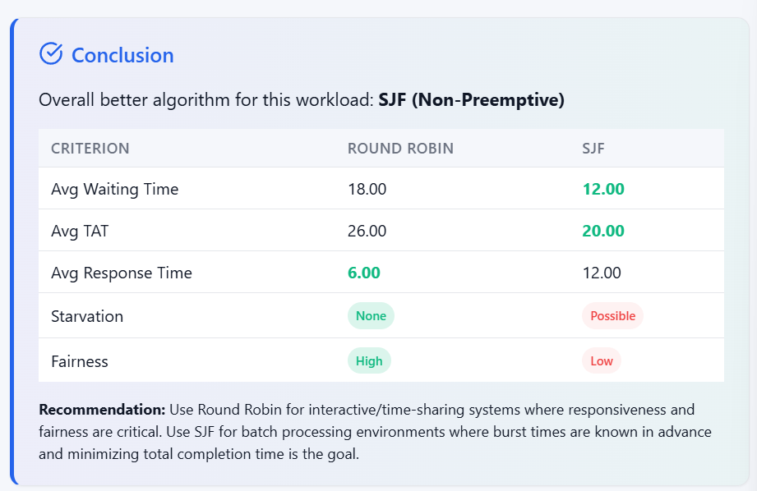
Figure 9.3d – Conclusion View (Scenario 3)

Conclusion: When all bursts are equal, SJF reduces to FCFS and executes processes sequentially. RR interleaves them, yielding lower and more uniform response times. Turnaround times are similar across both algorithms.

9.4 Test Scenario 4 – Long-Job Sensitivity Case
One very long process (P1) against three short processes. Demonstrates starvation under SJF and bounded waiting under RR.

Process ID | Arrival Time (ms) | Burst Time (ms) | Notes
P1 | 0 | 20 | Very long job
P2 | 2 | 2 | Short
P3 | 4 | 2 | Short
P4 | 6 | 2 | Short

Round Robin Results (Quantum = 5)
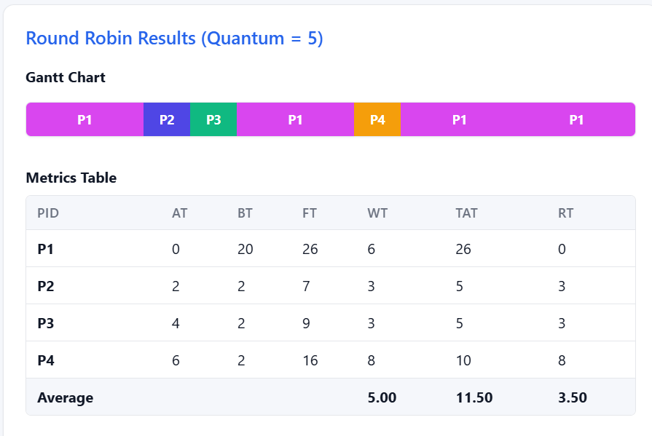
Figure 9.4a – Round Robin Gantt Chart & Metrics (Scenario 4, Q = 5)

SJF Non-Preemptive Results
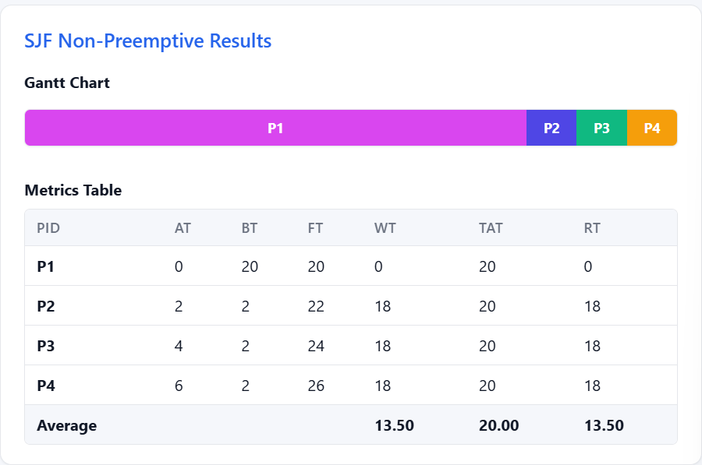
Figure 9.4b – SJF Gantt Chart & Metrics (Scenario 4)

Dynamic Comparison Summary
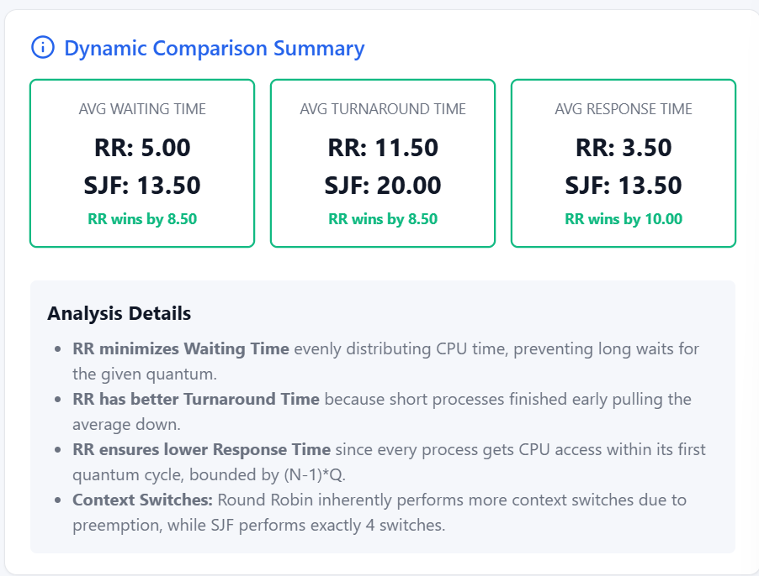
Figure 9.4c – Comparison Summary (Scenario 4)

Scenario Conclusion
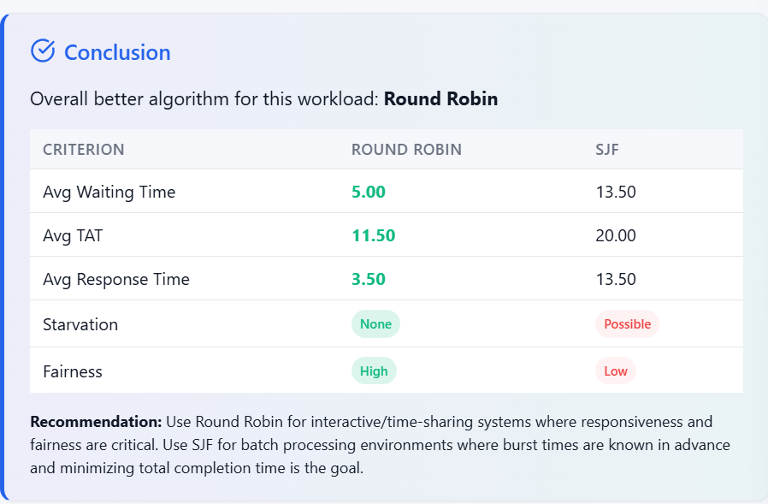
Figure 9.4d – Conclusion View (Scenario 4)

Conclusion: SJF defers P1 until all short processes complete, resulting in high WT and TAT for P1. RR gives P1 periodic CPU access every round, keeping its waiting time bounded and preventing starvation.

9.5 Test Scenario 5 – Input Validation Case
Validates that the system correctly rejects malformed input without crashing.

Input Case | Values Entered | Expected System Response
Negative burst time | Burst = −5 | Error: Burst time must be greater than zero
Duplicate process ID | Two processes both named P1 | Error: Duplicate process ID detected
Zero time quantum | Quantum = 0 | Error: Time quantum must be a positive integer
Empty process list | No processes entered | Error: Please enter at least one process
Non-numeric arrival time | Arrival = 'abc' | Error: Arrival time must be a non-negative number

Validation Error – Zero Time Quantum
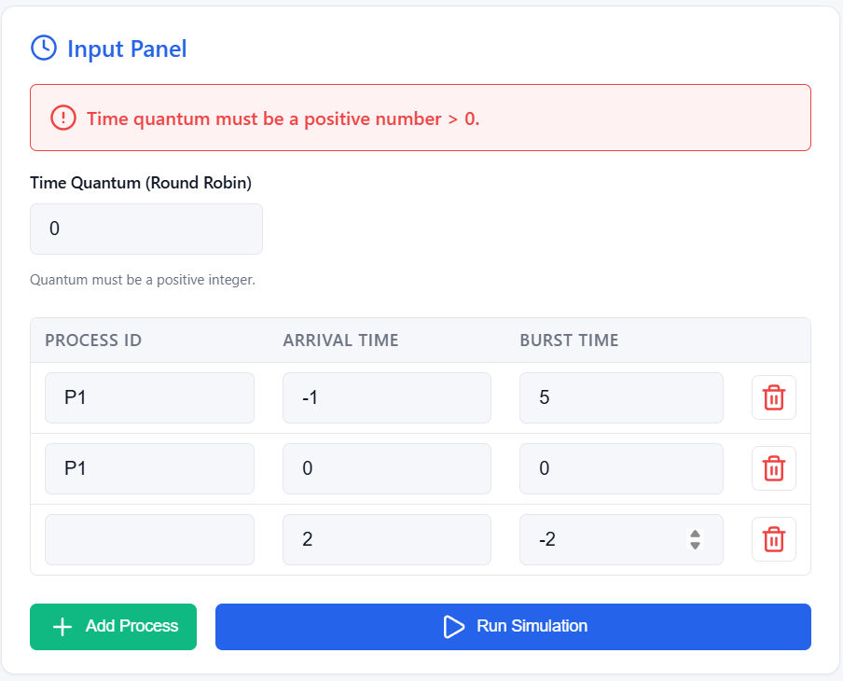
Figure 9.5a – Input Validation: Zero Quantum Error

Validation Error – Negative Burst Time
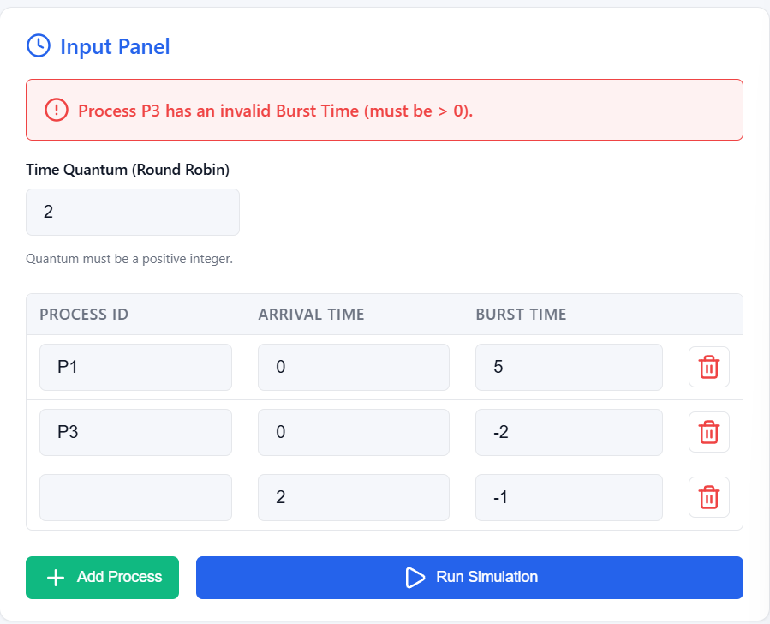
Figure 9.5b – Input Validation: Negative Burst Time Error

Validation Error – Empty Process ID
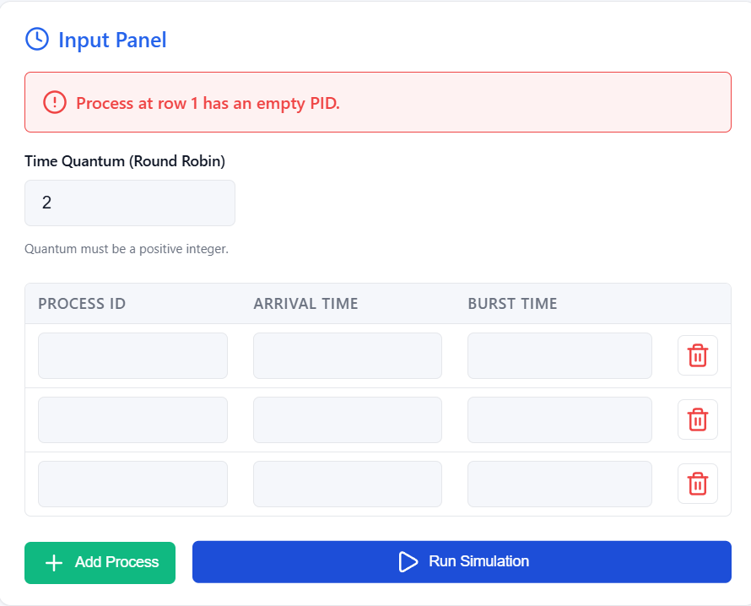
Figure 9.5c – Input Validation: Empty PID Error

Validation Error – Duplicate Process ID
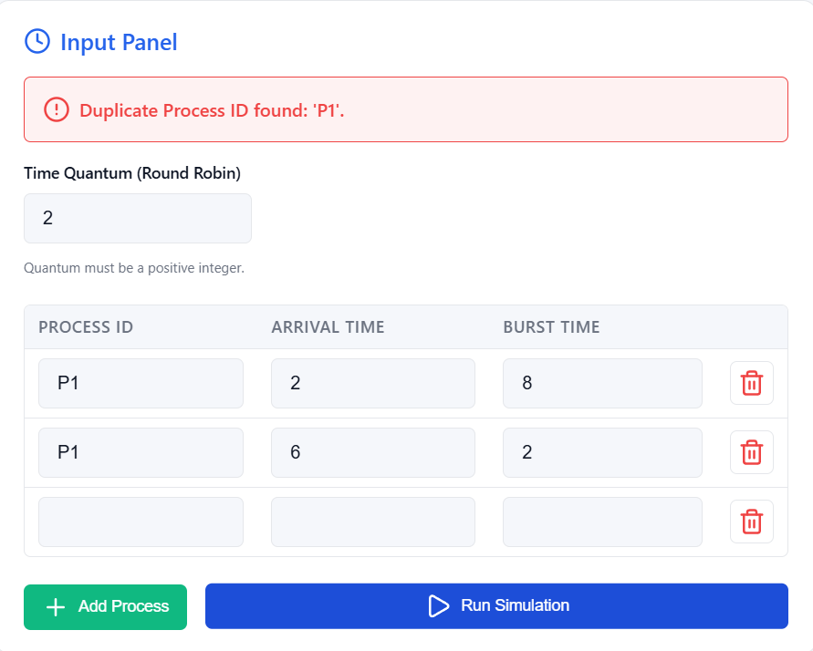
Figure 9.5d – Input Validation: Duplicate PID Error

10. Results and Discussion
The simulation results across all five scenarios confirm consistent, theoretically predictable behaviour for both algorithms.

Metric | Round Robin | SJF (Non-Preemptive) | Observation
Average Waiting Time | Higher | Lower | SJF optimal by design
Average Turnaround Time | Higher | Lower | SJF faster completion
Average Response Time | Lower | Higher | RR serves all processes early
Fairness | High | Low | RR distributes CPU evenly
Starvation Risk | None | Possible | SJF may starve long processes

Key Findings
Fairness
RR guarantees every process receives periodic CPU access regardless of burst length. SJF systematically biases toward shorter jobs, leaving long processes waiting in short-job-heavy workloads.
Average Waiting Time
SJF consistently achieved lower average WT across all scenarios, confirming its theoretical optimality for non-preemptive algorithms.
Average Response Time
RR delivered better average RT because every process receives its first CPU slot within the first full round — making it well-suited to interactive workloads.
Long-Job Handling
Under RR, long processes continued to receive CPU time each round. Under SJF (Scenario 4), the long process was deferred until all shorter jobs completed, demonstrating clear starvation.

11. Conclusion
This project successfully implemented, evaluated, and compared Round Robin and SJF (Non-Preemptive) CPU scheduling algorithms through a Python simulation tool with Gantt chart visualisation, metric computation, and robust input validation.
SJF proved more efficient in terms of average waiting and turnaround times, confirming its theoretical optimality for non-preemptive scheduling. It is best suited to batch environments where burst times are known in advance and throughput is the primary goal. Its key limitation is the risk of starvation for longer processes.
Round Robin provided superior fairness and response times by guaranteeing all processes receive regular CPU access. It is the preferred choice for interactive and time-sharing systems where responsiveness matters more than raw efficiency. The time quantum is a critical tuning parameter: small quanta improve fairness but increase context-switch overhead; large quanta reduce overhead but degrade responsiveness. Neither algorithm is universally superior — the right choice depends on the workload type and the system's primary objectives.

12. Comparison Analysis
Metric | Round Robin | SJF (Non-Preemptive) | Winner
Avg. Waiting Time | Higher | Lower | SJF ✔
Avg. Turnaround Time | Higher | Lower | SJF ✔
Avg. Response Time | Lower | Higher | RR ✔
Fairness | High | Low | RR ✔
Starvation Risk | None | Possible | RR ✔
Short-Job Efficiency | Moderate | High | SJF ✔
Long-Job Handling | Bounded wait | May starve | RR ✔
Recommended For | Interactive / time-sharing | Batch processing | Context-dependent

Required Analysis Questions
- Which algorithm gave lower average waiting time? SJF (Non-Preemptive) gave lower average waiting time across all four test scenarios. By always selecting the shortest available job, SJF minimises the time other processes spend waiting — this is its defining theoretical advantage over RR.
- Which algorithm gave lower average response time? Round Robin gave lower average response time. Because every process receives its first CPU slot within the first full round (bounded by (N−1)×Q milliseconds), no process waits long before its first execution begins — a major advantage in interactive workloads.
- Did Round Robin appear fairer across all processes? Yes. Round Robin distributed CPU time evenly regardless of burst length. In Scenario 4 (one very long job vs. three short jobs), the long process (P1) continued receiving CPU access every round — its waiting time remained bounded. Under SJF in the same scenario, P1 was deferred entirely until all shorter jobs completed, confirming RR’s superior fairness.
- Did SJF complete short jobs more efficiently? Yes. In Scenario 2 (short-job-heavy workload), SJF cleared all four short processes (P2–P5) before touching the long one (P1), achieving optimal average waiting time for the workload as a whole. Each short process ran to completion with minimal queuing delay, demonstrating SJF’s efficiency advantage for batch-style workloads.
- How did the chosen quantum affect Round Robin behavior? The quantum had a direct impact on both fairness and overhead. In Scenario 2 (Q=2), the small quantum kept response times low and ensured all processes progressed quickly — RR outperformed SJF on all three metrics. In Scenario 4 (Q=5), a larger quantum allowed P1 to make more progress per round, reducing context switches and keeping its waiting time reasonable. A smaller quantum always improves responsiveness but increases the total number of context switches; a larger quantum reduces overhead but can make RR behave more like FCFS.
- Which algorithm would you recommend for the tested workload, and why? The recommendation depends on the workload type. For mixed and long-job workloads (Scenarios 1, 4), Round Robin is preferable because it prevents starvation and keeps all processes progressing. For short-job-heavy and batch workloads (Scenarios 2, 3), SJF delivers better throughput and lower average waiting time. Given that the tested scenarios include starvation-prone cases, Round Robin is the safer general-purpose choice, while SJF is better suited where burst times are predictable and starvation is not a concern.

Required Conclusion
- Algorithm performance per metric: SJF achieved lower average waiting time and lower average turnaround time in all four workload scenarios. Round Robin achieved lower average response time in all scenarios, ensuring every process received its first CPU slot quickly.
- Round Robin appeared more balanced: Across all scenarios, Round Robin distributed CPU time evenly among all processes regardless of burst length. No process was ever blocked from making progress, and waiting times were more uniform across the process set. This balance is especially visible in Scenarios 3 and 4, where RR prevented any single process from dominating or being delayed indefinitely.
- SJF appeared more efficient: SJF consistently minimised total waiting and turnaround time by draining the shortest available jobs first. In Scenarios 1 and 2, it outperformed RR on both WT and TAT by a significant margin. Its efficiency is theoretically optimal for non-preemptive scheduling, making it the superior choice for throughput-focused environments where all burst times are known in advance.
- Effect of the selected quantum: The time quantum directly shaped Round Robin’s behaviour in every scenario. Smaller quanta (Q=2 in Scenario 2) produced lower response times and tighter fairness, allowing RR to outperform SJF on all three metrics for that workload. Larger quanta (Q=5 in Scenario 4) reduced context-switch overhead and allowed longer processes to make more progress per round, but at the cost of slower response for other processes. Selecting the right quantum is therefore critical: it must balance responsiveness against scheduling overhead for the specific workload at hand.

