

北 京 科 技 大 学

生产实习报告

学 院 数理学院
专业班级 信计182
姓 名 张宇洋
学 号 41821219
指导教师 吕国才

2021年7月
说 明

- 生产实习是本科教学重要的实践教学环节，是提高学生应用能力的重要措施。所有参加生产实习的学生都必须撰写实习报告
- 生产实习报告的质量反映了生产实习的教学质量，它是评定生产实习成绩的主要依据之一。不交实习报告者不得参加实习成绩评定。
- 实习报告要求条理清晰，内容详尽，数据准确。
- 生产实习活动结束后请将本报告上交学院存档保存。

报告一、机器学习
- 开发语言和环境
1、开发技术：numpy、pandas、sklearn
2、开发环境：python3、spyder、macOS
- 系统分析
1、需求分析：为矿石数据集做二分类的预测模型
2、系统结构：
数据结构：声纳数据集（Sonar Dataset）------- sonar.all-data.csv
一共有208 个观察值，60 个输入变量（不同的声呐探测数据）和1 个输出变量（分类结果，
M为金属，R 为岩石）。各输入变量的数据类型均为float64。
数据处理方法：利用train_test_split函数将数据分成训练集与测试集，在训练集上进行模型训练，并在测试集上进行模型评估。
所用算法：8种机器学习常用的分类回归算法，SVM、EM、Kmeans、Kneighbors、Cart、C4.5、AdaBoost、NaiveBayes
- 主要代码：
- 算法流程图
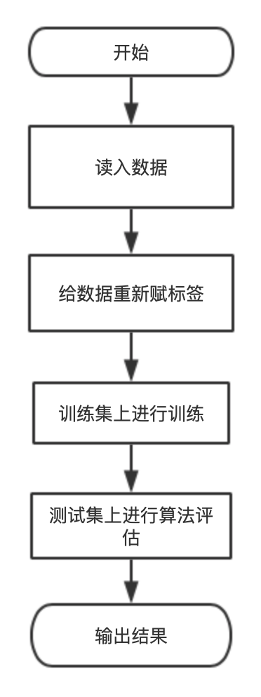
2.程序代码
import pandas as pd
import numpy as np
from sklearn.model_selection import train_test_split
from sklearn.metrics import confusion_matrix
from sklearn import metrics
import matplotlib.pyplot as plt
from sklearn.metrics import accuracy_score

fname = 'sonar.all-data.csv'
raw_data = pd.read_csv(fname)
data = raw_data.values
X = np.array(data[:, 0:60])
Y = np.array(data[:, 60])
Y_to_int = []
for i in range(0, len(Y)):
if Y[i] == 'R':
Y_to_int.append(0)
else:
Y_to_int.append(1)
Y = np.array(Y_to_int)
test_size = 0.2
seed = 0
X_train,X_test,Y_train,Y_test = train_test_split(X, Y, test_size = test_size, random_state = seed)

########################### SVM ###############################
from sklearn import svm
svm = svm.SVC(kernel = 'rbf', gamma = 1, C = 1).fit(X_train, Y_train)s
vm_pred = svm.predict(X_test)
#accuracy_svm = svm.score(X_test, Y_test)
#print("Accuracy of SVM Radial Basis Kernel:", accuracy_svm)
accuracy_svm = metrics.f1_score(Y_test, svm_pred, average = 'weighted')
print("F1 of SVM:", accuracy_svm)

########################### EM ###############################
from sklearn.mixture import GaussianMixturegm = GaussianMixture(n_components = 2, random_state = 0).fit(X_train, Y_train)gm_pred = gm.predict(X_test)accuracy_gm = gm.score(X_test, Y_test)
#accuracy_em = accuracy_score(Y_test, gm_pred)
#print("Result of EM:", accuracy_em)
accuracy_em = metrics.f1_score(Y_test, gm_pred, average = 'weighted')
print("F1 of EM:",accuracy_em)

########################### Kmeans ##############################
from sklearn.cluster import KMeans
kmeans = KMeans(n_clusters = 2, random_state = 0).fit(X_train, Y_train)
kmeans_pred = kmeans.predict(X_test)
accuracy_kmeans = metrics.f1_score(Y_test, kmeans_pred, average = 'weighted')
print("F1 of K-Means:", accuracy_kmeans)

########################### KNeighbors ##########################
from sklearn.neighbors import KNeighborsClassifier
neigh = KNeighborsClassifier(n_neighbors=3).fit(X_train, Y_train)
neigh_pred = neigh.predict(X_test)
accuracy_knn = metrics.f1_score(Y_test, neigh_pred, average = 'weighted')
print("F1 of KNN:", accuracy_knn)

########################### Cart ############################
from sklearn import tree
cart = tree.DecisionTreeClassifier().fit(X_train, Y_train)
cart_pred = cart.predict(X_test)
accuracy_cart = metrics.f1_score(Y_test, cart_pred, average = 'weighted')
print("F1 of Cart:", accuracy_cart)

########################### C4.5 ##########################
from sklearn import treec45 = tree.DecisionTreeClassifier(criterion="entropy").fit(X_train, Y_train)
c45_pred = c45.predict(X_test)
accuracy_c45 = metrics.f1_score(Y_test, c45_pred, average = 'weighted')
print("F1 of C4.5:", accuracy_c45)

########################## AdaBoost #######################
from sklearn.ensemble import AdaBoostClassifier
ada = AdaBoostClassifier(n_estimators=100, random_state=0).fit(X_train, Y_train)
ada_pred = ada.predict(X_test)
accuracy_ada = metrics.f1_score(Y_test, ada_pred, average = 'weighted')
print("F1 of AdaBoost:", accuracy_ada)

################### ###### naive_bayes ########################
from sklearn.naive_bayes import GaussianNB
naive_bayes = GaussianNB().fit(X_train, Y_train)
naive_bayes_pred = ada.predict(X_test)accuracy_
naive_bayes = metrics.f1_score(Y_test, naive_bayes_pred, average = 'weighted') print("F1 of Naive Bayes:", accuracy_naive_bayes)

- 总结：
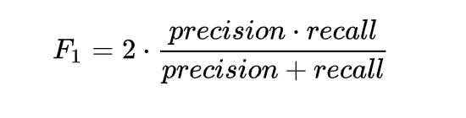
利用F1值进行算法评估，得到各种算法的F1值如下：
F1 of SVM: 0.8330484330484331
F1 of EM: 0.4366471734892786
F1 of K-Means: 0.5468457468457469
F1 of KNN: 0.7838659328021029
F1 of Cart: 0.6788897377132672
F1 of C4.5: 0.7062184873949579
F1 of AdaBoost: 0.7282913165266107
F1 of Naive Bayes: 0.7282913165266107
可以看出在声纳数据上，带有rbf核函数的SVM效果比较好。
报告二、深度学习
- 开发语言和环境
1、开发技术：numpy、pandas、sklearn
2、开发环境：python3、spyder、macOS
- 系统分析
1、需求分析：解决手写数字集的识别问题，以及猫狗大战中对生活场景下猫和狗图片的识别。
2、系统结构：
基本流程：
神经网络：
1. 获取数据，并做一定的预处理
2. 构建神经网络，初始化权重参数，准备开始训练
3. 将数据分成若干批次，代入模型跑一次前向运算并计算损失函数
4. 反向传播求偏导数，得到损失函数对权重的梯度
5. 使用优化算法修改权重，得到下一次前向传播的权重
6. 重复3~5步，每完成一个epoch输出一次预测结果
7. 完成设定次数的epoch后训练完成，得到最终模型，在此基础上对网 络加以改进
所用数据集：
MNIST手写数字识别数据集

- 主要代码：
1.BP神经网络基本构造：
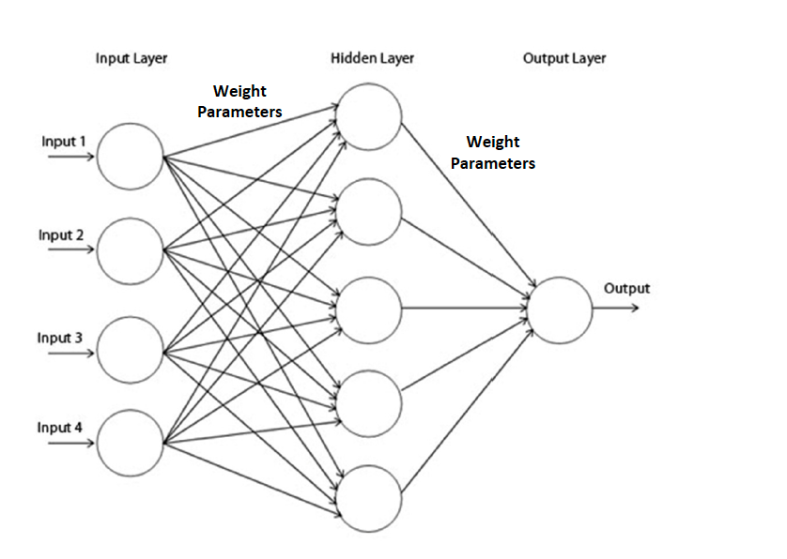
- 卷积神经网络LeNet-5：
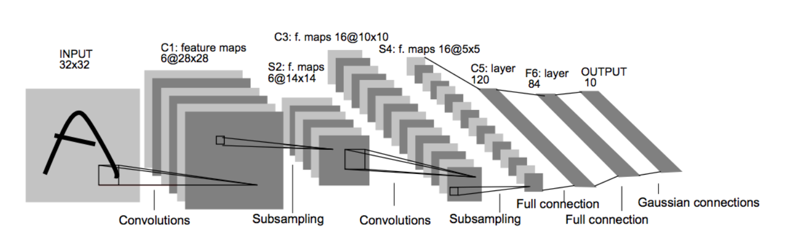
3.算法流程
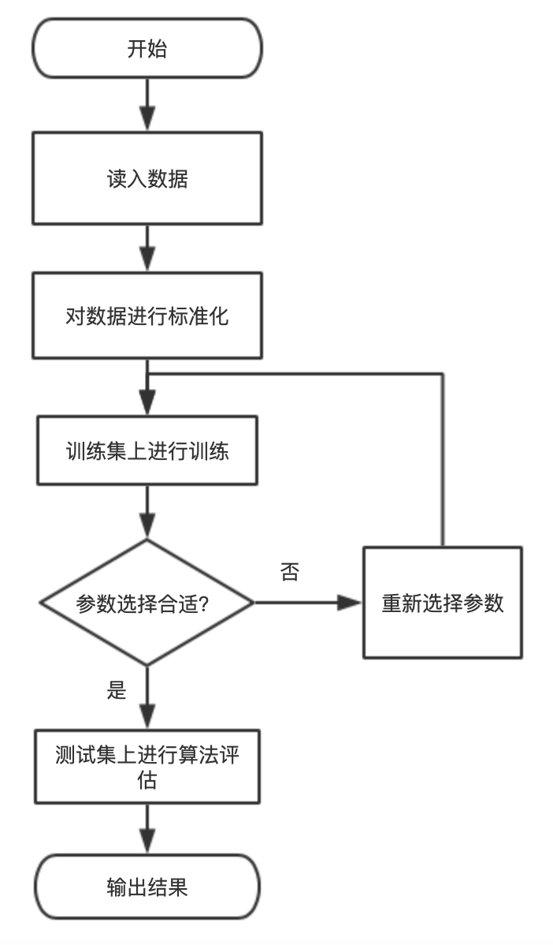
- 程序代码
1.BP神经网络
#!/usr/bin/env python3
# -*- coding: utf-8 -*-
"""
Created on Tue Jul 13 17:17:25 2021
@author: zyy
"""
import pandas as pd
import numpy as np
from sklearn.model_selection import train_test_split
from sklearn.metrics import confusion_matrix
from sklearn import metrics
import matplotlib.pyplot as plt
from sklearn.metrics import accuracy_score
import struct,os
from array import array as pyarray
from numpy import append, array, int8, uint8, zeros
from sklearn.neural_network import MLPClassifier
from sklearn.metrics import accuracy_score,classification_report
def load_mnist(image_file, label_file, path = "."):
digits = np.arange(10)

fname_image = os.path.join(path, image_file)
fname_label = os.path.join(path, label_file)

flbl = open(fname_label, 'rb')
# >：大端
# I unsignedint
magic_nr, size = struct.unpack(">II", flbl.read(8))
# b signedchar
lbl = pyarray("b", flbl.read())
flbl.close()

fimg = open(fname_image, 'rb')

magic_nr, size, rows, cols = struct.unpack(">IIII", fimg.read(16))
# B unsigned char
img = pyarray("B", fimg.read())
fimg.close()

images = zeros((size, rows*cols), dtype = uint8)
labels = zeros((size, 1), dtype = int8)
for i in range(size):
images[i] = array(img[ i *rows*cols : (i+1)*rows*cols ]).reshape((1, rows*cols))
labels[i] = lbl[i]

return images, labels

if __name__=="__main__":
train_image, train_label = load_mnist("train-images.idx3-ubyte", "train-labels.idx1-ubyte")
test_image, test_label = load_mnist("t10k-images.idx3-ubyte", "t10k-labels.idx1-ubyte")
train_image = [im/255.0 for im in train_image]
test_image = [im/255.0 for im in test_image]

# alpha = 0.0001
clf = MLPClassifier(solver = 'adam', max_iter = 100, alpha = 1e-3, hidden_layer_sizes = (50,20), random_state = 1, verbose = True)
clf.fit(train_image, train_label)
# 模型效果获取
r = clf.score(train_image, train_label)
print("训练集准确率: %.4lf" % r)
predict = clf.predict(test_image)
print("预测集准确率: %.4lf" % accuracy_score(predict,test_label))

- 卷积神经网络LeNet-5
#!/usr/bin/env python3
# -*- coding: utf-8 -*-
"""
Created on Sun Jul 18 12:41:41 2021
@author: zyy
"""

import gzip
import numpy as np
import pandas as pd
from time import time
from sklearn.model_selection import train_test_split
import tensorflow as tf
import keras
import keras.layers as layers
from keras.models import Sequential
from keras.preprocessing.image import ImageDataGenerator
from keras.utils.np_utils import to_categorical
from keras.callbacks import TensorBoard

def read_mnist(images_path: str, labels_path: str):
with gzip.open(labels_path, 'rb') as labelsFile:
labels = np.frombuffer(labelsFile.read(), dtype=np.uint8, offset=8)

with gzip.open(images_path,'rb') as imagesFile:
length = len(labels)
# Load flat 28x28 px images (784 px), and convert them to 28x28 px
features = np.frombuffer(imagesFile.read(), dtype=np.uint8, offset=16) \
.reshape(length, 784) \
.reshape(length, 28, 28, 1)

return features, labels

import matplotlib.pyplot as pltimport seaborn as snssns.set()

train = {}
test = {}
from keras.datasets import mnist
#(train['features'], train['labels']),(test['features'], test['labels']) = mnist.load_data()
train['features'], train['labels'] = read_mnist('train-images-idx3-ubyte.gz', 'train-labels-idx1-ubyte.gz')
test['features'], test['labels'] = read_mnist('t10k-images-idx3-ubyte.gz', 't10k-labels-idx1-ubyte.gz')

print('# of training images:', train['features'].shape[0])print('# of test images:', test['features'].shape[0])

def display_image(position):
image = train['features'][position].squeeze()
plt.title('Example %d. Label: %d' % (position, train['labels'][position]))
plt.imshow(image, cmap=plt.cm.gray_r)
display_image(0)display_image(1)
train_labels_count = np.unique(train['labels'], return_counts=True)
dataframe_train_labels = pd.DataFrame({'Label':train_labels_count[0], 'Count':train_labels_count[1]})
validation = {}
train['features'], validation['features'], train['labels'], validation['labels'] = train_test_split(train['features'], train['labels'], test_size=0.2, random_state=0)

print('# of training images:', train['features'].shape[0])
print('# of validation images:', validation['features'].shape[0])

# Pad images with 0s
train['features'] = np.pad(train['features'], ((0,0),(2,2),(2,2),(0,0)), 'constant')
validation['features'] = np.pad(validation['features'], ((0,0),(2,2),(2,2),(0,0)), 'constant')
test['features'] = np.pad(test['features'], ((0,0),(2,2),(2,2),(0,0)), 'constant')

print("Updated Image Shape: {}".format(train['features'][0].shape))

model = keras.Sequential()
model.add(layers.Conv2D(filters=6, kernel_size=(5, 5), activation='relu', input_shape=(32,32,1)))
model.add(layers.AveragePooling2D())
model.add(layers.Conv2D(filters=16, kernel_size=(5, 5), activation='relu'))
model.add(layers.AveragePooling2D())
model.add(layers.Flatten())
model.add(layers.Dense(units=120, activation='relu'))
model.add(layers.Dense(units=84, activation='relu'))
model.add(layers.Dense(units=10, activation = 'softmax'))
model.summary()
model.compile(loss=keras.losses.categorical_crossentropy, optimizer=keras.optimizers.Adam(), metrics=['accuracy'])
EPOCHS = 10
BATCH_SIZE = 128
X_train, y_train = train['features'], to_categorical(train['labels'])
X_validation, y_validation = validation['features'], to_categorical(validation['labels'])
train_generator = ImageDataGenerator().flow(X_train, y_train, batch_size=BATCH_SIZE)
validation_generator = ImageDataGenerator().flow(X_validation, y_validation, batch_size=BATCH_SIZE)

print('# of training images:', train['features'].shape[0])
print('# of validation images:', validation['features'].shape[0])
steps_per_epoch = X_train.shape[0]//BATCH_SIZE
validation_steps = X_validation.shape[0]//BATCH_SIZE
tensorboard = TensorBoard(log_dir="logs/{}".format(time()))
model.fit_generator(train_generator, steps_per_epoch=steps_per_epoch, epochs=EPOCHS,
validation_data=validation_generator,validation_steps=validation_steps,
shuffle=True, callbacks=[tensorboard])
score = model.evaluate(test['features'], to_categorical(test['labels']))
print('Test loss:', score[0])
print('Test accuracy:', score[1])

- 总结：
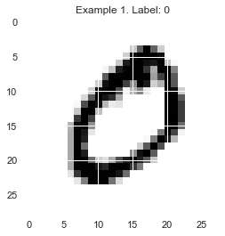
神经网络训练过程（70次迭代之后）
Iteration 70, loss = 0.00365914
Iteration 71, loss = 0.00362521
Iteration 72, loss = 0.00357932
Iteration 73, loss = 0.01018362
Iteration 74, loss = 0.02372291
Iteration 75, loss = 0.00735141
Iteration 76, loss = 0.00497743
Iteration 77, loss = 0.00406544
Iteration 78, loss = 0.00374507
Iteration 79, loss = 0.00359304
Iteration 80, loss = 0.00409540
Iteration 81, loss = 0.00373427
Training loss did not improve more than tol=0.000100 for 10 consecutive epochs. Stopping.
训练集准确率: 1.0000
预测集准确率: 0.9754

LeNet-5:
# of training images: 60000
# of test images: 10000
# of training images: 48000
# of validation images: 12000
Updated Image Shape: (32, 32, 1)
Model: "sequential_1"
_________________________________________________________________
Layer (type) Output Shape Param #
=================================================================
conv2d_2 (Conv2D) (None, 28, 28, 6) 156
_________________________________________________________________
average_pooling2d_2 (Average (None, 14, 14, 6) 0
_________________________________________________________________
conv2d_3 (Conv2D) (None, 10, 10, 16) 2416
_________________________________________________________________
average_pooling2d_3 (Average (None, 5, 5, 16) 0
_________________________________________________________________
flatten_1 (Flatten) (None, 400) 0
_________________________________________________________________
dense_3 (Dense) (None, 120) 48120
_________________________________________________________________
dense_4 (Dense) (None, 84) 10164
_________________________________________________________________
dense_5 (Dense) (None, 10) 850
=================================================================
Total params: 61,706
Trainable params: 61,706
Non-trainable params: 0
_________________________________________________________________
# of training images: 48000
# of validation images: 12000

375/375 [==============================] - 10s 26ms/step - loss: 1.8283 - accuracy: 0.7683 - val_loss: 0.1093 - val_accuracy: 0.9666
Epoch 2/10
375/375 [==============================] - 10s 27ms/step - loss: 0.0943 - accuracy: 0.9708 - val_loss: 0.0789 - val_accuracy: 0.9766
Epoch 3/10
375/375 [==============================] - 11s 28ms/step - loss: 0.0578 - accuracy: 0.9829 - val_loss: 0.0583 - val_accuracy: 0.9819
Epoch 4/10
375/375 [==============================] - 11s 29ms/step - loss: 0.0456 - accuracy: 0.9857 - val_loss: 0.0597 - val_accuracy: 0.9820
Epoch 5/10
375/375 [==============================] - 11s 29ms/step - loss: 0.0317 - accuracy: 0.9898 - val_loss: 0.0605 - val_accuracy: 0.9819
Epoch 6/10
375/375 [==============================] - 11s 29ms/step - loss: 0.0283 - accuracy: 0.9907 - val_loss: 0.0573 - val_accuracy: 0.9832
Epoch 7/10
375/375 [==============================] - 13s 35ms/step - loss: 0.0275 - accuracy: 0.9909 - val_loss: 0.0513 - val_accuracy: 0.9859
Epoch 8/10
375/375 [==============================] - 11s 30ms/step - loss: 0.0225 - accuracy: 0.9925 - val_loss: 0.0667 - val_accuracy: 0.9840
Epoch 9/10
375/375 [==============================] - 12s 31ms/step - loss: 0.0225 - accuracy: 0.9926 - val_loss: 0.0564 - val_accuracy: 0.9851
Epoch 10/10
375/375 [==============================] - 12s 31ms/step - loss: 0.0185 - accuracy: 0.9941 - val_loss: 0.0562 - val_accuracy: 0.9852
313/313 [==============================] - 1s 2ms/step - loss: 0.0403 - accuracy: 0.9880
Test loss: 0.040332358330488205
Test accuracy: 0.9879999756813049

可以看到在0.001的误差水平下，模型在81次迭代时就已经收敛了，并且在训练集上的准确率接近1，但是模型预测效果依然比较好，所以并没有发生比较严重的过拟合现象，可能是由于神经网络的参数比较多，拟合模型所需数据量比较大，并没有那么容易发生过拟合。
可以看出LeNet-5的效果也不错，并且更加迅速，准确率略高，当然调节BP神经网络的结果也能达到类似的效果但是训练时间比较长
报告三、社交网络
- 开发语言和环境
1、开发技术：numpy、pandas、sklearn
2、开发环境：python3、spyder、Ubuntu
- 系统分析
1、需求分析：从《权力的游戏》的关系背景出发，通过图论的基础发现社区的存在，并度量各种中心性，划分出最短路径。
2、系统结构：
算法流程：
1. 读取数据，构建关系图
2. 计算各类指标并输出
3. 划分社区
所用数据：
权利的游戏人物关系表
- 主要代码：
主要流程：
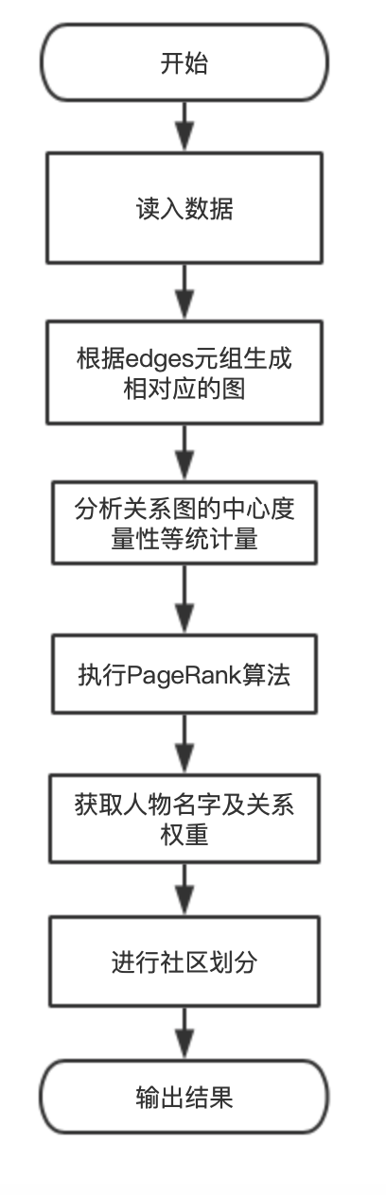

#!/usr/bin/env python3
# -*- coding: utf-8 -*-
"""
Created on Fri Jul 16 15:13:37 2021
@author: zyy
"""
import csv
from igraph import Graph as IGraph
# read data and skip first line items# save data in edges
def read_data(filename):
edges = []
firstline = True
with open(filename,'r',encoding = 'utf-8') as f:
for row in csv.reader(f.read().splitlines()):
if firstline == True:
firstline = False
continue
u, v, weight = [i for i in row]
edges.append((u,v,int(weight)))
return edges

# Using package IGraph TupleList function, generate graph depends on tuple edges
# undirected
def get_igraph(edges):
g = IGraph.TupleList(edges = edges, directed = False, vertex_name_attr = "name", \
edge_attrs = None, weights = True)
return g

# Get Game of Thrones characters name and relation weight
# output 10 items
def get_graphData(graph):
names = graph.vs["name"]
weights = graph.es["weight"]
print('Character name :', names[:10])
print('Relation weight :', weights[:10])
return names, weights

# Degree Centrality
def Degree_Centrality(g):
p = list(zip(g.vs['name'],g.vs.degree()))
p_sort = sorted(p,key = lambda p:p[1], reverse = True)
return p_sort

# Weighted Degree Centrality
def Weighted_Degree_Centrality(g,edges):
WDC = []
for p in g.vs:
neighbors = [x['name'] for x in p.neighbors()]
weightedDegree = sum([w for a, b, w in edges for c in neighbors \
if (a == p['name']) and b == c or (b == p['name'] and a == c)])
WDC.append([p['name'], weightedDegree])
WDC_sort = sorted(WDC, key = lambda p:p[1], reverse = True)
return WDC_sort

# Neighbor Average Degree
def Neighbor_Average_Degree(g):
p = list(zip(g.vs['name'], g.knn()[0]))
p_sort = sorted(p, key = lambda p:p[1], reverse = True)
return p_sort

# Betweenness Centrality
def Betweenness_Centrality(g):
p = list(zip(g.vs['name'], g.betweenness()))
p_sort = sorted(p, key = lambda p:p[1], reverse = True)
return p_sort

# Closeness Centrality
def Closeness_centrality(g):
p = list(zip(g.vs['name'], g.closeness()))
p_sort = sorted(p, key = lambda p:p[1], reverse = True)
return p_sort

# PageRank
def PageRank(g):
p = list(zip(g.vs['name'], g.pagerank()))
p_sort = sorted(p, key = lambda p:p[1], reverse = True)
return p_sort

# Community Detection
def Community_Detection(g):
clusters = IGraph.community_walktrap(g, weights = "weight").as_clustering()
n = len(clusters.sizes())
for i in range(n):
print('Community', i, ":", [g.vs['name'][j] for j in clusters[i]])
return clusters

if __name__ == '__main__':
# read data
edges = read_data('stormofswords.csv')
# generate graph
g = get_igraph(edges)

# characters name and relation weight
names, weights = get_graphData(g)

# Analyze
print('--------------------------------------------------')
# Number Of Characters
print('Number of Characters: ', g.vcount())
# The Role on The Diameter
print('The Network Diameter: ', g.diameter())
print('The Role on The Diameter: ', [names[x] for x in g.get_diameter()])

print('--------------------------------------------------')
# Get Shortest Path Using Function of IGraph , get_shortest_paths and get_all_shortest_paths
print('The Length of Shortest Path From Catelyn to Drogo :', \
g.get_shortest_paths('Catelyn','Drogo')[0])

print('The Shortest Path From Catelyn to Drogo :', [names[x] \
for x in g.get_shortest_paths('Catelyn', 'Drogo')[0]])
print('\r All Shortest Path From Catelyn to Drogo :')
paths = g.get_all_shortest_paths('Catelyn', 'Drogo')
for p in paths:
print([names[x] for x in p])

print('--------------------------------------------------')

# Degree Centrality
print('Degree Centrality: ', Degree_Centrality(g)[:10])
print('Weighted Degree Centrality: ', Weighted_Degree_Centrality(g, edges)[:10])
print('Neighbor Average Degree: ', Neighbor_Average_Degree(g)[:10])
print('Betweenness Centrality: ', Betweenness_Centrality(g)[:10])
print('Closeness centrality: ', Closeness_centrality(g)[:10])
print('PageRank Alg: ', PageRank(g)[:10])

print('--------------------------------------------------')
print('Community Detection: ', Community_Detection(g))

- 总结：
人物网络：
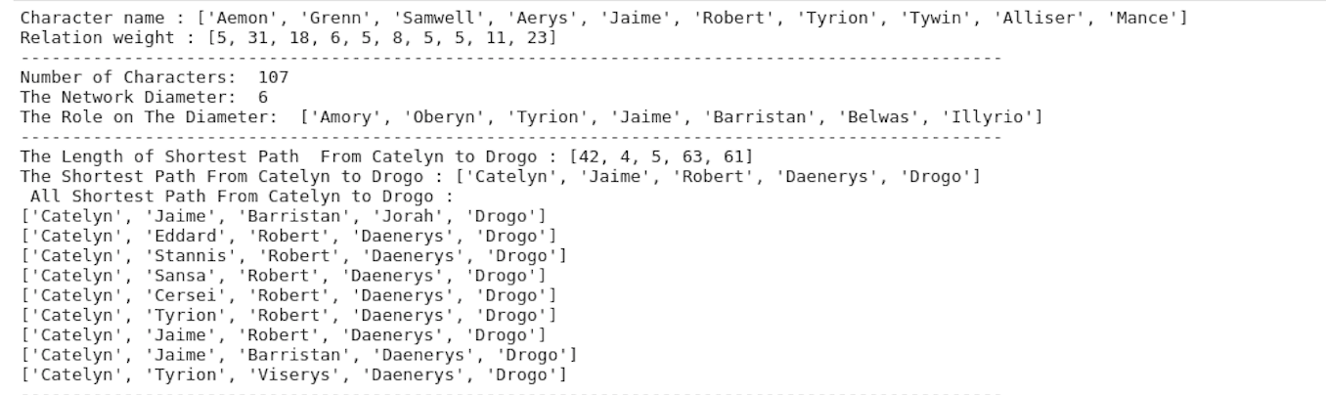

度中间性：
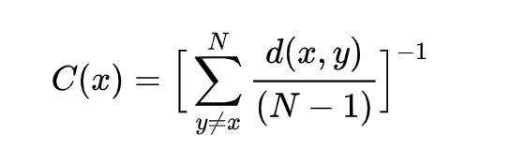
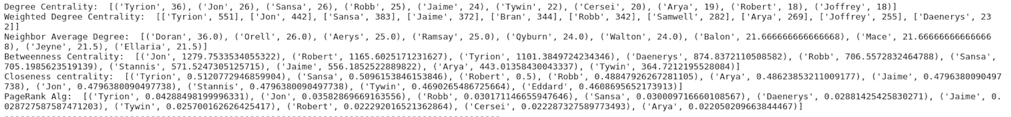
社区划分：
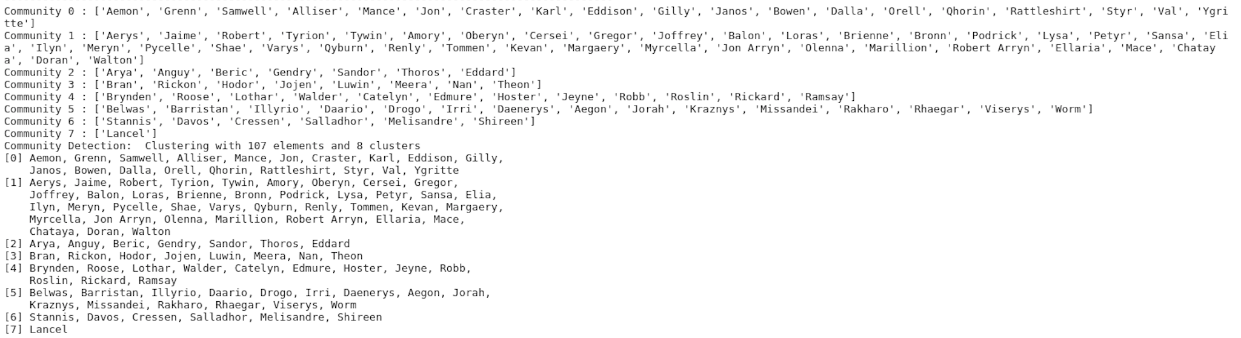
在实验过程中安装igraph的包可能会遇到问题，首先igraph与python-igraph不能共存，需要卸载python-igraph包，如果使用Linux系统不会遇到其他问题，如果使用windows系统，由于此包已经不再被官方支持，属于旧包我们需要自己手动安装，首先运行pip debug --verbose 命令查看pip支持whl版本，然后再登陆https://www.fld.uci.edu/~gohlke/pythonlibs下载支持的python-igraph与pycairo再利用pip手动安装即可以解决问题。
报告四、数据分析
- 开发语言和环境
1、开发技术：numpy、pandas、sklearn
2、开发环境：python3、spyder、macOS
- 系统分析
1、需求分析：为波士顿房价做回归预测模型
2、系统结构：
数据结构：
波士顿房价数据集（Boston House Proce）------- housing.csv
该数据集中每一行数据都是对波士顿周边或城镇房价的描述，是1978 年统计收集
的，数据中包含14 个特征和506 条数据。其中前13 个特征为输入变量，第14 个
特征为输出变量。
所用算法：
线性算法：LA、LASSO、EN，非线性算法CART、SVM、KNN，并选择集成学习
种Bagging的中的RF和ET算法，与Boosting中的Ada、GBM算法。
- 主要代码：
1.主要流程
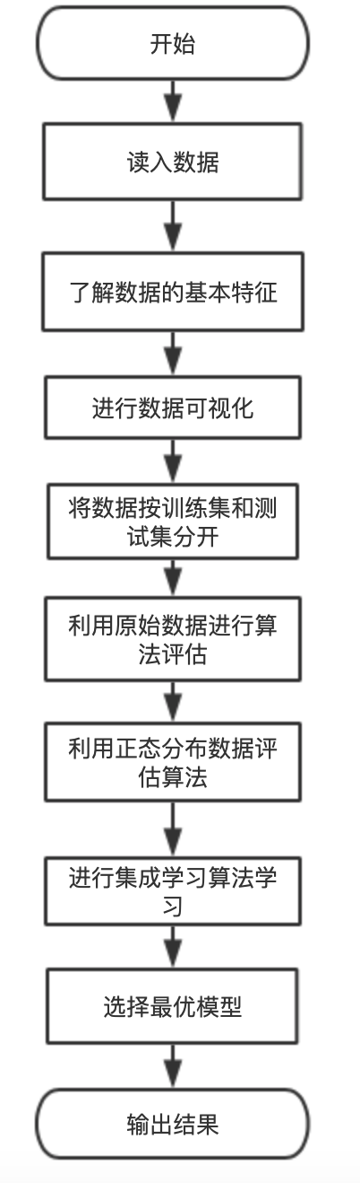
2.程序代码
#!/usr/bin/env python3
# -*- coding: utf-8 -*-
"""
Created on Fri Jul 16 01:58:22 2021
@author: zyy
"""

import numpy as np
from numpy import arange
from matplotlib import pyplot
from pandas import read_csv
from pandas import set_option
from pandas.plotting import scatter_matrix
from sklearn.preprocessing import StandardScaler
from sklearn.model_selection import train_test_split
from sklearn.model_selection import KFold
from sklearn.model_selection import cross_val_score
from sklearn.model_selection import GridSearchCV
from sklearn.linear_model import LinearRegression
from sklearn.linear_model import Lasso
from sklearn.linear_model import ElasticNet
from sklearn.tree import DecisionTreeRegressor
from sklearn.neighbors import KNeighborsRegressor
from sklearn.svm import SVR
from sklearn.pipeline import Pipeline
from sklearn.ensemble import RandomForestRegressor
from sklearn.ensemble import GradientBoostingRegressor
from sklearn.ensemble import ExtraTreesRegressor
from sklearn.ensemble import AdaBoostRegressor
from sklearn.metrics import mean_squared_error

# import data
filename = '02-boston_house_prices.csv'
names = ['CRIM','ZN','INDUS','CHAS','NOX','RM','AGE','DIS','RAD','TAX','PRTATTO','B', 'LSTAT','MEDV']
dataset = read_csv(filename, names = names,encoding = 'utf-8', header = 1)
# out
# print data dim
print(dataset.shape)
# check data type
print(dataset.dtypes)
#dataset['CRIM'] = dataset['CRIM'].astype(np.float)
# check 10 head
print(dataset.head(10))

print('DATA decribe:')
print(dataset.describe())

print('Pearson Corr:')
print(dataset.corr(method='pearson'))

######################################################################### # Data Visualization
#########################################################################

# Histogram
dataset.hist(sharex = False, sharey = False, xlabelsize = 1, ylabelsize = 1)
pyplot.show()

# Density
dataset.plot(kind ='density',subplots = True, layout=(4,4), sharex = False, fontsize = 1)
pyplot.show()

# Boxplot
dataset.plot(kind ='box', subplots = True, layout = (4,4), sharex = False, sharey = False, fontsize = 8)
pyplot.show()

# Scatter Matrix
scatter_matrix(dataset)
pyplot.show()

# Correlation matrix
fig = pyplot.figure()
ax = fig.add_subplot(111)
ca = ax.matshow(dataset.corr(), vmin = -1, vmax = 1, interpolation = 'none')
fig.colorbar(cax)
ticks = np.arange(0, 14, 1)
ax.set_xticks(ticks)
ax.set_yticks(ticks)
labels(names)
pyplot.show()

# Split
array = dataset.values
X = array[:, 0:13]
Y = array[:, 13]
validation_size = 0.2
seed = 7
X_train, X_validation, Y_train, Y_validation = train_test_split(X, Y,test_size = validation_size, random_state = seed, shuffle = True)

# 10 flod check, using NMSE Function Evaluate
num_folds = 10
seed = 7
scoring = 'neg_mean_squared_error'

# Linear Model:
# Linear Regression（LR）
# least absolute shrinkage and selection（LASSO）
# ElasticNet（EN）
models = {}
models['LR'] = LinearRegression()
models['LASSO'] = Lasso()
models['EN'] = ElasticNet()
# non-Linear Model：
# Classification And Regression Tree（CART）
# Support vector machine（SVM）
# k-nearest neighbors （KNN）
models['KNN'] = KNeighborsRegressor()
models['CART'] = DecisionTreeRegressor()
models['SVM'] = SVR()

results = []
for key in models:
kfold = KFold(n_splits = num_folds, random_state = seed, shuffle = True)
cv_result = cross_val_score(models[key], X_train, Y_train, cv = kfold, scoring = scoring)
results.append(cv_result)
print('%13s: mean: %.4f std: %.4f' % (key, cv_result.mean(), cv_result.std()))
# Boxplot
fig = pyplot.figure()
fig.suptitle('Algorithm Comparison')
ax = fig.add_subplot(111)
pyplot.boxplot(results)
ax.set_xticklabels(models.keys())
pyplot.show()

# Evaluate
# Use normally distributed data to evaluate the model
pipelines = {}
pipelines['ScalerLR'] = Pipeline([('Scaler', StandardScaler()), ('LR',LinearRegression())])
pipelines['ScalerLASSO'] = Pipeline([('Scaler', StandardScaler()), ('LASSO', Lasso())])
pipelines['ScalerEN'] = Pipeline([('Scaler',StandardScaler()), ('EN', ElasticNet())])
pipelines['ScalerKNN'] = Pipeline([('Scaler',StandardScaler()), ('KNN',KNeighborsRegressor())])
pipelines['ScalerCART'] = Pipeline([('Scaler',StandardScaler()), ('CART',DecisionTreeRegressor())])
pipelines['ScalerSVM'] = Pipeline([('Scaler',StandardScaler()), ('SVM', SVR())])
results = []for key in pipelines:
kfold = KFold(n_splits=num_folds, random_state = seed, shuffle = True)
cv_result = cross_val_score(pipelines[key], X_train, Y_train, cv = kfold, scoring = scoring)
results.append(cv_result)
print('%13s: mean: %.4f std: %.4f' % (key, cv_result.mean(), cv_result.std()))

# Boxplot
fig = pyplot.figure()
fig.suptitle('Algorithm Comparison')
ax = fig.add_subplot(111)
pyplot.boxplot(results)
ax.set_xticklabels(pipelines.keys())
pyplot.show()

print('\n************************* KNN *************************')
# Choice Best Neighbor Number
scaler = StandardScaler().fit(X_train)
rescaledX = scaler.transform(X_train)
param_grid = {'n_neighbors': [1, 2, 3, 4, 5, 7, 9, 11, 15, 17, 20]}
model = KNeighborsRegressor()
kfold = KFold(n_splits = num_folds, random_state = seed, shuffle = True)
grid = GridSearchCV(estimator = model, param_grid = param_grid, scoring = scoring, cv = kfold)
grid_result = grid.fit(X = rescaledX, y = Y_train)
print('Best KNN Result parameter: %s Use: %s' % (grid_result.best_score_, grid_result.best_params_))
cv_results = zip(grid_result.cv_results_['mean_test_score'],grid_result.cv_results_['std_test_score'],grid_result.cv_results_['params']
)
for mean, std, param in cv_results:
print('mean: %.4f std: %f with %r' % (mean, std, param))

############################## Enseemble ################################
# Bagging : randomForest（RF）Extremely randomized trees(ET)
# Boosting：AdaBoost（Ada）Gradient Boosting Machin（GBT）###########################################################################
print('\n*********************** Bagging *************************')
ensembles = {}
# CartReg
ensembles['ScaledAB'] = Pipeline([('Scaler',StandardScaler()), ('AB', AdaBoostRegressor())])
ensembles['ScaledAB-KNN'] = Pipeline([('Scaler',StandardScaler()), ('ABKNN', AdaBoostRegressor(base_estimator = KNeighborsRegressor(n_neighbors = 3)))])
ensembles['ScaledAB-LR'] = Pipeline([('Scaler',StandardScaler()), ('ABLR',AdaBoostRegressor(LinearRegression()))])
ensembles['ScaledGBR'] = Pipeline([('Scaler',StandardScaler()), ('RBR', GradientBoostingRegressor())])
# ******************** Add *************************
ensembles['ScaledAB-DR'] = Pipeline([('Scaler',StandardScaler()), ('RBR',AdaBoostRegressor(DecisionTreeRegressor()))])

ensembles['ScaledRFR'] = Pipeline([('Scaler',StandardScaler()), ('RFR', RandomForestRegressor())])
ensembles['ScaledETR'] = Pipeline([('Scaler',StandardScaler()), ('ETR', ExtraTreesRegressor())])
results = []
for key in ensembles:
kfold = KFold(n_splits = num_folds, random_state = seed, shuffle = True)
cv_result = cross_val_score(ensembles[key], X_train, Y_train, cv = kfold, scoring = scoring)
results.append(cv_result)
print('%13s: mean: %.4f std: %.4f' % (key, cv_result.mean(), cv_result.std()))
# Boxplot
fig = pyplot.figure()
fig.suptitle('Algorithm Comparison')
ax = fig.add_subplot(111)
pyplot.boxplot(results)
ax.set_xtick
labels(ensembles.keys())
pyplot.show()

# Adjustment parameters ---- GBM
print('\n************************* GBM *************************')
caler = StandardScaler().fit(X_train)
rescaledX = scaler.transform(X_train)
param_grid = {'n_estimators': [10, 50, 100, 200, 300, 400, 500, 600, 700, 800, 900]}
model = GradientBoostingRegressor()
kfold = KFold(n_splits = num_folds, random_state = seed, shuffle = True)
grid = GridSearchCV(estimator = model, param_grid=param_grid, scoring=scoring, cv = kfold)grid_result = grid.fit(X = rescaledX, y = Y_train)
print('Best GBM: %s Use :%s' % (grid_result.best_score_, grid_result.best_params_))

# Adjustment parameters ---- ET
print('\n************************* ET *************************')
scaler = StandardScaler().fit(X_train)
rescaledX = scaler.transform(X_train)
param_grid = {'n_estimators': [5, 10, 20, 30, 40, 50, 60, 70, 80, 90, 100]}
model = ExtraTreesRegressor()
kfold = KFold(n_splits = num_folds, random_state = seed, shuffle = True)
grid = GridSearchCV(estimator = model, param_grid = param_grid, scoring = scoring, cv = kfold)grid_result = grid.fit(X = rescaledX, y = Y_train)
print(' Best ET: %s USe:%s' % (grid_result.best_score_, grid_result.best_params_))

# Adjustment parameters ---- AdaDT
print('\n*************** Ada_DecisionTreeRegressor ********************')
scaler = StandardScaler().fit(X_train)
rescaledX = scaler.transform(X_train)
param_grid = {'n_estimators': [100, 120, 130, 140 ,150]}
model = AdaBoostRegressor(DecisionTreeRegressor(max_depth = 100), random_state = seed, loss='linear')
kfold = KFold(n_splits = num_folds, random_state = seed, shuffle = True)
grid = GridSearchCV(estimator = model, param_grid = param_grid, scoring = scoring, cv = kfold)grid_result = grid.fit(X = rescaledX, y = Y_train)
print(' Best Ada: %s USe:%s' % (grid_result.best_score_, grid_result.best_params_))

########################### Final Training #####################
print('\n******************* Final Training *************************')# Trainingcaler = StandardScaler().fit(X_train)
rescaledX = scaler.transform(X_train)
gbr = ExtraTreesRegressor(n_estimators = 80)
gbr.fit(X = rescaledX, y = Y_train)
# Test
rescaledX_validation = scaler.transform(X_validation)
predictions = gbr.predict(rescaledX_validation)
print('Prediction set ET', mean_squared_error(Y_validation, predictions))

# Training
caler = StandardScaler().fit(X_train)
rescaledX = scaler.transform(X_train)
gbr = GradientBoostingRegressor(n_estimators = 600)
gbr.fit(X = rescaledX, y = Y_train)
# Test
rescaledX_validation = scaler.transform(X_validation)
predictions = gbr.predict(rescaledX_validation)
print('Prediction set GBR', mean_squared_error(Y_validation, predictions))

# Training
caler = StandardScaler().fit(X_train)
rescaledX = scaler.transform(X_train)
gbr = AdaBoostRegressor(DecisionTreeRegressor(max_depth = 100), random_state=seed, loss='linear')
gbr.fit(X = rescaledX, y = Y_train)
# Test
rescaledX_validation = scaler.transform(X_validation)
predictions = gbr.predict(rescaledX_validation)
print('Prediction set AdaDR', mean_squared_error(Y_validation, predictions))

- 总结：
数据直方图：
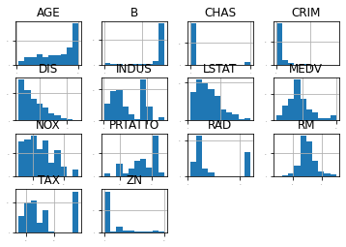
密度图：

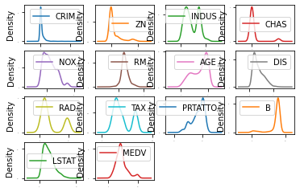
箱线图：

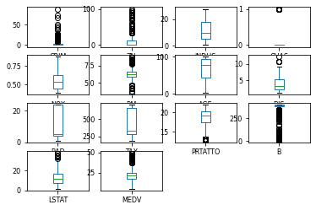
散点矩阵：
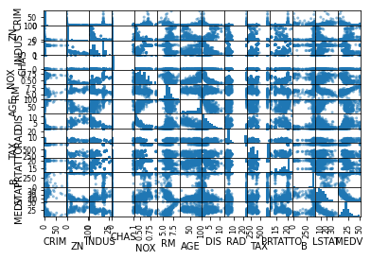
相关系数
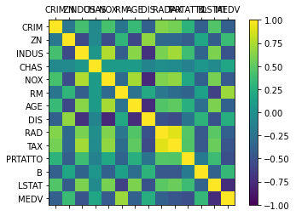
算法箱线图：
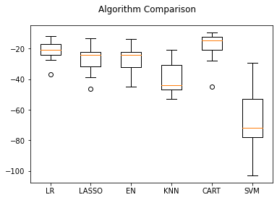
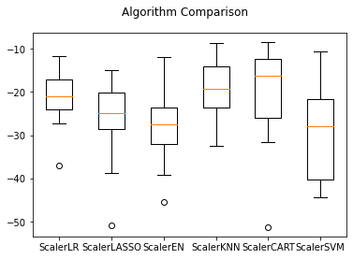

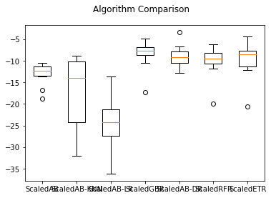

数据类型
(505, 14)
CRIM float64
ZN float64
INDUS float64
CHAS int64
NOX float64
RM float64
AGE float64
DIS float64
RAD int64
TAX int64
PRTATTO float64
B float64
LSTAT float64
MEDV float64
dtype: object
CRIM ZN INDUS CHAS NOX ... TAX PRTATTO B LSTAT MEDV
0 0.02731 0.0 7.07 0 0.469 ... 242 17.8 396.90 9.14 21.6
1 0.02729 0.0 7.07 0 0.469 ... 242 17.8 392.83 4.03 34.7
2 0.03237 0.0 2.18 0 0.458 ... 222 18.7 394.63 2.94 33.4
3 0.06905 0.0 2.18 0 0.458 ... 222 18.7 396.90 5.33 36.2
4 0.02985 0.0 2.18 0 0.458 ... 222 18.7 394.12 5.21 28.7
5 0.08829 12.5 7.87 0 0.524 ... 311 15.2 395.60 12.43 22.9
6 0.14455 12.5 7.87 0 0.524 ... 311 15.2 396.90 19.15 27.1
7 0.21124 12.5 7.87 0 0.524 ... 311 15.2 386.63 29.93 16.5
8 0.17004 12.5 7.87 0 0.524 ... 311 15.2 386.71 17.10 18.9
9 0.22489 12.5 7.87 0 0.524 ... 311 15.2 392.52 20.45 15.0

数据基本特征：
[10 rows x 14 columns]
DATA decribe:
CRIM ZN INDUS ... B LSTAT MEDV
count 505.000000 505.000000 505.000000 ... 505.000000 505.000000 505.000000
mean 3.620667 11.350495 11.154257 ... 356.594376 12.668257 22.529901
std 8.608572 23.343704 6.855868 ... 91.367787 7.139950 9.205991
min 0.009060 0.000000 0.460000 ... 0.320000 1.730000 5.000000
25% 0.082210 0.000000 5.190000 ... 375.330000 7.010000 17.000000
50% 0.259150 0.000000 9.690000 ... 391.430000 11.380000 21.200000
75% 3.678220 12.500000 18.100000 ... 396.210000 16.960000 25.000000
max 88.976200 100.000000 27.740000 ... 396.900000 37.970000 50.000000

Pearson 相关性：
[8 rows x 14 columns]
Pearson Corr:
CRIM ZN INDUS ... B LSTAT MEDV
CRIM 1.000000 -0.200283 0.406251 ... -0.384839 0.455329 -0.388249
ZN -0.200283 1.000000 -0.534022 ... 0.175319 -0.412894 0.360393
INDUS 0.406251 -0.534022 1.000000 ... -0.356506 0.602737 -0.484126
CHAS -0.056132 -0.042550 0.062350 ... 0.049040 -0.054576 0.175364
NOX 0.420934 -0.516574 0.764556 ... -0.380006 0.591262 -0.427295
RM -0.218978 0.311835 -0.391330 ... 0.127754 -0.613734 0.695365
AGE 0.352701 -0.569524 0.645543 ... -0.273486 0.602782 -0.376932
DIS -0.379627 0.664395 -0.708848 ... 0.291451 -0.497277 0.249896
RAD 0.625396 -0.311717 0.594167 ... -0.444065 0.487608 -0.381690
TAX 0.582568 -0.314351 0.720561 ... -0.441505 0.543435 -0.468543
PRTATTO 0.289394 -0.391713 0.380955 ... -0.176515 0.372148 -0.508411
B -0.384839 0.175319 -0.356506 ... 1.000000 -0.365637 0.333394
LSTAT 0.455329 -0.412894 0.602737 ... -0.365637 1.000000 -0.738187
MEDV -0.388249 0.360393 -0.484126 ... 0.333394 -0.738187 1.000000

基本算法模型训练结果
[14 rows x 14 columns]
LR: mean: -21.2606 std: 7.1240
LASSO: mean: -26.8961 std: 9.7794
EN: mean: -26.6873 std: 9.2284
KNN: mean: -40.0204 std: 11.0280
CART: mean: -18.6414 std: 10.2051
SVM: mean: -66.2907 std: 20.0101
ScalerLR: mean: -21.2606 std: 7.1240
ScalerLASSO: mean: -26.7722 std: 10.3717
ScalerEN: mean: -27.8833 std: 9.4433
ScalerKNN: mean: -19.1121 std: 7.0713
ScalerCART: mean: -21.2088 std: 12.3301
ScalerSVM: mean: -28.8106 std: 11.4886

KNN参数调整：

************************* KNN *************************
Best KNN Result parameter: -17.956190396341462 Use: {'n_neighbors': 2}
mean: -18.3584 std: 9.351399 with {'n_neighbors': 1}
mean: -17.9562 std: 9.269155 with {'n_neighbors': 2}
mean: -19.0841 std: 8.741352 with {'n_neighbors': 3}
mean: -19.7569 std: 8.300340 with {'n_neighbors': 4}
mean: -19.3263 std: 7.001439 with {'n_neighbors': 5}
mean: -19.7839 std: 7.156892 with {'n_neighbors': 7}
mean: -19.5728 std: 6.822209 with {'n_neighbors': 9}
mean: -20.0701 std: 6.939799 with {'n_neighbors': 11}
mean: -21.5848 std: 6.844447 with {'n_neighbors': 15}
mean: -22.6353 std: 7.121345 with {'n_neighbors': 17}
mean: -23.6770 std: 7.657120 with {'n_neighbors': 20}

Bagging算法结果输出：
************************* Bagging *************************
ScaledAB: mean: -13.1277 std: 2.5656
ScaledAB-KNN: mean: -17.0797 std: 8.3124
ScaledAB-LR: mean: -25.0912 std: 6.6084
ScaledGBR: mean: -8.5292 std: 3.2320
ScaledAB-DR: mean: -8.9072 std: 2.5000
ScaledRFR: mean: -10.0995 std: 3.7289
ScaledETR: mean: -9.9940 std: 4.1852

GBM算法参数调整：
************************* GBM *************************
Best GBM: -7.892540381567537 Use :{'n_estimators': 300}

ET算法参数调整：
************************* ET *************************
Best ET: -9.573458598132616 USe:{'n_estimators': 80}

AdaBoost算法参数调整：
************************* Ada_DecisionTreeRegressor *************************
Best Ada: -8.6645 USe:{'n_estimators': 150}

************************* Final Training *************************
Prediction set ET 11.785750247524762
Prediction set GBR 16.170731597788848
Prediction set AdaDR 19.61732673267327

可以看出大部分算法的效果都比较符合预期，但是比较奇怪的是Bagging的效果比Boosting好，推测可能的原因是boosting模型比较简单效果不是很好，同时没用做stacking，另一个比较大的原因可能是数据量比较小，不能体现boosting算法的优势，虽然经过参数调整boosting也能达到和bagging查不多的结果，可能是由于boosting对模型的参数与离群点比bagging更加敏感，所以在数据集上boosting并未达到bagging的效果。

