**Result Management System in Android**

**by**

**Md. Tashnov Faeem [151014019]**

**Musfiqur Rahman [151014040]**

**Samia Reaz Logon [143014057]**

**Md. Zahid Islam Shuvo [142014030]**

**Nikita Ghosh [151014038]**

A project report submitted in partial fulfillment of the requirements for the course of System Analysis & Design in

Computer Science and Engineering

Supervised By:

Dr. Farhana Sarkar

Assistant Professor



Computer Science and Engineering

University of Liberal Arts Bangladesh

House 56, Road 4/A @ Satmosjid Road,

Dhanmondi, Dhaka-1209,

Bangladesh.

**9th, May 2018**

**DECLARATION**

This project report is submitted to the Computer Science and Engineering, University of Liberal Arts Bangladesh in partial fulfillment of the requirements for the course of Bachelor of System Analysis & Design. So, I hereby, declare that this project report is based on the surveys found by me. Materials of work found by other researchers are mentioned by reference. This project report, neither in whole, nor in part, has been previously submitted for any degree.

*Tashnov Musfiqur Samia Zahid Nikita*

Md. Tashnov Faeem Musfiqur Rahman Samia Reaz Logon Md. Zahid Islam Shuvo Nikita Ghosh

151014019 151014040 143014057 142014030 151014038

[tashnov.faeem.cse@ulab.edu.bd](mailto:tashnov.faeem.cse@ulab.edu.bd) [musfiqur.rahman.cse@ulab.edu.bd](mailto:musfiqur.rahman.cse@ulab.edu.bd) [samia.logon.cse@ulab.edu.bd](mailto:samia.logon.cse@ulab.edu.bd) [zahid.islam.cse@ulab.edu.bd](mailto:zahid.islam.cse@ulab.edu.bd) [nikita.ghosh.cse@ulab.edu.bd](mailto:nikita.ghosh.cse@ulab.edu.bd)

**CERTIFICATE OF APPROVAL**

The project report entitled “Result Management System in Android” is submitted to the **Computer Science and Engineering**, University of Liberal Arts Bangladesh, Dhaka in partial fulfillment of the requirements for the course of System Analysis & Design**.**

9th May, 2018.

|  |  |
| --- | --- |
| Dr. Farhana Sarkar  **Computer Science and Engineering**  University of Liberal Arts Bangladesh | Signature & Date |

**ACKNOWLEDGEMENT**

We have taken effort in this project. However it would not have been possible without the kind support of many individuals and organizations. We are highly indebted to Dr. Farhana Sarkar for her guidance and constant supervision as well as for providing necessary information regarding the project & also for her support in completing the project. We would like to thank Dr. Farhana Sarkar for her professional input feedback and support for making our product a successful one.

**SUMMARY**

This project is mainly focus on the find out the efficient way of educational administration system. On the base of our country people are more comfortable with android application or mobile version than windows or web based version. Many universities have open course credit system, so students need to take course in every semester by their choice. Many universities posted result on pdf file and every see everyone’s result, that should not be. So we came with an idea that individual people login with ID and see their own result in very precious way. They can choose their course, see result, pay fees, can schedule meeting with teachers. Even faculty or teachers will be notify through app, if they have class in next 15 minutes also they can check their students result, give them suggestion and can chat with students.

The total application built up by Android Studio 2.0.2 and backend database is built up with MYSQL database. BY the connection of both systems we can work on it.

**LIST OF TABLES**

|  |  |  |
| --- | --- | --- |
| **TABLE** | **DESCRIPTION** | **PAGE** |
| 3.1 | Activity of CPM | 4 |
| 3.2 | Find Critical Activities | 4 |
| 3.3 | Pert Diagram Table | 10 |

**LIST OF FIGURES**

|  |  |  |
| --- | --- | --- |
| **FIGURE** | **DESCRIPTION** | **PAGE** |
| 3.1 | Result Management Function | 2 |
| 3.2 | Use Case Diagram | 5 |
| 3.3 | Student Activity Diagram | 6 |
| 3.4 | Teacher Activity Diagram | 7 |
| 3.5 | Administrator Activity Diagram | 8 |
| 3.6 | DFD | 9 |
| 3.7 | Arrow Pert Diagram | 10 |
| 6.1 | User Interface | 12 |
| 6.2 | App Controller | 13 |
| 6.3 | Adding Data | 13 |

**LIST OF ABBREVIATION**

CGPA= Cumulative Grade Point Average

DFD = Data Flow Diagram

GPA= Grade point Average

UML= Unified Modeling Language

**TABLE OF CONTENTS**

|  |  |  |
| --- | --- | --- |
| **CHAPTER** | **TITLE** | **PAGE** |
|  | Acknowledgement | iii |
|  | Summary | iv |
|  | List of Tables | v |
|  | List of Figures | vi |
|  | List of Abbreviation | vii |
| **1** | **Introduction** | 1 |
|  | 1.1 Statement of the Problem | 1 |
|  | 1.2 Objective | 1 |
| **2** | **Technology** | 1 |
|  | 2.1 User Interface | 1 |
|  | 2.2 Hardware | 1 |
|  | 2.3 Software | 1 |
|  | 2.4 Tools | 2 |
| **3** | **Project Description** | 2 |
|  | 3.1 Function | 2 |
|  | 3.2 Phase Development Process | 3 |
|  | 3.3 CPM | 4 |
|  | 3.4 UML | 5 |
|  | 3.5 Activity Diagram | 6-8 |
|  | 3.6 DFD | 9 |
|  | 3.7 Arrow Pert Diagram | 10 |
| **4** | **System Design** | 11 |
| **5** | **Conclusion** | 12 |
| **6** | **Screenshots** | 12-13 |

1. **INTRODUCTION**

At present many university result management and it’s all procedures are totally manual based. It creates a lot of problems due to wrong entries or mistakes in totaling etc. This system avoided such mistakes through proper checks and validation control methods in checking of student record, fee deposit particulars, teachers schedule, examination report, issue of transfer certificates etc.

Result Management System this software is used to maintain and manage the information of the student. This software helps the user to easy access the information of students. This software is also helpful for the administrator because he can easily bring changes to the records of the student.

* 1. **Statement of the problem:**

It has become a very vital issue as students spend so much time trying to know the number of credit units for each semester. This problem has leads to time wasting, inaccuracy of results and even open to fraud. Cases of missing results have been recorded thereby making examination processing more difficult and untimely.

* 1. **Objective:**

The objective of developing such an android system is to reduce the paper work and safe of time in result management. There by increasing the efficiency and decreasing the work load.

The project provides us the information about student record, faculty, maintain course, school fee, examination result and bill pay management. The system must provide the flexibility of generating the required documents on screen as well as on printer as and when required.

1. **Technology**
   1. **User Interface:**
2. Login screen for entering the ID and password. Administrator, data entry, teacher, student user pass will be given.
3. A screen showing marks obtained by the student, billing info, course schedule. The screen will show different type of interface on different type of user.
   1. **Hardware:**
4. Android 5.0 to till updating.
5. RAM: Minimum 1 GB.
6. ROM: 300 MB.
   1. **Software:**
7. An application.
8. OS: Android.
9. Usable in web also
   1. **Tools:**
10. **Frontend:** We are using Android Studio 2.0.2. For developing this app we are use java language. The component tree in the Layout Editor has better drag-and-drop view insertions, and a new error panel.
11. **Backend:** We are store our data at MYSQL. It is the world's most popular open source database. With its proven performance, reliability and ease-of-use, it has become the leading database choice for web-based applications and mobile application.It allows enforcing various data integrity constraints on the data being entered into the tables. Data-base can be accesses using many front tools and it can be installed on a simply configured system.
12. **Project Description**
    1. **Function:**

The result management system can be described using different modules. Each of the module performs a different function.

|  |
| --- |
| Result Management System |

Student Course Result Billing Pay

Profile Schedule Information Bill

*Fig 3.1: Result Management function*

1. **Student Profile:**

We can easily find out the details of student along with his photograph by entering his/her ID.

1. **Course Schedule:**

Student can choose or select particular subject he or she want to take in each semester.

1. **Result:**

Student can see their cgpa and gpa individually. In each subject what point he or she got the total overview can be visible in a secure way.

1. **Billing Information:**

In which date how much money he or she gave and how much money need to pay on which date all information will be visible to every login user.

1. **Pay Bill:**

Students can be pay bill through online system like bkash, cards etc.

* 1. **Phase Development Process:**

A development process consists of various phases, each phase ending with a

defined output. The phases are performed in an order specified by the process model

being followed. The main reason for having a phased process is that it breaks the problem of developing software into successfully performing a set of phases, each handling a different concern of software development. It allows proper checking for quality and progress for given software during development (end of phases). One phase would have to wait until the end what software has been produced. This will not work for large system. Hence for managing the complexity, project tracking, and quality, all the development process consists of set of phases. Various process models have been proposed for developing software. Each organization that follows a process has its own version. The different process can have different activities.

In general, we can say that any problem solving in software must consist of these

activities:

✓ Requirement specification for understanding and clearly stating the problem.

✓ Design for deciding a plan for a solution.

✓ Coding for implementing the planned solution

✓ Testing for verifying the programs

For small problem these activities may not be clearly defined, and no written

record of the activities may be kept. But for the complex and large system where the

problem solving activity may last couple of years and where many persons are involved

in development, and each of these four problem solving activities has to be done

formally. Each of these activities is a major task for large software projects.

* 1. **CPM:**

|  |  |  |  |
| --- | --- | --- | --- |
| Activity | Function | Duration | Precedence |
| A | Student Profile | 6 | - |
| B | Course Schedule | 8 | A |
| C | Result | 2 | A,D |
| D | Billing Information | 9 | A,B,E |
| E | Pay Bill | 7 | D |

*Table 3.1: Activity of CPM*

|  |  |  |  |  |  |  |
| --- | --- | --- | --- | --- | --- | --- |
| Activities | ES | EF | LS | LF | Slack Time | Critical Activities |
| A | 0 | 6 | 6 | 12 | 6 | No |
| B | 6 | 14 | 6 | 14 | 0 | Yes |
| C | 6 | 8 | 12 | 14 | 6 | No |
| D | 14 | 23 | 14 | 23 | 0 | Yes |
| E | 0 | 7 | 7 | 14 | 7 | No |

*Table 3.2: Find Critical Activities*

So the critical activity is:

B D.

* 1. **UML:**

|  |  |  |  |  |  |  |  |  |  |  |  |  |  |
| --- | --- | --- | --- | --- | --- | --- | --- | --- | --- | --- | --- | --- | --- |
| |  | | --- | | Login | | Change Password |  |  | | --- | | Update Result |  |  | | --- | | Profile |  |  | | --- | | Result |  |  | | --- | | Maintain User Info |  |  | | --- | | Pay bill |  |  | | --- | | Course Schedule |  |  | | --- | | Reset System |  |  | | --- | | Maintain Report |  |  | | --- | | Billing Info |  |  | | --- | | Maintain Result |  |  | | --- | | Data Entry | |



Teacher



Student



Administrator

*Fig 3.2: Use Case Diagram*

**3.5 Activity Diagram:**

|  |
| --- |
| Login |

Authentic

Invalid

Valid

Log out

Course Schedule

Pay Bill

Profile

Billing Info

Result

*Fig 3.3: Student Activity Diagram*

|  |
| --- |
| Login |

Authentic

Invalid

Valid

Schedule Manage

Profile

Update & Maintain Result

*Fig 3.4: Teacher Activity Diagram*

|  |
| --- |
| Login |

Authentic

Invalid

Valid

Maintain Report

Students result

Data Entry

Maintain User Info

*Fig 3.5: Administrator Activity Diagram*

* 1. **DFD:**

1. **Functional Activity:**
   * + - Profile
       - Result
       - Schedule
       - Billing Info
2. **Entity:**
   * + - Student
       - Teacher
       - Administrator

User Management

Profile

Pay fees

Update & Entry

Read & Execute

Result

Paid bill

Update

Select

Course Schedule

Billing Info

*Fig 3.6: DFD*

* 1. **Arrow Pert Diagram:**

|  |  |  |  |
| --- | --- | --- | --- |
| ID | NAME | DATE/DAY | GPA(PREDECESSOR) |
| 1 | A | 5 | - |
| 2 | B | 9 | A |
| 3 | C | 6 | A(3.9) |
| 4 | D | 10 | B(4.0) |
| 5 | E | 2 | C(2.1) |
| 6 | F | 5 | D(3.5) |
| 7 | G | 6 | B,E(3.8) |
| 8 | H | 8 | F,G(3.3) |

*Table 3.3: Pert Diagram Table*

B,9 D,10

F,5

A,5

C,6

H,8

E,2 G,6

*Fig 3.7: Arrow Pert Diagram*

1. **System Design**

It describes desired features and operations in detail, including screen layouts, business rules, process diagrams, pseudocode and other documentation. The most creative and challenges phase of the software development life cycle is software design. The term design describes final software and the process by which it is developed. The purpose of the design phase is to plan a solution of the problem specified by the requirements document. It also includes the construction of programs and program testing. Design takes us toward how to satisfy the needs. The design of a system is perhaps the most critical factor affecting the quality of the software; it has a major impact on the later phase, particularly testing and maintenance. The output of this phase is the design document.

The first step is to determine how the output is to be produced and in what format. Samples of the output and input are to present Second, input data and master files (database) have to be designed to meet the requirement of the purposed output. The operational (processing) phases are handled through program construction and testing, including a list of the programs needed to meet the software objectives and complete documentation.

The design activity is often dived into two phases-system design and detailed design. System design, which is sometimes also called top-level design, all the major data structures, file formats, output formats, and the major modules in the system and their specification are decided. During detailed design, the internal logic of each of the modules specified in system design is decided. During this phase further details of the data structure and algorithmic design of each of the modules is specified.

In system design focus is on identifying the modules, whereas during detailed design focus is on designing the logic for each of the modules. In other words, in system design the attention is on what components are needed, while in detailed design how the component can be implemented in software is the issue.

The design of an information system produces the details that state how a system will meet the requirements identified during systems analysis. Often systems specialists refer to this stage as logical design, in contrast to developing program software, which is referred to as physical design.

1. **Conclusion**

Result management system is basically for easiest way to use. There are so many institutions those who are use still use this functionality. When the application run then we can saw the app on view the result and teacher.

Our project is only a humble venture to satisfy the needs to manage their project work. Several user friendly coding have also adopted. This package shall prove to be a powerful package in satisfying all the requirements of the school. The objective of software planning is to provide a frame work that enables the manager to make reasonable estimates mad within a limited time frame at beginning of the software project and should be updated regularly as the project progresses.

1. **Screenshots**

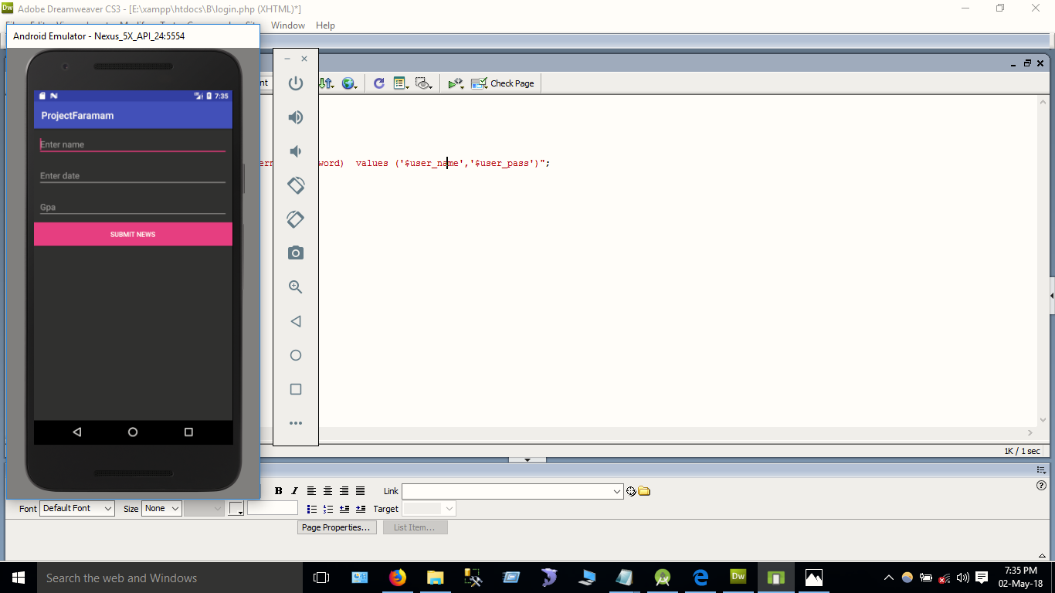

*Fig 6.1: User Interface*

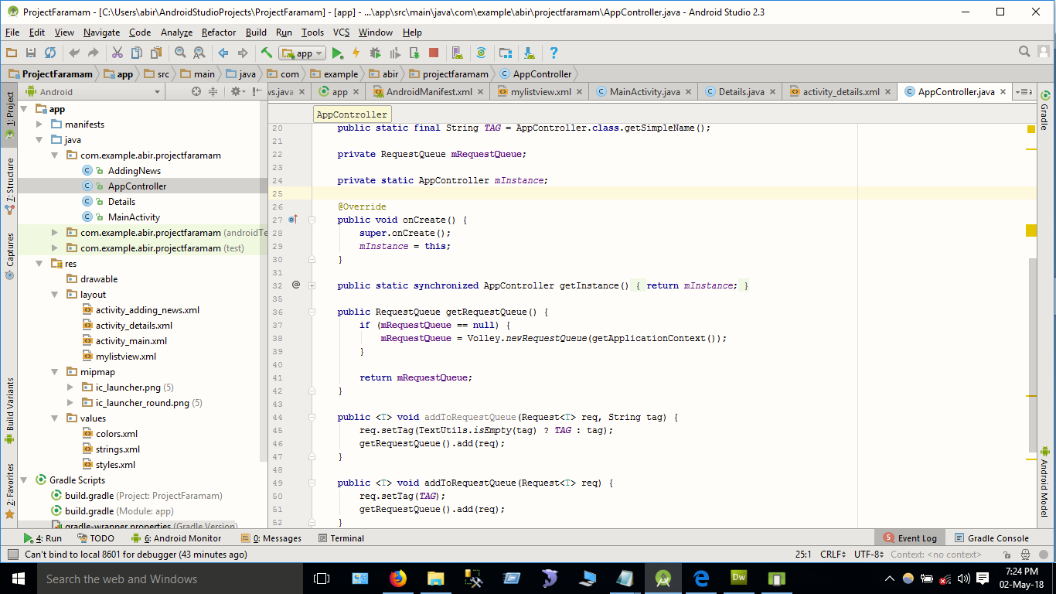

*Fig 6.2: App Controller*

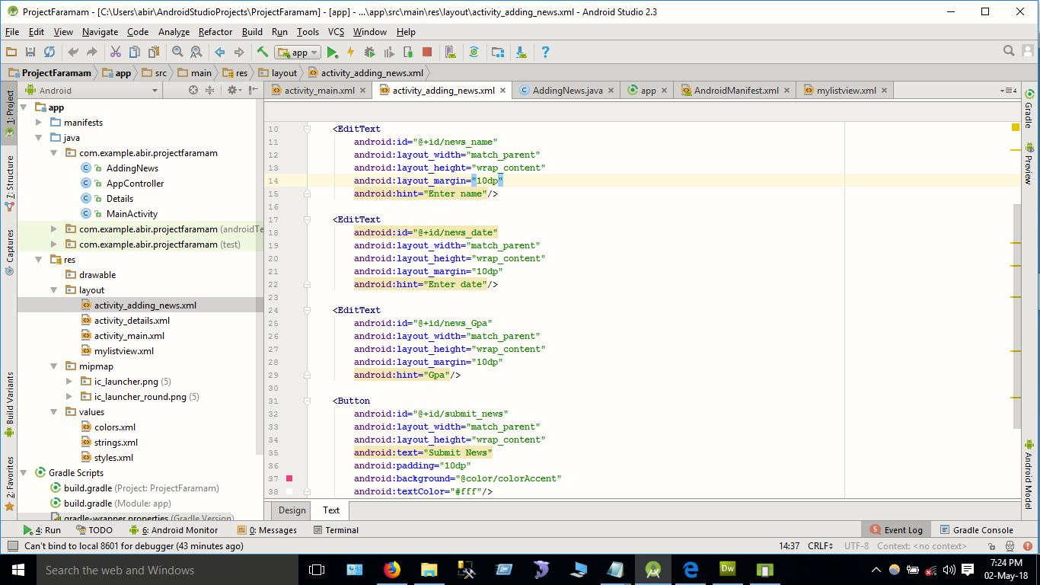

*Fig 6.3: Adding Data*

**REFERENCES**

[1] Code Smith. Creating Client App. [http://codesmith.in/control-pc-from-android-app-using-java/]. Accessed on March 14,2018.

[2] Tutorials Point. Android – PHP/MYSQL. [https://www.tutorialspoint.com/android/android_php_mysql.htm]. Accessed on March 19, 2018.

[3] Developers. Style and Themes [https://developer.android.com/guide/topics/ui/look-and-feel/themes]. Accessed on March 30, 2018.

[4] Developers. Android Studio. [https://developer.android.com/studio/write/image-asset-studio]. Accessed on April 7, 2018.

[5] Java Code Geeks. Main Activity UI. [https://www.javacodegeeks.com/2010/10/android-full-app-part-1-main-activity.html]. Accessed on April 12, 2018.