THE COPPERBELT UNIVERSITY
SCHOOL OF GRADUATE STUDIES
CS 594: CLIMATE MODELLING AND DATA ANALYSIS
PRACTICAL 04:
Computing ETCCDI Extreme Climate Indices

Name: Fadzai Dzehonye
Student Number: 25184237

Interpretation Report
The ETCCDI analysis for Mount Makulu (1981–2010) showed considerable year-to-year variability in both temperature and precipitation extremes. However, the Mann–Kendall test indicated that none of the four analysed indices had a statistically significant long-term trend at the 5% significance level.
TXx, representing the annual warmest daily maximum temperature, showed a slight increasing tendency of 0.0667 °C/year (p = 0.0704). Although this increase was not statistically significant, it suggests a possible tendency towards warmer extreme daytime temperatures. Such variations can be influenced by persistent high-pressure systems and atmospheric blocking, which may suppress cloud formation and rainfall and allow prolonged surface heating.
SU, representing the annual number of days with Tmax above 25°C, showed a weak decreasing tendency of −0.3333 days/year (p = 0.7776). This trend was not statistically significant. The difference between the slight increase in TXx and decrease in SU demonstrates that changes in the intensity of the hottest days do not necessarily correspond to an increase in the total number of hot days.
The precipitation indices also showed substantial interannual variability. RX1day had a weak decreasing tendency of −0.0600 mm/year (p = 0.8947), while R95pTOT decreased by approximately −0.1385 percentage points/year (p = 0.5666). Neither trend was statistically significant. Variability in heavy rainfall can be related to changes in atmospheric moisture and instability. In particular, higher Convective Available Potential Energy (CAPE) can favour stronger convection and potentially intense rainfall when sufficient moisture and appropriate triggering conditions are present.
Table 1. Trend analysis of ETCCDI indices, 1981–2010
Index | Sen's slope | p-value | Interpretation
TXx | +0.0667 °C/year | 0.0704 | Increasing, not significant
SU | −0.3333 days/year | 0.7776 | Decreasing, not significant
RX1day | −0.0600 mm/year | 0.8947 | Decreasing, not significant
R95pTOT | −0.1385 percentage points/year | 0.5666 | Decreasing, not significant

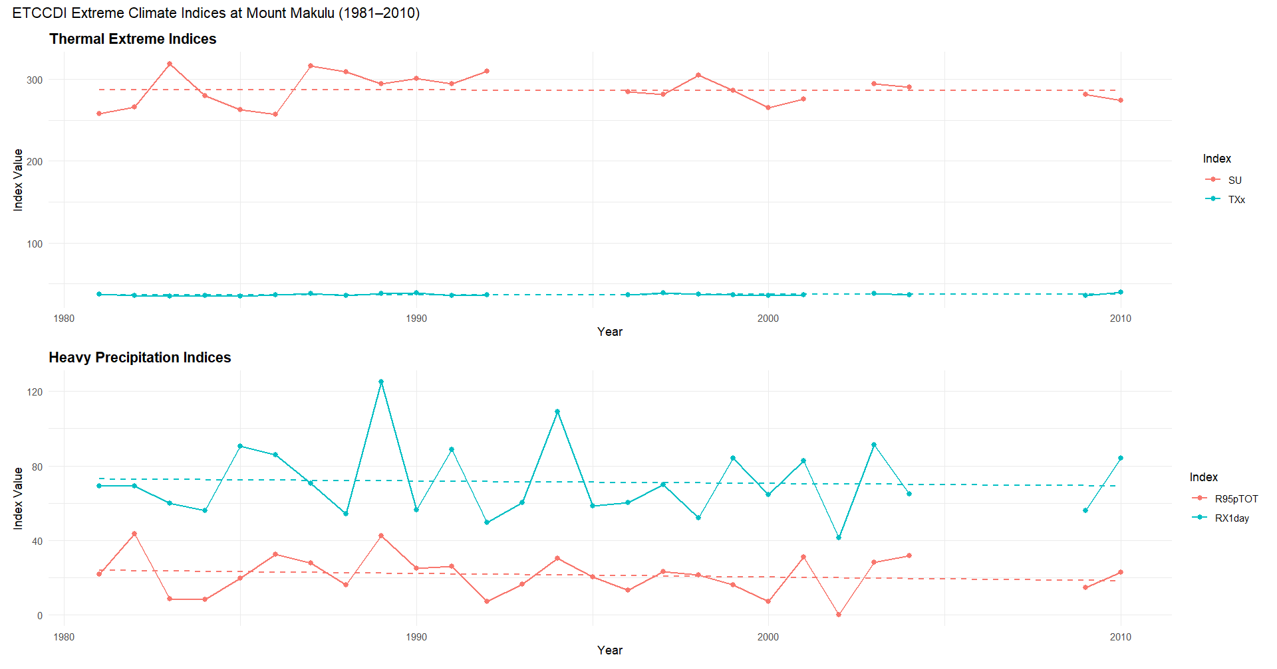Figure 1. Annual thermal and heavy precipitation extreme indices at Mount Makulu (1981–2010).
Overall, the results suggest that Mount Makulu experienced substantial interannual variability rather than statistically significant long-term changes in the selected climate extremes during 1981–2010. Atmospheric blocking and variations in CAPE provide possible physical explanations for temperature and rainfall extremes respectively; however, these mechanisms were not directly analysed in this practical. Therefore, they should be interpreted as potential regional physical drivers rather than confirmed causes of the observed patterns.
Conclusion
The analysis found no statistically significant trends in TXx, SU, RX1day or R95pTOT. Nevertheless, the variability observed in temperature and heavy rainfall extremes remains important for climate-risk assessment because individual extreme events can affect agriculture, water resources and infrastructure even in the absence of a significant long-term trend.

