Attribute-Driven Design
Disaster REsponse Communication and Coordination system architecture
Furqan Malik, Faezeh Kianimoravej, Ben Vos, Sepideh Qorbani
2025

Table of contents
Table of contents 1
Introduction 3
1 Iteration 1: Overall system structure 4
1.1 Review inputs 4
1.2 Iteration goal and drivers 4
1.3 Choose elements 5
1.4 Choose design concepts 5
1.5 instantiate elements, allocate responsibilities and define interfaces 6
1.6 Sketch views 7
1.7 Analyse design 8
1.8 Iteration summary 9
2 Iteration 2: Backend service structure 10
2.1 Review inputs 10
2.2 Iteration goal and drivers 10
2.3 Choose elements 11
2.4 Choose design concepts 11
2.5 instantiate elements, allocate responsibilities and define interfaces 12
2.6 Sketch views 13
2.7 Analyse design 13
2.8 Iteration summary 14
3 Iteration 3: Service communication, scalability and Availability 15
3.1 Review inputs 15
3.2 Iteration goal and drivers 15
3.3 Choose elements 15
3.4 Choose design concepts 16
3.5 instantiate elements, allocate responsibilities and define interfaces 16
3.6 Sketch views 17
3.7 Analyse design 19
3.8 Iteration summary 20
4 Iteration 4: Backend Design Optimization 21
4.1 Review inputs 21
4.2 Iteration goal and drivers 21
4.3 Choose elements 22
4.4 Choose design concepts 22
4.5 instantiate elements, allocate responsibilities and define interfaces 22
4.6 Sketch views 23
4.7 Analyse design 24
4.8 Iteration summary 24
5 Iteration 5: Mobile Client Architecture 25
5.1 Review inputs 25
5.2 Iteration goal and drivers 25
5.3 Choose elements 25
5.4 Choose design concepts 26
5.5 instantiate elements, allocate responsibilities and define interfaces 26
5.6 Sketch views 26
5.7 Analyse design 27
5.8 Iteration summary 28
6 Bibliography 32
7 Attachments 33
Attachment A: Domain stories 33
Attachment B: Quality attribute scenarios 33
Attachment C: Architectural concerns and constraints 33

Introduction
This document outlines the architectural design of the Disaster Response Communication and Coordination System (DRCCS), developed using the Attribute-Driven Design (ADD v3) method proposed by Humberto Cervantes and Rick Kazman in Designing Software Architectures: A Practical Approach. The ADD methodology provides a systematic, iterative process for deriving software architectures from explicitly defined quality attribute requirements, functional requirements, and constraints.
The DRCCS is intended to facilitate real-time communication and coordination among authorities, responders, NGOs, and citizens during disaster events. The system must satisfy stringent quality requirements, including 99.95% availability, real-time alert delivery within 60 seconds, and support for over 100,000 concurrent users. Furthermore, it must ensure compliance with GDPR and applicable cybersecurity frameworks (ISO 27001, NIST), integrate with legacy emergency systems (e.g., 112), and conform to Common Alerting Protocol (CAP) standards. Usability and maintainability are also critical, requiring WCAG-compliant interfaces, feature parity across platforms, and automated CI/CD pipelines enabling low-downtime updates.
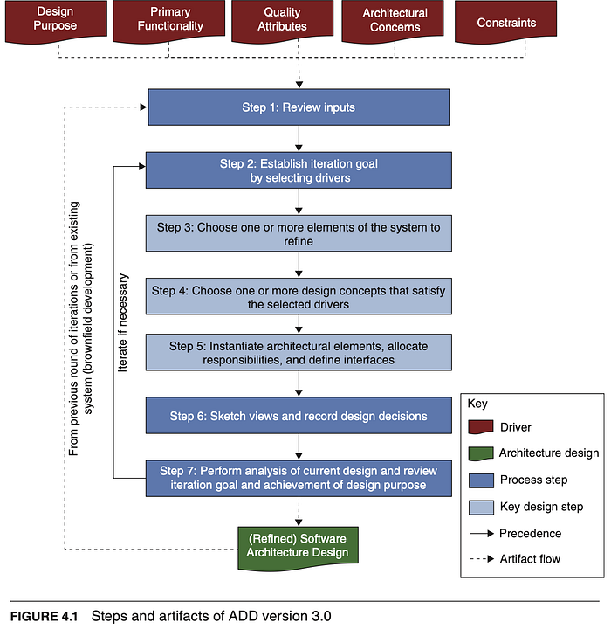
By applying ADD v3, the architectural design of the DRCCS is derived directly from these drivers, ensuring that all structural decisions are traceable to stakeholder concerns and aligned with operational, regulatory, and technical constraints. The resulting architecture emphasizes reliability, scalability, interoperability, and security, providing a robust foundation for effective disaster response operations.
The most up-to-date version of the architectural diagram can be found as a C4 model in the cloud, please refer to it for the latest version of the architecture (Latest ver sion of the DRCCS architecture)
Figure 1 Steps and artifacts of ADD version 3.0 (Cervantes & Kazman, 2024, Figure 4.1)

Iteration 1: Overall system structure
This section presents the results of the activities performed in each step of the ADD process during the first design iteration.

Review inputs
The first step of the ADD method involves reviewing the inputs and identifying which requirements will be considered architectural drivers. The inputs are summarized in Table 1.
Table 1 Inputs DRCCS Iteration 1
Category | Details
Design purpose | This project involves a greenfield development, as it entails the creation of a completely new system. The purpose of this design activity is to establish the foundational structure of the DRCCS to support all identified quality attributes and functional requirements.
Primary functional requirements | From the domain stories (Attachment A), the main functional requirements are:  - Create and manage incidents  - Assign resources  - Coordinate responders
Quality attribute scenarios | The prioritized quality attributes from Attachment B are the primary design drivers:  - QA-1: Performance  - QA-2: Availability  - QA-3: Reliability  - QA-4: Interoperability  - QA-5: Security
Architectural concerns and constraints | All constraints and concerns from Attachment C apply, including:  - Integration with legacy emergency systems (112)  - Compliance with CAP, GDPR, ISO 27001, and NIST  - CI/CD pipelines for maintainability  - WCAG compliance for usability

Iteration goal and drivers
This is the first design iteration of a greenfield system.
Iteration goal: Establish an overall system structure that provides the basis for subsequent decomposition and satisfies high-priority quality attributes.
Primary drivers:
- QA-1: Performance
- QA-2: Availability
- QA-3: Reliability
- QA-4: Interoperability
- QA-5: Security
- CON-6: Legacy system integration
- CRN-1: Timely alert delivery (≤ 60 seconds)
- CRN-2: High user load (≥ 100,000 concurrent users)
- CRN-9: API-first design
These drivers are chosen because they have system-wide impact and must be addressed through high-level structural decisions early in the process.

Choose elements
Because this iteration establishes the overall system structure, the element to refine is the entire Disaster Response Communication and Coordination System (DRCCS).
At this level, the architecture will be expressed in terms of major subsystems: backend services, external interfaces, data management, messaging infrastructure, and user-facing clients.

Choose design concepts
The following design concepts were selected to meet the iteration goal and address the primary quality drivers.
Table 2 Design Concept Selection Decisions for DRCCS: Iteration 1
Design Decision and Location | Rationale
Structure the backend following a microservices architecture. | A microservices architecture promotes scalability (QA-1) and availability (QA-2) by allowing independent deployment and scaling of services. It enhances reliability (QA-3) through fault isolation, failures in one service do not propagate to others. It also supports interoperability (QA-4) and maintainability by enabling integration via standardized APIs. Monolithic architecture was discarded as it limits scalability, agility, and resilience.
Secure exposed APIs implemented by the microservices with authentication and authorization, and by limiting access. | Ensures confidentiality and integrity (QA-5: Security). Employing an API Gateway with centralized security enforcement supports the “API-first” constraint (CRN-9) and compliance with GDPR and ISO 27001. Dispersed or ad hoc authentication models were discarded due to higher maintenance overhead and security risks.
Structure the clients using Rich Internet Application (RIA) and Mobile Client reference architectures. | Using a modular, component-based RIA design enables consistent user experience and responsiveness (QA-1, QA-2). It allows reuse of components across web and mobile clients, improving maintainability and time-to-market. This approach aligns with usability and accessibility requirements (WCAG compliance). A native-only design was discarded due to higher development and maintenance costs.

instantiate elements, allocate responsibilities and define interfaces
Based on the design concepts, the instantiated elements and their rationales are summarized in Table 3.
Table 3 Instantiation Decisions for DRCCS: Iteration 1
Design Decision and Location | Rationale
Use Apache Kafka for notifications and event streaming. | Kafka provides high throughput and horizontal scalability, directly supporting real-time alert delivery (CRN-1) and performance (QA-1). Its partitioning and replication features improve reliability (QA-3) and availability (QA-2). RabbitMQ was considered but rejected due to limited team expertise and less suitability for high-throughput, large-scale streaming workloads.
Create an external API layer to interface with legacy systems. | Encapsulates integration logic and isolates legacy dependencies, enhancing interoperability (QA-4) and maintainability. A shared database approach was discarded for security (QA-5) and data integrity reasons.
Use React to implement frontend components. | React offers a mature ecosystem, component reuse, and strong support for accessibility (WCAG). React Native facilitates cross-platform mobile development, reducing time-to-market and ensuring a unified user experience. Alternatives (Vue.js, Angular, Next.js) were discarded due to limited internal expertise and no significant functional advantage.
Secure the API through JSON Web Tokens (JWT) and use Keycloak for identity and access management. | JWT supports stateless authentication, enhancing scalability (QA-1) and availability (QA-2). Keycloak provides centralized identity management with OAuth2 and OpenID Connect support, ensuring compliance with GDPR and ISO 27001 (QA-5). Alternatives like custom token services were rejected for maintainability and security reasons.
Use an API Gateway to limit access to microservices and enforce security policies. | The API Gateway improves availability and performance by providing load balancing, caching, and rate limiting. It enforces consistent authentication and monitoring, aligning with security (QA-5) and interoperability (QA-4) drivers. Direct client-to-service access was discarded due to complexity and security risks.

Sketch views
Figures 2 and 3 show the App and Component diagrams, adapting the design decisions made in this iteration. These sketches represent a first architectural view of the system and include placeholder elements whose detailed design will be refined in later iterations as individual subsystems are decomposed.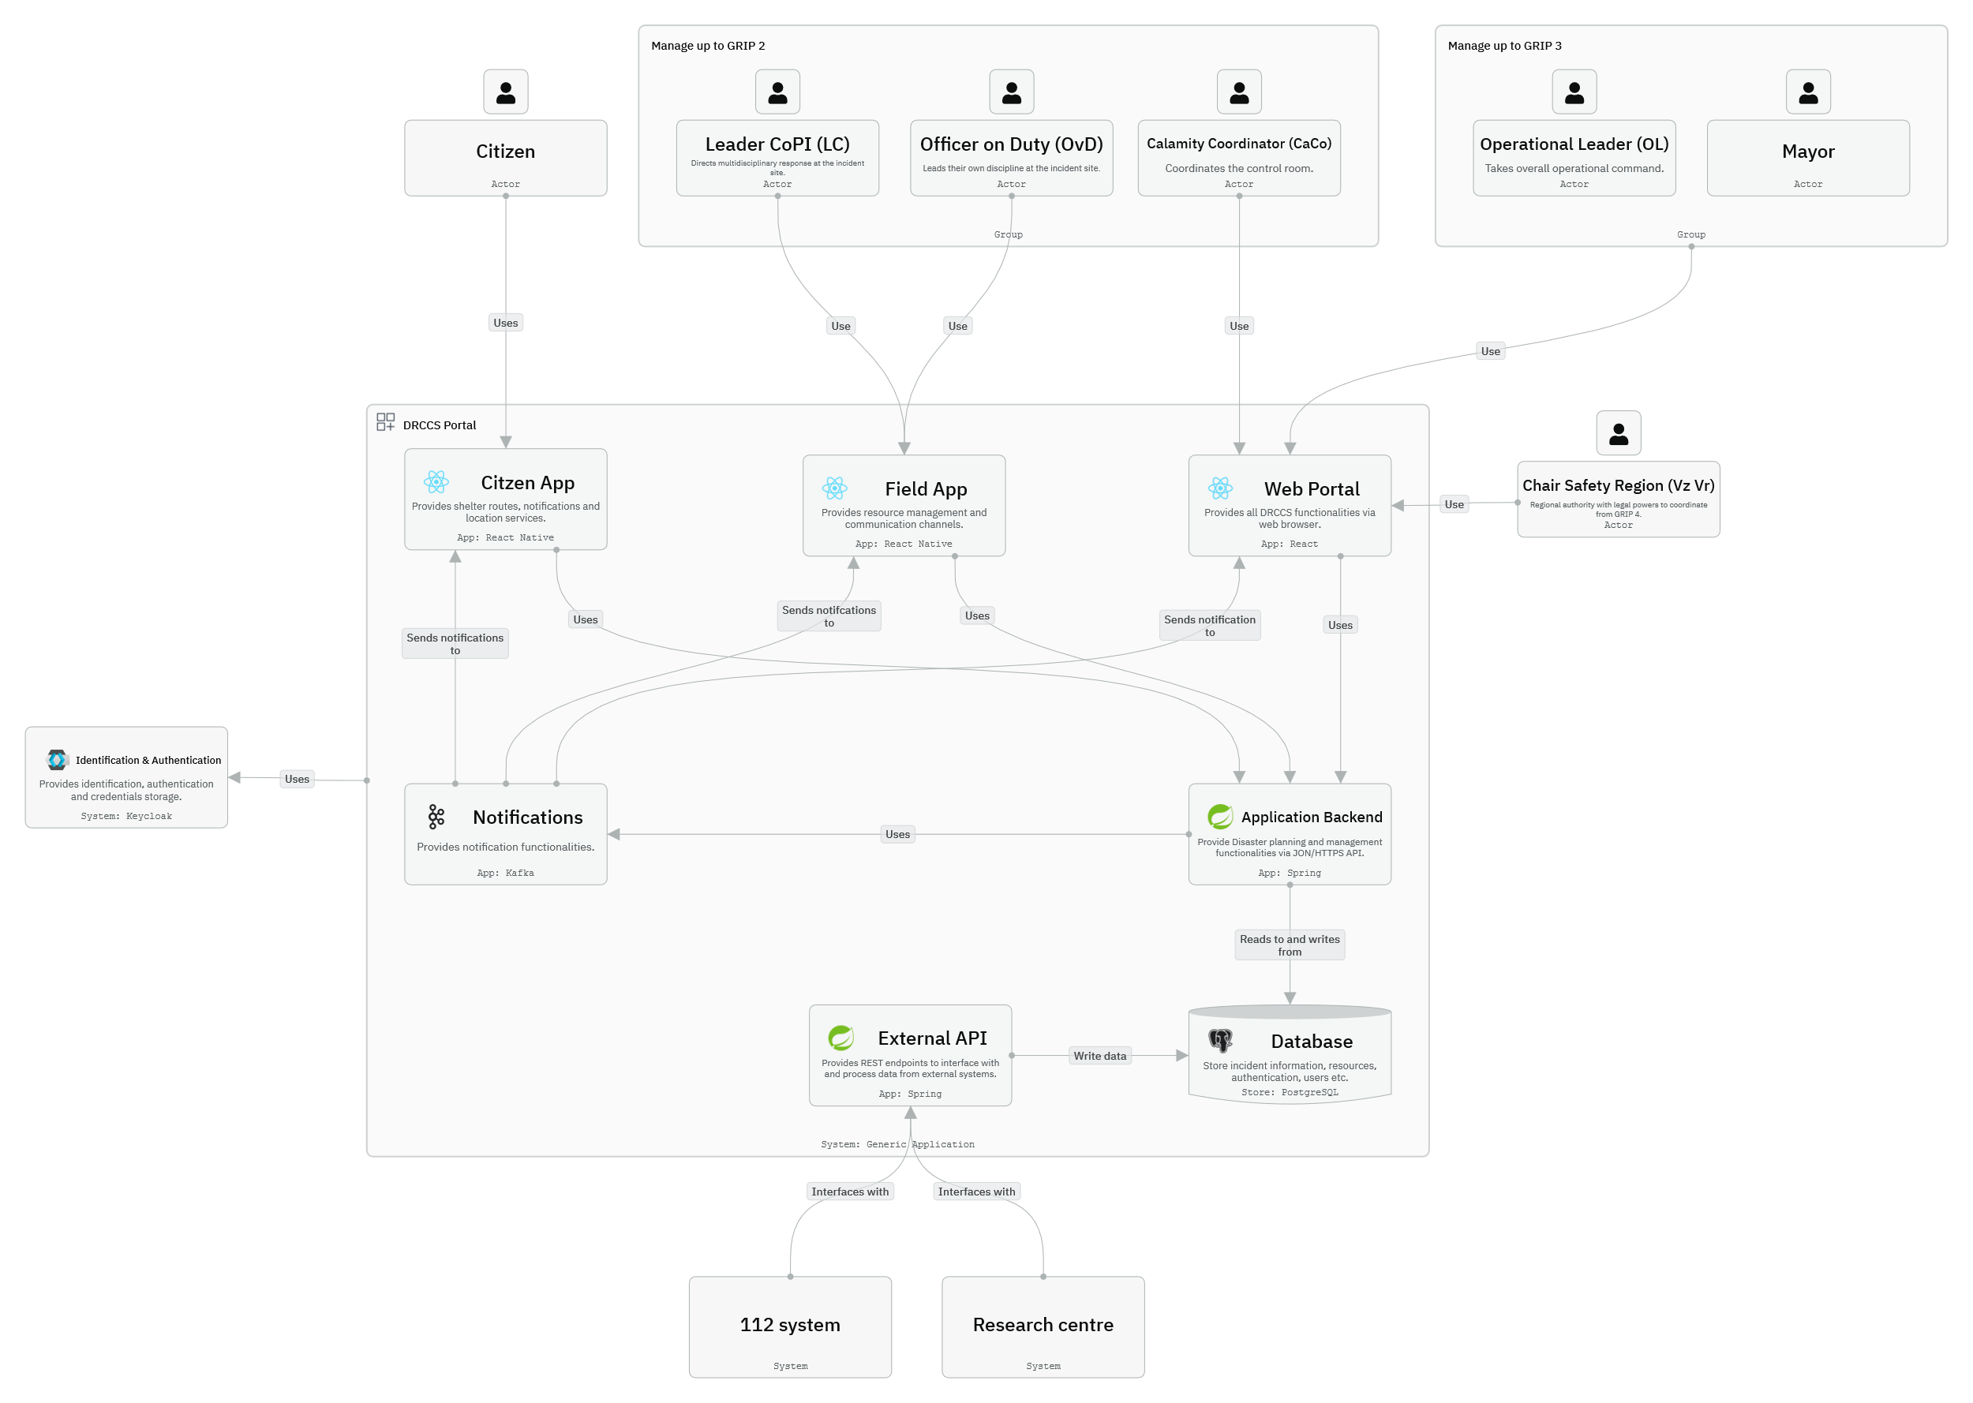
Figure 2 DRCCS Portal App Diagram: Iteration 1
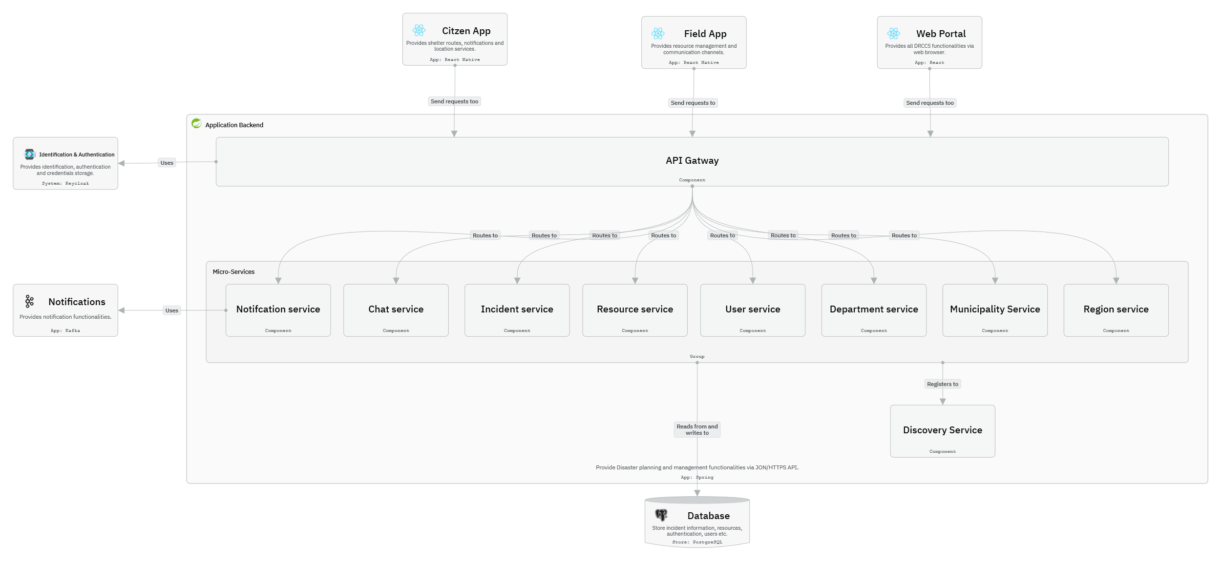
Figure 3 Application Backend Component Diagram: Iteration
Table 4 summarizes the key architectural elements captured in the diagrams and their responsibilities.
Table 4 Elements of DRCCS: Iteration 1
Element | Responsibility/Description
Web Portal | Client-side web application using a Rich Internet Application architecture, implemented in React. Provides real-time dashboards, communication, and incident management capabilities.
Citizen App/ Field App | Client-side mobile applications implemented in React Native, providing alert reception, reporting, and field coordination features for citizens and responders.
API Gateway | Mediates communication between clients and backend microservices, enforcing rate limiting, authentication, and authorization while providing a single access point for APIs.
Identification and Authentication | Manages user identities and access control via Keycloak. Issues and validates JWT tokens for secure, stateless client–server interactions.
External API | Dedicated interface layer for integration with external and legacy systems (e.g., 112 dispatch systems), encapsulating protocol and data transformation logic.
Notifications | Messaging infrastructure implemented with Apache Kafka to receive, persist, and distribute ordered event streams and notifications.
Notification service | Microservice responsible for processing and routing notifications to client interfaces and external endpoints, subscribing to Kafka topics as needed.
This initial sketch establishes the overall modular structure of the DRCCS, aligning with the microservices, API-first, and secure communication principles defined in this iteration.

Analyse design
Table 5 presents the design progress and the degree to which each driver has been addressed in this iteration.
Table 5 Design Progress for DRCCS: Iteration 1
Not Addressed | Partially Addressed | Completely Addressed | Design Decisions Made During the Iteration
 | QA-1 Performance |  | The adoption of a microservices architecture allows independent performance tuning and horizontal scaling of services. Performance monitoring and load balancing mechanisms will be designed in later iterations.
 | QA-2 Availability |  | Microservices and Kafka enhance system availability through redundancy and fault isolation. Future iterations will define replication strategies and failover mechanisms.
 | QA-3 Reliability |  | Kafka’s durability and ordered message processing improve reliability. Next iterations will specify backup policies, retry mechanisms, and message retention strategies.
 | QA-4 Interoperability |  | Using React/React Native and the External API layer improves interoperability with multiple clients and external systems. Interface standards (e.g., CAP compliance) and API contracts will be detailed later.
 | QA-5 Security |  | Security is partially addressed through the API Gateway, JWT, and Keycloak. Subsequent iterations will refine authorization policies, encryption in transit, and audit logging.
 | CON-6 Legacy System Integration |  | The External API provides the integration boundary. Detailed message formats and transformation logic will be designed in later iterations.
 | CRN-1 Timely Alert Delivery |  | Kafka supports real-time message streaming; however, end-to-end latency targets and QoS parameters remain to be specified.
 | CRN-2 High User Load |  | Scalability is supported by the microservices and client-side architectures. The deployment model and elastic scaling strategy (e.g., Kubernetes autoscaling) will be addressed in a later iteration.

Iteration summary
This first iteration established the overall architectural structure of the Disaster Response Communication and Coordination System. The key achievements include:
- Definition of a microservices-based backend with secure, API-first interfaces.
- Introduction of Kafka as the event-streaming and notification backbone.
- Definition of Keycloak for centralized authentication and authorization.
- Adoption of React and React Native for unified, accessible client experiences.
- Initial definition of an External API layer for legacy system interoperability.
While this iteration sets the architectural foundation, most quality attributes remain partially addressed and will be refined in subsequent iterations.

Iteration 2: Backend service structure
This iteration refines the Backend element identified in Iteration 1. The goal is to define the technologies, key backend services, and internal infrastructure required to support the DRCCS’s core functionality and quality attributes.

Review inputs
The inputs from Iteration 1 are refined by focusing on the backend subsystem and the requirements most relevant to data persistence, service orchestration, and scalability.
Table 6 Inputs for the Disaster Response System: Iteration 2
Category | Details
Design purpose | Refine the backend subsystem by selecting specific technologies and defining major domain services and their responsibilities.
Functional requirements | Derived from the domain model:  - Manage incidents and resources  - Enable communication between users (chat)  - Maintain user, department, and regional information  - Integrate event notifications and data consistency across services
Quality attribute scenarios | Focused quality drivers:  - QA-1: Performance  - QA-2: Availability  - QA-3: Reliability  - QA-4: Interoperability  - QA-5: Security
Architectural concerns and constraints | - API-first, microservices-based design  - Data consistency across services  - Use of standardized, open-source technologies  - Maintainability and CI/CD automation

Iteration goal and drivers
Goal:
Define the technological stack and service decomposition of the backend, ensuring consistent service discovery, communication, and reliable data management.
Drivers:
- QA-1: Performance (database efficiency, inter-service latency)
- QA-2: Availability (replication, failover)
- QA-3: Reliability (transactional consistency, fault isolation)
- QA-4: Interoperability (standardized REST APIs)
- QA-5: Security (data protection and authenticated service access)
- CON-6: Legacy system integration
- CRN-2: High user load (scalable microservice deployment)
- CRN-9: API-first design

Choose elements
The Backend System element from Iteration 1 is now decomposed into the following main components:
- Core domain services: Chat, Incident, Resource, User, Department, Municipality, Region
- Database subsystem
- Discovery service
- Supporting infrastructure (message broker, API Gateway, authentication).

Choose design concepts
The following design concepts were selected to meet the iteration goal and address the primary quality drivers.
Table 7 Design Concept Selection Decisions for DRCCS: Iteration 2
Design Decision and Location | Rationale
Use PostgreSQL as the main relational database technology. | PostgreSQL is a mature, open-source, ACID-compliant database that ensures reliability (QA-3) and consistency. It supports horizontal scaling and high availability through replication. It also aligns with open standards and existing team expertise. Alternatives like MySQL or MongoDB were discarded due to lower transactional guarantees or lack of native JSON and geospatial support required for incident and regional data.
Implement backend services in Java with Spring Boot. | Spring Boot offers production-grade support for building microservices, with strong integration for REST APIs, JPA, and Kafka. It improves developer productivity and maintainability while providing built-in support for security and configuration management. Alternatives such as Node.js or .NET were rejected because the team’s expertise and deployment environment favor the Java ecosystem.
Introduce a Discovery Service | Enables dynamic service discovery and routing among microservices, improving scalability (QA-1) and availability (QA-2). It decouples service endpoints from static configurations, facilitating elasticity and automated scaling in containerized deployments. Static service configurations were discarded due to reduced flexibility in dynamic environments.
Follow Domain-Driven Design (DDD) principles for service boundaries. | Each domain service (Chat, Incident, Resource, etc.) encapsulates its own business logic and data, ensuring clear ownership and low coupling. This supports maintainability, testability, and evolution of services independently.

instantiate elements, allocate responsibilities and define interfaces
Based on the design concepts, the instantiated elements and their rationales are summarized in Table 8.
Table 8 Instantiation Decisions for DRCCS: Iteration 2
Element | Responsibility/ Description | Rationale
Chat Service | Manages real-time chat and message persistence between responders, citizens, and control centers. Integrates with Kafka for event streaming. | Provides a core communication capability, directly supporting coordination efficiency (QA-1, QA-3).
Incident Service | Handles creation, tracking, and updating of incidents, including geolocation data, severity, and status. | Central to DRCCS functionality; encapsulates the main domain model.
Resource Service | Manages responder and equipment allocation, availability, and dispatch. | Supports scalability and efficiency in disaster operations.
User Service | Maintains user profiles, roles, and credentials; integrates with Keycloak for authentication. | Aligns with QA-5 Security and supports role-based access control.
Department Service | Represents organizational structures (e.g., police, fire department, medical teams. | Enables hierarchical coordination and reporting.
Municipality Service | Represents municipality structure. | Supports data segmentation and reporting across regions.
Region Service | Enabling large-scale reporting, analytics, and cross-region coordination. | Facilitates interoperability and scalability for multi-region deployments.
PostgreSQL Database (per service) | Each service maintains its own schema and database instance (schema-per-service pattern). | Improves isolation, reliability, and maintainability. Ensures that service boundaries match data ownership boundaries.
Discovery Service (Eureka) | Registers and locates microservices dynamically at runtime. | Simplifies routing, load balancing, and rolling updates.
Internal REST APIs | Each service exposes a REST API for communication through the API Gateway. | Maintains API-first and interoperability principles.

Sketch views
Figure 4 show the Component diagram of the backend, adapting the design decisions made in this iteration.

Figure 4 Application Backend Component Diagram: Iteration
Table 9 Elements introduced in Iteration 2
Element | Description
Chat Service | Handles messaging and streaming communication.
Incident Service | Core service managing disaster incidents.
Resource Service | Allocates and monitors resources.
User Service | Manages users and their access rights.
Department, Municipality, Region Services | Manage hierarchical administrative data for coordination.
Discovery Service | Enables runtime discovery and routing.
PostgreSQL Instances | Each service owns its own schema and database.

Analyse design
Table 10 presents the design progress and the degree to which each driver has been addressed in this iteration.
Table 10 Design Progress for the Disaster Response System: Iteration 2
Not Addressed | Partially Addressed | Completely Addressed | Design Decisions Made During the Iteration
 | QA-1 Performance |  | The use of Spring Boot microservices, PostgreSQL, and service discovery improves performance through efficient routing and parallel scaling. Further optimization of query patterns and caching will be defined later.
 | QA-2 Availability |  | Discovery service and database replication strategies enhance availability. Load balancing and fault recovery mechanisms will be detailed in subsequent iterations.
 | QA-3 Reliability |  | PostgreSQL’s ACID transactions and Kafka’s durable messaging support reliability. Additional retry and compensation mechanisms will be designed.
 | QA-4 Interoperability |  | Standard REST APIs across Java-based services ensure consistent integration. External API adaptations and CAP-compliant message formats to be refined later.
 | QA-5 Security |  | Integration with Keycloak and JWT-based authentication is planned; secure inter-service communication (e.g., mutual TLS) to be finalized.
 | CON-6 Legacy System Integration |  | Supported via the External API layer; data synchronization details pending.
 | CRN-2 High User Load |  | The chosen tech stack supports elastic scaling. Autoscaling configurations and container orchestration (e.g., Kubernetes) will be defined in Iteration 3.

Iteration summary
Iteration 2 refines the backend architecture by selecting specific technologies (PostgreSQL, Java Spring Boot) and introducing service discovery to manage runtime routing and scalability.
The decomposition into domain-specific microservices (Chat, Incident, Resource, User, Department, Municipality, Region) clarifies responsibility boundaries and supports independent evolution.
This iteration establishes the core service structure and technical stack that will be expanded in subsequent iterations to define.

Iteration 3: Service communication, scalability and Availability
This iteration refines the backend design by defining the mechanisms for inter-service communication, scalability, and fault tolerance.
The goal is to ensure the DRCCS can maintain performance and availability targets under extreme load and during component failures.

Review inputs
Table 11 Inputs for the DRCCS: Iteration 3
Category | Details
Design purpose | Refine how backend microservices communicate and scale to meet performance, availability, and reliability requirements.
Functional requirements | No new functional requirements introduced. Focus on operational and quality attribute refinement.
Quality attribute scenarios | Focused quality drivers:  - QA-1: Performance  - QA-2: Availability  - QA-3: Reliability
Architectural concerns and constraints | - API-first, microservices-based design  - Cloud-native deployment with elastic scaling  - Minimize downtime during disaster scenarios

Iteration goal and drivers
Goal:
Define service-to-service communication mechanisms and operational infrastructure to ensure scalability, load balancing, and high availability.
Drivers:
- QA-1: Performance (database efficiency, inter-service latency)
- QA-2: Availability (replication, failover)
- QA-3: Reliability (transactional consistency, fault isolation)
- CON-6: Legacy system integration
- CRN-2: High user load (scalable microservice deployment)
- CRN-9: API-first design

Choose elements
This iteration refines the following elements from Iteration 2:
- Microservices interaction layer
- Deployment and orchestration environment
- Database replication and failover mechanisms

Choose design concepts
The following design concepts were selected to meet the iteration goal and address the primary quality drivers.
Table 12 Design Concept Selection Decisions for DRCCS: Iteration 3
Design Decision and Location | Rationale
Use Feign Client for service-to-service communication within the Spring Cloud ecosystem. | Feign provides a declarative REST client, allowing microservices to call each other using annotated interfaces instead of manual HTTP logic. This reduces boilerplate code and improves maintainability. It integrates seamlessly with Spring Boot and Spring Cloud Eureka (Discovery Service) for dynamic service lookup, ensuring consistency and scalability. Alternatives such as manual RestTemplate or WebClient were rejected due to higher complexity and weaker integration with service discovery.
Deploy microservices on Kubernetes with auto-scaling and load balancing. | Kubernetes provides container orchestration, automated deployment, and self-healing capabilities. Horizontal Pod Autoscaling (HPA) dynamically adjusts instances based on CPU or traffic metrics, directly supporting QA-1 (Performance) and QA-2 (Availability). Kubernetes’ built-in load balancing evenly distributes requests and handles service discovery through internal DNS. Manual scaling or VM-based approaches were discarded due to limited elasticity.
Implement database replication and failover strategies (PostgreSQL streaming replication / cluster). | PostgreSQL replication ensures continuous data availability and fault tolerance. Read replicas support query load distribution and improve read performance. Automatic failover mechanisms (e.g., Patroni or PgPool-II) enhance resilience to hardware or network failures, supporting QA-2 (Availability) and QA-3 (Reliability). A single-instance setup was rejected as a single point of failure.
Use Kubernetes health checks and rolling updates for fault tolerance and zero-downtime deployments. | Enables automatic restart of failing pods and seamless updates, ensuring continuity during upgrades (QA-2 and QA-3).

instantiate elements, allocate responsibilities and define interfaces
Based on the design concepts, the instantiated elements and their rationales are summarized in Table 13.
Table 13 Instantiation Decisions for DRCCS: Iteration 3
Element | Responsibility/ Description | Rationale
Feign Client Interfaces (per service) | Define declarative HTTP clients for inter-service communication. Registered with Eureka for runtime discovery. | Simplifies development and testing of inter-service calls. Enhances maintainability and observability.
Kubernetes Deployment Cluster | Hosts microservices, Kafka, Keycloak, and PostgreSQL instances using containers. | Centralized management of deployments with self-healing and scaling capabilities.
Horizontal Pod Autoscaling (HPA) | Dynamically adjusts service replicas based on load metrics. | Ensures scalability and maintains performance under peak conditions.
Kubernetes Load Balancer (Service) | Distributes incoming traffic between pods and replicated services. | Prevents overload on individual instances and enhances resilience.
PostgreSQL Replication Cluster | Consists of one primary and multiple replica nodes. Failover controlled by Patroni / PgPool-II. | Provides high availability and reduces downtime risk.
Monitoring and Alerting (Next Iteration) | Planned integration with Prometheus and Grafana for performance and availability tracking. | Identified for further refinement in later iterations.

Sketch views
Figure 5 show the Communication and Discovery view for the backend, adapting the design decisions made in this iteration.
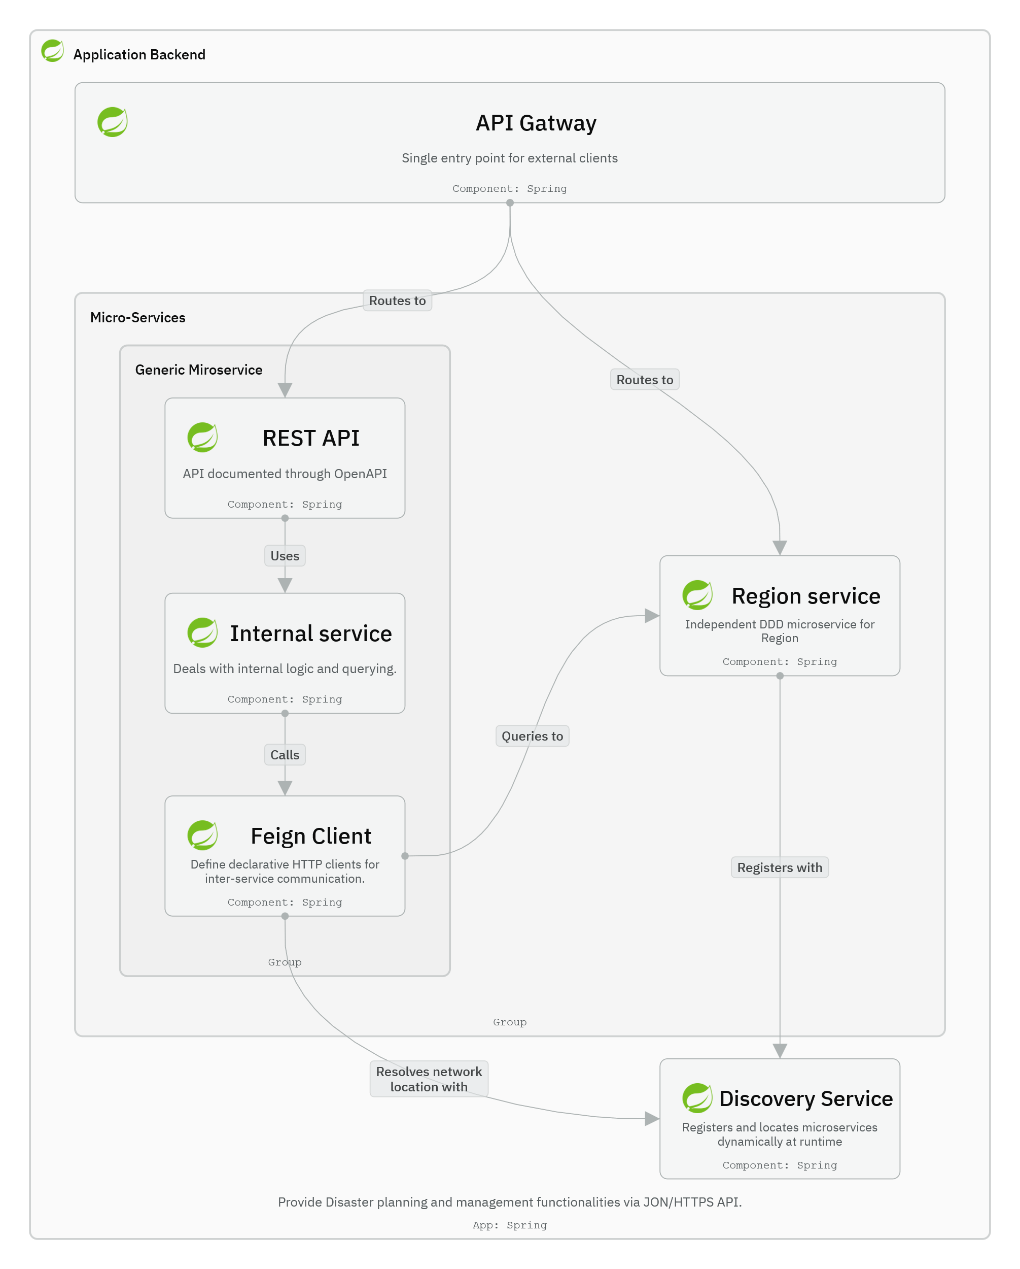
Figure 5 Service Communication and Discovery View
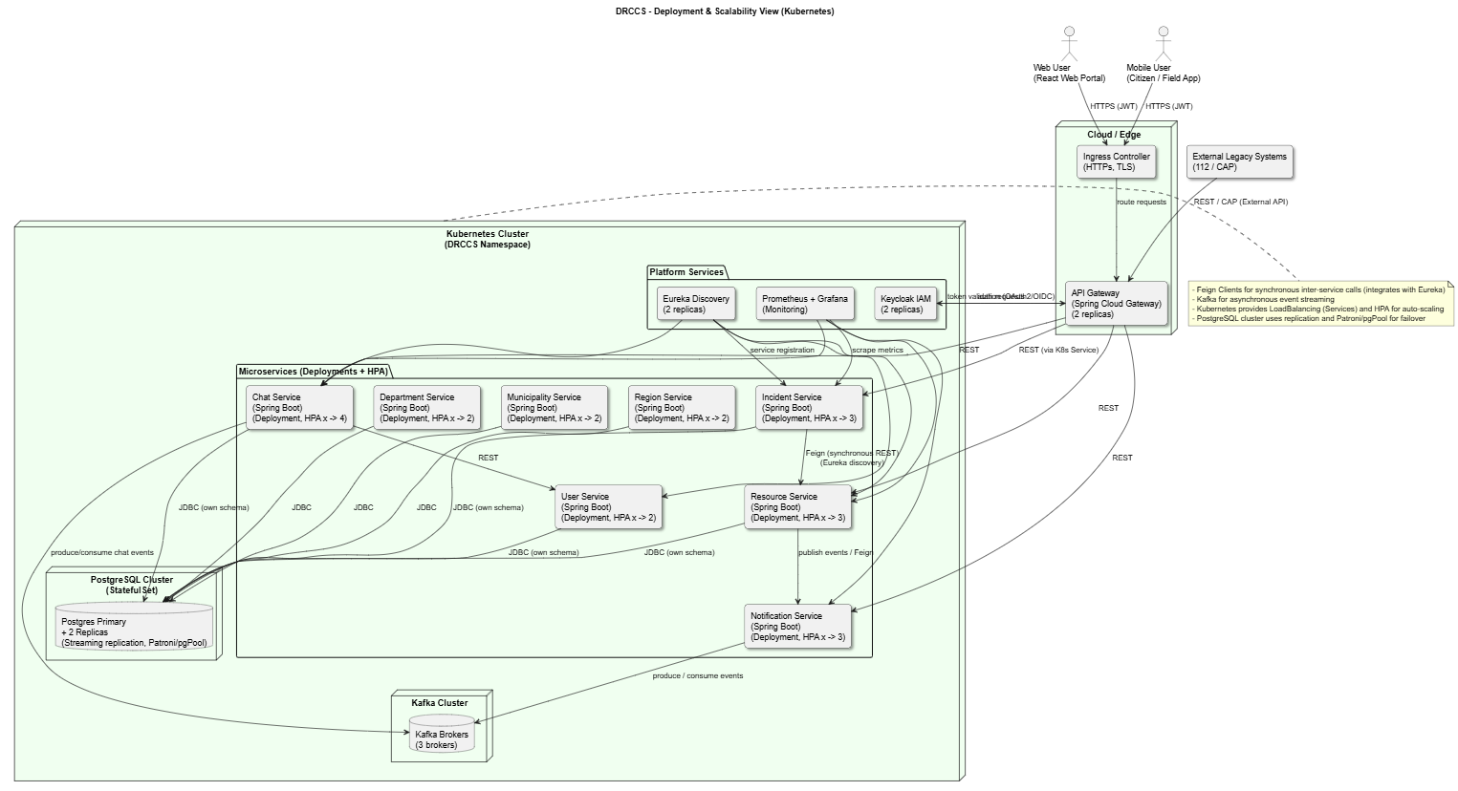
Figure 6 DRCCS Deployment and Scalability View
This deployment diagram shows the DRCCS architecture deployed within a Kubernetes environment. Each Spring Boot microservice is containerized and registered in Eureka for discovery. Services communicate synchronously via Feign Clients and asynchronously through Kafka. PostgreSQL operates as a replicated database cluster for high availability. Kubernetes provides auto-scaling, rolling updates, and load balancing across pods to ensure reliability and performance.
Table 14 Elements introduced in Iteration 3
Element | Description
Feign Client | Declarative REST client for internal microservice communication.
Kubernetes Cluster and HPA | Provides scalability and load balancing for all microservices.
PostgreSQL Replication Cluster | Ensures database redundancy and high availability.

Analyse design
Table 15 presents the design progress and the degree to which each driver has been addressed in this iteration.
Table 15 Design Progress for the Disaster Response System: Iteration 3
Not Addressed | Partially Addressed | Completely Addressed | Design Decisions Made During the Iteration
 | QA-1 Performance |  | Kubernetes auto-scaling and Feign-based optimized communication improve response times and reduce bottlenecks. Performance monitoring will be refined later.
 | QA-2 Availability |  | Replication, failover, and load balancing increase availability to meet the 99.95 % target. Geo-redundant deployment to be considered in future iterations.
 | QA-3 Reliability |  | Self-healing pods and redundant databases support recovery from failures. Further work needed on transactional resilience and data consistency across replicas.
 | QA-4 Interoperability |  | Maintained via standard REST APIs used by Feign Clients.
 | CRN-2 High User Load |  | Kubernetes HPA and load balancer ensure elastic response to traffic spikes.

Iteration summary
Iteration 3 introduced mechanisms ensuring resilient, scalable, and fault-tolerant operation of the DRCCS:
- Feign Client chosen for consistent, maintainable, and declarative service-to-service communication.
- Kubernetes orchestration and auto-scaling adopted to dynamically scale the system under heavy load.
- Database replication and failover mechanisms defined to ensure data continuity and service availability.
These decisions complete the foundation for reliable, cloud-native operations.

Iteration 4: Backend Design Optimization
This iteration refines the backend architectural design by optimizing microservice boundaries using Domain-Driven Design (DDD) principles, consolidating organizational domain services, and strengthening security and communication patterns. The goal is to reduce operational complexity, improve cohesion, and validate service interactions while maintaining scalability, availability, and security.

Review inputs
The inputs from Iterations 1–3 are refined by focusing on backend service boundaries, organizational domain consolidation, inter-service dependencies, and security integration.`
Table 16 Inputs for Disaster Response System: Iteration 4
Category | Details
Design purpose | Optimize backend service boundaries, consolidate organizational domain services, and define testing and validation strategies.
Functional requirements | - Manage organizational structures (departments, regions, municipalities, resources)  - Assign resources to incidents  - Support coordinated communication across services
Quality attribute scenarios | Focused quality drivers:  - QA-1 Performance  - QA-2 Availability  - QA-3 Reliability  - QA-4 Interoperability  - QA-5 Security
Architectural concerns and constraints | - DDD-aligned bounded contexts  - Avoid excessive domain coupling  - Secure authentication and authorization  - API-first and microservices-based design

Iteration goal and drivers
Goal:
Refine backend architecture by consolidating highly related domain services into a cohesive Organization Service, clarifying service responsibilities, strengthening security integration with Keycloak, and defining testing and optimization strategies.
Drivers:
- QA-1 Performance – reduced inter-service calls through consolidation
- QA-2 Availability – simpler deployment and fewer failure points
- QA-3 Reliability – clearer ownership and transactional boundaries
- QA-4 Interoperability – standardized APIs and event-based integration
- QA-5 Security – centralized, standards-compliant identity management
- CRN-9 API-first design
- CON-6 Legacy system integration

Choose elements
This iteration refines and restructures the following backend elements:
- Organizational domain services
- Deployment Service and its dependencies
- Security and identity management components
- Inter-service communication mechanisms
- Testing and validation infrastructure

Choose design concepts
The following design concepts were selected to meet the iteration goal and address the primary quality drivers.
Table 17 Design Concept Selection Decisions for DRCCS: Iteration 4
Design Decision and Location | Rationale
Consolidate Department, Region, Municipality, and Resource services into a single Organization Service | These domains represent tightly coupled organizational and physical management units. Consolidation improves cohesion, reduces cross-service communication, and aligns with DDD bounded context principles.
Maintain Deployment Service as a coordinating domain service | Deployment requires orchestration across Incident, Organization, and Chat services. Keeping it separate preserves single responsibility while acknowledging necessary domain coupling.
Use synchronous Feign-based communication for core domain interactions | Provides predictable request–response behavior for critical operations such as resource assignment and incident updates.
Use Kafka for asynchronous communication in Chat service | Enables scalable, non-blocking communication for real-time messaging and event streaming without coupling services synchronously.
Upgrade JWT-based security by integrating Keycloak fully | Keycloak provides centralized identity and access management with built-in support for SSO, role-based authorization, and token lifecycle management, which is not achievable with standalone JWT tokens. It reduces security logic inside microservices, improves consistency across web and mobile clients, and enhances scalability and maintainability. Therefore, Keycloak is a more suitable choice for a multi-service, multi-actor system like DRRCS.
Frontend authentication using OAuth2 PKCE | PKCE enhances security for public clients (React-based frontend) and prevents token interception.

Trade-Off Decision Table (JWT vs Keycloak)
Table 17.B Security Mechanism Selection Trade-Off
Attribute / Concern | Standalone JWT Tokens | Keycloak Integration | Decision Impact
Security | Basic token validation | Centralized IAM, RBAC, policies | Favors Keycloak
Scalability | Security logic duplicated per service | Centralized authentication & authorization | Favors Keycloak
Maintainability | High code duplication | Reduced security code in services | Favors Keycloak

instantiate elements, allocate responsibilities and define interfaces
Based on the design concepts, the instantiated elements and their rationales are summarized in Table 8.
Table 18 Instantiation Decisions for DRCCS: Iteration 4
Element | Responsibility/ Description | Rationale
Organization Service | Manages departments, regions, municipalities, and resources as a single bounded context | Improves cohesion, reduces duplication, and simplifies organizational data management
Deployment Service | Assigns organizational resources to incidents and coordinates with Chat and Incident services | Centralizes orchestration logic while preserving domain boundaries
Incident Service | Owns incident lifecycle and state | Remains independent core domain
User Service | Manages application users and provisions login accounts in Keycloak via Admin REST APIs | Separates identity lifecycle from authentication infrastructure
Keycloak | Centralized IAM system providing OAuth2/OIDC, refresh tokens, token rotation, SSO, audit logs | Strengthens QA-5 Security and compliance
API Gateway | Validates tokens, enforces authorization, and routes requests | Centralized security enforcement
Kafka | Event streaming for Chat and Notification services | Ensures scalability and loose coupling

Sketch views
Figure 7 shows the optimized backend component diagram after organizational service consolidation.

Figure 7 Application Backend Component Diagram: Iteration
Figure 8 shows the security and authentication flow involving React frontend, Keycloak, API Gateway, and backend services.
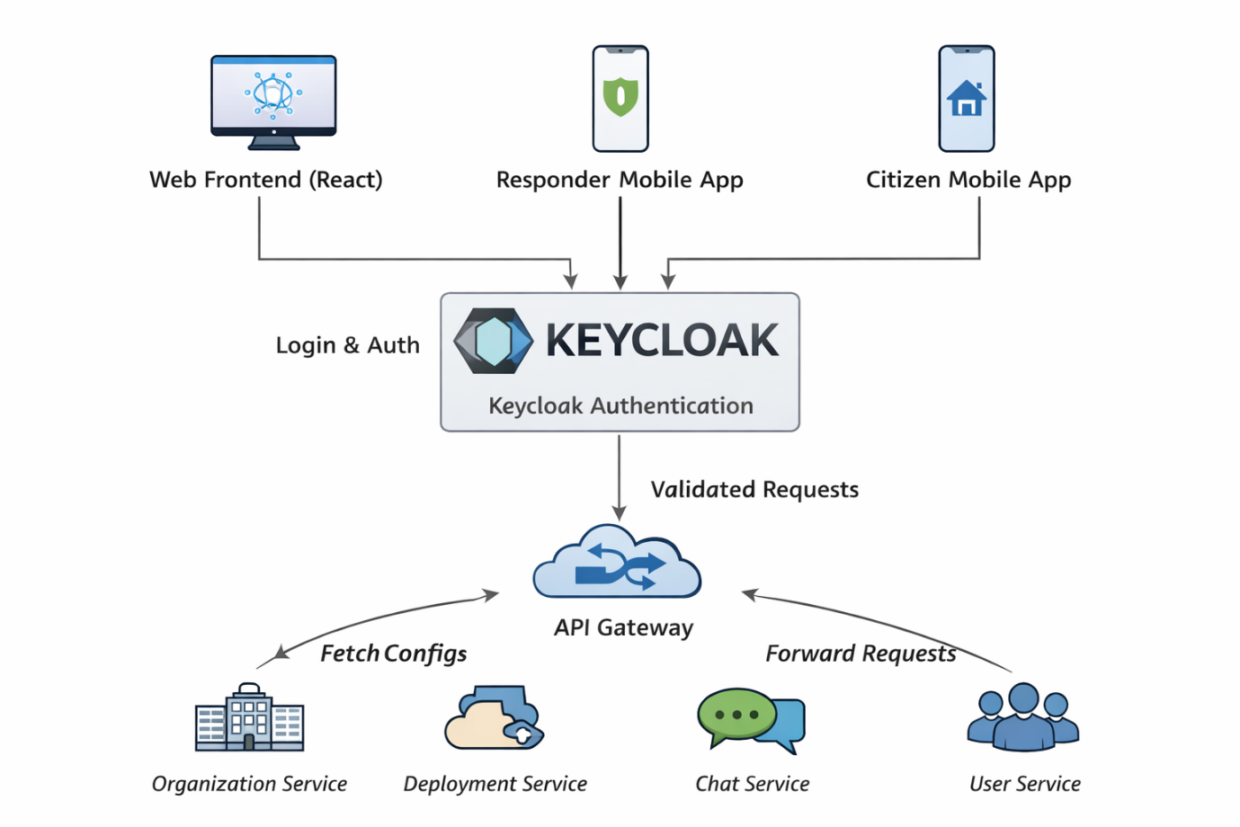

Figure 8 Authentication Flow Diagram: Iteration
Table 116 Elements introduced in Iteration 4
Element | Description
Organization Service | Consolidated organizational bounded context
Deployment Service | Domain orchestration service
Keycloak Integration | Full OAuth2/OIDC lifecycle management
PKCE-based Frontend Auth | Secure authentication for React client

Analyse design
Table 10 presents the design progress and the degree to which each driver has been addressed in this iteration.
Table 17 Design Progress for the Disaster Response System: Iteration 4
Not Addressed | Partially Addressed | Completely Addressed | Design Decisions Made During the Iteration
 | QA-1 Performance | Partially addressed | Reduced inter-service calls through consolidation; synchronous Feign calls optimized
 | QA-2 Availability | Partially addressed | Fewer services reduce failure surface; Kubernetes and replication remain key
 | QA-3 Reliability | Partially addressed | Clear ownership boundaries and reduced coordination complexity
 | QA-4 Interoperability | Completely addressed | Standard REST APIs, Kafka events, and API-first design
 | QA-5 Security | Completely addressed | Keycloak with PKCE, refresh tokens, revocation, audit logs
 | CRN-9 API first | Completely addressed | All services expose documented REST APIs

Iteration summary
Iteration 4 optimized the backend architecture by:
- Consolidating organizational domain services into a cohesive Organization Service.
- Clarifying domain boundaries using DDD bounded context principles.
- Defining clear synchronous and asynchronous communication rules.
- Strengthening security through full Keycloak integration with PKCE.
- Acknowledging and managing necessary domain coupling in the Deployment Service.
This iteration reduces architectural complexity, improves maintainability, and prepares the DRCCS backend for comprehensive testing and production hardening in subsequent iterations.

Iteration 5: Mobile Client Architecture
This iteration defines the Mobile Client architecture for the Disaster Response Communication and Coordination System (DRCCS), establishing a design from the ground up that prioritizes rapid deployment and high availability in unstable environments.

Review inputs
The design focuses on establishing the mobile presence for both Citizens and Responders, transitioning from the general "Client-side mobile applications" placeholder in Iteration 1.
Table 18 Inputs for the DRCCS: Iteration 5
Category | Details
Design purpose | Establish the mobile client architecture to support field operations and citizen alerts.
Quality attribute scenarios | Focused quality drivers:  - QA-2: Availability  - QA-3: Reliability  - QA-5: Security
Architectural concerns and constraints | - CON-10 Limited Manpower/Time: System must be developed and deployed rapidly with existing web-based skill sets.

Iteration goal and drivers
Goal:
The goal is to design a mobile architecture that provides native-like capabilities (offline storage and background notifications) while satisfying the manpower constraints of the project.
Drivers:
- QA-2 Availability: Support mission-critical tasks in areas with no cellular coverage.
- QA-3 Reliability: Ensure emergency alerts reach users within 60 seconds (CRN-1).
- QA-5 Security: Securely manage responder identities in the field.
- CON-10 Efficiency: Avoid the overhead of managing multiple native codebases and app store review delays.

Choose elements
The element being refined is the Mobile Client, which will be instantiated as two distinct views: the Responder App and the Citizen App.

Choose design concepts
The following design concepts were selected to meet the iteration goal and address the primary quality drivers.
Table 19 Design Concept Selection Decisions for DRCCS: Iteration 5
Design Concept | Choice | Rationale
Platform | Progressive Web App (PWA) | Chosen over native to satisfy CON-10. Allows a single React/TypeScript codebase for web and mobile, and enables instant deployment/updates without app store delays.
Data Persistence | Persistent Storage API + IndexedDB | Standard browser storage is "best-effort." Using navigator.storage.persist() ensures the OS does not purge critical disaster data during low-disk events (QA-2).
Real-time Alerts | Hybrid SSE + Web Push API | Uses SSE for low-latency updates while the app is active. The Web Push API wakes the Service Worker to show OS-level notifications when the app is in the background (QA-3).
Authentication | HttpOnly Cookies + PKCE | Securely stores refresh tokens in cookies inaccessible to JS. Uses OAuth2 with PKCE to authenticate the public PWA client against Keycloak (QA-5).

instantiate elements, allocate responsibilities and define interfaces
The Mobile Client is decomposed into the following functional modules:
Table 20 Instantiation Decisions for DRCCS: Iteration 5
Element | Responsibility
Service Worker | Acts as a network proxy. Manages the Cache API for the App Shell and intercepts fetch requests to provide offline fallbacks.
Persistence Manager | Interfaces with IndexedDB to store structured incident data. Executes the "Persistent Storage" request to the browser.
Notification Listener | Orchestrates the switch between active SSE streams and background Push API events based on app visibility state.
Sync Manager | Uses the Background Sync API to queue field reports made offline and re-transmit them when a connection is restored.

Sketch views
The following diagram illustrates the PWA architecture and the flow of emergency alerts.
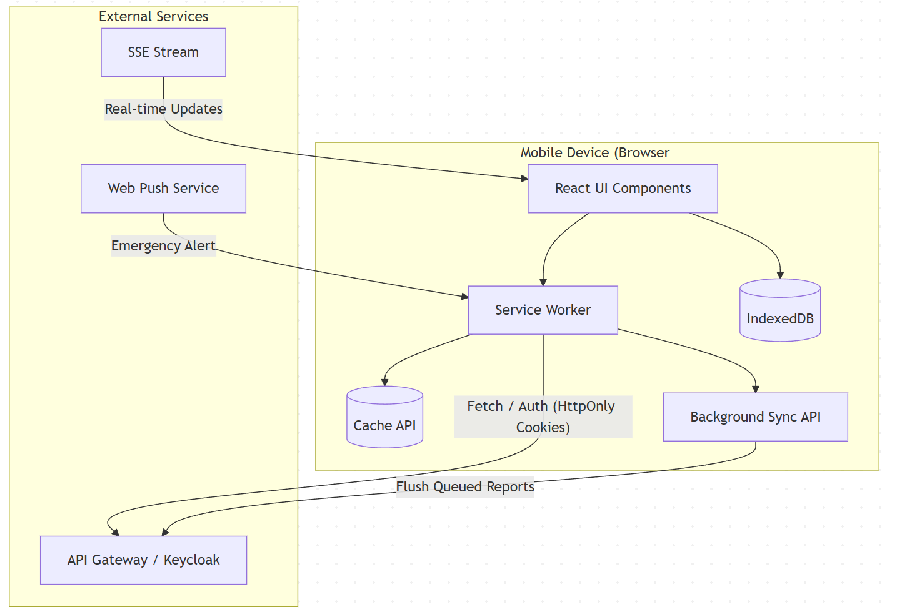
Figure 7 Flow of emergency alerts on PWA

Analyse design
Table 15 presents the design progress and the degree to which each driver has been addressed in this iteration.
Table 21 Design Progress for the Disaster Response System: Iteration 3
Driver | Achievement Status | Rationale
QA-2 Availability | Completely Addressed | Persistent Storage API + IndexedDB prevents data loss in zero-connectivity field zones.
QA-3 Reliability | Completely Addressed | Hybrid SSE/Web Push ensures 100% coverage for emergency alerts regardless of app state.
QA-5 Security | Completely Addressed | HttpOnly Cookies + PKCE mitigate XSS risks and provide secure Keycloak integration.
CON-10 Efficiency | Completely Addressed | Single codebase (PWA) reuses ~90% of web client logic, meeting manpower constraints.

Iteration summary
Iteration 5 successfully defines a mobile architecture that treats the web as a first-class platform for disaster response. By utilizing modern PWA APIs for persistent storage and hybrid notifications, the system achieves the reliability required for field operations while minimizing the development and maintenance burden on the team.

Iteration 6: Log Aggregation and Monitoring System
This iteration defines the architecture for centralized log aggregation, monitoring, and alerting for the DRCCS microservices ecosystem. The goal is to improve observability, fault diagnosis, operational reliability, and compliance by introducing a unified logging and monitoring infrastructure.

Review inputs
The inputs from Iterations 1–5 are refined by focusing on operational observability, runtime diagnostics, and system health monitoring across all backend services.
Table 21 Inputs for Disaster Response System: Iteration 6
Category | Details
Design purpose | Define centralized logging, monitoring, and alerting architecture for all DRCCS services.
Functional requirements | - Aggregate logs from all microservices; monitor system health; generate alerts
Quality attribute scenarios | Focused quality drivers:  - QA-1 Performance  - QA-2 Availability  - QA-3 Reliability  - QA-5 Security
Architectural concerns and constraints | - Kubernetes-based deployment, Docker containers, GDPR compliance, open-source tooling
The current microservices (api-gateway, chat-service, incident-service, deployment-service, discovery-service, notification-service, organization-service, user-service) lack a unified observability solution, making debugging and incident response difficult in distributed failure scenarios.

Iteration goal and drivers
Goal:
Design and integrate a centralized log aggregation and monitoring solution that provides real-time observability, supports root-cause analysis, and enables proactive alerting without impacting system performance.
Drivers:
- QA-1 Performance – Low-overhead logging and metrics collection
- QA-2 Availability – Early detection of outages and degraded services
- QA-3 Reliability – Faster diagnosis and recovery from failures
- QA-5 Security – Secure access to logs and audit trails
- CRN-2 High user load – Monitoring under peak disaster conditions

Choose elements
This iteration refines the following architectural elements:
- Backend microservices
- Kubernetes runtime environment
- Operational infrastructure (logging, monitoring, alerting)

Choose design concepts
The following design concepts were selected to meet the iteration goal and address the primary quality drivers.
Table 22 Design Concept Selection Decisions for DRCCS: Iteration 6
Design Decision and Location | Rationale
Centralized log aggregation architecture | Enables correlation of events across distributed microservices and simplifies debugging
Agent-based log collection in Kubernetes | Avoid application-level coupling and supports horizontal scaling
Separation of logs and metrics pipelines | Improves scalability and clarity of operational data
Metrics-based alerting | Enables proactive incident detection before user-visible failures.

instantiate elements, allocate responsibilities and define interfaces
Based on the design concepts, the instantiated elements and their responsibilities are summarized in Table 23.

Table 23 Instantiation Decisions for DRCCS: Iteration 6
Element | Responsibility/ Description | Rationale
Fluent Bit | Collects container logs from Kubernetes nodes and forwards them | Fluent Bit is chosen over Fluentd and Logstash because it has a significantly smaller memory footprint and lower CPU usage, making it better suited for Kubernetes node-level log collection. While Logstash offers richer processing capabilities, it is heavyweight and resource-intensive. Fluent Bit provides sufficient parsing and filtering while maintaining high performance and native Kubernetes integration.
Elasticsearch | Stores and indexes structured logs | Compared to alternatives such as OpenSearch, Splunk, or Loki, Elasticsearch provides a mature ecosystem, powerful full-text search, and flexible indexing for structured and unstructured logs. Splunk is proprietary and costly at scale, while Loki trades indexing flexibility for cost efficiency. Elasticsearch is selected for its balance of performance, scalability, and advanced query capabilities.
Kibana | Visualizes and queries aggregated logs | Kibana is tightly integrated with Elasticsearch, offering native support for querying, dashboards, and log exploration. Compared to Grafana (logs) or Splunk dashboards, Kibana provides deeper Elasticsearch-specific features and schema awareness. Grafana is better for metrics-first use cases, whereas Kibana excels at log-centric analysis and auditing.
Prometheus | Scrapes metrics from services and infrastructure | Prometheus is selected over Datadog, New Relic, and InfluxDB due to its open-source nature, Kubernetes-native service discovery, and pull-based metrics model. While SaaS tools offer ease of use, they introduce vendor lock-in and higher costs. Prometheus provides strong flexibility, community support, and seamless integration with cloud-native workloads.
Grafana | Dashboards for performance, availability, and resource usage | Grafana is chosen over built-in Prometheus UI or proprietary visualization tools because it supports multiple data sources (Prometheus, Elasticsearch, Loki) in a single interface. Unlike Kibana, which focuses on logs, Grafana excels at metrics visualization and correlation, making it ideal as a unified observability dashboard.
Alertmanager | Routes alerts based on thresholds and rules | Alertmanager is preferred over cloud-native alerting services or custom scripts due to its native integration with Prometheus, support for alert deduplication, silencing, and routing. SaaS alternatives may provide richer UI features but lack the same level of control and transparency in rule management for self-hosted environments.
Spring Boot Actuator | Exposes health, metrics, and readiness endpoints | Spring Boot Actuator is selected over custom health-check implementations or third-party libraries because it is built into the Spring ecosystem and requires minimal configuration. It provides standardized endpoints that integrate directly with Prometheus, reducing development effort while improving consistency and reliability.

Log format and standards:
All backend services adopt structured JSON logging with the following mandatory fields:
- timestamp
- serviceName
- logLevel
- message
- traceId
- userId (when applicable)
This standard enables log correlation across services and supports security auditing.

Sketch views
Figure 9 illustrates the centralized logging architecture.
- Microservices write logs to stdout
- Fluent Bit collects logs from Kubernetes nodes
- Logs are forwarded to Elasticsearch
- Kibana provides visualization and search

Figure 9 Centralized logging architecture
Figure 10 illustrates the monitoring and alerting flow.
- Services expose metrics via Actuator
- Prometheus scrapes metrics
- Grafana visualizes dashboards
- Alertmanager triggers alerts on threshold violations
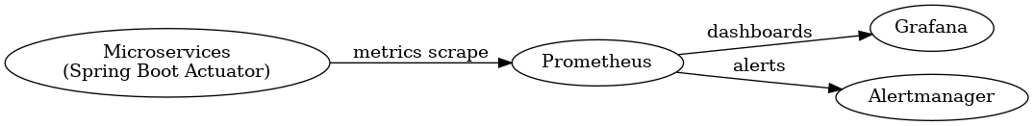
Figure 10 Authentication Flow Diagram

Analyse design
Table 24 presents the design progress and the degree to which each driver has been addressed in this iteration.
Table 24 Design Progress for the Disaster Response System: Iteration 6
Not Addressed | Partially Addressed | Completely Addressed | Design Decisions Made During the Iteration
 | QA-1 Performance | Partially addressed | Async logging minimizes overhead; tuning required
 | QA-2 Availability | Completely addressed | Health checks and alerts detect outages early
 | QA-3 Reliability | Completely addressed | Centralized logs reduce MTTR
 | QA-5 Security | Partially addressed | RBAC and retention policies defined; encryption detailed later

Iteration summary
Iteration 6 introduces a centralized observability layer for DRCCS, enabling effective monitoring, debugging, and alerting across the microservices architecture. By adopting ELK for logging and Prometheus/Grafana for monitoring, the system gains operational transparency critical for disaster response scenarios.
This iteration significantly strengthens system reliability and availability while preparing the architecture for production hardening. Future iterations may extend this design with distributed tracing (OpenTelemetry) and long-term log archiving strategies.

Iteration 7: Centralized Configuration Management
This iteration introduces a centralized configuration management solution for the DRCCS microservices architecture. The goal is to eliminate configuration duplication, improve consistency across services, and support environment-specific configuration while maintaining security, availability, and maintainability.

Review inputs
The inputs from Iterations 1–6 are refined by focusing on configuration management concerns across the distributed microservices environment.
Table 25 Inputs for DRCCS: Iteration 7
Category | Details
Design purpose | Introduce centralized configuration management for microservices
Functional requirements | Consistent configuration across services; environment-specific configuration
Quality attribute scenarios | QA-2 Availability, QA-3 Reliability, QA-4 Interoperability, QA-5 Security
Architectural concerns and constraints | Kubernetes-based deployment, API-first microservices, CI/CD automation, GDPR compliance
The current architecture uses service-local configuration files, leading to duplication and increased risk of configuration drift as the system scales.

Iteration goal and drivers
Goal:
Design a centralized configuration management mechanism that supports dynamic, environment-aware configuration for all backend microservices without increasing operational complexity or reducing system availability.
Drivers:
- QA-2 Availability – Configuration changes must not require rebuilding or redeploying all services
- QA-3 Reliability – Prevent configuration inconsistencies across services
- QA-4 Interoperability – Standardized configuration model across heterogeneous services
- QA-5 Security – Avoid hardcoding sensitive configuration values
- CRN-9 API-first design – Configuration must integrate cleanly with existing services
- Maintainability – Support CI/CD and reduce operational overhead

Choose elements
The element to refine in this iteration is:
- Backend Infrastructure, specifically the configuration management subsystem that supports all Spring Boot microservices.

Choose design concepts
Multiple configuration management approaches were evaluated. The selection was based on their ability to meet quality drivers while aligning with the existing Spring Boot, Kubernetes, and Docker-based ecosystem.
Design Alternatives Considered
Table 26 Configuration Management Alternatives Evaluation
Alternative | Description | Advantages | Disadvantages | Decision
Local application.yml per service | Each service maintains its own configuration files | Simple, low setup cost | High duplication, configuration drift, poor scalability | Rejected
Docker environment variables only | Config injected via Docker/Kubernetes manifests | Centralized per environment | Hard to manage large configs, weak structure | Rejected
Kubernetes ConfigMaps & Secrets | Externalized config via Kubernetes | Cloud-native, secure | Kubernetes-dependent, limited versioning | Considered
Spring Cloud Config Server | Centralized Git-backed config server | Versioned, scalable, Spring-native | Requires additional service | Selected
Selected Design Concept
Use Spring Cloud Config Server with a Git-backed configuration repository
Rationale:
- Natively integrates with Spring Boot microservices
- Supports environment-specific profiles (dev, test, prod)
- Enables centralized, version-controlled configuration
- Reduces duplication and configuration drift
- Aligns with CI/CD pipelines and GitOps practices

Instantiate elements, allocate responsibilities and define interfaces
Based on the selected design concept, the following elements are instantiated.
Table 27 Instantiation Decisions for DRCCS: Iteration 7
Element | Responsibility / Description | Rationale
Spring Cloud Config Server | Central service providing configuration to all microservices | Centralized, scalable configuration management
Git-based Config Repository | Stores versioned configuration files | Enables traceability, rollback, and CI/CD integration
Service-specific config files | incident-service.yml, chat-service.yml, etc. | Service-level customization without duplication
Shared application config | application.yml | Common properties (Kafka, discovery, logging)
Spring Profiles | dev, test, prod | Environment-specific behavior
Environment variables | Inject sensitive values (e.g., passwords) | Improves security without Vault

Configuration Access Pattern
Each microservice retrieves its configuration at startup using:
spring:
config:
import: optional:configserver:http://config-server:8888
Configuration updates can be refreshed dynamically using Spring Cloud Actuator.

Sketch views
Configuration Management View (Conceptual)
This view illustrates a single authoritative configuration source consumed by all backend services.
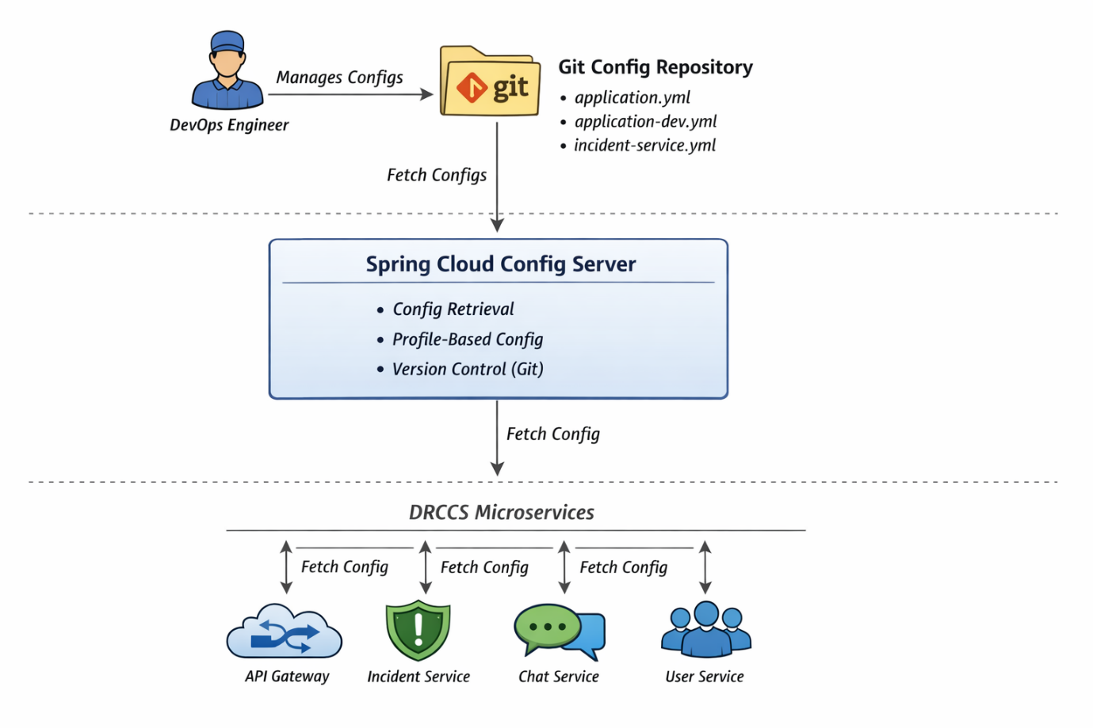

Analyse design
Table 28 Design Progress for DRCCS: Iteration 7
Driver | Achievement Status | Rationale
QA-2 Availability | Completely addressed | Configuration updates do not require image rebuilds
QA-3 Reliability | Completely addressed | Eliminates configuration drift
QA-4 Interoperability | Completely addressed | Uniform configuration model across services
QA-5 Security | Partially addressed | Secrets externalized via environment variables
Maintainability | Completely addressed | Git-backed configs enable CI/CD and auditing

Iteration summary
Iteration 7 introduces Spring Cloud Config Server as a centralized configuration management solution for the DRCCS microservices architecture.
Key achievements include:
- Elimination of duplicated configuration across services
- Environment-aware configuration via Spring Profiles
- Version-controlled, auditable configuration using Git
- Improved reliability and maintainability without added security complexity
The chosen solution aligns with the existing Spring Boot and Kubernetes ecosystem while deliberately avoiding over-engineering. Future iterations may extend this design for dynamic secret management if stricter security or compliance requirements emerge.

Bibliography
Cervantes, H., & Kazman, R. (2024). Designing Software Archtectures: A Practical Approach (2nd ed.). Pearson.

Attachments

Attachment A: Domain stories

Attachment B: Quality attribute scenarios

Attachment C: Architectural concerns and constraints

