User Story Mapping
Disaster REsponse Communication and Coordination system architecture
Furqan Malik, Faezeh Kianimoravej, Ben Vos, Sepideh Qorbani
2025
Contents
Introduction 2
High-Level User Story Map (Initial Design) 3
User Roles 4
Activities and User Stories (Release 1) 5
Resource Management 5
Incident Management 5
Resource Allocation 6
User Management 6
Example mapping 7

Introduction
The Disaster Response System is developed to help authorities, responders, and citizens collaborate effectively during emergencies.
Its purpose is to streamline the flow of information from incident reporting and prioritization to resource allocation and coordination within a unified digital environment.
This document outlines the User Story Map of the system, serving as a living artifact that evolves alongside the project.
It provides a structured overview of user interactions, major activities, and functional stories that guide both design and development efforts.
By mapping user goals across different roles including Citizen, Responder, Authority, and Administrator, the story map ensures that system functionality remains aligned with real-world operational needs. Each story is expressed following Agile and Behavior-Driven Development BDD) principles to maintain clarity, traceability, and shared understanding among stakeholders.
The document also supports ongoing refinement as new insights emerge and additional stories or dependencies are introduced, while preserving a coherent view of the overall system journey.

High-Level User Story Map (Initial Design)
This diagram provides an overview of the Disaster Response System during its initial design phase.
It visualizes the main personas (Citizen, Responder, Authority, and System), their key user tasks, and how these tasks are distributed across different functional areas such as Incident Detection, Alert and Notification, Coordination and Task Management, Communication and Collaboration, and Monitoring and Tracking.
This map guided the breakdown of features into detailed user stories implemented in later phases.
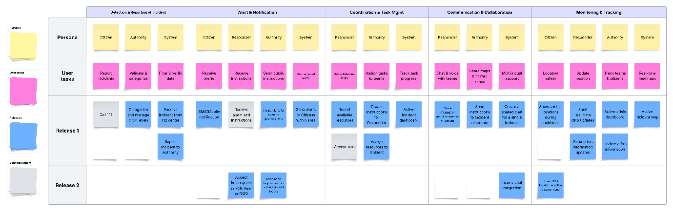
Figuur 1. High-Level User Story Map (click to view full image)

User Roles
The Disaster Response System enables effective coordination between multiple actors involved in managing emergencies.
It focuses on ensuring that incidents are reported quickly, prioritized correctly, and supported with appropriate resources.
The system is structured around four main roles:
- Citizen: Reports new incidents and provides situational details.
- Responder: Manages available resources and updates their status.
- Authority: Reviews incidents, assigns GRIP levels, and allocates resources.
- Administrator: Oversees user management, access control, and system configuration.
Each role contributes to a shared operational flow:
- Incident Reporting: Citizens and professionals submit incidents through defined channels.
- Incident Management: Authorities review and prioritize reported incidents.
- Resource Allocation: Resources are assigned, tracked, and adjusted based on availability.
- Notification and Coordination: Stakeholders receive timely updates to ensure aligned response efforts.
This structured flow allows the team to visualize dependencies between features, identify key user interactions, and maintain a clear development roadmap as the system evolves.

Activities and User Stories (Release 1)

Resource Management
User Story: US01 – Resource Reporting
Field | Details
Role | Responder
Goal | Report available resources for incident response so that resource allocation can be managed.
Acceptance Criteria | • Responders can submit resource availability.  • System tracks reported resources.

Incident Management
User Story: US02 – Receive Incidents
Field | Details
Role | System
Goal | Accept incident reports from both citizens (via 112) and professionals so that all incidents are registered and tracked efficiently.
Acceptance Criteria | • System logs incident data from 112.  • System logs incident data from professionals.  • Incidents are visible in the system.

User Story: US04 – Incident Prioritization
Field | Details
Role | Authority
Goal | Assign GRIP levels to incidents so that urgent incidents are handled first.
Acceptance Criteria | • Incidents have priority levels.  • System displays incidents sorted by priority.

User Story: US05 – Notify Authority of New Incidents
Field | Details
Role | System
Goal | Alert the authority about new incidents, including urgency details, so that response can be faster.
Acceptance Criteria | • Authority receives notifications with urgency information for new incidents.

Resource Allocation
User Story: US06 – Resource Assignment
Field | Details
Role | Authority
Goal | Assign and manage resources for specific incidents to ensure adequate response.
Acceptance Criteria | • Authority can allocate and deallocate resources for incidents.  • Allocation and changes are recorded and tracked.  • Resource availability and distance are considered.

User Management
User Story: US35 – CRUD User
Field | Details
Role | Administrator
Goal | Create, update, and remove users with role-based permissions.
Acceptance Criteria | • Admin can manage user data securely.  • Unique validation for email and mobile number.  • Access restricted to Admin users only.

Example mapping
Each story is described with its main rules, examples, and open questions to clarify boundaries and edge cases.
US01 — Resource Reporting
Rule | Example | Question
Responders must be able to report available resources. | Responder submits “5 ambulances” available from Enschede Department.
System must validate required resource details before submission. | Missing type or quantity disables “Submit” button. | Should partial submissions (e.g., type but no count) be saved as drafts?
Reported resources must be visible to Authority and System. | Authority dashboard lists all resources with status “Available.”

US02 — Receive Incidents
Rule | Example | Question
System must accept incident reports from citizens (via 112). | Citizen calls 112 → new “Flood in Deventer” incident created. | Should caller details be recorded for follow-up or hidden for privacy?
System must also accept incident reports from professionals. | Ranger reports a wildfire through the mobile app. | Should citizen and professional reports about the same location be merged automatically?
All incidents must appear on Authority’s dashboard. | “Factory Fire in Almelo” appears instantly in Authority view. | Should the default sorting be by creation time or by severity?

US04 — Incident Prioritization
Rule | Example | Question
Authority assigns GRIP levels to all incidents. | “Chemical Spill” set to GRIP 3 after initial review. | Should a default GRIP be auto-assigned when the level is unknown?
System sorts incidents by priority automatically. | GRIP 4 incidents appear before GRIP 2 in list view.

US05 — Notify Authority of New Incidents
Rule | Example | Question
Authority must be alerted about every new incident. | Pop-up: “New Incident – Flood in Hengelo .”
Authority must be able to open the incident detail by clicking the notification. | Authority clicks the alert → redirected to “Incident Details” page.
Notification history should remain accessible. | Authority opens “Notifications Log” to review older alerts.

US06 — Resource Assignment
Rule | Example | Question
Authority allocates available resources to incidents. | 3 ambulances assigned to “Flood in Enschede.”
Assigned resources must be tracked by the system. | Resource ID 102 marked as “Allocated to Incident #27.” | Should the system automatically release resources once an incident is closed?
Authority must be able to reassign or remove resources. | Reassigns ambulance from “Flood” to “Accident.” | Should the system keep a full allocation history for audit purposes?
System checks resource availability before assignment. | Attempt to assign already-in-use unit → “Unavailable” message.

US35 – CRUD User
Rule | Example | Question
Only Admin users can create, edit, or remove system users. | Admin logs in → opens “Create User” form.
System must validate all required fields before saving. | Missing “Email” disables “Save” button.
Email and mobile number must be unique across users. | Attempt to create user with duplicate email → “Email already in use” error.
Password must meet security requirements. | “abc123” rejected → must contain uppercase, lowercase, number, symbol. | Should password rules vary for different user roles?
Successful creation should show confirmation message | “User created successfully” appears after valid form submission.
Only Admins can delete users (soft delete). | Admin removes inactive user → user marked “Archived,” not removed from DB. | Should archived users still appear in search results?
User roles determine access to pages and actions. | Regular responder can only view resource data, not manage users.

